Rural Tribal Priority Window Filing Instructions
Application(s) for the Rural Tribal Priority Window must be filed through the Universal Licensing System (ULS). ULS may be accessed at https://www.fcc.gov/wireless/systems-utilities/universal-licensing-system.
In order to access ULS, the user must have an FCC Registration Number (FRN). To obtain an FRN or update an existing FRN, click on “New User Registration” on the ULS homepage (see Image 1 below). Follow the online prompts and continue through each screen until the FRN has been obtained or updated. Note: For assistance, contact the FCC Support Center at (877) 480-3201, option four; TTY: (202) 414-1255. To provide quality service and ensure security, all telephone calls are recorded.
Once the FRN has been obtained or updated, return to the ULS homepage and click on “File Online” (see Image 1 below).
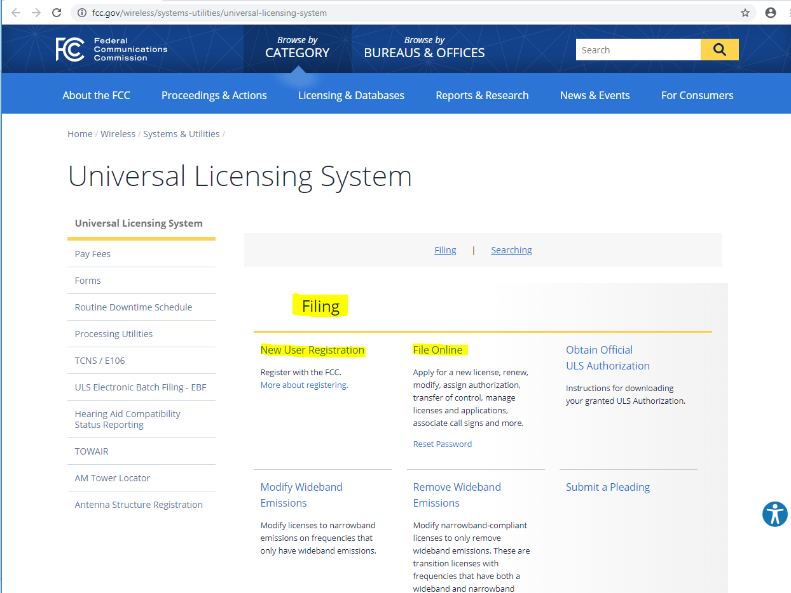
Image 1

Clicking “File Online” will take you to the License Manager (see Image 2 below). Enter your FRN and Password. Click Submit. ULS will verify that you have entered a valid FRN and password. If invalid, ULS will display an error message.
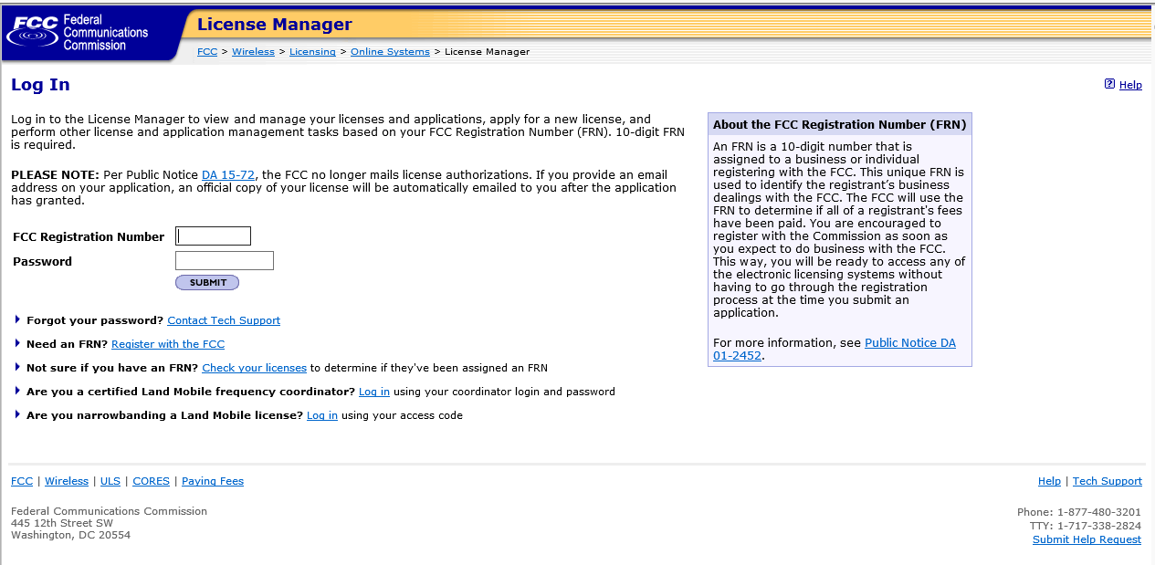
Image 2.

From License Manager, click “Apply for 2.5 GHz Tribal Priority License” (see Image 3 below).
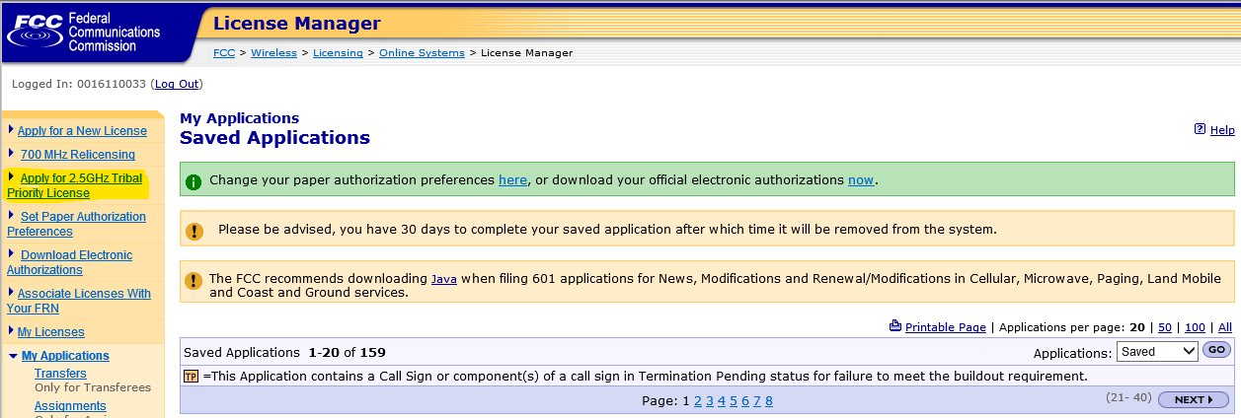
Image 3
Clicking on “Apply for 2.5 GHz Tribal Priority License” will launch a new application. Complete the questions on the pages as they appear, following the onscreen prompts and instructions. Use the buttons at the bottom of each page to continue to the next page or go back to the previous page.

Please enter your Applicant Information (see Image 4).
Real-party-in-interest (see Image 4). A real-party-in-interest is a person who “has an ownership interest, or will be in a position to actually or potentially control the operation of the station.” To be eligible to apply in the Tribal window, the applicant must be a federally recognized American Indian Tribe or Alaska Native Village, or an entity that is majority-owned and controlled by one or more federally-recognized Tribes or Alaska Native Villages. Thus, if a Tribe or Alaska Native Village is applying on its own behalf, this question should be left blank. If the applicant is a consortium of federally-recognized Tribes or Alaska Native Villages, the applicant should list each member of the consortium. If the applicant is an entity majority owned and controlled by one or more Tribes or Alaska Native Villages, the applicant should list all of the Tribes(s) or Alaska Native Village(s) which hold majority ownership and control of the applicant.

Image 4
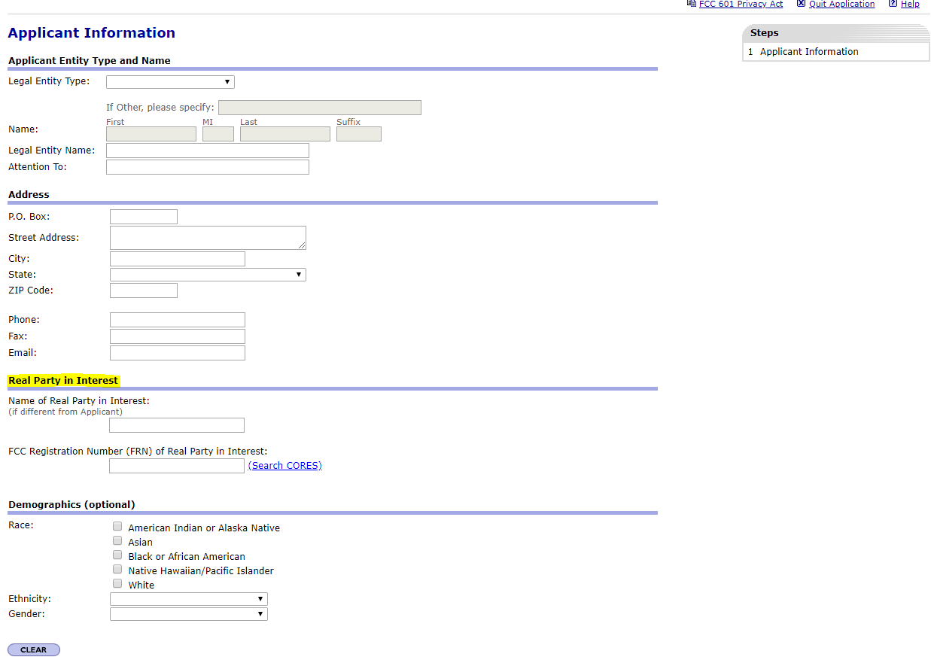

Please enter your Contact Information.

On the General Information page, the selection for Regulatory Status is prefilled to display non-common carrier, Type of Radio Service is prefilled to display “Fixed” and “Mobile.” and Interconnection is prefilled to display “No.” Review the prefilled selections; you can change the prefilled selections, if needed. Your selection here does not limit your future use of the spectrum.
Each applicant must upload an exhibit demonstrating its eligibility for the 2.5 GHz Rural Tribal Priority Window and its compliance with the “local presence” requirement.
On the Application Information page, please answer the question regarding whether the applicant is requesting a rule waiver. If the answer to this question is “yes,” then the Attachment question is defaulted to “yes” and cannot be changed, because the applicant must upload an appropriate attachment justifying the waiver request.
Any exhibits to be attached to the application in response to a question on the FCC Form 601 or as specified in the Commission’s rules or in this Public Notice should be added using the “Attachments” link. Click on “Attachments” link at the top of the page (see Image 5 below). This link will take you to the “Add Attachment” page (see Image 6 below). Select the appropriate attachment type from the pull-down menu in the text box provided, browse for your file, add a description and click on the “Add Attachment” button. ULS will accept many different types of computer files. Do not add password protection to the attached files. After the attachment(s) is added, click on “Return to Application” button. Please note: The Contact Information page is the first screen where attachments may be added. Attachments, however, may be added at any time during the application process but must be added prior to submitting.
Image 5.
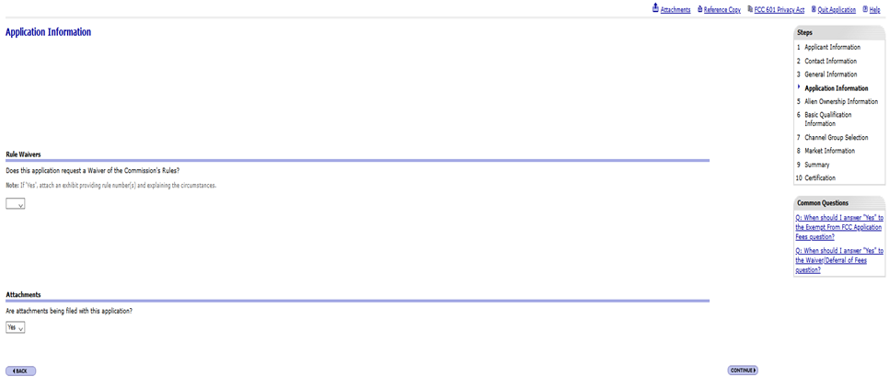
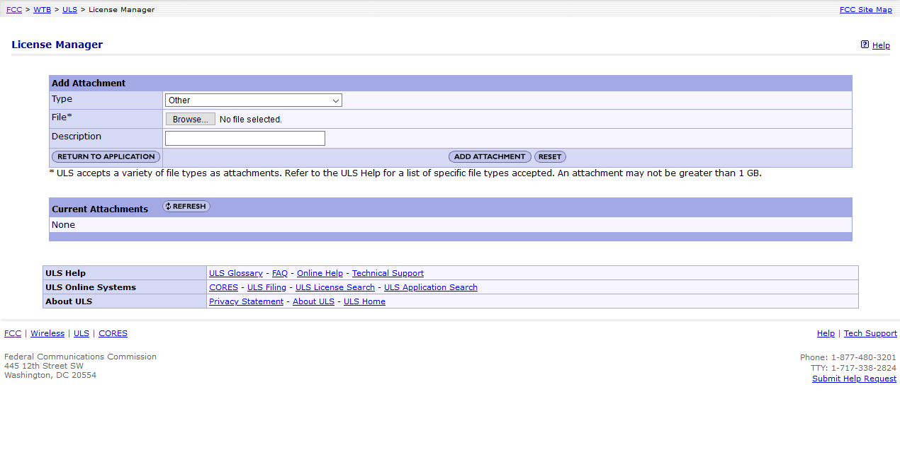
Image 6.

If your regulatory status is common carrier, you must answer the questions on the Alien Ownership Information page.

Please complete the Basic Qualification Information.

2.5 GHz Rural Tribal Priority Window Market Information (See Image 7 below). From this screen you will identify the Eligible Tribal land for which you are applying. The Commission has created shapefiles for each Eligible Tribal land.
In Alaska, all land (except for a limited amount of land contained in urban areas) is eligible rural Tribal land because the land covered by the Alaska Native regional corporations are “regions established pursuant to the Alaska Native Claims Settlement Act.” The Commission shapefiles include shapefiles for Alaska Native Village Statistical Areas and larger shapefiles for the land covered by the Alaska Native regional corporations. The listing of these by Alaska Native regional corporation name does NOT imply that those regional corporations are eligible entities for purposes of filing in this Window, nor does it imply that any eligible entity can necessarily meet the local presence requirement to apply for an entire region. Alaska eligible entities must demonstrate local presence over the land for which they apply. Thus, Alaska Native Villages are not limited to their statistical area, but can apply over rural land for which they can demonstrate local presence and commit to meet build out requirements. Thus, a custom shapefile may be required with the application. To view or download a shapefile prior to filing your application, go to https://us-fcc.app.box.com/s/fofbkwy5lxo6q8kq94i5bg8raob5gpui.

To select a Commission-created shapefile, click on the select a shape file from the FCC’s map. Select one Eligible Tribal Area Click Upload File. The selection will be uploaded to the map.
Image 7 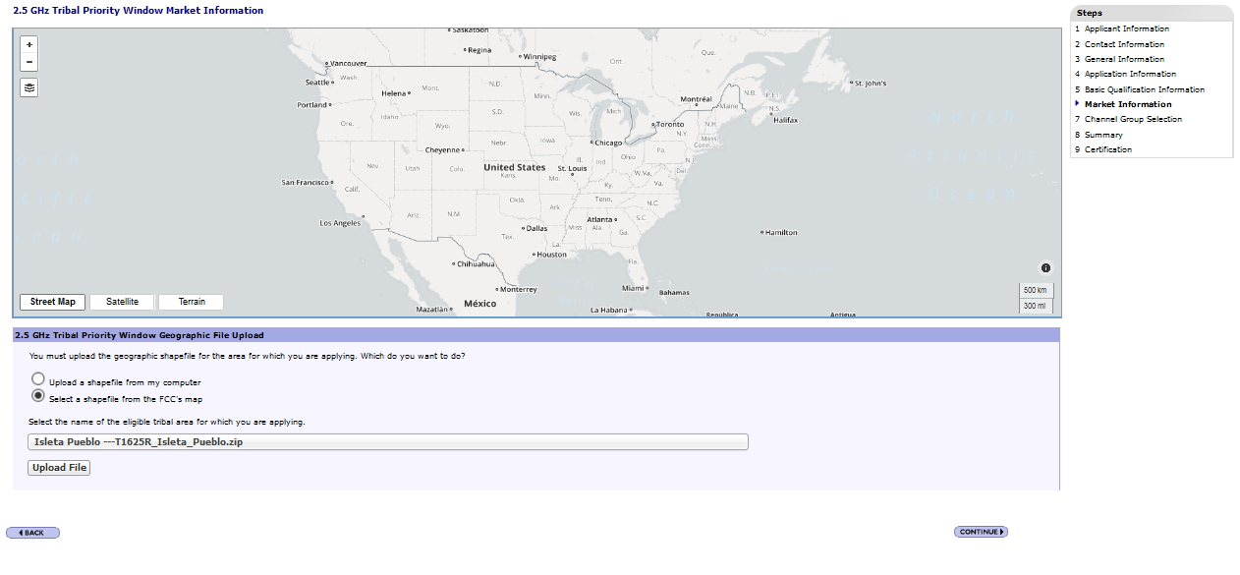
To upload a shapefile that you created on your own, click the upload a shapefile from my computer button and click “browse” to browse your computer to select the shape file that describes the Tribal area to be licensed. Select the Shapefile. Click Open. Click Upload File. Wait for the file to load. Please Note: Your shapefile must be within an Eligible Rural Tribal Land. Depending on the size of your shapefile and the speed of your connection, uploading or deleting shapefiles may take more than a few moments to complete. Do not interrupt the upload or deletion, do not use your browser’s back button, and do not quit the application until your file is loaded or deleted. Please remain on the market information screen until the process is complete. If the map does not display correctly or there is an “invalid” status, it may mean that something is wrong with your shapefile (see Image 9 below). You may click delete to remove a shapefile, but a new valid shapefile must be uploaded in order to file your application. Please note: If you are applying for an area for which there is not an uploadable shapefile, you must describe the area in your local presence or waiver attachment and upload your own shapefile. Applicants are reminded that any shapefile that is not limited to eligible, rural Tribal lands must be accompanied by a request for waiver.
Image 8.
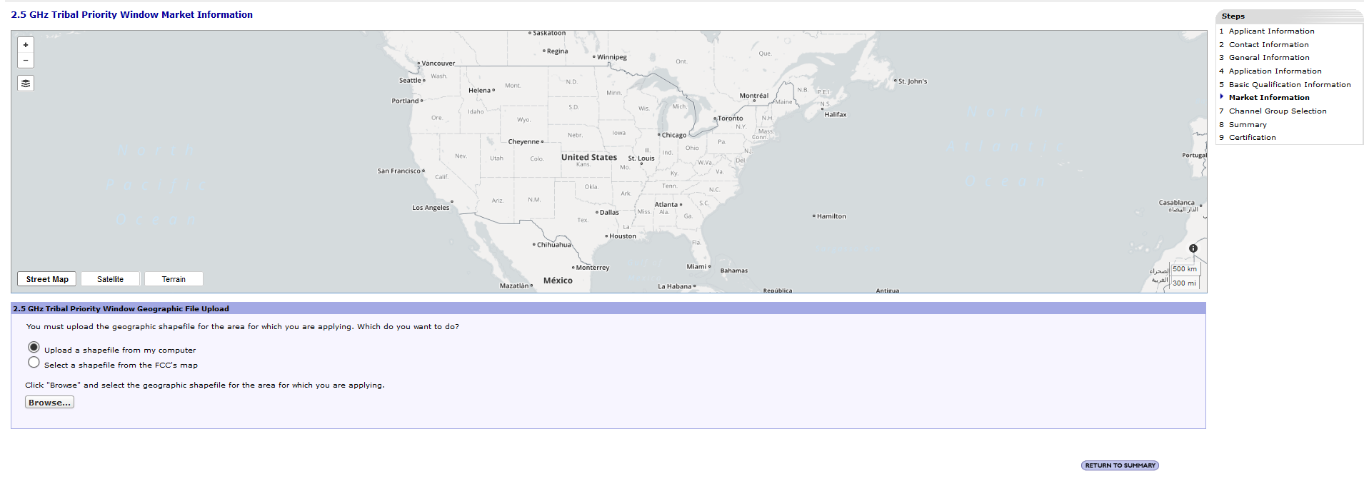
Image 9.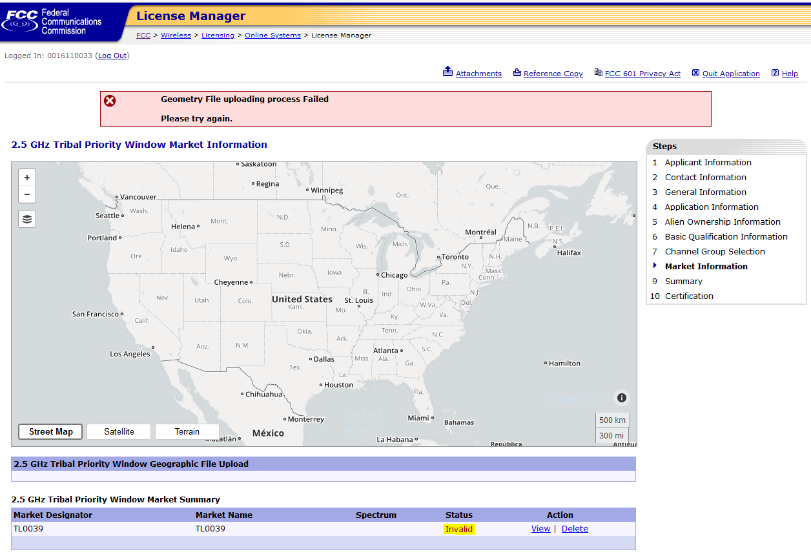

Channel Group Selection (see Image 10 below). From this screen you will select the channel block(s) that you are applying for. The listing of channel groups does not indicate actual availability. Check the mapping tool and ULS License Information to identify available spectrum. At least one channel group must be selected. Please note: To apply for all unassigned spectrum over your requested eligible rural license area, you should select all channel groups. Applicants may not add channel groups after the window closes.

Image 10
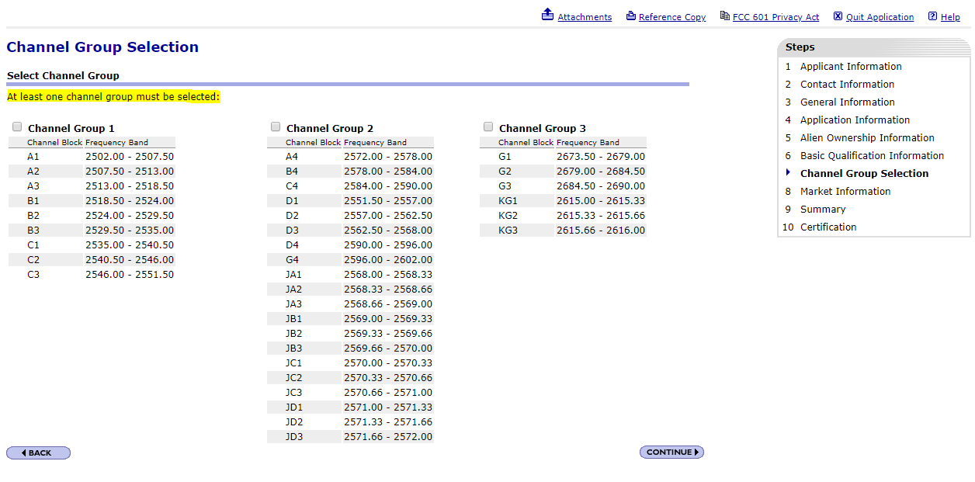

Summary Screen – The Summary Screen allows you to view or edit the information entered in previous screens and confirm that it is complete and accurate. The Summary Page will display errors with your application. Correct information as necessary. Once you are confident that the application is ready for certification and submission, click on the “Continue to Certify” button.
Certification Page – The Certification page provides General Certification Statements. By “signing” this form, an applicant certifies that the statements listed in this section are true, complete, correct, and made in good faith.
To submit the application to the Commission, click the “Submit Application” button.
After the application has been submitted, a Confirmation page displays a file number. Receiving a file number indicates that your application has been successfully submitted. Any future reference to this application must be made using the application file number. Applicants should print a copy of the Confirmation page for their records by choosing the “Print this Page” link. Applicants can also print a copy of their complete application by selecting the “Print Application” link.

To file a 602, click “Return to License Manager – My Applications” on the top right of the page. On the My Applications screen click “My Ownership Disclosure Information”.
Item 11
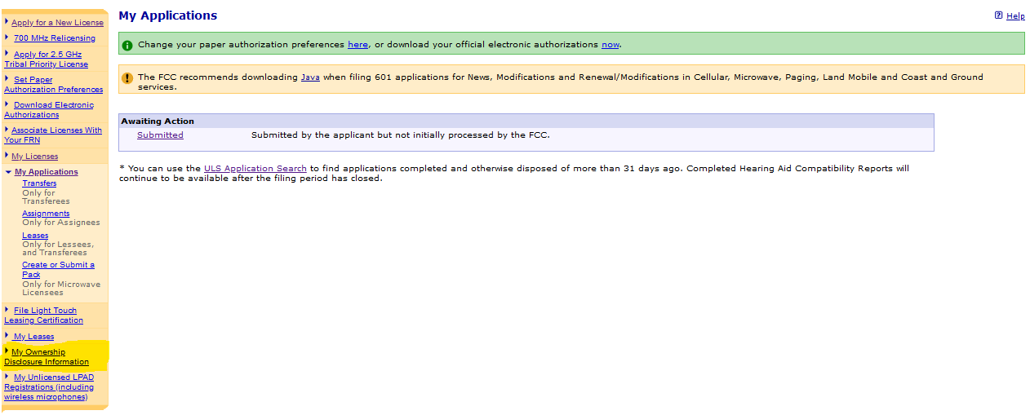

Click “Create New Filing” or “Create a new Ownership Disclosure filing.”
Item 12
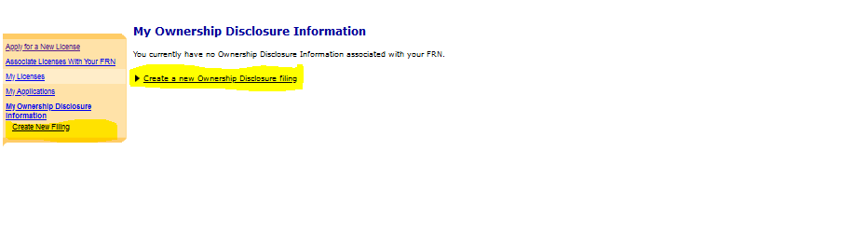

Filing Type prefills as “Current filing.” Click Continue
Item 13
Select “Filer Name (if entity)” and enter the applicant name. Complete the Contact Name and Contact Address, click save.
Item 14
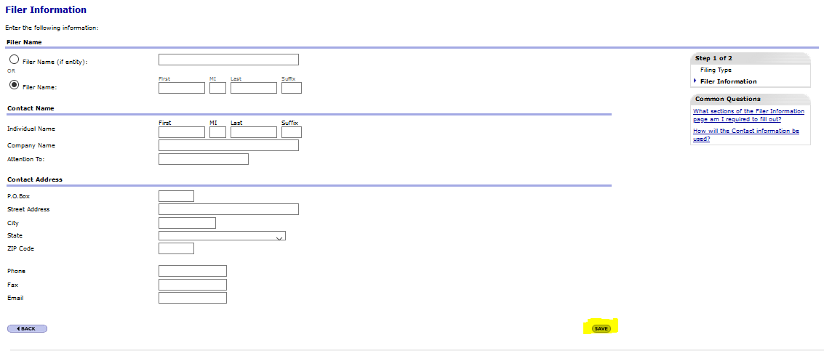

Click “Add FCC Regulated Business Filer.”
Item 15
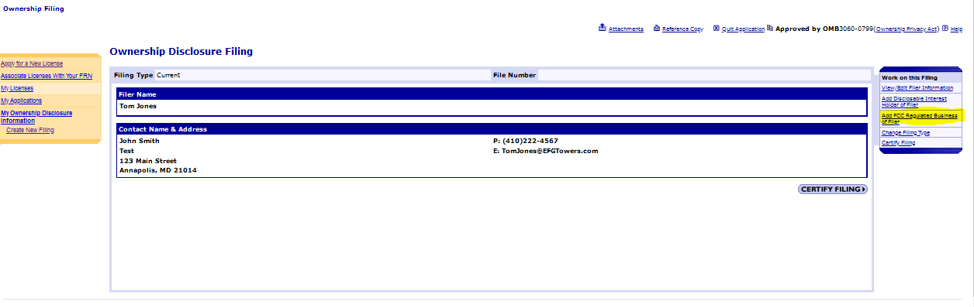

Click “Add FCC Regulated Business of the Filer”
Item 16

Add the requested information and click save\
Item 17

If the applicant is a Tribe, it should submit the main portion of Form 602 and an exhibit listing the name, address, and title(s) of each member of the governing council or other entity that oversees the Tribe’s affairs. Click “Attachments.”
Item 18
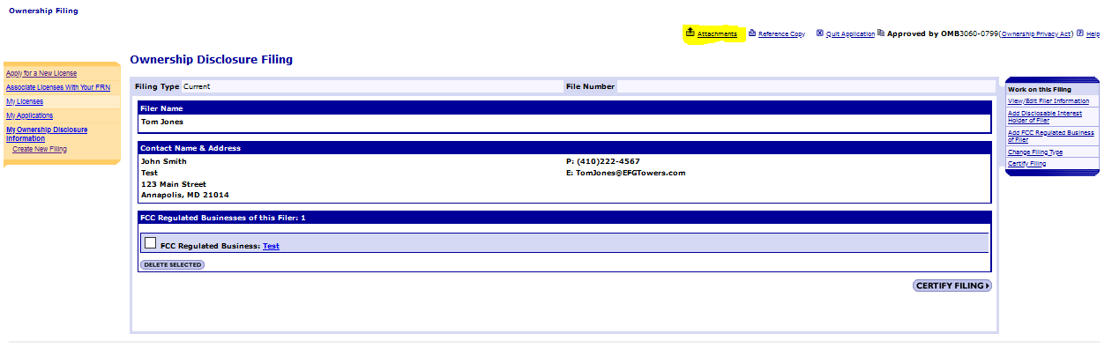

Tribal entities must submit an exhibit listing the name, address, and title(s) of each member of the governing council or other entity that oversees the Tribe’s affairs.
Select “Other” attachment Type. Click Browse to locate and select your document. Enter a Description.
Click Add Attachment
Item 19
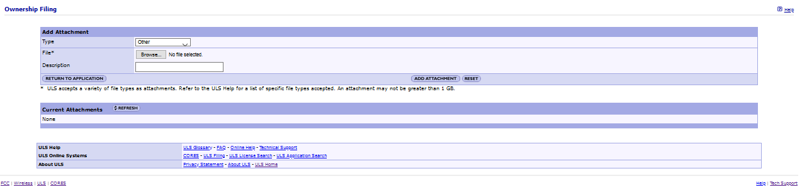

Click “Return to Application”
Item 20
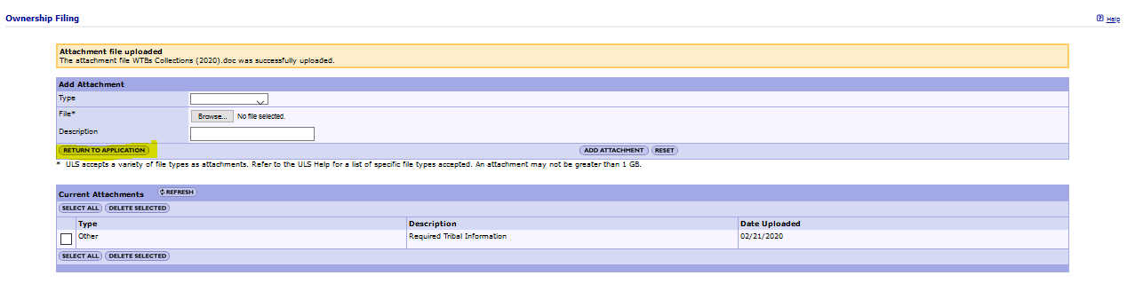

Non-Tribe applicants such as Tribally-owned and controlled corporate entities must also provide information about their disclosable interest holders. Click “Add Disclosable Interest Holder”. Corporate applicants should follow the instructions available at https://transition.fcc.gov/Forms/Form602/602.pdf and contact RuralTribalWindow@fcc.gov with questions relating to a specific ownership structure.
Tribal applicants not required to provided DIH information click “Certify Filing”.
Item 21
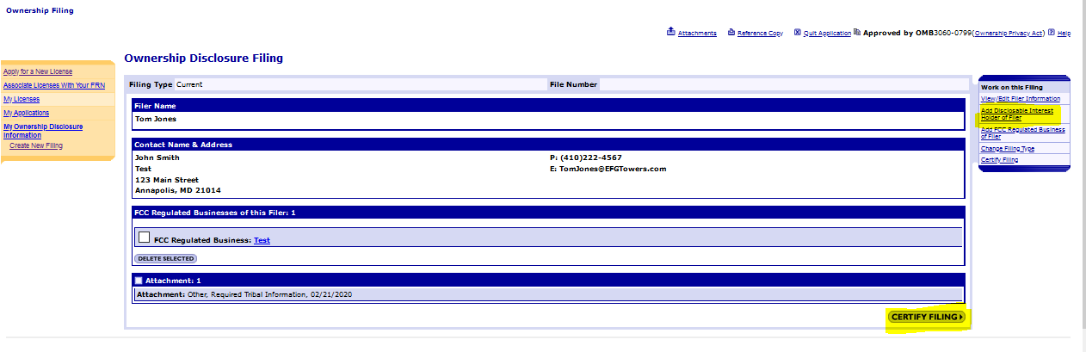

Enter the Name and Title of the party authorized to sign. Click “Submit Filing.” Once submitted you will see the Certification Page.
Item 22
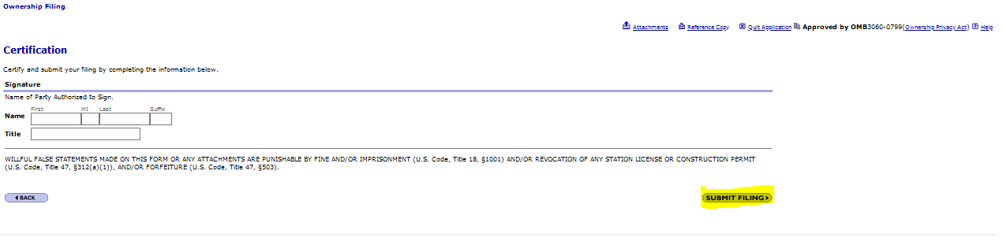
Certification Page – The Certification page provides General Certification Statements. By “signing” this form, an applicant certifies that the statements listed in this section are true, complete, correct, and made in good faith.
After the application has been submitted, a Confirmation page displays a file number. Receiving a file number indicates that your application has been successfully submitted. Any future reference to this application must be made using the application file number. Applicants should print a copy of the Confirmation page for their records by choosing the “Print this Page” link. Applicants can also print a copy of their complete application by selecting the “Print Application” link.

As noted in the Public Notice, the Alaska Native regional corporations are not eligible to apply in the Tribal Priority window because they are not entities “owned and controlled by a federally-recognized Tribe or a consortium of federally-recognized Tribes.”

