- Terrain Elevation
In this Appendix, we explain how we characterize variation in terrain for purposes of estimating the adjustment factor. Terrain variation generally can be characterized by the standard deviation of terrain elevation. To create a comparable terrain measure across geographic regions, we assign a terrain roughness value to each 100x100 meter grid cell (cell) by taking the standard deviation of terrain elevation of all cells that fall within a 2.5 kilometer radius of this 100x100 meter cell. We then determine the terrain roughness values across a geographic region or a particular geography (e.g. Census tract) by taking a simple average of the 100x100 grid cell standard deviations of all grid cells that fall within the boundaries of the relevant geography. We separate areas into three main categories: 1) flat (standard deviation of terrain elevation of 40 meters or less); 2) hilly (standard deviation of terrain elevation between 40 and 115 meters); and 3) mountainous (standard deviation of terrain elevation of greater than 115 meters). Fig. A-1 below illustrates the terrain variations within the United States according to these three classifications.
Fig. A-1: Terrain Categories in the United States
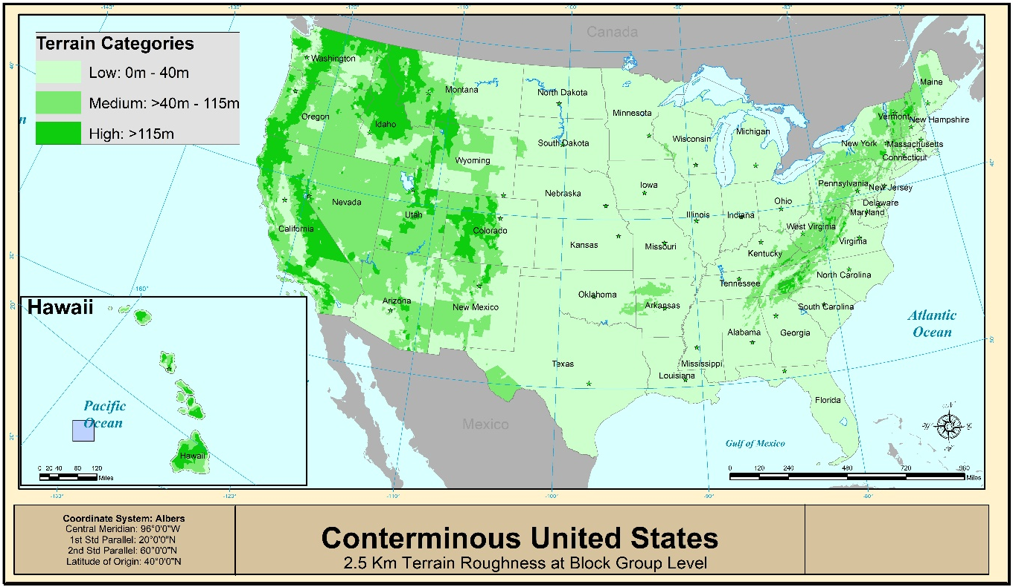

In general, more terrain variability (i.e., more dips and peaks) would, all else equal, result in reduced predicted coverage areas relative to a flat area.
See OBI Technical Working Paper No. 1, at 51.
This approach is similar to the approach taken in the National Broadband Plan (NBP), which calculated the standard deviation of elevation for block groups. OBI Technical Paper No. 1, at 50-52. Our approach differs from the NBP approach in that we calculate standard deviations over uniform geographic areas (in particular, we use a circular neighborhood of 2.5 kilometers) in order to produce a consistent measure across areas of different geographic size. We then calculate the average standard deviations in these areas (e.g., block groups, counties). The NBP approach takes the standard deviation of all points within a tract, but because census tracts are not uniform in size and thus contain varying numbers of elevation points, this leads to a distortion in the NBP approach wherein tracts with large land areas appear to be hillier than smaller tracts with the same set of elevation points. The distortion occurs because for any set of elevation points, S, the standard deviation of S is greater than or equal to the average of the standard deviations of any partitions of S. The approach adopted herein avoids this distortion by calculating standard deviations over areas of uniform size and then averaging over the standard deviations.

