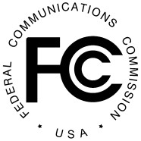
PUBLIC NOTICE
Federal Communications Commission News Media Information 202 / 418-0500
Internet: http://www.fcc.gov
445 12th St., S.W. TTY: 1-888-835-5322
Washington, D.C. 20554

DA 21-13
January 06, 2021
RADIO LICENSE EXPIRATIONS
On October 1, 2020, radio stations located in Iowa and Missouri were required to file applications for license renewal for terms expiring on February 1, 2021. The following stations failed to file license renewal applications and their licenses will expire as of February 1, 2021, provided no renewal application is received by midnight on the date of expiration:

Call sign | Community of License | Facility ID | Licensee
KRUU-LP | FAIRFIELD, IA | 133984 | FAIRFIELD YOUTH ADVOCACY, INC.
KBOL-LP | WATERLOO, IA | 134517 | THE COMMUNITY OUTREACH, INC
KCSW-LP | CANTON, MO | 131733 | CULVER-STOCKTON COLLEGE
KLHM-LP | ST. JOSEPH, MO | 131633 | LIGHTHOUSE RADIO MINISTRY, INC.

- FCC -

