DA 21-1403
Released: November 9, 2021

Wireline Competition Bureau completes initial phase of COVID-19 TELEHEALTH PROGRAM ROUND 2 AWARDS AND commences ten-day resubmission period
75 Health Care Providers Receive Critical Support for Telehealth and Connected Care Services in the Initial Phase
WC Docket No. 20-89

Today, the Wireline Competition Bureau (Bureau) approves the fourth group of funding commitments under Round 2 of the Coronavirus Disease 2019 (COVID-19) Telehealth Program (Program) and commits $42,163,705 in funding to 75 health care providers across the Nation. The funding commitments made today will provide critical support to health care providers on the front lines in the fight against the ongoing coronavirus pandemic. A full list of the funding awardees is included in Appendix A of this Public Notice.
This Public Notice completes the initial commitment phase of the Program. All Program applicants that did not receive funding commitments as part of this initial phase may supplement their applications during the ten-day resubmission period, which will close on Friday, November 19, at 5 PM ET.
The Federal Communications Commission (Commission) established the Program in April 2020 pursuant to the Coronavirus Aid, Relief, and Economic Security (CARES) Act to provide $200 million in emergency funding to health care providers for telehealth and connected care services in response to COVID-19. To build on the Program’s success, Congress appropriated $249.95 million in additional funding in the Consolidated Appropriations Act, 2021. On March 30, 2021, the Commission released the Second COVID-19 Report and Order, which initiated Round 2 of the Program by adopting additional requirements and processes to implement Congressional direction and improve Program administration. Applications for Round 2 were accepted from April 29, 2021, through May 6, 2021.
As the Commission established in the Second COVID-19 Report and Order, funding for Round 2 of the Program is to be awarded in two phases. In the initial commitment phase, at least $150 million was to be awarded based in part on geographic considerations and on the objective evaluation metrics outlined in the Second COVID-19 Report and Order. To date, 280 awardees have received funding commitments for $165,726,081.
All applicants that did not receive a funding commitment during the initial commitment phase will now have ten days to supplement their applications as required by the Consolidated Appropriations Act. Concurrent with the release of this Public Notice, the Bureau will send all such applicants an Intent to Deny Letter, stating their application’s score, the list of metrics for which the application is currently receiving points, and the reason that their application was not awarded funding during the initial commitment phase.
The ten-day period will begin on Tuesday, November 9, and will end at 5 PM ET on Friday, November 19. After the ten-day resubmission period, the Universal Service Administrative Company (USAC) will re-rank the remaining applications, which will include an evaluation of all remaining unfunded Round 2 applications, regardless of whether an applicant has chosen to supplement its application. The Bureau will then commit funding to the highest-scoring remaining applications. $92,082,563 is available for the second and final commitment window. Because the ten-day period is specified by statute, waivers of this deadline will not be granted.
A more complete guide for applicants to supplement their applications is attached to this Public Notice. The guide can also be accessed at https://www.usac.org/about/covid-19-telehealth-program/covid-19-telehealth-program-application-resources/supplementing-information-instructions/.
For further information regarding this Public Notice, please contact Nathan Eagan, Attorney Advisor, Wireline Competition Bureau, Nathan.Eagan@fcc.gov or (202) 418-0991. For more information about Round 2, refer to USAC’s website at www.usac.org/about/covid-19-telehealth-program.
For inquiries and support related to Round 2 invoicing, please contact Round2TelehlthInvoicSupp@FCC.gov.

-FCC-
APPENDIX A

Lead Health Care Provider or  Applicant | Eligible Funding  Amount
Adler Community Health Services | $359,836
Adult & Child Mental Health Center | $516,208
Advantage Behavioral Health Systems | $222,406
Albany Medical Center | $810,801
Ammonoosuc Community Health Services | $332,854
Aspire Indiana | $211,861
Astor Services for Children and Families | $344,119
Barnes-Jewish Hospital | $996,722
Los Barrios Unidos Community Clinic | $951,800
Bay Area Community Health | $960,436
Billings Area Office Indian Health Service | $1,000,000
Bluebonnet Trails Community Services | $724,411
Broad Top Area Medical Center | $354,602
Brooks Rehabilitation Hospital | $218,599
CareSTL Health | $386,476
Caromont Regional Medical Center | $130,591
Catholic Health Initiatives | $1,000,000
Centro de Salud Familiar La Fe | $750,948
CGH Medical Center | $183,015
CHI Saint Joseph Health System | $403,191
The Children's Hospital of Philadelphia | $869,672
Community Health Programs | $164,079
Duke University Health System | $955,557
El Centro del Barrio | $999,879
Elliot Health System | $984,953
FamilyCare Health Center | $406,896
Fort Defiance Indian Hospital Board | $244,614
Highlands Health: Laurel Highlands Free & Charitable Medical Clinic | $198,530
Honor Community Health | $693,990
Horizon Health Center | $74,100
Intermountain Centers for Human Development | $183,393
Kirkland Village | $1,000,000
Konza Prairie Community Health Center | $488,176
Lakewood Resource and Referral Center | $999,010
LifeStream Behavioral Center | $338,100
Louisiana Independent Hospital Network Coalition | $452,758
Maricopa County Special Health Care District | $975,530
University of Maryland Medical System | $795,146
Memorial Hospital of South Bend | $116,571
Methodist Hospitals – Northlake | $1,000,000
MidMichigan Health | $765,175
Mid-State Health Center | $198,662
Mountain Health and Wellness | $920,385
Mountain Park Health Center | $165,844
Munson Healthcare | $485,407
Native American Community Health Center | $416,006
Nemours Children's Hospital | $904,048
North Mississippi Medical Center-Tupelo | $1,000,000
North Valley Hospital | $92,591
Northern Lakes Community Mental Health | $404,812
Norton Healthcare | $964,576
Ochsner Medical Center | $999,996
Ossining Open Door | $426,039
Professional Care Services of West Tennessee | $195,953
Project Vida Health Center | $384,159
Red Lake Hospital | $291,148
Scheurer Hospital | $161,488
Shawnee Christian Healthcare Center | $320,808
Sisters of Charity | $955,102
Southern Illinois University School of Medicine | $967,430
St. Croix Regional Medical Center | $437,475
St. Joseph Mercy Oakland | $306,927
Sunset Park Health Center at NYU Langone | $1,000,000
Tampa Family Health Centers | $657,250
TCA Health | $99,574
University Medical Center Management Corporation | $996,376
Valle del Sol | $383,959
Valley Health | $1,000,000
The Visiting Nurse Association of Central Jersey Community Health Center | $204,808
Washington University School of Medicine | $737,109
The Wright Center Medical Group | $491,814
Yakutat Community Health Center | $454,343
York County Community Action | $346,506
Yukon-Kuskokwim Health Corporation | $520,597
Zufall Health Center | $707,508

APPENDIX B

COVID-19 TELEHEALTH PROGRAM ROUND 2 –
INSTRUCTIONS FOR SUPPLEMENTING APPLICATIONS

- Program applicants are not required to supplement their applications; applications will not lose any points even if they are not supplemented. All remaining applications, regardless of whether they include supplemental information, will be considered for awards from the outstanding funding.
- Applications should only be supplemented with information that was not included in the original application. Only the application evaluation metrics may be supplemented; changes to funding requests may not be made. A list of the application metrics, and the corresponding points for the metrics, can be found on page 18 of the Commission’s Round 2 Report and Order.
- When deciding whether to supplement their applications, applicants should check to make sure that they did not omit any material information, e.g., location on Tribal land, from their original applications.
- Applicants may use the COVID-19 Hotspot data set from either May 6, 2021, or Friday, November 19, 2021 consistent with the Bureau’s Order: https://www.fcc.gov/edocs/search-results?t=advanced&daNo=21-1404.
- In order to supplement their applications, applicants should log in to their applications at www.fcc.gov/covid19telehealth between Tuesday, November 9 and Friday, November 19. During that period, when applicants log in to their application, they will have the opportunity to enter new information and attach relevant files. The deadline to supplement applications is 5 PM ET on Friday, November 19. Applicants may only supplement their applications during that time.
- Applicants may only submit supplemental information once, so they should make sure that they have included all relevant information before clicking “submit.”
- In order to claim application evaluation points for a metric that they did not claim on their initial application, applicants must enter:
  - The metric or metrics for which they wish to receive points, in the “Applicant Response” box. In the image below, the applicant is claiming additional points for being located (1) on Tribal land and (2) in a sustained hotspot, as indicated by the green arrows.
  - The additional points the applicant is claiming, in the “Adjustment Claim” box. In the image below, the applicant is claiming 30 addition points, with 15 for being located on Tribal lands and 15 for being located in a sustained hotspot, as indicated by the red rectangle.
  - Any information necessary to verify the applicant’s claim in the “Applicant Response” box. In the image below, the applicant would submit, at a minimum, the names and addresses of the eligible HCPs which the applicant is using to claim the relevant metric points. Applicants may also submit attachments using the paperclip icon, as indicated by the blue circle. Applicants should include the name of the metric(s) requested in the title of any new supporting attachments and describe the purpose of the attachments in the “Applicant Response” box.
  - Applicants can only submit information in these fields and through attachments. Applicants may not make direct changes elsewhere in the application.
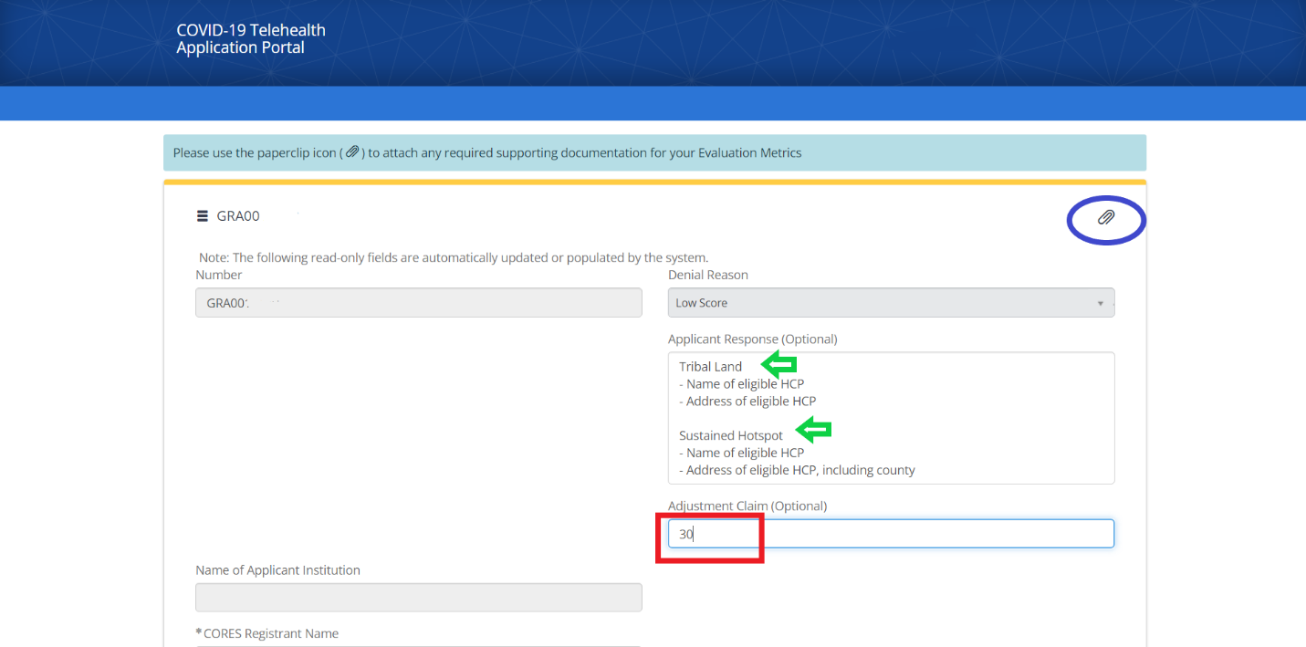
- Applicants should reach out to Round2TelehealthApplicationSupport@usac.org with any questions.

See FCC Announces Awards For Round 2 of the COVID-19 Telehealth Program, WC Docket No. 20-89, Public Notices, DA 21-1052, 21-1221, and 21-1319 (WCB 2021).
Promoting Telehealth for Low-Income Consumers; COVID-19 Telehealth Program, WC Docket Nos. 18-213, 20-89, Report and Order, 35 FCC Rcd 3366 (2020) (First COVID-19 Report and Order); Coronavirus Aid, Relief, and Economic Security Act, Pub. L. No 116-136, 134 Stat. 281 (2020) (CARES Act).
From April 16, 2020, through July 8, 2020, the Commission fully obligated the $200 million by issuing awards on a rolling basis to 539 applications. Press Release, FCC, FCC Approves Final Set of COVID-19 Telehealth Program Applications (July 8, 2020), https://www.fcc.gov/document/fcc-approves-final-set-covid-19-telehealth-program-applications.
Consolidated Appropriations Act, 2021, Pub. L. No: 116-260, Division N-Additional Coronavirus Response and Relief, Title IX-Broadband Internet Access Service, § 903 “FCC COVID-19 Telehealth Program” (2020), available at https://www.congress.gov/bill/116th-congress/house-bill/133/text (Consolidated Appropriations Act).
COVID-19 Telehealth Program; Promoting Telehealth for Low-Income Consumers, WC Docket Nos. 20-89 and 18-213, Report and Order and Order on Reconsideration, 36 FCC Rcd 7141 (2021) (Second COVID-19 Report and Order).
Wireline Competition Bureau Announces Application Filing Window for Round 2 of COVID-19 Telehealth Program Will Open April 29, 2021, WC Docket No. 20-89, Public Notice, 36 FCC Rcd 7321 (WCB 2021).
Second COVID-19 Report and Order, 36 FCC Rcd at 7171-73, paras. 61-69.
Second COVID-19 Report and Order, 36 FCC Rcd at 7157, para. 38.
Consolidated Appropriations Act §§ 903(c)(5)(A)-(C); see also Second COVID-19 Report and Order, 36 FCC Rcd at 7171, para. 61.
This amount is subject to change, pending additional de-obligations of remaining Round 1 funding.
Consolidated Appropriations Act §§ 903(c)(5)(A)-(C).
See Appendix B.

