DA 21-1642
Released: December 23, 2021

Wireline Competition Bureau Announces Performance Obligations For Rate-Of-Return Alaska Plan Recipients After The Midterm Review
WC Docket No. 10-90
WC Docket No. 16-271

On August 23, 2016, the Federal Communications Commission (Commission) adopted the Alaska Plan Order. In the Alaska Plan Order, the Commission provided a one-time opportunity for Alaskan rate-of-return carriers to elect to receive support frozen at adjusted 2011 levels for a 10-year term from 2016 until 2026 in exchange for meeting individualized performance obligations—offering voice and broadband services meeting specific service obligations at specified minimum speeds by five-year and 10-year service milestones to a specified number of locations.
The Commission also directed the Wireline Competition Bureau (Bureau) “to reassess the deployment obligations in the approved performance plans before the end of the fifth year of support,” that is, 2021, and required that “participating carriers update their end-of-term commitments no later than the end of the fourth year of support.” The Commission further delegated to “the Bureau the authority to review and approve modifications that serve the public interest.”
After reviewing the participants’ end-of-term commitments, annual location filings, and middle-mile map submissions, the Bureau approves the performance obligations in Appendix A. Appendix B to this public notice provides the minimum number of locations to be reported in the High-Cost Universal Broadband portal, or HUBB, i.e., newly deployed and upgraded locations over the term of the Alaska Plan, by speed and middle-mile at the five-year and 10-year service milestones.
For purposes of administrative convenience to allow the Universal Service Administrative Company (USAC) sufficient time to make modifications to the HUBB to account for revised commitments at speed tiers not yet available to report, on our own motion we waive the March 1, 2022 deadline for annual location reporting for rate-of-return Alaska Plan participants Adak Telephone Utility (Adak) (SAC 610989), Arctic Slope Telephone Cooperative (ASTAC) (SAC 613001), and Matanuska Telephone Association (MTA) (SAC 613015). Once USAC has made the needed modifications to the HUBB so that it can collect the information, the Bureau will announce a new deadline. These three rate-of-return Alaska Plan participants are still required to certify compliance with their respective five-year milestones by March 1, 2022 and file updated middle-mile maps also by March 1, 2022.
For additional information on this proceeding, contact Jesse Jachman, jesse.jachman@fcc.gov of the Wireline Competition Bureau, (202) 418-2668.

- FCC -

APPENDIX A
RATE-OF-RETURN ALASKA PLAN CARRIERS
PERFORMANCE OBLIGATIONS

Adak Telephone Utility
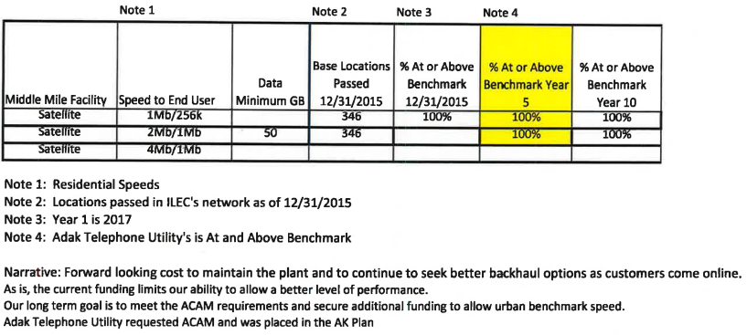
Arctic Slope Telephone Cooperative
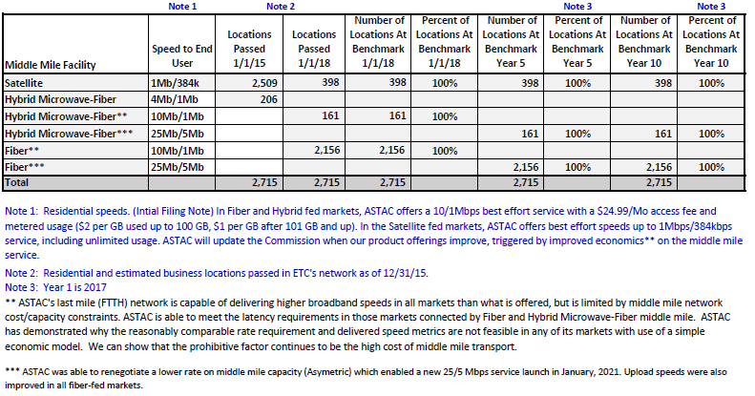
Bristol Bay Telephone Cooperative
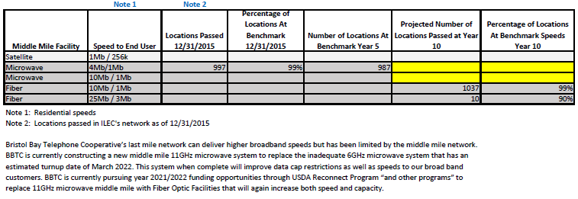
Bush-Tell Inc.
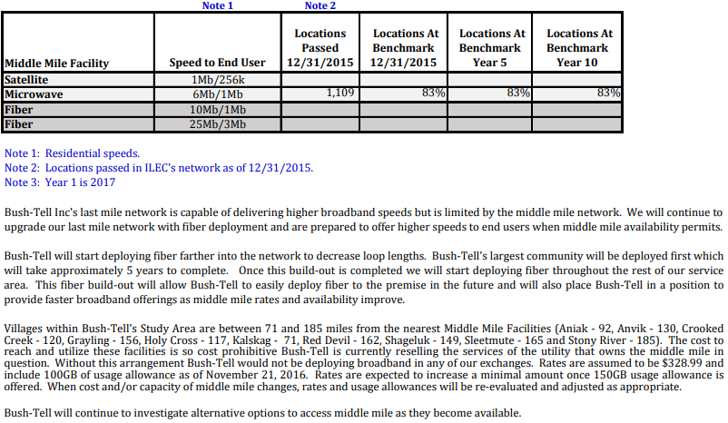

Circle Utilities
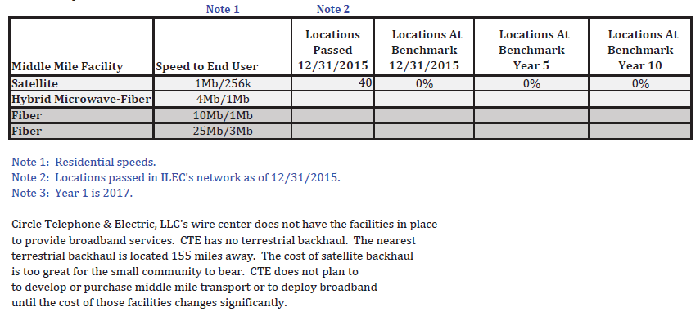
Copper Valley Telephone
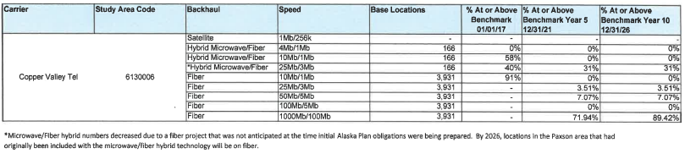

Cordova Telephone Cooperative

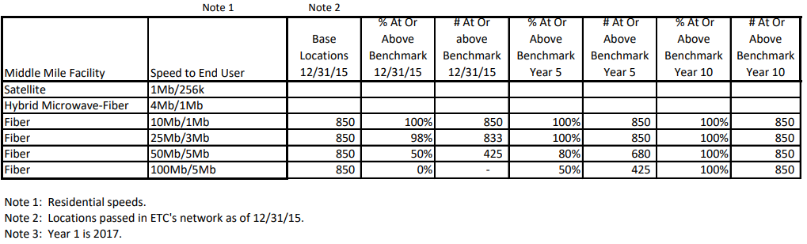

Interior Telephone Company
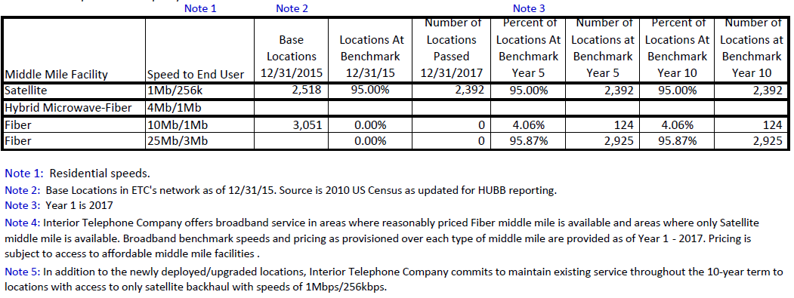

Mukluk Telephone Company, Inc.
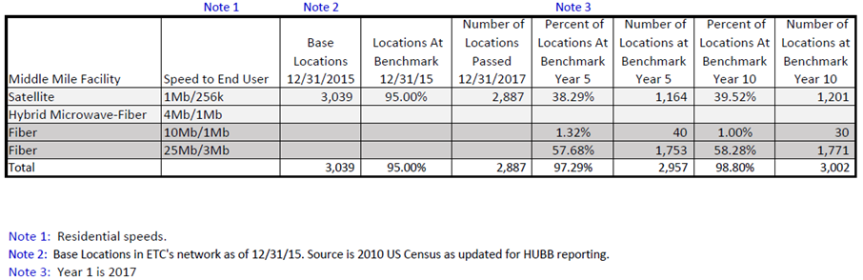

Ketchikan Public Utilities
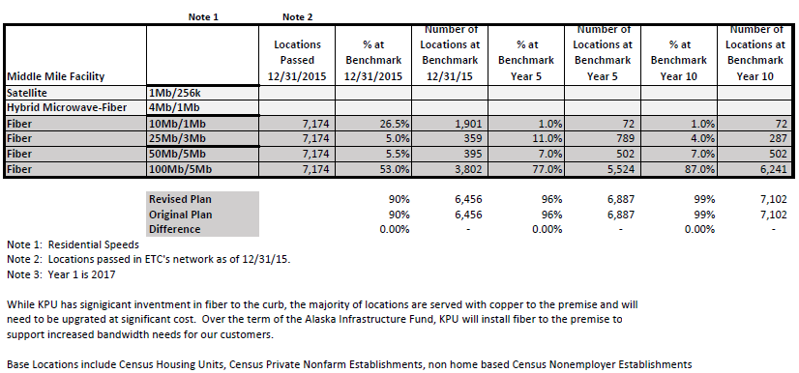

Mantuska Telephone Association
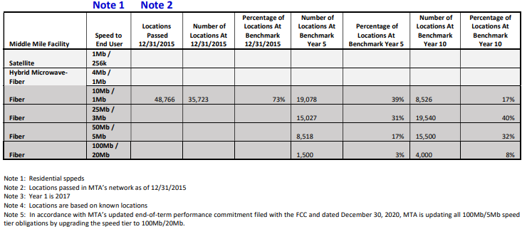

Nushagak Electric and Telephone Cooperative
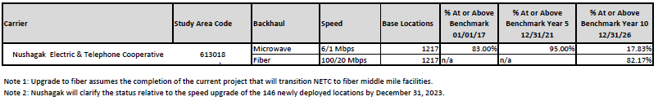

OTZ Telephone Cooperative
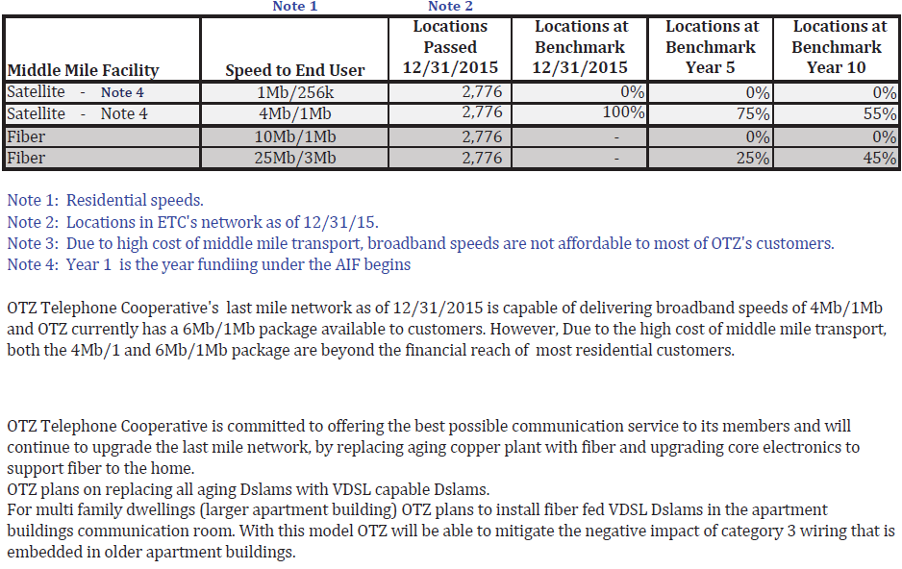
GCI Communication Corp. (United Utilities, Inc. – Yukon Telephone)
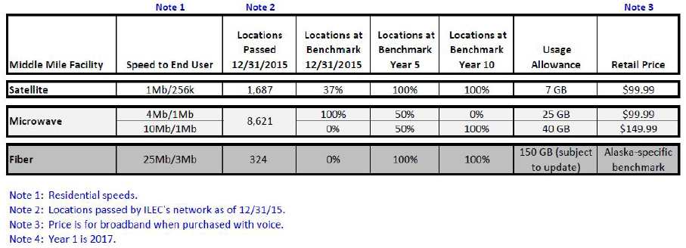

APPENDIX B
RATE-OF-RETURN ALASKA PLAN CARRIERS
HUBB LOCATIONS

Admin SAC | Carrier Name | Speed (Mbps) | Middle Mile | 5 Year Obligation Newly Deployed, Upgraded Locations by Dec. 31, 2021 | Minimum Total Locations Certified in the HUBB by Mar. 1, 2022 | 10 Year Obligation Newly Deployed, Upgraded Locations by Dec. 31, 2026 | Minimum Total Locations Certified in the HUBB by Mar. 1, 2027
613001 | ARTC | 25/5 | Hybrid | 161 |  | 161
613001 | ARTC | 25/5 | Fiber | 2156 |  | 2156
 |  | Total 25/5 |  | 2317 |  | 2317
 |  |  |  |  | 2317 |  | 2317
613006 | CPPR | 25/3 | Fiber | 138 |  | 138
613006 | CPPR | 50/5 | Fiber | 278 |  | 278
613006 | CPPR | 1000/100 | Fiber | 2828 |  | 3515
 |  |  |  |  | 3244 |  | 3931
613007 | CRDV | 25/3 | Fiber | 17 |  | 0
613007 | CRDV | 50/5 | Fiber | 255 |  | 0
613007 | CRDV | 100/5 | Fiber | 425 |  | 850
 |  |  |  |  | 697 |  | 850
613011 | AMRC (Interior) | 10/1 | Fiber | 124 |  | 124
613011 | AMRC (Interior) | 25/3 | Fiber | 2925 |  | 2925
 |  |  |  |  | 3049 |  | 3049
613011 | AMRC (Mukluk) | 1/256k | Satellite | 0 |  | 37
613011 | AMRC (Mukluk) | 10/1 | Fiber | 40 |  | 30
613011 | AMRC (Mukluk) | 25/3 | Fiber | 1753 |  | 1771
 |  |  |  |  | 1793 |  | 1838
 |  |  |  |  | 4842 |  | 4887
613013 | CTYF3 | 25/3 | Fiber | 430 |  | 287
613013 | CTYF3 | 50/5 | Fiber | 107 |  | 107
613013 | CTYF3 | 100/5 | Fiber | 1722 |  | 2439
 |  |  |  |  | 2260 |  | 2833
613015 | MTNS | 25/3 | Fiber | 15027 |  | 19540
613015 | MTNS | 50/5 | Fiber | 8518 |  | 15500
613015 | MTNS | 100/20 | Fiber | 1500 |  | 4000
 |  |  |  |  | 25045 |  | 39040
613018 | NSHG | 6/1 | Microwave | 146 |  | 146
 |  | 100/20 | Fiber | 0 |  | 1000
 |  |  |  |  | 146 |  | 1146
613019 | OTZT | 25/3 | Fiber | 694 | 694 | 1249 | 1249
613023 | GNRL | 1/256k | Satellite | 1063 |  | 1063
613023 | GNRL | 10/1 | Microwave | 4311 |  | 8621
613023 | GNRL | 25/3 | Fiber | 324 |  | 324
 |  |  |  |  | 5698 |  | 10008
610989 | ADKG | 2/1 | Satellite | 346 |  | 346
 |  |  |  |  | 346 |  | 346
613003 | BRST | 10/1 | Fiber | 0 |  | 1027
613003 | BRST | 25/3 | Fiber | 0 |  | 9
 |  |  |  |  | 0 |  | 1036
No Obligation for Newly Deployed/Upgraded Locations
613004 | BSHT
613005 | CRCL

Connect America Fund, et al., WC Docket No. 10-90 et al., Report and Order and Further Notice of Proposed Rulemaking, 31 FCC Rcd 10139 (2016) (Alaska Plan Order).
Id. at 10158, para. 61
Id. Carriers with approved plans to maintain existing levels service are subject to biennial review. See Alaska Plan Order, 31 FCC Rcd at 10158, para. 62. This midterm review also encompasses the Bureau’s biennial review.
47 CFR § 54.316(a)(5).
See Universal Service Administrative Company, High Cost Universal Broadband (HUBB) Data Formatting Instructions, https://www.usac.org/wp-content/uploads/high-cost/documents/Tools/HUBBDataFormatting.pdf, at 16-17 (Revised April 2021) (not available to report 2/1 (satellite), 25/5 (microwave/fiber), 25/5 (fiber), or 100/20 (fiber)).
47 CFR § 54.316(c). See also 47 CFR § 1.3 and Connect America Fund; ETC Annual Reports and Certifications, WC Docket Nos. 10-90, 14-58, 35 FCC Rcd 6543 (WCB 2020) (extending a filing deadline to allow USAC time to make updates to an online filing system). For performance measures testing, the Bureau and USAC will develop a timeline for Adak, ASTAC, and MTA to test at these new speeds, 2/1 Mbps, 25/5 Mbps, and 100/20 Mbps, as the speed tiers become available in the Performance Measures Module (PMM). In the meantime, ASTAC and MTA shall continue testing their existing samples at the previously committed speed tiers, 10/1 Mbps and 100/5 Mbps respectively. With Adak now having committed to new deployment, it will start performance measures testing for the first time at the 2/1 Mbps speed tier. See Connect America Fund, WC Docket No. 10-90, Order on Reconsideration, 34 FCC Rcd 10109, 10143-44, paras. 93-94 (2019).
See 47 CFR § 54.316(b)(6).
See 47 CFR § 54.316(a)(6), (c)(1).
See Letter from Andila Weaver, Vice President, Adak Telephone Utility, LLC, to Marlene Dortch, Secretary, FCC, WC Docket No. 16-271 (Jan. 8, 2021); Letter from Andila Weaver, Vice President, Adak Telephone Utility, LLC, to Marlene Dortch, Secretary, FCC, WC Docket No. 16-271 (Jan. 21, 2021).
See Letter from Jeffry H. Smith VP of Public Policy and Advocacy, Vantage Point, to Marlene Dortch, Secretary, FCC, WC Docket No. 16-271 (Dec. 22, 2020) (Arctic Slope Telephone Cooperative); Letter from Jeffry H. Smith VP of Public Policy and Advocacy, Vantage Point, to Marlene Dortch, Secretary, FCC, WC Docket No. 16-271 (Sept. 27, 2021) (Arctic Slope Telephone Cooperative).
See Letter from Earl Hubb, Bristol Bay Telephone Cooperative, to Marlene Dortch, Secretary, FCC, WC Docket No. 16-271 (Dec. 10, 2021).
See Letter from Roy Wrazen, General Manager, Bush-Tell, Inc., to Marlene Dortch, Secretary, FCC, WC Docket No. 16-271 (Jan.11, 2021); Letter from Christine O’Connor, Executive Director, Alaska Telephone Association, to Marlene Dortch, Secretary, FCC, WC Docket No. 16-271, at 2 (Nov. 22, 2016).
See Letter from Shawn DeVore, Vice President, Circle Telephone & Electric, LLC, to Marlene Dortch, Secretary, FCC, WC Docket No. 16-271 (Jan. 5, 2021); Letter from Shawn DeVore, Member Owner, Circle Telephone & Electric, LLC, to Marlene Dortch, Secretary, FCC, WC Docket No. 16-271 (Mar. 30, 2021); Letter from Christine O’Connor, Executive Director, Alaska Telephone Association, to Marlene Dortch, Secretary, FCC, WC Docket No. 16-271, at 9 (May 9, 2016) (ATA May 9, 2016 Ex Parte).
See Letter from Jeffry H. Smith VP of Public Policy and Advocacy, Vantage Point, to Marlene Dortch, Secretary, FCC, WC Docket No. 16-271 (Dec. 21, 2020) (Copper Valley Telephone); Letter from Jeffry H. Smith VP of Public Policy and Advocacy, Vantage Point, to Marlene Dortch, Secretary, FCC, WC Docket No. 16-271 (Aug. 5, 2020) (Copper Valley Telephone); Letter from Jeffry H. Smith VP of Public Policy and Advocacy, Vantage Point, to Marlene Dortch, Secretary, FCC, WC Docket No. 16-271 (Sept. 27, 2021) (Copper Valley Telephone).
See Letter from Lisa Koker CFO, Cordova Telecom Cooperative, to Marlene Dortch, Secretary, FCC, WC Docket No. 16-271 (Dec. 30, 2020).
See Letter from Brett Carter, President and General Manager, TelAlaska, Inc. to Marlene Dortch, Secretary, FCC, WC Docket No. 16-271 (Dec. 30, 2020); Letter from Brett Carter, President and General Manager, TelAlaska, Inc. to Marlene Dortch, Secretary, FCC, WC Docket No. 16-271 (July 7, 2020)
See id. See also Letter from David J. Goggins, President and General Manager, TelAlaska, Inc., to Marlene Dortch, Secretary, FCC, WC Docket No. 16-271 (May 17, 2019).
See Letter from Daniel B. Lindgren, Assistant KPU Telecommunications Division Manager, to Marlene Dortch, Secretary, FCC, WC Docket No. 16-271 (Dec. 30, 2020); Letter from Daniel B. Lindgren, Assistant KPU Telecommunications Division Manager, to Marlene Dortch, Secretary, FCC, WC Docket No. 16-271 (July 9, 2021).
See Letter from Michael C. Burke, Chief Executive Officer, Matanuska Telephone Association, to Marlene Dortch, Secretary, FCC, WC Docket No. 16-271 (Dec. 30, 2020); Letter from Ryan Ponder Director Legal, Regulatory, and Government Affairs, Matanuska Telephone Association, Inc. to Marlene Dortch, Secretary, FCC, WC Docket No. 16-271 (July 27, 2021); Letter from Ryan Ponder Director Legal, Regulatory, and Government Affairs, Matanuska Telephone Association, Inc. to Marlene Dortch, Secretary, FCC, WC Docket No. 16-271 (Sept. 24, 2021).
See Letter from Jeffry H. Smith VP of Public Policy and Advocacy, Vantage Point, to Marlene Dortch, Secretary, FCC, WC Docket No. 16-271 (Dec. 22, 2020) (Nushagak Electric and Telephone Cooperative), Letter from Jeffry H. Smith VP of Public Policy and Advocacy, Vantage Point, to Marlene Dortch, Secretary, FCC, WC Docket No. 16-271 (Nov. 4, 2021).
See Letter from Chris Barron, Regulatory Director, Alexicon Telecommunications Consultants, to Marlene Dortch, Secretary, FCC, WC Docket No. 16-271 (Dec. 29, 2020) (OTZ Telephone Cooperative); Letter from Chris Barron, Regulatory Director, Alexicon Telecommunications Consultants, to Marlene Dortch, Secretary, FCC, WC Docket No. 16-271 (July 8, 2021) (OTZ Telephone Cooperative); Letter from Chris Barron, Regulatory Director, Alexicon Telecommunications Consultants, to Marlene Dortch, Secretary, FCC, WC Docket No. 16-271 (Oct. 15, 2021); ATA May 9, 2016 Ex Parte at 18.
See Letter from Julie A. Veach Counsel to GCI Communication Corp., to Marlene Dortch, Secretary, FCC, WC Docket No. 16-271 (Dec. 23, 2020); Letter from Julie A. Veach Counsel to GCI Communication Corp., to Marlene Dortch, Secretary, FCC, WC Docket No. 16-271 (Sept. 8, 2021).
See supra Appendix A, Performance Obligations of Nushagak Electric and Telephone Cooperative, Note 2 (Nushagak will clarify the status relative to the speed upgrade of the 146 newly deployed locations by December 31, 2023).

