DA 21-50
Released: January 13, 2021

FCC RELEASES SPEAKERS’ BIOS FOR JANUARY 15, 2021
VIRTUAL SUMMIT ON TECH SECTOR EMPLOYMENT FOR DIVERSE HIGH SCHOOL AND COLLEGE STUDENTS

GN Docket No. 17-208

By this Public Notice, the Federal Communications Commission (FCC) releases the biographies of speakers participating in the upcoming virtual summit entitled A Road Map to Tech Jobs. As previously announced, this virtual summit will be held on January 15, 2021, from 12:00 p.m. to 3:00 pm EST, and will be co-hosted by the Diversity in the Tech Sector Working Group of the FCC’s Advisory Committee on Diversity and Digital Empowerment (ACDDE) and the FCC’s Media Bureau. Drawing on experts and participants from within the tech industry, the summit will provide information and resources on obtaining employment in the tech sector to diverse high school and college students, as well as to key influencers such as guidance counselors, placement officers, and parents. Topics to be covered during the summit include:

- Career opportunities in the tech sector and information about work experience,
- Education, skills, and experience needed to get a job in tech,
- How to build a strong, competitive resume,
- How to build a strong professional network within the tech and telecom realm and leverage that network,
- Appearance and professionalism,
- Communications skills, and
- How to interview for and land a job.

The previously-released agenda for the Summit and biographies for Summit speakers are included as Attachments 1 and 2 to this Public Notice.

The workshop will be convened in an online format and will be available to the public via live feed from the FCC’s web page at www.fcc.gov/live. The public may also follow the meeting on Twitter @FCC or via the Commission’s Facebook page at www.facebook.com/fcc. Members of the public may submit questions during the workshop to livequestions@fcc.gov. In addition to submitting questions during the Summit, the public may submit comments to the ACDDE using the FCC’s Electronic Comment Filing System, ECFS, at www.fcc.gov/ecfs. Comments to the ACDDE should be filed in GN Docket No. 17-208.

Registration is not required but is strongly encouraged and will provide the opportunity for registrants to submit questions in advance for speakers’ consideration and to receive event reminders. Please see the event webpage for more information at https://www.fcc.gov/news-events/events/2021/01/road-map-tech-jobs-virtual-summit.

To register,

- Click here or copy the link below and paste it into your browser
https://www.fcc.gov/advisory-committee-diversity-and-digital-empowerment/event-registration
- Complete the requested information and click Register.

Open captioning will be provided for this event. Other reasonable accommodations for people with disabilities are available upon request. Requests for such accommodations should be submitted via e-mail to fcc504@fcc.gov or by calling the Consumer & Governmental Affairs Bureau at (202) 418-0530 (voice), (202) 418-0432 (TTY). Such requests should include a detailed description of the accommodation needed, as well as contact information for the requester if more information is needed to address the request. Please allow at least five days’ advance notice for accommodation requests; last minute requests will be accepted but may not be possible to accommodate.

More information about the ACDDE is available at https://www.fcc.gov/advisory-committee-diversity-and-digital-enpowerment. You may also contact Jamila Bess Johnson, the Designated Federal Officer for the Advisory Committee on Diversity and Digital Empowerment, at (202) 418-2608, or Jamila-Bess.Johnson@fcc.gov; or Julie Saulnier, Deputy Designated Federal Officer, at (202) 418-1598, or Julie.Saulnier@fcc.gov; or Jamile Kadre, Deputy Designated Federal Officer, at (202) 418-2245 or Jamile.Kadre@fcc.gov.

– FCC –

ATTACHMENT 1

A Road Map to Tech Jobs
DIVERSITY IN THE TECH SECTOR VIRTUAL SUMMIT

Diversity in the Tech Sector Working Group of the
Advisory Committee on Diversity and Digital Empowerment
and the FCC’s Media Bureau

Federal Communications Commission
Washington, DC
January 15, 2021

12:00 p.m. to 3:00 p.m.

12:00 p.m. – 12:20 p.m. Welcome Remarks

Anna M. Gomez
Partner, Wiley Rein LLP
Representing Hispanic National Bar Association
Chair, Advisory Committee on Diversity and Digital Empowerment (ACDDE)

Heather Gate
Director, Digital Inclusion, Connected Nation
Vice Chair, ACDDE

Dr. Nicol Turner Lee, Senior Fellow and Director, Brookings Institution Center for Technology Innovation – Governance Studies
Chair, Diversity in the Tech Sector Working Group

Rosa Mendoza
President and CEO, ALLvanza
Workforce Diversity Subgroup Lead, Diversity in the Tech Sector Working Group, ACDDE

12:20 p.m. – 12:35 p.m. Keynote Address

Speaker:

Keiana Cavé
Scientist, Entrepreneur

12:35 p.m. – 1:35 p.m. Developing a Game Plan for a Tech Career

Moderator:

Deborah Augustine Elam
President & CEO, Corporate Playbook
Member, Diversity in the Tech Sector Working Group – Workforce
Diversity Subgroup, ACDDE

Panelists:

Rosalind Hudnell
Former Vice President of Human Resources and Director of Corporate Affairs, Intel & President, Intel Foundation (retired)

Dr. Calvin Mackie,
Founder, STEM NOLA

Stacey G. Mangham
Principal Systems Engineer and Group Leader, MITRE Corporation

Robert Vaughn
Vice President of the National Instructors Institute, NPower

Donna White
East Coast Regional Program Director, Black Girls Code

1:35 p.m. – 1:45 p.m. BREAK

1:45 p.m. – 2:45 p.m. Building Your Personal Brand

Moderator:

Maurita Coley
President & CEO, MMTC
Member, Diversity in the Tech Sector Working Group – Workforce
Diversity Subgroup, ACDDE

Panelists:

Celeste Carrasco
Director of Public Affairs, AT&T

Donald Cravins
Vice President, Policy and External Affairs, Charter Communications

John Gibson
Vice President, External and Multicultural Affairs, Motion Picture Association

Eric T. Gonzalez
Cloud Security Program Manager, Ridgeline

2:45 p.m. – 3:00 p.m. Next Steps and Closing Remarks

Rosa Mendoza
President and CEO, ALLvanza
Workforce Diversity Subgroup Lead, Diversity in the Tech Sector Working Group, ACDDE

Jamila Bess Johnson
Designated Federal Officer, ACDDE

ATTACHMENT 2

A Road Map to Tech Jobs
DIVERSITY IN THE TECH SECTOR VIRTUAL SUMMIT

Diversity in the Tech Sector Working Group of the
Advisory Committee on Diversity and Digital Empowerment
and the FCC’s Media Bureau

January 15, 2021
12:00 p.m. to 3:00 p.m.

SPEAKER LIST

Anna M. Gomez
Chair, ACDDE
Wiley Rein LLP

The former National Telecommunications and Information Administration (NTIA) Deputy Administrator, Anna specializes in a wide range of spectrum licensing issues and regulatory, policy, and transactional matters related to domestic and international telecommunications and unmanned aircraft systems. Anna also served for 12 years in various positions at the FCC, including Senior Legal Advisor to then-Chairman William E. Kennard and Deputy Chief of the International Bureau, where she developed and implemented Commission policy on international telecommunications and satellite spectrum. Anna is co-chair of Wiley’s Unmanned Aircraft Systems Practice Group and chairs Wiley’s Diversity, Equity, and Inclusion Committee.
Heather Gate
Vice Chair, ACDDE
Connected Nation

As the Director of Digital Inclusion for Connected Nation (CN), Heather Gate is responsible for strategy development and implementation of programs that impact digital inclusion for all people in all places. Ms. Gate has more than 12 years’ experience working in digital inclusion with the mission of improving the lives of vulnerable populations across the country. She has extensive experience engaging with minorities, rural communities, families, and others on the frontlines of the digital divide and working behind the scenes as an advocate and tactician with local, state, and federal leaders. Heather also serves as Vice Chair of the Federal Communications Commission’s Advisory Committee on Diversity and Digital Empowerment (ACDDE).
Dr. Nicol Turner Lee
Chair, Diversity in the Tech Sector Working Group, ACDDE
Brookings Institution Center for Technology Innovation – Governance Studies

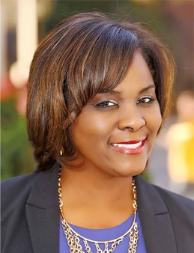

Dr. Nicol Turner Lee is a senior fellow in Governance Studies, the director of the Center for Technology Innovation, and serves as Co-Editor-In-Chief of TechTank. Dr. Turner Lee researches public policy designed to enable equitable access to technology across the United States and to harness its power to create change in communities across the world. Her work also explores global and domestic broadband deployment and internet governance issues. She is an expert on the intersection of race, wealth, and technology within the context of civic engagement, criminal justice, and economic development.
Her current research portfolio also includes artificial intelligence (AI), particularly machine learning algorithms and their unintended consequences on marginalized communities. Her recent co-authored paper on the subject has made her a sought-out speaker in the U.S. and around the world on the topics of digital futures, AI and ethics, algorithmic bias, and the intersection between technology and civil/human rights. She is also an expert on topics that include online privacy, 5G networks and the digital divide. Dr. Turner Lee has a forthcoming book on the U.S. digital divide titled Digitally Invisible: How the Internet is Creating the New Underclass (forthcoming 2021, Brookings Press). She sits on various U.S. federal agency and civil society boards. Dr. Turner Lee has a Ph.D. and M.A. from Northwestern University and graduated from Colgate University.

Rosa Mendoza
Lead, Diversity in the Tech Sector Working Group – Workforce Diversity Subgroup, ACDDE
ALLvanza

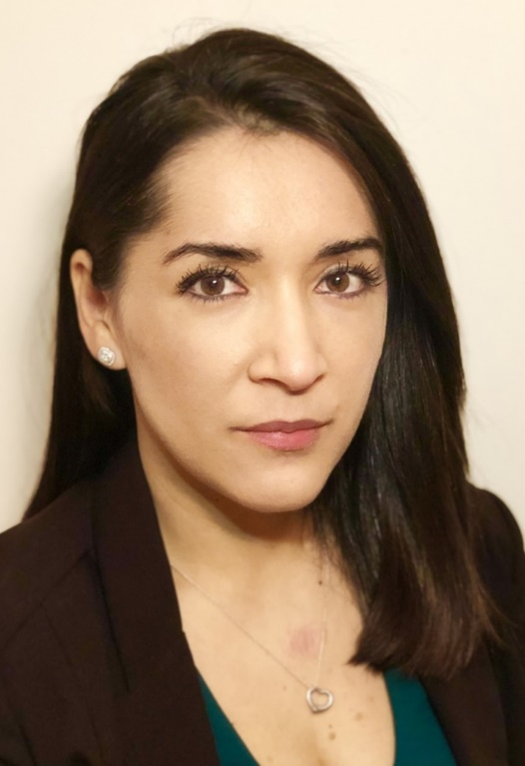

Rosa Mendoza is the Founder, President and CEO of ALLvanza and it is her vision, experience, both personally and professionally, and knowledge of underserved communities that gave birth to the organization and set the tone for the organization’s critical mission of ensuring Latinxs and other underserved communities have an equal opportunity for success in our technology-driven world. Rosa’s own experience as a first-generation college student incited her passion and gives her the insight to advocate for this equal opportunity.

Prior to founding ALLvanza, Rosa served as the Executive Director of the Hispanic Technology and Telecommunications Partnership (HTTP) where she informed administration officials, congressional staff, state and local representatives and other stakeholders on how telecommunications and technology policy issues impacted the Latino community. She represented HTTP at meetings, conferences, conventions and industry gatherings. Rosa expertly analyzed telecommunications and technology policy to develop advocacy briefs that brought the needs of Latinos to the forefront.
Prior to joining HTTP, Rosa served as the Manager of Special Projects for The Raben Group, where she assisted clients with coalition building, strategic planning and research, with a particular focus on the firm’s LatinStrategies division. Rosa worked with clients such as MasterCard and Hispanics for a Fair Judiciary.

Formerly, Rosa served as the Assistant Finance Director for Congressman Henry Cuellar (D-TX). As the primary point of contact for Congressman Cuellar, Rosa communicated with donors and constituents, coordinated fundraising events and managed logistics.

Previously, Rosa was hired as the Media Relations Executive for the Hispanic Communications Network (HCN), which designs customized radio, television and print media campaigns for the Latino market. In this role, Rosa built relationships with media affiliates, assisted with program development, and helped execute the firm’s large-scale media campaigns.

Before coming to Washington D.C., Rosa was the Coordinator for the Chicano/Latino Cultural Center and the Principal Assistant to the director of the Office of Multicultural Student Services at Washington State University.

Rosa holds a Bachelor of Arts in Communication with an emphasis in Public Relations and a Master’s Degree in Education with an emphasis in Higher Education Administration from Washington State University.

Dr. Dominique Harrison
Member, Diversity in the Tech Sector Working Group – Workforce Diversity Subgroup, ACDDE
Joint Center for Political and Economic Studies.

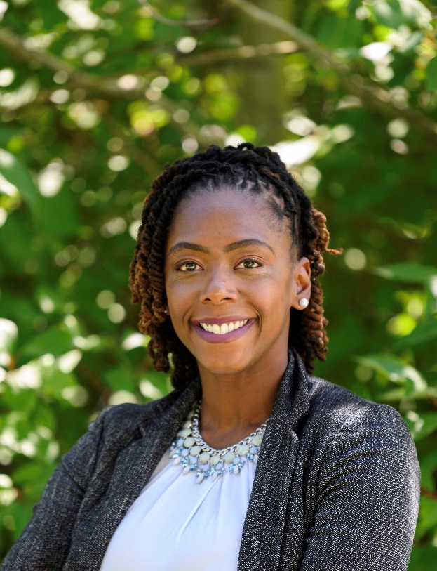

Dr. Dominique Harrison is the Director of the Technology Policy Program at the Joint Center for Political and Economic Studies. She leads the Center's work on key tech policy issues affecting Black communities. She focuses on platform accountability, the impact of data privacy, AI, broadband, and other emerging technologies.

Before her current role, Dr. Harrison served as Project Director in the Aspen Digital Program at the Aspen Institute, where she conceived, developed, and led projects at the intersection of media, technology, and public policy. She also served as the primary thought-leader on efforts related to justice, equity, race, and technology. At the Institute, Dr. Harrison developed the Tech X Talent Project, funded by the Ford Foundation and Schmidt Futures, that seeks to promote greater equity in the technology workforce.

Before joining the Institute, Dr. Harrison worked as a communications fellow at the United Nations Development Program Washington, D.C. office and as a monitoring and evaluation consultant at Internews, where she helped develop a published report on women-focused media development.
Her previous academic appointments include faculty and instructor positions at Howard University, the University of Texas at Austin, and Trinity Washington University.

Dr. Harrison earned her B.S. in Advertising from the University of Illinois Urbana-Champaign, an M.A. in Media Studies from the University of Texas at Austin, and a Ph.D. in Technology, Policy and Society from Howard University. Her dissertation examines gender awareness among stakeholders of Jamaica’s information and communication technology (ICT) policy.

Keiana Cavé
Scientist, Entrepreneur

Keiana Cave is a 22-year-old scientist, entrepreneur, and model from New Orleans, LA. She is currently on hiatus from her Chemical engineering degree at the University of Michigan in Ann Arbor to pursue her latest project, a pharmaceutical startup.

At 15, Keiana started her first research project in collaboration with Tulane University, which would go on to win second place at the International Science and Engineering Fair. Cave’s project, a novel method for identifying toxins in seawater after an oil spill, raised more than $1.5 million.

Keiana’s work has been recognized by numerous magazines and publications including Forbes 30 Under 30, Glamour Magazine Woman of the Year, and Entrepreneur Magazine’s Young Millionaires. She also uses her platform as a model for American Eagle’s swim & intimates brand, Aerie, to empower young women to pursue STEM careers.

Keiana’s current startup, a pharmaceutical company aimed at bringing the first non-hormonal birth control pill to market, is set to begin clinical trials in January 2021. She plans on returning to school as soon as her contraceptive drug gains FDA approval.

Deborah Augustine Elam
Member, Diversity in the Tech Sector Working Group – Workforce Diversity Subgroup, ACDDE
Corporate Playbook

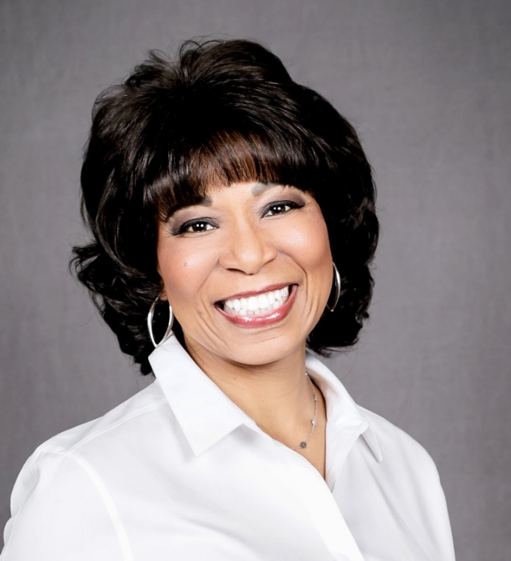

Deborah Elam (Deb), is a visionary senior executive and one of the country’s foremost experts in diversity. She is an inspiring speaker, presenting on diversity to such esteemed audiences as The United Nations in New York and The House of Commons in London.

Deb is the President and CEO of Corporate Playbook™, a company that provides leaders with strategic direction to elevate diversity, inclusion, philanthropy, and culture in the workplace.

In addition to Corporate Playbook™, Deb created and hosts Dining with Deb™, an innovative dining experience that brings together professional women across racial, religious and political lines to drive meaningful connections and conversations.

Deb was GE’s first-ever black female corporate officer. Her role as Global Chief Diversity Officer placed her in the top 185 of 300,000 employees. In Deb’s decorated thirty-year career at General Electric (GE), she led GE’s philanthropic efforts through the GE Foundation’s $130M budget and GE Volunteers, to tackle some of the world’s most critical challenges across health, education and skill attainment.

Deb is a powerful connector who elevates those around her. As a leader and mentor, she oversaw a course for women called Leadership Practices which had an 85% retention rate of participants 5 years later. The course became one of GE’s most highly rated courses.

Deb took this a step further with Developing Women Leaders: Synergistic Forces Driving Change. This initiative provided high-potential women with the experience and visibility necessary to become leaders and led to a significant increase in female representation at the leadership level. Deb’s efforts enabled GE to win the prestigious Catalyst award for foremost organizations supporting women’s growth and advancement.

Deb has received numerous accolades, including 50 Most Powerful Women in Philanthropy from Inside Philanthropy, Women of Excellence Legacy Award from the National Association for Female Executives, and Women of Power Award from the National Urban League.

Deb received a Bachelor of Arts in Sociology from Louisiana State University and a Master of Public Administration from Southern University in Baton Rouge, Louisiana. She was also awarded an Honorary Doctor of Science from Clarkson University in Potsdam, New York.

Deb serves on the board of directors of DJE Holdings (Edelman), the New Orleans Culinary and Hospitality Institute and the Louisiana State University Foundation. She was appointed to the Federal Communications Commission’s (FCC) Advisory Committee on Diversity and Digital Empowerment (ACDDE). Deb is also a member of the National Black MBA Association, Delta Sigma Theta Sorority, Incorporated and The Links, Incorporated.

Rosalind Hudnell
Intel & Intel Foundation (Retired)

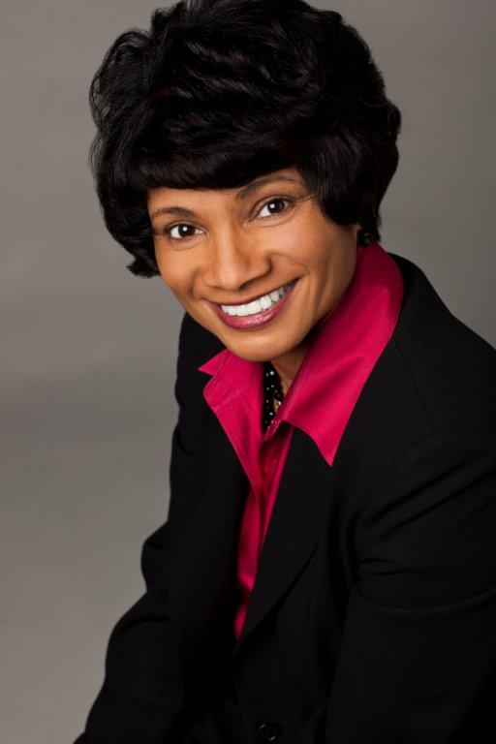

Rosalind Hudnell is a recognized global thought leader and passionate advocate for diversity and inclusion. As Intel’s first Chief Diversity Officer, she delivered the industry leading strategy which launched the $1b Diversity in Technology Initiative. With deep expertise in workforce development, Roz directed the 10K Engineer’s Initiative for President Barack Obama’s U.S. Council on Jobs & Competitiveness and as an advisory board member of the Global Business Coalition for Education, led the launch of the Youth Skills and Innovation Initiative. She has served on the World Economic Forum “Internet for All” Steering Committee and led a decade of research focused on equity and inclusion including serving as the co-author of the research report “The Battle for Female Talent” published in the Harvard Business Review. She was selected as a “Woman Helping the World” by Forbes Magazine and listed in Fast Company Magazine as one of the most creative leaders in business. Roz was also honored with the Corporate Social Impact Award from the Multicultural Media, Telecom and Internet Council.

Her career at Intel spanned over two decades with her leadership rise to Vice President, Human Resources and President of the Intel Foundation. Intel presented Roz with a lifetime achievement award for her impact on diversity and inclusion. An alumna of St. Mary’s College and Stanford Graduate School of Business Executive Accelerator program, Roz is a senior member of the American Leadership Forum and was recently named to the position of Chair of the Stanford Commission on Justice and Equity.

Dr. Calvin Mackie
STEM NOLA

Dr. Calvin Mackie is an award-winning mentor, an inventor, an author, a former engineering professor, an internationally renowned speaker, and a successful entrepreneur. His message as a mentor, author, speaker, and entrepreneur continues to transcend race, gender, ethnicity, religion, and time. A lifelong resident of New Orleans, Dr. Mackie graduated from Morehouse College, earning a degree in Mathematics in 1990, graduating Magna Cum Laude and becoming a member of the prestigious Phi Beta Kappa National Honor Society. He was simultaneously awarded a Bachelor’s degree in Mechanical Engineering from Georgia Tech, where he subsequently earned his Master’s and Ph.D. in Mechanical Engineering in 1996. Following graduation, he joined the faculty at Tulane University, where he enjoyed a respected academic career for twelve years, before refocusing his career on entrepreneurship, consulting and professional speaking.

Mackie has won numerous awards including the 2003 Presidential Award for Excellence in Science, Mathematics and Engineering Mentoring, presented in a White House ceremony. In 2013, Dr. Mackie was awarded the highest honor bestowed upon a graduate of Morehouse College, A Candle in the Dark’s “Bennie” Award for his many academic, professional, and entrepreneurial achievements. Dr. Mackie also received the 2019 Congressional Black Caucus Foundation Board’s Chair (CBCF) Phoenix Award. The Phoenix Award is the highest honor presented by CBCF. It recognizes individuals whose extraordinary achievements strengthen communities and improve the lives of individuals and families, nationally and globally.

Following the catastrophic Hurricanes Katrina and Rita in 2005, former Louisiana Governor Kathleen Blanco appointed Dr. Mackie to the thirty-three member board of the Louisiana Recovery Authority (LRA). In 2009, then-Louisiana Lt. Governor Mitch Landrieu appointed Dr. Mackie to the Louisiana Council on the Social Status of Black Boys and Black Men. Recently, Louisiana Governor John Bel Edwards appointed Mackie to the Coastal Protection and Restoration Authority Board (CPRA).

Presently, Mackie serves as the President and CEO of the Channel ZerO Group LLC, an educational and professional development consulting company he founded in 1992.

Most recently, Dr. Mackie founded STEM NOLA is a non-profit organization founded to expose, inspire and engage communities about the opportunities in Science, Technology, Engineering and Mathematics (STEM). Since December 2013, STEM NOLA has engaged over 50,000 K-12 students in hands-on, project- based STEM activities.

Dr. Mackie is the author of two award winning books: A View from the Roof: Lessons for Life and Business and Grandma's Hands: Cherished Moments of Faith and Wisdom.

Dr. Mackie is a devoted husband to his wife, Tracy, and father to his two sons, Myles Ahmad and Mason Amir.

Stacey G. Mangham
MITRE Corporation

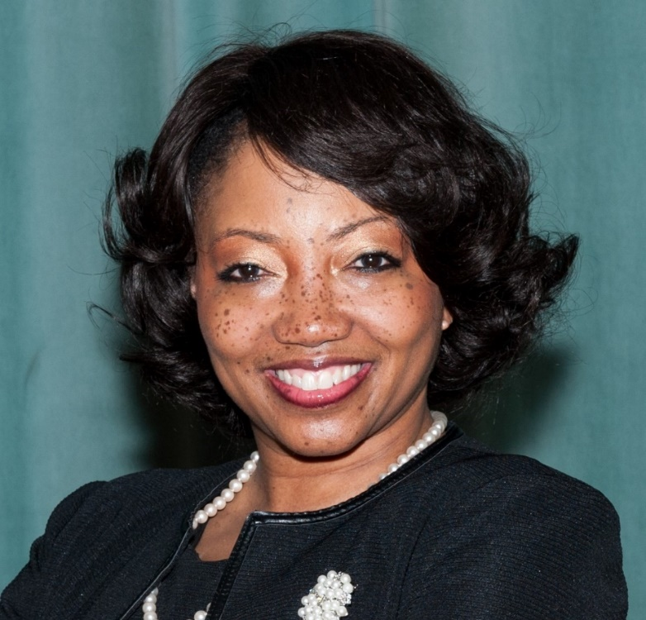

Stacey G. Mangham is a Principal Systems Engineer and Group Leader at the MITRE Corporation in McLean, VA. She began her career at the Lockheed Martin family of companies over 35 years ago as a Systems Engineer responsible for testing naval weapons systems. Over her 35-year career, Stacey has worked in various capacities including Senior Engineering Manager, Project Lead, Lead Systems Engineer, Technical Lead, Consultant and Individual Contributor supporting Department of Defense, Veterans Affairs, Health and Human Services, Air Traffic Control, and Treasury customers. More recently she served as the MITRE Project Leader for the Joint Interoperability Program Office for the Department of Defense and the Veterans Administration, established to ensure interoperability for Electronic Healthcare Records shared between the two agencies. Currently, Stacey serves as a Group Leader in the Systems Engineering Innovation Center (SEIC) and as the Technical Lead for a Grants Management Blockchain Proof of Concept effort to demonstrate how blockchain technologies can be used to gain efficiencies in the government’s award and management of grants. Additionally, she also serves as the Chair of MITRE’s Black Culture Network’s Social and Professional Networking Committee.

A resident of Rockville, MD, Stacey has been a member of the Patuxent River (MD) Chapter of The Links, Incorporated since the chapter’s chartering in 2014. She currently serves as the National Trends and Services Facet Chair and the Leads for Life Integrated Program Chair. Through these efforts, Stacey exposes students to financial education, career options and anti-bullying awareness as well as provides awareness on financial security and protection to senior citizens. Additionally, Stacey serves on the chapter’s Strategic Planning, Program, Legislative Affairs, Technology and Fundraising Committees. A loyal advocate for young girls in science and youth mentoring, she has also served on other community boards and organizations including the Montgomery County African American Health Program (AAHP), Alpha Kappa Alpha Sorority, Incorporated and The Society, Incorporated.

As a member of the Eastern Area Leadership Team of The Links, Incorporated, Stacey currently serves in the role of Chair of the STEM Initiative. Through the Links, Incorporated’s national partnership with National Society of Black Engineers (NSBE) and the National Wildlife Federation (NWF), Stacey and the Eastern Area STEM team have engaged their 80 chapters and over 4000 members in STEM by establishing over 25 NSBE Jr. Chapters and growing pollinator gardens through their youth programs and members, respectively. Stacey and her team are pushing to fill the STEM pipeline with black and brown girls through the Eastern Area’s partnership with Black Girls Code, Incorporated.

Originating from the Peach State of Georgia, Stacey holds a Bachelor of Science degree in Electrical Engineering from Tuskegee University in Tuskegee, Alabama and a Master of Science degree in Systems Engineering from Johns Hopkins University in Baltimore, MD.

Robert Vaughn
NPower

Robert Vaughn serves as Vice President of the National Instructors Institute at NPower Inc. Robert brings two decades of experience, having served in various roles such as a Chief Technology Officer, Executive Director and VP of Curriculum and STEM Programs, and Chief Information Security Officer for major corporations such as GM Financial, NetScale Systems, and Globe Life. Robert has trained thousands of young adults from underserved communities, veterans and service members. As a national leader in curriculum and IT certifications training, Robert has served as a National Dean for leading global for-profit training organizations (New Horizons, Virginia College, Internetworking Dynamics, Historical Black Colleges, Globalnet Training, and Global Knowledge). Robert brings over 42 professional IT certifications and a passion and commitment to developing untapped tech talent in underserved communities, delivering the trauma informed/culture sensitivity T.E.A.C.H. pedagogical proprietary method. Notable accomplishments include being recognized as a “Global Leadership Forum Superstar” on STEM at the 3rd annual Global Leadership Forum Summit 2019 and receiving an award for “Global Influence” at the SABSA World Congress APAC Conference.

Donna White
Black Girls Code

Donna White holds a Bachelor’s degree in International Studies from Emory University and a
Master’s in Urban Studies, Nonprofit Administration from Georgia State University. Ms. White
began her career in youth development in Atlanta, where her passion for working with children
and seeing them thrive became her life pursuit. Through her work with community-based organizations and schools, she has developed curricula, created new programs and helped organizations expand, all while helping students learn the tools of success and watching them recognize their potential to become successful adults.

Ms. White currently serves as the East Coast Regional Program Director at Black Girls Code,
supervising the regional program staff and overseeing development, evaluation and improvement of BGC programs. Her leadership supports building sustainable chapters and expanding the presence and impact in the East Coast region. While at BGC, she has launched the Detroit chapter, assisted in launching the Seattle chapter and increased annual engagement of participants and partners.

Prior to joining BGC, Ms. White served as the Director of Programs at the AnBryce Foundation,
a private family foundation in Virginia. During her tenure, she shaped all of the programs, including curriculum development, the summer internship program, and worked with undergraduate, first generation AnBryce Scholarship recipients at New York University. Ms. White also developed a high school leadership program and oversaw the implementation of a one-to-one mentoring program.

She is passionate about youth, girls, women and issues of inclusion and equity as they relate to
education and access. Providing access to resources and empowering underrepresented people and communities remains an important part of her work. Also, Ms. White thinks it is critical to lead and nurture teams to advance the critical work. She recognizes that passion for the work is only part of the equation, leadership development is an integral part of maintaining high functioning teams.

Ms. White completed the Center for Excellence in Nonprofit, Nonprofit Leadership Certificate
Boot Camp and is an alum of the Urban League Emerging Leaders program. She is a mentor;
loves sports; is a published sports blogger; never met a chocolate and shoes she doesn’t like;
and is a life-long learner.
Maurita Coley
Member, Diversity in the Tech Sector Working Group – Workforce Diversity Subgroup, ACDDE
Multicultural Media, Telecom and Internet Council

Maurita Coley Flippin, Esq., serves as President and CEO of the Multicultural Media, Telecom and Internet Council (MMTC), a national nonprofit, nonpartisan social impact organization dedicated to promoting and preserving equal opportunity in the tech, media, and telecom industries. She is currently serving her second term as a member of the Federal Communications Commission’s Advisory Committee on Diversity and Digital Empowerment, on the Diversity in the Tech Sector Working Group. Immediately, prior to MMTC, she served as the chief executive officer of Capital Area Asset Builders, a leading nonprofit in community economic development and asset building in the Washington, DC metropolitan area. Previously, she served on the executive management team of BET Holdings, Inc. (now Viacom, Inc.), owner and operator of the BET Cable Networks, with authority over legal affairs and later over television production operations. Coley is a former partner with the Davis, Wright, Tremaine and Cole, Raywid & Braverman law firms, where she represented cable television programmers and distributors and other media and entertainment businesses. She holds a B.A. in Mass Communications from Michigan State University, and a law degree from Georgetown Law where she has been the recipient of the Law Center’s highest honors. Passionate about media and diversity, Coley has been an investor in several award-winning independent films produced by filmmakers of color.

Celeste Carrasco
AT&T

Celeste Carrasco, a Director of Federal Public Affairs for AT&T, is responsible for executing national strategies that achieve corporate legislative and regulatory objectives, presenting company positions to external stakeholders in key issue areas, and managing community partnerships with non-profit organizations in the Latino, corporate social responsibility and consumer advocacy communities.

Celeste was honored as City Year Idealist of the Year in 2015 and was honored to receive the herMANA award in 2016 by the MANA organization. She has also been the recipient of the President’s Volunteer Service Award multiple years running. All recognitions highlight her passion for volunteerism and commitment to the communities she represents.

A dynamic and engaging leader, Celeste is a coalition builder at heart, always looking for ways to partner, engage and execute plans. Celeste possesses extensive experience in leading diverse and large teams in network operations and customer care organizations.

Previously, Celeste was a Regional Network Manager, where she led a team of managers with diverse roles and responsibilities in support of over 200 thousand AT&T Business customers. Focused on cost saving initiatives, Celeste was effective in reducing expenses and increasing productivity in her management of the AT&T Business Managed Internet (MIS) budget and human capital objectives. She was also involved with the MIS Pilot Program, which was tasked to create and implement the most efficient model to support AT&T customers by providing the “Highest Quality at the Lowest Cost.” Celeste demonstrated her ability to take on challenging projects by leading the transition of support to AT&T facilities in India and Malaysia, realizing a net-savings of $4 million per year.

Celeste’s humble beginnings at AT&T date back to 1996, while she was still a senior at Rutgers University, and became one of the first 10 team members to support the newly launched AT&T WorldNet Dial. From that role, she transitioned to working behind the scenes as a Process Owner for AT&T Virtual Private Network (VPN) Business Services, and later held multiple diverse roles within the MIS organization where she was a driving force behind many of the global virtual center designs in use today.

Due to all her accomplishments, Celeste was one of only fifty leaders across AT&T selected to participate in the 2011 Accelerated Development Program (ADP) – a year-long, intensive AT&T experience designed to advance business acumen and increase strategic perspective as preparation for future leadership opportunities. Presently, she continues to represent AT&T at Leadership Programs, like Mujeres De HACE.

Celeste holds a B.A. from Rutgers University, a MC in Project Management and a Master’s in Management from Stevens Institute of Technology. She is part of the National Executive board of HACEMOS, The Hispanic/Latino Employee Association of AT&T and is a strong advocate of diversity and inclusion. A native of Argentina, Celeste and her family live in Washington, D.C.

Donald Cravins
Charter Communications

Don Cravins, Jr. serves as Vice President of Policy and External Affairs at Charter Communications, Inc. Cravins assists in the development of the company’s policy agenda and in expanding its impact and influence with stakeholders and community partners. Prior to joining Charter, Cravins served as Senior Vice President for Policy of the National Urban League.

In 2004, he was elected to the Louisiana House of Representatives. In 2006, Cravins was elected to the Louisiana Senate. During his tenure in the legislature, Cravins was heavily involved in post-Hurricane Katrina issues as the Chairman of the Senate Insurance Committee.

In 2009, Cravins left the legislature to serve as Staff Director of the U.S. Senate Committee on Small Business and Entrepreneurship. In 2013, Cravins began serving as Chief of Staff for U.S. Senator Mary L. Landrieu of Louisiana.

In addition to his duties at Charter, Cravins is an adjunct professor at The George Washington University and serves as a Major in the DC National Guard. His honors include induction into the Southern University Law School Hall of Fame and being named a Distinguished Alumnus of LSU. He recently received the 2020 Advocacy Award from the National Bar Association.

John Gibson
Motion Picture Association

John Gibson is one of the leading diversity, equity, and inclusion change agents in the country. In 2012, he established the Motion Picture Association’s DE&I program – working simultaneously to promote and highlight the association and its member studios’ multicultural initiatives, while also managing the MPA’s partnerships with national civil rights and multicultural groups as part of the association’s outreach to leading third party organizations.

Since creating the MPA’s Inclusion and Multicultural Outreach Program, John has cultivated key partnerships with over 40 leading organizations such as the American Black Film Festival, Georgia Latino Film Festival, New York Latino Film Festival and the Entertainment Industry College Outreach Program (whose advisory boards he serves on); the National Urban League (serving on its Urban Solutions Council), Women in Film and ReFRAME, Center for Asian American Media, National Association of Latino Independent Producers, Urban World Film Festival and many other groups working tirelessly to promote gender equality and diversity, inclusion and ‘authentic’ cultural representation in film and television.

Prior to his work at the MPA, John advised the chief executives of an international private real estate investment management firm and two high-profile international corporate law firms. Earlier in his career, Gibson was a Clinton administration appointee at the U.S. Department of Agriculture where he advised then-Secretary Dan Glickman on executive operations, employee relations and civil rights outreach while simultaneously serving on the USDA/1890s Task Force – the department’s partnership with the “land grant” Historically Black Colleges and Universities. He previously also worked as a Legislative Aide for U.S. Senator Barbara Boxer (D-CA).

Eric T. Gonzalez
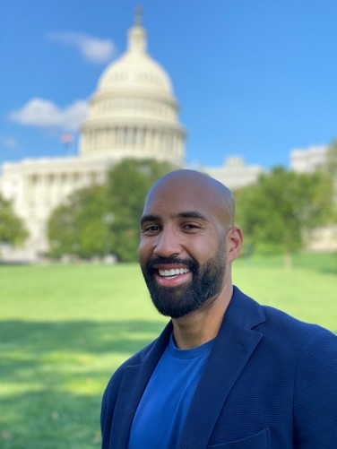
Ridgeline

Eric works as a Cloud Security Program Manager for Ridgeline, an investment management software company Headquartered in Lake Tahoe. His work includes the development and implementation of cloud security, data privacy, and compliance controls for Ridgeline’s enterprise software.

Eric is a proud Navy Veteran, having served 10 years. His career spans tours deploying to the Middle East Region aboard two warships, serving at National Security Agency Headquarters leading a data analytics office, flying onboard a military reconnaissance aircraft supporting national intelligence objectives, and completing his service at the Pentagon as a Cryptologic Staff Officer supporting Department of the Navy system acquisition programs.

He holds a Master of Engineering in Cybersecurity Policy and Compliance Degree from George Washington University and a B.S. in International Transportation and Trade from SUNY Maritime College.

Eric’s personal decorations include Navy Marine Corps Achievement Medal (twice awarded) while serving afloat, Joint Service Commendation Medal for his efforts as a Cryptologist supporting the National Security Agency, and Navy Marine Corps Commendation Medal while forward-deployed executing tactical intelligence missions.

Eric is a passionate advocate for initiatives supporting Latinx opportunities in tech and works to support transitioning veterans/new college graduates in pursuing careers in tech.

