PUBLIC NOTICE
Federal Communications Commission
45 L Street NE
Washington, D.C. 20554
News Media Information 202 / 418-0500
Internet: https://www.fcc.gov
TTY: 1-888-835-5322
DA 21-67
Released: January 15, 2021

CONSUMER AND GOVERNMENTAL AFFAIRS BUREAU AnnounceS TECHNICAL Specifications
FOR Reassigned Numbers Database Reporting
CG Docket No. 17-59

In December 2018, the Commission authorized establishment of the Reassigned Numbers Database. Once operational, the Database will allow callers to determine whether a telephone number has been permanently disconnected after a date certain and therefore is no longer assigned to the party the caller wants to reach. We now announce the technical specifications instructing voice service providers how to submit their data for the file containing information about disconnected numbers. Those specifications have been established by the Database Administrator and appear in Attachment A. We expect to announce soon when providers must begin reporting disconnection data.
For further information, contact Karen Schroeder, Consumer Policy Division, Consumer and Governmental Affairs Bureau, at (202) 418-0654 or karen.schroeder@fcc.gov.
ATTACHMENT A

Service Provider Disconnected Numbers Report/Toll Free Numbering Administrator (TFNA) Disconnected Numbers Report

Initial Seed Data

Initially, the RND will be populated with seed data. This data can be submitted with multiple files for each Company ID. The “seed” data will cover July 27, 2020 to the date of the first report; small providers will submit seed data covering January 27, 2021 to the date of their first report. The TN Report File Format is described in detail below.

TN Report File Format

Service Providers (SPs), Service Provider Agents (SPAs) and the TFNA will prepare a file in CSV or XLXS data format with a row for each TN and last date of permanent disconnection with their allocated and ported-in numbers. Each TN Monthly report file is limited to 1 million rows.
The company ID contained in the file must be registered in the Reassigned Numbers Database through https://www.reassigned.us

File format information:
- File Name
  - User can pick file name
- CompanyID - required
  - Must be the first row
  - Must only be one
  - The value is required to be registered in the RNDA prior to using
  - Must be in an active status
  - Must be associated with the user uploading the file
- Additional Information – optional. The user may provide additional data for their own purposes, such as Reporting Period or Internal tracking number. The system will ignore this information.
  - Additional Contacts may be provided in a row which will be used to send notifications for this submission.
  - The user may include up to 5 additional Contact email addresses. It is recommended to use distribution list if more than 5 are needed.
  - The additional contact email addresses will be courtesy copied (cc’d) on the confirmation email that system has processed the file and resulting errors
    - If more than 5 email addresses are supplied, then the first 5 will be included and the rest will be ignored by the system
    - If more than one row of additional contacts is supplied in the file, the last row will be processed with the first 5 email addresses cc’d on the email.
- Telephone Number List – required
  - Row must exist and will alert the system to start processing disconnected telephone numbers
  - TN format - valid formats
    - ########## (example: 8337632366)
    - Must be 10 digits
    - NPA must be 200 or greater
  - Date format - valid formats
    - YYYY-MM-DD – 2020-05-01
    - MM/DD/YY - 05/01/20
    - MM/DD/YYYY - 05/01/2020
    - M/D/YY - 5/1/20
    - M/D/YYYY - 5/1/2020
The file at a minimum must contain these rows in this order:
- CompanyID
- Telephone Number List
- Telephone, Date

Example File Formats

CSV File Format
CompanyID, ABC
Additional Contacts, joe@my.com, tom@my.com
Telephone Number List,
2025550100, 2020-01-12
5405550200, 2019-12-25
7035550122, 2019-02-28

xlsx Format
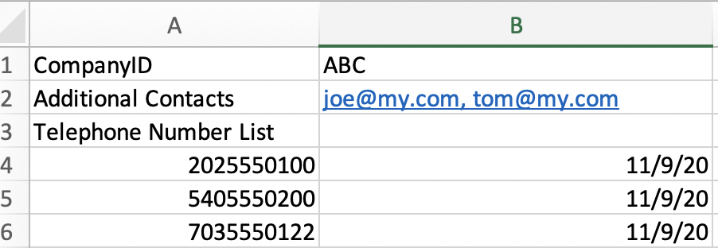

Submit TN Report – Initial “seed” data - BatchID

In order to submit the initial “seed” data, the TN report will be submitted via upload, using the same regular monthly TN report file format, with the insertion of “BatchID” on Row 2, as seen below:

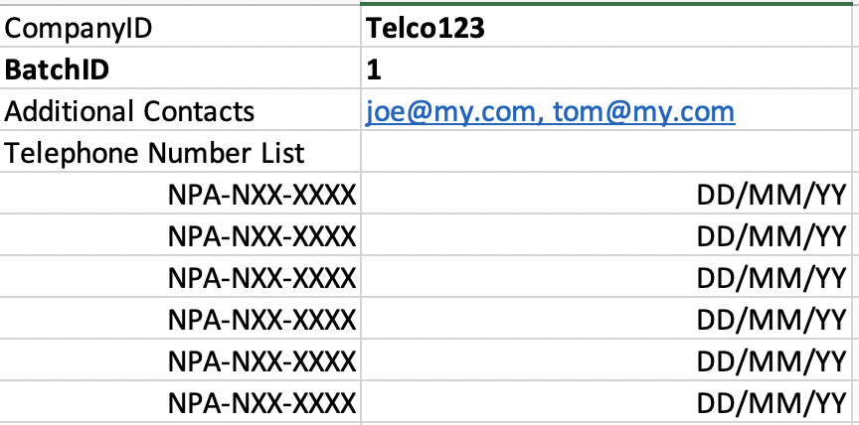

Submit TN Report through https://www.reassigned.us

In order to submit the monthly TN report by file upload in the GUI, the user must be a registered user. A file must be created according to the information provided above.
Submit Report by File Upload
- Login to System
- Navigate to Submit, TN Disconnect Upload
- To select a file to upload hit “Choose File”
  - Files must be .csv or .xlsx format
- The system will confirm successful upload on the screen
- The user will receive an email notification when the file is processed and any additional contacts will be cc’d on the email

Advanced Methods to Target and Eliminate Unlawful Robocalls, CG Docket No. 17-59, Second Report and Order, 33 FCC Rcd 12024, 12029, para. 11 (2018) (Reassigned Numbers Database Order). Providers are required to report the date of the most recent permanent disconnection for each number allocated to or ported to that provider. Id. at 12037, para. 35.
SomosGov, Inc. is the Reassigned Numbers Database Administrator. See Press Release, FCC, FCC Selects SomosGov as Next Telephone Number Administrator and Reassigned Numbers Database Administrator (Dec. 1, 2020), https://www.fcc.gov/document/fcc-selects-somosgov-next-telephone-number-administrator.
The Commission will publish a notice in the Federal Register announcing the date service providers are required to comply with the reporting rule. Service providers will submit their first reports the following month. Small providers will have an additional six months to comply with the reporting rule. Reassigned Numbers Database Order, 33 FCC Rcd at 12039, paras. 43-45.

