DA 21-858
Released: July 19, 2021

WIRELESS TELECOMMUNICATIONS BUREAU seeks comment on Drive Test parameters and model for ALASKA PLAN participants
WC Docket No. 16-271

Comment Date: [14 days after publication in the Federal Register]

By this Public Notice, the Wireless Telecommunications Bureau (Bureau) seeks comment on proposed drive test parameters and a model for the drive tests required of certain mobile providers participating in the Alaska Plan.
The Commission adopted the Alaska Plan Order in 2016 to address both fixed and mobile voice and broadband service in high-cost areas of the state of Alaska. Eight mobile providers chose to participate in the Alaska Plan and submitted performance plans in which they committed to specific deployment obligations and performance requirements sufficient to demonstrate that Alaska Plan support would be used in the public interest. In the performance plans, providers committed to cover a specified number of people by five-year (December 31, 2021) and 10-year (December 31, 2026) milestones at a specified minimum speed, broken down by each level of wireless service offered (2G/Voice, 3G, and 4G LTE) and each type of middle mile facility used in connection with the deployed mobile technology. Each participant must certify that it has met the reporting milestones, including minimum download and upload speeds set forth in its approved performance plans.
In addition, participants that receive more than $5 million annually in Alaska Plan support must supplement these certifications with “data received or used from drive tests analyzing network coverage for mobile service covering the population for which support was received and showing mobile transmissions to and from the . . . network meeting or exceeding the minimum expected download and upload speeds delineated in the approved performance plan[s].” The Alaska Plan Order specifies that participants may demonstrate coverage of an area with a “statistically significant number of tests in the vicinity of residences being covered.” The Alaska Plan Order further specifies that, as with Tribal Mobility Fund Phase I, these drive tests may be conducted by means other than in automobiles on roads due to the unique terrain and lack of road networks in remote areas of Alaska. In the Alaska Plan Order, the Commission delegated to the Bureau the authority to “effectuate plan implementation and administration,” including by “requir[ing] additional information . . . from individual participants that it deems necessary to establish clear standards for determining whether or not they meet their five- and 10-year commitments.” Drive test results confirming qualifying participants’ performance commitments for the five-year milestone are due by March 1, 2022.
Two participants meet the trigger for the drive test requirement: GCI and Copper Valley Wireless. Consistent with the Alaska Plan Order’s delegation of authority, we propose drive test parameters and a drive test model to ensure that GCI’s and Copper Valley Wireless’s drive tests allow the Commission to determine whether the carriers met their five-year commitments. Appendix A lists the data that we propose to require the carriers to collect during the drive tests and the format in which we propose it be reported. The parameters listed in Appendix A are consistent with requirements the Commission has established for mobile speed test data collected in other contexts, and we anticipate that these categories of data will allow the Bureau to evaluate whether GCI and Copper Valley Wireless have met their deployment benchmarks. Appendix B sets forth a drive test model that would help to ensure that the two carriers conduct a “statistically significant number of tests in the vicinity of residences being covered.” This proposal uses stratified random sampling to provide the carriers with locations to test within a grid system of their reported coverage areas. A confidence interval would be constructed around the drive test results to verify that a provider’s commitments have been met or determine the percentage by which the carrier’s coverage has failed to meet its commitment.
We seek comment on these proposals and on any alternatives that we should consider. Given that this Public Notice only affects two Alaska Plan participants, both of whom have been informed of this action and have indicated a desire to begin testing as soon as possible to maximize their ability to conduct drive testing during less adverse weather conditions, we find that a 14-day comment period will allow sufficient opportunity for public input and accordingly waive the default reply comment period.
***
Filing Requirements. Interested parties may file comments on or before the date indicated above and must reference WC Docket No. 16-271. Comments may be filed using the Commission’s Electronic Filing System (ECFS) or by filing paper copies.
- Electronic Filers: Comments may be filed electronically using the Internet by accessing the ECFS: http://apps.fcc.gov/ecfs/.
- Paper Filers: Parties who choose to file by paper must file an original and one copy of each filing.
- Filings can be sent by commercial overnight courier, or by first-class or overnight U.S. Postal Service mail. All filings must be addressed to the Commission’s Secretary, Office of the Secretary, Federal Communications Commission.
  - Commercial overnight mail (other than U.S. Postal Service Express Mail and Priority Mail) must be sent to 9050 Junction Drive, Annapolis Junction, MD 20701. U.S. Postal Service first-class, Express, and Priority mail must be addressed to 45 L Street, NE, Washington, DC 20554.
  - Effective March 19, 2020, and until further notice, the Commission no longer accepts any hand or messenger delivered filings. This is a temporary measure taken to help protect the health and safety of individuals, and to mitigate the transmission of COVID-19.
People with Disabilities. To request materials in accessible formats for people with disabilities (braille, large print, electronic files, audio format), send an e-mail to fcc504@fcc.gov or call the FCC’s Consumer and Governmental Affairs Bureau at (202) 418-0530 (voice).
Ex Parte Rules. This proceeding shall be treated as a “permit-but-disclose” proceeding in accordance with the Commission’s ex parte rules. Persons making ex parte presentations must file a copy of any written presentation or a memorandum summarizing any oral presentation within two business days after the presentation (unless a different deadline applicable to the Sunshine period applies). Persons making oral ex parte presentations are reminded that memoranda summarizing the presentation must (1) list all persons attending or otherwise participating in the meeting at which the ex parte presentation was made, and (2) summarize all data presented and arguments made during the presentation. If the presentation consisted in whole or in part of the presentation of data or arguments already reflected in the presenter’s written comments, memoranda or other filings in the proceeding, the presenter may provide citations to such data or arguments in his or her prior comments, memoranda, or other filings (specifying the relevant page and/or paragraph numbers where such data or arguments can be found) in lieu of summarizing them in the memorandum. Documents shown or given to Commission staff during ex parte meetings are deemed to be written ex parte presentations and must be filed consistent with rule 1.1206(b). In proceedings governed by rule 1.49(f) or for which the Commission has made available a method of electronic filing, written ex parte presentations and memoranda summarizing oral ex parte presentations, and all attachments thereto, must be filed through the electronic comment filing system available for that proceeding, and must be filed in their native format (e.g., .doc, .xml, .ppt, searchable .pdf). Participants in this proceeding should familiarize themselves with the Commission’s ex parte rules.
Initial Regulatory Flexibility Certification. As required by the Regulatory Flexibility Act, the Commission certifies that the proposals in this Public Notice, if adopted, will not have a significant impact on a substantial number of small entities. This Public Notice seeks comment on the drive testing proposals required by the Alaska Plan for those wireless participants receiving more than $5 million in annual Alaska Plan support, excluding the smaller wireless participants that receive less than that in annual support. The proposals, if adopted, would apply to only two entities, one of which does not qualify as a small entity.
Additional Information. For additional information on this proceeding, contact Matthew Warner of the Wireless Telecommunications Bureau, Competition & Infrastructure Policy Division, Matthew.Warner@fcc.gov, (202) 418-2419.
- FCC -

APPENDIX A
Mobile Speed Test Data Specification
- Overview
The Alaska Plan requires certain plan participants to conduct and report speed tests of their networks, as described in this PN and appendices. Appendix A describes the data to be collected and the format in which it is to be reported.
- Sample Data
{
"submission_type": "Alaska Plan",
"submissions": [
{
"test_id": "1599236609",
"timestamp": "2021-07-08T09:02:42-08:00",
"device_type": "Android",
"manufacturer": "Google",
"model": "PIXEL 3",
"operating_system": "Android 11",
"app_id": "FCC Speed Test app",
"app_version": "2.0.2496",
"provider_name": "GCI",
"tests": {
"download": {
"timestamp": "2021-07-08T09:02:42-08:00",
"duration": 4997185,
"bytes_transferred": 97382448,
"bytes_sec": 19487461,
"locations": [
{
"timestamp": "2021-07-08T09:02:42-08:00",
"latitude": 63.069168,
"longitude": -153.248195
},
{
"timestamp": "2021-07-08T09:02:47-08:00",
"latitude": 63.069168,
"longitude": -153.248195
}
],
"cells": [
{
"cell_id": 32193025,
"physical_cell_id": 192,
"cell_connection": 1,
"network_generation": "4G",
"network_subtype": "LTE",
"rssi": -77.1,
"rsrp": -95.2,
"rsrq": -16.5,
"sinr": 11.9,
"ec_io": -8.3,
"rcsp": -84.2,
"cqi": 10,
"spectrum_bandwidth": 20,
"arfcn": 66786
},
{
"cell_id": 10283265,
"physical_cell_id": 101,
"cell_connection": 2,
"network_generation": "4G",
"network_subtype": "LTE",
"rssi": -77.1,
"rsrp": -97.2,
"rsrq": -10.1,
"sinr": 21.2,
"ec_io": -8.3,
"rcsp": -84.2,
"cqi": 10,
"spectrum_bandwidth": 15,
"arfcn": 68686
}
]
},
"upload": {
"timestamp": "2021-07-08T09:02:51-08:00",
"duration": 5000085,
"bytes_transferred": 15129062,
"bytes_sec": 3025761,
"locations": [
{
"timestamp": "2021-07-08T09:02:51-08:00",
"latitude": 63.069168,
"longitude": -153.248195
},
{
"timestamp": "2021-07-08T09:02:56-08:00",
"latitude": 63.069168,
"longitude": -153.248195
}
],
"cells": [
{
"cell_id": 32193025,
"physical_cell_id": 192,
"cell_connection": 1,
"network_generation": "4G",
"network_subtype": "LTE",
"rssi": -77.1,
"rsrp": -96.2,
"rsrq": -9.1,
"sinr": 10.5,
"ec_io": -8.3,
"rcsp": -84.2,
"cqi": 10,
"spectrum_bandwidth": 20,
"arfcn": 66786
},
{
"cell_id": 35988099,
"physical_cell_id": 192,
"cell_connection": 2,
"network_generation": "4G",
"network_subtype": "LTE",
"rssi": -71.1,
"rsrp": -99.1,
"rsrq": -6.9,
"sinr": 9.7,
"ec_io": -8.3,
"rcsp": -84.2,
"cqi": 10,
"spectrum_bandwidth": 20,
"arfcn": 39874
}
]
}
}
}
]
}
- Mobile Speed Test Data
This section details the data structure common for all mobile speed test data in the Alaska Plan. This file contains records of each mobile speed test in JavaScript Object Notation (JSON) format matching the specification in the table and sections below:
Field | Data Type | Example | Description / Notes
submission_type | Enumerated | Alaska Plan | Type of data submission.  - Value must be “Alaska Plan”.
submissions | Array  [Submission Object] |  | List of drive test data submissions.  Note: the specification for the Submission Object is described in Section aa.
  - Submission Object
Field | Data Type | Example | Description / Notes
test_id | String | 1599236609 | Unique identifier used by the app to differentiate tests.
timestamp | Datetime | 2021-07-08T09:02:42-08:00 | Timestamp of the time at which the set of test metrics commenced.  - Value must match valid ISO-8601 format including seconds and timezone offset, e.g.: YYYY-MM-DD[T]hh:mm:ss±hh:mm
device_type | Enumerated | Android | Type of device.  - Value must be one of the following:  {iOS|Android|Other}
manufacturer | String | Google | Name of the device manufacturer.
model | String | PIXEL 3 | Name of the device model
operating_system | String | Android 11 | Name and version of the device operating system.
app_id | String | FCC Speed Test app | Name of the mobile speed test app.
app_version | String | 2.0.2496 | Version of the mobile speed test app.
provider_name | String | GCI | Name of the mobile service provider.
tests | Test Object |  | Information about the test metrics.  Note: the specification for the Test Object is described in Section b.
  - Test Object
Field | Data Type | Example | Description / Notes
download | Download Test Object |  | Information about the download test metric.  Note: the specification for the Download Test Object is described in Section c.
upload | Upload Test Object |  | Information about the upload test metric.  Note: the specification for the Upload Test Object is described in Section d.
  - Download Test Object
Field | Data Type | Example | Description / Notes
timestamp | Datetime | 2021-07-08T09:02:42-08:00 | Timestamp of the time at which the test metric commenced.  - Value must match valid ISO-8601 format including seconds and timezone offset, i.e.: YYYY-MM-DD[T]hh:mm:ss±hh:mm
duration | Integer | 4997185 | Duration that the test metric took to complete in microseconds.
bytes_transferred | Integer | 97382448 | Measured total amount of data in bytes that the test metric transferred.
bytes_sec | Integer | 19487461 | Measure number of bytes per second that the test metric transferred.
locations | Array  [Location Object] |  | List of geographic coordinates of the locations measured during the speed test.  Note: the specification for each Location Object element is described in Section e.
cells | Array  [Cell Object] |  | List of cellular telephony information measured during the speed test.  Note: the specification for each Cell Object element is described in Section f.
  - Upload Test Object
Field | Data Type | Example | Description / Notes
timestamp | Datetime | 2021-07-08T09:02:51-08:00 | Timestamp of the time at which the test metric commenced.  - Value must match valid ISO-8601 format including seconds and timezone offset, i.e.: YYYY-MM-DD[T]hh:mm:ss±hh:mm
duration | Integer | 5000085 | Duration that the test metric took to complete in microseconds.
bytes_transferred | Integer | 15129062 | Measured total amount of data in bytes that the test metric transferred.
bytes_sec | Integer | 3025761 | Measure number of bytes per second that the test metric transferred.
locations | Array  [Location Object] |  | List of geographic coordinates of the locations measured during the speed test.  Note: the specification for each Location Object element is described in Section e.
cells | Array  [Cell Object] |  | List of cellular telephony information measured during the speed test.  Note: the specification for each Cell Object element is described in Section f.
  - Location Objects
Each element of the “locations” array contains the geographic coordinates of the locations measured at the start and end of the speed test, as well as during the test (if measured).
Field | Data Type | Example | Description / Notes
timestamp | Datetime | 2021-07-08T09:02:58-08:00 | Timestamp of the time at which the location was recorded.  - Value must match valid ISO-8601 format including seconds and timezone offset, i.e.: YYYY-MM-DD[T]hh:mm:ss±hh:mm
latitude | Decimal  (3,7) | 63.069168 | Unprojected (WGS-84) geographic coordinate latitude in decimal degrees of the reported location where the test was conducted.  - Value must have minimum precision of 6 decimal places.
longitude | Decimal  (3,7) | -153.248195 | Unprojected (WGS-84) geographic coordinate longitude in decimal degrees of the reported location where the test was conducted.  - Value must have minimum precision of 6 decimal places.
  - Cell Objects
Each element of the “cells” array contains telephony information about the cell / carrier.
Field | Data Type | Example | Description / Notes
cell_id | Numeric | 32193025 | Measured cell identifier.
physical_cell_id | Integer | 192 | Measured Physical Cell Identity (PCI) of the cell.  Note: this value is only required for LTE and 5G network generations and may be null for 2G/3G network generations.
cell_connection | Enumerated | 1 | Connection status of the cell.  - Value must be one of the following codes:  0 – Not Serving  1 – Primary Serving  2 – Secondary Serving  Note: this value may be null if connection status returns unknown.
network_  generation | Enumerated | 4G | String representing the network generation of the cell.  - Value must be one of the following:  {2G|3G|4G|5G|Other}
network_subtype | Enumerated | LTE | String representing the network subtype of the cell.  - Value must be one of the following:  {1X|EVDO|WCDMA|GSM|HSPA|HSPA+|  LTE|NR}
rssi | Decimal  (3,1) | -57.2 | Measured Received Signal Strength Indication (RSSI) in dBm of the cell.  Note: this value is required for all network generations and subtypes.
rsrp | Decimal  (3,1) | -92.1 | Measured Reference Signal Received Power (RSRP) in dBm of the cell.  Note: this value is only required for LTE and NR subtypes, and may be null for all other network subtypes.
rsrq | Decimal  (3,1) | -12.5 | Measured Reference Signal Received Quality (RSRQ) in dB of the cell.  Note: this value is only required for LTE and NR subtypes, and may be null for all other network subtypes.
sinr | Decimal  (3,1) | 21.3 | Measured Signal to Interference and Noise Ratio (SINR) in dB of the cell.  Note: this value is only required for 2G, LTE, and 5G network generations, and may be null for 3G.
ec_io | Decimal  (3,1) | -8.3 | Measured Energy per Chip to Interference Power Ratio in dB of the cell.  Note: this value is only required for CDMA 1X, EVDO, WCDMA, HSPA, and HSPA+ network subtypes, and may be null for all other network subtypes.
rscp | Decimal  (3,1) | -87.2 | Measured Received Signal Code Power in dBm of the cell.  Note: this value is only required for WCDMA, HSPA, and HSPA+ network subtypes, and may be null for all other network subtypes.
cqi | Integer | 11 | Measured Channel Quality Indicator (CQI) of the cell.  Note: this field is only required for WCDMA, HSPA, HSPA+, LTE, and NR network subtypes, and may be null for all other network subtypes.
spectrum_bandwidth | Numeric | 15 | Total amount of spectral bandwidth used by the cell in MHz.
arfcn | Integer | 66786 | Absolute radio-frequency channel number, measured absolute physical RF channel number of the cell.

APPENDIX B
Drive Test Procedures—Technical Appendix

Introduction
This technical appendix provides information about the proposed mobile certification process for Alaska Plan providers subject to drive testing. The Alaska Plan requires such testing to include “a statistically significant number of tests in the vicinity of residences being covered” to demonstrate that plan participants have met the commitments in the performance plans approved by the Wireless Telecommunications Bureau (Bureau).
Remote Alaska is extraordinarily sparsely populated; virtually all its county-level geographies have population densities of three or fewer people per square mile. Accordingly, testing every location for a provider’s coverage would be unduly burdensome, and testing a sample of locations is required.
For the sampling required to implement the testing procedures under the Alaska Plan, staff proposes to use stratified random sampling. When properly implemented, this sampling methodology can achieve an optimal balance between the statistical significance required by the Alaska Plan and the burden on providers to conduct tests from a sufficient number of locations.
The following sections describe the details of the proposed testing process. These technical details serve as a guide to both the Bureau and the providers doing the testing in determining:
- where, within the geographic boundaries of the coverage map, a provider should conduct testing;
- how many locations a provider must test;
- what speed test measurements will be accepted for staff analysis by the Bureau; and
- how Bureau staff will evaluate the test data and adjudicate whether the provider has passed or failed the testing process.

Sample Frame Construction
To select locations for testing, one must first construct a list (known as a “sampling frame” or “frame”) of possible locations to select from. The construction of this frame is a multi-part process. First, we propose creating a set of “eligible populated areas.” Census blocks eligible for frozen-support funding would be included, and these census blocks would be merged with the populated areas of the Alaska Population Distribution model. Second, the Form 477 reported coverage for which a provider committed to deploy subject to testing would be merged with the eligible populated areas to create a set of “covered populated areas.” Third, a grid of 1 km x 1 km squares would be overlaid onto the covered populated areas. Due to the fact that the Alaska Population Distribution model uniformly distributes population within the populated area of a block, the covered populated areas of a block would likewise have a uniform population distribution. The total population of each grid cell is the sum of the populations of the covered populated areas contained within a given grid cell. For example, if a grid cell contains 25% of the covered populated area of a census block, that grid would be credited with 25% of that block’s covered population. That same grid cell might also contain 100% of a second census block’s covered populated area. So all of that census block’s covered population would be credited to that grid cell, and the grid cell’s total population would be the sum of these two populations. Lastly, any grid cell that contains fewer than 100,000 square meters of covered populated area, or 10% of the grid cell, would be excluded from the frame. This ensures that all grid cells have a reasonable testable area, reducing burden on providers. Grid cells with smaller levels of covered populated area were less likely to have areas that were publicly accessible or large enough to conduct mobile testing. Figures 1-4 below detail this process.
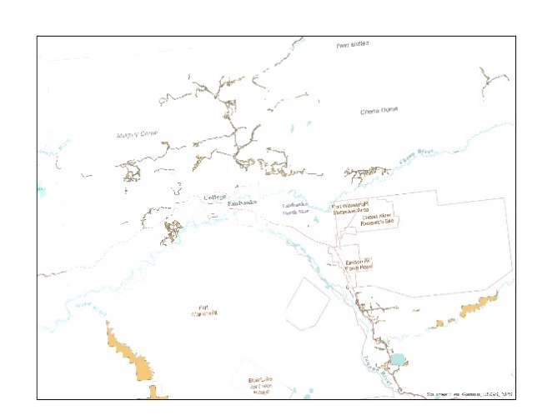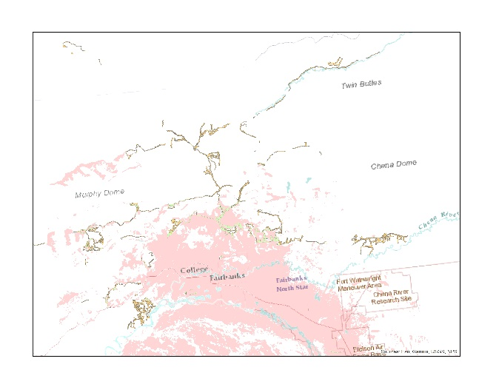
Fig. 1: Eligible Blocks and Populated Areas Fig. 2: Eligible Populated Areas and Coverage
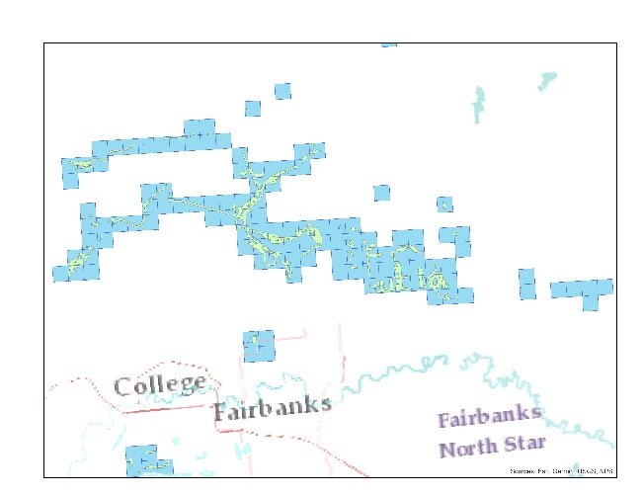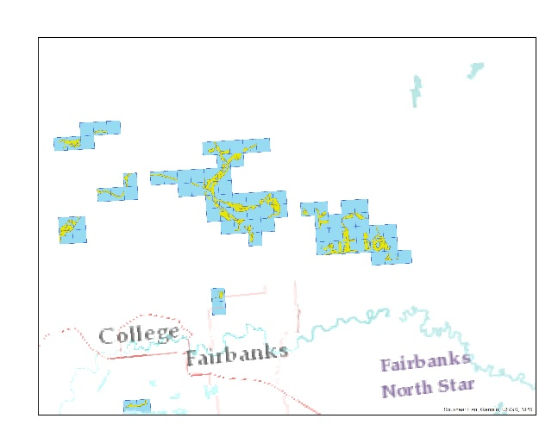
Fig. 3: Covered Populated Areas with Grid Fig 4: Grid Cells Eligible for Selection
For commitments that do not promise different speeds for different middle-mile technologies, the frame would utilize the most recent Form 477 submissions from the provider, which currently is the provider’s deployment data as of December 2020. For areas served by more than one technology, the area would only be included in the frame for the latest generation technology. For example, if an area is covered by both 2G and 3G, then the area would only be included in the 3G frame. As no commitments were made for 5G service, any 5G coverage will be included within the LTE frame. Where a provider has committed to different speeds in different areas due to different middle-mile technologies, the frame would rely on additional data submitted by the provider to differentiate the covered areas of a given technology (e.g., LTE) with multiple middle-mile types.
If a provider wishes to submit data that better reflects the December 2021 Form 477 data that it is likely to submit in March 2022 than the December 2020 data that the Commission currently has, then it should notify the Bureau within the Public Notice comment cycle and submit the updated coverage data within 10 days of the adoption of the Order. The Bureau will create a stratified random sample for the provider to test within 15 days of receipt of updated data, or, in the event of no new data submitted, 10 days of the adoption of an Order.

Frame Stratification
Frame stratification is the process of dividing a frame into subsets of similar characteristics, called strata. This methodology allows fewer grid cells to be selected for testing while producing the same level of accuracy as sampling the entire frame, thus reducing testing burden.
The number of strata for each frame depends on the number of grid cells in a given frame. To create the strata, the Bureau proposes to use the cumulative square root of the frequency (CSRF) method, based on grid-level estimates of covered population. CSRF is a standard stratification method used to define the breaks between strata. It creates equal intervals not on the scale along the stratification variable (in this case, covered population) scale, but rather on the scale along the cumulated square root of the count (frequency) of grid cells belonging to equal intervals of the stratification variable.
Based on the data staff currently has, it is expected that each frame will contain between two and eight strata. Staff analysis has found that this stratification method produces strata of more equal sizes than other potential stratification methods (e.g., based on census tracts), which reduces the number of grid cells that need to be selected for testing.
Further, staff proposes to select certain grid cells with probability 1 (grid cells that are called certainties) within each stratum. This ensures that grid cells that have a high population within a given stratum are tested; this should prevent the testing results of the stratum from being skewed by outlier results from low-weighted grid cells.

Sample Size Calculation and Allocation and Sample Selection
The Bureau proposes to decide the number of grid cells that the provider has to test (that is, the sample size, $n$), based on a set of statistical and logistical assumptions. The statistical assumption is that the variance of the desired estimate of average population served cannot exceed a specified value, $V$. The logistical assumption is that the cost of drive testing is constant in every grid cell selected in the sample. Under these assumptions, a theoretical value for the sample size can be calculated as detailed below.
Let $L$ denote the number of strata in the frame and let the index $h$ distinguish these $L$ strata. Further, denote or define the following quantities:
- Number of grid cells in the stratum $=N_{h}$ (thus, $N=\sum_{h=1}^{L}{N_{h}}$)
- Weight of the stratum $=W_{h}=N_{h}/N$
- Mean of $X$ in the stratum $={\overline{X}}_{h}=\frac{1}{N_{h}}\sum_{i=1}^{N_{h}}{X_{h,i}}$ where $X_{h,i}$ is the value of committed population $X$ in the $i$th grid cell of stratum $h$
- Variance of $X$ in the stratum $={V(X)}_{h}=\frac{\sum_{i=1}^{N_{h}}{{(X_{h,i}-{\overline{X}}_{h})}^{2}}}{N_{h}-1}$
Under our proposal, the theoretical minimum sample size is given by:
$$n=\frac{{\left(W_{h}\sqrt{{V(X)}_{h}}\right)}^{2}}{V+(1/N)\sum_{h=1}^{L}{W_{h}{V(X)}_{h}}}∙$$
Once determined, $n$ would be allocated among the different strata. Specifically, if $n_{h}$ is the number of sample grid cells allocated to the stratum, then:
$$n_{h}=n\frac{W_{h}\sqrt{{V(X)}_{h}}}{\sum_{h=1}^{L}{W_{h}\sqrt{{V(X)}_{h}}}}=n\frac{N_{h}\sqrt{{V(X)}_{h}}}{\sum_{h=1}^{L}{N_{h}\sqrt{{V(X)}_{h}}}}$$
This method of apportioning the sample among the various strata is called Neyman allocation. Note that $n=\sum_{h=1}^{L}{n_{h}}$.
Guided by the allocation scheme from the previous section, staff proposes to use geographic information systems (GIS) tools to randomly select grid cells in each stratum, including options within these tools that ensure geographic dispersion for selected grid cells within a stratum. The provider subject to testing would then be notified of the sample grid cells in which it would be required to conduct on-the-ground speed tests.

Drive Testing Data Collection
We propose that, within each selected grid cell, a carrier would conduct a minimum of 20 tests, no less than 50% of which are to be conducted while in-motion from a vehicle. This is the minimum number of tests to support the use of the binomial distribution to approximate the normal distribution that is needed in calculating the gap in coverage based on a one-sided 90% confidence interval, as discussed later in Section VII.
To be considered valid, each test should be conducted between the hours of 6:00 a.m. and 10 p.m., within the selected grid cell, and report all relevant parameters defined in Appendix A. Each component of a test (i.e., download and upload speeds) should have a duration between 5 and 30 seconds. Mobile tests are considered to be located within the grid cell containing the starting location, as a tester has full control over the starting location of a test but may not always be able to control the ending location of a test. Testers should, however, attempt to conduct a mobile test within a single grid cell as much as is reasonably and safely possible. A mobile test should initiate when moving away from the location of a stationary test after having reached the speed of the surrounding traffic, or a safe and reasonable operating speed in the event no traffic is present.

Statistical Analysis of Testing Results
Upon receipt of drive testing submissions, the Bureau will perform a statistical analysis of the data to estimate the desired total population covered. Because the sample is selected using stratified random sampling, estimation techniques appropriate for this particular sampling method must be used.
Stratified random sampling requires an aggregate measurement from a sampled grid cell that will be combined with measurements from the other sampled grid cells to calculate stratum-level estimates of total covered population. These estimates will, in turn, be combined to produce an overall estimate of covered population. Drive tests conducted in a sample grid cell will be aggregated based on the following rule:
Let $p$ be the percentage of drive tests that meet or exceed the applicable minimum. If $p$ is at least 85%, then the full population of the sample grid cell will be deemed as covered; otherwise, 0% will be deemed as covered.
To calculate the stratum-level estimates and the overall estimate of the covered population, the Bureau proposes to use the estimation method appropriate for stratified random sampling, described next.
Let $x_{h,i}$ be the (deemed) covered population in the $i$th grid cell of stratum $h$, where $i=1,…,n_{h}$. Based on the rule above, $x_{h,i}=X_{h,i}$ if $p≥0.85$, and $x_{h,i}=0$ if $p<0.85$. The stratum sample mean covered population, ${\overline{x}}_{h}$, is calculated as ${\overline{x}}_{h}=\sum_{i=1}^{n_{h}}{x_{h,i}}/n_{h}$; the stratum sample total covered population is $N_{h}{\overline{x}}_{h};$ and the stratum sample variance, ${s_{h}}^{2}$, is calculated as ${s_{h}}^{2}= \frac{\sum_{i=1}^{N_{h}}{{(x_{h,i}-{\overline{x}}_{h})}^{2}}}{n_{h}-1}$.
Combining these stratum-level estimates, we arrive at the overall covered population mean, $\overline{x},$ calculated as:
$$\overline{x} =\sum_{h=1}^{L}{\frac{N_{h}{\overline{x}}_{h}}{N}}=\sum_{h=1}^{L}{W_{h}{\overline{x}}_{h}}$$
with variance:
$$V\left(\overline{x} \right)=\frac{1}{N^{2}}\sum_{h=1}^{L}{N_{h}(}N_{h}-n_{h})\frac{ {s_{h}}^{2}}{n_{h}}.$$
To more accurately reflect coverage at the time of deployment and to fulfill the Alaska Plan’s requirement to evaluate a provider’s commitments based on December 2021 Form 477 coverage data, we propose to adjust the covered population of the sample frames $N_{h}$ relative to covered population according to the December 2020 Form 477 data. For frames where coverage would be reduced, we would proportionally reduce population, and, for where coverage would increase, we would proportionally increase population.
Finally, the overall covered population total, $\hat{X}$, is estimated as
$$\hat{X} =N\overline{x}.$$

Adjudication of the Outcome of the Testing Process
Because the estimate of the total covered population $\hat{X}$ comes from a sample, direct comparison of $\hat{X}$ against the committed covered population is not appropriate. Instead, staff proposes to construct a confidence interval that takes into account the variability arising from the estimate $\hat{X}$, and use this confidence interval to adjudicate the outcome of the testing process.
Because the Alaska Plan calls for a tiered approach in levying penalties for providers failing the testing process, the Bureau proposes to use a one-sided 90% confidence interval for $\hat{X}$ to quantify the gap in coverage. In particular, the Bureau proposes to use the upper limit of this confidence interval, which is calculated as $\hat{X}+1.28N\sqrt{V\left(\overline{x} \right)}$.
The gap in coverage is then calculated as:
Gap in Coverage = Total Population Coverage Commitment $- ( \hat{X}+1.28N\sqrt{V\left(\overline{x} \right)} ).$
If the gap in coverage is no more than 5% of the total population of a given commitment, no penalties will apply. Otherwise, penalties will apply according to the tiers adopted by the Commission.
Additionally, it is possible to have a negative gap in coverage if the upper limit of the confidence interval is greater than the total committed population. If a provider has committed to multiple tiers of technology (i.e., 2G, 3G, and 4G LTE), then any excess coverage, as defined by a negative gap in coverage, can be applied to the next lowest tier of technology. For example, if a provider has committed to cover 25,000 people with 4G LTE and the upper limit of the confidence interval shows adequate coverage for 30,000 people, then the remaining 5,000 coverage can be applied to its 3G commitment. This process is iterative, so any further excess coverage can be applied to its 2G commitment. Accordingly, the formula above would be re-written as:
Gap in Coverage = Total Population Coverage Commitment – ($\hat{X}+1.28N\sqrt{V\left(\overline{x} \right)}$ + Excess Coverage from Higher Technology)
This methodology therefore will not punish carriers for improving coverage beyond what they committed.

See Connect America Fund et al., WC Docket No. 16-271, Report and Order and Further Notice of Proposed Rulemaking, 31 FCC Rcd 10139 (2016) (Alaska Plan Order).
Alaska Plan Order, 31 FCC Rcd at 10140, 10162-63, 10167, paras. 1, 72, 86.
See Wireless Telecommunications Bureau Approves Performance Plans of the Eight Wireless Providers That Elected to Participate in the Alaska Plan, WC Docket No. 16-271, Public Notice, 31 FCC Rcd 13317, 13318-23, Appx. (WTB 2016) (Alaska Plan Public Notice); see also Wireless Telecommunications Bureau Approves GCI’s Revised Performance Plan Pursuant to the Alaska Plan Order, WC Docket No. 16-271, Public Notice, 35 FCC Rcd 9539, 9539-41, Appx. (2020) (accepting GCI’s second-revised performance plan).
47 CFR $§$54.317; see also Alaska Plan Order, 31 FCC Rcd at 10166, para. 85; Alaska Plan Public Notice, 31 FCC Rcd at 13318 (stating that the disbursement of Alaska Plan support would start on January 1, 2017, making the five-year and ten-year milestones December 31, 2021, and December 31, 2026).
See 47 CFR § 54.321; Alaska Plan Order, 31 FCC Rcd at 10173, para. 103.
47 CFR § 54.321; Alaska Plan Order, 31 FCC Rcd at 10173, para. 103.
Alaska Plan Order, 31 FCC Rcd at 10173, para. 103.
Alaska Plan Order, 31 FCC Rcd at 10173, para. 103.
Alaska Plan Order, 31 FCC Rcd at 10160, 10166, paras. 67, 85.
See 47 CFR § 54.321(a) (stating that the certification and supporting data is due “[n]o later than 60 days after the end of each participating carrier’s first five-year term of support”); Alaska Plan Order, 31 FCC Rcd at 10173, para. 103.
See Establishing the Digital Opportunity Data Collection, Modernizing the FCC Form 477 Data Program, WC Docket Nos. 19-195 & 11-10, Third Report and Order, 36 FCC Rcd 1126, 1166-67, para. 103 (2021). While we draw on prior Commission guidance in other contexts, we note that the parameters proposed in Appendix A are to be used for the distinct purpose of assessing Alaska Plan performance commitments and are without prejudice to future decisions to use different or additional parameters in any other Commission proceedings.
Alaska Plan Order, 31 FCC Rcd at 10173, para. 103.
Stratified random sampling is a process whereby a population is subdivided into nonoverlapping groupings, or strata, and a simple random sample is taken from each stratum. See William G. Cochran, Sampling Techniques ch. 5 (3rd ed. 1977).
47 CFR § 1.415(c); see also 47 CFR § 1.3 (specifying that the Commission may “on its own motion” waive a rule “for good cause shown, in whole or in part, at any time.”).
See Electronic Filing of Documents in Rulemaking Proceedings, GC Docket No. 97-113, Report and Order, 13 FCC Rcd 11322 (1998).
47 CFR § 1.1200 et seq.
5 U.S.C. § 603.
5 U.S.C. § 605(b).
Alaska Plan Order, 31 FCC Rcd at 10173, para. 103.
See 13 CFR § 121.201; NAICS Code 517312 (specifying that a wireless telecommunications carrier is a small entity if it has 1500 or fewer employees). GCI has over 2,000 employees. See GCI, Executive Team, https://www.gci.com/about/executiveteam (observing that GCI has over 2,000 employees) (last visited July 15, 2021).
Alaska Plan Order, 31 FCC Rcd at 10173, para. 103; see also Connect America Fund—Alaska Plan, WC Docket No. 16-271, Order, 35 FCC Rcd 10373 (WTB 2020) (Alaska Population Distribution Order) (adopting a methodology for estimating the number of Alaskans who receive mobile service within census blocks in remote areas of Alaska).
William G. Cochran, Sampling Techniques ch. 5 (3rd ed. 1977).
Alaska Population Distribution Order, 35 FCC Rcd at 10378, para. 15; Letter from Julie A. Veach, Counsel, GCI, to Marlene H. Dortch, Secretary, FCC, WC Docket No. 16-271, Attach. (filed Nov. 29, 2016).
Alaska Population Distribution Order, 35 FCC Rcd at 10373.
Staff proposes to use this particular type of grid because census blocks are not of uniform geographic size, which could require a different number of speed tests for each block, and, in turn, could increase the testing burden on providers. Grids of smaller sizes and shapes were less likely to provide easily accessible areas for testing given the nature of roads and population distribution in remote Alaska, and grids of larger sizes and shapes would provide more heterogeneous wireless performance, which would require more cumbersome rules for actually conducting drive testing to ensure geographic diversity of the sample within each grid.
See, e.g., Alaska Plan Order, 31 FCC Rcd at 10173, para. 102 (for areas where the provider was not able to commit to 10/1 Mbps LTE, requiring the provider to submit Form 481 updates and new performance plans where new middle mile options become commercially available); E-mail from Julie A. Veach, Counsel for GCI, to Matthew J. Collins, Economist, Wireless Telecommunication Bureau, FCC (Oct. 1, 2018, 10:14 EDT), Attach. (providing a census-block-by-census-block list of last mile technology available at start of plan and middle mile available).
Alaska Plan Order, 31 FCC Rcd at 10173, para. 103 (“We will rely on participating carriers’ Form 477 submissions in determining whether each carrier’s five-year and 10-year milestones have been met.”).
William G. Cochran, Sampling Techniques at 89.
Id. at 127-31.
Sharon L. Lohr, Sampling: Design and Analysis ch. 2 (1999).
William G. Cochran, Sampling Techniques at 98.
Id. at 99.
ESRI, Create Random Points, https://desktop.arcgis.com/en/arcmap/latest/tools/data-management-toolbox/create-random-points.htm (last visited May 27, 2021).
Marco Taboga, Lectures on Probability Theory and Mathematical Statistics ch. 79 (3d ed. 2017).
For 2G tests, the applicable minimum speeds would be 22.8 kbps for both download and upload tests, as this is the minimum equivalent data rate for voice service, accounting for the voice codec rate and channel coding rate requirements. See ETSI, CODECs, https://www.etsi.org/technologies/codecs (last visited July 14, 2021).
The 85% threshold was used in the Alaska Plan as the threshold appropriate in remote Alaska for determining whether a population is considered covered. See Alaska Plan Order, 31 FCC Rcd at 10167-69, paras. 87, 90.
William G. Cochran, Sampling Techniques at 91-96.
Alaska Plan Order, 31 FCC Rcd at 10173, para. 103.
See 47 CFR § 54.320(d).
Id. at 95.
47 CFR § 54.320(d).

