DA 22-501

Warren Feldman, Chief Executive Officer
Covista, Inc.
150 Clove Road, 8th Floor
Little Falls, New Jersey 07424

Via Certified Mail, Return Receipt Requested

Re: Potential Reclamation of Covista, Inc.’s International Signaling
Point Code, 3-035-4 (Newark, NJ)

Dear Mr. Feldman:

By this letter, we inform you of our intent to reclaim the above-captioned International Signaling Point Code (ISPC), provisionally assigned to Covista, Inc. (Covista) unless you respond to this letter within thirty (30) days, by June 6, 2022.

The Federal Communications Commission (Commission), as the Administrator for the United States, assigns ISPCs for Signaling System No. 7 networks under ITU-T Recommendation Q.708. In 1997, the Commission granted TotalTel, Inc.’s application for an ISPC in Newark, NJ and provisionally assigned it ISPC 3-035-4. In 2003, TotalTel, Inc. changed its name to Covista.

The Commission has explained that ISPCs are a scarce resource and “[a]s a result, code assignments are conditional upon their being used within one year lead time, so that the Commission can reassign unused codes to another carrier.” Additionally, ITU-T Recommendation Q.708 provides that the Commission should withdraw an ISPC assignment if the code is “no longer in use or required” by the operator, among other reasons. Further, Covista was subject to the annual traffic and revenue reporting requirements at the time of its ISPC assignment. Despite these provisions, we have no record that Covista informed the International Bureau of the date the code was implemented or filed any International Traffic Data Reports for the years 2014-2015.

Commission staff has made several attempts to contact Covista to ascertain whether it is using its provisionally assigned ISPC. On April 30, 2021 and May 5, 2021, Commission staff called the telephone numbers associated with Covista on the FCC’s Form 499 Filer Database, but the calls were not answered. On April 30, 2021, Commission staff called the office of Lance J.M. Steinhart, P.C., identified as Covista’s contact on a related international section 214 application. An individual from this office informed staff it no longer represents Covista. On February 28, 2022 and March 14, 2022, the staff sent email inquiries to email addresses on file for Covista. These emails were either returned as undeliverable or went unanswered. According to the FCC’s Form 499 Filer Database, Covista has not been active since March 25, 2013 and sold all its assets to another party. Finally, staff viewed the Tennessee Secretary of State’s Business Information Search website, according to which Covista has been inactive since September 7, 2013. Based on our inability to contact a representative of Covista, our records, and the records of the Tennessee Secretary of State, we believe Covista may no longer be providing services and may no longer be using its assigned ISPC.

We request that you respond to this letter by June 6, 2022, and indicate the date the code was implemented and describe the current use of Covista’s ISPC (3-035-4). A failure to respond to this letter by this date will serve as confirmation that Covista is no longer using its provisionally assigned ISPC and has failed to comply with our ISPC requirements. Consistent with the terms of the ITU-T Recommendation Q.708, we will reclaim the ISPC (3-035-4) and immediately thereafter make the code available for reassignment if you fail to respond to this letter as requested. We are addressing this letter to the most recent contact and addresses of record provided by Covista and its successors.

If you have any questions please contact me at (202) 418-7370 or Francis.Gutierrez@fcc.gov or my colleague Stacey Ashton at (202) 418-2214 or Stacey.Ashton@fcc.gov.

Sincerely,

/Francis Gutierrez/

Francis Gutierrez
Deputy Chief, Telecommunications and Analysis Division
International Bureau

cc:

A. John Leach, Chief Executive Officer
Henry G. Luken, III, Chairman
Covista, Inc.
721 Broad St., Suite 200
Chattanooga, TN 37402

Covista, Inc.
c/o Ron Kuzon and Douglas D. Orvis
2020 K Street, NW
Washington, DC 20006

TSC Corporation Services, Inc
400 7th St. NW, Suite 101
Washington, DC 20004

Warren Feldman, Chief Executive Officer
Norman Klugman, Chairman
Covista, Inc.
4289 Bonny Oaks Drive, Suite 102
Chattanooga, TN 37402

Covista, Inc.
225 E. 8th St. Ste. 400
Chattanooga, TN 37402-2200
Attachment

Email Exchange 1
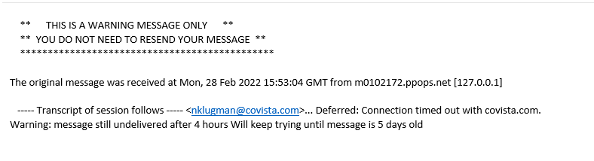

The original message was received at Mon, 28 Feb 2022 15:53:04 GMT from m0102172.ppops.net [127.0.0.1]

----- The following addresses had permanent fatal errors ----- <nklugman@covista.com>

----- Transcript of session follows ----- <nklugman@covista.com>... Deferred: Connection timed out with covista.com.
Message could not be delivered for 5 days Message will be deleted from queue

From: Stacey Ashton <Stacey.Ashton@fcc.gov>
Sent: Monday, February 28, 2022 10:53 AM
To: nklugman@covista.com; rkuzon@hotmail.com
Cc: Arthur Lechtman <Arthur.Lechtman@fcc.gov>; Francis Gutierrez <Francis.Gutierrez@fcc.gov>
Subject: RE: International Signaling Point Code Inquiry (Covista, Inc.)

Dear Mr. Klugman and Mr. Kuzon:

My office in the FCC’s International Bureau is reviewing international signaling point code (ISPC) records. In 1997, the International Bureau provisionally assigned the ISPC 3-035-4 (Newark, NJ) to TotalTel Inc., later renamed Covista, Inc. (Covista). We are trying to determine if Covista is using the assigned ISPC. We obtained your email address from a 2013 international section 214 assignment application and associated consummation notification (see IBFS file number ITC-ASG-20121221-00326). Is Covista or any other entity to your knowledge currently using ISPC 3-035-4? If you do not know the status of 3-035-4, but have other contact information for Covista (names, email addresses, phone numbers), that would also be helpful. Thank you for your assistance.

Stacey Ashton
International Bureau/TAD
Federal Communications Commission
202.418.2214

Email Exchange 2
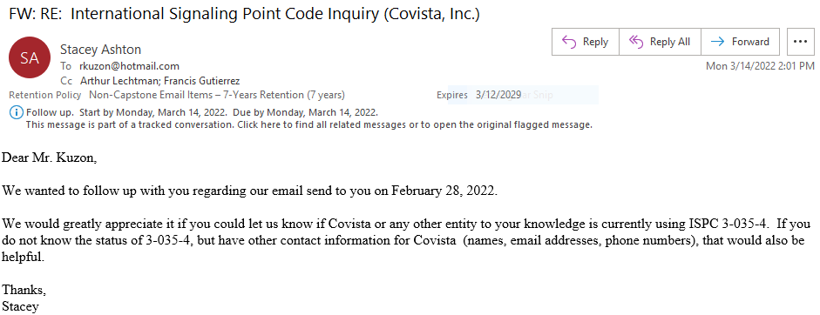

International Telecommunication Union (ITU), ITU-T Recommendation Q.708 (03/99), Series Q: Switching and Signalling, Specifications of Signalling System No. 7 – Message Transfer Part (MTP), Assignment procedures for international signalling point codes, https://www.itu.int/rec/recommendation.asp?lang=en&parent=T-REC-Q.708-199903-I (ITU-T Recommendation Q.708).
See Letter from Charlotte Lacey, Legal Assistant to Lance J.M. Steinhart, Attorney for Covista, Inc. f/k/a TotalTel, Inc., to Secretary, Federal Communications Commission (Feb. 24, 2003) (on file in ITC-214-19981023-00834) (Covista Feb. 24, 2003 Letter).
Reporting Requirements for U.S. Providers of International Telecommunications Services; Amendment of Part 43 of the Commission’s Rules, Notice of Proposed Rulemaking, 19 FCC Rcd 6460, 6474, para. 36, n.83 (2004); see also China Telecom (Americas) Corporation, GN Docket No. 20-109 et al., Order Instituting Proceedings on Revocation and Termination and Memorandum Opinion and Order, 35 FCC Rcd 15006, 15040, para 58 (2020) (“ISPCs are a scarce resource that are used by international Signaling System 7 (SS7) gateways as addresses for routing domestic voice traffic to an international provider and anyone seeking an ISPC assignment is required by rule to file an application with the Commission and comply with its procedures.”).
ITU-T Recommendation Q.708 at 6.
See generally Amendment of Section 43.61 of the Commission’s Rules, CC Docket No. 91-22, Report and Order, 7 FCC Rcd 1379 (1992) (establishing the traffic and revenue reporting requirements that were in effect at the time of Covista’s ISPC assignment).
In 2017, the Commission eliminated the requirement that U.S. providers of international telecommunications services file annual Traffic and Revenue Reports. See Section 43.62 Reporting Requirements for U.S. Providers of International Services; 2016 Biennial Review of Telecommunications Regulations, IB Docket Nos. 17-55, 16-131, Report and Order, 32 FCC Rcd 8115 (2017). Providers, including Covista, were required to file the final traffic and revenue data for calendar year 2015.
Staff called (202) 783-2700 and (423) 648-9595, the phone numbers associated with Covista on the FCC’s Form 499 Filers Database. Covista, Inc., FCC Form 499 Filer Database, https://go.usa.gov/xu8K8 (last visited Apr. 22, 2022) (Covista Form 499 Filer Data).
See IBFS File No. ITC-214-19981023-00834. Staff called (770) 232-9200, the contact number listed in the Covista Feb. 24, 2003 Letter.
Email from Stacey Ashton, Telecommunications Analyst, Telecommunications and Analysis Division, International Bureau to Mr. Norman Klugman, Covista, Inc. (nklugman@covista.com) and Mr. Ron Kuzon, Covista, Inc.(rkuzon@hotmail.com) (Feb. 28, 2022); Return email from Mail Delivery Subsystem to Stacey Ashton, Telecommunications Analyst, Telecommunications and Analysis Division, International Bureau (Feb. 28, 2022, 15:53:04 PM). Email from Stacey Ashton, Telecommunications Analyst, Telecommunications and Analysis Division, International Bureau to Mr. Ron Kuzon, Covista (rkuzon@hotmail.com) (Mar. 14, 2022).
Covista Form 499 Filer Data. According to the Commission’s records, Birch Communications, Inc. and Birch Telecom, Inc. (together, Birch) acquired certain assets from Covista in 2013. See International Authorizations Granted, Section 214 Applications (47 C.F.R. § 63.18); Section 310(b)(4) Requests, Report No. TEL-01604, Public Notice, 28 FCC Rcd. 1316 (Feb. 21, 2013). Staff contacted Birch counsel by phone (423-648-9595) on April 30, 2021 and inquired whether the asset transfer to Birch included Covista’s ISPC, 3-035-4. Counsel for Birch indicated that the ISPC was not part of the asset transfer.
See Tennessee, Secretary of State, Division of Corporations, Business Information Search, https://tnbear.tn.gov/Ecommerce/FilingSearch.aspx.

