SIXTH report on ownership of

broadcast stations

**FCC Form 323 and Form 323-E Ownership Data as of   
October 1, 2021**

**DA 23-35**

Media Bureau and Office of Economics and Analytics

JANUARY 2023

fcc_logo

This report is available for download from the Commission’s website at <https://www.fcc.gov/media>.

Table of Contents

[**I.** **INTRODUCTION** 1](#_Toc81555504)

[**II.** **MEASURES OF OWNERSHIP** 5](#_Toc81555505)

[A. Attributable Ownership Interest 5](#_Toc81555506)

[B. Majority Ownership Interest 5](#_Toc81555507)

[C. Caveats and Clarifications 5](#_Toc81555508)

[**III.** **SUMMARY OF RESULTS** 6](#_Toc81555509)

[A. Full Power Commercial Television 8](#_Toc81555510)

[B. Class A Television 9](#_Toc81555511)

[C. Low Power Television 10](#_Toc81555512)

[D. Commercial AM Radio 11](#_Toc81555513)

[E. Commercial FM Radio 12](#_Toc81555514)

[F. Full Power Noncommercial Television 13](#_Toc81555515)

[G. Class A Noncommercial Television 14](#_Toc81555516)

[H. Low Power Noncommercial Television 15](#_Toc81555517)

[I. Noncommercial AM Radio 16](#_Toc81555518)

[J. Noncommercial FM Radio 17](#_Toc81555519)

APPENDIX A: Explanatory Notes

APPENDIX B: Tables

Table A. 1-4. 2021. Full Power Commercial Television

Table B. 1-4. 2021. Class A Television

Table C. 1-4. 2021. Low Power Television

Table D. 1-4. 2021. Commercial AM Radio

Table E. 1-4. 2021. Commercial FM Radio

Table F. 1-4. 2021. Full Power Noncommercial Television

Table G. 1-4. 2021. Class A Noncommercial Television

Table H. 1-4. 2021. Low Power Noncommercial Television

Table I. 1-4. 2021. Noncommercial AM Radio

Table J. 1-4. 2021. Noncommercial FM Radio

1. **INTRODUCTION**

The Federal Communications Commission’s (Commission’s) biennial commercial and noncommercial broadcast ownership reporting forms—FCC Form 323 and Form 323-E, respectively—are designed to obtain detailed ownership information from the broadcast industry. This report, which presents data on ownership interests in commercial and noncommercial broadcast stations as of October 1, 2021 by gender, race, and ethnicity,[[1]](#footnote-3) is the latest in a series of such publicly released tabulations. On November 14, 2012, the Media Bureau released the first electronic analysis of commercial broadcast ownership data submitted pursuant to the revised biennial reporting requirements for 2009 and 2011.[[2]](#footnote-4) Subsequent reports contained analyses of the commercial broadcast ownership data submitted during the 2013, 2015, 2017, and 2019 filing cycles.[[3]](#footnote-5) Accordingly, this report presents a tabulation of the seventh data collection using the current version of Form 323 and the third data collection using the current version of Form 323-E.[[4]](#footnote-6) Like the prior reports, the data contained in these reportsare “snapshots” of the status of minority and female ownership in the broadcast industry taken every two years. The collection, tabulation, and release of these data are useful to the public, Congress, and the Commission because they provide an insight into the ownership of broadcast stations, both commercial and noncommercial, over time, that could be relevant to the Commission’s policymaking as well as used by interested parties.[[5]](#footnote-7)

This report covers commercial and noncommercial stations in five broadcast services—full power television, Class A television, low power television, AM radio, and FM radio. As of October 1, 2021, there were approximately 1,760 licensed full power television stations, 380 licensed Class A television stations, 1,740 licensed low power television stations, 4,520 licensed AM radio stations, and 10,890 licensed FM radio stations.

This report focuses on two aspects of the recently collected ownership data—“attributable” ownership interests and “majority” ownership interests—using the lenses of gender, race, and ethnicity.[[6]](#footnote-8) First, the report analyzes the reported information concerning attributable interest holders, consistent with the Commission’s broadcast ownership attribution rules.[[7]](#footnote-9) Those rules represent the Commission’s best judgment concerning when an interest is sufficient to confer on the owner a potential degree of influence over a licensee that should be cognizable for purposes of applying the Commission’s broadcast ownership rules. As a general matter, the Commission for decades has deemed officers and directors of licensee entities, as well as holders of 5% or more voting interests, to be attributable owners.[[8]](#footnote-10) Within this rubric, the report considers the gender, race, and ethnicity of attributable ownership interest holders. In graphs and tables reporting attributable ownership interests, the gender, race, and ethnicity categories are not mutually exclusive. Each station may appear in multiple gender, race, and ethnicity categories because many stations have attributable interest holders who belong to different gender, racial, or ethnic groups. For example, a station with both male and female attributable interest holders would be counted in both the male and female categories.

Second, the report adapts a measure the Commission often employs in ownership analyses generally, the majority ownership interest. In those other contexts, the Commission pays heed to whether a station’s attributable ownership ranks include a party that holds more than 50% of a station’s voting interests, because of the degree of influence that entity likely would have over station operations and decision-making.[[9]](#footnote-11) Along the same lines, this report considers whether a person or group of people sharing the same gender, race or ethnicity characteristics collectively hold more than 50% of the voting interests in a licensee. For example , a station’s majority ownership interest in gender would be female if a single woman or a group of women held more than 50% of the voting interests in the licensee. A station’s majority interest in race and ethnicity is determined in the same way. Notably, some stations do not have a discernable majority interest on the basis of gender, race, or ethnicity.[[10]](#footnote-12) Such stations are classified as having “No Majority Interest.”

**Overview of 2021 Broadcast Station Ownership Data**

The shares of stations held by the various classifications reported below are calculated on the basis of the number of stations filing usable data, not on the basis of the total number of licensed stations.[[11]](#footnote-13)

Figure 1 below summarizes the majority ownership interest of all commercial broadcast stations in gender, race, and ethnicity. Women held a majority ownership interest in 9% of commercial broadcast stations, while men held a majority ownership interest in 61% of commercial broadcast stations. White persons held a majority ownership interest in 73% of commercial broadcast stations, while persons belonging to racial minority groups held a majority ownership interest in 4% of commercial broadcast stations. Finally, Hispanic/Latino persons held a majority ownership interest in 6% of commercial broadcast stations while non-Hispanic/Latino persons held a majority ownership interest in 70% of commercial broadcast stations.

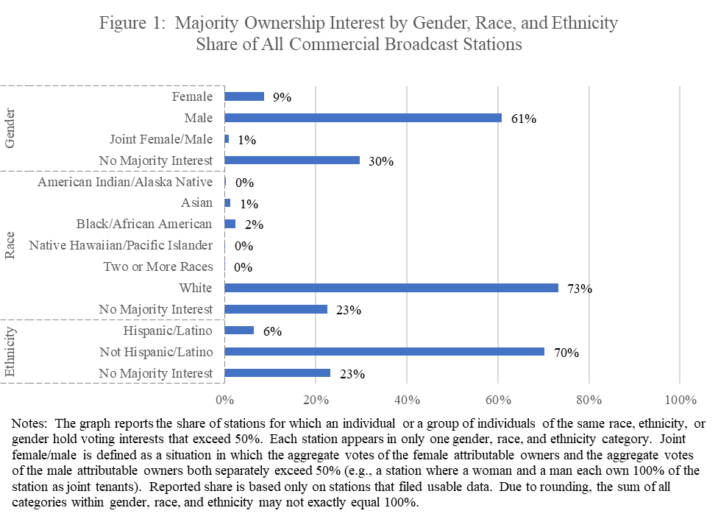

Figure 2 below summarizes the majority ownership interest of all noncommercial broadcast stations by gender, race, and ethnicity. Women held a majority ownership interest in 15% of noncommercial broadcast stations, while men held a majority ownership interest in 77% of noncommercial broadcast stations. White persons held a majority ownership interest in 93% of noncommercial broadcast stations, while persons belonging to racial minority groups held a majority ownership interest in 3% of noncommercial broadcast stations. Finally, Hispanic/Latino persons held a majority ownership interest in 3% of noncommercial broadcast stations, while non-Hispanic/Latino persons held a majority ownership interest in 94% of noncommercial broadcast stations.

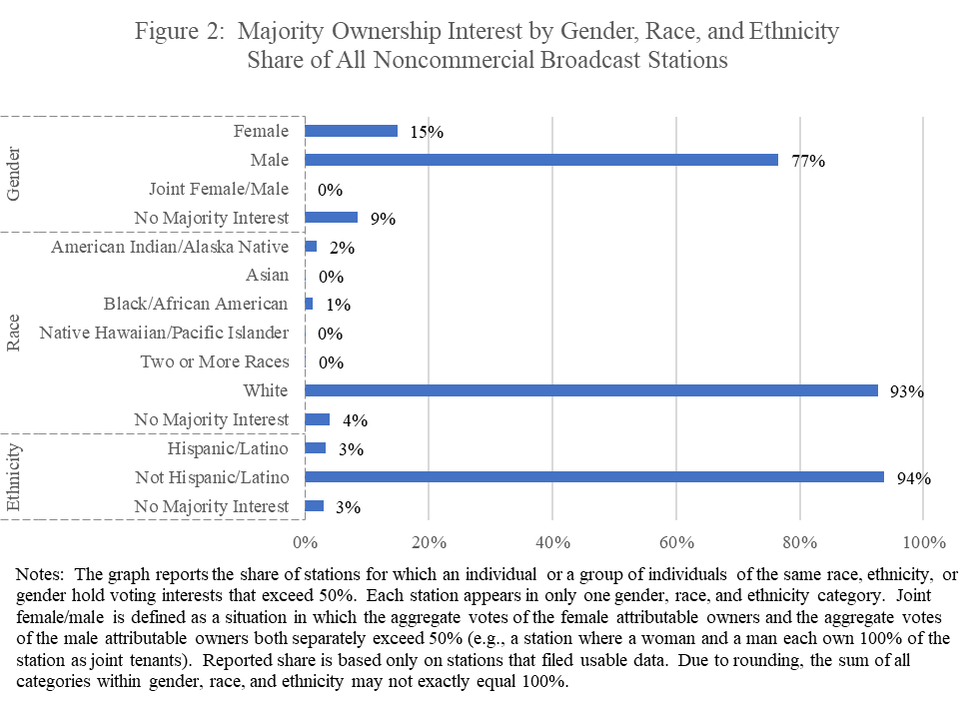For reference, we also present demographic information for the U.S. population. In 2021, the U.S. population was almost evenly split between men and women. About 80% of the U.S. population identified as not Hispanic/Latino while about 20% identified as Hispanic/Latino. By race, 61% of the U.S. population identified as White, about 12% identified as Black or African American, and about 6% identified as Asian. About 1% of the U.S. population identified as American Indian or Alaska Native and a smaller share identified as Native Hawaiian or Other Pacific Islander. About 13% of the U.S. population identified as belonging to two or more racial groups and about 7% belonged to some other racial group. In total, just over 40% of the U.S. population identified as belonging to a racial or ethnic minority group whereas the share of the U.S. population identifying as White, not Hispanic/Latino was about 60%.[[12]](#footnote-14)

The remainder of the report contains: (1) a discussion of the ownership measures used in this report to summarize station ownership filings; (2) a comparison of certain 2021 and 2019 data for commercial and noncommercial broadcast stations—full power television, Class A television, low-power television (LPTV), AM radio, and FM radio; and (3) more detailed information about station ownership in the attached tables and appendices, as well as in accompanying spreadsheets released in conjunction with this report.[[13]](#footnote-15)

1. **MEASURES OF OWNERSHIP**

## Attributable Ownership Interest

As noted above, a station’s ownership report must identify all of its attributable interest holders.[[14]](#footnote-16) The attribution rules represent the Commission’s best judgment concerning when an interest is sufficient to confer on the owner a potential degree of influence over a licensee that should be cognizable for purposes of applying the Commission’s broadcast ownership rules.

With regard to corporations, individuals holding voting stock interests in a broadcast licensee of 5% or greater are considered attributable interest holders.[[15]](#footnote-17) Further, individuals holding particular positions within a broadcast licensee entity also are attributable interest holders, regardless of their shares of voting stock. For example, officers and directors of broadcast licensee entities are attributable based on their corporate positions, as are members of limited liability companies and partners in a limited or general partnership, respectively.[[16]](#footnote-18) Consistent with the Commission’s rules, these individuals are deemed to have a role in the ownership and control of the broadcast licensee. Further, these individuals may exercise control of a licensee in cases where no single individual holds a majority of the voting interests in that licensee and therefore are more likely to exercise such control where no attributable voting interests are identified. This, however, cannot be inferred from the Form 323/323-E data alone, as the specific facts of each case would be required to determine actual control.

In graphs and tables reporting attributable ownership interests, the gender, race, and ethnicity categories are not mutually exclusive. Each station may appear in multiple gender, race, and ethnicity categories because many stations have attributable interest holders who belong to different gender, racial, or ethnic groups. For example, a station with both male and female attributable interest holders would be counted in both the male and female categories.

## Majority Ownership Interest

The report also uses the concept of majority ownership interest to summarize station ownership. As stated above, a station has a majority ownership interest in gender, race, or ethnicity if a single individual or a group of individuals belonging to the same gender, racial, or ethnic group hold more than 50% of the voting interests in the licensee. For example, if a single woman or a group of women hold more than 50% of voting interests in a licensee, the station’s majority ownership interest in gender is female. The majority ownership interests in race and ethnicity are determined in the same way.

If there is no gender, racial, or ethnic group whose members hold more than 50% of voting interests, the station is classified as having “No Majority Interest.” Our classification of a licensee in this report as having “No Majority Interest” does not necessarily mean that no classification of persons by gender, race, or ethnicity has a majority interest in the station, only that these facts could not be determined from the reported Form 323/323-E data in the absence of additional information. Stations may be classified as having no majority interest because some of a licensee’s voting stock are not reported on Form 323 or Form 323-E. This occurs because the Commission does not attribute ownership of a licensee corporation to anyone who holds less than 5% of the outstanding voting interest of that corporation.[[17]](#footnote-19) Particularly where the licensee is a public, widely held entity, it is common for large portions of a licensee’s voting stock not to be reported on Form 323/323-E. In some cases, no attributable voting stock may be reported.

## Caveats and Clarifications

This report provides detailed information by gender, race, and ethnicity about the ownership of commercial and noncommercial television, radio, Class A television, and LPTV stations. As with previous reports, however, this report tallies and presents the data as provided to the Commission by filers. Therefore, its results ultimately rely on the accuracy and completeness of those filings.

Users of the information in this report should also bear in mind that while “control” of a licensee in the usual parlance of the Commission’s cases, rules, and procedures refers to actual control of the licensee, either in terms of *de jure* or *de facto* control by an identifiable individual or group, the tabulation of interests in this report focuses on individuals or groups that share self-identified traits, irrespective of whether the person or group has *de jure* or *de facto* control. Because the Commission reports interests here that are held collectively by certain classes of individuals who may have no connection with one another beyond their shared classification by gender, race, or ethnicity, the fact that a particular class of individuals may have a majority of the voting stock, membership, or partnership interests in a licensee does not necessarily indicate actual control of the licensee by that class of individuals. Rather, absent a single majority interest holder, control of these stations would be determined on a *de facto* basis, which requires access to facts not reported on Form 323. Accordingly, this report refers to these collective interests as “majority” interests, rather than “controlling” interests. Similarly, where no majority interest is reported, a *de facto* control analysis would be required to determine actual control. However, when a single individual, of whatever classification, holds a majority voting interest in a licensee, this would indicate *de jure* control by that individual and is considered a controlling interest.

Some parties have suggested that, due to dissimilarities between the governance of commercial and noncommercial stations, the concept of “ownership” for noncommercial stations may be less obvious than in the context of commercial stations.[[18]](#footnote-20) Nonetheless, for both Form 323 (commercial) and Form 323-E (noncommercial) purposes, the concept of ownership relies on the attribution standards set forth in Section 73.3555 of the Commission’s rules, which generally do not depend on equity interests but instead “seek to identify those interests . . . that confer . . . a degree of influence or control such that the holders have a realistic potential to affect the programming decisions of licensees or other core operating functions.”[[19]](#footnote-21) The Commission’s attribution standards apply to both commercial and noncommercial stations, because the Commission has concluded that individuals and entities captured by these standards have the potential to exert influence over the licensee, regardless of whether the station at issue is commercial or noncommercial.[[20]](#footnote-22) Officers and directors therefore are attributable owners of the noncommercial licensees they serve, and such individuals historically have been reported as attributable interest holders on both commercial and noncommercial broadcast ownership reports.[[21]](#footnote-23)

1. **SUMMARY OF RESULTS**

This section presents a summary of FCC Form 323 and Form 323-E data by category of ownership (attributable ownership interest and majority ownership interest) and by gender, race, and ethnicity. [[22]](#footnote-24) Results are reported by service. For clarity and to provide context, we present 2021 figures against the backdrop of 2019 figures. The following summary uses data from the 2021 Form 323 and Form 323-E biennial reports, representing information current as of October 1, 2021, and the 2019 Form 323 and Form 323-E biennial reports, representing information current as of October 1, 2019. The share of stations held by individuals in the various classifications reported below are calculated on the basis of the number of stations filing usable data, not on the basis of the total number of licensed stations. Stations that did not file an ownership report are not included in the majority ownership interest or the attributable ownership interest calculations. In addition, some stations submitted one or more ownership reports, but their filings were incomplete. While these stations are not included in the majority ownership interest calculations, attributable interest holders disclosed on reports for these stations are included in the attributable ownership interest calculations.

The first figure for each service reports the share of stations with at least one attributable interest holder who belongs to each gender, race, or ethnicity classification. Each station may appear in more than one gender, race, or ethnicity classification.

The second figure for each service reports the share of stations for which an individual or a group of individuals of the same gender, race, or ethnicity hold, either individually or collectively, a majority of the voting interests in the licensee, that is, their voting interests exceed 50%. When a station is identified as having no majority interest, that does not necessarily mean that no particular classification of persons has a majority interest in the station, only that this cannot be determined from the reported Form 323 or Form 323-E data as submitted. In the second figure, each station appears in only one gender, race, and ethnicity classification. *Joint female/male* is defined as a situation in which the aggregate votes of the female attributable owners and the aggregate votes of the male attributable owners both separately exceed 50% (e.g., a station where a female and a male each own 100% of the station as joint tenants).

The information summarized graphically is provided in Appendix B in a series of tables presenting the sources of ownership attribution. Detailed information, including market size data, is contained in the tables in Appendix B and in the accompanying Excel spreadsheets released in conjunction with this report.

## Full Power Commercial Television

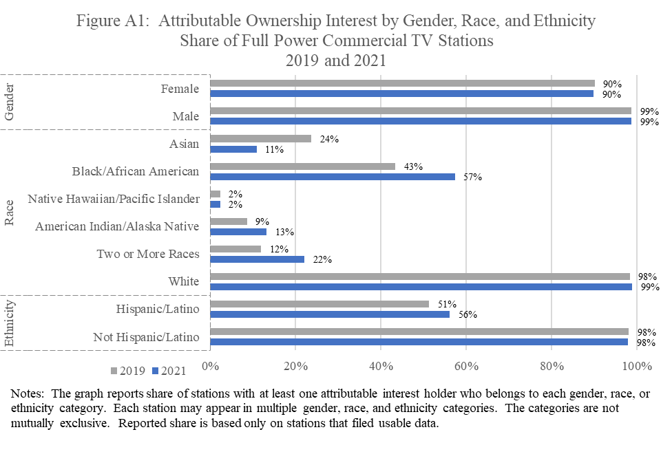

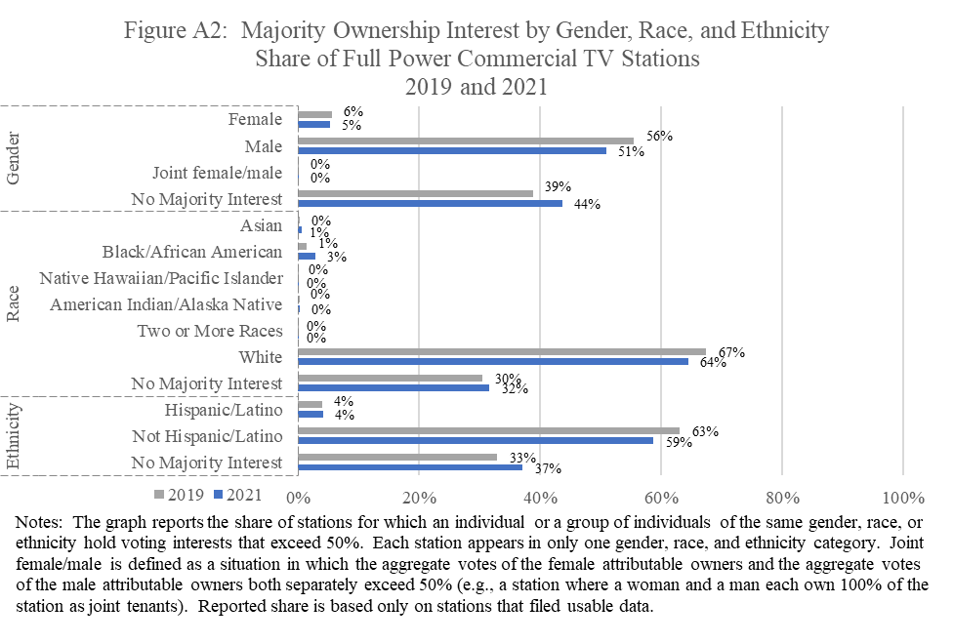

## Class A Television

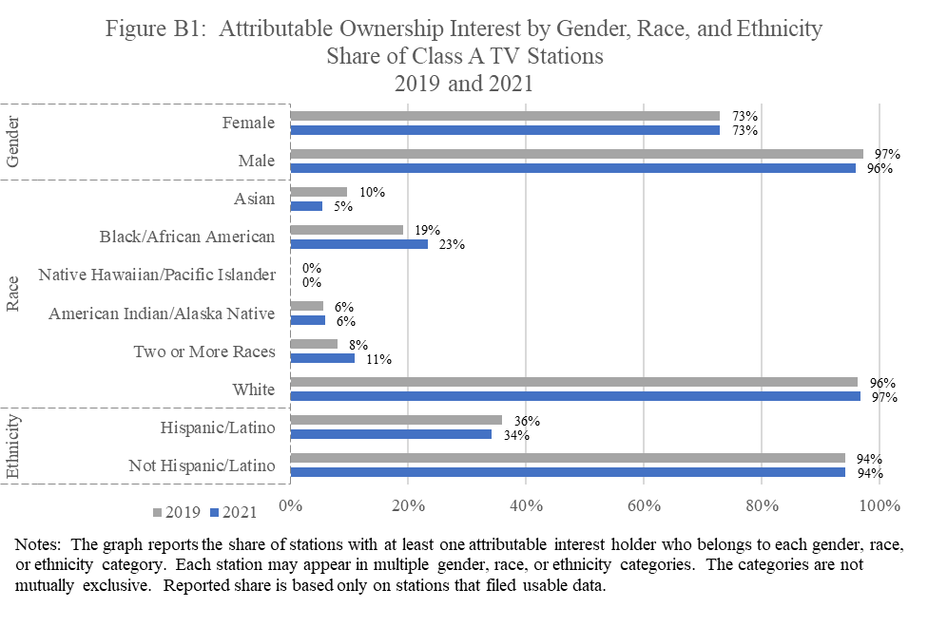

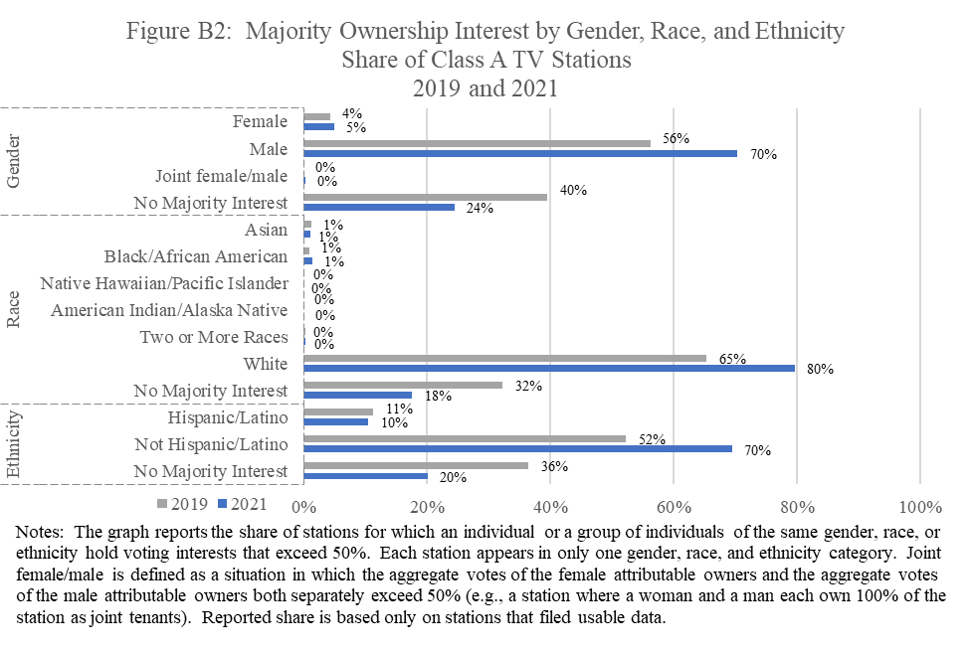

## Low Power Television

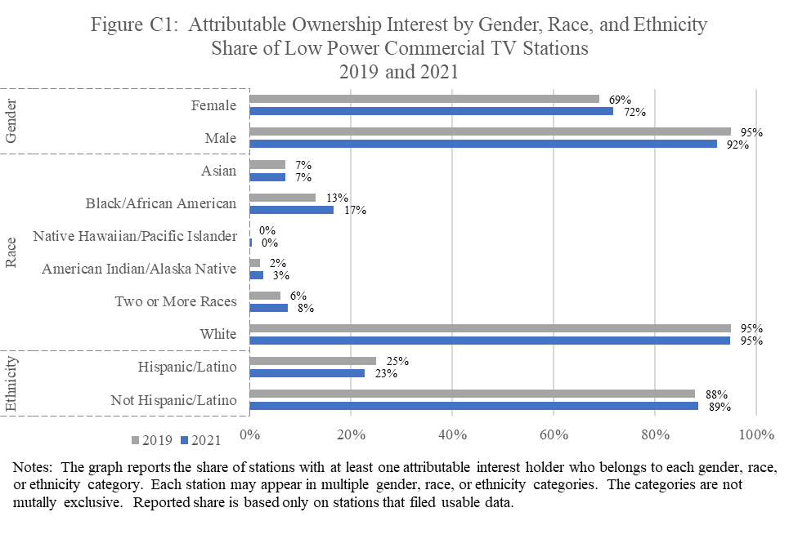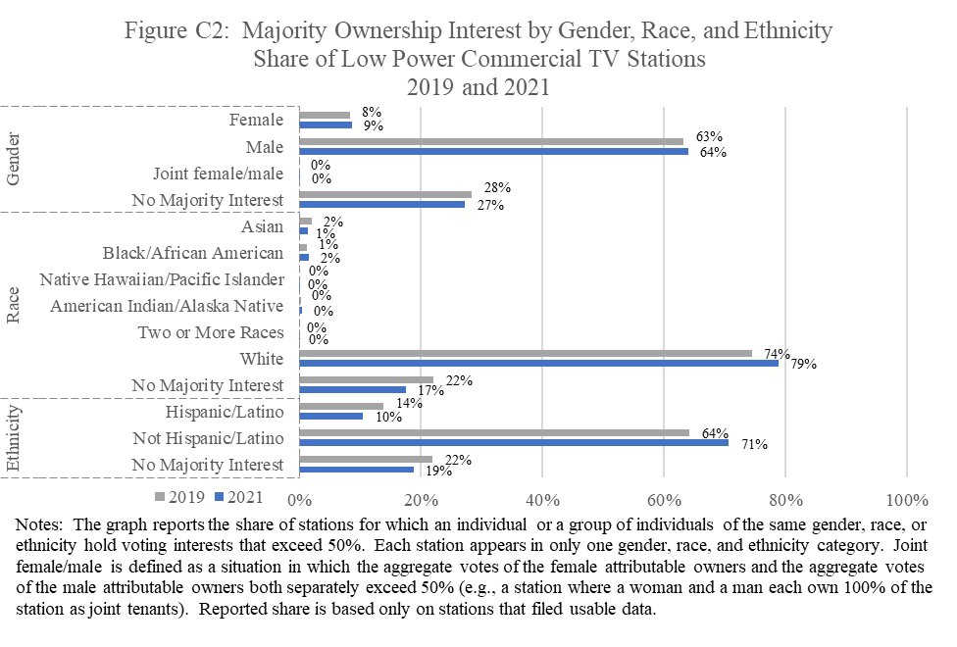

## Commercial AM Radio

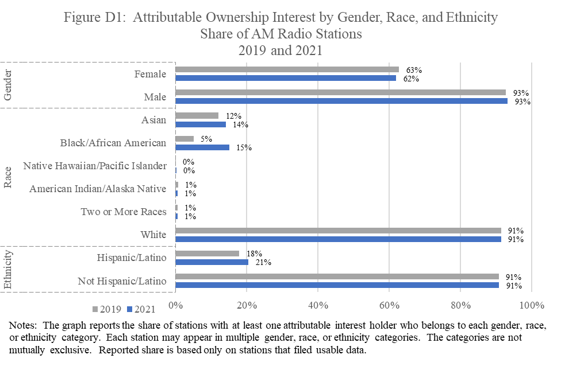

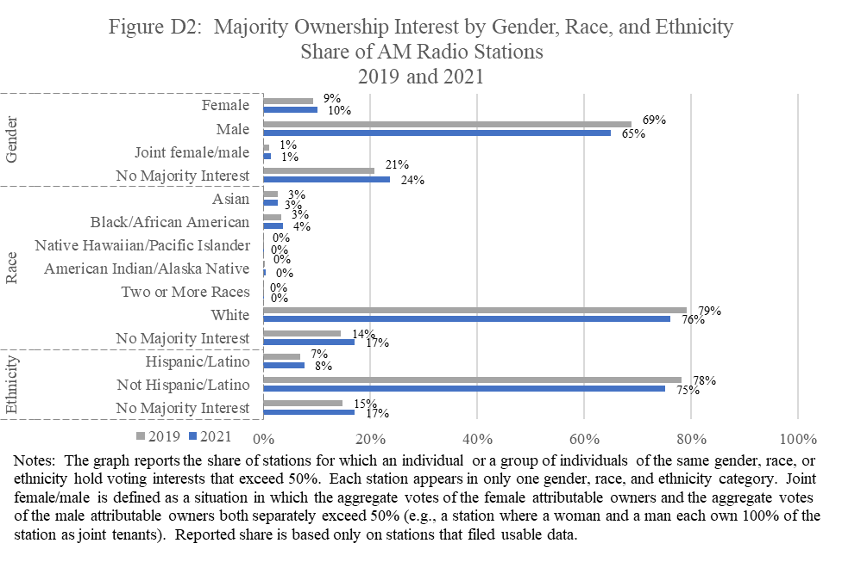

## Commercial FM Radio

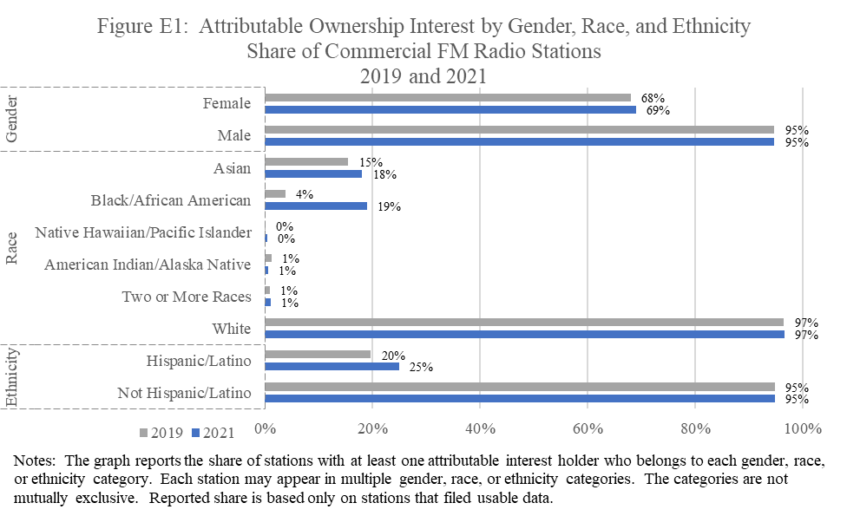

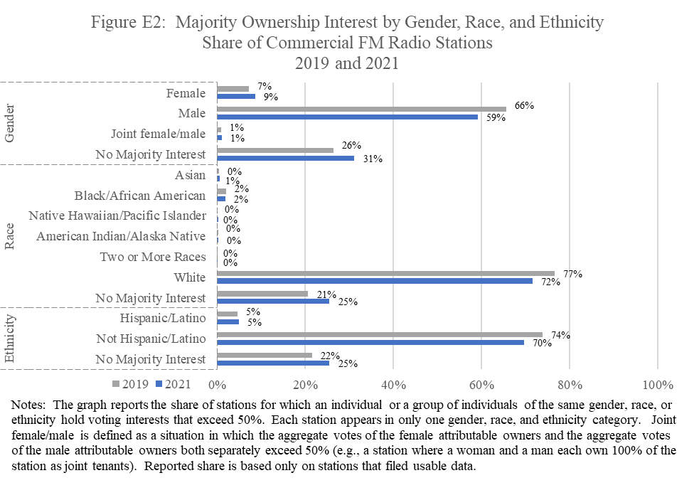

## Full Power Noncommercial Television

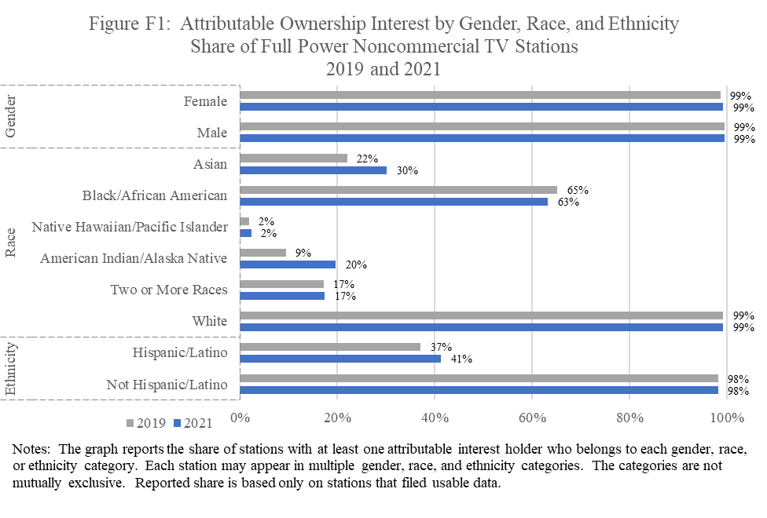

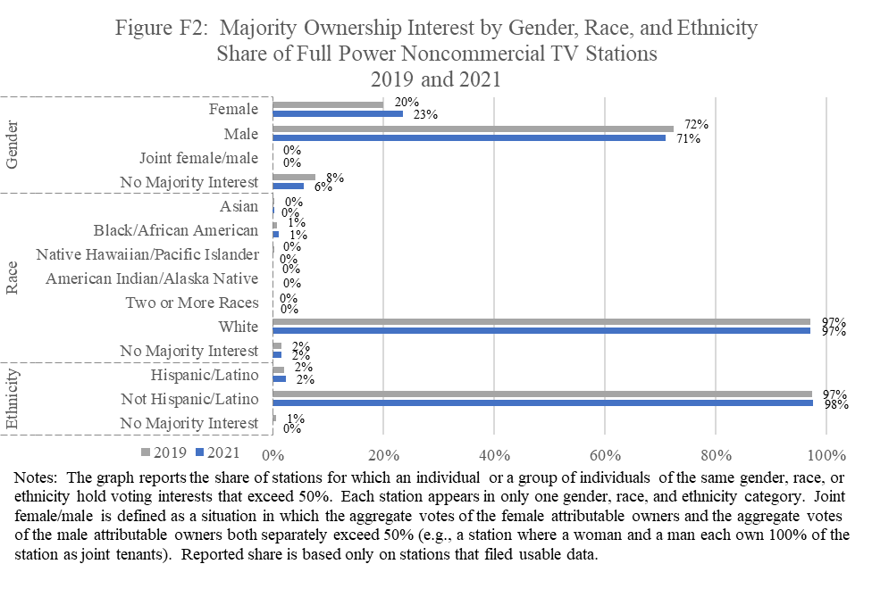

## Class A Noncommercial Television

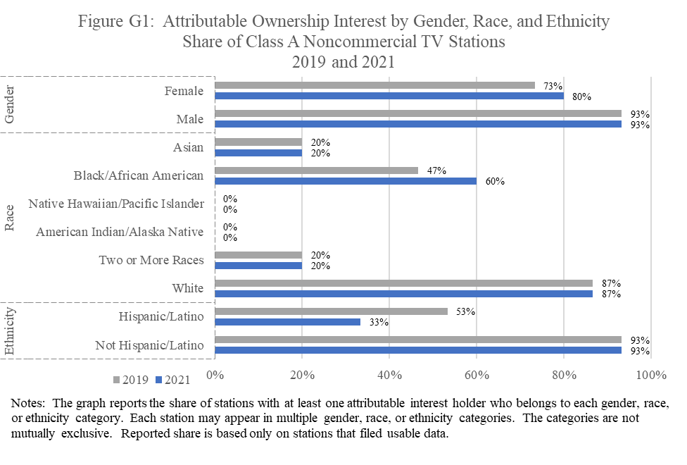

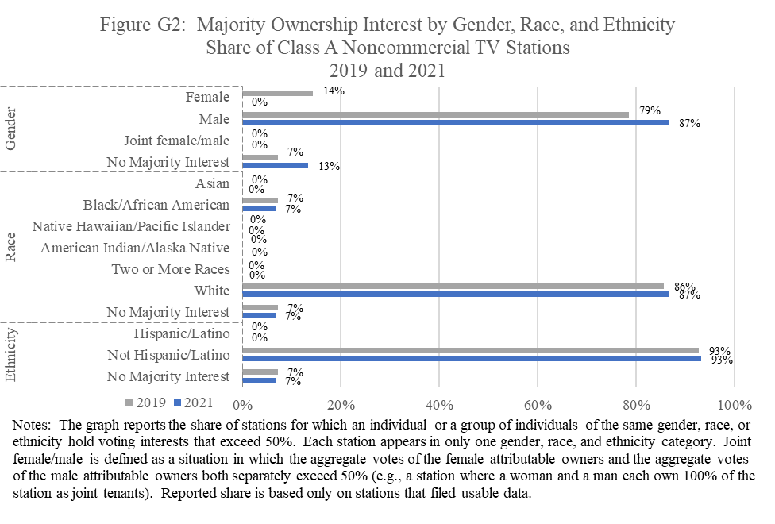

## Low Power Noncommercial Television

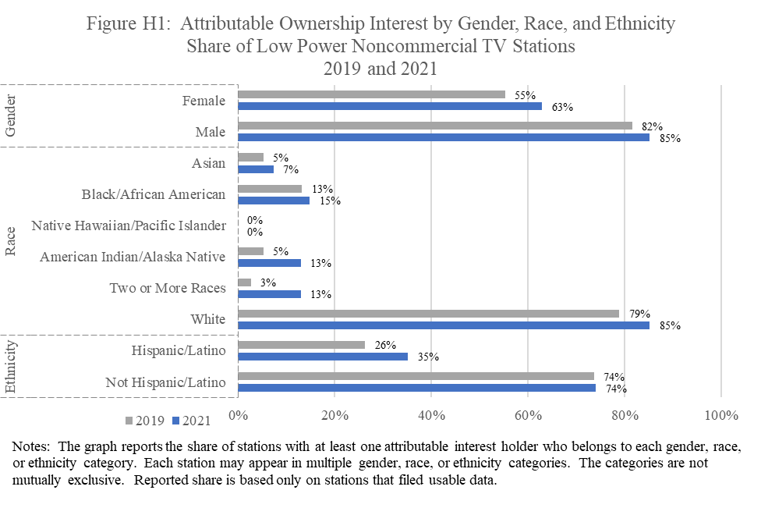

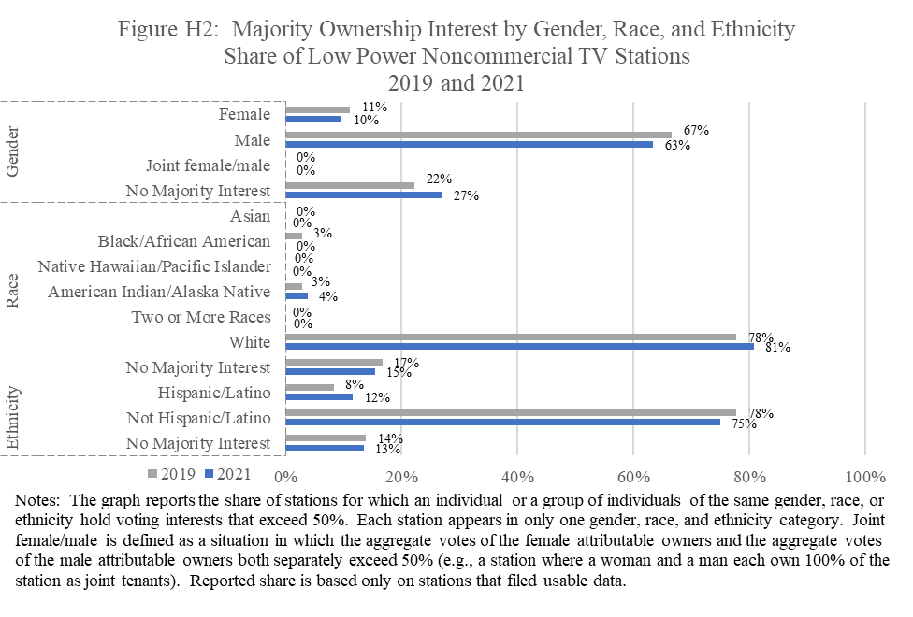

## Noncommercial AM Radio

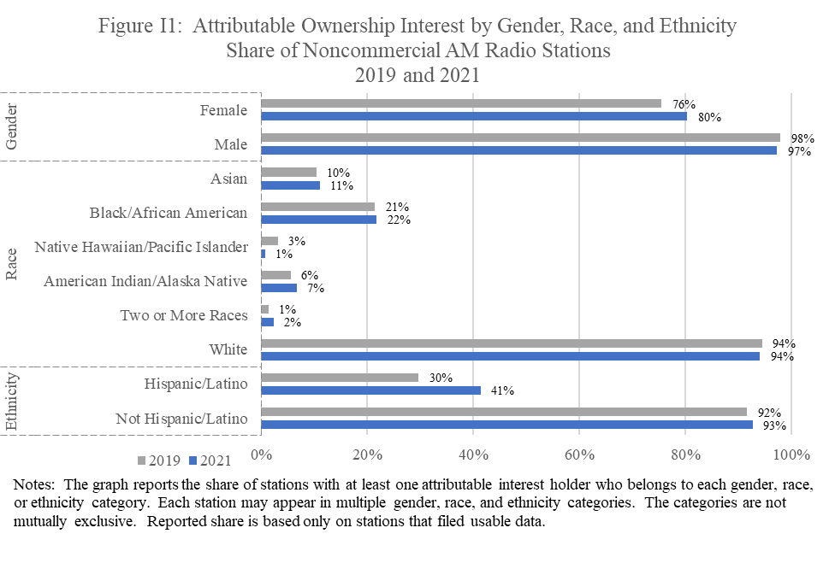

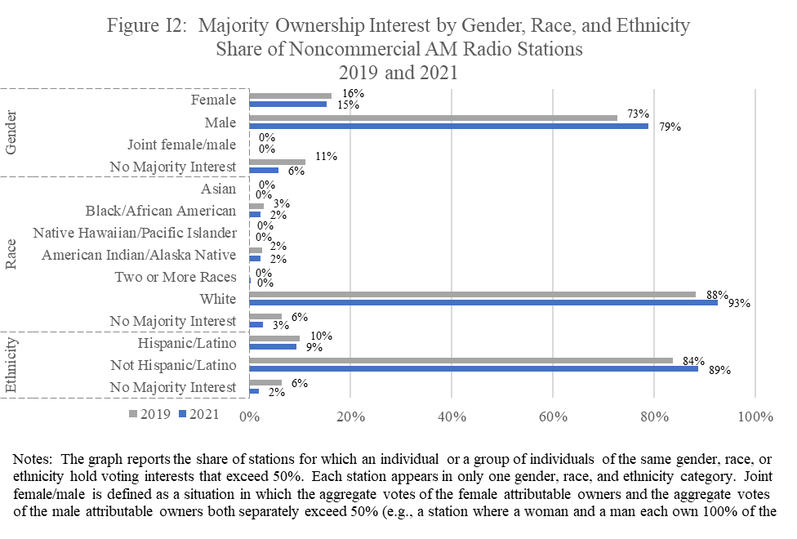

## Noncommercial FM Radio

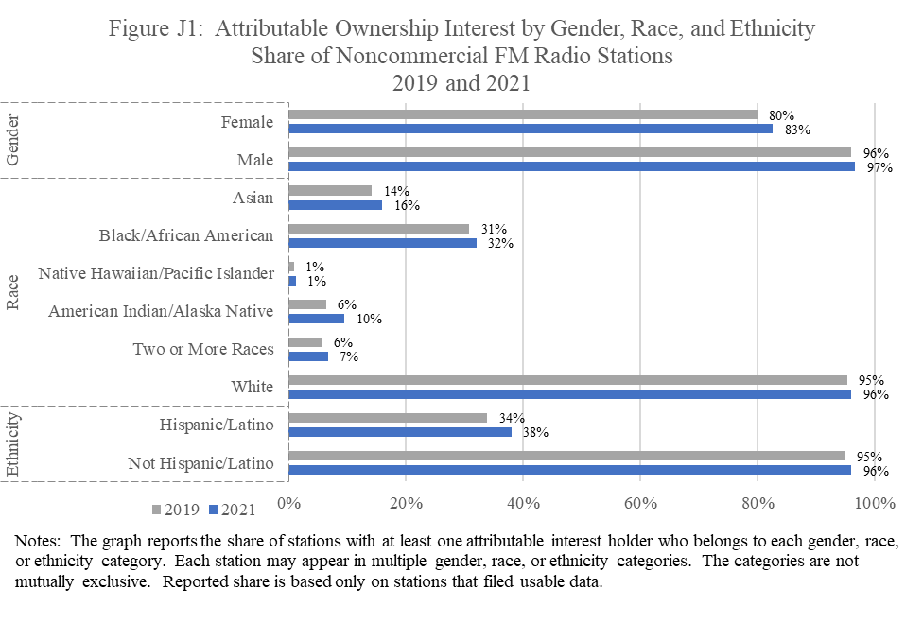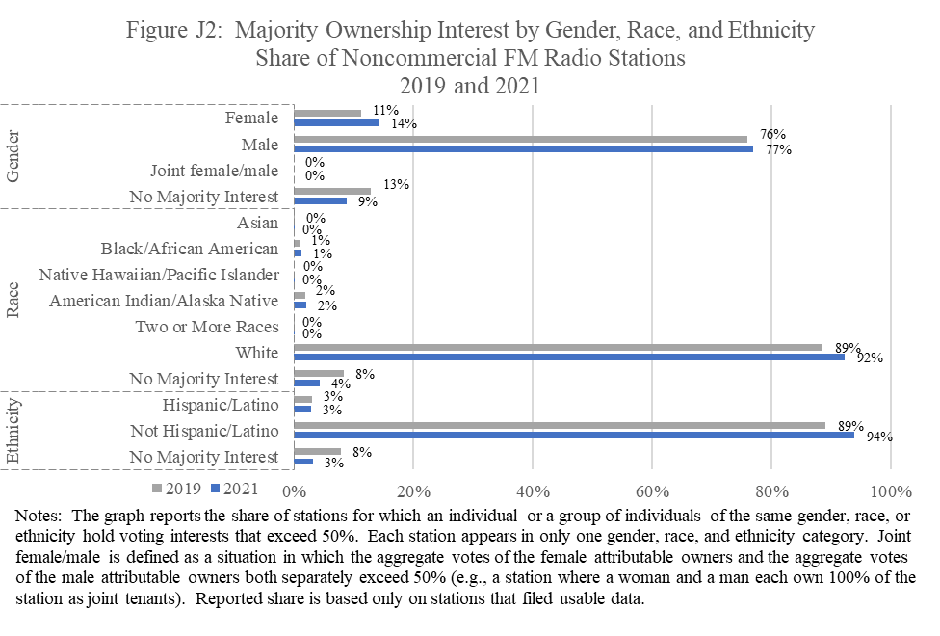

**APPENDIX A**

**Explanatory Notes**

**Licensing and Management System**

The 2021 filing cycle marks the third time Form 323 and 323-E broadcast ownership data were submitted via the Commission’s Licensing and Management System (LMS).[[23]](#footnote-25) The 2021 biennial ownership data analyzed in the report were pulled from LMS on October 7, 2022. The Media Bureau compiled the 2021 biennial ownership filings using both algorithmic analysis and manual adjustments to improve the accuracy of the reported ownership status and trends.

The public can search and retrieve ownership reports submitted in LMS based on multiple criteria, including call sign, facility ID number, service, station location (city and state), and/or FCC Registration Number (FRN), among other things.[[24]](#footnote-26) For each report listed, the LMS search results screen indicates whether that report was submitted for a licensee/permittee or for a parent entity. This allows users to quickly identify filings that contain relevant information.[[25]](#footnote-27) In addition, the data contained in each Form 323 and 323-E ownership report are publicly available and may be downloaded from the Commission’s website then aggregated, cross-referenced, and searched electronically by interested parties.[[26]](#footnote-28)

**Insufficient and Missing Data**

*Insufficient data to identify:*For stations classified as insufficient data,the computer code was unable to process the voting interests submitted to the Commission in these stations’ biennial filings. For the first four reports, stations classified as insufficient data for purposes of determining voting interests were also classified as insufficient data for counting attributable individuals. Subsequent reports, including the current report, include individuals with attributable interests for all stations that submitted one or more 323/323-E filings, even if filings for those stations were incomplete.  This approach allows us to include attributable interest holders for more stations but, for stations with incomplete filings, the set of attributable interest holders reported may be incomplete.

*Not filed:* This category includes situations where (a) the station’s licensee did not file a biennial 323 or 323-E form, or (b)the Commission’s LMS was unable to accept the licensee’s filing as a result of the licensee failing to file a fee**,** or (c) the licensee’s filing could not be processed at all by the computer code.

**Ethnicity and Race Definitions**

*Ethnicity Definition:*

* *Hispanic or Latino*: A person of Cuban, Mexican, Puerto Rican, South or Central American, or other Spanish Culture or origin, regardless of race.[[27]](#footnote-29)

*Race Definitions:*

* *American Indian or Alaska Native:* A person having origins in any of the original peoples of North America and South America including Central America, and who maintains tribal affiliation or community attachment.
* *Asian:* A person having origins in any of the original peoples of the Far East, Southeast Asia, or Indian Subcontinent including Cambodia, China, India, Japan, Korea, Malaysia, Pakistan, the Philippine Islands, Thailand, and Vietnam.
* *Black or African American:* A person having origins in any of the black racial groups of Africa.
* *Native Hawaiian or Other Pacific Islander:* A person having origins in any of the original peoples of Hawaii, Guam, Samoa, or other Pacific Islands.
* *Two or more races:* A person having origins in two or more races.
* *White:* A person having origins in any of the original peoples of Europe, the Middle East, or North Africa.[[28]](#footnote-30)

**Manual Adjustments to Data**

The computer code was unable to process a number of biennial submissions due to filing errors. Commission staff manually examined a number of filings, based on the data contained in the Form 323 submissions, together with other available information (such as communications with licensees or their counsel, as well as analysis of additional reports and applications filed by stations), and reassigned the stations to the appropriate category for the purposes of this report.

**APPENDIX B**

**Tables**

In this Appendix, we report four tables for each of the ten categories of broadcast stations: (A) Full Power Commercial Television, (B) Class A Television, (C) Low Power Television, (D) Commercial AM Radio, (E) Commercial FM Radio, (F) Full Power Noncommercial Television, (G) Class A Noncommercial Television, (H) Low Power Noncommercial Television, (I) Noncommercial AM Radio, and (J) Noncommercial FM Radio.

Tables 1 and 2 summarize station ownership by the gender, race, and ethnicity of stations’ attributable interest holders. Tables 3 and 4 report the majority ownership interest of all stations by gender, race, and ethnicity. Each table reports measures nationally and by market size. The share of stations held by individuals in the various classifications reported below are calculated on the basis of the number of stations filing usable data, not on the basis of the total number of licensed stations. Stations that did not file an ownership report are classified as “Not Filed” in all tables and are not included in the majority ownership interest or the attributable ownership interest calculations.  In addition, some stations submitted one or more ownership reports, but their filings were incomplete.  These stations are classified as “insufficient data” in Tables 3 and 4, and while these stations are not included in the majority ownership interest calculations, attributable interest holders disclosed on reports for these stations are included in the attributable ownership interest calculations.

**Table 1** reports the number and share of stations with at least one attributable interest holder who belongs to each gender, race, or ethnicity classification. This table also reports the number and share of stations that have at least one attributable interest holder who belongs to a racial and/or ethnic minority group. Each station may appear in more than one gender, race, and ethnicity classification in this table. The gender, race, and ethnicity categories are not mutually exclusive in this table.

**Table 2** reports the number and share of stations that have at least one attributable interest holder who belongs to each race and gender (e.g., Black/African American male, Asian female, etc.) and ethnicity and gender (e.g., Hispanic/Latino female, not Hispanic/Latino male, etc.) classification. The table also reports the number and share of stations that have at least one attributable interest holder who belongs to a racial and/or ethnic minority group and gender classification (i.e., racial and/or ethnic minority male and racial and/or ethnic minority female). Each station may appear in more than one race and gender, ethnicity and gender, and racial/ethnic minority and gender classification in this table. The race and gender, ethnicity and gender, and racial/ethnic minority and gender categories are not mutually exclusive in this table.

Tables 1 and 2 report the presence of attributable interest holders in a licensee who belong to different gender, race, and ethnicity classifications. These tables, however, do not offer information on the voting interests held by members of each group. In addition, a station must only have one attributable interest holder in a gender, race, or ethnicity classification to be counted in that category. For instance, a station with ten attributable interest holders who are white and one attributable interest holder who is Asian would be classified in the same way as a station with ten attributable interest holders who are Asian and one attributable interest holder who is white. Both stations would be classified as having at least one attributable interest holder who is Asian and at least one attributable interest holder who is white.

**Table 3** reports the number and share of stations for which an individual or a group of individuals of the same gender, race, or ethnicity hold, either individually or collectively, a majority of the voting interests in the licensee; that is, their voting interests exceed 50%. The table also reports the number and share of stations for which members of a racial or ethnic minority group hold a majority of voting interests in the licensee. When a station is identified as having no majority interest, that does not necessarily mean that no particular classification of persons has a majority interest in the station, only that this cannot be determined from the reported Form 323 or Form 323-E data as submitted. Each station appears in only one gender, race, and ethnicity classification in this table. The gender, race, and ethnicity categories are mutually exclusive in this table.

*Joint female/male* is defined as a situation in which the aggregate votes of the female attributable owners and the aggregate votes of the male attributable owners both separately exceed 50%. For example, a station where a woman and a man each own 100% of the station as joint tenants would be classified as having a joint female/male majority interest in gender.

**Table 4** reports the number and share of stations by majority ownership interest in race and gender and ethnicity and gender categories. The table also reports the number and share of stations with a majority interest held by a racial and/or ethnic minority group and gender classification (i.e., racial and/or ethnic minority male, racial and/or ethnic minority female, racial and/or ethnic minority combination). Each station appears in only one race and gender, ethnicity and gender, and racial/ethnic minority and gender classification in this table. The race and gender, ethnicity and gender, and racial/ethnic minority and gender categories are mutually exclusive in this table.

*Combination* includes situations in which the aggregate votes of the female attributable owner(s) and the aggregate votes of the male attributable owner(s) of the same race or ethnicity both separately exceed 50%. For example, a station in which a woman and man, both Hispanic/Latino, each own 100% as joint tenants would be classified as Hispanic/Latino combination. Combination also includes situations in which the aggregate votes of neither gender exceed 50%, but the aggregate votes of the female attributable owner(s) and the aggregate votes of the male attributable owner(s) of the same ethnicity or race together exceed 50%. For example, a station in which Asian women hold 40% of the vote and Asian men hold 40% of the vote would be classified as Asian combination.

Some stations that are classified as combination stations are classified as having no majority interest in gender in Table 3. For example, a station in which Hispanic/Latino women hold 45% of the vote, Hispanic/Latino men hold 45% of the vote, and 10% of the vote is unattributed would be classified as Hispanic/Latino combination and no majority interest in gender. However, some combination stations have a majority interest in gender. For example, a station in which Hispanic/Latino women hold 45% of the vote, Hispanic/Latino men hold 45% of the vote, and not Hispanic/Latino women hold 10% of the vote would be classified as Hispanic/Latino combination in Table 4 but female majority interest in gender in Table 3.

**TABLE A**

**1 - 4**

**2021**

**Full Power Commercial Television**

|  |  |  |  |  |  |  |  |  |
| --- | --- | --- | --- | --- | --- | --- | --- | --- |
| Table A(1) | | | | | | | | |
| Attributable Ownership Interest by Gender, Race, and Ethnicity | | | | | | | | |
| Stations with One or More Attributable Persons | | | | | | | | |
| Full Power Commercial Television Stations – 2021 | | | | | | | | |
|  | No. of Stations and % of Total | | | | | | | |
|  | Nationally | | Nielsen DMA 1-50 | | Nielsen DMA 51-100 | | Nielsen DMA 101+ | |
| No. | % | No. | % | No. | % | No. | % |
| Gender |  |  |  |  |  |  |  |  |
| Female | 1,227 | 89.9% | 494 | 91.3% | 336 | 94.9% | 397 | 84.5% |
| Male | 1,349 | 98.8% | 540 | 99.8% | 351 | 99.2% | 458 | 97.4% |
| Race |  |  |  |  |  |  |  |  |
| Asian | 148 | 10.8% | 120 | 22.2% | 22 | 6.2% | 6 | 1.3% |
| Black/African American | 783 | 57.4% | 314 | 58.0% | 229 | 64.7% | 240 | 51.1% |
| Native Hawaiian/Pacific Islander | 32 | 2.3% | 29 | 5.4% | 1 | 0.3% | 2 | 0.4% |
| American Indian/Alaska Native | 180 | 13.2% | 118 | 21.8% | 39 | 11.0% | 23 | 4.9% |
| Two or More Races | 301 | 22.1% | 92 | 17.0% | 85 | 24.0% | 124 | 26.4% |
| White | 1,350 | 98.9% | 536 | 99.1% | 350 | 98.9% | 464 | 98.7% |
| Ethnicity |  |  |  |  |  |  |  |  |
| Hispanic/Latino | 766 | 56.1% | 354 | 65.4% | 185 | 52.3% | 227 | 48.3% |
| Not Hispanic/Latino | 1,337 | 97.9% | 536 | 99.1% | 354 | 100.0% | 447 | 95.1% |
|  |  |  |  |  |  |  |  |  |
| Any racial or ethnic minority | 1,023 | 74.9% | 446 | 82.4% | 269 | 76.0% | 308 | 65.5% |
|  |  |  |  |  |  |  |  |  |
| Total stations | 1,365 | 100% | 541 | 100% | 354 | 100% | 470 | 100% |
| Stations not filed | 0 | --- | 0 | --- | 0 | --- | 0 | --- |
| All licensed stations | 1,365 | --- | 541 | --- | 354 | --- | 470 | --- |
| Notes: The table reports the number and share of stations that have at least one person, by gender, race, or ethnicity, with an attributable interest, nationally and by DMA rank. Each station may appear in multiple gender, race, and ethnicity categories. | | | | | | | | |

|  |  |  |  |  |  |  |  |  |  |
| --- | --- | --- | --- | --- | --- | --- | --- | --- | --- |
| Table A(2) | | | | | | | | | |
| Attributable Ownership Interest by Race and Gender and by Ethnicity and Gender | | | | | | | | | |
| Stations with One or More Attributable Persons | | | | | | | | | |
| Full Power Commercial Television Stations – 2021 | | | | | | | | | |
|  | Gender | No. of Stations and % of Total | | | | | | | |
|  | Nationally | | Nielsen DMA 1-50 | | Nielsen DMA 51-100 | | Nielsen DMA 101+ | |
| No. | % | No. | % | No. | % | No. | % |
| Race |  |  |  |  |  |  |  |  |  |
| Asian | Female | 133 | 9.7% | 113 | 20.9% | 16 | 4.5% | 4 | 0.9% |
| Male | 145 | 10.6% | 118 | 21.8% | 22 | 6.2% | 5 | 1.1% |
| Black/African American | Female | 547 | 40.1% | 204 | 37.7% | 154 | 43.5% | 189 | 40.2% |
| Male | 781 | 57.2% | 312 | 57.7% | 229 | 64.7% | 240 | 51.1% |
| Native Hawaiian/ Pacific Islander | Female | 32 | 2.3% | 29 | 5.4% | 1 | 0.3% | 2 | 0.4% |
| Male | 1 | 0.1% | 0 | 0.0% | 0 | 0.0% | 1 | 0.2% |
| American Indian/ Alaska Native | Female | 78 | 5.7% | 59 | 10.9% | 13 | 3.7% | 6 | 1.3% |
| Male | 114 | 8.4% | 71 | 13.1% | 26 | 7.3% | 17 | 3.6% |
| Two or More Races | Female | 100 | 7.3% | 58 | 10.7% | 24 | 6.8% | 18 | 3.8% |
| Male | 299 | 21.9% | 92 | 17.0% | 85 | 24.0% | 122 | 26.0% |
| White | Female | 1,169 | 85.6% | 484 | 89.5% | 316 | 89.3% | 369 | 78.5% |
| Male | 1,334 | 97.7% | 535 | 98.9% | 346 | 97.7% | 453 | 96.4% |
| Ethnicity |  |  |  |  |  |  |  |  |  |
| Hispanic/Latino | Female | 497 | 36.4% | 240 | 44.4% | 117 | 33.1% | 140 | 29.8% |
| Male | 647 | 47.4% | 286 | 52.9% | 152 | 42.9% | 209 | 44.5% |
| Not Hispanic/Latino | Female | 1,155 | 84.6% | 448 | 82.8% | 327 | 92.4% | 380 | 80.9% |
| Male | 1,323 | 96.9% | 535 | 98.9% | 351 | 99.2% | 437 | 93.0% |
|  |  |  |  |  |  |  |  |  |  |
| Any racial or ethnic minority | Female | 812 | 59.5% | 366 | 67.7% | 212 | 59.9% | 234 | 49.8% |
| Male | 940 | 68.9% | 403 | 74.5% | 245 | 69.2% | 292 | 62.1% |
|  |  |  |  |  |  |  |  |  |  |
| Total stations | --- | 1,365 | 100% | 541 | 100% | 354 | 100% | 470 | 100% |
| Stations not filed | --- | 0 | --- | 0 | --- | 0 | --- | 0 | --- |
| All licensed stations | --- | 1,365 | --- | 541 | --- | 354 | --- | 470 | --- |
| Notes: The table reports the number and share of stations that have at least one person, by race and gender or by ethnicity and gender, with an attributable interest, nationally and by DMA rank. Each station may appear in multiple race/gender and ethnicity/gender categories. | | | | | | | | | |

|  |  |  |  |  |  |  |  |  |
| --- | --- | --- | --- | --- | --- | --- | --- | --- |
| Table A(3) | | | | | | | | |
| Majority Ownership Interest by Gender, Race, and Ethnicity | | | | | | | | |
| Voting Interest Exceeds 50% Individually or Collectively | | | | | | | | |
| Full Power Commercial Television Stations – 2021 | | | | | | | | |
|  | No. of Stations and % of Total | | | | | | | |
|  | Nationally | | Nielsen DMA 1-50 | | Nielsen DMA 51-100 | | Nielsen DMA 101+ | |
| No. | % | No. | % | No. | % | No. | % |
| Gender |  |  |  |  |  |  |  |  |
| Female | 72 | 5.3% | 10 | 1.8% | 18 | 5.1% | 44 | 9.4% |
| Male | 695 | 50.9% | 292 | 54.0% | 168 | 47.5% | 235 | 50.0% |
| Joint female/male | 2 | 0.1% | 1 | 0.2% | 0 | 0.0% | 1 | 0.2% |
| No majority interest | 596 | 43.7% | 238 | 44.0% | 168 | 47.5% | 190 | 40.4% |
| Race |  |  |  |  |  |  |  |  |
| Asian | 8 | 0.6% | 1 | 0.2% | 4 | 1.1% | 3 | 0.6% |
| Black/African American | 39 | 2.9% | 6 | 1.1% | 14 | 4.0% | 19 | 4.0% |
| Native Hawaiian/Pacific Islander | 1 | 0.1% | 0 | 0.0% | 0 | 0.0% | 1 | 0.2% |
| American Indian/Alaska Native | 4 | 0.3% | 2 | 0.4% | 2 | 0.6% | 0 | 0.0% |
| Two or More Races | 1 | 0.1% | 1 | 0.2% | 0 | 0.0% | 0 | 0.0% |
| White | 880 | 64.5% | 395 | 73.0% | 199 | 56.2% | 286 | 60.9% |
| No majority interest | 432 | 31.6% | 136 | 25.1% | 135 | 38.1% | 161 | 34.3% |
| Ethnicity |  |  |  |  |  |  |  |  |
| Hispanic/Latino | 56 | 4.1% | 17 | 3.1% | 6 | 1.7% | 33 | 7.0% |
| Not Hispanic/Latino | 802 | 58.8% | 338 | 62.5% | 198 | 55.9% | 266 | 56.6% |
| No majority interest | 507 | 37.1% | 186 | 34.4% | 150 | 42.4% | 171 | 36.4% |
|  |  |  |  |  |  |  |  |  |
| Racial or ethnic minority group holds majority ownership interest | 109 | 8.0% | 27 | 5.0% | 26 | 7.3% | 56 | 11.9% |
|  |  |  |  |  |  |  |  |  |
| Total stations | 1,365 | 100% | 541 | 100% | 354 | 100% | 470 | 100% |
| Insufficient data | 0 | --- | 0 | --- | 0 | --- | 0 | --- |
| Stations not filed | 0 | --- | 0 | --- | 0 | --- | 0 | --- |
| All licensed stations | 1,365 | --- | 541 | --- | 354 | --- | 470 | --- |
| Notes: The table reports the number and share of stations for which an individual or a group of individuals of the same gender, race, or ethnicity hold voting interests that exceed 50%, nationally and by DMA rank. Each station appears in only one gender, race, and ethnicity category. Joint female/male is defined as a situation in which the aggregate votes of the female attributable owners and the aggregate votes of the male attributable owners both separately exceed 50% (e.g., a station where a woman and a man each own 100% of the station as joint tenants). | | | | | | | | |

|  |  |  |  |  |  |  |  |  |  |
| --- | --- | --- | --- | --- | --- | --- | --- | --- | --- |
| Table A(4) | | | | | | | | | |
| Majority Ownership Interest by Race and Gender and by Ethnicity and Gender | | | | | | | | | |
| Voting Interest Exceeds 50% Individually or Collectively | | | | | | | | | |
| Full Power Commercial Television Stations – 2021 | | | | | | | | | |
|  | Gender of majority interest group | No. of Stations and % of Total | | | | | | | |
| Nationally | | Nielsen DMA 1-50 | | Nielsen DMA 51-100 | | Nielsen DMA 101+ | |
| No. | % | No. | % | No. | % | No. | % |
| Race |  |  |  |  |  |  |  |  |  |
| Asian | Female | 1 | 0.1% | 0 | 0.0% | 0 | 0.0% | 1 | 0.2% |
| Male | 7 | 0.5% | 1 | 0.2% | 4 | 1.1% | 2 | 0.4% |
| Combination | 0 | 0.0% | 0 | 0.0% | 0 | 0.0% | 0 | 0.0% |
| Black/African American | Female | 1 | 0.1% | 0 | 0.0% | 0 | 0.0% | 1 | 0.2% |
| Male | 34 | 2.5% | 5 | 0.9% | 13 | 3.7% | 16 | 3.4% |
| Combination | 4 | 0.3% | 1 | 0.2% | 1 | 0.3% | 2 | 0.4% |
| Native Hawaiian/ Pacific Islander | Female | 0 | 0.0% | 0 | 0.0% | 0 | 0.0% | 0 | 0.0% |
| Male | 1 | 0.1% | 0 | 0.0% | 0 | 0.0% | 1 | 0.2% |
| Combination | 0 | 0.0% | 0 | 0.0% | 0 | 0.0% | 0 | 0.0% |
| American Indian/ Alaska Native | Female | 0 | 0.0% | 0 | 0.0% | 0 | 0.0% | 0 | 0.0% |
| Male | 4 | 0.3% | 2 | 0.4% | 2 | 0.6% | 0 | 0.0% |
| Combination | 0 | 0.0% | 0 | 0.0% | 0 | 0.0% | 0 | 0.0% |
| Two or More Races | Female | 0 | 0.0% | 0 | 0.0% | 0 | 0.0% | 0 | 0.0% |
| Male | 1 | 0.1% | 1 | 0.2% | 0 | 0.0% | 0 | 0.0% |
| Combination | 0 | 0.0% | 0 | 0.0% | 0 | 0.0% | 0 | 0.0% |
| White | Female | 69 | 5.1% | 10 | 1.8% | 17 | 4.8% | 42 | 8.9% |
| Male | 644 | 47.2% | 281 | 51.9% | 149 | 42.1% | 214 | 45.5% |
| Combination | 167 | 12.2% | 104 | 19.2% | 33 | 9.3% | 30 | 6.4% |
| No majority interest | All Stations | 432 | 31.6% | 136 | 25.1% | 135 | 38.1% | 161 | 34.3% |
| Ethnicity |  |  |  |  |  |  |  |  |  |
| Hispanic/Latino | Female | 5 | 0.4% | 1 | 0.2% | 0 | 0.0% | 4 | 0.9% |
| Male | 49 | 3.6% | 15 | 2.8% | 6 | 1.7% | 28 | 6.0% |
| Combination | 2 | 0.1% | 1 | 0.2% | 0 | 0.0% | 1 | 0.2% |
| Not Hispanic/ Latino | Female | 67 | 4.9% | 9 | 1.7% | 18 | 5.1% | 40 | 8.5% |
| Male | 645 | 47.3% | 276 | 51.0% | 162 | 45.8% | 207 | 44.0% |
| Combination | 90 | 6.6% | 53 | 9.8% | 18 | 5.1% | 19 | 4.0% |
| No majority interest | All Stations | 507 | 37.1% | 186 | 34.4% | 150 | 42.4% | 171 | 36.4% |
|  |  |  |  |  |  |  |  |  |  |
| Any Racial or Ethnic Minority Group | Female | 7 | 0.5% | 1 | 0.2% | 0 | 0.0% | 6 | 1.3% |
| Male | 96 | 7.0% | 24 | 4.4% | 25 | 7.1% | 47 | 10.0% |
| Combination | 6 | 0.4% | 2 | 0.4% | 1 | 0.3% | 3 | 0.6% |
|  |  |  |  |  |  |  |  |  |  |
| Total stations | --- | 1,365 | 100% | 541 | 100% | 354 | 100% | 470 | 100% |
| Insufficient data | --- | 0 | --- | 0 | --- | 0 | --- | 0 | --- |
| Stations not filed | --- | 0 | --- | 0 | --- | 0 | --- | 0 | --- |
| All licensed stations | --- | 1,365 | --- | 541 | --- | 354 | --- | 470 | --- |
| Notes: The table reports the number and share of stations for which an individual or a group of individuals of the same race and gender or the same ethnicity and gender hold voting interests that exceed 50%, nationally and by DMA rank. A station is classified as a combination if individuals of the same race or ethnicity hold voting interests that exceed 50%, but no gender group within the race or ethnicity group holds voting interests that exceed 50% (e.g., a station where Hispanic/Latino women hold 30% of voting shares and Hispanic/Latino men hold 25% of voting shares). Each station appears in only one race/gender and ethnicity/gender category. | | | | | | | | | |

**TABLE B**

**1 - 4**

**2021**

**Class A Television**

|  |  |  |  |  |  |  |  |  |
| --- | --- | --- | --- | --- | --- | --- | --- | --- |
| Table B(1) | | | | | | | | |
| Attributable Ownership Interest by Gender, Race, and Ethnicity | | | | | | | | |
| Stations with One or More Attributable Persons | | | | | | | | |
| Class A Television Stations – 2021 | | | | | | | | |
|  | No. of Stations and % of Total | | | | | | | |
|  | Nationally | | Nielsen DMA 1-50 | | Nielsen DMA 51-100 | | Nielsen DMA 101+ | |
| No. | % | No. | % | No. | % | No. | % |
| Gender |  |  |  |  |  |  |  |  |
| Female | 269 | 72.9% | 125 | 70.2% | 53 | 58.9% | 91 | 90.1% |
| Male | 354 | 95.9% | 170 | 95.5% | 89 | 98.9% | 95 | 94.1% |
| Race |  |  |  |  |  |  |  |  |
| Asian | 20 | 5.4% | 17 | 9.6% | 3 | 3.3% | 0 | 0.0% |
| Black/African American | 86 | 23.3% | 43 | 24.2% | 16 | 17.8% | 27 | 26.7% |
| Native Hawaiian/Pacific Islander | 0 | 0.0% | 0 | 0.0% | 0 | 0.0% | 0 | 0.0% |
| American Indian/Alaska Native | 22 | 6.0% | 13 | 7.3% | 4 | 4.4% | 5 | 5.0% |
| Two or More Races | 40 | 10.8% | 16 | 9.0% | 7 | 7.8% | 17 | 16.8% |
| White | 357 | 96.7% | 168 | 94.4% | 88 | 97.8% | 101 | 100.0% |
| Ethnicity |  |  |  |  |  |  |  |  |
| Hispanic/Latino | 126 | 34.1% | 65 | 36.5% | 19 | 21.1% | 42 | 41.6% |
| Not Hispanic/Latino | 348 | 94.3% | 167 | 93.8% | 86 | 95.6% | 95 | 94.1% |
|  |  |  |  |  |  |  |  |  |
| Any racial or ethnic minority | 155 | 42.0% | 76 | 42.7% | 25 | 27.8% | 54 | 53.5% |
|  |  |  |  |  |  |  |  |  |
| Total stations | 369 | 100% | 178 | 100% | 90 | 100% | 101 | 100% |
| Stations not filed | 0 | --- | 0 | --- | 0 | --- | 0 | --- |
| All licensed stations | 369 | --- | 178 | --- | 90 | --- | 101 | --- |
| Notes: The table reports the number and share of stations that have at least one person, by gender, race, or ethnicity, with an attributable interest, nationally and by DMA rank. Each station may appear in multiple gender, race, and ethnicity categories. | | | | | | | | |

|  |  |  |  |  |  |  |  |  |  |
| --- | --- | --- | --- | --- | --- | --- | --- | --- | --- |
| Table B(2) | | | | | | | | | |
| Attributable Ownership Interest by Race and Gender and by Ethnicity and Gender | | | | | | | | | |
| Stations with One or More Attributable Persons | | | | | | | | | |
| Class A Television Stations – 2021 | | | | | | | | | |
|  | Gender | No. of Stations and % of Total | | | | | | | |
|  | Nationally | | Nielsen DMA 1-50 | | Nielsen DMA 51-100 | | Nielsen DMA 101+ | |
| No. | % | No. | % | No. | % | No. | % |
| Race |  |  |  |  |  |  |  |  |  |
| Asian | Female | 18 | 4.9% | 16 | 9.0% | 2 | 2.2% | 0 | 0.0% |
| Male | 20 | 5.4% | 17 | 9.6% | 3 | 3.3% | 0 | 0.0% |
| Black/African American | Female | 64 | 17.3% | 34 | 19.1% | 12 | 13.3% | 18 | 17.8% |
| Male | 84 | 22.8% | 42 | 23.6% | 15 | 16.7% | 27 | 26.7% |
| Native Hawaiian/ Pacific Islander | Female | 0 | 0.0% | 0 | 0.0% | 0 | 0.0% | 0 | 0.0% |
| Male | 0 | 0.0% | 0 | 0.0% | 0 | 0.0% | 0 | 0.0% |
| American Indian/ Alaska Native | Female | 14 | 3.8% | 12 | 6.7% | 2 | 2.2% | 0 | 0.0% |
| Male | 8 | 2.2% | 1 | 0.6% | 2 | 2.2% | 5 | 5.0% |
| Two or More Races | Female | 12 | 3.3% | 2 | 1.1% | 2 | 2.2% | 8 | 7.9% |
| Male | 36 | 9.8% | 15 | 8.4% | 7 | 7.8% | 14 | 13.9% |
| White | Female | 263 | 71.3% | 120 | 67.4% | 52 | 57.8% | 91 | 90.1% |
| Male | 347 | 94.0% | 165 | 92.7% | 87 | 96.7% | 95 | 94.1% |
| Ethnicity |  |  |  |  |  |  |  |  |  |
| Hispanic/Latino | Female | 82 | 22.2% | 37 | 20.8% | 13 | 14.4% | 32 | 31.7% |
| Male | 116 | 31.4% | 59 | 33.1% | 18 | 20.0% | 39 | 38.6% |
| Not Hispanic/Latino | Female | 229 | 62.1% | 109 | 61.2% | 47 | 52.2% | 73 | 72.3% |
| Male | 342 | 92.7% | 164 | 92.1% | 86 | 95.6% | 92 | 91.1% |
|  |  |  |  |  |  |  |  |  |  |
| Any racial or ethnic minority | Female | 116 | 31.4% | 59 | 33.1% | 18 | 20.0% | 39 | 38.6% |
| Male | 145 | 39.3% | 72 | 40.4% | 25 | 27.8% | 48 | 47.5% |
|  |  |  |  |  |  |  |  |  |  |
| Total stations | --- | 369 | 100% | 178 | 100% | 90 | 100% | 101 | 100% |
| Stations not filed | --- | 0 | --- | 0 | --- | 0 | --- | 0 | --- |
| All licensed stations | --- | 369 | --- | 178 | --- | 90 | --- | 101 | --- |
| Notes: The table reports the number and share of stations that have at least one person, by race and gender or by ethnicity and gender, with an attributable interest, nationally and by DMA rank. Each station may appear in multiple race/gender and ethnicity/gender categories. | | | | | | | | | |

|  |  |  |  |  |  |  |  |  |
| --- | --- | --- | --- | --- | --- | --- | --- | --- |
| Table B(3) | | | | | | | | |
| Majority Ownership Interest by Gender, Race, and Ethnicity | | | | | | | | |
| Voting Interest Exceeds 50% Individually or Collectively | | | | | | | | |
| Class A Television Stations – 2021 | | | | | | | | |
|  | No. of Stations and % of Total | | | | | | | |
|  | Nationally | | Nielsen DMA 1-50 | | Nielsen DMA 51-100 | | Nielsen DMA 101+ | |
| No. | % | No. | % | No. | % | No. | % |
| Gender |  |  |  |  |  |  |  |  |
| Female | 18 | 4.9% | 9 | 5.1% | 2 | 2.2% | 7 | 7.1% |
| Male | 256 | 70.3% | 124 | 70.5% | 62 | 69.7% | 70 | 70.7% |
| Joint female/male | 1 | 0.3% | 1 | 0.6% | 0 | 0.0% | 0 | 0.0% |
| No majority interest | 89 | 24.5% | 42 | 23.9% | 25 | 28.1% | 22 | 22.2% |
| Race |  |  |  |  |  |  |  |  |
| Asian | 4 | 1.1% | 4 | 2.3% | 0 | 0.0% | 0 | 0.0% |
| Black/African American | 5 | 1.4% | 2 | 1.1% | 3 | 3.4% | 0 | 0.0% |
| Native Hawaiian/Pacific Islander | 0 | 0.0% | 0 | 0.0% | 0 | 0.0% | 0 | 0.0% |
| American Indian/Alaska Native | 0 | 0.0% | 0 | 0.0% | 0 | 0.0% | 0 | 0.0% |
| Two or More Races | 1 | 0.3% | 1 | 0.6% | 0 | 0.0% | 0 | 0.0% |
| White | 290 | 79.7% | 133 | 75.6% | 71 | 79.8% | 86 | 86.9% |
| No majority interest | 64 | 17.6% | 36 | 20.5% | 15 | 16.9% | 13 | 13.1% |
| Ethnicity |  |  |  |  |  |  |  |  |
| Hispanic/Latino | 38 | 10.4% | 14 | 8.0% | 7 | 7.9% | 17 | 17.2% |
| Not Hispanic/Latino | 253 | 69.5% | 124 | 70.5% | 65 | 73.0% | 64 | 64.6% |
| No majority interest | 73 | 20.1% | 38 | 21.6% | 17 | 19.1% | 18 | 18.2% |
|  |  |  |  |  |  |  |  |  |
| Racial or ethnic minority group holds majority ownership interest | 48 | 13.2% | 21 | 11.9% | 10 | 11.2% | 17 | 17.2% |
|  |  |  |  |  |  |  |  |  |
| Total stations | 364 | 100% | 176 | 100% | 89 | 100% | 99 | 100% |
| Insufficient data | 5 | --- | 2 | --- | 1 | --- | 2 | --- |
| Stations not filed | 0 | --- | 0 | --- | 0 | --- | 0 | --- |
| All licensed stations | 369 | --- | 178 | --- | 90 | --- | 101 | --- |
| Notes: The table reports the number and share of stations for which an individual or a group of individuals of the same gender, race, or ethnicity hold voting interests that exceed 50%, nationally and by DMA rank. Each station appears in only one gender, race, and ethnicity category. Joint female/male is defined as a situation in which the aggregate votes of the female attributable owners and the aggregate votes of the male attributable owners both separately exceed 50% (e.g., a station where a woman and a man each own 100% of the station as joint tenants). | | | | | | | | |

|  |  |  |  |  |  |  |  |  |  |
| --- | --- | --- | --- | --- | --- | --- | --- | --- | --- |
| Table B(4) | | | | | | | | | |
| Majority Ownership Interest by Race by Gender and Ethnicity by Gender | | | | | | | | | |
| Voting Interest Exceeds 50% Individually or Collectively | | | | | | | | | |
| Class A Television Stations – 2021 | | | | | | | | | |
|  | Gender of majority interest group | No. of Stations and % of Total | | | | | | | |
| Nationally | | Nielsen DMA 1-50 | | Nielsen DMA 51-100 | | Nielsen DMA 101+ | |
| No. | % | No. | % | No. | % | No. | % |
| Race |  |  |  |  |  |  |  |  |  |
| Asian | Female | 3 | 0.8% | 3 | 1.7% | 0 | 0.0% | 0 | 0.0% |
| Male | 1 | 0.3% | 1 | 0.6% | 0 | 0.0% | 0 | 0.0% |
| Combination | 0 | 0.0% | 0 | 0.0% | 0 | 0.0% | 0 | 0.0% |
| Black/African American | Female | 0 | 0.0% | 0 | 0.0% | 0 | 0.0% | 0 | 0.0% |
| Male | 4 | 1.1% | 2 | 1.1% | 2 | 2.2% | 0 | 0.0% |
| Combination | 1 | 0.3% | 0 | 0.0% | 1 | 1.1% | 0 | 0.0% |
| Native Hawaiian/ Pacific Islander | Female | 0 | 0.0% | 0 | 0.0% | 0 | 0.0% | 0 | 0.0% |
| Male | 0 | 0.0% | 0 | 0.0% | 0 | 0.0% | 0 | 0.0% |
| Combination | 0 | 0.0% | 0 | 0.0% | 0 | 0.0% | 0 | 0.0% |
| American Indian/ Alaska Native | Female | 0 | 0.0% | 0 | 0.0% | 0 | 0.0% | 0 | 0.0% |
| Male | 0 | 0.0% | 0 | 0.0% | 0 | 0.0% | 0 | 0.0% |
| Combination | 0 | 0.0% | 0 | 0.0% | 0 | 0.0% | 0 | 0.0% |
| Two or More Races | Female | 0 | 0.0% | 0 | 0.0% | 0 | 0.0% | 0 | 0.0% |
| Male | 1 | 0.3% | 1 | 0.6% | 0 | 0.0% | 0 | 0.0% |
| Combination | 0 | 0.0% | 0 | 0.0% | 0 | 0.0% | 0 | 0.0% |
| White | Female | 14 | 3.8% | 6 | 3.4% | 1 | 1.1% | 7 | 7.1% |
| Male | 250 | 68.7% | 120 | 68.2% | 60 | 67.4% | 70 | 70.7% |
| Combination | 26 | 7.1% | 7 | 4.0% | 10 | 11.2% | 9 | 9.1% |
| No majority interest | All Stations | 64 | 17.6% | 36 | 20.5% | 15 | 16.9% | 13 | 13.1% |
| Ethnicity |  |  |  |  |  |  |  |  |  |
| Hispanic/Latino | Female | 6 | 1.6% | 2 | 1.1% | 0 | 0.0% | 4 | 4.0% |
| Male | 31 | 8.5% | 11 | 6.3% | 7 | 7.9% | 13 | 13.1% |
| Combination | 1 | 0.3% | 1 | 0.6% | 0 | 0.0% | 0 | 0.0% |
| Not Hispanic/ Latino | Female | 11 | 3.0% | 7 | 4.0% | 1 | 1.1% | 3 | 3.0% |
| Male | 222 | 61.0% | 112 | 63.6% | 55 | 61.8% | 55 | 55.6% |
| Combination | 20 | 5.5% | 5 | 2.8% | 9 | 10.1% | 6 | 6.1% |
| No majority interest | All Stations | 73 | 20.1% | 38 | 21.6% | 17 | 19.1% | 18 | 18.2% |
|  |  |  |  |  |  |  |  |  |  |
| Any Racial or Ethnic Minority Group | Female | 9 | 2.5% | 5 | 2.8% | 0 | 0.0% | 4 | 4.0% |
| Male | 37 | 10.2% | 15 | 8.5% | 9 | 10.1% | 13 | 13.1% |
| Combination | 2 | 0.5% | 1 | 0.6% | 1 | 1.1% | 0 | 0.0% |
|  |  |  |  |  |  |  |  |  |  |
| Total stations | --- | 364 | 100% | 176 | 100% | 89 | 100% | 99 | 100% |
| Insufficient data | --- | 5 | --- | 2 | --- | 1 | --- | 2 | --- |
| Stations not filed | --- | 0 | --- | 0 | --- | 0 | --- | 0 | --- |
| All licensed stations | --- | 369 | --- | 178 | --- | 90 | --- | 101 | --- |
| Notes: The table reports the number and share of stations for which an individual or a group of individuals of the same race and gender or the same ethnicity and gender hold voting interests that exceed 50%, nationally and by DMA rank. A station is classified as a combination if individuals of the same race or ethnicity hold voting interests that exceed 50%, but no gender group within the race or ethnicity group holds voting interests that exceed 50% (e.g., a station where Hispanic/Latino women hold 30% of voting shares and Hispanic/Latino men hold 25% of voting shares). Each station appears in only one race/gender and ethnicity/gender category. | | | | | | | | | |

**TABLE C**

**1 - 4**

**2021**

**Low Power Television**

|  |  |  |  |  |  |  |  |  |
| --- | --- | --- | --- | --- | --- | --- | --- | --- |
| Table C(1) | | | | | | | | |
| Attributable Ownership Interest by Gender, Race, and Ethnicity | | | | | | | | |
| Stations with One or More Attributable Persons | | | | | | | | |
| Low Power Commercial Television Stations – 2021 | | | | | | | | |
|  | No. of Stations and % of Total | | | | | | | |
|  | Nationally | | Nielsen DMA 1-50 | | Nielsen DMA 51-100 | | Nielsen DMA 101+ | |
| No. | % | No. | % | No. | % | No. | % |
| Gender |  |  |  |  |  |  |  |  |
| Female | 1,166 | 71.9% | 428 | 70.7% | 188 | 69.6% | 550 | 73.6% |
| Male | 1,497 | 92.3% | 562 | 92.9% | 257 | 95.2% | 678 | 90.8% |
| Race |  |  |  |  |  |  |  |  |
| Asian | 114 | 7.0% | 63 | 10.4% | 21 | 7.8% | 30 | 4.0% |
| Black/African American | 270 | 16.6% | 69 | 11.4% | 48 | 17.8% | 153 | 20.5% |
| Native Hawaiian/Pacific Islander | 6 | 0.4% | 5 | 0.8% | 0 | 0.0% | 1 | 0.1% |
| American Indian/Alaska Native | 42 | 2.6% | 23 | 3.8% | 6 | 2.2% | 13 | 1.7% |
| Two or More Races | 123 | 7.6% | 19 | 3.1% | 15 | 5.6% | 89 | 11.9% |
| White | 1,541 | 95.0% | 570 | 94.2% | 263 | 97.4% | 708 | 94.8% |
| Ethnicity |  |  |  |  |  |  |  |  |
| Hispanic/Latino | 369 | 22.7% | 117 | 19.3% | 49 | 18.1% | 203 | 27.2% |
| Not Hispanic/Latino | 1,439 | 88.7% | 546 | 90.2% | 251 | 93.0% | 642 | 85.9% |
|  |  |  |  |  |  |  |  |  |
| Any racial or ethnic minority | 572 | 35.3% | 197 | 32.6% | 79 | 29.3% | 296 | 39.6% |
|  |  |  |  |  |  |  |  |  |
| Total stations | 1,623 | 100% | 606 | 100% | 270 | 100% | 747 | 100% |
| Stations not filed | 64 | --- | 22 | --- | 9 | --- | 33 | --- |
| All licensed stations | 1,687 | --- | 628 | --- | 279 | --- | 780 | --- |
| Notes: The table reports the number and share of stations that have at least one person, by gender, race, or ethnicity, with an attributable interest, nationally and by DMA rank. Each station may appear in multiple gender, race, and ethnicity categories. | | | | | | | | |

|  |  |  |  |  |  |  |  |  |  |
| --- | --- | --- | --- | --- | --- | --- | --- | --- | --- |
| Table C(2) | | | | | | | | | |
| Attributable Ownership Interest by Race and Gender and by Ethnicity and Gender | | | | | | | | | |
| Stations with One or More Attributable Persons | | | | | | | | | |
| Low Power Commercial Television Stations – 2021 | | | | | | | | | |
|  | Gender | No. of Stations and % of Total | | | | | | | |
|  | Nationally | | Nielsen DMA 1-50 | | Nielsen DMA 51-100 | | Nielsen DMA 101+ | |
| No. | % | No. | % | No. | % | No. | % |
| Race |  |  |  |  |  |  |  |  |  |
| Asian | Female | 65 | 4.0% | 35 | 5.8% | 16 | 5.9% | 14 | 1.9% |
| Male | 75 | 4.6% | 43 | 7.1% | 9 | 3.3% | 23 | 3.1% |
| Black/African American | Female | 173 | 10.7% | 34 | 5.6% | 28 | 10.4% | 111 | 14.9% |
| Male | 237 | 14.6% | 59 | 9.8% | 42 | 15.6% | 136 | 18.2% |
| Native Hawaiian/ Pacific Islander | Female | 6 | 0.4% | 5 | 0.8% | 0 | 0.0% | 1 | 0.1% |
| Male | 1 | 0.1% | 0 | 0.0% | 0 | 0.0% | 1 | 0.1% |
| American Indian/ Alaska Native | Female | 19 | 1.2% | 14 | 2.3% | 3 | 1.1% | 2 | 0.3% |
| Male | 26 | 1.6% | 12 | 2.0% | 3 | 1.1% | 11 | 1.5% |
| Two or More Races | Female | 34 | 2.1% | 9 | 1.5% | 2 | 0.7% | 23 | 3.1% |
| Male | 110 | 6.8% | 18 | 3.0% | 15 | 5.6% | 77 | 10.3% |
| White | Female | 1,119 | 69.0% | 408 | 67.4% | 184 | 68.1% | 527 | 70.5% |
| Male | 1,460 | 90.0% | 544 | 89.9% | 253 | 93.7% | 663 | 88.8% |
| Ethnicity |  |  |  |  |  |  |  |  |  |
| Hispanic/Latino | Female | 207 | 12.8% | 62 | 10.2% | 28 | 10.4% | 117 | 15.7% |
| Male | 320 | 19.7% | 100 | 16.5% | 41 | 15.2% | 179 | 24.0% |
| Not Hispanic/Latino | Female | 1,081 | 66.6% | 393 | 65.0% | 179 | 66.3% | 509 | 68.1% |
| Male | 1,375 | 84.8% | 522 | 86.3% | 244 | 90.4% | 609 | 81.5% |
|  |  |  |  |  |  |  |  |  |  |
| Any racial or ethnic minority | Female | 343 | 21.1% | 110 | 18.2% | 53 | 19.6% | 180 | 24.1% |
| Male | 493 | 30.4% | 167 | 27.6% | 69 | 25.6% | 257 | 34.4% |
|  |  |  |  |  |  |  |  |  |  |
| Total stations | --- | 1,623 | 100% | 606 | 100% | 270 | 100% | 747 | 100% |
| Stations not filed | --- | 64 | --- | 22 | --- | 9 | --- | 33 | --- |
| All licensed stations | --- | 1,687 | --- | 628 | --- | 279 | --- | 780 | --- |
| Notes: The table reports the number and share of stations that have at least one person, by race and gender or by ethnicity and gender, with an attributable interest, nationally and by DMA rank. Each station may appear in multiple race/gender and ethnicity/gender categories. | | | | | | | | | |

|  |  |  |  |  |  |  |  |  |
| --- | --- | --- | --- | --- | --- | --- | --- | --- |
| Table C(3) | | | | | | | | |
| Majority Ownership Interest by Gender, Race, and Ethnicity | | | | | | | | |
| Voting Interest Exceeds 50% Individually or Collectively | | | | | | | | |
| Low Power Commercial Television Stations – 2021 | | | | | | | | |
|  | No. of Stations and % of Total | | | | | | | |
|  | Nationally | | Nielsen DMA 1-50 | | Nielsen DMA 51-100 | | Nielsen DMA 101+ | |
| No. | % | No. | % | No. | % | No. | % |
| Gender |  |  |  |  |  |  |  |  |
| Female | 137 | 8.7% | 51 | 8.6% | 17 | 6.4% | 69 | 9.6% |
| Male | 1,008 | 64.0% | 426 | 72.0% | 159 | 59.6% | 423 | 59.1% |
| Joint female/male | 1 | 0.1% | 1 | 0.2% | 0 | 0.0% | 0 | 0.0% |
| No majority interest | 429 | 27.2% | 114 | 19.3% | 91 | 34.1% | 224 | 31.3% |
| Race |  |  |  |  |  |  |  |  |
| Asian | 23 | 1.5% | 12 | 2.0% | 0 | 0.0% | 11 | 1.5% |
| Black/African American | 25 | 1.6% | 11 | 1.9% | 4 | 1.5% | 10 | 1.4% |
| Native Hawaiian/Pacific Islander | 1 | 0.1% | 0 | 0.0% | 0 | 0.0% | 1 | 0.1% |
| American Indian/Alaska Native | 7 | 0.4% | 6 | 1.0% | 1 | 0.4% | 0 | 0.0% |
| Two or More Races | 2 | 0.1% | 1 | 0.2% | 0 | 0.0% | 1 | 0.1% |
| White | 1,242 | 78.9% | 494 | 83.4% | 197 | 73.8% | 551 | 77.0% |
| No majority interest | 275 | 17.5% | 68 | 11.5% | 65 | 24.3% | 142 | 19.8% |
| Ethnicity |  |  |  |  |  |  |  |  |
| Hispanic/Latino | 165 | 10.5% | 55 | 9.3% | 18 | 6.7% | 92 | 12.8% |
| Not Hispanic/Latino | 1,114 | 70.7% | 458 | 77.4% | 184 | 68.9% | 472 | 65.9% |
| No majority interest | 296 | 18.8% | 79 | 13.3% | 65 | 24.3% | 152 | 21.2% |
|  |  |  |  |  |  |  |  |  |
| Racial or ethnic minority group holds majority ownership interest | 222 | 14.1% | 84 | 14.2% | 23 | 8.6% | 115 | 16.1% |
|  |  |  |  |  |  |  |  |  |
| Total stations | 1,575 | 100% | 592 | 100% | 267 | 100% | 716 | 100% |
| Insufficient data | 48 | --- | 14 | --- | 3 | --- | 31 | --- |
| Stations not filed | 64 | --- | 22 | --- | 9 | --- | 33 | --- |
| All licensed stations | 1,687 | --- | 628 | --- | 279 | --- | 780 | --- |
| Notes: The table reports the number and share of stations for which an individual or a group of individuals of the same gender, race, or ethnicity hold voting interests that exceed 50%, nationally and by DMA rank. Each station appears in only one gender, race, and ethnicity category. Joint female/male is defined as a situation in which the aggregate votes of the female attributable owners and the aggregate votes of the male attributable owners both separately exceed 50% (e.g., a station where a woman and a man each own 100% of the station as joint tenants). | | | | | | | | |

|  |  |  |  |  |  |  |  |  |  |
| --- | --- | --- | --- | --- | --- | --- | --- | --- | --- |
| Table C(4) | | | | | | | | | |
| Majority Ownership Interest by Race by Gender and Ethnicity by Gender | | | | | | | | | |
| Voting Interest Exceeds 50% Individually or Collectively | | | | | | | | | |
| Low Power Commercial Television Stations – 2021 | | | | | | | | | |
|  | Gender of majority interest group | No. of Stations and % of Total | | | | | | | |
| Nationally | | Nielsen DMA 1-50 | | Nielsen DMA 51-100 | | Nielsen DMA 101+ | |
| No. | % | No. | % | No. | % | No. | % |
| Race |  |  |  |  |  |  |  |  |  |
| Asian | Female | 14 | 0.9% | 5 | 0.8% | 0 | 0.0% | 9 | 1.3% |
| Male | 8 | 0.5% | 6 | 1.0% | 0 | 0.0% | 2 | 0.3% |
| Combination | 1 | 0.1% | 1 | 0.2% | 0 | 0.0% | 0 | 0.0% |
| Black/African American | Female | 7 | 0.4% | 4 | 0.7% | 2 | 0.7% | 1 | 0.1% |
| Male | 17 | 1.1% | 7 | 1.2% | 2 | 0.7% | 8 | 1.1% |
| Combination | 1 | 0.1% | 0 | 0.0% | 0 | 0.0% | 1 | 0.1% |
| Native Hawaiian/ Pacific Islander | Female | 0 | 0.0% | 0 | 0.0% | 0 | 0.0% | 0 | 0.0% |
| Male | 1 | 0.1% | 0 | 0.0% | 0 | 0.0% | 1 | 0.1% |
| Combination | 0 | 0.0% | 0 | 0.0% | 0 | 0.0% | 0 | 0.0% |
| American Indian/ Alaska Native | Female | 4 | 0.3% | 4 | 0.7% | 0 | 0.0% | 0 | 0.0% |
| Male | 3 | 0.2% | 2 | 0.3% | 1 | 0.4% | 0 | 0.0% |
| Combination | 0 | 0.0% | 0 | 0.0% | 0 | 0.0% | 0 | 0.0% |
| Two or More Races | Female | 0 | 0.0% | 0 | 0.0% | 0 | 0.0% | 0 | 0.0% |
| Male | 2 | 0.1% | 1 | 0.2% | 0 | 0.0% | 1 | 0.1% |
| Combination | 0 | 0.0% | 0 | 0.0% | 0 | 0.0% | 0 | 0.0% |
| White | Female | 112 | 7.1% | 38 | 6.4% | 15 | 5.6% | 59 | 8.2% |
| Male | 969 | 61.5% | 408 | 68.9% | 155 | 58.1% | 406 | 56.7% |
| Combination | 161 | 10.2% | 48 | 8.1% | 27 | 10.1% | 86 | 12.0% |
| No majority interest | All Stations | 275 | 17.5% | 68 | 11.5% | 65 | 24.3% | 142 | 19.8% |
| Ethnicity |  |  |  |  |  |  |  |  |  |
| Hispanic/Latino | Female | 43 | 2.7% | 13 | 2.2% | 5 | 1.9% | 25 | 3.5% |
| Male | 109 | 6.9% | 35 | 5.9% | 12 | 4.5% | 62 | 8.7% |
| Combination | 13 | 0.8% | 7 | 1.2% | 1 | 0.4% | 5 | 0.7% |
| Not Hispanic/ Latino | Female | 94 | 6.0% | 38 | 6.4% | 12 | 4.5% | 44 | 6.1% |
| Male | 870 | 55.2% | 372 | 62.8% | 146 | 54.7% | 352 | 49.2% |
| Combination | 150 | 9.5% | 48 | 8.1% | 26 | 9.7% | 76 | 10.6% |
| No majority interest | All Stations | 296 | 18.8% | 79 | 13.3% | 65 | 24.3% | 152 | 21.2% |
|  |  |  |  |  |  |  |  |  |  |
| Any Racial or Ethnic Minority Group | Female | 68 | 4.3% | 26 | 4.4% | 7 | 2.6% | 35 | 4.9% |
| Male | 139 | 8.8% | 50 | 8.4% | 15 | 5.6% | 74 | 10.3% |
| Combination | 15 | 1.0% | 8 | 1.4% | 1 | 0.4% | 6 | 0.8% |
|  |  |  |  |  |  |  |  |  |  |
| Total stations | --- | 1,575 | 100% | 592 | 100% | 267 | 100% | 716 | 100% |
| Insufficient data | --- | 48 | --- | 14 | --- | 3 | --- | 31 | --- |
| Stations not filed | --- | 64 | --- | 22 | --- | 9 | --- | 33 | --- |
| All licensed stations | --- | 1,687 | --- | 628 | --- | 279 | --- | 780 | --- |
| Notes: The table reports the number and share of stations for which an individual or a group of individuals of the same race and gender or the same ethnicity and gender hold voting interests that exceed 50%, nationally and by DMA rank. A station is classified as a combination if individuals of the same race or ethnicity hold voting interests that exceed 50%, but no gender group within the race or ethnicity group holds voting interests that exceed 50% (e.g., a station where Hispanic/Latino women hold 30% of voting shares and Hispanic/Latino men hold 25% of voting shares). Each station appears in only one race/gender and ethnicity/gender category. | | | | | | | | | |

**TABLE D**

**1 - 4**

**2021**

**Commercial AM Radio**

|  |  |  |  |  |  |  |  |  |
| --- | --- | --- | --- | --- | --- | --- | --- | --- |
| Table D(1) | | | | | | | | |
| Attributable Ownership Interest by Gender, Race, and Ethnicity | | | | | | | | |
| Stations with One or More Attributable Persons | | | | | | | | |
| AM Radio Stations – 2021 | | | | | | | | |
|  | No. of Stations and % of Total | | | | | | | |
|  | Nationally | | Nielsen Audio Metro 1-100 | | Nielsen Audio Nielsen Audio Metro 101+ | | Outside Metro | |
| No. | % | No. | % | No. | % | No. | % |
| Gender |  |  |  |  |  |  |  |  |
| Female | 2,494 | 62.0% | 1009 | 66.9% | 525 | 62.1% | 960 | 57.6% |
| Male | 3,752 | 93.3% | 1,427 | 94.6% | 803 | 95.0% | 1,522 | 91.4% |
| Race |  |  |  |  |  |  |  |  |
| Asian | 567 | 14.1% | 326 | 21.6% | 162 | 19.2% | 79 | 4.7% |
| Black/African American | 605 | 15.0% | 343 | 22.7% | 151 | 17.9% | 111 | 6.7% |
| Native Hawaiian/Pacific Islander | 8 | 0.2% | 1 | 0.1% | 1 | 0.1% | 6 | 0.4% |
| American Indian/Alaska Native | 24 | 0.6% | 5 | 0.3% | 8 | 0.9% | 11 | 0.7% |
| Two or More Races | 26 | 0.6% | 9 | 0.6% | 4 | 0.5% | 13 | 0.8% |
| White | 3,678 | 91.5% | 1,340 | 88.8% | 779 | 92.2% | 1,559 | 93.6% |
| Ethnicity |  |  |  |  |  |  |  |  |
| Hispanic/Latino | 825 | 20.5% | 501 | 33.2% | 202 | 23.9% | 122 | 7.3% |
| Not Hispanic/Latino | 3,654 | 90.9% | 1,290 | 85.5% | 791 | 93.6% | 1,573 | 94.4% |
|  |  |  |  |  |  |  |  |  |
| Any racial or ethnic minority | 1,236 | 30.7% | 770 | 51.0% | 267 | 31.6% | 199 | 11.9% |
|  |  |  |  |  |  |  |  |  |
| Total stations | 4,022 | 100% | 1,510 | 100% | 845 | 100% | 1,667 | 100% |
| Stations not filed | 125 | --- | 42 | --- | 28 | --- | 55 | --- |
| All licensed stations | 4,147 | --- | 1,552 | --- | 873 | --- | 1,722 | --- |
| Notes: The table reports the number and share of stations that have at least one person, by gender, race, or ethnicity, with an attributable interest, nationally and by metro rank. Each station may appear in multiple gender, race, and ethnicity categories. | | | | | | | | |

|  |  |  |  |  |  |  |  |  |  |
| --- | --- | --- | --- | --- | --- | --- | --- | --- | --- |
| Table D(2) | | | | | | | | | |
| Attributable Ownership Interest by Race and Gender and by Ethnicity and Gender | | | | | | | | | |
| Stations with One or More Attributable Persons | | | | | | | | | |
| AM Radio Stations – 2021 | | | | | | | | | |
|  | Gender | No. of Stations and % of Total | | | | | | | |
|  | Nationally | | Nielsen Audio Metro 1-100 | | Nielsen Audio Metro 101+ | | Outside Metro | |
| No. | % | No. | % | No. | % | No. | % |
| Race |  |  |  |  |  |  |  |  |  |
| Asian | Female | 354 | 8.8% | 225 | 14.9% | 87 | 10.3% | 42 | 2.5% |
| Male | 273 | 6.8% | 152 | 10.1% | 77 | 9.1% | 44 | 2.6% |
| Black/African American | Female | 443 | 11.0% | 276 | 18.3% | 112 | 13.3% | 55 | 3.3% |
| Male | 252 | 6.3% | 128 | 8.5% | 57 | 6.7% | 67 | 4.0% |
| Native Hawaiian/ Pacific Islander | Female | 8 | 0.2% | 1 | 0.1% | 1 | 0.1% | 6 | 0.4% |
| Male | 3 | 0.1% | 0 | 0.0% | 0 | 0.0% | 3 | 0.2% |
| American Indian/ Alaska Native | Female | 6 | 0.1% | 3 | 0.2% | 0 | 0.0% | 3 | 0.2% |
| Male | 22 | 0.5% | 4 | 0.3% | 8 | 0.9% | 10 | 0.6% |
| Two or More Races | Female | 22 | 0.5% | 6 | 0.4% | 4 | 0.5% | 12 | 0.7% |
| Male | 5 | 0.1% | 4 | 0.3% | 0 | 0.0% | 1 | 0.1% |
| White | Female | 2,314 | 57.6% | 893 | 59.2% | 499 | 59.1% | 922 | 55.3% |
| Male | 3,533 | 87.9% | 1,294 | 85.8% | 762 | 90.2% | 1,477 | 88.7% |
| Ethnicity |  |  |  |  |  |  |  |  |  |
| Hispanic/Latino | Female | 467 | 11.6% | 299 | 19.8% | 104 | 12.3% | 64 | 3.8% |
| Male | 535 | 13.3% | 343 | 22.7% | 115 | 13.6% | 77 | 4.6% |
| Not Hispanic/Latino | Female | 2,321 | 57.7% | 882 | 58.4% | 508 | 60.1% | 931 | 55.9% |
| Male | 3,497 | 87.0% | 1,237 | 82.0% | 771 | 91.2% | 1,489 | 89.4% |
|  |  |  |  |  |  |  |  |  |  |
| Any racial or ethnic minority | Female | 751 | 18.7% | 504 | 33.4% | 140 | 16.6% | 107 | 6.4% |
| Male | 796 | 19.8% | 502 | 33.3% | 163 | 19.3% | 131 | 7.9% |
|  |  |  |  |  |  |  |  |  |  |
| Total stations | --- | 4,022 | 100% | 1,510 | 100% | 845 | 100% | 1,667 | 100% |
| Stations not filed | --- | 125 | --- | 42 | --- | 28 | --- | 55 | --- |
| All licensed stations | --- | 4,147 | --- | 1,552 | --- | 873 | --- | 1,722 | --- |
| Notes: The table reports the number and share of stations that have at least one person, by race and gender or by ethnicity and gender, with an attributable interest, nationally and by metro rank. Each station may appear in multiple race/gender and ethnicity/gender categories. | | | | | | | | | |

|  |  |  |  |  |  |  |  |  |
| --- | --- | --- | --- | --- | --- | --- | --- | --- |
| Table D(3) | | | | | | | | |
| Majority Ownership Interest by Gender, Race, and Ethnicity | | | | | | | | |
| Voting Interest Exceeds 50% Individually or Collectively | | | | | | | | |
| AM Radio Stations – 2021 | | | | | | | | |
|  | No. of Stations and % of Total | | | | | | | |
|  | Nationally | | Nielsen Audio Metro 1-100 | | Nielsen Audio Metro 101+ | | Outside Metro | |
| No. | % | No. | % | No. | % | No. | % |
| Gender |  |  |  |  |  |  |  |  |
| Female | 385 | 10.0% | 132 | 9.1% | 73 | 9.1% | 180 | 11.4% |
| Male | 2,496 | 65.0% | 935 | 64.2% | 480 | 60.0% | 1,081 | 68.3% |
| Joint female/male | 51 | 1.3% | 24 | 1.6% | 3 | 0.4% | 24 | 1.5% |
| No majority interest | 908 | 23.6% | 366 | 25.1% | 244 | 30.5% | 298 | 18.8% |
| Race |  |  |  |  |  |  |  |  |
| Asian | 104 | 2.7% | 84 | 5.8% | 8 | 1.0% | 12 | 0.8% |
| Black/African American | 138 | 3.6% | 76 | 5.2% | 29 | 3.6% | 33 | 2.1% |
| Native Hawaiian/Pacific Islander | 4 | 0.1% | 0 | 0.0% | 1 | 0.1% | 3 | 0.2% |
| American Indian/Alaska Native | 14 | 0.4% | 3 | 0.2% | 5 | 0.6% | 6 | 0.4% |
| Two or More Races | 2 | 0.1% | 1 | 0.1% | 0 | 0.0% | 1 | 0.1% |
| White | 2,924 | 76.1% | 1,008 | 69.2% | 539 | 67.4% | 1,377 | 87.0% |
| No majority interest | 654 | 17.0% | 285 | 19.6% | 218 | 27.3% | 151 | 9.5% |
| Ethnicity |  |  |  |  |  |  |  |  |
| Hispanic/Latino | 296 | 7.7% | 222 | 15.2% | 35 | 4.4% | 39 | 2.5% |
| Not Hispanic/Latino | 2,889 | 75.2% | 945 | 64.9% | 548 | 68.5% | 1,396 | 88.2% |
| No majority interest | 655 | 17.1% | 290 | 19.9% | 217 | 27.1% | 148 | 9.3% |
|  |  |  |  |  |  |  |  |  |
| Racial or ethnic minority group holds majority ownership interest | 553 | 14.4% | 383 | 26.3% | 78 | 9.8% | 92 | 5.8% |
|  |  |  |  |  |  |  |  |  |
| Total stations | 3,840 | 100% | 1,457 | 100% | 800 | 100% | 1,583 | 100% |
| Insufficient data | 182 | --- | 53 | --- | 45 | --- | 84 | --- |
| Stations not filed | 125 | --- | 42 | --- | 28 | --- | 55 | --- |
| All licensed stations | 4,147 | --- | 1,552 | --- | 873 | --- | 1,722 | --- |
| Notes: The table reports the number and share of stations for which an individual or a group of individuals of the same gender, race, or ethnicity hold voting interests that exceed 50%, nationally and by metro rank. Each station appears in only one gender, race, and ethnicity category. Joint female/male is defined as a situation in which the aggregate votes of the female attributable owners and the aggregate votes of the male attributable owners both separately exceed 50% (e.g., a station where a woman and a man each own 100% of the station as joint tenants). | | | | | | | | |

|  |  |  |  |  |  |  |  |  |  |
| --- | --- | --- | --- | --- | --- | --- | --- | --- | --- |
| Table D(4) | | | | | | | | | |
| Majority Ownership Interest by Race and Gender and by Ethnicity and Gender | | | | | | | | | |
| Voting Interest Exceeds 50% Individually or Collectively | | | | | | | | | |
| AM Radio Stations – 2021 | | | | | | | | | |
|  | Gender of majority interest group | No. of Stations and % of Total | | | | | | | |
| Nationally | | Nielsen Audio Metro 1-100 | | Nielsen Audio Metro 101+ | | Outside Metro | |
| No. | % | No. | % | No. | % | No. | % |
| Race |  |  |  |  |  |  |  |  |  |
| Asian | Female | 25 | 0.7% | 20 | 1.4% | 0 | 0.0% | 5 | 0.3% |
| Male | 73 | 1.9% | 58 | 4.0% | 8 | 1.0% | 7 | 0.4% |
| Combination | 6 | 0.2% | 6 | 0.4% | 0 | 0.0% | 0 | 0.0% |
| Black/African American | Female | 23 | 0.6% | 13 | 0.9% | 5 | 0.6% | 5 | 0.3% |
| Male | 104 | 2.7% | 56 | 3.8% | 22 | 2.8% | 26 | 1.6% |
| Combination | 11 | 0.3% | 7 | 0.5% | 2 | 0.3% | 2 | 0.1% |
| Native Hawaiian/ Pacific Islander | Female | 3 | 0.1% | 0 | 0.0% | 1 | 0.1% | 2 | 0.1% |
| Male | 1 | 0.0% | 0 | 0.0% | 0 | 0.0% | 1 | 0.1% |
| Combination | 0 | 0.0% | 0 | 0.0% | 0 | 0.0% | 0 | 0.0% |
| American Indian/ Alaska Native | Female | 0 | 0.0% | 0 | 0.0% | 0 | 0.0% | 0 | 0.0% |
| Male | 14 | 0.4% | 3 | 0.2% | 5 | 0.6% | 6 | 0.4% |
| Combination | 0 | 0.0% | 0 | 0.0% | 0 | 0.0% | 0 | 0.0% |
| Two or More Races | Female | 1 | 0.0% | 0 | 0.0% | 0 | 0.0% | 1 | 0.1% |
| Male | 1 | 0.0% | 1 | 0.1% | 0 | 0.0% | 0 | 0.0% |
| Combination | 0 | 0.0% | 0 | 0.0% | 0 | 0.0% | 0 | 0.0% |
| White | Female | 332 | 8.6% | 99 | 6.8% | 66 | 8.3% | 167 | 10.5% |
| Male | 2294 | 59.7% | 814 | 55.9% | 440 | 55.0% | 1040 | 65.7% |
| Combination | 298 | 7.8% | 95 | 6.5% | 33 | 4.1% | 170 | 10.7% |
| No majority interest | All Stations | 654 | 17.0% | 285 | 19.6% | 218 | 27.3% | 151 | 9.5% |
| Ethnicity |  |  |  |  |  |  |  |  |  |
| Hispanic/Latino | Female | 43 | 1.1% | 31 | 2.1% | 4 | 0.5% | 8 | 0.5% |
| Male | 198 | 5.2% | 148 | 10.2% | 29 | 3.6% | 21 | 1.3% |
| Combination | 55 | 1.4% | 43 | 3.0% | 2 | 0.3% | 10 | 0.6% |
| Not Hispanic/ Latino | Female | 341 | 8.9% | 100 | 6.9% | 69 | 8.6% | 172 | 10.9% |
| Male | 2289 | 59.6% | 780 | 53.5% | 450 | 56.3% | 1059 | 66.9% |
| Combination | 259 | 6.7% | 65 | 4.5% | 29 | 3.6% | 165 | 10.4% |
| No majority interest | All Stations | 655 | 17.1% | 290 | 19.9% | 217 | 27.1% | 148 | 9.3% |
|  |  |  |  |  |  |  |  |  |  |
| Any Racial or Ethnic Minority Group | Female | 94 | 2.4% | 64 | 4.4% | 10 | 1.3% | 20 | 1.3% |
| Male | 387 | 10.1% | 263 | 18.1% | 64 | 8.0% | 60 | 3.8% |
| Combination | 72 | 1.9% | 56 | 3.8% | 4 | 0.5% | 12 | 0.8% |
|  |  |  |  |  |  |  |  |  |  |
| Total stations | --- | 3,840 | 100% | 1,457 | 100% | 800 | 100% | 1,583 | 100% |
| Insufficient data | --- | 182 | --- | 53 | --- | 45 | --- | 84 | --- |
| Stations not filed | --- | 125 | --- | 42 | --- | 28 | --- | 55 | --- |
| All licensed stations | --- | 4,147 | --- | 1,552 | --- | 873 | --- | 1,722 | --- |
| Notes: The table reports the number and share of stations for which an individual or a group of individuals of the same race and gender or the same ethnicity and gender hold voting interests that exceed 50%, nationally and by DMA rank. A station is classified as a combination if individuals of the same race or ethnicity hold voting interests that exceed 50%, but no gender group within the race or ethnicity group holds voting interests that exceed 50% (e.g., a station where Hispanic/Latino women hold 30% of voting shares and Hispanic/Latino men hold 25% of voting shares). Each station appears in only one race/gender and ethnicity/gender category. | | | | | | | | | |

**TABLE E**

**1 - 4**

**2021**

**Commercial FM Radio**

|  |  |  |  |  |  |  |  |  |
| --- | --- | --- | --- | --- | --- | --- | --- | --- |
| Table E(1) | | | | | | | | |
| Attributable Ownership Interest by Gender, Race, and Ethnicity | | | | | | | | |
| Stations with One or More Attributable Persons | | | | | | | | |
| FM Radio Stations – 2021 | | | | | | | | |
|  | No. of Stations and % of Total | | | | | | | |
|  | Nationally | | Nielsen Audio Metro 1-100 | | Nielsen Audio Metro 101+ | | Outside Metro | |
| No. | % | No. | % | No. | % | No. | % |
| Gender |  |  |  |  |  |  |  |  |
| Female | 4,464 | 69.0% | 1,478 | 82.2% | 1,186 | 71.9% | 1,800 | 59.6% |
| Male | 6,130 | 94.8% | 1,759 | 97.8% | 1,582 | 95.9% | 2,789 | 92.4% |
| Race |  |  |  |  |  |  |  |  |
| Asian | 1,167 | 18.0% | 570 | 31.7% | 435 | 26.4% | 162 | 5.4% |
| Black/African American | 1,226 | 19.0% | 732 | 40.7% | 331 | 20.1% | 163 | 5.4% |
| Native Hawaiian/Pacific Islander | 22 | 0.3% | 1 | 0.1% | 4 | 0.2% | 17 | 0.6% |
| American Indian/Alaska Native | 39 | 0.6% | 7 | 0.4% | 6 | 0.4% | 26 | 0.9% |
| Two or More Races | 65 | 1.0% | 17 | 0.9% | 16 | 1.0% | 32 | 1.1% |
| White | 6,251 | 96.6% | 1,768 | 98.3% | 1,591 | 96.4% | 2,892 | 95.8% |
| Ethnicity |  |  |  |  |  |  |  |  |
| Hispanic/Latino | 1,612 | 24.9% | 816 | 45.4% | 535 | 32.4% | 261 | 8.6% |
| Not Hispanic/Latino | 6,136 | 94.9% | 1,697 | 94.4% | 1,581 | 95.8% | 2,858 | 94.6% |
|  |  |  |  |  |  |  |  |  |
| Any racial or ethnic minority | 2,168 | 33.5% | 1,160 | 64.5% | 600 | 36.4% | 408 | 13.5% |
|  |  |  |  |  |  |  |  |  |
| Total stations | 6,469 | 100% | 1,798 | 100% | 1,651 | 100% | 3,020 | 100% |
| Stations not filed | 67 | --- | 5 | --- | 12 | --- | 50 | --- |
| All licensed stations | 6,536 | --- | 1,803 | --- | 1,663 | --- | 3,070 | --- |
| Notes: The table reports the number and share of stations that have at least one person, by gender, race, or ethnicity, with an attributable interest, nationally and by metro rank. Each station may appear in multiple gender, race, and ethnicity categories. | | | | | | | | |

|  |  |  |  |  |  |  |  |  |  |
| --- | --- | --- | --- | --- | --- | --- | --- | --- | --- |
| Table E(2) | | | | | | | | | |
| Attributable Ownership Interest by Race and Gender and by Ethnicity and Gender | | | | | | | | | |
| Stations with One or More Attributable Persons | | | | | | | | | |
| FM Radio Stations – 2021 | | | | | | | | | |
|  | Gender | No. of Stations and % of Total | | | | | | | |
|  | Nationally | | Nielsen Audio Metro 1-100 | | Nielsen Audio Metro 101+ | | Outside Metro | |
| No. | % | No. | % | No. | % | No. | % |
| Race |  |  |  |  |  |  |  |  |  |
| Asian | Female | 676 | 10.5% | 371 | 20.6% | 230 | 13.9% | 75 | 2.5% |
| Male | 518 | 8.0% | 211 | 11.7% | 207 | 12.5% | 100 | 3.3% |
| Black/African American | Female | 962 | 14.9% | 634 | 35.3% | 250 | 15.2% | 78 | 2.6% |
| Male | 385 | 6.0% | 195 | 10.8% | 92 | 5.6% | 98 | 3.2% |
| Native Hawaiian/ Pacific Islander | Female | 16 | 0.2% | 1 | 0.1% | 4 | 0.2% | 11 | 0.4% |
| Male | 10 | 0.2% | 0 | 0.0% | 0 | 0.0% | 10 | 0.3% |
| American Indian/ Alaska Native | Female | 11 | 0.2% | 0 | 0.0% | 2 | 0.1% | 9 | 0.3% |
| Male | 37 | 0.6% | 7 | 0.4% | 5 | 0.3% | 25 | 0.8% |
| Two or More Races | Female | 60 | 0.9% | 17 | 0.9% | 14 | 0.8% | 29 | 1.0% |
| Male | 5 | 0.1% | 0 | 0.0% | 2 | 0.1% | 3 | 0.1% |
| White | Female | 4,300 | 66.5% | 1,416 | 78.8% | 1,160 | 70.3% | 1,724 | 57.1% |
| Male | 6,012 | 92.9% | 1,735 | 96.5% | 1,549 | 93.9% | 2,728 | 90.3% |
| Ethnicity |  |  |  |  |  |  |  |  |  |
| Hispanic/Latino | Female | 926 | 14.3% | 514 | 28.6% | 279 | 16.9% | 133 | 4.4% |
| Male | 955 | 14.8% | 475 | 26.4% | 293 | 17.8% | 187 | 6.2% |
| Not Hispanic/Latino | Female | 4,224 | 65.3% | 1,347 | 74.9% | 1,147 | 69.5% | 1,730 | 57.3% |
| Male | 5,900 | 91.2% | 1,666 | 92.7% | 1,536 | 93.1% | 2,698 | 89.3% |
|  |  |  |  |  |  |  |  |  |  |
| Any racial or ethnic minority | Female | 1,365 | 21.1% | 825 | 45.9% | 321 | 19.5% | 219 | 7.3% |
| Male | 1,186 | 18.3% | 575 | 32.0% | 327 | 19.8% | 284 | 9.4% |
|  |  |  |  |  |  |  |  |  |  |
| Total stations | --- | 6,469 | 100% | 1,798 | 100% | 1,651 | 100% | 3,020 | 100% |
| Stations not filed | --- | 67 | --- | 5 | --- | 12 | --- | 50 | --- |
| All licensed stations | --- | 6,536 | --- | 1,803 | --- | 1,663 | --- | 3,070 | --- |
| Notes: The table reports the number and share of stations that have at least one person, by race and gender or by ethnicity and gender, with an attributable interest, nationally and by metro rank. Each station may appear in multiple race/gender and ethnicity/gender categories. | | | | | | | | | |

|  |  |  |  |  |  |  |  |  |  |  |  |  |  |  |  |  |  |  |
| --- | --- | --- | --- | --- | --- | --- | --- | --- | --- | --- | --- | --- | --- | --- | --- | --- | --- | --- |
| Table E(3) | | | | | | | | | | | | | | | | | | |
| Majority Ownership Interest by Gender, Race, and Ethnicity | | | | | | | | | | | | | | | | | | |
| Voting Interest Exceeds 50% Individually or Collectively | | | | | | | | | | | | | | | | | | |
| FM Radio Stations – 2021 | | | | | | | | | | | | | | | | | | |
|  | | No. of Stations and % of Total | | | | | | | | | | | | | | | | |
|  | | Nationally | | | | Nielsen Audio Metro 1-100 | | | | Nielsen Audio Metro 101+ | | | | Outside Metro | | | | |
| No. | | % | | No. | | % | | No. | | % | | No. | | | % | |
| Gender | |  | |  | |  | |  | |  | |  | |  | | |  | |
| Female | | 535 | | 8.7% | | 68 | | 3.9% | | 126 | | 8.0% | | 341 | | | 11.9% | |
| Male | | 3,650 | | 59.1% | | 878 | | 50.7% | | 808 | | 51.2% | | 1,964 | | | 68.7% | |
| Joint female/male | | 64 | | 1.0% | | 17 | | 1.0% | | 5 | | 0.3% | | 42 | | | 1.5% | |
| No majority interest | | 1,922 | | 31.1% | | 770 | | 44.4% | | 640 | | 40.5% | | 512 | | | 17.9% | |
| Race | |  | |  | |  | |  | |  | |  | |  | | |  | |
| Asian | | 34 | | 0.6% | | 9 | | 0.5% | | 4 | | 0.3% | | 21 | | | 0.7% | |
| Black/African American | | 111 | | 1.8% | | 55 | | 3.2% | | 25 | | 1.6% | | 31 | | | 1.1% | |
| Native Hawaiian/Pacific Islander | | 11 | | 0.2% | | 0 | | 0.0% | | 4 | | 0.3% | | 7 | | | 0.2% | |
| American Indian/Alaska Native | | 19 | | 0.3% | | 4 | | 0.2% | | 3 | | 0.2% | | 12 | | | 0.4% | |
| Two or More Races | | 4 | | 0.1% | | 0 | | 0.0% | | 2 | | 0.1% | | 2 | | | 0.1% | |
| Joint NHPI/White | | 2 | | 0.0% | | 0 | | 0.0% | | 0 | | 0.0% | | 2 | | | 0.1% | |
| White | | 4,419 | | 71.6% | | 943 | | 54.4% | | 950 | | 60.2% | | 2,526 | | | 88.4% | |
| No majority interest | | 1,571 | | 25.5% | | 722 | | 41.7% | | 591 | | 37.4% | | 258 | | | 9.0% | |
| Ethnicity | |  | |  | |  | |  | |  | |  | |  | | |  | |
| Hispanic/Latino | | 305 | | 4.9% | | 137 | | 7.9% | | 57 | | 3.6% | | 111 | | | 3.9% | |
| Not Hispanic/Latino | | 4,296 | | 69.6% | | 875 | | 50.5% | | 929 | | 58.8% | | 2,492 | | | 87.2% | |
| No majority interest | | 1,570 | | 25.4% | | 721 | | 41.6% | | 593 | | 37.6% | | 256 | | | 9.0% | |
|  | |  | |  | |  | |  | |  | |  | |  | | |  | |
| Racial or ethnic minority group holds majority ownership interest | | 481 | | 7.8% | | 205 | | 11.8% | | 92 | | 5.8% | | 184 | | | 6.4% | |
|  | |  | |  | |  | |  | |  | |  | |  | | |  | |
| Total stations | | 6,171 | | 100% | | 1,733 | | 100% | | 1,579 | | 100% | | 2,859 | | | 100% | |
| Insufficient data | | 298 | | --- | | 65 | | --- | | 72 | | --- | | 161 | | | --- | |
| Stations not filed | | 67 | | --- | | 5 | | --- | | 12 | | --- | | 50 | | | --- | |
| All licensed stations | | 6,536 | | --- | | 1,803 | | --- | | 1,663 | | --- | | 3,070 | | | --- | |
| Notes: The table reports the number and share of stations for which an individual or a group of individuals of the same gender, race, or ethnicity hold voting interests that exceed 50%, nationally and by metro rank. Each station appears in only one gender, race, and ethnicity category. Joint female/male is defined as a situation in which the aggregate votes of the female attributable owners and the aggregate votes of the male attributable owners both separately exceed 50% (e.g., a station where a woman and a man each own 100% of the station as joint tenants). Similarly, joint NHPI/White is defined as a situation in which the aggregate votes of the Native Hawaiian/Pacific Islander attributable owners and the aggregate votes of the white attributable owners both separately exceed 50%. | | | | | | | | | | | | | | | | | | |
| Table E(4) | | | | | | | | | | | | | | | | | |
| Majority Ownership Interest by Race and Gender and by Ethnicity and Gender | | | | | | | | | | | | | | | | | |
| Voting Interest Exceeds 50% Individually or Collectively | | | | | | | | | | | | | | | | | |
| FM Radio Stations – 2021 | | | | | | | | | | | | | | | | | |
|  | Gender of majority interest group | | No. of Stations and % of Total | | | | | | | | | | | | | | |
| Nationally | | | | Nielsen Audio Metro 1-100 | | | | Nielsen Audio Metro 101+ | | | | Outside Metro | | |
| No. | | % | | No. | | % | | No. | | % | | No. | % | |
| Race |  | |  | |  | |  | |  | |  | |  | |  |  | |
| Asian | Female | | 13 | | 0.2% | | 1 | | 0.1% | | 0 | | 0.0% | | 12 | 0.4% | |
| Male | | 14 | | 0.2% | | 3 | | 0.2% | | 4 | | 0.3% | | 7 | 0.2% | |
| Combination | | 7 | | 0.1% | | 5 | | 0.3% | | 0 | | 0.0% | | 2 | 0.1% | |
| Black/African American | Female | | 8 | | 0.1% | | 2 | | 0.1% | | 1 | | 0.1% | | 5 | 0.2% | |
| Male | | 100 | | 1.6% | | 51 | | 2.9% | | 24 | | 1.5% | | 25 | 0.9% | |
| Combination | | 3 | | 0.0% | | 2 | | 0.1% | | 0 | | 0.0% | | 1 | 0.0% | |
| Native Hawaiian/ Pacific Islander | Female | | 8 | | 0.1% | | 0 | | 0.0% | | 4 | | 0.3% | | 4 | 0.1% | |
| Male | | 3 | | 0.0% | | 0 | | 0.0% | | 0 | | 0.0% | | 3 | 0.1% | |
| Combination | | 0 | | 0.0% | | 0 | | 0.0% | | 0 | | 0.0% | | 0 | 0.0% | |
| American Indian/ Alaska Native | Female | | 0 | | 0.0% | | 0 | | 0.0% | | 0 | | 0.0% | | 0 | 0.0% | |
| Male | | 19 | | 0.3% | | 4 | | 0.2% | | 3 | | 0.2% | | 12 | 0.4% | |
| Combination | | 0 | | 0.0% | | 0 | | 0.0% | | 0 | | 0.0% | | 0 | 0.0% | |
| Two or More Races | Female | | 1 | | 0.0% | | 0 | | 0.0% | | 1 | | 0.1% | | 0 | 0.0% | |
| Male | | 3 | | 0.0% | | 0 | | 0.0% | | 1 | | 0.1% | | 2 | 0.1% | |
| Combination | | 0 | | 0.0% | | 0 | | 0.0% | | 0 | | 0.0% | | 0 | 0.0% | |
| White | Female | | 503 | | 8.2% | | 64 | | 3.7% | | 119 | | 7.5% | | 320 | 11.2% | |
| Male | | 3,503 | | 56.8% | | 817 | | 47.1% | | 775 | | 49.1% | | 1,911 | 66.8% | |
| Combination | | 413 | | 6.7% | | 62 | | 3.6% | | 56 | | 3.5% | | 295 | 10.3% | |
| Joint NHPI/White | Combination | | 2 | | 0.0% | | 0 | | 0.0% | | 0 | | 0.0% | | 2 | 0.1% | |
| No majority interest | All Stations | | 1,571 | | 25.5% | | 722 | | 41.7% | | 591 | | 37.4% | | 258 | 9.0% | |
| Ethnicity |  | |  | |  | |  | |  | |  | |  | |  |  | |
| Hispanic/Latino | Female | | 41 | | 0.7% | | 6 | | 0.3% | | 8 | | 0.5% | | 27 | 0.9% | |
| Male | | 232 | | 3.8% | | 117 | | 6.8% | | 45 | | 2.8% | | 70 | 2.4% | |
| Combination | | 32 | | 0.5% | | 14 | | 0.8% | | 4 | | 0.3% | | 14 | 0.5% | |
| Not Hispanic/ Latino | Female | | 493 | | 8.0% | | 61 | | 3.5% | | 118 | | 7.5% | | 314 | 11.0% | |
| Male | | 3,412 | | 55.3% | | 759 | | 43.8% | | 762 | | 48.3% | | 1,891 | 66.1% | |
| Combination | | 391 | | 6.3% | | 55 | | 3.2% | | 49 | | 3.1% | | 287 | 10.0% | |
| No majority interest | All Stations | | 1,570 | | 25.4% | | 721 | | 41.6% | | 593 | | 37.6% | | 256 | 9.0% | |
|  |  | |  | |  | |  | |  | |  | |  | |  |  | |
| Any Racial or Ethnic Minority Group | Female | | 71 | | 1.2% | | 9 | | 0.5% | | 14 | | 0.9% | | 48 | 1.7% | |
| Male | | 368 | | 6.0% | | 175 | | 10.1% | | 74 | | 4.7% | | 119 | 4.2% | |
| Combination[[29]](#footnote-31) | | 42 | | 0.7% | | 21 | | 1.2% | | 4 | | 0.3% | | 17 | 0.6% | |
|  |  | |  | |  | |  | |  | |  | |  | |  |  | |
| Total stations | --- | | 6,171 | | 100% | | 1,733 | | 100% | | 1,579 | | 100% | | 2,859 | 100% | |
| Insufficient data | --- | | 298 | | --- | | 65 | | --- | | 72 | | --- | | 161 | --- | |
| Stations not filed | --- | | 67 | | --- | | 5 | | --- | | 12 | | --- | | 50 | --- | |
| All licensed stations | --- | | 6,536 | | --- | | 1,803 | | --- | | 1,663 | | --- | | 3,070 | --- | |
| Notes: The table reports the number and share of stations for which an individual or a group of individuals of the same race and gender or the same ethnicity and gender hold voting interests that exceed 50%, nationally and by metro rank. A station is classified as a combination if individuals of the same race or ethnicity hold voting interests that exceed 50%, but no gender group within the race or ethnicity group holds voting interests that exceed 50% (e.g., a station where Hispanic/Latino women hold 30% of voting shares and Hispanic/Latino men hold 25% of voting shares). Each station appears in only one race/gender and ethnicity/gender category. Joint NHPI/White is defined as a situation in which the aggregate votes of the Native Hawaiian/Pacific Islander attributable owners and the aggregate votes of the white attributable owners both separately exceed 50%. | | | | | | | | | | | | | | | | | |

**TABLE F**

**1 - 4**

**2021**

**Full Power Noncommercial Television**

|  |  |  |  |  |  |  |  |  |
| --- | --- | --- | --- | --- | --- | --- | --- | --- |
| Table F(1) | | | | | | | | |
| Attributable Ownership Interest by Gender, Race, and Ethnicity | | | | | | | | |
| Stations with One or More Attributable Persons | | | | | | | | |
| Full Power Noncommercial Television Stations – 2021 | | | | | | | | |
|  | No. of Stations and % of Total | | | | | | | |
|  | Nationally | | Nielsen DMA 1-50 | | Nielsen DMA 51-100 | | Nielsen DMA 101+ | |
| No. | % | No. | % | No. | % | No. | % |
| Gender |  |  |  |  |  |  |  |  |
| Female | 389 | 99.2% | 148 | 98.0% | 103 | 100.0% | 138 | 100.0% |
| Male | 390 | 99.5% | 149 | 98.7% | 103 | 100.0% | 138 | 100.0% |
| Race |  |  |  |  |  |  |  |  |
| Asian | 118 | 30.1% | 72 | 47.7% | 23 | 22.3% | 23 | 16.7% |
| Black/African American | 248 | 63.3% | 112 | 74.2% | 66 | 64.1% | 70 | 50.7% |
| Native Hawaiian/Pacific Islander | 9 | 2.3% | 3 | 2.0% | 3 | 2.9% | 3 | 2.2% |
| American Indian/Alaska Native | 77 | 19.6% | 23 | 15.2% | 12 | 11.7% | 42 | 30.4% |
| Two or More Races | 68 | 17.3% | 20 | 13.2% | 17 | 16.5% | 31 | 22.5% |
| White | 389 | 99.2% | 149 | 98.7% | 103 | 100.0% | 137 | 99.3% |
| Ethnicity |  |  |  |  |  |  |  |  |
| Hispanic/Latino | 162 | 41.3% | 77 | 51.0% | 30 | 29.1% | 55 | 39.9% |
| Not Hispanic/Latino | 385 | 98.2% | 151 | 100.0% | 103 | 100.0% | 131 | 94.9% |
|  |  |  |  |  |  |  |  |  |
| Any racial or ethnic minority | 348 | 88.8% | 133 | 88.1% | 85 | 82.5% | 130 | 94.2% |
|  |  |  |  |  |  |  |  |  |
| Total stations | 392 | 100% | 151 | 100% | 103 | 100% | 138 | 100% |
| Stations not filed | 0 | --- | 0 | --- | 0 | --- | 0 | --- |
| All licensed stations | 392 | --- | 151 | --- | 103 | --- | 138 | --- |
| Notes: The table reports the number and share of stations that have at least one person, by gender, race, or ethnicity, with an attributable interest, nationally and by DMA rank. Each station may appear in multiple gender, race, and ethnicity categories. | | | | | | | | |

|  |  |  |  |  |  |  |  |  |  |
| --- | --- | --- | --- | --- | --- | --- | --- | --- | --- |
| Table F(2) | | | | | | | | | |
| Attributable Ownership Interest by Race and Gender and by Ethnicity and Gender | | | | | | | | | |
| Stations with One or More Attributable Persons | | | | | | | | | |
| Full Power Noncommercial Television Stations – 2021 | | | | | | | | | |
|  | Gender | No. of Stations and % of Total | | | | | | | |
|  | Nationally | | Nielsen DMA 1-50 | | Nielsen DMA 51-100 | | Nielsen DMA 101+ | |
| No. | % | No. | % | No. | % | No. | % |
| Race |  |  |  |  |  |  |  |  |  |
| Asian | Female | 61 | 15.6% | 42 | 27.8% | 10 | 9.7% | 9 | 6.5% |
| Male | 84 | 21.4% | 48 | 31.8% | 18 | 17.5% | 18 | 13.0% |
| Black/African American | Female | 191 | 48.7% | 93 | 61.6% | 41 | 39.8% | 57 | 41.3% |
| Male | 165 | 42.1% | 82 | 54.3% | 42 | 40.8% | 41 | 29.7% |
| Native Hawaiian/ Pacific Islander | Female | 5 | 1.3% | 0 | 0.0% | 3 | 2.9% | 2 | 1.4% |
| Male | 5 | 1.3% | 3 | 2.0% | 0 | 0.0% | 2 | 1.4% |
| American Indian/ Alaska Native | Female | 39 | 9.9% | 19 | 12.6% | 4 | 3.9% | 16 | 11.6% |
| Male | 44 | 11.2% | 6 | 4.0% | 8 | 7.8% | 30 | 21.7% |
| Two or More Races | Female | 43 | 11.0% | 11 | 7.3% | 15 | 14.6% | 17 | 12.3% |
| Male | 41 | 10.5% | 9 | 6.0% | 6 | 5.8% | 26 | 18.8% |
| White | Female | 384 | 98.0% | 146 | 96.7% | 101 | 98.1% | 137 | 99.3% |
| Male | 386 | 98.5% | 147 | 97.4% | 103 | 100.0% | 136 | 98.6% |
| Ethnicity |  |  |  |  |  |  |  |  |  |
| Hispanic/Latino | Female | 117 | 29.8% | 56 | 37.1% | 19 | 18.4% | 42 | 30.4% |
| Male | 101 | 25.8% | 54 | 35.8% | 17 | 16.5% | 30 | 21.7% |
| Not Hispanic/Latino | Female | 381 | 97.2% | 148 | 98.0% | 102 | 99.0% | 131 | 94.9% |
| Male | 382 | 97.4% | 148 | 98.0% | 103 | 100.0% | 131 | 94.9% |
|  |  |  |  |  |  |  |  |  |  |
| Any racial or ethnic minority | Female | 289 | 73.7% | 124 | 82.1% | 67 | 65.0% | 98 | 71.0% |
| Male | 261 | 66.6% | 106 | 70.2% | 54 | 52.4% | 101 | 73.2% |
|  |  |  |  |  |  |  |  |  |  |
| Total stations | --- | 392 | 100% | 151 | 100% | 103 | 100% | 138 | 100% |
| Stations not filed | --- | 0 | --- | 0 | --- | 0 | --- | 0 | --- |
| All licensed stations | --- | 392 | --- | 151 | --- | 103 | --- | 138 | --- |
| Notes: The table reports the number and share of stations that have at least one person, by race and gender or by ethnicity and gender, with an attributable interest, nationally and by DMA rank. Each station may appear in multiple race/gender and ethnicity/gender categories. | | | | | | | | | |

|  |  |  |  |  |  |  |  |  |
| --- | --- | --- | --- | --- | --- | --- | --- | --- |
| Table F(3) | | | | | | | | |
| Majority Ownership Interest by Gender, Race, and Ethnicity | | | | | | | | |
| Voting Interest Exceeds 50% Individually or Collectively | | | | | | | | |
| Full Power Noncommercial Television Stations – 2021 | | | | | | | | |
|  | No. of Stations and % of Total | | | | | | | |
|  | Nationally | | Nielsen DMA 1-50 | | Nielsen DMA 51-100 | | Nielsen DMA 101+ | |
| No. | % | No. | % | No. | % | No. | % |
| Gender |  |  |  |  |  |  |  |  |
| Female | 92 | 23.5% | 36 | 23.8% | 18 | 17.5% | 38 | 27.5% |
| Male | 278 | 70.9% | 109 | 72.2% | 75 | 72.8% | 94 | 68.1% |
| Joint female/male | 0 | 0.0% | 0 | 0.0% | 0 | 0.0% | 0 | 0.0% |
| No majority interest | 22 | 5.6% | 6 | 4.0% | 10 | 9.7% | 6 | 4.3% |
| Race |  |  |  |  |  |  |  |  |
| Asian | 1 | 0.3% | 1 | 0.7% | 0 | 0.0% | 0 | 0.0% |
| Black/African American | 4 | 1.0% | 3 | 2.0% | 0 | 0.0% | 1 | 0.7% |
| Native Hawaiian/Pacific Islander | 0 | 0.0% | 0 | 0.0% | 0 | 0.0% | 0 | 0.0% |
| American Indian/Alaska Native | 0 | 0.0% | 0 | 0.0% | 0 | 0.0% | 0 | 0.0% |
| Two or More Races | 0 | 0.0% | 0 | 0.0% | 0 | 0.0% | 0 | 0.0% |
| White | 381 | 97.2% | 145 | 96.0% | 99 | 96.1% | 137 | 99.3% |
| No majority interest | 6 | 1.5% | 2 | 1.3% | 4 | 3.9% | 0 | 0.0% |
| Ethnicity |  |  |  |  |  |  |  |  |
| Hispanic/Latino | 9 | 2.3% | 1 | 0.7% | 1 | 1.0% | 7 | 5.1% |
| Not Hispanic/Latino | 383 | 97.7% | 150 | 99.3% | 102 | 99.0% | 131 | 94.9% |
| No majority interest | 0 | 0.0% | 0 | 0.0% | 0 | 0.0% | 0 | 0.0% |
|  |  |  |  |  |  |  |  |  |
| Racial or ethnic minority group holds majority ownership interest | 14 | 3.6% | 5 | 3.3% | 1 | 1.0% | 8 | 5.8% |
|  |  |  |  |  |  |  |  |  |
| Total stations | 392 | 100% | 151 | 100% | 103 | 100% | 138 | 100% |
| Insufficient data | 0 | --- | 0 | --- | 0 | --- | 0 | --- |
| Stations not filed | 0 | --- | 0 | --- | 0 | --- | 0 | --- |
| All licensed stations | 392 | --- | 151 | --- | 103 | --- | 138 | --- |
| Notes: The table reports the number and share of stations for which an individual or a group of individuals of the same gender, race, or ethnicity hold voting interests that exceed 50%, nationally and by DMA rank. Each station appears in only one gender, race, and ethnicity category. Joint female/male is defined as a situation in which the aggregate votes of the female attributable owners and the aggregate votes of the male attributable owners both separately exceed 50% (e.g., a station where a woman and a man each own 100% of the station as joint tenants). | | | | | | | | |

|  |  |  |  |  |  |  |  |  |  |
| --- | --- | --- | --- | --- | --- | --- | --- | --- | --- |
| Table F(4) | | | | | | | | | |
| Majority Ownership Interest by Race by Gender and Ethnicity by Gender | | | | | | | | | |
| Voting Interest Exceeds 50% Individually or Collectively | | | | | | | | | |
| Full Power Noncommercial Television Stations – 2021 | | | | | | | | | |
|  | Gender of majority interest group | No. of Stations and % of Total | | | | | | | |
| Nationally | | Nielsen DMA 1-50 | | Nielsen DMA 51-100 | | Nielsen DMA 101+ | |
| No. | % | No. | % | No. | % | No. | % |
| Race |  |  |  |  |  |  |  |  |  |
| Asian | Female | 1 | 0.3% | 1 | 0.7% | 0 | 0.0% | 0 | 0.0% |
| Male | 0 | 0.0% | 0 | 0.0% | 0 | 0.0% | 0 | 0.0% |
| Combination | 0 | 0.0% | 0 | 0.0% | 0 | 0.0% | 0 | 0.0% |
| Black/African American | Female | 1 | 0.3% | 1 | 0.7% | 0 | 0.0% | 0 | 0.0% |
| Male | 0 | 0.0% | 0 | 0.0% | 0 | 0.0% | 0 | 0.0% |
| Combination | 3 | 0.8% | 2 | 1.3% | 0 | 0.0% | 1 | 0.7% |
| Native Hawaiian/ Pacific Islander | Female | 0 | 0.0% | 0 | 0.0% | 0 | 0.0% | 0 | 0.0% |
| Male | 0 | 0.0% | 0 | 0.0% | 0 | 0.0% | 0 | 0.0% |
| Combination | 0 | 0.0% | 0 | 0.0% | 0 | 0.0% | 0 | 0.0% |
| American Indian/ Alaska Native | Female | 0 | 0.0% | 0 | 0.0% | 0 | 0.0% | 0 | 0.0% |
| Male | 0 | 0.0% | 0 | 0.0% | 0 | 0.0% | 0 | 0.0% |
| Combination | 0 | 0.0% | 0 | 0.0% | 0 | 0.0% | 0 | 0.0% |
| Two or More Races | Female | 0 | 0.0% | 0 | 0.0% | 0 | 0.0% | 0 | 0.0% |
| Male | 0 | 0.0% | 0 | 0.0% | 0 | 0.0% | 0 | 0.0% |
| Combination | 0 | 0.0% | 0 | 0.0% | 0 | 0.0% | 0 | 0.0% |
| White | Female | 36 | 9.2% | 9 | 6.0% | 9 | 8.7% | 18 | 13.0% |
| Male | 171 | 43.6% | 68 | 45.0% | 53 | 51.5% | 50 | 36.2% |
| Combination | 174 | 44.4% | 68 | 45.0% | 37 | 35.9% | 69 | 50.0% |
| No majority interest | All Stations | 6 | 1.5% | 2 | 1.3% | 4 | 3.9% | 0 | 0.0% |
| Ethnicity |  |  |  |  |  |  |  |  |  |
| Hispanic/Latino | Female | 3 | 0.8% | 1 | 0.7% | 1 | 1.0% | 1 | 0.7% |
| Male | 5 | 1.3% | 0 | 0.0% | 0 | 0.0% | 5 | 3.6% |
| Combination | 1 | 0.3% | 0 | 0.0% | 0 | 0.0% | 1 | 0.7% |
| Not Hispanic/ Latino | Female | 61 | 15.6% | 23 | 15.2% | 13 | 12.6% | 25 | 18.1% |
| Male | 255 | 65.1% | 100 | 66.2% | 72 | 69.9% | 83 | 60.1% |
| Combination | 67 | 17.1% | 27 | 17.9% | 17 | 16.5% | 23 | 16.7% |
| No majority interest | All Stations | 0 | 0.0% | 0 | 0.0% | 0 | 0.0% | 0 | 0.0% |
|  |  |  |  |  |  |  |  |  |  |
| Any Racial or Ethnic Minority Group | Female | 5 | 1.3% | 3 | 2.0% | 1 | 1.0% | 1 | 0.7% |
| Male | 5 | 1.3% | 0 | 0.0% | 0 | 0.0% | 5 | 3.6% |
| Combination | 4 | 1.0% | 2 | 1.3% | 0 | 0.0% | 2 | 1.4% |
|  |  |  |  |  |  |  |  |  |  |
| Total stations | --- | 392 | 100% | 151 | 100% | 103 | 100% | 138 | 100% |
| Insufficient data | --- | 0 | --- | 0 | --- | 0 | --- | 0 | --- |
| Stations not filed | --- | 0 | --- | 0 | --- | 0 | --- | 0 | --- |
| All licensed stations | --- | 392 | --- | 151 | --- | 103 | --- | 138 | --- |
| Notes: The table reports the number and share of stations for which an individual or a group of individuals of the same race and gender or the same ethnicity and gender hold voting interests that exceed 50%, nationally and by DMA rank. A station is classified as a combination if individuals of the same race or ethnicity hold voting interests that exceed 50%, but no gender group within the race or ethnicity group holds voting interests that exceed 50% (e.g., a station where Hispanic/Latino women hold 30% of voting shares and Hispanic/Latino men hold 25% of voting shares). Each station appears in only one race/gender and ethnicity/gender category. | | | | | | | | | |

**TABLE G**

**1 - 4**

**2021**

**Class A Noncommercial Television**

|  |  |  |  |  |  |  |  |  |
| --- | --- | --- | --- | --- | --- | --- | --- | --- |
| Table G(1) | | | | | | | | |
| Attributable Ownership Interest by Gender, Race, and Ethnicity | | | | | | | | |
| Stations with One or More Attributable Persons | | | | | | | | |
| Class A Noncommercial Television Stations – 2021 | | | | | | | | |
|  | No. of Stations and % of Total | | | | | | | |
|  | Nationally | | Nielsen DMA 1-50 | | Nielsen DMA 51-100 | | Nielsen DMA 101+ | |
| No. | % | No. | % | No. | % | No. | % |
| Gender |  |  |  |  |  |  |  |  |
| Female | 12 | 80.0% | 9 | 81.8% | 1 | 100.0% | 2 | 66.7% |
| Male | 14 | 93.3% | 11 | 100.0% | 1 | 100.0% | 2 | 66.7% |
| Race |  |  |  |  |  |  |  |  |
| Asian | 3 | 20.0% | 3 | 27.3% | 0 | 0.0% | 0 | 0.0% |
| Black/African American | 9 | 60.0% | 9 | 81.8% | 0 | 0.0% | 0 | 0.0% |
| Native Hawaiian/Pacific Islander | 0 | 0.0% | 0 | 0.0% | 0 | 0.0% | 0 | 0.0% |
| American Indian/Alaska Native | 0 | 0.0% | 0 | 0.0% | 0 | 0.0% | 0 | 0.0% |
| Two or More Races | 3 | 20.0% | 3 | 27.3% | 0 | 0.0% | 0 | 0.0% |
| White | 13 | 86.7% | 10 | 90.9% | 1 | 100.0% | 2 | 66.7% |
| Ethnicity |  |  |  |  |  |  |  |  |
| Hispanic/Latino | 5 | 33.3% | 5 | 45.5% | 0 | 0.0% | 0 | 0.0% |
| Not Hispanic/Latino | 14 | 93.3% | 11 | 100.0% | 1 | 100.0% | 2 | 66.7% |
|  |  |  |  |  |  |  |  |  |
| Any racial or ethnic minority | 10 | 66.7% | 10 | 90.9% | 0 | 0.0% | 0 | 0.0% |
|  |  |  |  |  |  |  |  |  |
| Total stations | 15 | 100% | 11 | 100% | 1 | 100% | 3 | 100% |
| Stations not filed | 0 | --- | 0 | --- | 0 | --- | 0 | --- |
| All licensed stations | 15 | --- | 11 | --- | 1 | --- | 3 | --- |
| Notes: The table reports the number and share of stations that have at least one person, by gender, race, or ethnicity, with an attributable interest, nationally and by DMA rank. Each station may appear in multiple gender, race, and ethnicity categories. | | | | | | | | |

|  |  |  |  |  |  |  |  |  |  |
| --- | --- | --- | --- | --- | --- | --- | --- | --- | --- |
| Table G(2) | | | | | | | | | |
| Attributable Ownership Interest by Race and Gender and by Ethnicity and Gender | | | | | | | | | |
| Stations with One or More Attributable Persons | | | | | | | | | |
| Class A Noncommercial Television Stations – 2021 | | | | | | | | | |
|  | Gender | No. of Stations and % of Total | | | | | | | |
|  | Nationally | | Nielsen DMA 1-50 | | Nielsen DMA 51-100 | | Nielsen DMA 101+ | |
| No. | % | No. | % | No. | % | No. | % |
| Race |  |  |  |  |  |  |  |  |  |
| Asian | Female | 1 | 6.7% | 1 | 9.1% | 0 | 0.0% | 0 | 0.0% |
| Male | 3 | 20.0% | 3 | 27.3% | 0 | 0.0% | 0 | 0.0% |
| Black/African American | Female | 7 | 46.7% | 7 | 63.6% | 0 | 0.0% | 0 | 0.0% |
| Male | 9 | 60.0% | 9 | 81.8% | 0 | 0.0% | 0 | 0.0% |
| Native Hawaiian/ Pacific Islander | Female | 0 | 0.0% | 0 | 0.0% | 0 | 0.0% | 0 | 0.0% |
| Male | 0 | 0.0% | 0 | 0.0% | 0 | 0.0% | 0 | 0.0% |
| American Indian/ Alaska Native | Female | 0 | 0.0% | 0 | 0.0% | 0 | 0.0% | 0 | 0.0% |
| Male | 0 | 0.0% | 0 | 0.0% | 0 | 0.0% | 0 | 0.0% |
| Two or More Races | Female | 2 | 13.3% | 2 | 18.2% | 0 | 0.0% | 0 | 0.0% |
| Male | 1 | 6.7% | 1 | 9.1% | 0 | 0.0% | 0 | 0.0% |
| White | Female | 11 | 73.3% | 8 | 72.7% | 1 | 100.0% | 2 | 66.7% |
| Male | 13 | 86.7% | 10 | 90.9% | 1 | 100.0% | 2 | 66.7% |
| Ethnicity |  |  |  |  |  |  |  |  |  |
| Hispanic/Latino | Female | 2 | 13.3% | 2 | 18.2% | 0 | 0.0% | 0 | 0.0% |
| Male | 5 | 33.3% | 5 | 45.5% | 0 | 0.0% | 0 | 0.0% |
| Not Hispanic/Latino | Female | 12 | 80.0% | 9 | 81.8% | 1 | 100.0% | 2 | 66.7% |
| Male | 14 | 93.3% | 11 | 100.0% | 1 | 100.0% | 2 | 66.7% |
|  |  |  |  |  |  |  |  |  |  |
| Any racial or ethnic minority | Female | 7 | 46.7% | 7 | 63.6% | 0 | 0.0% | 0 | 0.0% |
| Male | 10 | 66.7% | 10 | 90.9% | 0 | 0.0% | 0 | 0.0% |
|  |  |  |  |  |  |  |  |  |  |
| Total stations | --- | 15 | 100% | 11 | 100% | 1 | 100% | 3 | 100% |
| Stations not filed | --- | 0 | --- | 0 | --- | 0 | --- | 0 | --- |
| All licensed stations | --- | 15 | --- | 11 | --- | 1 | --- | 3 | --- |
| Notes: The table reports the number and share of stations that have at least one person, by race and gender or by ethnicity and gender, with an attributable interest, nationally and by DMA rank. Each station may appear in multiple race/gender and ethnicity/gender categories. | | | | | | | | | |

|  |  |  |  |  |  |  |  |  |
| --- | --- | --- | --- | --- | --- | --- | --- | --- |
| Table G(3) | | | | | | | | |
| Majority Ownership Interest by Gender, Race, and Ethnicity | | | | | | | | |
| Voting Interest Exceeds 50% Individually or Collectively | | | | | | | | |
| Class A Noncommercial Television Stations – 2021 | | | | | | | | |
|  | No. of Stations and % of Total | | | | | | | |
|  | Nationally | | Nielsen DMA 1-50 | | Nielsen DMA 51-100 | | Nielsen DMA 101+ | |
| No. | % | No. | % | No. | % | No. | % |
| Gender |  |  |  |  |  |  |  |  |
| Female | 0 | 0.0% | 0 | 0.0% | 0 | 0.0% | 0 | 0.0% |
| Male | 13 | 86.7% | 10 | 90.9% | 1 | 100.0% | 2 | 66.7% |
| Joint female/male | 0 | 0.0% | 0 | 0.0% | 0 | 0.0% | 0 | 0.0% |
| No majority interest | 2 | 13.3% | 1 | 9.1% | 0 | 0.0% | 1 | 33.3% |
| Race |  |  |  |  |  |  |  |  |
| Asian | 0 | 0.0% | 0 | 0.0% | 0 | 0.0% | 0 | 0.0% |
| Black/African American | 1 | 6.7% | 1 | 9.1% | 0 | 0.0% | 0 | 0.0% |
| Native Hawaiian/Pacific Islander | 0 | 0.0% | 0 | 0.0% | 0 | 0.0% | 0 | 0.0% |
| American Indian/Alaska Native | 0 | 0.0% | 0 | 0.0% | 0 | 0.0% | 0 | 0.0% |
| Two or More Races | 0 | 0.0% | 0 | 0.0% | 0 | 0.0% | 0 | 0.0% |
| White | 13 | 86.7% | 10 | 90.9% | 1 | 100.0% | 2 | 66.7% |
| No majority interest | 1 | 6.7% | 0 | 0.0% | 0 | 0.0% | 1 | 33.3% |
| Ethnicity |  |  |  |  |  |  |  |  |
| Hispanic/Latino | 0 | 0.0% | 0 | 0.0% | 0 | 0.0% | 0 | 0.0% |
| Not Hispanic/Latino | 14 | 93.3% | 11 | 100.0% | 1 | 100.0% | 2 | 66.7% |
| No majority interest | 1 | 6.7% | 0 | 0.0% | 0 | 0.0% | 1 | 33.3% |
|  |  |  |  |  |  |  |  |  |
| Racial or ethnic minority group holds majority ownership interest | 1 | 6.7% | 1 | 9.1% | 0 | 0.0% | 0 | 0.0% |
|  |  |  |  |  |  |  |  |  |
| Total stations | 15 | 100% | 11 | 100% | 1 | 100% | 3 | 100% |
| Insufficient data | 0 | --- | 0 | --- | 0 | --- | 0 | --- |
| Stations not filed | 0 | --- | 0 | --- | 0 | --- | 0 | --- |
| All licensed stations | 15 | --- | 11 | --- | 1 | --- | 3 | --- |
| Notes: The table reports the number and share of stations for which an individual or a group of individuals of the same gender, race, or ethnicity hold voting interests that exceed 50%, nationally and by DMA rank. Each station appears in only one gender, race, and ethnicity category. Joint female/male is defined as a situation in which the aggregate votes of the female attributable owners and the aggregate votes of the male attributable owners both separately exceed 50% (e.g., a station where a woman and a man each own 100% of the station as joint tenants). | | | | | | | | |

|  |  |  |  |  |  |  |  |  |  |
| --- | --- | --- | --- | --- | --- | --- | --- | --- | --- |
| Table G(4) | | | | | | | | | |
| Majority Ownership Interest by Race by Gender and Ethnicity by Gender | | | | | | | | | |
| Voting Interest Exceeds 50% Individually or Collectively | | | | | | | | | |
| Class A Noncommercial Television Stations – 2021 | | | | | | | | | |
|  | Gender of majority interest group | No. of Stations and % of Total | | | | | | | |
| Nationally | | Nielsen DMA 1-50 | | Nielsen DMA 51-100 | | Nielsen DMA 101+ | |
| No. | % | No. | % | No. | % | No. | % |
| Race |  |  |  |  |  |  |  |  |  |
| Asian | Female | 0 | 0.0% | 0 | 0.0% | 0 | 0.0% | 0 | 0.0% |
| Male | 0 | 0.0% | 0 | 0.0% | 0 | 0.0% | 0 | 0.0% |
| Combination | 0 | 0.0% | 0 | 0.0% | 0 | 0.0% | 0 | 0.0% |
| Black/African American | Female | 0 | 0.0% | 0 | 0.0% | 0 | 0.0% | 0 | 0.0% |
| Male | 1 | 6.7% | 1 | 9.1% | 0 | 0.0% | 0 | 0.0% |
| Combination | 0 | 0.0% | 0 | 0.0% | 0 | 0.0% | 0 | 0.0% |
| Native Hawaiian/ Pacific Islander | Female | 0 | 0.0% | 0 | 0.0% | 0 | 0.0% | 0 | 0.0% |
| Male | 0 | 0.0% | 0 | 0.0% | 0 | 0.0% | 0 | 0.0% |
| Combination | 0 | 0.0% | 0 | 0.0% | 0 | 0.0% | 0 | 0.0% |
| American Indian/ Alaska Native | Female | 0 | 0.0% | 0 | 0.0% | 0 | 0.0% | 0 | 0.0% |
| Male | 0 | 0.0% | 0 | 0.0% | 0 | 0.0% | 0 | 0.0% |
| Combination | 0 | 0.0% | 0 | 0.0% | 0 | 0.0% | 0 | 0.0% |
| Two or More Races | Female | 0 | 0.0% | 0 | 0.0% | 0 | 0.0% | 0 | 0.0% |
| Male | 0 | 0.0% | 0 | 0.0% | 0 | 0.0% | 0 | 0.0% |
| Combination | 0 | 0.0% | 0 | 0.0% | 0 | 0.0% | 0 | 0.0% |
| White | Female | 0 | 0.0% | 0 | 0.0% | 0 | 0.0% | 0 | 0.0% |
| Male | 8 | 53.3% | 5 | 45.5% | 1 | 100.0% | 2 | 66.7% |
| Combination | 5 | 33.3% | 5 | 45.5% | 0 | 0.0% | 0 | 0.0% |
| No majority interest | All Stations | 1 | 6.7% | 0 | 0.0% | 0 | 0.0% | 1 | 33.3% |
| Ethnicity |  |  |  |  |  |  |  |  |  |
| Hispanic/Latino | Female | 0 | 0.0% | 0 | 0.0% | 0 | 0.0% | 0 | 0.0% |
| Male | 0 | 0.0% | 0 | 0.0% | 0 | 0.0% | 0 | 0.0% |
| Combination | 0 | 0.0% | 0 | 0.0% | 0 | 0.0% | 0 | 0.0% |
| Not Hispanic/ Latino | Female | 0 | 0.0% | 0 | 0.0% | 0 | 0.0% | 0 | 0.0% |
| Male | 10 | 66.7% | 7 | 63.6% | 1 | 100.0% | 2 | 66.7% |
| Combination | 4 | 26.7% | 4 | 36.4% | 0 | 0.0% | 0 | 0.0% |
| No majority interest | All Stations | 1 | 6.7% | 0 | 0.0% | 0 | 0.0% | 1 | 33.3% |
|  |  |  |  |  |  |  |  |  |  |
| Any Racial or Ethnic Minority Group | Female | 0 | 0.0% | 0 | 0.0% | 0 | 0.0% | 0 | 0.0% |
| Male | 1 | 6.7% | 1 | 9.1% | 0 | 0.0% | 0 | 0.0% |
| Combination | 0 | 0.0% | 0 | 0.0% | 0 | 0.0% | 0 | 0.0% |
|  |  |  |  |  |  |  |  |  |  |
| Total stations | --- | 15 | 100% | 11 | 100% | 1 | 100% | 3 | 100% |
| Insufficient data | --- | 0 | --- | 0 | --- | 0 | --- | 0 | --- |
| Stations not filed | --- | 0 | --- | 0 | --- | 0 | --- | 0 | --- |
| All licensed stations | --- | 15 | --- | 11 | --- | 1 | --- | 3 | --- |
| Notes: The table reports the number and share of stations for which an individual or a group of individuals of the same race and gender or the same ethnicity and gender hold voting interests that exceed 50%, nationally and by DMA rank. A station is classified as a combination if individuals of the same race or ethnicity hold voting interests that exceed 50%, but no gender group within the race or ethnicity group holds voting interests that exceed 50% (e.g., a station where Hispanic/Latino women hold 30% of voting shares and Hispanic/Latino men hold 25% of voting shares). Each station appears in only one race/gender and ethnicity/gender category. | | | | | | | | | |

**TABLE H**

**1- 4**

**2021**

**Low Power Noncommercial Television**

|  |  |  |  |  |  |  |  |  |
| --- | --- | --- | --- | --- | --- | --- | --- | --- |
| Table H(1) | | | | | | | | |
| Attributable Ownership Interest by Gender, Race, and Ethnicity | | | | | | | | |
| Stations with One or More Attributable Persons | | | | | | | | |
| Low Power Noncommercial Television Stations – 2021 | | | | | | | | |
|  | No. of Stations and % of Total | | | | | | | |
|  | Nationally | | Nielsen DMA 1-50 | | Nielsen DMA 51-100 | | Nielsen DMA 101+ | |
| No. | % | No. | % | No. | % | No. | % |
| Gender |  |  |  |  |  |  |  |  |
| Female | 34 | 63.0% | 16 | 80.0% | 2 | 40.0% | 16 | 55.2% |
| Male | 46 | 85.2% | 18 | 90.0% | 4 | 80.0% | 24 | 82.8% |
| Race |  |  |  |  |  |  |  |  |
| Asian | 4 | 7.4% | 2 | 10.0% | 0 | 0.0% | 2 | 6.9% |
| Black/African American | 8 | 14.8% | 4 | 20.0% | 2 | 40.0% | 2 | 6.9% |
| Native Hawaiian/Pacific Islander | 0 | 0.0% | 0 | 0.0% | 0 | 0.0% | 0 | 0.0% |
| American Indian/Alaska Native | 7 | 13.0% | 3 | 15.0% | 1 | 20.0% | 3 | 10.3% |
| Two or More Races | 7 | 13.0% | 2 | 10.0% | 0 | 0.0% | 5 | 17.2% |
| White | 46 | 85.2% | 18 | 90.0% | 4 | 80.0% | 24 | 82.8% |
| Ethnicity |  |  |  |  |  |  |  |  |
| Hispanic/Latino | 19 | 35.2% | 9 | 45.0% | 0 | 0.0% | 10 | 34.5% |
| Not Hispanic/Latino | 40 | 74.1% | 15 | 75.0% | 4 | 80.0% | 21 | 72.4% |
|  |  |  |  |  |  |  |  |  |
| Any racial or ethnic minority | 25 | 46.3% | 12 | 60.0% | 2 | 40.0% | 11 | 37.9% |
|  |  |  |  |  |  |  |  |  |
| Total stations | 54 | 100% | 20 | 100% | 5 | 100% | 29 | 100% |
| Stations not filed | 0 | --- | 0 | --- | 0 | --- | 0 | --- |
| All licensed stations | 54 | --- | 20 | --- | 5 | --- | 29 | --- |
| Notes: The table reports the number and share of stations that have at least one person, by gender, race, or ethnicity, with an attributable interest, nationally and by DMA rank. Each station may appear in multiple gender, race, and ethnicity categories. | | | | | | | | |

|  |  |  |  |  |  |  |  |  |  |
| --- | --- | --- | --- | --- | --- | --- | --- | --- | --- |
| Table H(2) | | | | | | | | | |
| Attributable Ownership Interest by Race and Gender and by Ethnicity and Gender | | | | | | | | | |
| Stations with One or More Attributable Persons | | | | | | | | | |
| Low Power Noncommercial Television Stations – 2021 | | | | | | | | | |
|  | Gender | No. of Stations and % of Total | | | | | | | |
|  | Nationally | | Nielsen DMA 1-50 | | Nielsen DMA 51-100 | | Nielsen DMA 101+ | |
| No. | % | No. | % | No. | % | No. | % |
| Race |  |  |  |  |  |  |  |  |  |
| Asian | Female | 1 | 1.9% | 0 | 0.0% | 0 | 0.0% | 1 | 3.4% |
| Male | 3 | 5.6% | 2 | 10.0% | 0 | 0.0% | 1 | 3.4% |
| Black/African American | Female | 4 | 7.4% | 1 | 5.0% | 1 | 20.0% | 2 | 6.9% |
| Male | 7 | 13.0% | 4 | 20.0% | 2 | 40.0% | 1 | 3.4% |
| Native Hawaiian/ Pacific Islander | Female | 0 | 0.0% | 0 | 0.0% | 0 | 0.0% | 0 | 0.0% |
| Male | 0 | 0.0% | 0 | 0.0% | 0 | 0.0% | 0 | 0.0% |
| American Indian/ Alaska Native | Female | 6 | 11.1% | 3 | 15.0% | 0 | 0.0% | 3 | 10.3% |
| Male | 5 | 9.3% | 2 | 10.0% | 1 | 20.0% | 2 | 6.9% |
| Two or More Races | Female | 3 | 5.6% | 2 | 10.0% | 0 | 0.0% | 1 | 3.4% |
| Male | 4 | 7.4% | 0 | 0.0% | 0 | 0.0% | 4 | 13.8% |
| White | Female | 32 | 59.3% | 16 | 80.0% | 2 | 40.0% | 14 | 48.3% |
| Male | 46 | 85.2% | 18 | 90.0% | 4 | 80.0% | 24 | 82.8% |
| Ethnicity |  |  |  |  |  |  |  |  |  |
| Hispanic/Latino | Female | 15 | 27.8% | 9 | 45.0% | 0 | 0.0% | 6 | 20.7% |
| Male | 17 | 31.5% | 9 | 45.0% | 0 | 0.0% | 8 | 27.6% |
| Not Hispanic/Latino | Female | 29 | 53.7% | 13 | 65.0% | 2 | 40.0% | 14 | 48.3% |
| Male | 40 | 74.1% | 15 | 75.0% | 4 | 80.0% | 21 | 72.4% |
|  |  |  |  |  |  |  |  |  |  |
| Any racial or ethnic minority | Female | 21 | 38.9% | 11 | 55.0% | 1 | 20.0% | 9 | 31.0% |
| Male | 24 | 44.4% | 11 | 55.0% | 2 | 40.0% | 11 | 37.9% |
|  |  |  |  |  |  |  |  |  |  |
| Total stations | --- | 54 | 100% | 20 | 100% | 5 | 100% | 29 | 100% |
| Stations not filed | --- | 0 | --- | 0 | --- | 0 | --- | 0 | --- |
| All licensed stations | --- | 54 | --- | 20 | --- | 5 | --- | 29 | --- |
| Notes: The table reports the number and share of stations that have at least one person, by race and gender or by ethnicity and gender, with an attributable interest, nationally and by DMA rank. Each station may appear in multiple race/gender and ethnicity/gender categories. | | | | | | | | | |

|  |  |  |  |  |  |  |  |  |
| --- | --- | --- | --- | --- | --- | --- | --- | --- |
| Table H(3) | | | | | | | | |
| Majority Ownership Interest by Gender, Race, and Ethnicity | | | | | | | | |
| Voting Interest Exceeds 50% Individually or Collectively | | | | | | | | |
| Low Power Noncommercial Television Stations – 2021 | | | | | | | | |
|  | No. of Stations and % of Total | | | | | | | |
|  | Nationally | | Nielsen DMA 1-50 | | Nielsen DMA 51-100 | | Nielsen DMA 101+ | |
| No. | % | No. | % | No. | % | No. | % |
| Gender |  |  |  |  |  |  |  |  |
| Female | 5 | 9.6% | 2 | 10.0% | 0 | 0.0% | 3 | 10.7% |
| Male | 33 | 63.5% | 11 | 55.0% | 3 | 75.0% | 19 | 67.9% |
| Joint female/male | 0 | 0.0% | 0 | 0.0% | 0 | 0.0% | 0 | 0.0% |
| No majority interest | 14 | 26.9% | 7 | 35.0% | 1 | 25.0% | 6 | 21.4% |
| Race |  |  |  |  |  |  |  |  |
| Asian | 0 | 0.0% | 0 | 0.0% | 0 | 0.0% | 0 | 0.0% |
| Black/African American | 0 | 0.0% | 0 | 0.0% | 0 | 0.0% | 0 | 0.0% |
| Native Hawaiian/Pacific Islander | 0 | 0.0% | 0 | 0.0% | 0 | 0.0% | 0 | 0.0% |
| American Indian/Alaska Native | 2 | 3.8% | 0 | 0.0% | 0 | 0.0% | 2 | 7.1% |
| Two or More Races | 0 | 0.0% | 0 | 0.0% | 0 | 0.0% | 0 | 0.0% |
| White | 42 | 80.8% | 17 | 85.0% | 3 | 75.0% | 22 | 78.6% |
| No majority interest | 8 | 15.4% | 3 | 15.0% | 1 | 25.0% | 4 | 14.3% |
| Ethnicity |  |  |  |  |  |  |  |  |
| Hispanic/Latino | 6 | 11.5% | 3 | 15.0% | 0 | 0.0% | 3 | 10.7% |
| Not Hispanic/Latino | 39 | 75.0% | 15 | 75.0% | 3 | 75.0% | 21 | 75.0% |
| No majority interest | 7 | 13.5% | 2 | 10.0% | 1 | 25.0% | 4 | 14.3% |
|  |  |  |  |  |  |  |  |  |
| Racial or ethnic minority group holds majority ownership interest | 8 | 15.4% | 3 | 15.0% | 0 | 0.0% | 5 | 17.9% |
|  |  |  |  |  |  |  |  |  |
| Total stations | 52 | 100% | 20 | 100% | 4 | 100% | 28 | 100% |
| Insufficient data | 2 | --- | 0 | --- | 1 | --- | 1 | --- |
| Stations not filed | 0 | --- | 0 | --- | 0 | --- | 0 | --- |
| All licensed stations | 54 | --- | 20 | --- | 5 | --- | 29 | --- |
| Notes: The table reports the number and share of stations for which an individual or a group of individuals of the same gender, race, or ethnicity hold voting interests that exceed 50%, nationally and by DMA rank. Each station appears in only one gender, race, and ethnicity category. Joint female/male is defined as a situation in which the aggregate votes of the female attributable owners and the aggregate votes of the male attributable owners both separately exceed 50% (e.g., a station where a woman and a man each own 100% of the station as joint tenants). | | | | | | | | |

|  |  |  |  |  |  |  |  |  |  |
| --- | --- | --- | --- | --- | --- | --- | --- | --- | --- |
| Table H(4) | | | | | | | | | |
| Majority Ownership Interest by Race and Gender and by Ethnicity and Gender | | | | | | | | | |
| Voting Interest Exceeds 50% Individually or Collectively | | | | | | | | | |
| Low Power Noncommercial Television Stations – 2021 | | | | | | | | | |
|  | Gender of majority interest group | No. of Stations and % of Total | | | | | | | |
| Nationally | | Nielsen DMA 1-50 | | Nielsen DMA 51-100 | | Nielsen DMA 101+ | |
| No. | % | No. | % | No. | % | No. | % |
| Race |  |  |  |  |  |  |  |  |  |
| Asian | Female | 0 | 0.0% | 0 | 0.0% | 0 | 0.0% | 0 | 0.0% |
| Male | 0 | 0.0% | 0 | 0.0% | 0 | 0.0% | 0 | 0.0% |
| Combination | 0 | 0.0% | 0 | 0.0% | 0 | 0.0% | 0 | 0.0% |
| Black/African American | Female | 0 | 0.0% | 0 | 0.0% | 0 | 0.0% | 0 | 0.0% |
| Male | 0 | 0.0% | 0 | 0.0% | 0 | 0.0% | 0 | 0.0% |
| Combination | 0 | 0.0% | 0 | 0.0% | 0 | 0.0% | 0 | 0.0% |
| Native Hawaiian/ Pacific Islander | Female | 0 | 0.0% | 0 | 0.0% | 0 | 0.0% | 0 | 0.0% |
| Male | 0 | 0.0% | 0 | 0.0% | 0 | 0.0% | 0 | 0.0% |
| Combination | 0 | 0.0% | 0 | 0.0% | 0 | 0.0% | 0 | 0.0% |
| American Indian/ Alaska Native | Female | 0 | 0.0% | 0 | 0.0% | 0 | 0.0% | 0 | 0.0% |
| Male | 2 | 3.8% | 0 | 0.0% | 0 | 0.0% | 2 | 7.1% |
| Combination | 0 | 0.0% | 0 | 0.0% | 0 | 0.0% | 0 | 0.0% |
| Two or More Races | Female | 0 | 0.0% | 0 | 0.0% | 0 | 0.0% | 0 | 0.0% |
| Male | 0 | 0.0% | 0 | 0.0% | 0 | 0.0% | 0 | 0.0% |
| Combination | 0 | 0.0% | 0 | 0.0% | 0 | 0.0% | 0 | 0.0% |
| White | Female | 4 | 7.7% | 2 | 10.0% | 0 | 0.0% | 2 | 7.1% |
| Male | 28 | 53.8% | 10 | 50.0% | 2 | 50.0% | 16 | 57.1% |
| Combination | 10 | 19.2% | 5 | 25.0% | 1 | 25.0% | 4 | 14.3% |
| No majority interest | All Stations | 8 | 15.4% | 3 | 15.0% | 1 | 25.0% | 4 | 14.3% |
| Ethnicity |  |  |  |  |  |  |  |  |  |
| Hispanic/Latino | Female | 0 | 0.0% | 0 | 0.0% | 0 | 0.0% | 0 | 0.0% |
| Male | 3 | 5.8% | 2 | 10.0% | 0 | 0.0% | 1 | 3.6% |
| Combination | 3 | 5.8% | 1 | 5.0% | 0 | 0.0% | 2 | 7.1% |
| Not Hispanic/ Latino | Female | 4 | 7.7% | 2 | 10.0% | 0 | 0.0% | 2 | 7.1% |
| Male | 27 | 51.9% | 7 | 35.0% | 3 | 75.0% | 17 | 60.7% |
| Combination | 8 | 15.4% | 6 | 30.0% | 0 | 0.0% | 2 | 7.1% |
| No majority interest | All Stations | 7 | 13.5% | 2 | 10.0% | 1 | 25.0% | 4 | 14.3% |
|  |  |  |  |  |  |  |  |  |  |
| Any Racial or Ethnic Minority Group | Female | 0 | 0.0% | 0 | 0.0% | 0 | 0.0% | 0 | 0.0% |
| Male | 5 | 9.6% | 2 | 10.0% | 0 | 0.0% | 3 | 10.7% |
| Combination | 3 | 5.8% | 1 | 5.0% | 0 | 0.0% | 2 | 7.1% |
|  |  |  |  |  |  |  |  |  |  |
| Total stations | --- | 52 | 100% | 20 | 100% | 4 | 100% | 28 | 100% |
| Insufficient data | --- | 2 | --- | 0 | --- | 1 | --- | 1 | --- |
| Stations not filed | --- | 0 | --- | 0 | --- | 0 | --- | 0 | --- |
| All licensed stations | --- | 54 | --- | 20 | --- | 5 | --- | 29 | --- |
| Notes: The table reports the number and share of stations for which an individual or a group of individuals of the same race and gender or the same ethnicity and gender hold voting interests that exceed 50%, nationally and by DMA rank. A station is classified as a combination if individuals of the same race or ethnicity hold voting interests that exceed 50%, but no gender group within the race or ethnicity group holds voting interests that exceed 50% (e.g., a station where Hispanic/Latino women hold 30% of voting shares and Hispanic/Latino men hold 25% of voting shares). Each station appears in only one race/gender and ethnicity/gender category. | | | | | | | | | |

**TABLE I**

**1 - 4**

**2021**

**Noncommercial AM Radio**

|  |  |  |  |  |  |  |  |  |
| --- | --- | --- | --- | --- | --- | --- | --- | --- |
| Table I(1) | | | | | | | | |
| Attributable Ownership Interest by Gender, Race, and Ethnicity | | | | | | | | |
| Stations with One or More Attributable Persons | | | | | | | | |
| Noncommercial AM Radio Stations – 2021 | | | | | | | | |
|  | No. of Stations and % of Total | | | | | | | |
|  | Nationally | | Nielsen Audio Metro 1-100 | | Nielsen Audio Metro 101+ | | Outside Metro | |
| No. | % | No. | % | No. | % | No. | % |
| Gender |  |  |  |  |  |  |  |  |
| Female | 299 | 80.4% | 156 | 81.7% | 61 | 81.3% | 82 | 77.4% |
| Male | 362 | 97.3% | 190 | 99.5% | 73 | 97.3% | 99 | 93.4% |
| Race |  |  |  |  |  |  |  |  |
| Asian | 41 | 11.0% | 21 | 11.0% | 7 | 9.3% | 13 | 12.3% |
| Black/African American | 81 | 21.8% | 42 | 22.0% | 15 | 20.0% | 24 | 22.6% |
| Native Hawaiian/Pacific Islander | 3 | 0.8% | 1 | 0.5% | 0 | 0.0% | 2 | 1.9% |
| American Indian/Alaska Native | 25 | 6.7% | 4 | 2.1% | 4 | 5.3% | 17 | 16.0% |
| Two or More Races | 9 | 2.4% | 2 | 1.0% | 3 | 4.0% | 4 | 3.8% |
| White | 350 | 94.1% | 185 | 96.9% | 71 | 94.7% | 94 | 88.7% |
| Ethnicity |  |  |  |  |  |  |  |  |
| Hispanic/Latino | 154 | 41.4% | 97 | 50.8% | 26 | 34.7% | 31 | 29.2% |
| Not Hispanic/Latino | 345 | 92.7% | 175 | 91.6% | 70 | 93.3% | 100 | 94.3% |
|  |  |  |  |  |  |  |  |  |
| Any racial or ethnic minority | 213 | 57.3% | 126 | 66.0% | 35 | 46.7% | 52 | 49.1% |
|  |  |  |  |  |  |  |  |  |
| Total stations | 372 | 100% | 191 | 100% | 75 | 100% | 106 | 100% |
| Stations not filed | 0 | --- | 0 | --- | 0 | --- | 0 | --- |
| All licensed stations | 372 | --- | 191 | --- | 75 | --- | 106 | --- |
| Notes: The table reports the number and share of stations that have at least one person, by gender, race, or ethnicity, with an attributable interest, nationally and by metro rank. Each station may appear in multiple gender, race, and ethnicity categories. | | | | | | | | |

|  |  |  |  |  |  |  |  |  |  |
| --- | --- | --- | --- | --- | --- | --- | --- | --- | --- |
| Table I(2) | | | | | | | | | |
| Attributable Ownership Interest by Race and Gender and by Ethnicity and Gender | | | | | | | | | |
| Stations with One or More Attributable Persons | | | | | | | | | |
| Noncommercial AM Radio Stations – 2021 | | | | | | | | | |
|  | Gender | No. of Stations and % of Total | | | | | | | |
|  | Nationally | | Nielsen Audio Metro 1-100 | | Nielsen Audio Metro 101+ | | Outside Metro | |
| No. | % | No. | % | No. | % | No. | % |
| Race |  |  |  |  |  |  |  |  |  |
| Asian | Female | 21 | 5.6% | 8 | 4.2% | 5 | 6.7% | 8 | 7.5% |
| Male | 28 | 7.5% | 19 | 9.9% | 4 | 5.3% | 5 | 4.7% |
| Black/African American | Female | 36 | 9.7% | 20 | 10.5% | 7 | 9.3% | 9 | 8.5% |
| Male | 67 | 18.0% | 36 | 18.8% | 11 | 14.7% | 20 | 18.9% |
| Native Hawaiian/ Pacific Islander | Female | 2 | 0.5% | 0 | 0.0% | 0 | 0.0% | 2 | 1.9% |
| Male | 2 | 0.5% | 1 | 0.5% | 0 | 0.0% | 1 | 0.9% |
| American Indian/ Alaska Native | Female | 12 | 3.2% | 0 | 0.0% | 3 | 4.0% | 9 | 8.5% |
| Male | 20 | 5.4% | 4 | 2.1% | 1 | 1.3% | 15 | 14.2% |
| Two or More Races | Female | 4 | 1.1% | 1 | 0.5% | 1 | 1.3% | 2 | 1.9% |
| Male | 7 | 1.9% | 2 | 1.0% | 3 | 4.0% | 2 | 1.9% |
| White | Female | 283 | 76.1% | 151 | 79.1% | 59 | 78.7% | 73 | 68.9% |
| Male | 347 | 93.3% | 184 | 96.3% | 70 | 93.3% | 93 | 87.7% |
| Ethnicity |  |  |  |  |  |  |  |  |  |
| Hispanic/Latino | Female | 59 | 15.9% | 36 | 18.8% | 11 | 14.7% | 12 | 11.3% |
| Male | 143 | 38.4% | 93 | 48.7% | 23 | 30.7% | 27 | 25.5% |
| Not Hispanic/Latino | Female | 266 | 71.5% | 129 | 67.5% | 58 | 77.3% | 79 | 74.5% |
| Male | 342 | 91.9% | 174 | 91.1% | 69 | 92.0% | 99 | 93.4% |
|  |  |  |  |  |  |  |  |  |  |
| Any racial or ethnic minority | Female | 99 | 26.6% | 53 | 27.7% | 16 | 21.3% | 30 | 28.3% |
| Male | 202 | 54.3% | 124 | 64.9% | 31 | 41.3% | 47 | 44.3% |
|  |  |  |  |  |  |  |  |  |  |
| Total stations | --- | 372 | 100% | 191 | 100% | 75 | 100% | 106 | 100% |
| Stations not filed | --- | 0 | --- | 0 | --- | 0 | --- | 0 | --- |
| All licensed stations | --- | 372 | --- | 191 | --- | 75 | --- | 106 | --- |
| Notes: The table reports the number and share of stations that have at least one person, by race and gender or by ethnicity and gender, with an attributable interest, nationally and by Metro rank. Each station may appear in multiple race/gender and ethnicity/gender categories. | | | | | | | | | |

|  |  |  |  |  |  |  |  |  |
| --- | --- | --- | --- | --- | --- | --- | --- | --- |
| Table I(3) | | | | | | | | |
| Majority Ownership Interest by Gender, Race, and Ethnicity | | | | | | | | |
| Voting Interest Exceeds 50% Individually or Collectively | | | | | | | | |
| Noncommercial AM Radio Stations – 2021 | | | | | | | | |
|  | No. of Stations and % of Total | | | | | | | |
|  | Nationally | | Nielsen Audio Metro 1-100 | | Nielsen Audio Metro 101+ | | Outside Metro | |
| No. | % | No. | % | No. | % | No. | % |
| Gender |  |  |  |  |  |  |  |  |
| Female | 56 | 15.3% | 26 | 13.6% | 14 | 19.4% | 16 | 15.5% |
| Male | 289 | 79.0% | 162 | 84.8% | 51 | 70.8% | 76 | 73.8% |
| Joint female/male | 0 | 0.0% | 0 | 0.0% | 0 | 0.0% | 0 | 0.0% |
| No majority interest | 21 | 5.7% | 3 | 1.6% | 7 | 9.7% | 11 | 10.7% |
| Race |  |  |  |  |  |  |  |  |
| Asian | 0 | 0.0% | 0 | 0.0% | 0 | 0.0% | 0 | 0.0% |
| Black/African American | 8 | 2.2% | 6 | 3.1% | 0 | 0.0% | 2 | 1.9% |
| Native Hawaiian/Pacific Islander | 0 | 0.0% | 0 | 0.0% | 0 | 0.0% | 0 | 0.0% |
| American Indian/Alaska Native | 8 | 2.2% | 0 | 0.0% | 1 | 1.4% | 7 | 6.8% |
| Two or More Races | 1 | 0.3% | 0 | 0.0% | 1 | 1.4% | 0 | 0.0% |
| White | 339 | 92.6% | 185 | 96.9% | 68 | 94.4% | 86 | 83.5% |
| No majority interest | 10 | 2.7% | 0 | 0.0% | 2 | 2.8% | 8 | 7.8% |
| Ethnicity |  |  |  |  |  |  |  |  |
| Hispanic/Latino | 34 | 9.3% | 28 | 14.7% | 5 | 6.9% | 1 | 1.0% |
| Not Hispanic/Latino | 325 | 88.8% | 163 | 85.3% | 65 | 90.3% | 97 | 94.2% |
| No majority interest | 7 | 1.9% | 0 | 0.0% | 2 | 2.8% | 5 | 4.9% |
|  |  |  |  |  |  |  |  |  |
| Racial or ethnic minority group holds majority ownership interest | 51 | 13.9% | 34 | 17.8% | 7 | 9.7% | 10 | 9.7% |
|  |  |  |  |  |  |  |  |  |
| Total stations | 366 | 100% | 191 | 100% | 72 | 100% | 103 | 100% |
| Insufficient data | 6 | --- | 0 | --- | 3 | --- | 3 | --- |
| Stations not filed | 0 | --- | 0 | --- | 0 | --- | 0 | --- |
| All licensed stations | 372 | --- | 191 | --- | 75 | --- | 106 | --- |
| Notes: The table reports the number and share of stations for which an individual or a group of individuals of the same gender, race, or ethnicity hold voting interests that exceed 50%, nationally and by metro rank. Each station appears in only one gender, race, and ethnicity category. Joint female/male is defined as a situation in which the aggregate votes of the female attributable owners and the aggregate votes of the male attributable owners both separately exceed 50% (e.g., a station where a woman and a man each own 100% of the station as joint tenants). | | | | | | | | |

|  |  |  |  |  |  |  |  |  |  |
| --- | --- | --- | --- | --- | --- | --- | --- | --- | --- |
| Table I(4) | | | | | | | | | |
| Majority Ownership Interest by Race and Gender and by Ethnicity and Gender | | | | | | | | | |
| Voting Interest Exceeds 50% Individually or Collectively | | | | | | | | | |
| Noncommercial AM Radio Stations – 2021 | | | | | | | | | |
|  | Gender of majority interest group | No. of Stations and % of Total | | | | | | | |
| Nationally | | Nielsen Audio Metro 1-100 | | Nielsen Audio Metro 101+ | | Outside Metro | |
| No. | % | No. | % | No. | % | No. | % |
| Race |  |  |  |  |  |  |  |  |  |
| Asian | Female | 0 | 0.0% | 0 | 0.0% | 0 | 0.0% | 0 | 0.0% |
| Male | 0 | 0.0% | 0 | 0.0% | 0 | 0.0% | 0 | 0.0% |
| Combination | 0 | 0.0% | 0 | 0.0% | 0 | 0.0% | 0 | 0.0% |
| Black/African American | Female | 2 | 0.5% | 2 | 1.0% | 0 | 0.0% | 0 | 0.0% |
| Male | 5 | 1.4% | 4 | 2.1% | 0 | 0.0% | 1 | 1.0% |
| Combination | 1 | 0.3% | 0 | 0.0% | 0 | 0.0% | 1 | 1.0% |
| Native Hawaiian/ Pacific Islander | Female | 0 | 0.0% | 0 | 0.0% | 0 | 0.0% | 0 | 0.0% |
| Male | 0 | 0.0% | 0 | 0.0% | 0 | 0.0% | 0 | 0.0% |
| Combination | 0 | 0.0% | 0 | 0.0% | 0 | 0.0% | 0 | 0.0% |
| American Indian/ Alaska Native | Female | 4 | 1.1% | 0 | 0.0% | 0 | 0.0% | 4 | 3.9% |
| Male | 3 | 0.8% | 0 | 0.0% | 1 | 1.4% | 2 | 1.9% |
| Combination | 1 | 0.3% | 0 | 0.0% | 0 | 0.0% | 1 | 1.0% |
| Two or More Races | Female | 1 | 0.3% | 0 | 0.0% | 1 | 1.4% | 0 | 0.0% |
| Male | 0 | 0.0% | 0 | 0.0% | 0 | 0.0% | 0 | 0.0% |
| Combination | 0 | 0.0% | 0 | 0.0% | 0 | 0.0% | 0 | 0.0% |
| White | Female | 37 | 10.1% | 18 | 9.4% | 9 | 12.5% | 10 | 9.7% |
| Male | 256 | 69.9% | 151 | 79.1% | 46 | 63.9% | 59 | 57.3% |
| Combination | 46 | 12.6% | 16 | 8.4% | 13 | 18.1% | 17 | 16.5% |
| No majority interest | All Stations | 10 | 2.7% | 0 | 0.0% | 2 | 2.8% | 8 | 7.8% |
| Ethnicity |  |  |  |  |  |  |  |  |  |
| Hispanic/Latino | Female | 4 | 1.1% | 4 | 2.1% | 0 | 0.0% | 0 | 0.0% |
| Male | 17 | 4.6% | 13 | 6.8% | 4 | 5.6% | 0 | 0.0% |
| Combination | 13 | 3.6% | 11 | 5.8% | 1 | 1.4% | 1 | 1.0% |
| Not Hispanic/ Latino | Female | 45 | 12.3% | 18 | 9.4% | 12 | 16.7% | 15 | 14.6% |
| Male | 242 | 66.1% | 133 | 69.6% | 45 | 62.5% | 64 | 62.1% |
| Combination | 38 | 10.4% | 12 | 6.3% | 8 | 11.1% | 18 | 17.5% |
| No majority interest | All Stations | 7 | 1.9% | 0 | 0.0% | 2 | 2.8% | 5 | 4.9% |
|  |  |  |  |  |  |  |  |  |  |
| Any Racial or Ethnic Minority Group | Female | 11 | 3.0% | 6 | 3.1% | 1 | 1.4% | 4 | 3.9% |
| Male | 25 | 6.8% | 17 | 8.9% | 5 | 6.9% | 3 | 2.9% |
| Combination | 15 | 4.1% | 11 | 5.8% | 1 | 1.4% | 3 | 2.9% |
|  |  |  |  |  |  |  |  |  |  |
| Total stations | --- | 366 | 100% | 191 | 100% | 72 | 100% | 103 | 100% |
| Insufficient data | --- | 6 | --- | 0 | --- | 3 | --- | 3 | --- |
| Stations not filed | --- | 0 | --- | 0 | --- | 0 | --- | 0 | --- |
| All licensed stations | --- | 372 | --- | 191 | --- | 75 | --- | 106 | --- |
| Notes: The table reports the number and share of stations for which an individual or a group of individuals of the same race and gender or the same ethnicity and gender hold voting interests that exceed 50%, nationally and by metro rank. A station is classified as a combination if individuals of the same race or ethnicity hold voting interests that exceed 50%, but no gender group within the race or ethnicity group holds voting interests that exceed 50% (e.g., a station where Hispanic/Latino women hold 30% of voting shares and Hispanic/Latino men hold 25% of voting shares). Each station appears in only one race/gender and ethnicity/gender category. | | | | | | | | | |

**TABLE J**

**1 - 4**

**2021**

**Noncommercial FM Radio**

|  |  |  |  |  |  |  |  |  |
| --- | --- | --- | --- | --- | --- | --- | --- | --- |
| Table J(1) | | | | | | | | |
| Attributable Ownership Interest by Gender, Race, and Ethnicity | | | | | | | | |
| Stations with One or More Attributable Persons | | | | | | | | |
| Noncommercial FM Radio Stations – 2021 | | | | | | | | |
|  | No. of Stations and % of Total | | | | | | | |
|  | Nationally | | Nielsen Audio Metro 1-100 | | Nielsen Audio Metro 101+ | | Outside Metro | |
| No. | % | No. | % | No. | % | No. | % |
| Gender |  |  |  |  |  |  |  |  |
| Female | 3,504 | 82.7% | 999 | 85.8% | 807 | 84.9% | 1,698 | 79.9% |
| Male | 4,097 | 96.7% | 1,118 | 96.0% | 923 | 97.2% | 2,056 | 96.8% |
| Race |  |  |  |  |  |  |  |  |
| Asian | 676 | 15.9% | 252 | 21.6% | 142 | 14.9% | 282 | 13.3% |
| Black/African American | 1,356 | 32.0% | 498 | 42.7% | 331 | 34.8% | 527 | 24.8% |
| Native Hawaiian/Pacific Islander | 50 | 1.2% | 11 | 0.9% | 3 | 0.3% | 36 | 1.7% |
| American Indian/Alaska Native | 403 | 9.5% | 66 | 5.7% | 57 | 6.0% | 280 | 13.2% |
| Two or More Races | 286 | 6.7% | 87 | 7.5% | 62 | 6.5% | 137 | 6.5% |
| White | 4,071 | 96.0% | 1,116 | 95.8% | 919 | 96.7% | 2,036 | 95.9% |
| Ethnicity |  |  |  |  |  |  |  |  |
| Hispanic/Latino | 1,611 | 38.0% | 542 | 46.5% | 364 | 38.3% | 705 | 33.2% |
| Not Hispanic/Latino | 4,070 | 96.0% | 1,106 | 94.9% | 920 | 96.8% | 2,044 | 96.2% |
|  |  |  |  |  |  |  |  |  |
| Any racial or ethnic minority | 2,522 | 59.5% | 781 | 67.0% | 573 | 60.3% | 1,168 | 55.0% |
|  |  |  |  |  |  |  |  |  |
| Total stations | 4,239 | 100% | 1,165 | 100% | 950 | 100% | 2,124 | 100% |
| Stations not filed | 118 | --- | 42 | --- | 21 | --- | 55 | --- |
| All licensed stations | 4,357 | --- | 1,207 | --- | 971 | --- | 2,179 | --- |
| Notes: The table reports the number and share of stations that have at least one person, by gender, race, or ethnicity, with an attributable interest, nationally and by metro rank. Each station may appear in multiple gender, race, and ethnicity categories. | | | | | | | | |

|  |  |  |  |  |  |  |  |  |  |
| --- | --- | --- | --- | --- | --- | --- | --- | --- | --- |
| Table J(2) | | | | | | | | | |
| Attributable Ownership Interest by Race and Gender and by Ethnicity and Gender | | | | | | | | | |
| Stations with One or More Attributable Persons | | | | | | | | | |
| Noncommercial FM Radio Stations – 2021 | | | | | | | | | |
|  | Gender | No. of Stations and % of Total | | | | | | | |
|  | Nationally | | Nielsen Audio Metro 1-100 | | Nielsen Audio Metro 101+ | | Outside Metro | |
| No. | % | No. | % | No. | % | No. | % |
| Race |  |  |  |  |  |  |  |  |  |
| Asian | Female | 387 | 9.1% | 138 | 11.8% | 82 | 8.6% | 167 | 7.9% |
| Male | 468 | 11.0% | 196 | 16.8% | 92 | 9.7% | 180 | 8.5% |
| Black/African American | Female | 852 | 20.1% | 333 | 28.6% | 226 | 23.8% | 293 | 13.8% |
| Male | 1,089 | 25.7% | 409 | 35.1% | 257 | 27.1% | 423 | 19.9% |
| Native Hawaiian/ Pacific Islander | Female | 29 | 0.7% | 2 | 0.2% | 1 | 0.1% | 26 | 1.2% |
| Male | 26 | 0.6% | 10 | 0.9% | 2 | 0.2% | 14 | 0.7% |
| American Indian/ Alaska Native | Female | 242 | 5.7% | 34 | 2.9% | 23 | 2.4% | 185 | 8.7% |
| Male | 261 | 6.2% | 46 | 3.9% | 38 | 4.0% | 177 | 8.3% |
| Two or More Races | Female | 181 | 4.3% | 61 | 5.2% | 37 | 3.9% | 83 | 3.9% |
| Male | 157 | 3.7% | 48 | 4.1% | 35 | 3.7% | 74 | 3.5% |
| White | Female | 3,390 | 80.0% | 970 | 83.3% | 798 | 84.0% | 1,622 | 76.4% |
| Male | 4,006 | 94.5% | 1,096 | 94.1% | 912 | 96.0% | 1,998 | 94.1% |
| Ethnicity |  |  |  |  |  |  |  |  |  |
| Hispanic/Latino | Female | 684 | 16.1% | 245 | 21.0% | 145 | 15.3% | 294 | 13.8% |
| Male | 1,342 | 31.7% | 458 | 39.3% | 297 | 31.3% | 587 | 27.6% |
| Not Hispanic/Latino | Female | 3,416 | 80.6% | 977 | 83.9% | 794 | 83.6% | 1,645 | 77.4% |
| Male | 4,005 | 94.5% | 1,088 | 93.4% | 914 | 96.2% | 2,003 | 94.3% |
|  |  |  |  |  |  |  |  |  |  |
| Any racial or ethnic minority | Female | 1,510 | 35.6% | 486 | 41.7% | 321 | 33.8% | 703 | 33.1% |
| Male | 2,213 | 52.2% | 710 | 60.9% | 497 | 52.3% | 1,006 | 47.4% |
|  |  |  |  |  |  |  |  |  |  |
| Total stations | --- | 4,239 | 100% | 1,165 | 100% | 950 | 100% | 2,124 | 100% |
| Stations not filed | --- | 118 | --- | 42 | --- | 21 | --- | 55 | --- |
| All licensed stations | --- | 4,357 | --- | 1,207 | --- | 971 | --- | 2,179 | --- |
| Notes: The table reports the number and share of stations that have at least one person, by race and gender or by ethnicity and gender, with an attributable interest, nationally and by Metro rank. Each station may appear in multiple race/gender and ethnicity/gender categories. | | | | | | | | | |

|  |  |  |  |  |  |  |  |  |
| --- | --- | --- | --- | --- | --- | --- | --- | --- |
| Table J(3) | | | | | | | | |
| Majority Ownership Interest by Gender, Race, and Ethnicity | | | | | | | | |
| Voting Interest Exceeds 50% Individually or Collectively | | | | | | | | |
| Noncommercial FM Radio Stations – 2021 | | | | | | | | |
|  | No. of Stations and % of Total | | | | | | | |
|  | Nationally | | Nielsen Audio Metro 1-100 | | Nielsen Audio Metro 101+ | | Outside Metro | |
| No. | % | No. | % | No. | % | No. | % |
| Gender |  |  |  |  |  |  |  |  |
| Female | 589 | 14.2% | 160 | 14.0% | 108 | 11.7% | 321 | 15.5% |
| Male | 3,189 | 77.0% | 871 | 76.3% | 734 | 79.3% | 1,584 | 76.4% |
| Joint female/male | 0 | 0.0% | 0 | 0.0% | 0 | 0.0% | 0 | 0.0% |
| No majority interest | 364 | 8.8% | 111 | 9.7% | 84 | 9.1% | 169 | 8.1% |
| Race |  |  |  |  |  |  |  |  |
| Asian | 4 | 0.1% | 3 | 0.3% | 1 | 0.1% | 0 | 0.0% |
| Black/African American | 48 | 1.2% | 29 | 2.5% | 6 | 0.6% | 13 | 0.6% |
| Native Hawaiian/Pacific Islander | 2 | 0.0% | 0 | 0.0% | 0 | 0.0% | 2 | 0.1% |
| American Indian/Alaska Native | 83 | 2.0% | 5 | 0.4% | 5 | 0.5% | 73 | 3.5% |
| Two or More Races | 4 | 0.1% | 1 | 0.1% | 1 | 0.1% | 2 | 0.1% |
| White | 3,824 | 92.3% | 1,037 | 90.8% | 872 | 94.2% | 1,915 | 92.3% |
| No majority interest | 177 | 4.3% | 67 | 5.9% | 41 | 4.4% | 69 | 3.3% |
| Ethnicity |  |  |  |  |  |  |  |  |
| Hispanic/Latino | 116 | 2.8% | 34 | 3.0% | 12 | 1.3% | 70 | 3.4% |
| Not Hispanic/Latino | 3,893 | 94.0% | 1,058 | 92.6% | 879 | 94.9% | 1,956 | 94.3% |
| No majority interest | 133 | 3.2% | 50 | 4.4% | 35 | 3.8% | 48 | 2.3% |
|  |  |  |  |  |  |  |  |  |
| Racial or ethnic minority group holds majority ownership interest | 254 | 6.1% | 70 | 6.1% | 25 | 2.7% | 159 | 7.7% |
|  |  |  |  |  |  |  |  |  |
| Total stations | 4,142 | 100% | 1,142 | 100% | 926 | 100% | 2,074 | 100% |
| Insufficient data | 97 | --- | 23 | --- | 24 | --- | 50 | --- |
| Stations not filed | 118 | --- | 42 | --- | 21 | --- | 55 | --- |
| All licensed stations | 4,357 | --- | 1,207 | --- | 971 | --- | 2,179 | --- |
| Notes: The table reports the number and share of stations for which an individual or a group of individuals of the same gender, race, or ethnicity hold voting interests that exceed 50%, nationally and by metro rank. Each station appears in only one gender, race, and ethnicity category. Joint female/male is defined as a situation in which the aggregate votes of the female attributable owners and the aggregate votes of the male attributable owners both separately exceed 50% (e.g., a station where a woman and a man each own 100% of the station as joint tenants). | | | | | | | | |

|  |  |  |  |  |  |  |  |  |  |
| --- | --- | --- | --- | --- | --- | --- | --- | --- | --- |
| Table J(4) | | | | | | | | | |
| Majority Ownership Interest by Race and Gender and by Ethnicity and Gender | | | | | | | | | |
| Voting Interest Exceeds 50% Individually or Collectively | | | | | | | | | |
| Noncommercial FM Radio Stations – 2021 | | | | | | | | | |
|  | Gender of majority interest group | No. of Stations and % of Total | | | | | | | |
| Nationally | | Nielsen Audio Metro 1-100 | | Nielsen Audio Metro 101+ | | Outside Metro | |
| No. | % | No. | % | No. | % | No. | % |
| Race |  |  |  |  |  |  |  |  |  |
| Asian | Female | 1 | 0.0% | 1 | 0.1% | 0 | 0.0% | 0 | 0.0% |
| Male | 1 | 0.0% | 1 | 0.1% | 0 | 0.0% | 0 | 0.0% |
| Combination | 2 | 0.0% | 1 | 0.1% | 1 | 0.1% | 0 | 0.0% |
| Black/African American | Female | 8 | 0.2% | 3 | 0.3% | 2 | 0.2% | 3 | 0.1% |
| Male | 20 | 0.5% | 13 | 1.1% | 3 | 0.3% | 4 | 0.2% |
| Combination | 20 | 0.5% | 13 | 1.1% | 1 | 0.1% | 6 | 0.3% |
| Native Hawaiian/ Pacific Islander | Female | 0 | 0.0% | 0 | 0.0% | 0 | 0.0% | 0 | 0.0% |
| Male | 1 | 0.0% | 0 | 0.0% | 0 | 0.0% | 1 | 0.0% |
| Combination | 1 | 0.0% | 0 | 0.0% | 0 | 0.0% | 1 | 0.0% |
| American Indian/ Alaska Native | Female | 36 | 0.9% | 1 | 0.1% | 2 | 0.2% | 33 | 1.6% |
| Male | 30 | 0.7% | 1 | 0.1% | 3 | 0.3% | 26 | 1.3% |
| Combination | 17 | 0.4% | 3 | 0.3% | 0 | 0.0% | 14 | 0.7% |
| Two or More Races | Female | 4 | 0.1% | 1 | 0.1% | 1 | 0.1% | 2 | 0.1% |
| Male | 0 | 0.0% | 0 | 0.0% | 0 | 0.0% | 0 | 0.0% |
| Combination | 0 | 0.0% | 0 | 0.0% | 0 | 0.0% | 0 | 0.0% |
| White | Female | 314 | 7.6% | 94 | 8.2% | 48 | 5.2% | 172 | 8.3% |
| Male | 2,708 | 65.4% | 727 | 63.7% | 631 | 68.1% | 1,350 | 65.1% |
| Combination | 802 | 19.4% | 216 | 18.9% | 193 | 20.8% | 393 | 18.9% |
| No majority interest | All Stations | 177 | 4.3% | 67 | 5.9% | 41 | 4.4% | 69 | 3.3% |
| Ethnicity |  |  |  |  |  |  |  |  |  |
| Hispanic/Latino | Female | 15 | 0.4% | 7 | 0.6% | 0 | 0.0% | 8 | 0.4% |
| Male | 58 | 1.4% | 19 | 1.7% | 8 | 0.9% | 31 | 1.5% |
| Combination | 43 | 1.0% | 8 | 0.7% | 4 | 0.4% | 31 | 1.5% |
| Not Hispanic/ Latino | Female | 439 | 10.6% | 112 | 9.8% | 77 | 8.3% | 250 | 12.1% |
| Male | 2,999 | 72.4% | 818 | 71.6% | 695 | 75.1% | 1,486 | 71.6% |
| Combination | 455 | 11.0% | 128 | 11.2% | 107 | 11.6% | 220 | 10.6% |
| No majority interest | All Stations | 133 | 3.2% | 50 | 4.4% | 35 | 3.8% | 48 | 2.3% |
|  |  |  |  |  |  |  |  |  |  |
| Any Racial or Ethnic Minority Group | Female | 62 | 1.5% | 11 | 1.0% | 5 | 0.5% | 46 | 2.2% |
| Male | 109 | 2.6% | 34 | 3.0% | 14 | 1.5% | 61 | 2.9% |
| Combination[[30]](#footnote-32) | 83 | 2.0% | 25 | 2.2% | 6 | 0.6% | 52 | 2.5% |
|  |  |  |  |  |  |  |  |  |  |
| Total stations | --- | 4,142 | 100% | 1,142 | 100% | 926 | 100% | 2,074 | 100% |
| Insufficient data | --- | 97 | --- | 23 | --- | 24 | --- | 50 | --- |
| Stations not filed | --- | 118 | --- | 42 | --- | 21 | --- | 55 | --- |
| All licensed stations | --- | 4,357 | --- | 1,207 | --- | 971 | --- | 2,179 | --- |
| Notes: The table reports the number and share of stations for which an individual or a group of individuals of the same race and gender or the same ethnicity and gender hold voting interests that exceed 50%, nationally and by metro rank. A station is classified as a combination if individuals of the same race or ethnicity hold voting interests that exceed 50%, but no gender group within the race or ethnicity group holds voting interests that exceed 50% (e.g., a station where Hispanic/Latino women hold 30% of voting shares and Hispanic/Latino men hold 25% of voting shares). Each station appears in only one race/gender and ethnicity/gender category. | | | | | | | | | |

1. The Media Bureau’s previous Report presented data on commercial broadcast stations as reported in the 2019 filing cycle. *See* Fifth Report on Ownership of Broadcast Stations, FCC Form 323 and Form 323-E Ownership Data as of October 1, 2019 (MB, OEA 2021), <https://docs.fcc.gov/public/attachments/DA-21-1101A1.pdf> (*Fifth 323 and 323-E Report*). [↑](#footnote-ref-3)
2. *See 2010 Quadrennial Regulatory Review – Review of the Commission’s Broadcast Ownership Rules and Other Rules Adopted Pursuant to Section 202 of the Telecommunications Act of 1996 et al.*, Report on Ownership of Commercial Broadcast Stations, 27 FCC Rcd 13814, 13815, para. 2 (2012). [↑](#footnote-ref-4)
3. *See Fifth 323 and 323-E Report;* Fourth Report on Ownership of Broadcast Stations, FCC Form 323 and Form 323-E Ownership Data as of October 1, 2017 (MB 2020), <https://www.fcc.gov/document/fcc-form-323-and-323-e-ownership-report-data-october-1-2017>; Third Report on Ownership of Commercial Broadcast Stations, FCC Form 323 Ownership Data as of October 1, 2015 (MB 2017), <https://www.fcc.gov/document/form-323-ownership-report-data-october-1-2015>; *2014 Quadrennial Regulatory Review – Review of the Commission’s Broadcast Ownership Rules and Other Rules Adopted Pursuant to Section 202 of the Telecommunications Act of 1996 et al.*, Report on Ownership of Commercial Broadcast Stations,29 FCC Rcd 7835, 7836, para. 2 (2014). [↑](#footnote-ref-5)
4. In 2009, the Commission made significant revisions to the ownership reporting form for commercial broadcast stations to improve the accuracy and reliability of collected biennial ownership data and allow that data to be searched, aggregated, and cross-referenced electronically. *See*, *e.g.*, *Promoting Diversification of Ownership in the Broadcasting Services et al.*, Report and Order, Second Report and Order, and Order on Reconsideration, 31 FCC Rcd 398, 400-01, paras. 4-6 (2016) (*2016 323 and 323-E Order*). In 2016, the Commission revised the ownership reporting form for noncommercial broadcast stations, Form 323-E, to align the reporting requirements for noncommercial stations more closely with those for commercial stations. *See id. at* 420-28, paras. 43-55; *see also Promoting Diversification of Ownership in the Broadcasting Services et al.*, Order on Reconsideration, 32 FCC Rcd 3440 (2017) (*2017 323-E Order on Reconsideration*)(further revising noncommercial filing requirements). Pursuant to the *2016 323 and 323-E Order*, noncommercial stations are now required to submit biennial ownership reports on the same schedule applicable to commercial stations, including the October 1 “as of” date. *See 2016 323 and 323-E Order*, 31 FCC Rcdat 432-33, paras. 64-67. Such filings were submitted by noncommercial licensees for the first time as part of the 2017 biennial filing cycle. *See id.* at 429, 432, paras. 58, 66; *Promoting Diversification of Ownership in the Broadcasting Services*, Order, 31 FCC Rcd 13263, 13263-64, paras. 1-2 (MB 2016) (suspending rolling filing deadlines for noncommercial stations and instead requiring all such stations to file on or before December 1, 2017). [↑](#footnote-ref-6)
5. The information in this report meets the Commission’s information quality guidelines. *See Implementation of Guidelines for Ensuring and Maximizing the Quality, Objectivity, Utility and Integrity of Information Pursuant to Section 515 of Public Law No. 105-554,* Information Quality Guidelines, 17 FCC Rcd 19890 (2002). [↑](#footnote-ref-7)
6. Following government standards, the report employs two gender classifications (male and female), six racial classifications (American Indian or Alaska Native, Asian, Black or African American, Native Hawaiian or Other Pacific Islander, Two or more races, and White), and two ethnic classifications (Hispanic/Latino and not Hispanic/Latino). The gender, race, and ethnicity categories identified in Forms 323 and 323-E follow the guidance provided by the Office of Management and Budget. *See* Revisions to the Standards for the Classification of Federal Data on Race and Ethnicity, Notice of Decision, 62 Fed. Reg. 58,782 (Oct. 30, 1997). *See* Appendix A for the definitions of each racial and ethnic classification. [↑](#footnote-ref-8)
7. *See* the notes to 47 CFR § 73.3555. [↑](#footnote-ref-9)
8. For details, see Section II.A**.**  [↑](#footnote-ref-10)
9. *See, e.g.,* *Instructions for Ownership Report for Commercial Broadcast Stations,* FCC Form 323, OMB Approval No. 3060-0010, at 6 (<https://www.fcc.gov/sites/default/files/323.pdf>) (FCC Sept. 2022) (most recent approval of decades-old form). [↑](#footnote-ref-11)
10. The next section presents more detail about the two measures of ownership used in this report, attributable ownership interest and majority ownership interest. In addition, the following section discusses the reasons why a station may have no discernable majority ownership interest in one of the demographic categories. [↑](#footnote-ref-12)
11. Information regarding the usable reports for each respective service is contained in the relevant tables below. Recognizing that there are certain limited instances where a non-profit entity holds a commercial license—and therefore parts of Form 323 may be inapplicable to the entity’s structure—the Commission permits such an entity to file Form 323-E instead of Form 323. *See* *2016 323 and 323-E Order*, 31 FCC Rcd at 423-24, para. 48 n.175. All stations that filed Form 323-E are treated as noncommercial for purposes of this report. [↑](#footnote-ref-13)
12. U.S. Census Bureau, 2021 American Community Survey 1-Year Estimates, *ACS Demographic and Housing Estimates*, <https://data.census.gov/table?g=0100000US&tid=ACSDP1Y2021.DP05> (last visited Nov. 23, 2022). [↑](#footnote-ref-14)
13. The accompanying spreadsheets present ownership characteristics for each broadcast station, identified by its Facility ID number. These spreadsheets also provide the current call sign for each broadcast station. The spreadsheets are available at <https://www.fcc.gov/biennial-forms-323-and-323-e-broadcast-ownership-data-and-reports>. [↑](#footnote-ref-15)
14. *See* the notes to 47 CFR § 73.3555. [↑](#footnote-ref-16)
15. Ownership of less than 5% of the outstanding voting stock of a corporation, however, is not attributable. *See* 47 CFR § 73.3555, Note 2a. [↑](#footnote-ref-17)
16. *See* 47 CFR § 73.3555, Note 2g. The relevant question on Form 323/323-E identifies the following additional categories of positional interests: General Partner; Limited Partner; LC/LLC/PLLC Member/Owner/Stockholder; Attributable Creditor; and Attributable Investor. The question also provides an “Other” option for users to specify an attribution category not contained in our list. All stations reporting persons identified by any one of these categories are included in Tables 1 and 2. [↑](#footnote-ref-18)
17. *See* 47 CFR § 73.3555, Note 2a. [↑](#footnote-ref-19)
18. *2016 323 and 323-E Order*, 31 FCC Rcd at 422, para. 46. [↑](#footnote-ref-20)
19. *Id.* at 422-23, para. 47 (quoting *Review of the Commission’s Regulations Governing Attribution of Broadcast and Cable/MDS Interests*, Report and Order, 14 FCC Rcd 12559, 12560, para. 1 (1999)). [↑](#footnote-ref-21)
20. *Id.* at 423-24, para. 48. [↑](#footnote-ref-22)
21. *Id.* at 422-23, paras. 47 (“Officers and directors of NCE stations already are defined as attributable interest holders in NCE stations and they already are reported on Form 323-E.”). [↑](#footnote-ref-23)
22. Previous versions of this report, including the report presenting data for the 2019 filing cycle, can be found at <https://www.fcc.gov/biennial-forms-323-and-323-e-broadcast-ownership-data-and-reports>. We note that a number of possible factors could account for shifts or changes in data from 2019 to 2021, including intervening station transfers or assignments; other changes in a licensee’s ownership between 2019 and 2021; differences between the actual entities that filed reports in the 2019 window versus the 2021 window; diversification of ownership within a licensee or respondent that results in fewer findings of a majority control group consisting primarily of one gender, racial, or ethnic group; or transfers or assignments of licenses from entities with defined control groups to entities with no identifiable control group, among others. [↑](#footnote-ref-24)
23. *See 2016 323 and 323-E Order*, 31 FCC Rcd at 438 n.279. Previously, reports were submitted via the Commission’s Consolidated Database System (CDBS). [↑](#footnote-ref-25)
24. The specialized ownership report search is available via the LMS Search webpage, <https://enterpriseefiling.fcc.gov/dataentry/public/tv/publicSearchLanding.html>. [↑](#footnote-ref-26)
25. *Id.* [↑](#footnote-ref-27)
26. The relevant data tables are available via the LMS Public Database Files webpage, <https://enterpriseefiling.fcc.gov/dataentry/public/tv/lmsDatabase.html>. [↑](#footnote-ref-28)
27. Office of Management and Budget, Revisions to the Standards for the Classification of Federal Data on Race and Ethnicity, Notice of Decision, 62 Fed. Reg. 58782, 58789 (Oct. 30, 1997) (OMB Standards Notice). [↑](#footnote-ref-29)
28. OMB Standards Notice, 62 Fed. Reg. at 58789. [↑](#footnote-ref-30)
29. This total includes one station for which (1) more than 50% of the votes are held by Hispanic or Latino women

    and (2) more than 50% of the votes are held by a combination of Black or African American men and

    Black or African American women. [↑](#footnote-ref-31)
30. This total includes one station for which (1) more than 50% of the votes are held by Hispanic or Latino women

    and (2) more than 50% of the votes are held by a combination of American Indian/Alaska Native men and

    American Indian/Alaska Native women. [↑](#footnote-ref-32)