DA 23-39
Released: January 17, 2023

WIRELINE COMPETITION BUREAU APPROVES FURTHER REVISED ALASKA PLAN PERFORMANCE PLAN FOR ARCTIC SLOPE TELEPHONE COOPERATIVE
WC Docket No. 10-90
WC Docket No. 16-271

In this Public Notice, the Wireline Competition Bureau (Bureau) approves a revised performance plan for rate-of-return Alaska Plan participant Arctic Slope Telephone Cooperative (ASTAC) (SAC 613001).
In the Alaska Plan Order, the Commission provided a one-time opportunity for Alaskan rate-of-return carriers to elect to receive support frozen at adjusted 2011 levels for a 10-year term in exchange for meeting individualized performance obligations—offering voice and broadband services at specified minimum speeds by five-year and 10-year service milestones to a specified number of locations. On December 16, 2016, the Bureau authorized the individualized performance obligations and support amounts for 13 rate-of-return companies in Alaska. The Commission directed the Bureau “to reassess the deployment obligations in the approved performance plans before the end of the fifth year of support,” that is, 2021, and required that “participating carriers update their end-of-term commitments no later than the end of the fourth year of support.” The Commission further delegated to the Bureau the “authority to review and approve modifications that serve the public interest,” including deployment obligations if changes are necessary based on changed circumstances.
On December 23, 2021, the Bureau announced the performance obligations for rate-of-return Alaska Plan carriers as part of the five-year midterm review. As part of its mid-term review, the Bureau approved revised performance obligations for ASTAC, which ASTAC certified to meeting. On November 18, 2022, ASTAC submitted updated wireline performance obligations, and supplemented those on December 19, 2022. ASTAC states that it was able to (1) negotiate access to fiber middle mile capacity at a lower rate, allowing ASTAC to offer service at higher speeds, i.e., at least 100/20 Mbps, in many areas, and (2) move service in Atqasuk from satellite to fiber middle mile resulting in an additional 78 newly deployed/upgraded locations by the end of the 10-year term.
We find it is in the public interest to approve ASTAC’s revised performance obligations, which are in Appendix A to this Public Notice. Appendix B to this Public Notice provides the minimum number of locations to be reported in the High-Cost Universal Broadband portal, or HUBB, i.e., newly deployed and upgraded locations over the term of the Alaska Plan, by speed and middle-mile, at the five-year and 10-year service milestones. The performance obligations we approve today replace the performance obligations the Bureau approved for ASTAC on December 23, 2021.
For additional information on this proceeding, contact Rebekah Douglas, Wireline Competition Bureau, at rebekah.douglas@fcc.gov or (202) 418-7931.

- FCC -

APPENDIX A
PERFORMANCE OBLIGATIONS

Arctic Slope Telephone Cooperative

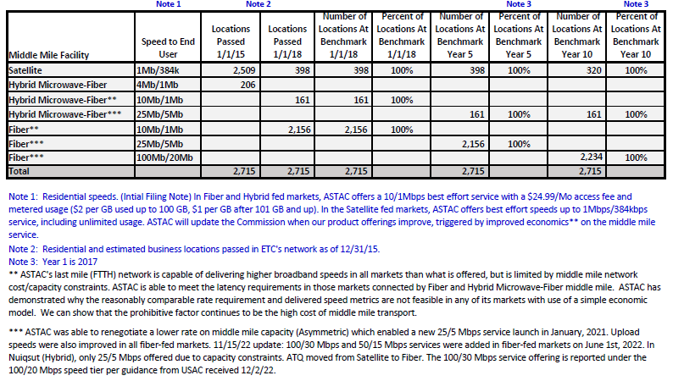

APPENDIX B
HUBB LOCATIONS

Admin SAC | Carrier Name | Speed (Mbps) | Middle Mile | 5 Year Obligation Newly Deployed, Upgraded Locations by Dec. 31, 2021 | Minimum Total Locations Certified in the HUBB by Mar. 1, 2022 | 10 Year Obligation Newly Deployed, Upgraded Locations by Dec. 31, 2026 | Minimum Total Locations Certified in the HUBB by Mar. 1, 2027
613001 | ARTC | 25/5 | Hybrid | 161 |  | 161
613001 | ARTC | 25/5 | Fiber | 2156 |  | 0
613001 | ARTC | 100/20 | Fiber | 0 |  | 2234
 |  |  |  |  | 2317 |  | 2395

Connect America Fund, et al., WC Docket No. 10-90 et al., Report and Order and Further Notice of Proposed Rulemaking, 31 FCC Rcd 10139 (2016) (Alaska Plan Order); 47 CFR § 54.306(b).
Wireline Competition Bureau Authorizes Alaska Plan Support for 13 Alaskan Rate-of-Return Companies, WC Docket Nos. 10-90, 16-271, Public Notice, 31 FCC Rcd 13347 (WCB 2016) (Alaska Plan Wireline Authorization Public Notice). See also Connect America Fund, WC Docket No. 10-90, Order on Reconsideration, 34 FCC Rcd 10109, 10143-44, paras. 93-94 (2019) (imposing additional reporting obligations on Alaska Plan carriers).
Alaska Plan Order, 31 FCC Rcd at 10158, para. 61.
Id. Carriers with approved plans to maintain existing service levels are subject to biennial review. See Alaska Plan Order, 31 FCC Rcd at 10158, paras. 61-62. This midterm review also encompasses the Bureau’s biennial review. 47 CFR § 54.306(b).
Alaska Plan Order, 31 FCC Rcd at 10158-59, para. 63.
Wireline Competition Bureau Announces Performance Obligations for Rate-Of-Return Alaska Plan Recipients After the Midterm Review, WC Docket Nos. 10-90, 16-271, Public Notice, DA 21-1642 (WCB Dec. 23, 2021) (Midterm Review Public Notice).
See Midterm Review Public Notice at 3, Appendix A. The fifth year of support ended on December 31, 2021.
Letter from Jeffry H. Smith, VP Public Policy and Advocacy, Vantage Point, Jens Laipenieks, ASTAC CEO to Marlene Dortch, Secretary, Federal Communications Commission, WC Docket No. 16-271 (filed Nov. 18, 2022) (including Attachment ASTAC WCBs Update DC 111522) (ASTAC Ex Parte Letter).
Letter from Jeffry H. Smith, VP Public Policy and Advocacy, to Marlene Dortch, Secretary, Federal Communications Commission, WC Docket No. 16-271 (filed Dec. 19, 2022) (including Attachment ASTAC Updates Obligations 121622).
Id. Other fiber projects are planned for 2023-2025. See ASTAC Ex Parte Letter Attachment.
See Appendix A. See also Midterm Review Public Notice at 3, Appendix A. See also Alaska Plan Wireline Authorization Public Notice, 31 FCC Rcd at 13354, Appendix B; supra note 2.
Wireline Competition Bureau Announces The HUBB Certification Deadline for Deployed Fixed Locations for Alaska Plan Carriers ADAK, ASTAC, and MTA, WC Docket Nos. 10-90, 16-271, Public Notice, DA 22-618 (WCB June 7, 2022); Wireline Competition Bureau Further Extends the HUBB Certification Deadline for Deployed Fixed Locations For Alaska Plan Carriers ADAK, ASTAC, and MTA and Announces New Deadline, WC Docket Nos. 10-90, 16-271, Public Notice, DA 22-846 (WCB Aug. 10, 2022).

