FEDERAL COMMUNICATIONS COMMISSION

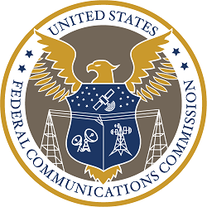

Agency Financial Report
Fiscal Year 2025

TABLE OF CONTENTS

I. MANAGEMENT’S DISCUSSION AND ANALYSIS (UNAUDITED) 3
Message from the Chairman 3
Overview of the Federal Communications Commission 6
Introduction 6
About the Federal Communications Commission 6
Leadership 6
Mission 6
Organizational Structure 7
Organizational Chart 9
Map of FCC Enforcement Bureau’s Field Offices 10
Strategic Goals and Objectives 11
Strategies & Resources to Achieve Goals 12
Components of the Commission for Financial Statements Purposes 12
Payment Integrity 14
Performance Highlights 15
Overall Status of Audit Recommendations 19
Management Assurances 20
Financial Management Systems Strategy 22
Financial Discussion and Analysis 23
Other Key Financial Statement Highlights 28
II. Consolidated Financial Statements and Independent Auditors’ Report 29
Transmittal from Office of Inspector General 29
Independent Auditors’ Report 31
Independent Auditors’ Report on Internal Control over Financial Reporting 34
Independent Auditor’s Report on Compliance with Laws, Regulations, Contracts, and Grant Agreements 40
Commission’s Response to Independent Auditors’ Reports 41
Principal Statements 42
Consolidated Balance Sheet 42
Consolidated Statement of Net Cost 43
Consolidated Statement of Changes in Net Position and Custodial Activity 44
Combined Statement of Budgetary Resources 45
Notes to the Principal Financial Statements 46
Required Supplementary Information 70
III. OTHER INFORMATION (UNAUDITED) 73
Summary of Financial Statement Audit 73
Summary of Management Assurances 73
Payment Integrity 74
Civil Monetary Penalty Adjustment for Inflation 78
Office of Inspector General’s Management and Performance Challenges 79

MANAGEMENT’S DISCUSSION AND ANALYSIS (UNAUDITED)

Message from the Chairman
As the Chairman of the Federal Communications Commission (FCC or Commission), I am pleased to present the FCC’s fiscal year (FY) 2025 Agency Financial Report. This report provides financial and performance information about the FCC’s activities over the course of FY 2025.

The FCC has moved quickly to execute an ambitious set of reforms since President Trump designated me as the Chairman of the agency in January. We are advancing a Build America Agenda—a concrete plan to unleash high-speed infrastructure builds, drive down prices for consumers, and restore U.S. leadership in wireless. We are reinvigorating the agency’s consumer protection work, including its efforts to crack down on illegal robocalls. We are empowering broadcasters to meet their public interest obligations. We are strengthening America’s national security and advancing public safety. We are undertaking the largest deregulatory effort in the agency’s history. And we are eliminating waste while improving efficiency and modernizing agency operations. The FCC’s Build America Agenda focuses on a number of core priorities.

To start, the FCC is working to unleash high-speed infrastructure builds in communities across the country. We are modernizing permitting rules and cutting red tape. This includes making it easier for providers to retire slow and old copper lines and replace them with the modern, high-speed ones that consumers want. We are accelerating and simplifying the process for extending new lines across existing utility poles. And we are pursuing a range of additional steps that can remove barriers to deployment and streamline regulatory approaches. These actions will free up billions of dollars in capital that can go to work closing the digital divide.

We are restoring America’s leadership in wireless by freeing up more spectrum that connects our communities and restore America’s wireless leadership. In June, Congress restored the FCC’s spectrum auction authority after it lapsed in 2023 and created a large pipeline of dedicated spectrum, advancing U.S. leadership in wireless. To create jobs, encourage innovation, and expand high-speed connections to more Americans, the FCC is taking action to make additional spectrum available for 5G services, to include high-band, mid-band, low-band, and unlicensed.

President Trump has been clear that the Administration is ushering in a new Golden Age for space innovation in America. The FCC is following the White House’s lead. We are looking to give the private sector a predictable regulatory framework by focusing on four main principles: speed, simplicity, security, and satellite spectrum abundance. We are already clearing out application backlogs and standardizing procedures in furtherance of that agenda.

Strengthening the nation’s telecom workforce is important to the FCC. Over the last year, many communications providers have committed to a range of workforce reforms that will result in a more sustainable environment for America’s tower and telecom crews. Providers are now adopting faster payment cycles and fairer pricing metrics. They are minimizing layers of subcontracting, which will allow for greater oversight of crews and stronger safety protections. And they are closing loopholes that allowed foreign, fly-by-night groups to swoop in and undercut U.S. crews. The FCC will continue to look out for American workers.

The FCC has been working hard to reinvigorate and modernize our consumer protection work. The issue the FCC hears about the most through consumer complaints is illegal robocalls. And on this front, the FCC has started a new campaign to tackle illegal robocalls at every point in the call path. We are focusing on prevention—stopping bad actors from ever originating calls in the first place. We are pushing carriers to block more illegal robocalls before they reach consumers. We are giving consumers better tools to distinguish legitimate calls from scams. We are looking to curb scam calls that originate outside of the United States by deterring the use of U.S. area codes for calls originating overseas. And we are stepping up enforcement to make sure every provider doing business in the U.S. takes proactive steps to mitigate robocalls. Our work on consumer protection matters also includes our efforts to help Americans access the right resources during a time of crisis. This year, for instance, we adopted rules requiring wireless providers to develop the capability to transmit georouting data when someone sends a text to 988. This means that someone reaching out for help during a crisis will get the localized help they need.

The FCC is working to empower local broadcasters to serve the public interest and meet the needs of their communities. Broadcasters are required by both the Communications Act and the terms of their FCC-issued licenses to operate in the public interest. This sets them apart from cable channels, podcasts, streaming services, social media, and countless other types of distributors that have no public interest obligation. The FCC’s broadcast hoax rule, its news distortion policy, its political equal opportunity regulation, its prohibition on obscene, indecent, and profane content, its localism requirements—all of those and more apply uniquely to broadcasters. Congress has instructed the FCC to enforce public interest requirements on broadcasters. The FCC is going to continue its efforts to empower local broadcasters to meet their public interest obligations.

The FCC has significantly ramped up its efforts this year to promote our country’s national security and advance public safety. Earlier this year, we stood up a new Council on National Security within the FCC to leverage all of the agency’s authorities, expertise, and relevant workstreams to counter the threats posed by foreign adversaries, including the government of China. The FCC cracked down on what we call “Bad Labs”—labs that review and approve electronics for use in the United States, but are owned or controlled by foreign adversary governments. The Council on National Security also executed Operation Clean Carts, which worked with e-commerce platforms to take down millions of listings of devices on the FCC’s Covered List or otherwise prohibited for sale in the United States. The FCC adopted new rules on undersea cable security, following President Trump’s America First Investment Policy Memorandum. In those rules, we took action to unleash the build out of undersea cables to ensure the U.S. leads the world on Artificial Intelligence (AI) infrastructure, while mitigating threats to undersea cables from foreign adversaries. And most recently, in the wake of SALT Typhoon, the FCC has worked directly with carriers to ensure that they are adapting their cybersecurity practices and hardening their networks against future attacks, including by working with federal partners like the FBI, NSA, and CISA to receive technical assistance on networks, rapidly share information, and working together to strengthen cyber defenses.

Beyond threats from foreign adversaries, the FCC also continues to foster network resilience in the face of natural disasters. We began the process of a ground-up re-examination of the national alert and warning systems, including the Emergency Alert System and Wireless Emergency Alerts. The underlying frameworks of these systems are 31 and 13 years old, respectively, so it is important to ensure the FCC is leveraging the latest technology to save lives. The FCC has also worked to strengthen and modernize our Nation’s public safety systems. The FCC proposed requirements to improve location precision for 911 callers in multistory buildings. We also moved forward with a proposal that would make the transition from legacy 911 to NG911 effective and reliable without creating new vulnerabilities in critical public safety networks.

The FCC is also undertaking the largest deregulatory initiative in the agency’s history. The FCC launched an effort titled “In Re: Delete, Delete, Delete.” Since then, the FCC has been reviewing every rule, regulation, and guidance document for the purpose of eliminating unnecessary regulatory burdens, and we sought feedback from stakeholders to get their perspectives as well. To date, the FCC has removed or teed up for removal 1,108 rules and regulations, 134,928 words, and 312 pages of the Code of Federal Regulations. The FCC has also worked to close out inactive dockets and has terminated a record 2,048 inactive proceedings. These initiatives further the Commission’s goal of promoting good governance, increasing efficiency, and modernizing agency processes. In improving efficiencies at the FCC, we generated millions of dollars in savings by eliminating or modifying unnecessary contracts.

As you can tell, the FCC and its hardworking staff have been moving fast to deliver great results for the American people this year. For the twentieth consecutive year, the Commission’s financial statements have received an unmodified or clean audit opinion from the independent external auditors hired by the Office of Inspector General. As we wrapped up FY 2025, I thank the Commission staff for their dedication, commitment to excellence, and hard work and very much look forward to the great results that this FCC team will deliver over the coming years.

Sincerely,

Brendan Carr, Chairman
December 18, 2025

Overview of the Federal Communications Commission

Introduction

Office of Management and Budget (OMB) Circular No. A-136, released on July 14, 2025, states that agencies may choose to produce either a consolidated Performance and Accountability Report (PAR) or a separate Agency Financial Report (AFR) with an Annual Performance Report (APR). The Federal Communications Commission (FCC, Agency, or Commission) has chosen to produce the AFR. The FCC will include its Fiscal Year (FY) 2025 APR with its Congressional Budget Justification and will post it on the Commission’s website at https://www.fcc.gov/about/strategic-plans-budget.

The Commission’s AFR includes three sections:

Section 1 consists of Management’s Discussion and Analysis (MD&A) that presents a message from the Chairman, an overview of the FCC, including the senior leadership, Agency’s mission statement, organizational structure, organizational chart, map of field offices, strategic goals and objectives, strategies and resources to achieve goals, entity components for financial statement purposes, payment integrity, performance highlights, overall status of audit recommendations, management assurances, financial management systems strategy, financial discussion and analysis, and other key financial statement analysis.

Section 2 contains the Commission’s financial information. This section contains the independent auditor’s reports, Commission’s response to the independent auditor’s reports, consolidated financial statements, notes to the financial statements, and required supplementary information.

Section 3 presents other information such as a summary of financial statement audit and management assurances, required reporting on payment integrity pursuant to the Payment Integrity Information Act of 2019, information relegated to annual inflation adjustments of civil monetary penalties, Office of Inspector General’s management and performance challenges, and Management’s response to OIG’s management and performance challenges.

About the Federal Communications Commission

The FCC is a regulatory agency of the United States (U.S.) Government. The FCC is charged with regulating interstate and international communications by radio, television, wire, satellite, and cable. The Commission also regulates telecommunications, advanced communication services, and video programming for people with disabilities, as set forth in various sections of the Communications Act.

The Commission’s headquarters is located in Washington, D.C. It has 13 field offices throughout the nation, including three regional offices located in Atlanta, GA, Columbia, MD, and Los Angeles, CA.

Leadership

The current Commission has three Commissioners. The current Chairman and the Commissioners are:

- Chairman Brendan Carr
- Commissioner Anna Gomez
- Commissioner Olivia Trusty

Mission

The Federal Communications Commission (FCC) regulates interstate and international communications by radio, television, wire, satellite, and cable in all 50 states, the District of Columbia and U.S. territories. A U.S. government agency overseen by Congress, the Commission is the federal agency responsible for implementing and enforcing America’s communications law and regulations.

Organizational Structure

The FCC is organized by function. There are seven Bureaus and eleven Offices. The Bureaus and the Offices develop and administer the FCC’s policies and regulations, process applications for licenses to operate facilities and provide communications services; analyze complaints from consumers and other licensees; conduct investigations; develop and implement regulatory programs; inform and educate consumers and conduct outreach, and organize and participate in hearings, workshops, conferences, webinars and other events. Generally, the Offices provide specialized support services. The Bureaus and Offices are:

- Consumer & Governmental Affairs Bureau (CGB) develops and implements the commission’s consumer policies, including disability access. CGB serves as the public face of the Commission through outreach and education, as well as through the consumer center, which is responsible for responding to consumer inquiries and complaints. CGB also maintains collaborative partnerships with state, local and Tribal governments in critical areas such as emergency preparedness and implementation of new technologies.

- Enforcement Bureau (EB) is the FCC unit primarily responsible for ensuring regulated entities comply with the Communications Act, its implementing regulations, and various licensing terms and conditions. It conducts nonpublic investigations that involve: consumer protection and national security; privacy, data protection, cybersecurity, and supply chain integrity; public safety, emergency services, and harmful interference; targeting fraud in critical FCC-funded and -administered programs; and fair competition and equal opportunities.

- Media Bureau (MB) plays a key role in promoting innovation in the media marketplace, as it develops, recommends, and administers the policy and licensing programs relating to the media industry, including cable television, broadcast television, and radio. It also handles post-licensing matters for satellite services and releases public reports on the data collected from the industry.

- Public Safety and Homeland Security Bureau (PSHSB) promotes the public’s access to reliable 911, emergency alerting, and first responder communications. PSHSB does this by developing and implementing policies, consistent with the FCC’s statutory authority, to ensure that our Nation’s first responders and the American public have access to effective and reliable communications, and by collaborating with Federal government partners responsible for protecting the Nation’s communications infrastructure.

- Space Bureau (SB) plays a key role in advancing the Commission’s Space Innovation Agenda to meet the needs of the next generation Space Age. The Bureau promotes a competitive and innovative global communications marketplace by leading policy and licensing matters related to satellite and space-based communications and activities. Among its responsibilities, the Bureau: leads complex policy analysis and rulemakings; authorizes satellite and earth station systems used for space-based services; streamlines regulatory processes to provide maximum flexibility for operators to meet customer needs; and fosters the efficient use of scarce spectrum and orbital resources. SB also serves as the FCC’s focal point for coordination with other U.S. government agencies on matters of space policy and governance, and collaborates with the Office of International Affairs (OIA) for consultations with other countries, international and multi-lateral organizations, and foreign government officials that involve satellite and space policy matters.

- Wireless Telecommunications Bureau (WTB) advises and makes recommendations to the Commission, or acts for the Commission under delegated authority, in matters pertaining to the regulation and licensing of wireless communications services, devices, facilities, and electromagnetic spectrum resources. The Bureau develops and recommends policy goals, objectives, programs, and plans for the Commission on matters concerning wireless communications and electromagnetic spectrum resources, drawing upon relevant economic, technological, legislative, regulatory, and judicial information and developments. Such matters include the following: addressing present and future wireless communications and spectrum needs in the United States; establishing rules and procedures that will support the deployment of 5G and the next generations of service by a variety of mobile providers; promoting access, efficiency, and innovation in the use of the electromagnetic spectrum through licensing procedures and policies; and promoting investment in wireless communications infrastructure, including broadband.

- Wireline Competition Bureau (WCB) is the FCC’s home for policies and programs focused on closing the digital divide and accelerating the transition to next-generation communications networks. Dedicated staff are committed to making available to everyone an internet that is fast, open, and fair. Through the FCC’s funding programs, WCB supports carriers to help provide reliable access to affordable broadband and voice services for rural and urban households, schools and libraries, and rural health care providers. By implementing Congressional initiatives, WCB establishes rules to foster competition, encourage broadband deployment, protect consumers, and protect national security.

- Office of Administrative Law Judges (ALJ) is composed of one judge (and associated staff) who presides over hearings and issues decisions on matters referred by the FCC.

- The Office of Communications Business Opportunities (OCBO) promotes competition and innovation in telecommunications ownership and information services. The Office also supports opportunities for small businesses, as well as women-owned and minority-owned communications businesses.

- Office of Economics and Analytics (OEA) is responsible for expanding and deepening the use of economic analysis into Commission policy making, for enhancing the development and use of auctions, and for implementing consistent and effective agency-wide data practices and policies.

- Office of Engineering and Technology (OET) advises the FCC on technical and engineering matters and develops and administers Commission decisions regarding spectrum allocations. OET also grants equipment authorizations, experimental licenses, and special temporary operation authority.

- Office of the General Counsel (OGC) serves as the FCC’s chief legal advisor and representative.

- Office of the Inspector General (OIG) is a statutorily created independent entity whose mission is to detect and deter waste, fraud, abuse, and misconduct in FCC programs and personnel, and to promote economy and efficiency in those programs.

- Office of International Affairs (OIA) is responsible for the Commission’s engagement of foreign and international regulatory authorities, including multilateral and regional organizations.

- Office of Legislative Affairs (OLA) serves as the liaison between the FCC and Congress, as well as other Federal agencies.

- Office of the Managing Director (OMD) administers and manages the FCC.

- Office of Media Relations (OMR) informs the media of FCC decisions and serves as the FCC’s main point of contact with the media.

- Office of Workplace Diversity (OWD) ensures that the FCC provides employment opportunities for all persons regardless of race, color, sex, national origin, religion, age, disability, or sexual preference.
Additional information on specific Bureau and Office responsibilities can be found in Title 47 of the Code of Federal Regulations and on the Commission’s web site at: http://www.fcc.gov.

Organizational Chart

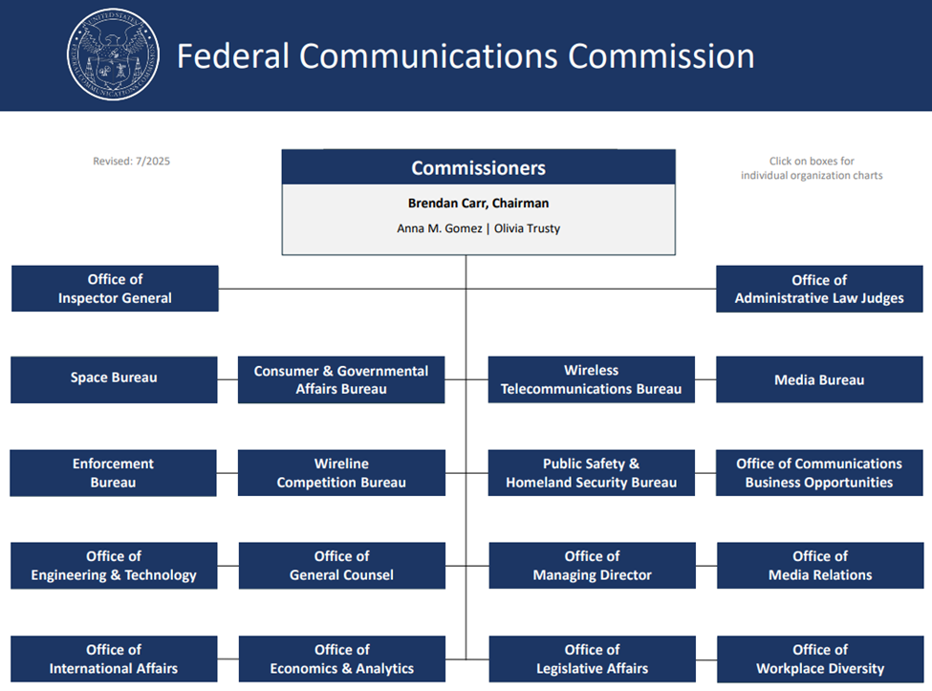

Map of FCC Enforcement Bureau’s Field Offices

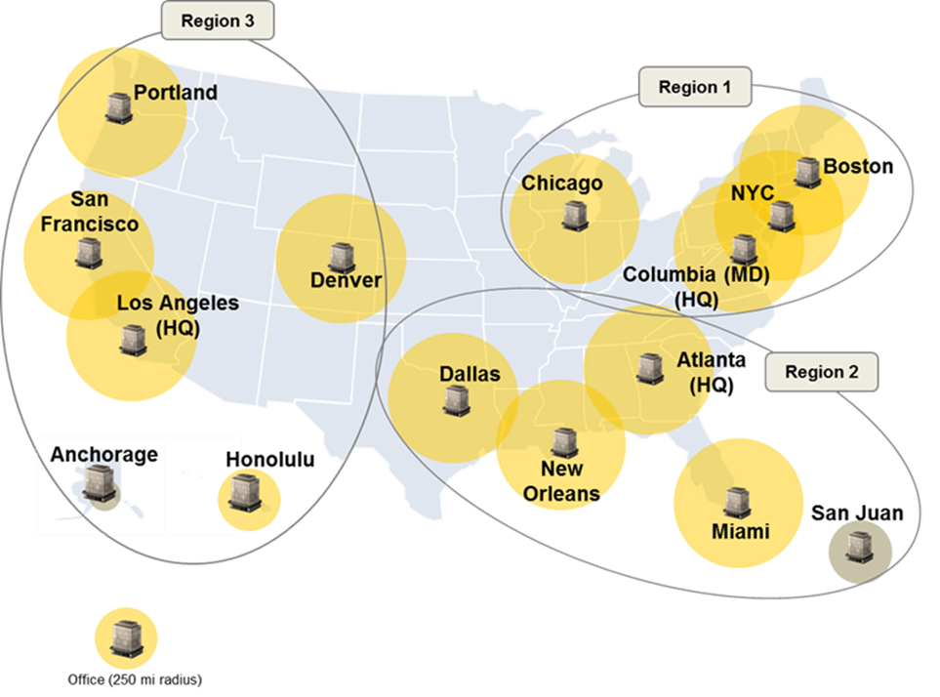

Note: The San Juan and Anchorage offices are not staffed by Full-Time Equivalents (FTEs) on a regular basis.

Strategic Goals and Objectives

The FCC, in accordance with its statutory authority and in support of its mission, has established four strategic goals. They are:

Strategic Goal 1: Accelerate High-Speed Internet Builds

The FCC must promote a pro-growth agenda to unleash the U.S. economy and give all Americans a fair shot at next-generation connectivity. Maintaining and extending U.S. leadership in wireless communications is fundamental to that effort. Getting spectrum policies right translates directly into bringing Americans across the digital divide, creating jobs, and growing the U.S. economy. Through our spectrum auction authority, the FCC will enable greater and more intensive use of spectrum—particularly prime, mid-band spectrum—to harness the promise of new wireless technologies. The FCC must also cut red tape to help ensure that providers roll out upgraded, high-speed networks to more Americans on a faster timeline. The FCC must utilize the full complement of its capabilities, including restoring spectrum auction authority, to free up unused and underutilized spectrum to serve as a catalyst for innovation and growth.

Strategic Goal 2: Promote National Security and Public Safety

The U.S. continues to face persistent threats from foreign adversaries that explore ways to breach our networks, devices, and technology ecosystem. The FCC plays a vital role in safeguarding national security by protecting U.S. communications networks from equipment and services that pose national security risks, and by ensuring the resiliency of our critical communications networks. To safeguard and strengthen U.S. communications networks, the FCC must take concrete actions to address the human, technological, and natural threats and hazards jeopardizing the safety and prosperity of Americans and American companies. The Commission must bring to bear the full range of its regulatory, investigatory, and enforcement authorities and capabilities to maintain awareness of and respond to threats and hazards, align America’s technological and national security priorities, and do its part to promote the security and stability of the Nation. Also, America’s leadership in wireless deployment and standard setting is critical to our geopolitical leadership and national security. It ensures next-generation wireless services develop in ways that will benefit our innovators and interests—rather than regimes that seek to diminish America’s standing in the world.

The Commission also has a responsibility to promote the public’s access to 911, public safety, ensuring the American people have the means to communicate during major events and disasters, and that first responders and emergency managers have access to reliable communications to facilitate emergency response. The FCC develops and implements policies to ensure that our Nation’s first responders and the American public have access to effective and reliable communications and by collaborating with Federal government partners responsible for protecting the Nation’s communications infrastructure. The FCC supports public safety entities to protect the welfare of life and property and to safeguard the Nation’s security. To that end, the FCC develops rules and policies to ensure that the public safety community in the U.S. uses the limited spectrum resource to serve the public with freedom from harmful interference, access to the latest technologies, and minimal regulatory constraints. The FCC also engages Canada and Mexico to develop cross-border spectrum and frequency use agreements to promote efficient use of spectrum by U.S. public safety agencies and commercial operators offering services to public safety agencies and commercial operators offering services to public safety agencies in the border areas. The FCC also works closely with other U.S. government agencies and its international counterparts to help build international coalitions regionally and globally to lead secure network initiatives, secure communications supply chain, and minimize security vulnerabilities of interconnected global communications infrastructures.

Strategic Goal 3: Protect Consumers and Promote Free Speech

Advancements in communications services and technologies have created new challenges for American consumers. The FCC will continue to prioritize consumer protection and empower consumer choice in a rapidly changing communications landscape. The FCC will pursue effective enforcement and new approaches to protect consumers from illegal calls, phone-based scams, and other marketplace trends that affect consumers. The FCC will work to pursue policies that protect free speech and access to information, including efforts to foster media competition and ensuring access to local news sources. The FCC must also continue to ensure the availability of quality, functionally equivalent communications services to persons with disabilities.

Strategic Goal 4: Enhance Efficiency, Accountability, and Reduce Waste

The FCC will unleash prosperity through deregulation and ensure that they are efficiently delivering great results for the American people. The FCC will manage and direct the organization’s resources consistent with Administration policies and the authorities provided by Congress.

Strategies & Resources to Achieve Goals

The Commission has identified strategies and resources to achieve its performance goals for each strategic goal. Details on the Commission’s strategies and resources for achieving its strategic goals are included in the Commission’s strategic plan at: https://www.fcc.gov/about/strategic-plans-budget.

Components of the Commission for Financial Statements Purposes

In addition to the activities directly undertaken by the above bureaus and offices, the Commission’s components for financial statement purposes include:

Universal Service Fund (USF) – The Telecommunications Act of 1996 amended the Communications Act of 1934 (Act) to codify and modify the Commission’s longstanding policy of promoting universal telecommunications service throughout the nation. Pursuant to section 254(d) of the Act, the Commission established rules and regulations governing how certain telecommunications service providers contribute to the USF and how those monies are disbursed. The four USF programs include: the High Cost Program (also known as the Connect America Fund), the Lifeline Program, the Rural Health Care Program, and the Schools and Libraries Program (also known as E-Rate).

The Universal Service Administrative Company (USAC) administers the four USF programs and the Connected Care Pilot Program (CCPP) under the Commission’s direction. These four programs and the CCPP are funded through mandatory contributions from U.S. telecommunications service providers, including local and long-distance phone companies, wireless and paging companies, payphone providers, and providers of interconnected Voice over Internet Protocol (VoIP) services. The High Cost Program provides funding to eligible service providers to help defray the cost of serving customers in high cost and rural areas. The Lifeline Program provides monthly discounts to help make communications services more affordable for low-income consumers. The Rural Health Care Program provides support for both telecommunications and advanced telecommunications and information services for eligible health care providers. The E-Rate Program provides discounts for telecommunications, Internet access, and internal connections to eligible schools and libraries. Lastly, the CCPP provides support to help defray health care providers’ costs of providing connected care services, particularly to low-income Americans and veterans. In FY 2025, the USF accounted for approximately $8,573 million in new available funds on the Commission’s Combined Statement of Budgetary Resources. Additional information on USAC and the USF can be found at http://www.usac.org and https://www.fcc.gov/general/universal-service.

Telecommunication Relay Service (TRS) Fund – The TRS Fund represents a program established under section 225 of the Act. This statute provides for a mechanism to support relay services necessary for telecommunications access by speech or hearing-impaired populations. Rolka Loube, LLC (RL) is the administrator for the TRS Fund. The TRS Fund compensates TRS providers for the reasonable costs of providing interstate telephone transmission services that enable a person with a hearing or speech disability to communicate with a person without hearing or speech disabilities. The costs of providing interstate TRS are recovered from subscribers of interstate telecommunications services. In FY 2025, the TRS Fund accounted for approximately $1,500 million in new available funds on the Commission’s Combined Statement of Budgetary Resources. Additional information on RL and the TRS Fund can be found at http://www.rolkaloube.com/ and https://www.fcc.gov/general/telecommunications-relay-services-trs.

For further clarification on the financial relationships between the Commission and these components, see Note 1 of the financial statements in Section 2. Also, see the chart below which shows the relative size of the component funds in comparison to the major sources of funds for the Commission.

FCC Appropriations – Pursuant to sections 9 and 9A of the Act and the Appropriations Act, the Commission is required by Congress to assess regulatory fees every fiscal year in an amount that can reasonably be expected to equal the amount of its annual appropriation. The Commission’s appropriations of approximately $390 million reflects the amount of regulatory fees the Commission is required to collect for FY 2025.

Secure and Trusted Communications Networks Reimbursement or the Supply Chain Reimbursement Program (SCRP) – Pursuant to the Servicemember Quality of Life Improvement and National Defense Authorization Act (NDAA) of Fiscal Year 2025 (Public Law No. 118-159), the Commission is authorized to borrow from the Treasury of the United States up to an additional $3,080 million to carry out the SCRP. The Commission borrowed the full amount authorized under the statute.

Spectrum Auctions Program – Pursuant to 47 U.S.C. § 309, the Commission may retain a portion of the spectrum auction proceeds to offset the cost of performing the auction function. The Spectrum Auctions Program spending cap of $136 million for FY 2025 is collections from auction revenues used to offset the cost of performing auctions-related activities.

As of September 30, 2025, the Commission has the following disclosure entities which do not substantially meet the requirements of consolidated entities.

- Universal Service Administrative Company (USAC)
- National Exchange Carrier Association, Inc. (NECA)
- Local Number Portability Administrator (LNPA) Program

Payment Integrity

In accordance with the Improper Payments Information Act (IPIA) of 2002, as amended by the Improper Payments Elimination and Recovery Act (IPERA) of 2010, Improper Payments Elimination and Recovery Improvement Act (IPERIA) of 2012, and Payment Integrity Information Act (PIIA) of 2019, the Commission has made significant efforts to implement policies and procedures to strengthen internal controls that prevent improper payments. In addition, the Commission oversees a payment recapture program that includes both audits and transaction testing to search for and recapture overpayments. Section 3 of the AFR provides further details on these efforts. Additional information reported by the Commission on Payment Integrity can also be found on https://paymentaccuracy.gov/.

Performance Highlights

Strategic Goal 1: Accelerate High-Speed Internet Builds

Streamlined procedures for replacing legacy copper phone services with modern networks. Made it easier for providers to invest in new, high-speed networks by allowing them to use streamlined procedures when they apply to discontinue old copper telephone lines.

Granted Carriers Authority to Grandfather Legacy Services and Waiving the Filing Requirement. Waived unnecessary requirements that kicked in when a provider stopped offering legacy service to new customers.

Waived FCC filing requirements for certain network filing requirements. Waived costly and excessive notice requirements in cases where they provide no demonstrable benefit, such as network change disclosure filings.

Waived Stand‑Alone and Single‑Service Requirements for Discontinuing Legacy Voice Services. Adopted a waiver that allows providers to retire copper networks, not only in cases where replacement voice services are available on a stand-alone basis, but in cases where those services are available on a bundled basis. The FCC’s pro-consumer pricing protections will remain in place.

Accelerated Submarine Cable Buildout and Security. Made it easier and faster to build secure undersea internet cables, which carry nearly all global web traffic. New rules help protect these cables from foreign threats and support America’s leadership in Artificial Intelligence (AI) and tech.

Refined the Commission’s Alaska High-Cost Mobile-Support Programs. Adjusted the Alaska Connect Fund to ensure limited federal dollars are used more efficiently to deliver 5G internet across Alaska. The changes better align the program with Alaska’s needs and eliminate unnecessary red tape for tracking compliance.

Ended Proposal Requiring Unnecessary Environmental Reviews on Tower Builds. Ended a proposal that subjected tower construction to costly, unnecessary, and time-consuming environmental reviews. By eliminating this regulatory burden, the Commission has cleared the way for faster broadband deployment, expanding internet access for millions of Americans.

Improved Engineering Review for Broadband Data Collection. Eliminated an unnecessary barrier to providing reliable broadband data for inclusion on the FCC's National Broadband Map.

Established a Licensing Framework for the Lower 37 GHz Band. Adopted new spectrum sharing rules to bolster innovative commercial uses in the lower 37 GHz band, a framework expected to support Internet of Things systems, wireless broadband, internet backhaul, and greater mobile capacity. The Commission also established a nationwide, non‑exclusive licensing regime that opens 600 MHz of the same band for commercial services while preserving coordination and protections for incumbent military uses.

Updated AWS-3 Service-Specific Requirements. Prepared to auction unused wireless spectrum to improve internet access and fund network security.

Enabled Expanded Direct-to-Cell Service via Emissions Waiver. Approved SpaceX’s request to boost satellite signal strength for better mobile coverage in remote areas, as long as it doesn’t interfere with nearby wireless networks.

Expedited Initial Processing of Satellite and Earth Station Applications to Boost Space Innovation: Made it easier for space companies, especially startups, to get permission to operate. New rules cut paperwork and let companies share ground stations without needing to build their own, helping speed up innovation and satellite services.

Approved Verizon-Frontier Merger. Approved Verizon’s $20B purchase of Frontier, unleashing billions of dollars in new infrastructure builds in rural and other communities across the country.

Approved of T-Mobile and UScellular Transfer Control of Licenses, Authorizations, and Leases. Approved T‑Mobile’s acquisition of UScellular’s wireless operations, customers, and approximately 30% of its licensed spectrum. The transaction is expected to deliver substantial network benefits for customers, including improved coverage and enhanced fixed wireless access service.

Strategic Goal 2: Promote National Security and Public Safety

Established New Council on National Security within Agency. Launched a new Council to help protect America’s tech and telecom systems from foreign threats, especially those linked to China. The Council will work across the agency to boost cybersecurity, reduce risky supply chain dependencies, and support U.S. leadership in key technologies like 5G, AI, and satellites.

Safeguarded the Equipment Authorization Process from Bad Labs. Moved to stop foreign adversaries from influencing the labs that test wireless devices for the U.S. market by blocking problematic ownership ties, requiring approval for all radio‑emitting products, and targeting labs found to have concerning links that tested many devices heading to U.S. consumers. Blocked more electronic labs tied to foreign adversaries that pose a national security risk. In total, 15 of these “bad labs” have now been denied or targeted for removal.

Modified the Commission’s Equipment Authorization Program to Protect Against National Security Threats. Tightened tech security rules by blocking older approved devices and foreign-made parts—like certain transmitters—that were slipping through past loopholes. The goal is to better protect U.S. networks from surveillance and national security threats.

Announced Initial Success of an Operation to Remove Covered CCP Affiliated Equipment from E-Commerce Sites. Worked with major online retailers to remove millions of banned Chinese tech products from their sites. These devices were flagged as national security risks, and the companies agreed to help stop their sale and prevent future listings.

Launched Inquiry into the Development of PNT Technologies and Solutions. Asked industry and the public for ideas on backup systems for GPS because GPS can be disrupted or tampered with by hostile actors; the goal is to identify and promote technologies that keep navigation, timing, and related services working if GPS fails.

Made Wireless Emergency Alerts More Responsive to Public Safety & Consumer Needs. The FCC now allows emergency alerts to be sent silently—without loud sounds or vibrations—when needed to protect people, such as during an active shooter situation. This change helps reduce alert fatigue and gives people more control over how they receive alerts. Phones marketed as emergency-alert ready must now support all alert features, including silent messages and location-based targeting.

Strategic Goal 3: Protect Consumers and Promote Free Speech

Strengthened the Commission’s Call Blocking Rules. Required phone companies to block scam calls that appear to come from fake or unused numbers, including government numbers that don’t make outgoing calls. The new rules also make sure that legitimate callers are notified when their calls are blocked, so they can fix the issue.

Reduced Pricing for Reassigned Numbers Database. Lowered prices and added new subscription options for its database that shows whether a phone number has been reassigned, making it easier and cheaper for businesses and callers to avoid dialing the wrong person and to reduce unwanted or mistaken calls.

Removed Non-Compliant Providers from Robocall Mitigation Database. Removed over 1,300 non-compliant voice service providers from the Robocall Mitigation Database, effectively barring them from transmitting calls to U.S. networks. These providers failed to maintain valid certifications despite repeated warnings and were either involved in illegal robocall campaigns or failed to cooperate with investigations. The FCC emphasized the importance of accurate database filings to ensure transparency and accountability in robocall prevention.

Ended Proposal to Regulate Bulk-Billing Arrangements. Bulk-billing programs are contractual arrangements between internet service providers and rental property owners that allow families living in apartments to access lower-cost internet services. The FCC rejected a proposal to regulate these agreements, which could have led to a significant increase in internet prices for rental tenants.

Removed Obsolete Unworkable Cable Television Rate Rules. Cut dozens of outdated cable rules to reduce paperwork, help small providers, and modernize approach to cable pricing.

Improved Access to the 988 Lifeline by Utilizing Geo-routing. Adopted rules requiring wireless providers to georoute 988 text messages based on the sender’s general physical location rather than area code. This change aligns text routing with voice call practices and improves access to local crisis centers, enabling better follow-up care and mental health support.

Adopted Interim Rates for Incarcerated People’s Communications Services. The FCC is updating prison phone rules to better reflect safety costs and make sure services stay available, while keeping rates fair for families.

Proposed Fines Against Pirate Radio Operations. Under the PIRATE Act, the FCC proposes nearly $400,000 in fines against two repeat offenders for operating illegal radio stations in Miami. These unauthorized broadcasts undermine licensed stations and cause harmful interference to lawful public services.

Strategic Goal 4: Enhance Efficiency, Accountability, and Reduce Waste

Launched a Massive Deregulation Initiative “Delete, Delete, Delete”. The FCC asked the public to help identify outdated or overly burdensome rules that may be slowing down innovation or hurting small businesses. This review supports a broader push to simplify regulations and make sure they reflect today’s technology, market conditions, and legal standards. This included: removing over 40 outdated rules that no longer serve a purpose and burden internet and network connection; deleting rules about telegraphs, rabbit-ear TVs, and phone booths; removing nearly 100 old broadcast rules, some dating back 50 years; nearly 400 primarily wireline-related rules and requirements that govern obsolete technology, are duplicative, and no longer used in practice, and much more. To date, the Commission has removed or teed up for removal 1,108 rules and regulations, 134,928 words, and 312 pages of the Code of Federal Regulations. The FCC has also worked to close out inactive dockets and has terminated a record 2,048 inactive proceedings. These initiatives further the Commission’s goal of promoting good governance, increasing efficiency, and modernizing agency processes.

Saves Taxpayers Over $9 Million Following Audit Reviews. The FCC ordered seven phone companies to repay over $9 million to the Universal Service Fund after audits confirmed they received improper support. The Wireline Competition Bureau affirmed the Universal Service Administrative Company's findings and emphasized the need to transition from legacy rate-of-return programs to more efficient fixed-support models and modern IP networks.

FCC & DOJ Announce Q Link Wireless $110M Global Resolution. Q Link Wireless LLC (Q Link) and its owner, Issa Asad, located in Dania Beach, Florida, have agreed to pay $110,637,057 to resolve criminal charges and civil allegations that they violated the False Claims Act by submitting false claims to the FCC’s Lifeline Program.

Demanded Repayment of $1.18 Million for Provider Overbilling of Computer Tablets in COVID-Era Programs. The FCC ordered $1.18 million to be repaid to American taxpayers by Boomerang Wireless and Assist Wireless after audits revealed they overclaimed reimbursement for connected devices under COVID-era programs. The companies sought up to $100 per tablet for devices that were widely available at significantly lower market prices.

Overall Status of Audit Recommendations

The chart below shows the number of audit recommendations outstanding, both public and non-public, from various audits conducted by FCC’s Office of Inspector General (OIG) and the Government Accountability Office (GAO) as of September 30, 2025. The numbers shown below exclude those recommendations for which the Commission has already submitted information to GAO and OIG requesting closure of the recommendation. The count also excludes those recommendations that the Commission has determined to be closed as not implemented. For FY 2025, the Commission has implemented (closed) 42 outstanding recommendations, received 48 new and reopen recommendations, and finished the month of September 2025 with a total of 62 open recommendations. In FY 2019, there was a large number of new recommendations received just before the fiscal year end, which led to the increased number of open recommendations in that fiscal year.

As can be seen by the number of implemented recommendations during FY 2025, the Commission has been actively working to implement (close) open recommendations as quickly as possible. The Commission will continue to work as quickly as possible to implement (close) the outstanding recommendations.

Management Assurances

Section 2 of the Federal Managers’ Financial Integrity Act of 1982 (FMFIA) establishes overall requirements with regard to internal control. FMFIA requires agencies to establish controls that reasonably ensure that: (i) obligations and costs are in compliance with applicable laws; (ii) funds, property, and other assets are safeguarded against waste, loss, unauthorized use, or misappropriation; and (iii) revenues and expenditures applicable to agency operations are properly recorded and accounted for to permit the preparation of accounts and reliable financial and statistical reports, and to maintain accountability over assets. Pursuant to FMFIA’s requirements, agencies must annually evaluate their system of internal controls and report on the results of those evaluations through management assurance statements.

In accordance with Office of Management and Budget (OMB) guidance related to FMFIA, OMB Circular A-123, Management’s Responsibility for Enterprise Risk Management and Internal Control, the Commission maintains internal controls for financial and management reporting that provide reasonable assurance that the consolidated financial statements fairly present information related to assets, liabilities, and net position and do not contain material misstatements. Transactions are executed in accordance with budgetary and financial laws, consistent with the Commission’s statutory requirements, and are recorded in accordance with Federal accounting standards. Additionally, assets are properly acquired, used, and safeguarded to deter theft, accidental loss or unauthorized disposition, and fraud. Furthermore, the Commission’s internal controls provide for the reliability and completeness of its financial and performance data.

The FY 2025 auditors’ report identified a repeated significant deficiency in Information Technology controls collectively related to risk management, configuration management, identity and access management, and information security continuous monitoring. The Commission will make every effort in FY 2026 to implement corrective action plans for each of the recommendations associated with these findings to avoid any repeat findings in these areas.

Status of Internal Controls – Section 2 of FMFIA

During FY 2025, the Commission continued its efforts to improve and strengthen its internal controls over operations and financial reporting by building upon continuing improvements to its risk assessment processes. The Commission continued to improve its pre-existing processes for internal control evaluation, both at the Commission and at its reporting components, USF and TRS. The Commission’s risk assessment process integrates the latest versions of the Government Accountability Office’s (GAO), Standards for Internal Control in the Federal Government (Green Book), as well as OMB’s Circular A-123, Management's Responsibility for Enterprise Risk Management and Internal Control. Utilizing GAO’s Green Book as a blueprint, the Commission’s entity level risk assessment tool is completed each fiscal year by its Bureaus and Offices as well as its reporting components. Furthermore, utilizing the GAO’s Fraud Risk Framework the Commission continued Fraud Risk Management within the agency, including the new appropriated programs.

The FCC has a Fraud Risk Group to serve as the governing body for FCC’s Fraud Risk Management. Additionally, FCC’s Senior Management Council (SMC) continued its oversight of the Commission’s entity level risk assessments as part of its overall Enterprise Risk Management process pursuant to OMB Circular A-123. The SMC includes representatives from across the Commission’s Bureaus and Offices to more fully integrate the Commission’s internal control assessment processes into the operations of the Bureaus and Offices while also identifying, monitoring, and mitigating risks throughout the year. While the Commission has received unmodified opinions over its consolidated financial statements for the twentieth consecutive year, the Commission understands that maintaining proper internal control requires continuous review of its internal controls and implementing improvements to them on an ongoing basis.
Financial Management Systems – Section 4 of FMFIA

Section 4 of FMFIA and the Federal Financial Management Improvement Act of 1996 (FFMIA) requires agencies to report on whether their financial management systems provide reliable, consistent disclosure of financial data and conform to government-wide requirements. In FY 2025, the Commission’s financial management systems were in compliance with government-wide requirements. The Commission continues to work with its reporting components on their financial systems.

Statement of Assurance

Commission management is responsible for managing risks and maintaining effective internal controls to meet the objectives of Sections 2 and 4 of FMFIA. The Commission conducted its assessment of risk and internal control in accordance with OMB Circular A-123, Management’s Responsibility for Enterprise Risk Management and Internal Control. Based on the results of the assessment, the Commission can provide reasonable assurance that internal controls over operations, reporting, and compliance were operating effectively and financial management systems conform to government-wide standards as of September 30, 2025.

Brendan Carr, Chairman
December 18, 2025

Financial Management Systems Strategy

The Commission’s financial management system, Genesis, is a Momentum based product that serves as the financial accounting system of record and provides for the core accounting services of the Commission. These services include: funds control, budget execution, general ledger, accounts payable, accounts receivable, financial reports, and access controls. Genesis facilitates compliance with the Federal Managers’ Financial Integrity Act (FMFIA), and the maintenance of an unmodified financial audit opinion.

Genesis continues to support the accounting for the spectrum auctions program at the Commission, including the activities under the Spectrum Act, which provides for the reimbursement of relocation expenses for eligible entities. The Commission Registration System (CORES) allows eligible entities to seek reimbursement and enter their banking information into CORES online, and allows an entity to view their available balance for reimbursement along with the history of payments made to the entity. Additionally, Genesis supports efficiency initiatives, including the Invoice Processing Platform (IPP), which reduces the paper chain associated with the document review process and reduces, and/or eliminates, instances of duplicate data entry, the Treasury G-Invoicing Initiative and the IRS Employer Identification Number Initiative (EIN). Genesis also provides self-service capability for the Bureaus and Offices to execute accounting functions, including business analytics for decision making.

In support of the Coronavirus Aid, Relief, and Economic Security (CARES) Act (P.L. 116-136), the Consolidated Appropriations Act, 2021 (P.L. 116-260), the American Rescue Plan Act of 2021 (P.L. 117-2), and the Infrastructure Investment and Jobs Act, 2021 (P.L. 117-58), the Commission continues to leverage the scalable functionality of Genesis and IPP to quickly accommodate requirements for the five programs—COVID-19 Telehealth Program (Round 2), Emergency Broadband Connectivity Fund – Emergency Broadband Benefit Program, Emergency Connectivity Fund, the Secure & Trusted Communications Network Reimbursement Program, and the Affordable Connectivity Program—mandated to the Commission under these laws. Financial Operations systems continues to support the Commission’s mission.

The Commission continues to optimize financial management system controls through ongoing monitoring reviews, business process engineering initiatives and implementation of best practices, including the hosting of Genesis in a Cloud environment. In FY 2025, additional Commission financial legacy systems were modernized, continuing to decrease operations and maintenance costs and supporting efficiency initiatives. Additionally, the Commission continues to maintain a steady state within the core financial system and fully utilizes Genesis’ features and functions, aligning financial system activities with the Commission’s business management goals. The Commission’s financial management system strategy continues to build on processes that: improve internal controls; increase integration; implement tools that enhance budget formulation and performance; and improve financial coordination with our reporting components.

Financial Discussion and Analysis

UNDERSTANDING THE FINANCIAL STATEMENTS

The Commission is committed to excellence and accuracy in financial reporting, transparency, and financial management. Preparing the Commission’s financial statements is part of the goal to improve financial management and provide accurate and reliable financial information that is useful for assessing performance and allocating resources. The Commission’s management is responsible for the integrity and objectivity of the information presented in the financial statements. For the twentieth consecutive year, the Commission’s financial statements have received an unmodified or clean audit opinion from the independent external auditors hired by the Office of Inspector General.

The principal financial statements have been prepared to report the financial position and results of operations of the Commission. The statements have been prepared from the books and records of the Commission, in accordance with U.S. generally accepted accounting principles (GAAP) for federal entities. The financial statements and notes are presented in accordance with Office of Management and Budget (OMB) Circular No. A-136, Financial Reporting Requirements—Revised, dated July 14, 2025.

This section presents a summary analysis of key financial statement core business activities. The principal financial statements include: the Consolidated Balance Sheet, the Consolidated Statement of Net Cost, the Consolidated Statement of Changes in Net Position and Custodial Activity, and the Combined Statement of Budgetary Resources. This section also summarizes the financial activity and net position of the Commission. The complete set of principal financial statements is included in Section 2 of this report.

A summary of the Commission’s major financial activities in Fiscal Year (FY) 2025 is presented in the table on the next page. This table represents the resources available for use (assets) against the amount owed (liabilities) and the amount that comprises the difference (net position). The net cost represents the gross cost of operating the Commission’s lines of business less earned revenue. Budgetary resources represent funds made available to the Commission.

The following is a brief description of the nature of each required financial statement and its relevance, including a description of certain significant balances on Commission operations.

Consolidated Balance Sheet: The Consolidated Balance Sheet presents the total amounts available for use by the Commission (total assets) and the amounts owed by the Commission (total liabilities). Fund Balance with Treasury represents 93 percent of total assets as of September 30, 2025.

The pie chart below presents the total assets of the Commission as of September 30, 2025. The Fund Balance with Treasury of $14,759 million is primarily related to the Universal Service Fund (USF), the Affordable Connectivity Fund – Affordable Connectivity Program (ACF-ACP), the Emergency Connectivity Fund (ECF), the Supply Chain Reimbursement Program (SCRP), and the spectrum auctions program.

The Accounts Receivable balance of $934 million is primarily due to USF receivables totaling $831 million.

The pie chart below presents the total liabilities of the Commission as of September 30, 2025. The Commission’s most significant liabilities are Debt of $3,149 million, Liability to the General Fund of the U.S. Government for Custodial and Other Non-entity Assets of $3,117 million, Other than Intragovernmental Accounts Payable of $385 million, and Accrued Liabilities for USF and TRS of $518 million, which accounted for 97 percent of total liabilities as of September 30, 2025.

The debt is composed of the amount borrowed by the Commission from the Treasury and related interest accrual for the SCRP.

The Liability to the General Fund of the U.S. Government for Custodial and Other Non-entity Assets is primarily composed of the custodial collections earned from spectrum auctions program and miscellaneous receipts.

The Accrued Liabilities for USF and TRS represent the expected October (FY 2026) payments for the USF’s High Cost Legacy Support, Lifeline Program, and the expected October and November (FY 2026) payments for the TRS Program.

The Other than Intragovernmental Accounts Payable balance is primarily composed of the expense accrual for the Enhanced Alternative Connect American Cost Model (E-ACAM) and the Rural Digital Opportunity Fund (RDOF).

Consolidated Statement of Net Cost: This statement presents the annual cost of operating the Commission’s programs. The Consolidated Statement of Net Cost is aligned with the four strategic goals of the Commission: (1) Accelerate High-Speed Internet Builds; (2) Promote National Security and Public Safety; (3) Protect Consumers and Promote Free Speech; and (4) Enhance Efficiency and Accountability, and Reduce Waste. The program costs for the USF are allocated to the strategic goals to Pursue “Accelerate High-Speed Internet Builds.” The program costs for the TRS are allocated to the strategic goal to Protect Consumers and Promote Free Speech. Due to the cost allocation for USF, ACF-ACP, and ECF, the costs for the strategic goal to Pursue “Accelerate High-Speed Internet Builds” are significantly higher than the costs of other strategic goals. Contributions received for the USF and TRS programs are shown on the Statement of Changes in Net Position and do not directly offset the costs of these programs on the Statement of Net Cost.

The pie chart below presents the total program costs for each strategic goal.

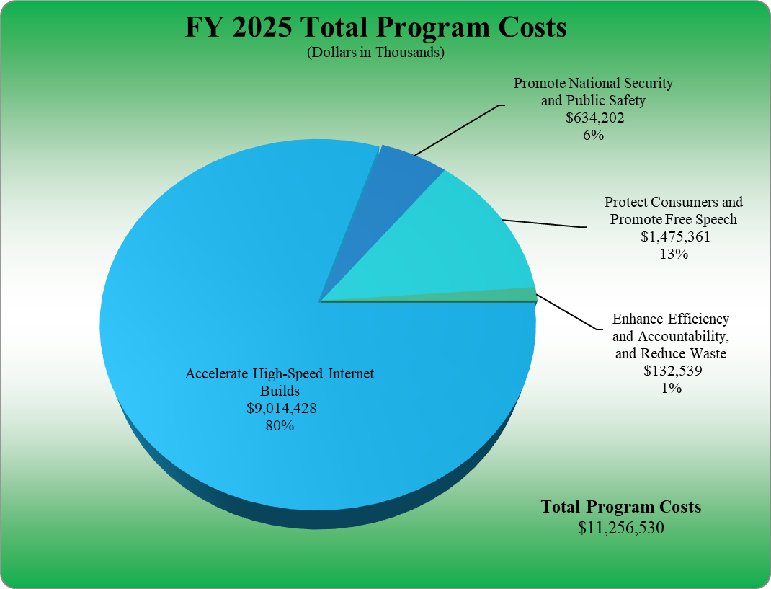
Consolidated Statement of Changes in Net Position and Custodial Activity: This statement presents the Commission’s net position and its custodial activity. As of September 30, 2025, the Cumulative Results of Operations of $6,160 million represents 73% of total net position and is primarily related to USF.

In FY 2025, the Commission recognized $8.8 million in custodial revenue and transferred the $59 million in miscellaneous receipts, fines, and penalties to the Treasury General Fund.

Other Key Financial Statement Highlights

Regulatory Fee Collections

Pursuant to 47 U.S.C. § 159, the Commission is required to collect regulatory fees each fiscal year and retains those collections to offset certain costs incurred by the Commission. The amount the Commission is required to collect is included in the Commission’s annual appropriations.

Regulatory fees are collected and warranted back to the Treasury to offset the Commission’s appropriations for the current fiscal year. In FY 2025, the Commission was required to collect $390 million in regulatory fees. Excess regulatory fees collections of $9.7 million were transferred to the General Fund of the Treasury for the sole purpose of deficit reduction.

Limitations on the Financial Statements

The financial statements are prepared to report the financial position, financial condition, and results of operations, consistent with the requirements of 31 U.S.C. § 3515(b). The statements are prepared from records of Federal entities in accordance with Federal generally accepted accounting principles (GAAP) and the formats prescribed by OMB. Reports used to monitor and control budgetary resources are prepared from the same records. Users of the statements are advised that the statements are for a component of the U.S. Government.

Consolidated Financial Statements and Independent Auditors’ Report

Transmittal from Office of Inspector General

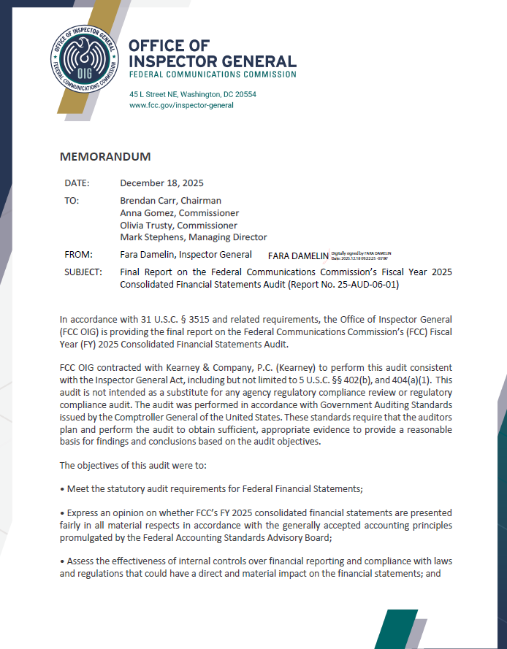

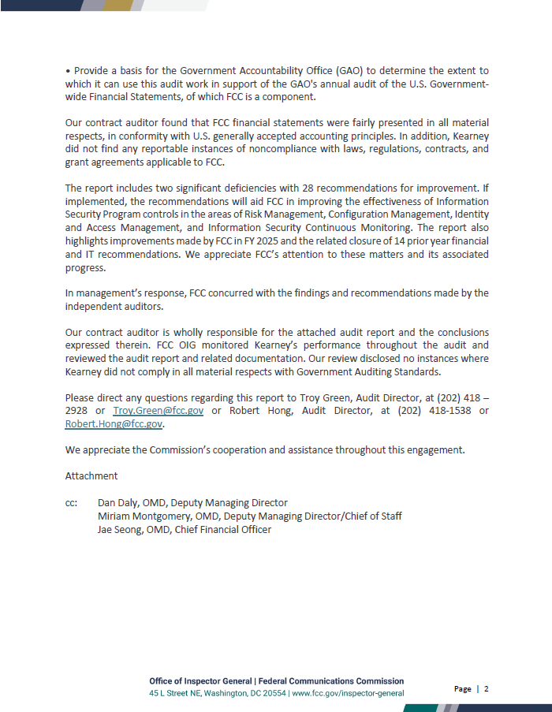

Independent Auditors’ Report

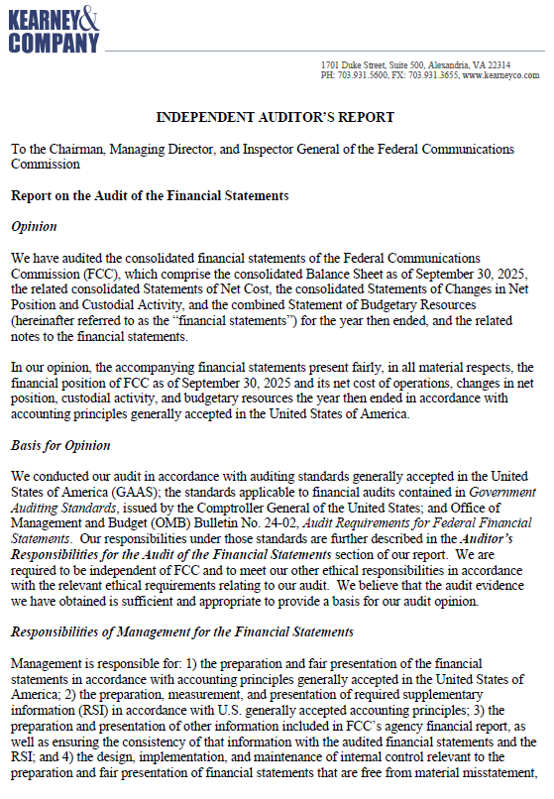

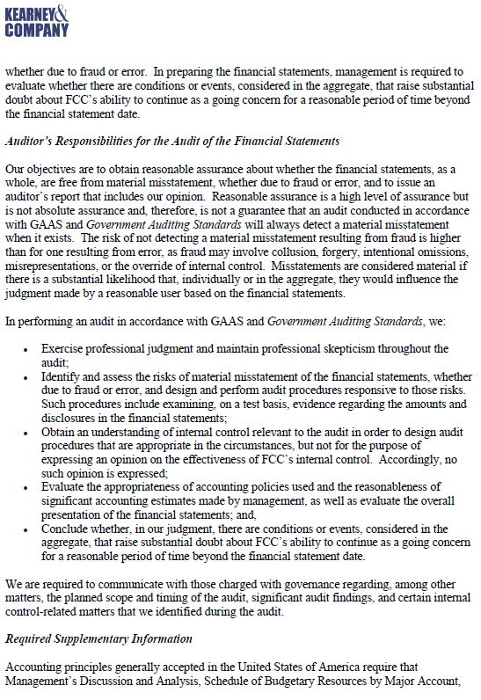

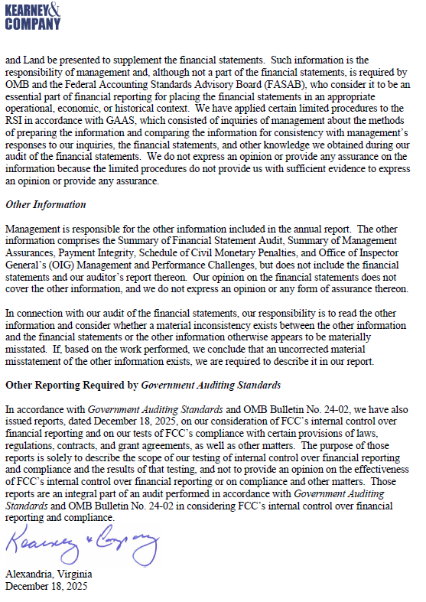

Independent Auditors’ Report on Internal Control over Financial Reporting

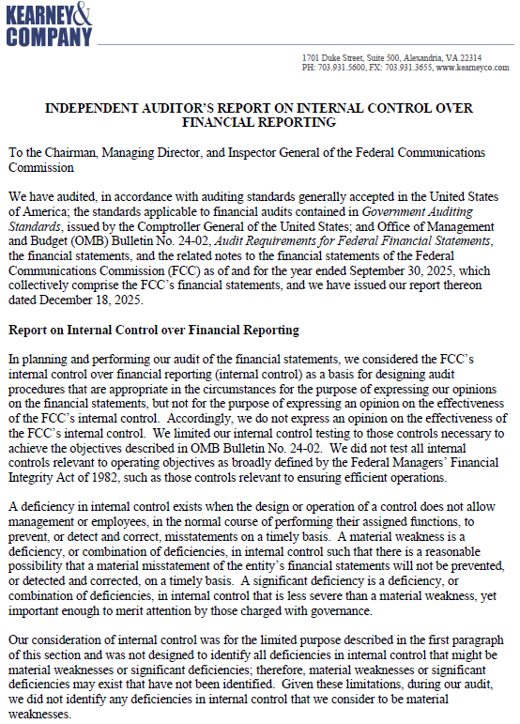

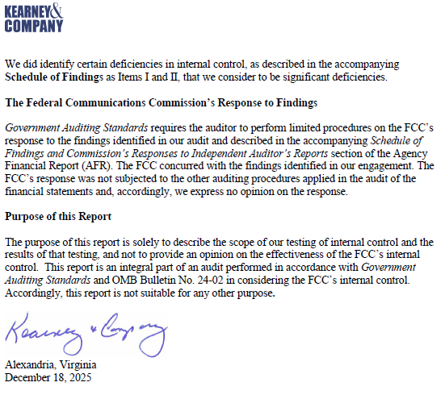
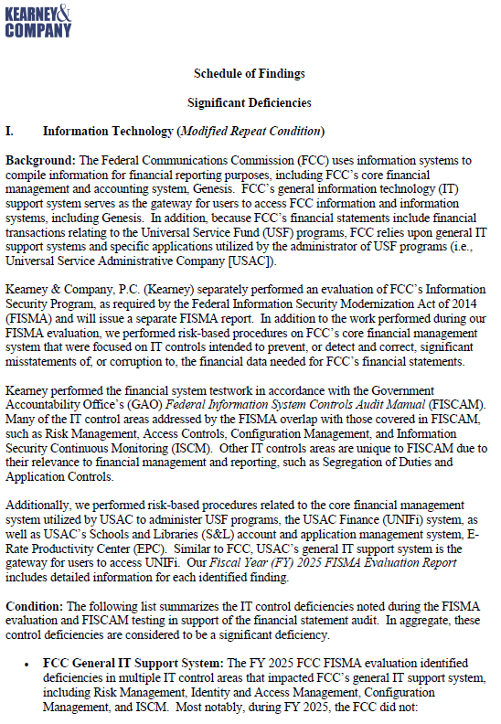

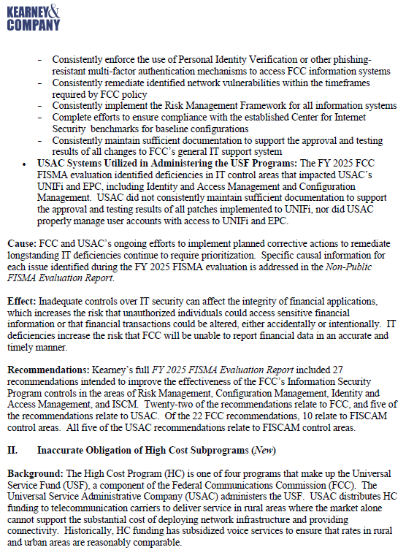

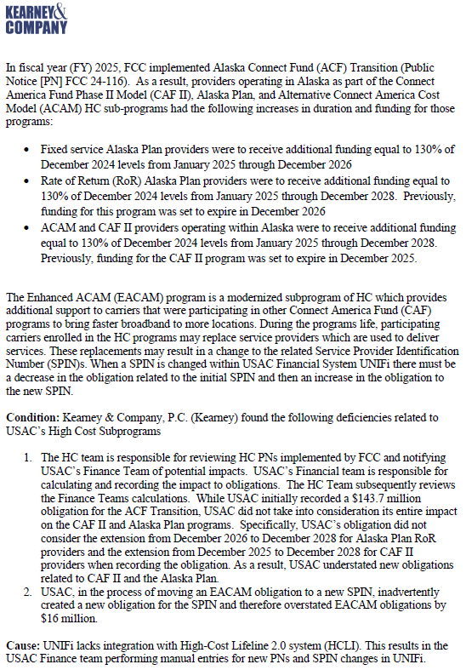

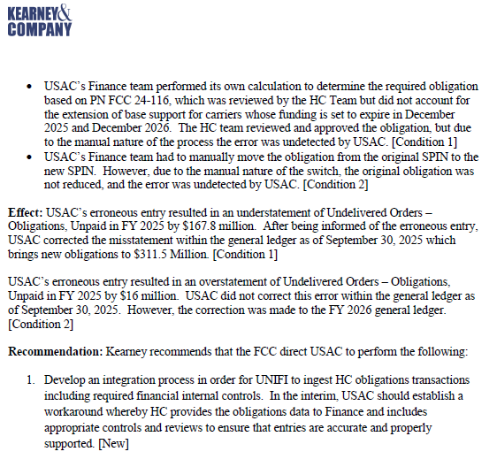

Independent Auditor’s Report on Compliance with Laws, Regulations, Contracts, and Grant Agreements

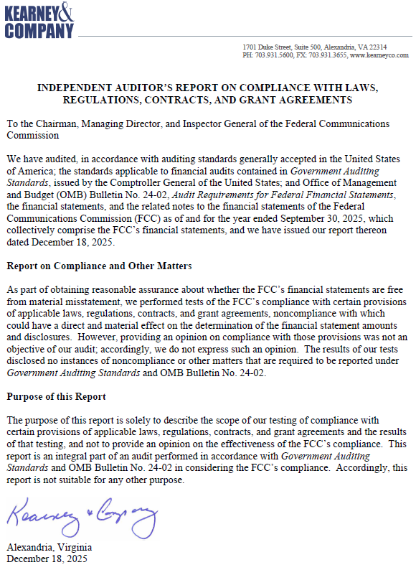

Commission’s Response to Independent Auditors’ Reports

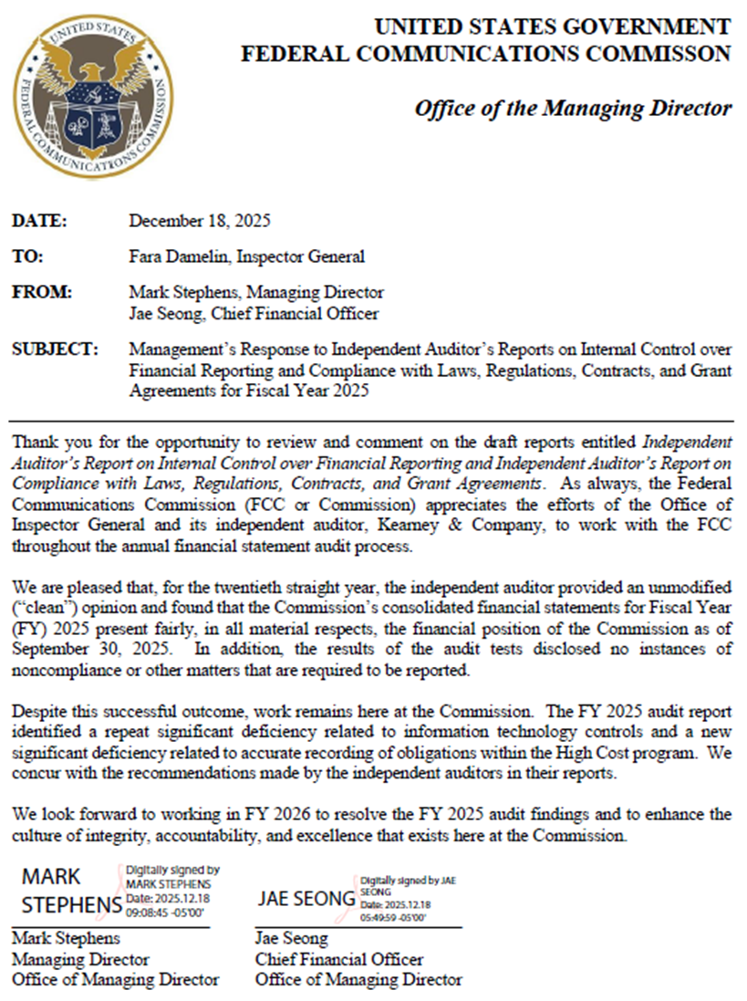

Principal Statements
Federal Communications Commission

Consolidated Balance Sheet
As of September 30, 2025
(Dollars in Thousands)
The accompanying notes are an integral part of these statements.
Federal Communications Commission

Consolidated Statement of Net Cost
For the Year Ended September 30, 2025
(Dollars in Thousands)

The accompanying notes are an integral part of these statements.
Federal Communications Commission

Consolidated Statement of Changes in Net Position and Custodial Activity
For the Year Ended September 30, 2025
(Dollars in Thousands)
The accompanying notes are an integral part of these statements.

Federal Communications Commission

Combined Statement of Budgetary Resources
For the Year Ended September 30, 2025
(Dollars in Thousands)

The accompanying notes are an integral part of these statements.

Notes to the Principal Financial Statements
For the Year Ended September 30, 2025
(Dollars in Thousands Unless Otherwise Stated)

Note 1 – Summary of Significant Accounting Policies

A. Reporting Entity

The Federal Communications Commission (FCC or Commission) is a United States (U.S.) government agency, established by the Communications Act of 1934 (Act), as amended. The Commission is charged with regulating interstate and international communications by radio, television, wire, satellite, and cable. The Commission’s jurisdiction spans the 50 states, the District of Columbia, and the U.S. possessions. The Commission is directed by five Commissioners who are appointed by the President of the United States and confirmed by the Senate for five-year terms, except when filling an unexpired term or serving in holdover status.

The Commission is comprised of three reporting components. The primary component consists of Commission headquarters and field offices. The two additional components are the Universal Service Fund (USF) and the Telecommunications Relay Service (TRS) Fund. The USF reports the results of the four universal service programs (established pursuant to section 254 of the Act, as amended), and the Connected Care Pilot Program (CCPP). Section 1113 of the Full-Year Continuing Appropriations and Extensions Act, 2025, P.L. 119-4 extends Section 510 of Division B of the Further Consolidated Appropriations Act, 2024, P. L. 118-364, which amended Section 302 of the Universal Service Anti-deficiency Temporary Suspension Act, Title III of P. L. 108-494 and extended the universal service programs exemption from the application of the provisions of the Anti-deficiency Act until September 30, 2025. Accordingly, the USF is not subject to apportionment by the Office of Management and Budget (OMB). The TRS Fund was established by the Americans with Disabilities Act of 1990, Title IV, and is not exempt from the Anti-deficiency Act and must be apportioned by OMB before funds are available for use. Information regarding disclosure entities is separately disclosed in Note 19 Disclosure Entities.

B. Accounting Policies

The consolidated and combined financial statements (collectively, financial statements) have been prepared from the accounting records of the Commission and its components, in conformity with U.S. generally accepted accounting principles (GAAP) and the form and content for federal entity financial statements specified by OMB Circular No. A-136, Financial Reporting Requirements—Revised. Custodial activity reported on the Statement of Changes in Net Position and Custodial Activity is prepared on the modified cash basis.

The preparation of financial statements in conformity with GAAP requires management to make estimates and assumptions that affect the amounts reported in the financial statements. Actual results may differ from those estimates.

C. Fund Balance with Treasury (FBWT) and Funds from Dedicated Collections

FBWT is an asset of a reporting entity and a liability of the General Fund. Funds with the U.S. Department of the Treasury (Treasury) primarily represent general, revolving, special, and deposit funds. The Commission may use the general and revolving funds to finance expenses, depending on budgetary availability. The special funds are used to account for dedicated collections and deposit funds are used to hold amounts temporarily until they can be properly disbursed or distributed.

Note 1 – Summary of Significant Accounting Policies (continued)

D. Classified Activities

Statement of Federal Financial Accounting Standards (SFFAS) 56, Classified Activities, requires all reporting entities to disclose that accounting standards allow certain presentations and disclosures to be modified, if needed, to prevent the disclosure of classified information.

E. Accounts Receivable, Net

Accounts Receivable consists of claims made for payment from the public and other federal entities. Gross receivables are reduced to net realizable value by an allowance for doubtful accounts.

The USF portion of the allowance is determined by calculating an estimated general allowance for doubtful accounts receivable. The general allowance is calculated by multiplying the receivable amounts by the percentage of the estimated uncollectible amount as determined by a review of historical collection rates by type of receivable.

The USF’s E-Rate program has Commitment Adjustment (COMAD) receivables. COMAD or audit receivables are subject to appeal and are not considered final until the appeals period has lapsed, or a final determination has been issued.

The TRS portion of the allowance is based on estimated exposure to risk of nonpayment of billed balances, primarily based on collection experience. The allowance includes reserves for identified bankruptcies, identified inactive contributors, contributors on appeal more than two years, delinquent amounts that are referred to Treasury for collection, and other items. The TRS administrator periodically reviews the estimates and may change the assessment of recoverability based on actual results.

The Commission’s portion of the allowance for doubtful accounts is determined by applying predetermined percentages against the respective date the receivable was established. An additional analysis of higher dollar value receivables is also performed on individual account balances. As such, an additional allowance for doubtful accounts for the higher dollar value receivables may be recorded considering inherent uncertainties and risks.

The allowance related to Affordable Connectivity Program (ACP) and Emergency Connectivity Fund (ECF) is calculated by multiplying the receivable amounts by the percentage of the estimated uncollectible amount used for the USF Lifeline and E-Rate Programs due to program similarities.

F. Property, Plant, and Equipment, Net

The basis for recording purchased Property, Plant, and Equipment (PP&E) is full cost, including all costs incurred to bring the PP&E to and from a location suitable for its intended use. The capitalization threshold is $100 for PP&E and $200 for internally developed software with an estimated useful life of two years or more. There is no capitalization of bulk purchases of similar items. PP&E is depreciated on a straight-line basis over the estimated useful lives of the items.

The following chart summarizes the PP&E classifications with related estimated useful lives:

Note 1 – Summary of Significant Accounting Policies (continued)

F. Property, Plant, and Equipment (continued)

PP&E Classification |  | Estimated Useful Lives (years)
Building |  | 40
Non-Computer Equipment |  | 7
Computer & Vehicle Equipment |  | 5
Software |  | 3

Land, including permanent improvements, and software in development are not depreciated. Normal maintenance and repair costs are expensed as incurred.

Leasehold and building improvements, which includes all costs incurred during the design and construction phase of the improvement, are either amortized over the remaining life of the lease or building, respectively, or the useful life of the improvement, whichever is shorter.

G. Advances and Prepayments

Intragovernmental advances and prepayments represent advance payments for intragovernmental agreements. Advances and prepayments with the public represent the balance of transfers less expenses made by the USF to the Universal Service Administrative Company (USAC), the USF administrator, to fund administrative costs in advance. Advances are drawn down as expenses are incurred, and a balance typically remains in this account for future expenses.

H. Accounts Payable and Accrued Liabilities

Accounts Payable and Accrued Liabilities represent a probable future outflow or other sacrifice of resources as a result of past transactions or events. Liabilities are recognized when they are incurred, regardless of whether they are covered by available budgetary resources. Liabilities cannot be liquidated without legislation that provides resources to do so. Payments of all liabilities other than contracts can be abrogated by the U.S. Government, which is a sovereign entity, and its components, which includes the Commission.

The USF and TRS expenses are non-exchange expenses. Accrued Liabilities for USF mostly represent liabilities recorded for anticipated subsidies in the Lifeline program, and for all legacy support mechanisms within the High Cost program, and TRS support mechanisms. An Accounts Payable accrual is recorded for subsidies related to support mechanisms in TRS and the following USF programs: Connect America Fund (CAF) Phase II, CAF Phase II reverse auction (CAF II Auction), Rural Broadband Experiment, Alternative Connected America Cost Model (A-CAM), A-CAM II, Enhanced A-CAM (EACAM), Alaska Plan, Puerto Rico and the Virgin Islands, and Rural Digital Opportunity Fund (RDOF). The Commission does not accrue for payments under the E-Rate or Rural Health Care Programs until potentially eligible costs pass through a thorough review process and the costs are approved for disbursement.

Similar to the USF Rural Health Care and E-Rate Programs, the expenses related to the Secure and Trusted Networks Communications Act Reimbursement Program, also known as the Supply Chain Reimbursement Program (SCRP), and the ECF are non-exchange expenses. The Commission does not accrue payments under the SCRP or ECF until submitted eligible expenses are approved for payment. The ACP expenses are also non-exchange and similar to the Lifeline Program, and as such, the Commission accrues the expected payments.

Note 1 – Summary of Significant Accounting Policies (continued)

I. Advances From Others and Deferred Revenue

The Commission’s advances from others and deferred revenue consists of intragovernmental advances and deferred revenue. Intergovernmental advances are the result of interagency agreements where the Commission agrees to provide certain services.

The Commission collects proceeds from the sale of spectrum licenses to the public on behalf of the U.S. Government. All proceeds collected up to the amount of the net winning bid are recognized as deferred revenue until a “prepared to grant” or “grant” public notice is issued.

In addition, the Commission collects multi-year regulatory fees for five and ten-year periods that are recorded as deferred revenue and amortized over the period of the fee.

The TRS collects contributions from telecommunications carriers to cover the costs of the programs. Some carriers have the option of paying monthly or annually. The unearned portion of annual contributions is recognized as deferred revenue.

J. Retirement Plans and Other Benefits

Federal employee benefits consist of the actuarial portion of future benefits earned by federal employees, including pensions, other retirement benefits, and other post-employment benefits. The Office of Personnel Management (OPM) administers these benefits. The Commission does not recognize any liability on the Balance Sheet for pensions, other retirement benefits, and other post-employment benefits. The Commission recognizes and allocates the imputed costs on the Statement of Net Cost and recognizes imputed financing related to these costs on the Statement of Changes in Net Position.

Pensions provide benefits upon retirement and may also provide benefits for death, disability, or other separations from employment before retirement. Pension plans may also include benefits to survivors and dependents, and they may contain early retirement or other special features. Most Commission employees participate in the Civil Service Retirement System (CSRS), the Federal Employee Retirement System (FERS), the FERS-Revised Annuity Employee (FERS-RAE), or the FERS-Further Revised Annuity Employee (FERS-FRAE). Under CSRS, the Commission makes matching contributions equal to seven percent (7%) of basic pay. Under all FERS plans, the Commission contributes the employer’s matching share for Social Security. All employees are eligible to contribute to the Thrift Savings Plan (TSP), which is a defined contribution retirement savings and investment plan. For those employees covered by the FERS plans, a TSP account is automatically established to which the Commission is required to contribute one percent (1%) of gross pay, match dollar-for-dollar on the first three percent (3%) of pay contributed each pay period, and match 50 cents on the dollar for the next two percent (2%) of pay contributed. No government contributions are made to the TSP accounts established by CSRS employees. Most employees hired after December 31, 1983, are covered by the FERS plans.

OPM reports on CSRS, FERS, FERS-RAE, and FERS-FRAE assets, accumulated plan benefits, and unfunded liabilities, if any, applicable to Federal employees. The actuarial liability for future workers’ compensation benefits payable includes the expected liability for death, disability, medical, and miscellaneous costs for approved compensation cases, as well as a component for incurred but not reported claims. The liability is determined by using historical benefit payment patterns related to injury years to predict the ultimate payment.

Note 1 – Summary of Significant Accounting Policies (continued)

J. Retirement Plans and Other Benefits (continued)

The unfunded Federal Employees’ Compensation Act (FECA) liability covers compensation and medical benefits for work related injury. The calculation takes the amount of benefit payments over the last nine to twelve quarters and then calculates the annual average of payments. The compensation and medical payments can be found in the chargeback reports that are issued by the U.S. Department of Labor.

K. Leave

Annual leave is accrued as earned, and the accrual is reduced as leave is taken. Each year, the balance in the accrued annual leave account is adjusted to reflect current leave balances and pay rates. Annual leave is reflected as a liability not covered by current budgetary resources. Sick leave and other types of non-vested leave are expensed as taken.

L. Exchange Revenue, Non-Exchange Revenue, and Financing Sources

Regulatory Fee Offsetting Collections (Exchange) – Pursuant to 47 U.S.C. § 159, the Commission assesses and collects regulatory fees to recover the costs incurred in carrying out its mission through its strategic goals: Accelerate High-Speed Internet Builds; Promote National Security and Public Safety; Protect Consumers and Promote Free Speech; and Enhance Efficiency and Accountability, and Reduce Waste. Since 1993, Congress annually reviews the regulatory fee collection requirements of the Commission and establishes the total regulatory fee levels to be collected in annual Appropriations Acts. Regulatory fees collected up to the level established by Congress are applied against the Commission’s appropriation at the close of each fiscal year. The Repack Airwaves Yielding Better Access for Users of Modern Services Act of 2018 (RAY BAUM’S Act), Division P of P. L. 115-141, requires the Commission to transfer all excess regulatory fee collections from prior and subsequent fiscal years to the General Fund of the Treasury for the sole purpose of deficit reduction. The Commission collected the appropriated regulatory fee levels of $390,192. Excess collections of $9,667 were transferred to the Treasury for the sole purpose of deficit reduction.

Competitive Bidding System Offsetting Collections (Exchange) – One of the Commission’s primary functions is managing the spectrum auctions program. Proceeds from the auctions are initially remitted to the Commission and are later transferred either to the Treasury or to the appropriate agency as required by applicable laws. Pursuant to 47 U.S.C. § 309, the Commission may retain a portion of the spectrum auction proceeds to offset the cost of performing the auction function. Collections used to offset the cost of performing auctions-related activity were appropriated at $136,167.

Radio Spectrum Auction Proceeds (Exchange) – In accordance with the provisions of SFFAS 7, Accounting for Revenue and Other Financing Sources, the Commission accounts for this exchange revenue as a custodial activity. Revenue from spectrum auctions is recognized when a “prepared to grant” or “grant” public notice is issued. The value of available spectrum is determined in the marketplace at the time of auction.

The Commission’s authority to conduct new auctions and grant a license or permit under section 309(j) of the Communications Act expired March 9, 2023, except that, with respect to the electromagnetic spectrum identified under section 1004(a) of the Spectrum Pipeline Act of 2015, such authority shall expire on September 30, 2025, and with respect to the electromagnetic spectrum identified under section 90008(b)(2)(A)(ii) of the Infrastructure Investment and Jobs Act (P.L. 117-58), such authority shall expire on November 15, 2028, seven (7) years after the date of enactment of that Act.
Note 1 – Summary of Significant Accounting Policies (continued)

L. Exchange Revenue, Non-Exchange Revenue, and Financing Source (continued)

The One Big Beautiful Bill Act (P.L. 119-21), section 43101, reauthorizes the Commission’s use of competitive bidding (auctions) to grant licenses for the use of specific frequencies through September 30, 2034.

The Commission recognized $502 of custodial revenue (net of accrual adjustments) related to spectrum auctions. There were no spectrum auction transfers.

Application Fees (Exchange) – Pursuant to 47 U.S.C. § 158, the Commission collects application processing fees at such rates as the Commission establishes in a schedule of application fees to recover the costs of the Commission to process applications. Section 8(b) of the Act requires the Commission, in every even-numbered year, to adjust the schedule of application fees to reflect increases or decreases in the Consumer Price Index (CPI), rounded to the nearest $5 increment. In addition to the CPI adjustment as required by 8(b) of the Act, section 8(c) of the Act requires the Commission to, by rule, amend the application fee schedule if the Commission determines that the schedule requires amendment so that: (1) such fees reflect increases or decreases in the costs of processing applications at the Commission or (2) such schedule reflects the consolidation or addition of new categories of applications. Application fees are deposited in the Treasury and are not available for the Commission’s use. Application fee revenue totaled $19,976. The most recent Order increasing application fees to reflect changes in the CPI index was adopted by the Commission on December 31, 2024 and released on January 7, 2025.

900 Megahertz (MHz) Anti-Windfall Program (Exchange) – On May 13, 2021, the Commission realigned the 900 MHz band to make available six megahertz of low-band spectrum for the development of critical wireless broadband technologies and services, while reserving the remaining four megahertz of spectrum for continued narrowband operations. Applicants that relinquish less than six megahertz of spectrum are required to make an anti-windfall payment before the Commission will grant its 900 MHz broadband segment application. Anti-windfall payment revenue totaled $3,546.

Reimbursable Work Agreements (Exchange) – The Commission recognizes reimbursable work agreement revenue when earned, i.e., goods that have been delivered or services rendered. The Commission executed agreements totaling $2,072.

Allocation of Exchange Revenues – The Commission reports the entire balance of exchange revenue on the line “Less: earned revenues not attributed to programs” since there is no direct relationship between earned revenues and specific programs.

USF and TRS (Non-Exchange) – Carriers conducting interstate telecommunications are required to contribute a portion of their revenues to fund the cost of providing universal service programs and TRS. These contributions represent dedicated collections. In addition to contributions, non-exchange revenues also include fines, penalties, and interest. Non-exchange revenues earned were $8,650,569 by USF and $1,489,849 by TRS. For more information, refer to Note 11 Funds from Dedicated Collections.

Appropriations (Financing Source) – The Commission receives a Salaries and Expenses appropriation from Congress. These funds are used to pay for operations during the fiscal year and are repaid to the Treasury once regulatory fees are collected. Since FY 2014, Congress has authorized the Commission to retain its appropriation as available until expended. The Commission’s appropriations were $390,192.

Note 1 – Summary of Significant Accounting Policies (continued)

M. Net Position

Net Position is the residual difference between assets and liabilities and is comprised of Unexpended Appropriations and Cumulative Results of Operations. Unexpended Appropriations represents the amount of unobligated and unexpended budget authority. Unobligated Balance is the amount of appropriations or other authority remaining after deducting the cumulative obligations from the amount available for obligation. Cumulative Results of Operations is the net difference since the inception of the Commission of (1) expenses and losses and (2) financing sources including appropriations used, revenues, and gains. Net position of funds from dedicated collections is separately disclosed in Note 11 Funds from Dedicated Collections.

N. Broadcast Incentive Auction

The Broadcast Incentive Auction (BIA) was authorized by provisions in Title VI of the Middle Class Tax Relief and Job Creation Act of 2012, P. L. 112-96 (Spectrum Act) and modified in Section 511 of Title V of Division E of the Consolidated Appropriations Act, 2018, P. L. 115-141, also known as the Reimbursement Expansion Act (REA). The Spectrum Act and REA require the Commission to reimburse relocation costs reasonably incurred by full power and Class A broadcasters, Multichannel Video Programming Distributors (MVPDs), (Low Power Television) LPTV/ (Television) TV Translator and by Frequency Modulation (FM) stations that were involuntarily reassigned to new channels or disrupted or displaced as a result of the BIA. In implementing the REA for eligible LPTV/ TV Translator and by FM stations, the Commission determined in the REA Report & Order, adopted March 15, 2022, that reimbursement of full power and Class A stations and MVPDs would be prioritized over reimbursement of LPTV/ TV Translator and FM stations.

In implementing the REA for eligible LPTV/ TV Translator and by FM stations, the Commission determined in the REA Report & Order, adopted March 15, 2022, that reimbursement of full power and Class A stations and MVPDs would be prioritized over reimbursement of LPTV/ TV Translator and FM stations.

Pursuant to the REA, the reimbursement period for the Television Broadcaster Relocation Fund (TVBRF) was extended to July 3, 2023. At that time, any unobligated amounts “shall be rescinded and deposited in the general fund of the Treasury.” Amounts allocated to stations in the reimbursement program are obligated amounts. There are a small number of TV stations in the program which are expected to incur costs as a result of the repack beyond July 3, 2023 due to circumstances beyond their control. Therefore, some stations have been granted an extension of the final invoice filing deadline beyond July 3, 2023 where such stations: (1) will incur costs after July 3, 2023, (2) can substantiate that the station has diligently pursued construction project during the program period, (3) face circumstances beyond station’s control, and (4) provides estimates and documentation sufficient to support a verified estimate for costs to be incurred after July 3, 2023. Unobligated funds will be transferred to the Treasury.

As of September 30, 2025, the Commission made a total allocation of $1,847,000 for eligible full power and Class A broadcasters, MVPDs, LPTV/ TV Translators and FM stations.

The TVBRF had zero obligations and net outlays of $6,014 in FY 2025.

Note 1 – Summary of Significant Accounting Policies (continued)

O. Affordable Connectivity Fund (ACF) and Emergency Broadband Connectivity Fund, Emergency Broadband Benefit Program (EBCF-EBBP)

On December 27, 2020, the Consolidated Appropriations Act, 2021 (Consolidated Appropriations Act, P.L. 116-260), was signed into law. In the Consolidated Appropriations Act, Congress appropriated $3,200,000
for the EBCF for fiscal year 2021, to remain available until expended or six months after the end of the public health emergency. The Consolidated Appropriations Act established the EBCF-EBBP, under which eligible low-income households may receive a discounted broadband service and certain connected devices during an emergency period relating to the COVID-19 pandemic, and participating providers can receive a reimbursement for such discounts.

On November 15, 2021, the Infrastructure Act was signed into law. In the Infrastructure Act, Congress appropriated $14,200,000 to build on the EBCF-EBBP and replace it with the longer-term broadband Affordable Connectivity Program (ACP). In addition, the Infrastructure Act authorized the Commission to use that funding to conduct ACP outreach and awareness, including providing grants to outreach partners. The Commission allocated up to $100,000 for outreach, including an outreach grant program and outreach activities by the Commission’s Consumer and Governmental Affairs Commission, and $10,000 for broadband mapping.

Effective February 8, 2024, the ACP stopped accepting new enrollments and May 2024 was the ACP’s last supported service month. As of the date of the enrollment freeze, there were 23.3 million households enrolled in the program. In FY 2025, the FCC obligated $3,056 and had net outlays of $78,648 for the ACP, broadband mapping, and grants or outreach. For EBCF-EBBP, the FCC had net refunds of $33,861. Also, see Note 1 H Accounts Payable and Accrued Liabilities.

P. Emergency Connectivity Fund (ECF)

The ECF was established to help schools and libraries provide connected devices, such as a laptop, tablet, or similar end-user devices, and connectivity to students, school staff, and library patrons during the COVID-19 pandemic, Congress established a $7,172,000 ECF (of which $1,000 was for OIG), to remain available until September 30, 2030 as part of the American Rescue Plan Act of 2022 (ARPA, P.L. 117-2) signed into law on March 11, 2021.

The ECF Program application filing final window closed on May 13, 2022. During the final filing window, eligible schools and libraries could request funding for eligible equipment, non-recurring services, and up to 12 months of recurring services that will be delivered or received between July 1, 2022, through December 31, 2023. ECF Program support is only available for purchases of eligible equipment and services made by September 30, 2024.

In FY 2025, the ECF had obligations of $1,365 and net outlays of $199,824. Also, see Note 1 H Accounts Payable and Accrued Liabilities; and Note 1 L. Exchange Revenue, Non-Exchange Revenue, and Financing Sources; and Note 3 Fund Balance with Treasury.

Note 1 – Summary of Significant Accounting Policies (continued)

Q. Secure & Trusted Communications Networks Reimbursement Program or the Supply Chain Reimbursement Program (SCRP)

On March 12, 2020, the Secure and Trusted Communications Networks Act of 2019 (Secure Networks Act, P.L. 116-124) was signed into law. The Secure Networks Act, among other measures, directed the Commission to establish the SCRP to fund the removal, replacement, and disposal of covered communications equipment or services that pose an unacceptable risk to the national security of the United States (U.S.) or the security and safety of U.S. persons from the networks of providers of advanced communications service. On December 10, 2020, the Commission adopted a Second Report and Order implementing the Secure Networks Act by establishing rules for the SCRP. The SCRP provides funding allocations to eligible providers based on their estimated costs. SCRP recipients can then obtain funding disbursements from their allocation upon showing of actual expenses incurred. SCRP recipients have one year from the initial disbursement to complete the permanent removal, replacement, and disposal of covered communications equipment or services, unless a general and individual extensions of that deadline is granted by the Commission. Recipients of SCRP funds shall use these funds solely to: (1) permanently remove covered communications equipment and services from their networks; (2) replace the covered communications equipment and services with non-covered equipment or services; and (3) dispose of the covered communications equipment and services in accordance with the Secure Networks Act.

On July 15, 2022, the Commission informed Congress that to fund all reasonable and supported cost estimates submitted to the SCRP and cover estimated administrative expenses, the SCRP would require approximately $4,980,000, reflecting an approximate $3,080,000 shortfall from the $1,900,000 appropriation. On December 23, 2024, the Servicemember Quality of Life Improvement and National Defense Authorization Act (NDAA) of Fiscal Year 2025 (Pub. L. 118-159) was enacted, authorizing the Commission to borrow from the Treasury of the United States up to an additional $3,080,000 to carry out the SCRP. The Commission borrowed the full amount authorized under the statute.

The Commission announced on April 15, 2025 that it had allocated additional funding to active Priority 1 recipients equal to 100% of their original reasonable and supported cost estimates. Priority 1 recipients receiving the additional allocation now have one year from the initial distribution of funds from this further allocation to complete the permanent removal, replacement, and disposal of covered communications equipment and services, unless the Commission determines that a general or individual extension of that deadline is warranted. On April 24, 2025, the Commission granted the application of the single Priority 3 recipient (with between two million and ten million customers; there were no Priority 2 recipients), which previously had been denied due to lack of funding. With the remaining available funding from the borrowed $3,080,000, the Commission issued the Priority 3 recipient a prorated allocation equal to approximately 29.79% of its reasonable estimated costs. That recipient will have from the receipt of its first disbursement to complete the permanent removal, replacement, and disposal of covered communications equipment and services, subject to any general or individual extensions.

In FY 2025, the SCRP obligated $2,853,867 and had net outlays of $427,733. Also, see Note 1 H Accounts Payable and Accrued Liabilities and Note 3 Fund Balance with Treasury.

R. Connect America Fund

After completing the Connect America Fund Phase II reverse auction (CAF II Auction), the FCC committed to award a potential total of $1,488,330 over a 10-year period. As of September 30, 2025, the FCC has directed USAC to obligate a total of $1,483,812 for carriers who have successfully complied with the requirements to be eligible to receive support to provide fixed broadband and voice services to over 700,000
Note 1 – Summary of Significant Accounting Policies (continued)

R. Connect America Fund (continued)

locations in 45 states. There are $10,246 bids in default as of September 30, 2025, leaving no balance to be obligated. In addition, the FCC committed to award a potential total of $170,400 to carriers that won the CAF II New York Auction over a 10-year period. The FCC has directed USAC to obligate a total amount of $65,487, with remaining balance of $104,913 to be obligated. There are $54,549 for CAF II and $660 for CAF II New York de-obligation due to carrier default or lack of CFR compliance as of September 30, 2025.

S. Rural Digital Opportunity Fund (RDOF)

Pursuant to a public notice, DA 20-1422, released on December 7, 2020 by the Rural Broadband Auctions Task Force (RBATF), the Wireline Competition Bureau (WCB), and the Office of Economics and Analytics (OEA), there were 180 winning bidders in the Rural Digital Opportunity Fund Phase I auction (Auction 904), with the 10-year support amount totaling $9,230,688 and covering 5,220,833 locations in 49 states and one territory. The FCC has directed USAC to obligate a total of approximately $6,064,438 for applicants who have successfully complied with the requirements to be eligible to receive support to provide voice and broadband services.

The Commission has announced that applicants have defaulted on approximately $3,285,194 in support associated with winning bids. There are total $189,831 de-obligation for RDOF due to downward adjustments of current obligation.

T. Rate of Return Alternative Connect America Cost Model (ROR A-CAM)

Pursuant to FCC Public Order DA 23-1025, released on October 30, 2023, and consistent with the Commission’s Enhanced A-CAM Order, the Wireline Competition Bureau (WCB) authorizes 368 rate-of-return companies that elected offers of Enhanced Alternative Connect America Cost Model (Enhanced A-CAM) support to receive model-based support. The authorizations specify support to the electing companies for a 15-year period beginning January 1, 2024, in exchange for these companies committing to deploy broadband service of at least 100/20 Mbps service to over 700,000 unserved locations across the United States and maintain or improve existing 100/20 Mbps service to approximately 2 million locations.

The Enhanced A-CAM support obligated totals, $18,259,716, over the full 15-year term. The WCB authorizes and directs the USAC to obligate and disburse the annual support amounts over a 15-year term, from January 1, 2024, to December 31, 2038.

U. Comparison and Other

The FCC presents single-year statements and notes per OMB Circular No. A-136, Financial Reporting Requirements—Revised, released on July 14, 2025.

Note 2 – Non-entity Assets

The following summarizes Non-entity Assets as of September 30, 2025:

 | FY 2025
Intragovernmental Assets
Fund Balance with Treasury | $ 3,146,517
Total Intragovernmental | 3,146,517
Other than Intragovernmental Assets
Accounts Receivable, Net | 8,519
Total Other than Intragovernmental Assets | 8,519
Total Non-entity Assets | 3,155,036
Total Entity Assets | 12,662,488
Total Assets | $ 15,817,524

Non-entity Fund Balance with Treasury (FBWT) primarily represents auction deposits. Accounts receivable considered non-entity include regulatory fees, application fees, fines and forfeitures, spectrum auctions.

Note 3 – Fund Balance with Treasury

The following summarizes FBWT as of September 30, 2025:

 | FY 2025
Status of Fund Balance with Treasury
Unobligated Balance | $ (18,316,121)
Obligated Balance not yet Disbursed | 29,928,782
Non-Budgetary FBWT | 3,146,517
Total Fund Balance with Treasury | $ 14,759,138

The FBWT includes general funds, revolving funds, special funds, and deposit funds.

General Funds – Includes the salaries and expense appropriation used to fund agency operations, COVID-19 Telehealth Program, Broadband DATA Act program, ACP, EBCF-EBBP, SCRP, ECF, the auction and reimbursable accounts, the credit reform program account, other no-year accounts used to carry over spectrum auction funds, offsetting collections, and the Office of Inspector General USF.

Revolving Funds – Includes the credit reform financing account used to record cash flows associated with the Commission’s spectrum auction loan program.

Special Funds – Includes funds from TVBRF, USF and TRS fund. Universal Service Funds are for the four USF programs and the CCPP. The USF programs are exempt from the application of the provisions of the Anti-deficiency Act by Congress through September 30, 2025 and are not subject to an apportionment by OMB.

Note 3 – Fund Balance with Treasury (continued)

Deposit Funds – Includes monies being held for regulatory fees and spectrum auctions. Deposit funds are non-budgetary and are not available for use by the Commission unless they are properly identified or reclassified as Commission funds. Otherwise, these funds are returned to the depositor or transferred to the Treasury General Fund or other federal agencies.

Note 4 – Accounts Receivable, Net

The following summarizes Accounts Receivable, Net as of September 30, 2025:

FY 2025 | Intragovernmental |  | Public |  | Total
Gross Accounts Receivable | $ 3 |  | $ 2,611,534 |  | $ 2,611,537
Allowance for Doubtful Accounts | - |  | (1,677,439) |  | (1,677,439)
Accounts Receivable, Net | $ 3 |  | $ 934,095 |  | $ 934,098

The following summarizes accounts receivable by type as of September 30, 2025:

The Commission expects to collect 100% of intragovernmental receivables and no allowance is recorded. See Note 1 E Accounts Receivable, Net for more information on the estimation method used to determine the allowance for uncollectible amounts.

Note 5 – Property, Plant, and Equipment, Net

The following table summarizes total PP&E and accumulated depreciation as of September 30, 2025. See Note 1 F Property, Plant, and Equipment, Net for more information.
 |  | FY 2025
 |  | Net PP&E
Balance Beginning of Year, Adjusted |  | $ 117,220
Capitalized acquisitions |  | 17,932
Dispositions |  | (321)
Depreciation Expense |  | (24,781)
Balance at End of Year |  | $ 110,050

The following table summarizes total PP&E and accumulated depreciation by major class as of September 30, 2025.

FY 2025
Major Class | Cost | Accumulated depreciation | Book value, net
Land | $ 1,431 | $ - | $ 1,431
Buildings | 18,970 | (7,157) | 11,813
Equipment | 48,473 | (45,639) | 2,834
Leasehold Improvements | 20,909 | (13,910) | 6,999
Software | 301,458 | (283,314) | 18,144
Software In Development | 68,829 | - | 68,829
Total | $ 460,070 | $ (350,020) | $ 110,050

Note 6 – Liabilities Not Covered by Budgetary Resources

The following summarizes Liabilities Not Covered by Budgetary Resources as of September 30, 2025:
Liabilities not covered by budgetary resources are liabilities incurred that are not covered by realized budgetary resources as of the Balance Sheet date.

Note 7 – Debt

In FY 2025, the SCRP was authorized in Section 5404 of the NDAA (Pub. L. 118-159) to borrow $3,080,000 from the Treasury. The Commission borrowed the full amount authorized under the statute. The repayment of the borrowings and interest will be from auction 113 proceeds. See Note 1 Q Secure & Trusted Communications Networks Reimbursement Program or the Supply Chain Reimbursement Program (SCRP) for more information.

FY 2025
Source of Debt | Beginning Balance | Borrowing | Repayment | Interest | Ending Balance
Debt Owed to Treasury other than the Federal Financing Bank | $ - | $ 3,080,000 | $ - | $ 69,216 | $ 3,149,216

Note 8 – Other Liabilities

The following summarizes Other Liabilities as of September 30, 2025:

The Liability to the General Fund and Other Non-Entity Assets includes both cash collected, and net accounts receivable being held for transfer to the Treasury General Fund or other Federal agencies. The Commission collects the following types of custodial revenue: fines and forfeitures revenue, penalty revenue on regulatory fees and spectrum auctions program revenue.

Prepaid Contributions include USF and TRS contribution overpayments that may be refunded or used to offset future payments. Accrued Liabilities for USF and TRS primarily represent anticipated future payments for the Lifeline Program, and certain support mechanisms within the High Cost Program and TRS. The obligations for these subsidies are not recognized until payment files are approved in the subsequent month.

Deposit/Unapplied Liabilities include upfront auction payments received. The remaining Other Liabilities primarily represent anticipated payments related to payroll and other services, Energy Saving Performance Contract, and funds received that are being held until proper application is determined.

Note 9 – Leases

The Commission has occupancy agreements (OAs) for its headquarters building and field offices located throughout the United States and its territories, that house day-to-day mission operations. The General Services Administration (GSA) leases commercial facilities and provides spaces in federal buildings for occupancy by the agency. The OAs range from 12 months to 180 months, however, the OAs with the GSA are cancellable. The annual operating lease/OA payments with GSA were $29,206.

Note 10 – Commitments and Contingencies

The Commission is a party in various administrative proceedings, legal actions, and claims brought by or against the agency. The Commission, USAC, and the U.S. Department of Justice (DOJ) are investigating several cases and prosecuting others related to disbursements of universal service funds from its programs which might result in future proceedings or actions. Similarly, the Commission, the TRS Fund Administrator, and the DOJ are investigating several cases related to the TRS funds.

The complexity of these future actions precludes management from estimating the total amount of recovery that may result.

In addition, there are certain operating leases and contracts that may contain provisions regarding contract termination costs upon early contract termination. In management’s opinion, early contract termination will not materially affect the Commission’s consolidated financial statements.

As of September 30, 2025, the Commission has a reasonably possible contingent liability regarding a legal case pertaining to a forfeiture order.

 | Accrued |  |  | Estimated Range of Loss
FY 2025 | Liabilities |  |  | Lower End | Upper End
Legal Contingencies:
Reasonably Possible | $ - |  |  | $57,266 | $57,266

Note 11 – Funds from Dedicated Collections

The telecommunications companies in the U.S. are obligated to make contributions to the USF and the TRS Fund. The Commission currently recognizes the contributions collected under the USF and TRS as Non-exchange revenue on its Statement of Changes in Net Position and Custodial Activity, and the related disbursements as program expenses on the Statement of Net Cost. The program costs for the USF are allocated to the strategic goal Acceleration High-Speed Internet Builds and program costs for the TRS are allocated to Protect Consumers and Promote Free Speech.

As previously discussed, the Spectrum Act requires the Commission to reimburse relocation costs reasonably incurred by full power and Class A broadcasters and MVPDs who are involuntarily reassigned to new channels as a result of the BIA. In FY 2018, Congress appropriated additional funding and also expanded the universe of entities eligible for reimbursement. These reimbursement costs are accounted for in the U.S. Budget as the “TV Broadcaster Relocation Fund,” which is funded by forward auction proceeds and direct appropriations. The Commission recognized the reimbursement costs for the TVBRF as program expenses on the Statement of Net Cost.

The Commission had no activity related to Gifts and Bequests.

The following pages summarize the significant assets, liabilities, and costs incurred related to the TVBRF, USF and TRS as of September 30, 2025. The information below is shown on a combined and consolidated basis. The Commission had no eliminations between dedicated collection funds. Therefore, the combined and consolidated are the same.
Note 11 – Funds from Dedicated Collections (continued)

Note 11 – Funds from Dedicated Collections (continued)

The funds from dedicated collections are presented on a combined basis. The table below summarizes the elimination of activities between dedicated collections and all other fund types to arrive at the consolidated assets and liabilities as presented on the balance sheet.

 | Dedicated Collections Combined | All Other Amounts (with Eliminations) | Total Combined | Consolidating Eliminations Between Dedicated & All Other | Consolidated
FY 2025
Assets Other Than Intragovernmental
Accounts Receivable, Net | $ 907,541 | $ 26,866 | $ 934,407 | $ (312) | $ 934,095
Liabilities Other Than Intragovernmental
Other Liabilities - Other | $ 600,692 | $ 6,031 | $ 606,723 | $ (312) | $ 606,411

Note 12 – Inter-Entity Costs

Goods and services are received from other federal entities at no cost or at a cost less than the full cost to the providing federal entity. Consistent with accounting standards, certain costs of the providing entity that are not fully reimbursed by the Commission are recognized as imputed cost in the Statement of Net Cost and are offset by imputed revenue in the Statement of Changes in Net Position. Such imputed costs and revenues relate to employee benefits. However, unreimbursed costs of goods and services other than those identified above are not included in our financial statements.

Note 13 – Undelivered Orders at the End of the Period

The amount of budgetary resources obligated for undelivered orders totaled $29,474,508 as of September 30, 2025. The following summarizes Undelivered Orders.

FY 2025 | Federal |  | Non-Federal |  | Total
Undelivered Orders-Unpaid | $ 7,339 |  | $ 29,455,073 |  | $ 29,462,412
Undelivered Orders-Paid | (928) |  | 13,024 |  | 12,096
Total | $ 6,411 |  | $ 29,468,097 |  | $ 29,474,508

Note 14 – Permanent Indefinite Appropriations

The Commission has permanent indefinite appropriations available to fund its USF programs and TRS, subsidy costs incurred under credit reform programs, and the development and implementation costs related to the competitive auction program.

Pursuant to 47 U.S.C. § 254 and § 225, the FCC has a permanent indefinite appropriation to fund its universal service programs including the TRS Fund. These programs operate by collecting mandatory contributions from telecommunications carriers providing interstate telecommunications services, and from other providers

Note 14 – Permanent Indefinite Appropriations (continued)

of interstate telecommunications required to contribute if the public interest so requires.

Credit reform is mainly available to finance any disbursements incurred under the liquidating accounts. These appropriations become available pursuant to standing provisions of law without further action by Congress after transmittal of the budget for the year involved. They are treated as permanent the first year they become available, as well as in succeeding years. However, they are not stated as specific amounts but instead are determined by specified variable factors, such as cash needs for liquidating accounts, and information about the actual performance of a cohort or estimated changes in future cash flows of the cohort in the program accounts.

Pursuant to 47 U.S.C. § 309(j)(8)(B), the FCC can retain proceeds from spectrum auctions for amounts that may be necessary for the costs of developing and implementing the competitive auction program. These retained proceeds are offsetting collections that remain available until expended. Notwithstanding 47 U.S.C. § 309(j)(8)(B), Congress limited the amount of the auction proceeds that may be retained and made available for obligation to $136,167.

Note 15 – Legal Arrangements Affecting Use of Unobligated Balances

Offsetting collections received in excess of $390,192 are precluded from obligation. In addition, the RAY BAUM’S Act requires the Commission to transfer all excess regulatory fees collected from prior and subsequent fiscal years to the Treasury General Fund for the sole purpose of deficit reduction.

Note 16 – Explanation of Differences between the Statement of Budgetary Resources and the Budget of the U.S. Government

There were no material differences between the Combined Statement of Budgetary Resources (SBR) for FY 2024 and the FY 2026 Budget of the United States Government. The FY 2027 Budget of the United States Government, which will include actual numbers for FY 2025, has not been published at this time. Pursuant to 31 U.S.C. § 1105, the Budget of the United States Government will be released not later than the first Monday in February and will be available at the following website: https://www.whitehouse.gov/omb/budget/.

Note 17 – Custodial Revenues

In accordance with the provisions of SFFAS 7, Accounting for Revenue & Other Financing Sources, the Commission collects non-exchange revenues, on a modified cash basis of accounting. The non-exchange revenues are not reported in the Commission’s net cost or net position. Custodial collections consist of miscellaneous receipts, and fines and forfeitures to be deposited in the Treasury General Fund. Fines and Forfeitures are made up of consent decrees and forfeiture orders. Forfeiture orders are probable, measurable, and legally enforceable claims, but need to result in a judgement issued by a federal court before they become legally collectible debts. Consent decrees are legally collectible debts. Additionally, the Commission reports exchange revenue associated with radio spectrum auction proceeds on the Statement of Custodial Activity. For more information, refer to Note 1 L Exchange Revenue, Non-Exchange Revenue, and Financing Sources. The total custodial non-exchange collections were $59,169. There were no material refunds issued for the period.

Note 18 – Reconciliation of Net Cost to Net Outlays (Budget to Accrual Reconciliation)

Budgetary and financial accounting information differ. Budgetary accounting is used for planning and control purposes and relates to both the receipt and use of cash, as well as reporting the federal deficit. Financial accounting is intended to provide a picture of the government’s financial operations and financial position, so it presents information on an accrual basis. The accrual basis includes information about costs arising from the consumption of assets and the incurrence of liabilities. The reconciliation of net outlays, presented on a budgetary basis, and the net cost, presented on an accrual basis, provides an explanation of the relationship between budgetary and financial accounting information. The reconciliation serves not only to identify costs paid for in the past and those that will be paid in the future, but also to assure integrity between budgetary and financial accounting.

The following analysis illustrates this reconciliation by listing the Commission’s key differences between net cost and net outlays for the reporting period.

Note 19 – Disclosure Entities

Universal Service Administrative Company (USAC) – The Commission is responsible for the overall management and oversight of the USF, including all USF policy decisions. USAC was established in 1997 as a not-for-profit subsidiary of the National Exchange Carrier Association, Inc. (NECA), and in that same year, the FCC appointed USAC as the permanent administrator, under the Commission’s direction, of the four USF programs. The four USF programs are High Cost, Lifeline, Rural Health Care, and E-Rate. USAC, as the administrator of the USF, is responsible for the effective administration of the USF programs, including billing, collection, and disbursement.

National Exchange Carrier Association, Inc. (NECA) – NECA was established as a non-stock Delaware corporation, which, pursuant to FCC rules, files interstate access tariffs and administers interstate access revenue pools for local telephone companies throughout the United States including its territories. NECA performs data collection functions for the High Cost Program and bills USAC for the associated costs. NECA is compensated by USAC in accordance with NECA’s Cost Accounting and Procedures Manual. NECA has no management control over USAC and derives no economic benefits from this subsidiary relationship. NECA does not consolidate with USAC’s financial statements since it does not meet the criteria for consolidation in accordance with the accounting standards for consolidation of all majority-owned subsidiaries. The investment in USAC, which is carried at cost, is insignificant to these financial statements.

Local Number Portability Administrator (LNPA) Program – The LNPA program facilitates portability of U.S. geographic telephone numbers between telephony service providers. The LNPA program provides and operates the Number Portability Administration Center (NPAC) system that provides local number portability for the United States, performing the service of porting telephone numbers between service providers. The LNPA program is funded by fees the LNPA charges telecommunications service providers for its service, pursuant to FCC rules.

The FCC exercises oversight of the LNPA procurement process and regulates local number portability. The FCC has authorized the telephony service provider industry consortium, North American Portability Management, LLC (NAPM), to procure the LNPA and oversee the LNPA’s performance and operation of the LNPA program. Currently iconectiv, LLC is the LNPA under a contract with NAPM; iconectiv, LLC is a subsidiary, subject to a voting trust, of Telefonaktiebolaget LM Ericsson (d/b/a Ericsson), a publicly traded Swedish multinational networking and telecommunications company.

In accordance with SFFAS 47, Reporting Entity, none of these entities substantially meet the requirements for consolidated entities. As of September 30, 2025, the likelihood is considered remote of any potential financial and non-financial risks or benefits for the Commission associated with the control of or involvement with USAC, NECA, or LNPA program. USAC and NECA are all not-for-profit corporations and LNPA is a program pursuant to FCC rules. USAC’s annual reports are available at https://www.usac.org, while NECA’s annual reports are available at https://www.neca.org. LNPA program’s annual reports are submitted to North American Portability Management LLC, which provides them to the FCC.

Note 19 – Disclosure Entities (continued)

The following summarizes the balances from transactions with Disclosure Entities as of September 30, 2025.

FY 2025 | USAC |  | NECA |  | Total
Balance Sheet
Advances and prepayments  (Note 1 G. Advances and Prepayments) | $ 13,024 |  | $ - |  | $ 13,024
Accounts payable | 7,652 |  | - |  | 7,652
Statement of Net Cost
Net cost of operations | $ 256,237 |  | $ 549 |  | $ 256,786
Statement of Changes in Net Position
Net cost of operations² | $ 256,237 |  | $ 549 |  | $ 256,786

Note 20 – Reclassification of Financial Statement Line Items for Financial Report Compilation Process

To prepare the Financial Report of the U.S. Government (Financial Report), the U.S. Department of the Treasury requires agencies to submit an adjusted trial balance, which is a listing of amounts by U.S. Standard General Ledger account that appear in the financial statements. Treasury uses the trial balance information reported in the Government-wide Treasury Account Symbol Adjusted Trial Balance System (GTAS) to develop a Reclassified Statement of Net Cost and a Reclassified Statement of Changes in Net Position. Treasury eliminates intragovernmental balances from the reclassified statements and aggregates lines with the same title to develop the Financial Report statements. This note shows the FCC’s financial statements and the FCC’s reclassified statements prior to elimination of intragovernmental balances and prior to aggregation of repeated Financial Report line items. A copy of the 2025 Financial Report once released can be found here: https://fiscal.treasury.gov/reports-statements/financial-report/current-report.html

The term “intragovernmental” is used in this note to refer to amounts that result from other components of the Federal Government.

The term “non-federal” is used in this note to refer to Federal Government amounts that result from transactions with non-federal entities. These include transactions with individuals, businesses, non-profit entities, and State, local, and foreign governments.

Note 20 – Reclassification of Financial Statement Line Items for Financial Report Compilation Process (continued)

Reclassification of Statement of Net Cost to Line Items Used for the Government-wide Statement of Net Cost for the Year Ended September 30, 2025

Note 20 – Reclassification of Financial Statement Line Items for Financial Report Compilation Process (continued)

Reclassification of Statement of Changes in Net Position to Line Items Used for Government-wide Statement of Operations and Changes in Net Position for the Year Ended September 30, 2025

Required Supplementary Information

A. Schedule of Budgetary Resources by Major Account

For the Year Ended September 30, 2025
(Dollars in thousands)

OMB Circular No. A-136, Financial Reporting Requirements—Revised, requires additional disclosure of an entity’s budgetary information by major budgetary accounts if the information was aggregated for presentation purposes on the Statement of Budgetary Resources. Major budgetary accounts of the Commission include S&E, Auctions, COVID-19 Telehealth, EBCF-EBBP, ACF, SCRP, ECF, TVBRF, USF and TRS. S&E represents general salaries and expenses of the Commission. Auctions include salaries and expenses of the spectrum auctions program. The COVID-19 Telehealth Program represents support for eligible health care providers responding to the pandemic by providing funding for telecommunications services, information services, and connected devices necessary to provide critical connected care services whether for treatment of the COVID-19 disease or other health conditions during the COVID-19 pandemic. The EBCF-EBBP under which eligible low-income households may receive a discount off the cost of broadband service and certain connected devices during an emergency period relating to the COVID-19 pandemic. The ACF consists of the ACP, which eligible low-income households may receive a discount off the cost of broadband service and certain connected devices; broadband mapping; and the ACP Outreach Grant Program. The SCRP represents the program under which reimbursements for the removal, replacement, and disposal of covered communications equipment or services that pose an unacceptable risk to the national security of the United States or the security and safety of U.S. persons from the networks of providers of advanced communications service. The ECF assists schools and libraries by providing connected devices such as laptops, tablets, or similar end-user devices, and connectivity, to students, school staff, and library patrons during the COVID-19 Pandemic. The TVBRF represents reimbursements of relocation costs for eligible entities and for consumer education relating to the reorganization of broadcast television. USF includes the High Cost, Lifeline, Rural Health Care, E-Rate and the CCPP programs. The TRS Fund represents a program established to support relay services necessary for telecommunications access by speech or hearing-impaired individuals. Non-major budgetary accounts are aggregated under the Other column.

Reflected in the following chart are the major budgetary accounts of the Commission that are aggregated and presented in the Combined Statement of Budgetary Resources as of September 30, 2025.

Required Supplementary Information (continued)

A. Schedule of Budgetary Resources by Major Account (continued)

Required Supplementary Information (continued)

B. Land

As of September 30, 2025, the FCC owns fourteen real property sites totaling 2,093 acres of operational land. Operational land is land used for general or administrative purposes. The land is primarily used in support of the FCC’s Public Safety and Homeland Security mission of developing and implementing policies and programs to strengthen public safety communications and interoperability, homeland security, national security, emergency management and preparedness, disaster management, and network reliability and resiliency. Specifically, the land is used for public safety and homeland security monitoring activities. In addition to the monitoring activities, three of the sites have field offices and/or a lab. During FY 2025 the Commission transferred 11acres of land to the Department of Interior through GSA. Presently, none of the acreage is available for disposal or exchange.

Estimated Acreage by Predominant Use

PP&E Land | Operational
Start of FY 2025 | 2,104
End of FY 2025 | 2,093

III. OTHER INFORMATION (UNAUDITED)

Summary of Financial Statement Audit
Financial Statement Audit Opinion | Unmodified
Restatement | No
Material Weaknesses | Beginning Balance | New | Resolved | Consolidated | Ending Balance
 | 0 | 0 | 0 | 0 | 0
Total Material Weaknesses | 0 | 0 | 0 | 0 | 0
See accompanying auditor’s report.

Summary of Management Assurances

Effectiveness of Internal Control over Financial Reporting (FMFIA § 2)
Statement of Assurance | Unmodified
Material Weaknesses | Beginning Balance | New | Resolved | Consolidated | Reassessed | Ending Balance
 | 0 | 0 | 0 | 0 | 0 | 0
Total Material Weaknesses | 0 | 0 | 0 | 0 | 0 | 0
Effectiveness of Internal Control over Operations (FMFIA § 2)
Statement of Assurance | Unmodified
Material Weaknesses | Beginning Balance | New | Resolved | Consolidated | Reassessed | Ending Balance
 | 0 | 0 | 0 | 0 | 0 | 0
Total Material Weaknesses | 0 | 0 | 0 | 0 | 0 | 0

Conformance with financial management system requirements (FMFIA § 4)
Statement of Assurance | Federal Systems conform to financial management system requirements
Non-Conformances | Beginning Balance | New | Resolved | Consolidated | Reassessed | Ending Balance
 | 0 | 0 | 0 | 0 | 0 | 0
Total Non-Conformances | 0 | 0 | 0 | 0 | 0 | 0

Payment Integrity

The Federal Communications Commission (FCC or Commission) incorporated improper payment analysis and testing into its processes in Fiscal Year (FY) 2025 in compliance with Federal statutes and guidance detailed in the Office of Management and Budget (OMB) Circular A-123, Appendix C, Requirements for Payment Integrity Improvement (Appendix C). Appendix C defines “significant improper payments” as gross annual improper payments (i.e., the total amount of overpayments and underpayments) in the program exceeding (1) both 1.5% of program outlays and $10 million of all program or activity payments made during the fiscal year reported or (2) $100 million (regardless of the improper payment percentage of total program outlays).
The following link contains additional information on improper payments reported across the Federal government, including information reported by the FCC in prior fiscal years: https://paymentaccuracy.gov/.
The Commission has seventeen programs with funding disbursements that are under the direction of the Commission and its Administrators. The Commission categorizes the programs as listed below.
• Universal Service Fund High Cost Program (USF-HC)
• Universal Service Fund Schools and Libraries Program (USF-S&L) or (E-Rate)
• Universal Service Fund Lifeline Program (USF-Lifeline) or (USF-LL)
• Universal Service Fund Rural Health Care Program (USF-RHC)
• Universal Service Fund Administrative Costs (USF-Admin)
• Connected Care Pilot Program
• Interstate Telecommunications Relay Services Fund (TRS)
• North American Numbering Plan (NANP)
• FCC Operating Expenses (FCC)
• TV Broadcaster Relocation Fund (TVBRF)
• Coronavirus Disease 2019 (COVID-19) Telehealth Program (CV19)
• Affordable Connectivity Program (ACP)
• Broadband Deployment Locations Map
• Broadband Mapping
• Emergency Connectivity Fund (ECF)
• Secured & Trusted Communications Network Reimbursement Program (SCRP)
• Affordable Connectivity Program Outreach Grants

- Improper Payment Details
In compliance with Appendix C, Requirements for Payment Integrity Improvement, the FCC conducts risk assessments of all its components in a three-year cycle to determine if each component may be susceptible to significant improper payments. This cycle determines if programs should be categorized into Phase 1, not susceptible to significant improper payments, and Phase 2, susceptible to significant improper payments. For FY 2025, two out of seventeen components were categorized as Phase 2 programs and therefore, subject to improper payment analysis and testing: USF-High Cost Program and USF-Lifeline. These programs will remain Phase 2 programs on annual basis until the outlays are below the 1.5% threshold or the program or activity payments made in a given fiscal year is below $10 million. In addition, the FCC is moving the SCRP program to being categorized as susceptible to significant improper payments for FY 2026.
- USF-HC: The estimated improper payment rate decreased to 3.25%, equating to $62.24 million in improper payments. Key factors that contributed to this year’s improper payment rate include some carriers not adhering to the correct depreciation method and various carriers not being able to provide adequate asset and general ledger documentation. Minor contributing factors include support not used for intended purposes, lack of documentation (assets and general ledger), inaccurate loop count, inaccurate subscriber line charge (SLC) revenue, inaccurate consumer broadband only loop count and improper Part 36 reporting. The FCC and Universal Service Administrative Company (USAC) will continue to focus on Program Integrity Assurance (PIA) activities such as annual trend analyses and data validations for legacy funds; in addition, USAC will provide annual training webinars addressing common audit findings. The FCC, working with USAC, will introduce a new compliance layer by developing additional PIA procedures leveraging enhanced analytics and testing capabilities on a sample basis to identify potential violations.

- USF-LL: The estimated improper payment rate for this fiscal year is 9.12%, amounting to $75.63 million in improper payments. The key factors that contribute to the improper payment rate estimate are several carriers provided inadequate documentation to confirm subscriber usage is compliant with the FCC rule on qualifying usage criteria; furthermore, a number of subscriber’s eligibility could not be confirmed due to inadequate documentation provided by carriers. Minor factors that contribute to the improper payment estimate include certification/recertification documentation, one per household and pass-through inadequate claims. The FCC and USAC will review the root cause of the errors identified in the assessments and work with eligible telecommunications carriers (ETCs) and opt-out state administrators. The FCC and USAC will continue to assess ETC’s adherence to the non-usage rules. In addition, the FCC recently revoked California’s ‘opt-out’ status and will now require federal Lifeline applicants in California to comply with the Federal verification process that applies in nearly every other state. The FCC with USAC is taking steps to ensure compliance with this change.

II. Actions Taken to Address Auditor Recovery Recommendations
USF-HC

The following are brief descriptions of the FCC’s and USAC’s key efforts to prevent and reduce improper payments in the USF High Cost Program:

Improper Payment Testing Procedures: The FCC and USAC continue to work together to determine what procedures can be added or enhanced to ensure improper payment testing procedures adequately assess the risk associated with the USF High Cost Program. To assist in this initiative, USAC management continues to utilize the testing results from its Beneficiary and Contributor Audit Program (BCAP) audits to identify high-risk areas in the program. The resulting improper payment procedures have a deeper focus on these high-risk areas and complement FCC’s and USAC’s other program integrity efforts.

Program Integrity Efforts: As part of its Program Integrity Efforts, the FCC, working with USAC, has taken the following program integrity corrective actions:
- Implemented an annual Connect American Fund (CAF) Broadband Loop Support (BLS) trend analysis. USAC’s High Cost Program is conducting annual data validation (referred to as Trend Analysis) for CAF BLS, comparing projected and actual cost study data that determines carriers’ support for this fund. High Cost contacts carriers that are outside the established threshold, requesting additional information and variance explanation. USAC may also refer carriers that lack supporting documentation or acceptable explanation to its audit team to consider for high-risk targeted audit.
- Implemented a process to recalculate High Cost Loop (HCL) support and CAF Intercarrier Compensation (ICC) support. USAC is conducting annual data validation (referred to as Trend Analysis) of Part 36 data for HCL support, including manual calculation of support and outreach to carriers, as well as NECA to explain and substantiate variances and significant changes in year over year data summations. Please note that USAC neither calculates nor collects the cost study data (Part 36 data) required for HCL support calculation.
- USAC reviews the annual TRP (Tariff Review Plan) data for CAF ICC carriers and validates data and support amounts with the FCC prior to issuing support. Additionally, USAC conducts both manual calculation of support of a sample of carriers to ensure accuracy of support calculations as well as annual trend analysis and projection versus actual true up calculations that are reported by carriers. USAC then reaches out to outliers to explain variance and provide any supporting documentation. High risk cases and/or non-responsive carriers are referred to USAC’s audit team for further investigation.
- USAC will provide annual training webinars addressing common audit findings. These webinars provide insights on common errors and best practices suggested to avoid common audit findings.
- USAC’s High Cost Program is in the process of enhancing PIA procedures with improved analytics and plans for testing of some of the common audit findings on a sample basis in the future.

Improper Payment Analysis: USAC management continues to perform a deep-dive analysis of its improper payments to more thoroughly understand their root cause and to identify corrective actions that address the root cause. Through this analysis, USAC management has institutionalized corrective actions as part of its program integrity efforts to reduce future instances of improper payments.

USF-LL

The following are brief descriptions of the FCC’s and USAC’s key efforts to prevent and reduce improper payments in the USF Lifeline program:
- Eligibility – Inadequate Documentation: To further refine the verification process, USAC continues to work with states and territories to implement additional automated connections to eligibility databases. Specifically, USAC will continue to work with the California Public Utility Commission (PUC) to improve eligibility determinations. Where a consumer’s eligibility cannot be confirmed automatically, USAC manually reviews appropriate documentation to confirm that a consumer is eligible to participate in the Lifeline program and is not receiving duplicative support. USAC and its manual review vendor have a robust quality assurance process and continuously update training materials and resources for manual reviews. USAC will continue to review the root cause of the errors identified in the assessments and perform updates to training and materials related to the review of eligibility documentation and provide individual coaching for reviewers.

- Usage – Inadequate Documentation: USAC’s Lifeline will review the root causes of the usage errors and work with ETCs and opt-out state administrators to improve non-usage compliance. It was noted that two ETCs accounted for 80% of the improper payment rate related to non-usage. USAC will continue Program Integrity Assurance reviews, including the two ETCs, to assess adherence to the non-usage rules.

- Program Integrity Assurance Reviews: USAC conducts detailed analyses of Lifeline subscribership data to identify potential instances of non-compliance or fraud. Such analyses are rooted in trend reviews, ongoing examination of risk-focused data reports, continuous assessment of real-time provider activity and data, stakeholder referrals (FCC, whistleblowers, etc.), and other means. Based on these analyses, USAC performs targeted and random program integrity reviews of high-risk areas; these occur on recurring quarterly schedules with focus on specific risk areas, on ad hoc schedules when warranted by suspicion or evidence of non-compliance, and on a targeted basis when established risk-based data reports reflect the need. The results of these reviews are used to address compliance gaps, enhance preventive controls with the goal of reducing improper payments, and recover improper payments where identified.

- Improper Payment Analysis: Under the oversight of the FCC, USAC management continues to perform a deep-dive analysis of its improper payments to more thoroughly understand their root cause and to identify corrective actions that address the root cause. Through this analysis, USAC management has institutionalized corrective actions as part of its program integrity efforts to reduce future instances of improper payments.

- Improper Payment Testing Procedures: The FCC and USAC will continue to work together to determine what procedures can be added or enhanced to better ensure that improper payment testing procedures adequately assess the risk associated with the USF Lifeline program. To assist with this initiative, USAC has engaged external auditors who are testing the compliance of multiple service providers with the Lifeline program’s non-usage rules. The methodology used in such targeted audits will be used by USAC’s audit department to test other service providers in the future.

Civil Monetary Penalty Adjustment for Inflation

On November 2, 2015, the Federal Civil Penalties Inflation Adjustment Act Improvements Act of 2015 (“the 2015 Act”), which was included as Section 701 of the Bipartisan Budget Act of 2015, was signed into law. The 2015 Act amended the Federal Civil Penalties Inflation Adjustment Act of 1990 to improve the effectiveness of civil monetary penalties and to maintain their deterrent effect.

The 2015 Act required agencies use an interim final rulemaking (IFR) to adjust the level of civil monetary penalties in 2016 with an initial “catch-up” adjustment. The 2015 Act also requires agencies to continue to make annual inflation adjustments in future years by January 15 each year, and to report on these adjustments annually.

On December 17, 2024, OMB provided its annual inflation adjustment update to agencies through OMB Memorandum M-25-02, Implementation of Penalty Inflation Adjustments for 2025, Pursuant to the Federal Civil Penalties Inflation Adjustment Act Improvements Act of 2015. The Enforcement Bureau adopted and release an order on January 3, 2025, DA-25-5, which adjusted the Commission’s forfeiture penalties for inflation for 2025.

For 2025, the adjusted penalty or penalty range for each applicable penalty is calculated by multiplying the most recent penalty amount by the 2025 annual adjustment (1.02598), then rounding the result to the nearest dollar. The 2025 annual adjustment is based on the percent change between each published October's CPI-U; in this case, October 2024 CPI-U (315.664)/October 2023 CPI-U (307.671) = 1.02598.

On January 15, 2025, the Government Printing Office (GPO) published a summary of the FCC order in the Federal Register: FR Document 2025-00494 Citation 90 FR 3710 pages 3710-3713 (https://www.federalregister.gov/documents/2025/01/15/2025-00494/annual-adjustment-of-civil-monetary-penalties-to-reflect-inflation).

Office of Inspector General’s Management and Performance Challenges

Inspector General’s report on FCC’s Management and Performance Challenges can be found at https://www.fcc.gov/inspector-general/reports/challenges.

See Telecommunications Act of 1996, P. L. No. 104-104, 110 Stat. 56 (1996).
See 47 U.S.C. § 254(d).
See 47 U.S.C. §§ 225(a)(3), (b)(1).
This portion in the accounts payable consists of the administrative fee for USF due to USAC and NECA.
This portion of the operation expenses includes the administrative fees incurred in USF. The Commission approves the administrative costs to cover expenses such as: the salaries and benefits for the employees dedicated to managing the funds; rent and utilities for office space used; accounting and other financial reporting related services; and other management activities.
Pursuant to 47 U.S.C. § 309, the Commission may retain a portion of the spectrum auction proceeds to offset the cost of performing the auction function. Collections used to offset the cost of performing auction-related activity were appropriated at $136,167 for FY 2025. At the agency level these amounts are recognized on the Consolidated Statement of Custodial Activity in the “Refunds and Other Payments” sections on the line “Auctions Salaries & Expenses (FCC)” and the “Less: earned revenues not attributed to programs” on the Consolidated Statement of Net Cost. At the government-wide level these amounts are eliminated on the Reclassified Statement of Net Cost. Also, at the agency level, standard general ledger (SGL) 679000 Other Expenses Not Requiring Budgetary Resources, custodial is not cross walked to the Statement of Net Cost. At the government-wide level, SGL 679000 Other Expenses Not Requiring Budgetary Resources, custodial and non-custodial are cross walked to the Reclassified Statement of Net Cost.

