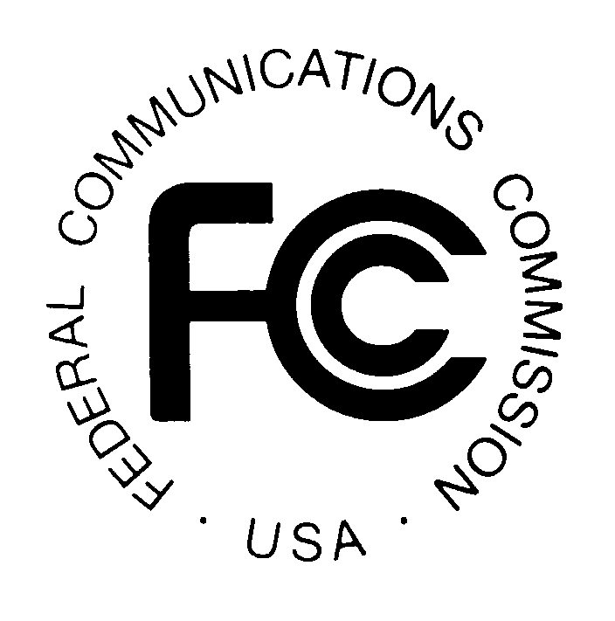

Datasets and Potential Research Questions 2013

Posted to the FCC blog on September 27, 2013 (revised October 18, 2013)

Introduction
To encourage dialogue between FCC staff and the research community, the following list contains ideas for research questions that are related to communications policy. A list of publicly available FCC data sets is also provided. The intent is to identify topics for research that could contribute scientific, economic and other expert knowledge and information that may be relevant to communications policy. While there may be existing literature in these areas, we have sought to identify topics for which additional scholarly research may be fruitful. For most questions, the FCC staffer who originated the topic is listed: staff may guide researchers to publicly available data on the topic already released by the FCC. This is not a solicitation of work and no funding has been or is expected to be obligated for any contractual undertakings. The list is designed primarily to promote discussion and to point researchers towards topics for research that are relevant to policy matters that may be considered by the Commission. Any efforts expended by researchers to address these topics are completely voluntary and no compensation of any kind will be provided by the FCC for any work that may follow. If you have further questions about this list, please contact International Bureau Senior Analyst Irene Wu (Irene.Wu@fcc.gov).

- Public Datasets

This is a sample list. Feel free to contact FCC staff with questions about additional publicly available datasets.

1. Broadcast ownership data as of November 1, 2009 and October 1, 2011. The Form 323 collects ownership information biennially for commercial broadcast licenses. In 2009, the Federal Communications Commission revised this report to obtain more complete, reliable, and accurate data on racial and ethnic minority and female broadcast ownership. Judith.Herman@fcc.gov
- See link http://transition.fcc.gov/bureaus/mb/industry_analysis/DA-12-1667-Report-Data.zip for data
- See link http://www.fcc.gov/document/report-ownership-commercial-broadcast-stations for background report
2. International traffic data. The FCC publishes data on international voice traffic between the U.S. and all other foreign countries. The data are cross-sectional, time series data from 1992-2010 see http://transition.fcc.gov/wcb/iatd/intl.html. Starting in 2014, the FCC expects that the data collection will expand to include VOIP between the U.S. and all other countries. Mark.Uretsky@fcc.gov
2. Video competition report. The FCC's 15th annual report on video competition is available at http://hraunfoss.fcc.gov/edocs_public/attachmatch/FCC-13-99A1.pdf. http://hraunfoss.fcc.gov/edocs_public/attachmatch/FCC-12-81A1.pdf See Key Industry Input section for history of online media. Marcia.Glauberman@fcc.gov

3. CDBS. CDBS is the FCC’s official licensing system for broadcast authorizations. CDBS contains the license applications and authorizations for broadcast services. The public can access CDBS at: http://licensing.fcc.gov/prod/cdbs/pubacc/prod/cdbs_pa.htm

4. Local telephone competition and Internet access services data. The FCC's Form 477 data contains time series on subscribership for Internet access, landline telephone, mobile telephone, and interconnected VoIP services. http:://transition.fcc.gov.wcb/iatd/stats.html

5. International broadband prices. The FCC's International Broadband Data Report contains price information on broadband offers around the world, over time. See http://www.fcc.gov/document/international-broadband-data-report. Arthur.Lechtman@fcc.gov

6. Broadband performance data. The FCC's Measuring Broadband America dataset is an ongoing nationwide study of residential broadband performance in the United States. This study, like those conducted before, involves actual performance tests for thousands of subscribers of Internet Service Providers (ISPs) serving well over 80 percent of the residential market. http://www.fcc.gov/measuring-broadband-america Henning.Schulzrinne@fcc.gov andWalter.Johnston@fcc.gov

7. Consumer complaints to the FCC. The FCC publishes quarterly the categories of consumer complaints received by the agency. http://www.fcc.gov/encyclopedia/quarterly-reports-consumer-inquiries-and-complaints Keyla.Hernandez-Ulloa@fcc.gov

8. Wireless ownership data. The Form 602 collects ownership information for applicants/licensees in Wireless Radio Services that are subject to the ownership reporting requirements of Section 1.2112 of the FCC’s rules. See link: http://wireless2.fcc.gov/UlsApp/ownershipSearch/query.jsp Diane.Dupert@fcc.gov

9. Universal Licensing System (ULS). The Universal Licensing System (ULS) is the FCC’s official licensing system for most wireless authorizations (excluding broadcast and satellite). ULS contains the license applications and authorizations for wireless services from fixed microwave links to amateur radio to mobile broadband services, as well as others. The ULS database is available for download at: http://wireless.fcc.gov/uls/index.htm?job=transaction&page=weekly Diane.Dupert@fcc.gov

10. Spectrum Dashboard. The Spectrum Dashboard provides a public means of reviewing how spectrum bands are allocated and for what uses, and who holds licenses and in what areas. This version provides basic, plain language information about frequencies generally deemed appropriate for mobile broadband (225 MHz to 3700 MHz). In addition, the Spectrum Dashboard contains more detailed information, mapping, and research capabilities for the bands where broadband service is either already available, or potentially could be provided. See link: www.fcc.gov/spectrumdashboard Diane.Dupert@fcc.gov

11. Annual Mobile Wireless Competition Report. The Commission’s Mobile Wireless Competition Report analyzes competitive marketplace conditions in the mobile wireless industry over time and contains an overview of the mobile wireless ecosystem. See link: http://www.fcc.gov/reports?filter_terms%5B96%5D=96&op=Apply+Filter Leon.Jackler@fcc.gov

B. Information that Could Be Built into a Dataset

1. For 911 calls, how many are made from indoors or outdoors? How many use automatic location information versus street address provided verbally to the 911 operator? Henning.Schulzrinne@fcc.gov
2. Consumer information. The FCC already provides at least two tools that allow consumers to type in an address and find information about communications services: the digital television map, http://transition.fcc.gov/mb/engineering/dtvmaps , and the national broadband map, http://broadbandmap.gov. What other tools would be useful? Would it be useful to provide contact information for communications industry or relevant government agencies’ customer service centers? David.Savolaine@fcc.gov

3. How much local market price and quality variation occurs in the U.S. wireless industry? aleks.yankelevich@fcc.gov

4. What is the current U.S. and global market size of cloud computing, per service type i.e., SaaS, LaaS, PaaS and NaaS? Ahmed.Lahjouji@fcc.gov

5. What will be the projected U.S. and global market size of cloud computing, per service type, in the next decade or two? Ahmed.Lahjouji@fcc.gov

C. Research Questions

Prices
1. Elasticity studies. It may be possible to calculate price elasticity of demand and/or income elasticity of demand for international voice calls over the last 25 years, a period of growing competition in telecom markets around the world. The FCC publishes cross-sectional, time series data from 1992-2010 (see http://transition.fcc.gov/wcb/iatd/intl.html). Mark.Uretsky@fcc.gov
2. Pricing of components within bundled communications service offers. Many communications services are offered as bundles containing regulated, unregulated, and deregulated services. How can price regulation, where still applicable, work in the context or presence of bundled communications service offerings? Are billing or survey data available to address this question? Henning.Schulzrinne@fcc.gov

Governance
3. What suggestions have been made to deal with the credibility challenges representative authorities have in making global Internet policy decisions, generally and specifically for technical decisions like assigning numbering resources, ensuring cybersecurity, and protecting privacy? Kiran.Duwadi@fcc.gov

4. Consumer mailbag. What kinds of mechanisms for online interaction exist now for regulatory agencies? What techniques are being used by other government agencies and how do they measure their effectiveness? David.Savolaine@fcc.gov
Enabling substitution and switching
5. The new Part 43 FCC international reporting requirements are expanding reporting of voice minutes that are connected to the PSTN on one or both ends, but do not include IP to IP calling. Is there anyone – perhaps companies that track eyeballs or advertising revenue – who may be in a position to actually track the number of minutes (volume) of IP-to-IP voice calling? Mark.Uretsky@fcc.gov and Sherille.Ismail@fcc.gov

Service quality and performance
6. What are the implications of high K_{a}-band satellite broadband service? One of the goals of universal service is to provide reasonably comparable access to broadband in rural areas at rates reasonably comparable to urban rates. What data are available to evaluate current service quality and performance of K_{a} -band satellite broadband to rural areas in the U.S. ? Soumitra.Das@fcc.gov
7. The FCC now gathers a range of broadband performance indicators that are highly correlated. What is their relationship with each other? Which of these are independent or dependent variables? Henning.Schulzrinne@fcc.gov

8. How have historical and projected analysis of downstream to upstream bandwidth requirement ratios changed? How are they changing? What can be forecast for changes? What applications are driving these changes? How are these changes affecting network design? What are the technical and economic impacts for future network infrastructures?

9. What are the approaches different companies and countries use to determine the performance of broadband networks for use in a regulatory environment? What are the necessary design considerations that should be applied? How could the validity of the solutions resulting from this framework be established, including through controlled experiments? What analytical methods should be applied to analyze the output of such monitoring and testing systems? Can the Measuring Broadband America dataset be used to answer this question (http://www.fcc.gov/measuring-broadband-america)? Henning.Schulzrinne@fcc.gov

10. What is the reliability of handset-provided location data? Henning.Schulrzinne@fcc.gov

11. What information is available regarding the current technical systems used by service providers to handle call timing when carrying wireless initiated voice over Ethernet-based backhaul networks? What technical solutions have service providers chosen to handle call timing, and what are they likely to choose in the future? What are the economic costs for the various technical solutions?
Applications
12. What is the relationship between broadband performance metrics (like throughput and delay) and application-specific data (such as voice and video)? Henning.Schulzrinne@fcc.gov

13. What is the best way to assess how much bandwidth a school needs? Do schools with a small number of students have different bandwidth requirements than those with a large number of students, for example? What is the impact of rurality on a school’s bandwidth needs? Soumitra.Das@fcc.gov

Universal Service
14. What kinds of network configurations make sense for different kinds of schools – for example, a suburban school of 2000 or an urban school of 500? Can diagrams of these networks be cataloged and made easily available to schools? Mark.Nadel@fcc.gov

15. What is the likely evolution of innovations such as flipped classrooms and online courses in the education arena? Does the assumption that K-12 education centers at schools' geographic location still hold? Mark.Nadel@fcc.gov

16. In a number of federal programs, federal funding is available to designated recipients to achieve public policy objectives, with some form of co-payment or minimum payment required of the recipient. What are examples of successful programs that require co-payment or funding from non-federal sources, and what is the relative amount of federal funding for such programs? What level of federal funding provides appropriate incentives to recipients to efficiently upgrade infrastructure? Soumitra.Das@fcc.gov, Steve.Wildman@fcc.gov

Public safety and security
17. What is the magnitude of consumer concern or complaints with regard to WIFI security? David.Savolaine@fcc.gov

18. What impact will cloud-based outages have on the U.S. and global economy? Ahmed.Lahjouji@fcc.gov

