FEDERAL COMMUNICATIONS COMMISSION
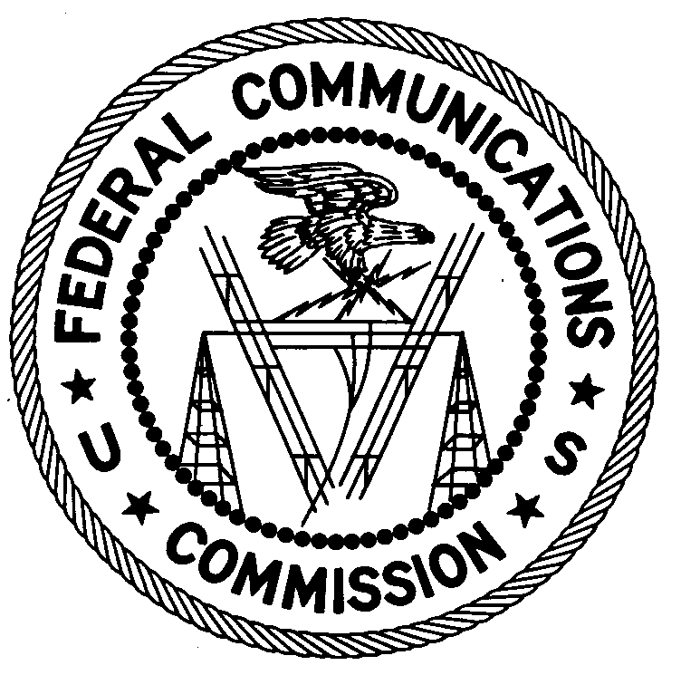
ENFORCEMENT BUREAU
WESTERN REGION

Los Angeles Office
18000 Studebaker Rd, #660

Cerritos, CA 90703
562-860-7474

October 31, 2013

Leon Krous
Leon Krous Drilling
Sylmar, California 91342

NOTICE OF UNLICENSED OPERATION

Case Number: EB-FIELDWR-13-00011681

Document Number: W201432900001

The Los Angeles Office received a complaint concerning harmful interference being caused to the licensed Beverly Hills Police Department radio communication system on 458.525 MHz. On October 4, 2013, an agent of the Los Angeles Office determined by direction finding techniques that a radio signal on the frequency 458.525 MHz was emanating from a construction site located at 141 N Clark Drive in Hollywood, California. You are identified as the Drilling Contractor for this construction site. A wireless device manufactured by Cavotec controlling drilling machinery was found to be the source of the harmful emission. The Commission’s records show that no license was issued for operation on 458.525 MHz in the Los Angeles metro area other than the Beverly Hills Police Department.

Radio stations must be licensed by the FCC pursuant to 47 U.S.C. § 301. The only exception to this licensing requirement is for certain transmitters using or operating at a power level that complies with the standards established in Part 15 of the Commission’s rules, 47 C.F.R. §§ 15.1 et seq. The field strength of the signal on frequency 458.525 MHz exceeded the maximum permitted level of 200 microvolts per meter (µV/m) at 3 meters for non-licensed devices. Thus, this station is operating in violation of 47 U.S.C. § 301. An FCC license is required for operation of the device in question.

You are hereby warned that operation of radio transmitting equipment without a valid radio station authorization constitutes a violation of the Federal laws cited above and could subject the operator of this illegal operation to severe penalties, including, but not limited to, substantial monetary forfeitures, in rem arrest action against the offending radio equipment, and criminal sanctions including imprisonment. (see 47 U.S.C. §§ 401, 501, 503 and 510).

UNLICENSED OPERATION OF THIS RADIO STATION MUST BE DISCONTINUED IMMEDIATELY.

You have ten (10) days from the date of this notice to respond with proof of your license or authority to operate granted by the FCC. Your response should be sent to the address in the letterhead and reference the listed case and document number. Under the Privacy Act of 1974, 5 U.S.C. § 552a(e)(3), we are informing you that the Commission’s staff will use all relevant material information before it to determine what, if any, enforcement action is required to ensure your compliance with FCC Rules. This will include any information that you disclose in your reply. In the reply, also identify the company and contact person of where the device was purchased.

You may contact this office if you have any questions.

Charles A. Cooper
District Director
Los Angeles Office

Attachments:
Excerpts from the Communications Act of 1934, As Amended
Enforcement Bureau, “Inspection Fact Sheet,” March 2005

