FEDERAL COMMUNICATIONS COMMISSION
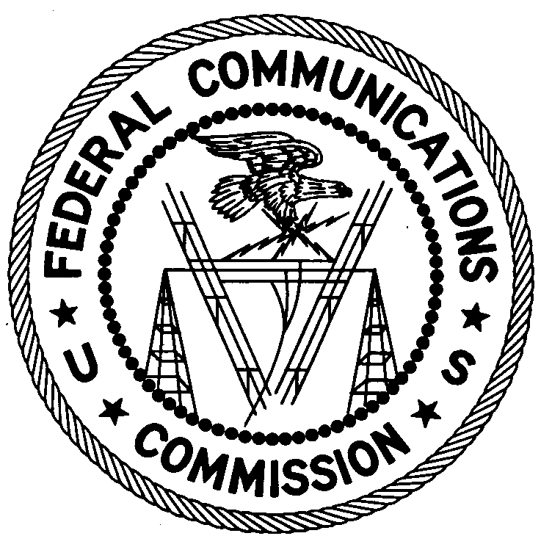
ENFORCEMENT BUREAU
WESTERN REGION

Los Angeles Office
18000 Studebaker Road, Suite 660

Cerritos, CA 90703
(562) 860-7474

November 21, 2013

Rosalia and Ricardo Rodriguez
Newhall, CA 91321

NOTICE OF UNLICENSED OPERATION

Case Number: EB-FIELDWR-13-00010322

Document Number: W201432900006

The Los Angeles Office received information that an unlicensed broadcast radio station on 95.1 MHz was allegedly operating in Pacoima, CA. On November 7, 2013, agents from this office confirmed by direction finding techniques that radio signals on frequency 95.1 MHz were emanating from Centro Cristiano Puerta de Bendicion at 10556 Ilex Ave, Pacoima, CA. Public records indicate you are the owners of the property. The Commission’s records show that no license was issued for operation of a broadcast station at this location on 95.1 MHz in Pacoima, CA.

Radio stations must be licensed by the FCC pursuant to 47 U.S.C. § 301. The only exception to this licensing requirement is for certain transmitters using or operating at a power level that complies with the standards established in Part 15 of the Commission’s rules, 47 C.F.R. §§ 15.1 et seq. The field strength of the signal on frequency 95.1 MHz exceeded the maximum permitted level of 250 microvolts per meter (µV/m) at 3 meters for non-licensed devices. Thus, this station is operating in violation of 47 U.S.C. § 301.

You are hereby warned that operation of radio transmitting equipment without a valid radio station authorization constitutes a violation of the Federal laws cited above and could subject the operator of this illegal operation to severe penalties, including, but not limited to, substantial monetary forfeitures, in rem arrest action against the offending radio equipment, and criminal sanctions including imprisonment. (See 47 U.S.C. §§ 401, 501, 503 and 510).

UNLICENSED OPERATION OF THIS RADIO STATION MUST BE DISCONTINUED IMMEDIATELY.

You have ten (10) days from the date of this notice to respond with proof of your license or authority to operate granted by the FCC. Your response should be sent to the address in the letterhead and reference the listed case and document number. Under the Privacy Act of 1974, 5 U.S.C. § 552a(e)(3), we are informing you that the Commission’s staff will use all relevant material information before it to determine what, if any, enforcement action is required to ensure your compliance with FCC Rules. This will include any information that you disclose in your reply.

You may contact this office if you have any questions.

Charles A. Cooper
District Director
Los Angeles Office

Attachments:
Excerpts from the Communications Act of 1934, As Amended
Enforcement Bureau, “Inspection Fact Sheet,” March 2005

