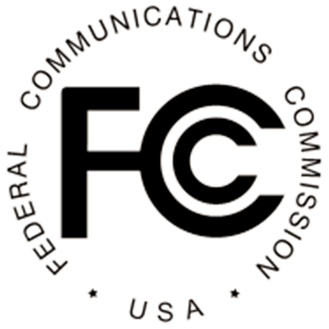 NEWS
Federal Communications Commission
445 12th Street, S.W. Washington, D. C. 20554

News Media Information 202 / 418-0500
Internet: http://www.fcc.gov
TTY: 1-888-835-5322

This is an unofficial announcement of Commission action. Release of the full text of a Commission order constitutes official action. See MCI v. FCC. 515 F 2d 385 (D.C. Circ 1974).

FOR IMMEDIATE RELEASE: NEWS MEDIA CONTACT: April 11, 2014 Mike Snyder, 202-418-0997
Email: michael.snyder@fcc.gov

FCC TO HOLD WORKSHOP IN HONOR OF OLDER AMERICANS MONTH

STAY SAFE, STAY HEALTHY, STAY CONNECTED

Washington, D.C. – In recognition of Older Americans Month, the FCC’s Consumer and Governmental Affairs Bureau will host a workshop on Thursday, May 22, 2014, in Washington, D.C. The workshop will provide information on online safety, communicating during emergencies, and how broadband and other technologies can be used to facilitate aging in place and telehealth. The event will include technology demonstrations.

What: Stay Safe, Stay Healthy, Stay Connected Workshop

When: 10:00 a.m. – 12:00 p.m.
Thursday, May 22, 2014

Where: FCC Commission Meeting Room
445 12th Street, S.W. Washington, D.C. 20554

An agenda, with a list of presenters, will be released at a later date. Details will be posted on our web site at: http://www.fcc.gov/events/workshop-older-americans-stay-safe-healthy-and-connected

The event is free and open to the public. The closest Metro stops to the FCC’s headquarters are Smithsonian and L’Enfant Plaza. Public parking is adjacent to the main entrance of the FCC on 12th Street, SW. Please bring valid government-issued identification to present to security at the building entrance.

The FCC will attempt to accommodate as many attendees as possible; however, admittance will be limited to seating availability. A free webcast of the live event, with open captioning over the Internet, will be available at FCC.gov/live.

Reasonable accommodations for people with disabilities are available upon request. Include a description of the accommodation and contact information in case we need more information. Make your request as early as possible by sending an e-mail to fcc504@fcc.gov or calling the Consumer & Governmental Affairs Bureau at 202-418-0530 (voice), 202-418-0432 (TTY).

For additional information about this event, please contact Anthony Butler by e-mail at Anthony.Butler@fcc.gov; or by phone at: 202.418.2372.

For more information about Older Americans Month, visit http://www.acl.gov/NewsRoom/Observances/oam/2014/Index.aspx

-FCC-

