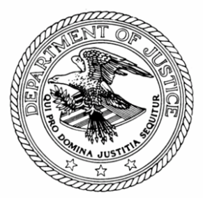
United States Attorney’s Office
Southern District of New York

U.S. Attorney Preet Bharara

FOR IMMEDIATE RELEASE CONTACT: U.S. ATTORNEY’S OFFICE
Monday, April 14, 2014 James Margolin, Jerika Richardson,
http://www.justice.gov/usao/nys Jennifer Queliz
(212) 637-2600

FCC
Mark Wigfield
(202) 418-0253

MANHATTAN U.S. ATTORNEY ANNOUNCES SEIZURE OF RADIO EQUIPMENT FROM PIRATE RADIO STATIONS

Preet Bharara, the United States Attorney for the Southern District of New York, and Travis LeBlanc, Acting Enforcement Bureau Chief of the Federal Communications Commission (“FCC”), announced the unsealing of two complaints seeking the forfeiture of radio transmission and production equipment allegedly used in the illegal broadcast of pirate radio stations on a total of four different FM frequencies, and further announced that on April 2, 2014, FCC agents and Deputy U.S. Marshals, pursuant to warrants, seized the radio transmission and production equipment identified in the two complaints.
The Communications Act of 1934 makes it unlawful to operate radio broadcasting equipment above certain low-intensity thresholds without having a license issued by the FCC, and authorizes the seizure and forfeiture of any equipment used with willful and knowing intent to broadcast without an FCC license.

FCC Acting Enforcement Bureau Chief Travis LeBlanc said: “As alleged, these pirate radio stations were for-profit businesses that broke the law to line their own pockets while disrupting legitimate broadcasters. They should be out of business and off the air.”

According to the two Complaints unsealed in Manhattan federal court, and various unsealed documents associated with the two warrants executed on April 2:

FCC agents identified a commercial space at 80-84 West 181st Street in the Bronx as the production studio for “Rika FM,” which illegally broadcasts its programming on 94.5 and 94.9 MHZ. FCC agents also identified a residence at 1370 St. Nicholas Avenue in Manhattan as the location of the radio transmission equipment by means of which “Rika FM” was illegally broadcast.

FCC agents also identified radio transmission equipment at a second residence at 1370 St. Nicholas Avenue in Manhattan that was being used to illegally broadcast on 95.3 MHZ and 100.1 MHZ.

Mr. Bharara praised the investigative work of the Federal Communications Commission and also thanked the United States Marshals Service for its assistance.
Assistant United States Attorney Arastu K. Chaudhury is in charge of these cases.

14-107 # # #

