Modernizing E-Rate:
Providing 21st Century Wi-Fi Networks
For Schools and Libraries across America

Federal Communications Commission
July 1, 2014

“Eighteen years ago, the idea of a student-accessible computer in the school building was a revolutionary concept. Thanks to E-Rate that rarity became commonplace and computers moved into classrooms. Now with the next generation of E-Rate, we are harnessing innovation to put that power directly in front of the student.”

FCC Chairman Tom Wheeler
National Digital Learning Day
February 5, 2014

I. Modernizing E-Rate to Deliver Digital Learning Faster
Established in 1996, the FCC’s E-Rate program is the federal government’s largest educational technology program – supporting Internet connectivity and other communications services for schools and libraries. Despite the increasing need for wireless connectivity to support the latest digital learning tools like tablets and interactive textbooks, the E-Rate program currently provides limited support for Wi-Fi.

On July 11, 2014, the FCC will vote on an E-Rate modernization proposal that would dramatically increase support for Wi-Fi connections in schools and libraries. FCC Chairman Tom Wheeler put forward this proposal as the first step in comprehensively modernizing the program. The proposal has three goals:
- Close the Wi-Fi gap – get high-speed Internet to all classrooms and libraries by 2019.
- Make the program rules fairer – ensure funding is available to the vast majority of schools and libraries, not just a few.
- Maximize existing funds – streamline the program and make it faster, simpler, more efficient for all schools and libraries
The following analysis provides a state-by-state breakdown of the estimated number of additional students, schools, and libraries that would gain the funding needed for Wi-Fi upgrades under the pending proposal.

High-speed Internet: Transforming our schools and libraries
High-speed Internet connectivity is transforming almost every aspect of our economy and society. Few areas hold more potential for technology-driven improvements than our nation’s schools and libraries.

Connecting classrooms to the Internet connects students to a world of almost infinite information online. It makes it possible for students in the most rural and remote communities who cannot otherwise take AP Physics or Calculus to do so remotely at their own school. And more powerful and affordable computers and mobile devices, coupled with new software, are enabling new interactive educational content; tools for student collaboration, student-teacher communication, and lesson planning; and remote tutoring.

The use of modern online tools, powered by high-speed Internet access and Wi-Fi, is revolutionizing classroom instruction. Rather than delivering a one-size-fits-all lecture at the front of the classroom, teachers are using technology to assess their students’ work in real-time and offer more individually-focused instruction tailored to each student’s strengths and weaknesses. Online learning also helps to ensure that American students have the digital literacy skills they need to compete in the 21st Century global information economy.

High-speed Internet is also transforming the roles of our libraries as places of learning and hubs of information. In community after community the library is the only place where students can go after school for free Internet access to complete homework assignments. And during the summer, libraries are the only place many students can go to continue their online exploration and learning. Many young adults rely on libraries to study for and take General Educational Development (GED) tests, as well as college and graduate-level courses. In addition, tens of millions of adult Americans use library computers to look for a job or learn new job skills, to apply for health insurance, or to access government services.

The Educational Digital Divide
One essential ingredient for unlocking the potential of digital learning is high-speed wireless connectivity in every classroom and every library workspace. Bringing wireless connectivity, through Wi-Fi, fundamentally changes the classroom from one that is static and restrictive to one that is dynamic and expansive, giving both teachers and students new ways to engage and learn. As the President said a year ago in announcing the ConnectED initiative, “[i]n a Nation where we expect free Wi-Fi with our coffee, why shouldn’t we have it in our schools?”

Yet, according to several studies, most schools and libraries lack robust Wi-Fi. A survey of district technology leaders last year led by the Consortium for School Networking (CoSN), found that only 43 percent of public school districts report that their internal connections are capable of supporting a one device (e.g., tablet, laptop) per student deployment.

The CoSN survey also found that 50 percent of schools lack the internal wiring needed to support the high-speed connections needed in today’s schools and that 28 percent of districts are using slower copper or wireless backbones in their school local area networks (LANs). While most public libraries offer some form of wireless local area network (WLAN) Internet access, libraries report that they are increasingly unable to meet growing demand.

Bringing E-Rate in to the 21st Century
The FCC’s E-Rate program has long been a vital source of support for communications services in schools and libraries. Yet it is not currently meeting the need for Wi-Fi, due in large part to the program’s structure.

E-Rate funding is currently broken into two categories:
- Priority 1 (telecommunications services, telecommunications, and Internet access services) and
- Priority 2 (internal connections and basic maintenance of internal connections).

Funding for Priority 2 is only available after all Priority 1 requests are funded. In Funding Year 2012, only the Priority 2 requests from the most impoverished schools (those eligible for a 90 percent discount rate) were funded. In Funding Year 2013, no funding was available for Priority 2 requests.

In addition, as illustrated in Figures 1 and 2, funding for internal connections has reached very few schools and libraries. From 2008 to 2013, E-Rate supported internal connections in just 4 to 11 percent of the more than 100,000 schools participating in the program each year.

Figure 1: E-Rate Funding for Internal Connections in Schools 2008-2013

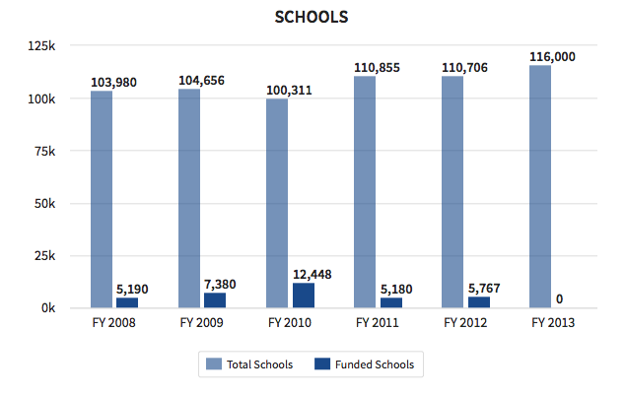

For libraries, the situation is even worse. In each of the last five years, no more than 3 percent of public library locations received a funding commitment for internal connections support, and in recent years that funding was available, the number was just 1 percent. In other words, just 100 to 200 libraries – out of almost 17,000 eligible libraries nationwide – received any E-rate funding at all for Wi-Fi.

Figure 2: E-Rate Funding for Internal Connections in Libraries 2008-2013

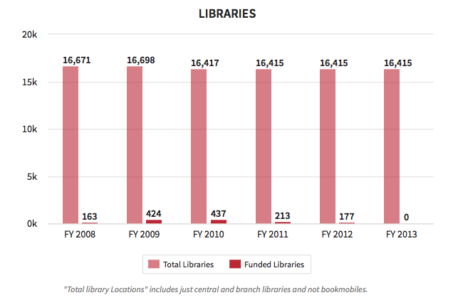
II. Closing the Wi-Fi Gap
Strategic adjustments in the operation of the E-Rate program can begin to quickly fill this Wi-Fi gap. The FCC and the program administrator, the Universal Service Administrative Company (USAC), are in the midst of implementing improved financial management practices to more quickly put to use excess cash balances. These changes are on track to free up $2 billion of new funding over the next two years – a billion to be spent in each of 2015 and 2016 – that would be invested in Wi-Fi upgrades under the new proposal.

Figure 3: Increase in E-Rate Funding for Wi-Fi in 2015 and 2016

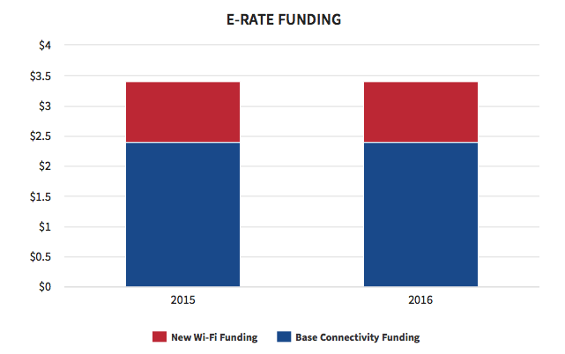

Maximize existing funds
Funds for the following three years would come from two significant changes. First, the Commission would phase down support for non-broadband services, like pagers, email and, over a multi-year period, voice service. Those funds – nearly $1.2 billion in the E-Rate program today – would be repurposed to support Wi-Fi. Second, the Commission would drive significant cost savings for broadband services by making prices more transparent and facilitating greater use of consortia-enabled bulk purchasing.

In addition, the FCC Chairman has proposed additional reforms that would allocate funding for Wi-Fi in a more equitable manner, helping schools and libraries gain access to critical network management services for today’s more complex networks, and bringing connectivity to millions of additional students and library patrons. As part of the Commission's ongoing modernization effort we will continue to assess long-term funding requirements.

More Wi-Fi for Rural, Urban Schools and Libraries
Modernizing our rules to facilitate investment in Wi-Fi would result in a 75 percent increase in Wi-Fi funding for rural areas, which have been disproportionately shut out by the current system. Under existing rules rural schools on average receive 25 percent less Wi-Fi funding for every student, and 50 percent less funding for every school, compared to their non-rural peers, because the current rules often put them at the back of the line.

Figure 4: Projected Increase in Rural School Funding for Internal Connections 2015-2019
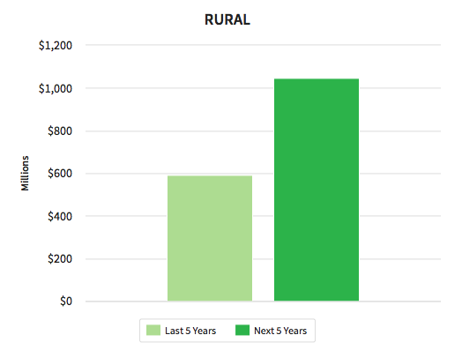

While increasing access to rural schools and libraries, the proposal would also dramatically increase Wi-Fi funding to non-rural schools. By the end of 2019, urban and suburban schools would see a 60 percent increase in funding compared to the last five years.

Figure 5: Projected Increase in Urban and Suburban School Funding for Internal Connections 2015-2019

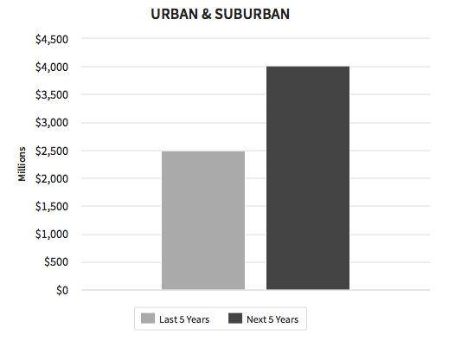
Maximizing current funds, connecting millions
This proposal, if adopted, would inject $2 billion dollars in new repurposed funding in 2015 and 2016, and, combined with the associated programmatic reforms, would result in millions more students, tens of thousands of additional schools, and thousands of additional libraries getting support for badly needed Wi-Fi upgrades by 2019. These positive impacts would be felt in every state nationwide.

Figure 6: Projected increase in students at schools receiving funding for Wi-Fi upgrades by 2019.

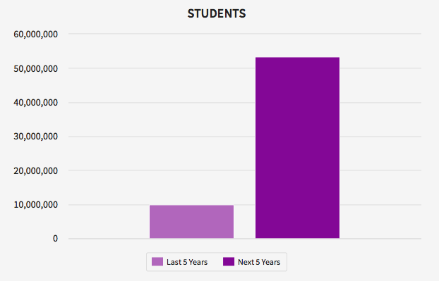
State Impacts
Section III provides a state-by-state breakdown of the estimated additional students, schools, and libraries that would gain the funding needed for Wi-Fi upgrades under the Chairman’s proposal. For each state, FCC staff compared the number of schools (all public and non-profit elementary and secondary schools in the state, except those with large private endowments) that received internal connections funding over the last five years to the number that would have guaranteed available Wi-Fi funding over the next five years under the proposed order. The table shows the increase in funded schools, as well as the number of students attending those schools. It also shows the increase in funded libraries. In each case, the table also shows the percentage increase—for example, if twice as many schools will receive funding over the next five years as received funding over the last five years, the table shows a 100% increase.

Wi-Fi upgrades are by no means the only piece of the puzzle when it comes to connecting all students to the benefits of digital learning and supporting all libraries in bringing robust connectivity to their communities. But by acting now, the FCC can move forward on these critical program updates this summer, even as it continues to work on other aspects of modernizing this large, complex, but vital program for 21st Century learning.

III. State by State Benefits of the Proposed E-Rate Modernization Order
Next 5 Years vs. Last 5 Years

State | Additional Students | % Change in Students Impact | Additional  Schools | Additional  Libraries | Additional Schools  & Libraries | % Change in Schools  & Libraries Funded
Alaska | 124,619 | 1132% | 449 | 107 | 556 | 479%
Alabama | 476,864 | 150% | 1,113 | 295 | 1,408 | 222%
Arkansas | 408,286 | 427% | 982 | 221 | 1,203 | 463%
Arizona | 776,834 | 224% | 1,834 | 198 | 2,032 | 320%
California | 5,377,301 | 401% | 10,755 | 1,083 | 11,838 | 467%
Colorado | 740,583 | 506% | 1,835 | 249 | 2,084 | 624%
Connecticut | 572,479 | 1189% | 1,384 | 242 | 1,626 | 1344%
District of Columbia | 70,120 | 439% | 245 | 0 | 245 | 310%
Delaware | 146,404 | 3470% | 323 | 32 | 355 | 4438%
Florida | 2,156,550 | 285% | 4,447 | 518 | 4,965 | 412%
Georgia | 1,276,445 | 247% | 2,138 | 380 | 2,518 | 288%
Hawaii | 188,020 | 809% | 367 | 51 | 418 | 889%
Iowa | 467,711 | 856% | 1,516 | 564 | 2,080 | 1612%
Idaho | 259,187 | 961% | 726 | 143 | 869 | 924%
Illinois | 2,069,263 | 875% | 5,210 | 793 | 6,003 | 1095%
Indiana | 1,022,699 | 903% | 2,345 | 431 | 2,776 | 1245%
Kansas | 470,693 | 1006% | 1,443 | 368 | 1,811 | 1215%
Kentucky | 465,138 | 176% | 1,100 | 199 | 1,299 | 207%
Louisiana | 620,709 | 325% | 1,360 | 272 | 1,632 | 306%
Massachusetts | 967,510 | 987% | 2,343 | 432 | 2,775 | 1101%
Maryland | 856,452 | 739% | 1,850 | 164 | 2,014 | 629%
Maine | 180,211 | 914% | 691 | 272 | 963 | 1376%
Michigan | 1,468,497 | 712% | 3,853 | 648 | 4,501 | 820%
Minnesota | 833,540 | 1030% | 2,470 | 360 | 2,830 | 1169%
Missouri | 910,761 | 875% | 2,577 | 345 | 2,922 | 984%
Mississippi | 325,631 | 158% | 649 | 184 | 833 | 159%
Montana | 140,009 | 1487% | 868 | 111 | 979 | 1659%
North Carolina | 1,210,542 | 328% | 2,296 | 379 | 2,675 | 331%
North Dakota | 101,037 | 2210% | 518 | 91 | 609 | 3806%
Nebraska | 325,206 | 5082% | 1,205 | 286 | 1,491 | 6777%
New Hampshire | 209,174 | 4480% | 736 | 235 | 971 | 6936%
New Jersey | 1,270,843 | 506% | 3,060 | 425 | 3,485 | 523%
New Mexico | 225,765 | 163% | 637 | 109 | 746 | 173%
Nevada | 426,062 | 1426% | 727 | 88 | 815 | 1315%
New York | 2,241,532 | 254% | 4,588 | 924 | 5,512 | 264%
Ohio | 1,741,184 | 866% | 4,142 | 695 | 4,837 | 873%
Oklahoma | 458,182 | 200% | 1,086 | 154 | 1,240 | 134%
Oregon | 495,526 | 496% | 1,459 | 214 | 1,673 | 644%
Pennsylvania | 1,684,486 | 521% | 4,539 | 533 | 5,072 | 633%
Rhode Island | 132,623 | 431% | 374 | 61 | 435 | 449%
South Carolina | 530,793 | 222% | 1,032 | 183 | 1,215 | 249%
South Dakota | 127,935 | 951% | 723 | 148 | 871 | 1300%
Tennessee | 899,547 | 536% | 1,849 | 287 | 2,136 | 595%
Texas | 4,144,033 | 412% | 8,148 | 834 | 8,982 | 489%
Utah | 563,912 | 1484% | 1,032 | 126 | 1,158 | 1182%
Virginia | 1,228,312 | 1051% | 2,367 | 332 | 2,699 | 1097%
Vermont | 89,635 | 2060% | 394 | 185 | 579 | 2517%
Washington | 966,487 | 635% | 2,480 | 337 | 2,817 | 751%
Wisconsin | 850,706 | 635% | 2,777 | 461 | 3,238 | 1062%
West Virginia | 253,463 | 621% | 739 | 164 | 903 | 717%
Wyoming | 87,378 | 2597% | 369 | 76 | 445 | 2119%
Total | 43,636,879 |  | 102,150 | 15,989 | 118,139

