Prepared Remarks of FCC Chairman Tom Wheeler
“The Facts and Future of Broadband Competition”
1776 Headquarters, Washington, D.C.
September 4, 2014

It’s great to be here at 1776 – “Where Revolutions Begin.” Two of my great passions are technology and history; so clearly, I’m a fan of this place. A U.S. history-themed startup incubator? Are you kidding me? It’s as if I designed my own amusement park!

Revolutionary technological ideas, like those here at 1776, are developing at a never-before-seen pace, all because of the Internet. Our economic future is inexorably tied to the continued expansion of the Internet. That is why today I’ve come here to address an essential key to that future: the state of broadband competition.

More specifically, I want to discuss how the growing bandwidth demands of businesses and consumers are changing the competitive broadband landscape. My goal is not to criticize, but to recognize that meaningful competition for high-speed wired broadband is lacking and Americans need more competitive choices for faster and better Internet connections, both to take advantage of today’s new services, and to incentivize the development of tomorrow’s innovations.

At the beginning of my term I spoke about the Network Compact, those immutable values consumers have a right to expect from their network providers – such as access, interconnection, consumer protection, public safety and national security. The goal of public policy should be to protect that Network Compact across all aspects of telecommunications.

In a similar vein, there should be an Agenda for Broadband Competition that establishes principles for all of our broadband activities. I say “principles” because they should be broad enough to reach across all the specific broadband policy issues, yet clear enough to be a roadmap.

The underpinning of broadband policy today is that competition is the most effective tool for driving innovation, investment, and consumer and economic benefits. Unfortunately, the reality we face today is that as bandwidth increases, competitive choice decreases. This chart says it all:
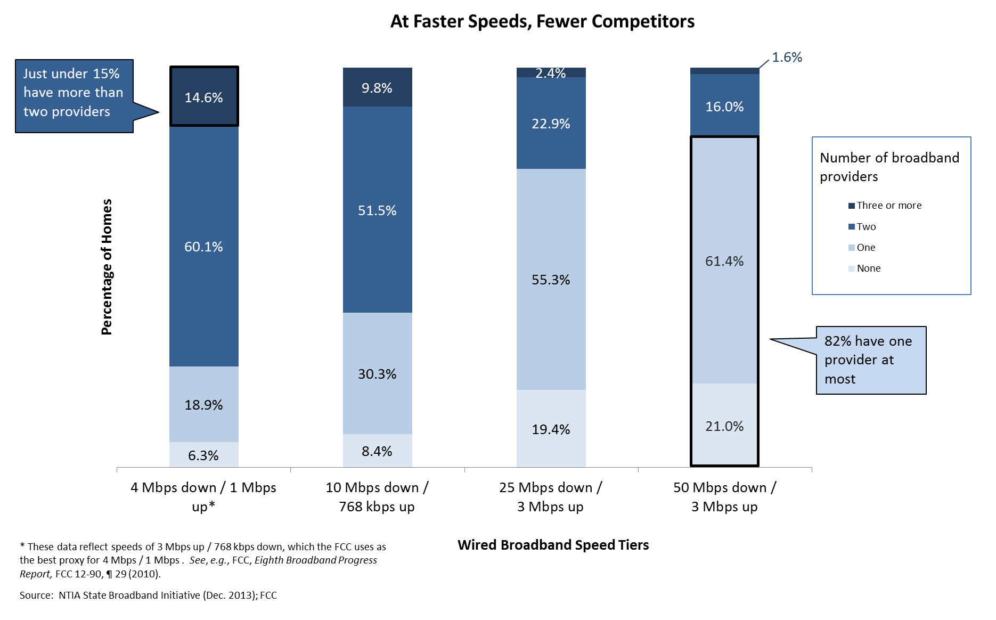

The lighter the blue, the fewer the options. You get the point.

The bar on the left reflects the availability of wired broadband using the FCC’s current broadband definition of 4 Mbps. But let’s be clear, this is “yesterday’s broadband.” Four megabits per second isn’t adequate when a single HD video delivered to home or classroom requires 5 Mbps of capacity. This is why we have proposed updating the broadband speed required for universal service support to 10 Mbps.

But even 10 Mbps doesn’t fully capture the increasing demand for better wired broadband, of which downstream speed is, of course, only one component. It’s not uncommon for a U.S. Internet-connected household to have six or more connected devices – including televisions, desktops, laptops, tablets, and smartphones. When these devices are used at the same time, as they often are in the evenings, it’s not hard to overwhelm 10 Mbps of bandwidth.

And consumer demand is growing; today over 60% of peak-time downloads are streaming audio and video. While today that video may be for entertainment, other applications are right behind. For instance, if we are to tackle healthcare costs, high-speed broadband video for remote examination, diagnosis and even surgery is important. If our students are to get a 21st Century education, high-speed broadband to the classroom is essential. And, increasingly, that high-speed will be in both directions.

As is proved here daily at 1776, high-speed connections are crucial not only for the kind of innovation that will educate our children and deliver quality health care, but also improve energy efficiency, fill the employment ranks, and maintain the United States as the world’s innovation leader for the 21st Century.

The history of our time will be recorded as a period in which ever-increasing network performance made possible an ever-expanding list of capabilities for both consumers and businesses. This is the virtuous cycle: the better the available broadband performance, the more that edge providers will take advantage of that performance with new applications, which in turn will drive more investment to meet that demand for next-generation broadband.

That’s why our focus cannot be on the left half of the chart. A 25 Mbps connection is fast becoming “table stakes” in 21st century communications. Today about 80 percent of American homes have access to a broadband connection that delivers 25 Mbps or better.

But we need to keep moving to the right on the chart. We will continue to establish requirements for our universal service programs, but beyond that, consumers are establishing their own expectations.

Today, a majority of American homes have access to 100 Mbps. It is that kind of bandwidth that we should be pointing to as we move further into the 21st century. And while it’s good that a majority of American homes have access to 100 Mbps, it is not acceptable that more than 40% do not.

But – and this is a very big but – just because most Americans have access to next-generation broadband doesn’t mean they have competitive choices. Here at 1776 it is good to recall our history.

It was the absence of competition that historically forced the imposition of strict government regulation in telecommunications. One of the consequences of such a regulated monopoly was the thwarting of the kind of innovation that competition stimulates. Today, we are buffeted by constant innovation precisely because of the policy decisions to promote competition made by the FCC and Justice Department since the 1970s and 1980s.

The path from narrowband, to broadband, to high-speed broadband, was forged by competition. In order to meet the competitive threat of satellite services, cable TV companies upgraded their facilities. When the Internet went mainstream, they found themselves in the enviable position of having greater network capacity than telephone companies.

Confronted by such competition, the telcos upgraded to DSL, and in some places deployed all-fiber, or fiber-and-copper networks. Cable companies further responded to this competition by improving their own broadband performance. All this investment was a very good thing.

The simple lesson of history is that competition drives deployment and network innovation. That was true yesterday and it will be true tomorrow. Our challenge is to keep that competition alive and growing.

Today, cable companies provide the overwhelming percentage of high-speed broadband connections in America. Industry observers believe cable’s advantage over DSL technologies will continue for the foreseeable future.

The question with which we as Americans must wrestle is whether broadband will continue to be responsive to competitive forces in order to produce the advances that consumers and our economy increasingly demand.

We’ve seen what happens when companies like Google bring new competition in the form of gigabit service to cities like Kansas City and Austin. In Kansas City, the cable company responded with its own upgrade to gigabit service; in Austin, it was the telephone company that upgraded competitively with its own ultra-high-speed service.

In fact, AT&T has announced plans to deploy gigabit fiber to 21 major metropolitan markets. Many of these are in same markets where Google has announced plans to lay fiber.
A year ago, Cox Cable said it wouldn’t be upgrading to gigabit networks because it would cost billions. Now it says it will, starting with communities where Google and CenturyLink are deploying fiber.

This is all great news. We applaud the investment by incumbents and new entrants alike that have brought better broadband to Americans. Clearly, the infrastructure companies are voting with their checkbooks to say that competition and investment not only can coexist, but also that they can drive each other to produce both profit and progress.

I am hopeful this growth in competitive, high-speed wired broadband will continue. These gigabit developments are positive, but they are not yet pervasive. Looking across the broadband landscape, we can only conclude that, while competition has driven broadband deployment, it has not yet done so a way that necessarily provides competitive choices for most Americans.

Take a look at the chart again. At the low end of throughput, 4 Mbps and 10 Mbps, the majority of Americans have a choice of only two providers. That is what economists call a “duopoly”, a marketplace that is typically characterized by less than vibrant competition.

But even two “competitors” overstates the case. Counting the number of choices the consumer has on the day before their Internet service is installed does not measure their competitive alternatives the day after. Once consumers choose a broadband provider, they face high switching costs that include early-termination fees, and equipment rental fees. And, if those disincentives to competition weren’t enough, the media is full of stories of consumers’ struggles to get ISPs to allow them to drop service.

It was precisely the analysis of switching costs that the Commission adopted in its 2010 Open Internet Order and that the D.C. Circuit affirmed. In upholding the Commission’s authority to maintain an Open Internet in order to limit the gatekeeper power of broadband ISPs, the D.C. Circuit affirmed these competitive realities, observing, “if end users could immediately respond to any given broadband provider’s attempt to impose restrictions on edge providers by switching broadband providers, this gatekeeper power might well disappear.”

But users cannot respond by easily switching providers. As a result, even though there may be competition, the marketplace may not be offering consumers competitive opportunities to change providers, especially once they’ve signed up with a provider in the first place.

Some of you are old enough – like me – to remember the long-distance telephone wars of the 1990s. Sign up with Sprint in April, switch to MCI in May, and then to AT&T in June. Choose any one of them, or others, in July. That is what a truly competitive telecommunications marketplace looks like. That is not the reality – even for “competitive broadband” – today.

Focus on the chart again. At 25 Mbps, there is simply no competitive choice for most Americans. Stop and let that sink in…three-quarters of American homes have no competitive choice for the essential infrastructure for 21st century economics and democracy. Included in that is almost 20 percent who have no service at all!

Things only get worse as you move to 50 Mbps where 82 percent of consumers lack a choice.

It’s important to understand the technical limitations of the twisted-pair copper plant on which telephone companies have relied for DSL connections. Traditional DSL is just not keeping up, and new DSL technologies, while helpful, are limited to short distances. Increasing copper’s capacity may help in clustered business parks and downtown buildings, but the signal’s rapid degradation over distance may limit the improvement’s practical applicability to change the overall competitive landscape.
We have great hopes for wireless as a potential substitute for fixed broadband connections. But today it seems clear that mobile broadband is just not a full substitute for fixed broadband, especially given mobile pricing levels and limited data allowances. We welcome, and we must encourage, the development of new technologies that can bring greater competition and more choices to consumers.

In the end, at this moment, only fiber gives the local cable company a competitive run for its money. Once fiber is in place, its beauty is that throughput increases are largely a matter of upgrading the electronics at both ends, something that costs much less than laying new connections. While LTE and LTE-A offer new potential, consumers have yet to see how these technologies will be used to offer fixed wireless service.

Hidden within the chart we’ve been reviewing lies a further concern: Americans living in urban areas are three times more likely to have access to high-speed broadband than Americans living in rural areas. As bandwidth needs increase, we cannot tolerate the broadband digital divide getting larger.

Let’s return to looking at history one more time. Communications policy has always agreed on one important concept: the exercise of uncontrolled last-mile power is not in the public interest. This has not changed as a result of new technology.

When network operators have unrestrained last-mile power, public policy can step in to protect consumers and innovators. When cable companies, for instance, were accused of using their control over the last-mile distribution of video programing to harm competition by keeping content from others, Congress stopped that practice in the 1992 Cable Act. There are two important lessons from this: First, last-mile power cannot be a lever for gaining an unfair advantage. Second, rules of the road can provide guidance to all players and, by restraining future actions that would harm the public interest, incent more investment and more innovation.

All of this raises the question: What is the FCC prepared to do in the face of this competitive reality? As must be clear by now, incentivizing competition should precede regulation. We must try our best – companies and communities, incumbents and insurgents – to foster more competition. The best answer for limited competition is more competition, plain and simple.

There is no doubt that regulation, even when necessary, imposes costs. Especially in a fast-moving sector, it is important that companies be free to develop better networks and to attract the investment necessary to do so.

Yet, let’s remember that no company should be held immune from the competition that drives such investment. As the same time, no company should be protected from public interest obligations, especially where meaningful competition is not present.

So what can we do?

At the outset of these remarks I mentioned an Agenda for Broadband Competition. Like the Network Compact, it is a set of policy goals that are broadly and continually applicable as technology and the marketplace evolve.

First, where competition exists, the Commission will protect it. Our effort opposing shrinking the number of nationwide wireless providers from four to three is an example. As applied to fixed networks, the Commission’s Order on tech transition experiments similarly starts with the belief that changes in network technology should not be a license to limit competition.

Second, where greater competition can exist, we will encourage it. Again, a good example comes from wireless broadband. The “reserve” spectrum in the Broadcast Incentive Auction will provide opportunities for wireless providers to gain access to important low-band spectrum that could enhance their ability to compete. Similarly, the entire Open Internet proceeding is about ensuring that the Internet remains free from barriers erected by last-mile providers.

Third, where meaningful competition is not available, the Commission will work to create it. For instance, our efforts to expand the amount of unlicensed spectrum creates alternative competitive pathways. And we understand the petitions from two communities asking us to pre-empt state laws against citizen-driven broadband expansion to be in the same category, which is why we are looking at that question so closely.

Incentivizing competition is a job for governments at every level. We must build on and expand the creative thinking that has gone into facilitating advanced broadband builds around the country. For example, Google Fiber’s “City Checklist” highlights the importance of timely and accurate information about and access to infrastructure, such as poles and conduit. Working together, we can implement policies at the federal, state, and local level that serve consumers by facilitating construction and encouraging competition in the broadband marketplace.

Fourth, where competition cannot be expected to exist, we must shoulder the responsibility of promoting the deployment of broadband. One thing we already know is the fact that something works in New York City doesn’t mean it works in rural South Dakota. We cannot allow rural America to be behind the broadband curve. Our universal service efforts are focused on bringing better broadband to rural America by whomever steps up to the challenge – not the highest speeds all at once, but steadily to prevent the creation of a new digital divide.

The examples of applying the Agenda for Broadband Competition that I’ve just listed are spread across many policy areas. This Agenda is a set of concise over-riding principles capable of leaping traditional categories.

The work of the Commission to implement this Agenda will never be done. New technologies, innovation, and market developments will continually redefine the reality of broadband service. Our goal is that whatever the new realities may be, competition is the North Star.

Since my first day as Chairman of the FCC my mantra has been consistent and concise: “Competition, Competition, Competition.”

As we have seen today, there is an inverse relationship between competition and the kind of broadband performance that consumers are increasingly demanding. This is not tolerable.

Our challenge – and by “our” I mean both industry and government – is to do everything in our power to ensure that the United States has the world’s most dynamic and competitive broadband ecosystem with a virtuous cycle of new investment, new innovations, and new services. It is a lofty goal. But I have no doubt this is achievable.

This is the country that invented the Internet! The future starts here in the United States of America.

That future is built on high-speed, competitive broadband choice for both consumers and companies.
By all our actions – again, both industry and government – we must demonstrate that we all are dedicated to that purpose.

