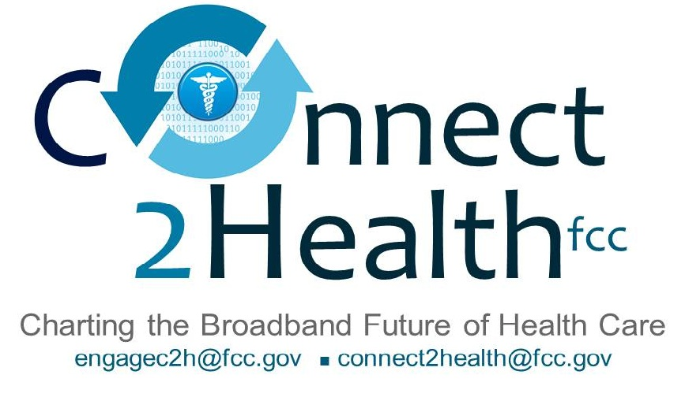

Remarks of
Commissioner Mignon L. Clyburn
“Realizing Broadband’s Grand Promise for Consumer Health IT”
September 15, 2014
Consumer Health IT Summit, Office of the National Coordinator, HHS
Washington, D.C.

Good afternoon. I am delighted to join you for the kickoff of National Health IT Week, and participate in this critical dialogue, on leveraging health IT, to improve consumer health. We are spending a lot of time thinking about, and working on this at the FCC, and I applaud Dr. DeSalvo, for her leadership.

You might be wondering, “What is the Federal Communications Commission,” doing at an event on consumer health, information technology?

In a nutshell, the technologies that hold the most promise in improving health and healthcare, depend on the availability of the broadband that we support, the spectrum that we regulate, and the equipment that we authorize. At the FCC, we are doing our part to seize the opportunities presented by these technologies, to improve health and healthcare…for all Americans.

Earlier this year, Chairman Wheeler and I created a multi-disciplinary task force – Connect2HealthFCC – to help accelerate the adoption of health care technologies, by leveraging broadband and other next-generation communications services. Connect2Health is the umbrella for all health-related activities at the FCC – a force multiplier, if you will, as we continue to chart the broadband future, of health care. Over the coming months, you will be hearing much more about how we plan to move the broadband health dialogue, forward.

Still, you might be asking why the FCC and why now?

Well, one simple answer is that, it is in our statute – the obligation in Section 706 of the Telecommunications Act, to “encourage the deployment on a reasonable and timely basis, of advanced telecommunications capability to all Americans.”

And five irrefutable truths, raise the stakes on getting this right, and getting it right soon:

First, we are living in the midst of a national population explosion.

Second, long-term (rather than infectious) illnesses, have become the major health threats of our day.

Third, people are living much longer than before, and will need even more care, over that lifespan.

Fourth, our country is becoming more racial and ethnically diverse, with all the opportunities and potential challenges, that brings.

And last, but certainly not least, annual increases in healthcare costs, are simply unsustainable.

Dr. DeSalvo has repeatedly called this a “looming threat,” and she is right. We all know the shocking numbers. By 2050, demographic projections suggest, that there will be approximately 438 million people living in the United States. By the year 2030, 71 million Americans – one out of every five – will be over the age of 65, while another 20 million, will be more than 80 years old. Eighty percent of seniors, have at least one chronic disease, and another 50 percent suffer, from two to five chronic illnesses. We now have over 30 million people living in the United States, with limited English proficiency, and approximately 115 million, with limited health literacy. Bottom line . . . there are large and increasing numbers of consumers, with communication challenges, who may have difficulty understanding even basic health information, or communicating adequately, with a provider or caregiver.

So with only about 300,000 to 400,000 primary care providers, projected to be available, it is a challenge, to see how every individual will be able to receive the care they need, over the course of their lifetime, without enhanced reliance, on broadband-enabled digital tools, and technologies.

However, as the expert communications agency, and with our statutory mandate firmly in mind, we do not just view broadband technology, as solving the current health care problem, but also as a paradigm buster, creating unprecedented opportunities, for consumers and health care professionals, alike.

We see opportunities to connect rural and remote areas to specialists, and support services, that would otherwise be unavailable. Not just in pockets here and there across the country, but in scalable and sustainable ways.

Broadband-enabled solutions, can help communities better manage chronic disease, address language barriers, improve health literacy, ensure that our veterans adjust and thrive, and help improve overall population health and wellness. More importantly, it can put the “consumer” back in “consumer health IT” – enabling engagement, on an unprecedented scale.

There are innovators, health care providers, and researchers, working on proof of concept across the country, as we speak – many of whom are in the audience today, or listening to the webcast of this event.
And I applaud your vision and your effort to develop, novel-consumer centric care models, that improve health outcomes and reduce costs. But one central pillar is connectivity – not only for health care facilities, but connectivity, where – hopefully – people spend most of their lives: in their homes, schools and neighborhoods.

* * *

Simply put, the vision of the FCC and its Connect2Health Task Force, is that everyone is connected . . . everywhere. Every consumer is connected to the people, services, and information they need to become healthy or stay well.

So, it is not just about patients in doctors’ offices and hospitals; it is about all consumers, having real access to broadband-enabled health tools and technologies, that they can use to get and stay healthy. In other words, broadband in and of itself is not the goal, it is about what broadband enables. That’s the vision in the 2010 National Broadband Plan. And our Chairman, Tom Wheeler, has repeatedly pledged the FCC to this end – that the Commission’s top priority, must be to make networks work, for everyone.

Over the past few years, we have made significant progress, toward our goal of getting all Americans, connected. Since 2008, the percentage of Americans who subscribe to fixed broadband at home, has increased from about 60% to about 70%, and the adoption gap between whites and African-Americans, has been nearly cut in half since 2009.
That’s the good news. But there are still millions of Americans – living in mostly rural areas – who could not get fixed broadband, even if they wanted to, because the infrastructure, is simply not there.

That is why, I was proud to take a leadership role, in the FCC's historic overhaul, of our universal service program, by converting an outdated inefficient program that supported voice-only service, into a program that supports broadband known as the Connect America Fund. The Connect America Fund is public-private partnership that has an annual budget of $4.5 billion, and framework to ensure that all consumers have access to broadband.
And, our Health Care Connect Fund will invest up to $400 million annually, to better connect rural communities and enable cutting edge tele-health solutions.

* * *

To me, perhaps the most exciting thing about health technology, are the breakthroughs still on the horizon. At the Commission, I have seen demonstrations of nascent technologies, that can help a blind person to see, and can restore sensation, mobility and other vital functions, to the limbs and organs of stroke victims.

Through the Connect2Health Task Force, we want to engage with stakeholders of every stripe – including our sister agencies who have key pieces of the puzzle, states and localities, innovators and entrepreneurs, health care providers, and yes, consumers.
We want to hear your stories, your vision and your challenges. And we want to work with you, to realize broadband’s grand promise, for consumer health IT.
We’ve come too far. We won’t stop now. So thank you, for the opportunity, to participate. Thank you for teaming up, to make real differences.

