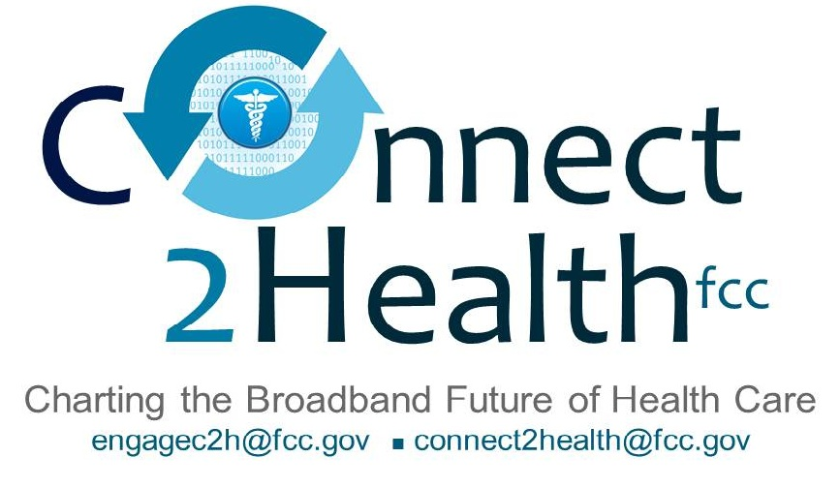

Remarks of
Commissioner Mignon L. Clyburn
“Ruby’s Magic Carpet: In Search of a Cure for Persistent Health Disparities”
September 16, 2014
National Health IT Collaborative
for the Underserved Conference
Washington, D.C.

Thank you, Luis, for that kind introduction and good morning everyone! It’s a real thrill to join you during the 9th Annual National Health IT Week.
Over the last six years, the NHIT has been doing outstanding work. In my view, under the leadership of first Ruth Perot and now Luis Belen, it has become one of the nation’s foremost public-private collaboratives focused on issues of health disparities and Health IT. But, with great success comes even greater responsibility. Luis, I know that you and your team are more than up to the challenge.
* * *
Now, I want to take you on a short journey. Imagine with me for a moment, Ruby. Ruby is a 76 year old Hispanic patient with congestive heart failure (CHF). She lives alone in Birmingham, Alabama and her husband died of a heart attack three years ago. Their three adult children have done well for themselves, but now live in other states with their own families.
For many years, Ruby’s struggled . . . requiring at least three hospitalizations a year. Even though she was doing her best to watch her diet and take her meds, Ruby and her children constantly lived in fear of the worst. But now, things are much better. Ever since the city installed the new “Internet highway” in her community, it has made her life easier and her health a whole lot better.
In the past, Ruby would always worry if today would be the day that she would have to be rushed back to the hospital (usually in an ambulance, sirens wailing). Now, she can relax, worry-free because, even before she realizes things are getting bad, her community health worker gives her a call anytime she gains three pounds. That’s because weight gain can sometimes be an early warning sign of worsening heart failure. You see the new bath mat in her bathroom, which came courtesy of her community health worker, is also a scale that automatically records her weight, just before she gets in the shower each day. This information is automatically sent to the community health worker and her doctor.
As Ruby tells it…
Whenever I gain five pounds or more, from my target weight, this magic carpet somehow contacts IRLA. IRLA has become such a wonderful friend.

IRLA is so concerned about me that whenever I have significant weight gain, she voluntarily analyzes my eating patterns over the last week to see if I have been taking in too much salt, carbs, fats, calories or not getting enough physical activity. Depending on the results, IRLA will suggest simple ways I can adjust my diet. Because I love to cook spicy foods, IRLA will even offer ideas for adjusting my favorite recipes.

IRLA is so supportive! She is always finding ways to compliment me for some healthy choice I’ve made. She knows me so well that she automatically contacts the local grocery store and orders the best foods that I like, and has them delivered right to my door, whenever I want.

I’m so happy because I no longer have to worry about catching the bus or standing for hours in the heat, snow or rain, with groceries, at the bus stop! Sometimes she even makes a reservation for me at the neighborhood YMCA so I can get the exercise I need. Whenever my kids want to know how I am doing, IRLA keeps track of everything and can tell them anything they want to know.

I just don’t know how IRLA does it. Whenever I need her or just want to talk, all I have to do is turn on the TV and press this button on one of my grandson’s game boxes and there she is. We talk and chat for as short or as long as I would like, day or night! If IRLA gets real worried about me, she will actually call my children to let them know what is going on, set up an appointment with my doctor and arrange for my church van to pick me up and bring me home after the visit.

Before I even get back home, IRLA comes to my home and leaves all this wonderful information that explains everything the doctor said . . . in Spanish! She also puts these wonderful videos on the television that I can watch — any time I need them — to help me understand my diagnosis even better. Sometimes my illness is overwhelming and I feel all alone. But if I am unsure and want to talk with someone else who is going through the same thing, IRLA arranges that too. Right there on my TV!

One thing is a bit strange about IRLA though. When I met her, they told me that IRLA is her nickname and that her full name is Interactive voice Response Lifestyle Assistant. What kind of parent would name their child something like that? Oh well, my children and I love her. She is making it possible – and fun again -- to live healthy.

* * *

Ruby is just one of the true-to-life examples gathered by the FCC’s Connect2Health Task Force.

For many of you in the audience today, I am sure, that with the exception of the technology, Ruby’s story is very familiar. Your passion and life’s work has been to “boost” Rubys from all walks of life . . . Rubys who are struggling with their health and uncertain about their futures.
You are making tremendous progress and your hard work is to be lauded. You see, there was a time when few people in this country were willing to even admit disparities existed. Today, we have this conference to galvanize awareness, catalyze action and focus specifically on tangible, scalable solutions. We have researchers and healthcare providers across our nation studying the problem. We have state and federal legislators crafting policies that, over time, hold the promise of ending this national scourge.
(By the way, my “Ruby” example could just have easily been a poor or disabled consumer with a family history of diabetes and no time or money to eat right or exercise. So these issues affect all of us regardless of race, gender, geography or socioeconomic background.)
However, let’s not fool ourselves, despite the awareness, the research and the progress, real health disparities are still with us. Too many people are still unaware, others remain unengaged and far too many still experience health challenges that are entirely preventable.
The noted British epidemiologist Geoffrey Rose put it this way, “…there is no scientific reason why one population should be any less healthy than any other.” (Geoffrey Rose – The Strategy of Preventive Medicine) Yet, as a nation, we have been largely unable to close any national health gaps.
As you probably know, the National Healthcare Disparities Report has been tracking our progress for almost 10 years. That’s the good news. Unfortunately, as a nation, we have made no systematic or sustained improvements in any healthcare disparity. Small improvements in a given year, maybe. But, no sustained progress. And, some gaps have even widened.
While this unfortunate reality is depressing, we simply can’t afford to be demoralized. After hundreds of years, we still have no cure for cancer or the common cold, but that’s not stopping us from believing that one day soon we will. Just think about every pink ribbon and every National Race for the Cure. Why don’t we, as a nation, believe the same about transcending health disparities?
In his historical novel, A Tale of Two Cities, noted author Charles Dickens wrote: “It was the best of times; it was the worst of times.” While the continued existence of health disparities in America may be seen as the worst of what this country has to offer, we at the FCC believe, that these are also very exciting times. For the first time in history, we may have at our disposal, the technology tools and national will we need to serve the health needs of every single person. And, not just curing people when they are sick, but helping them stay well.
We are living on the threshold of an age where virtually no one can be credibly called “hard to reach.” No longer is it necessary for people to go to a hospital, clinic or health center, to get healthcare. Increasingly healthcare can come to you, wherever you are. Surgeons, using robotic tools, can now operate on patients thousands of miles away. Critical health data can be transmitted wirelessly over many miles. Behavioral therapies can be delivered right to your bedroom . . . or even to the beach.
But providing medical treatment to everyone is not enough. For patients like Ruby, she lives alone and struggles from loneliness and social isolation. She is not a native English speaker and so has trouble understanding and communicating in English. She does not have reliable transportation and is unable to keep track of all of her personal health information. Every one of these social needs can profoundly impact her health and the quality of her healthcare.
As a nation, we must find cost effective ways to address the social needs of patients as well as their medical needs. Telehealth and other broadband-enabled health care technologies can help connect people to the health and support services they need, whenever they need them. I urge this group to be bold and relentless in pursuing this vision.
In order for Ruby to benefit, she needed to be better connected to the social service providers in her community and family members around the country. Distance and geography are no longer insurmountable barriers. This is why I believe that we can put a significant dent in disparities if every single person can be connected to all the resources they need to be healthy. They need to be able to be connected to these resources wherever they are and to access these resources whenever they need them. This is what broadband connectivity can do and this, I am proud to announce, is the vision of the Connect2Health task force.
When we achieve this vision, will we have ended all disparities? Certainly not. But I believe strongly, that it will help us make a tangible difference.
Let me be clear though, addressing disparities through broadband connectivity is about far more than ensuring everyone has a broadband connection. It has to be about ensuring that everyone is able to benefit, from what broadband has to offer. If only some reap these benefits, we run the risk of hardwiring disparities into our national fabric in ways that may haunt another generation of Americans. Indeed, disparities might increase. Solving the disparities problem is really about meeting the health needs of every person. The focus must remain on the person; the technology, as we saw from the example of Ruby, is simply a very important enabler.
As the expert agency on communications technology we have a critical role to play in the national dialogue on these issues. It’s a big task, but we’re not shying away. We’re bellying up to the bar, ready to roll up our sleeves and get to work.
* * *
With this vision in mind, the FCC has launched a new multi-disciplinary Task Force — Connect2HealthFCC — to explore the intersection of broadband, advanced technologies, and health. We see opportunities to bridge persistent health gaps, to connect rural and remote areas to specialties and support services that would otherwise be unavailable, to help manage chronic disease, to address language barriers and improve health literacy, to help our veterans adjust and thrive, and to improve overall population health and wellness.
Simply put, the FCC is working to demonstrate the value proposition of broadband in all of these areas and we can’t do it alone. We need to collaborate with a broad cross-section of stakeholders — our sister agencies who all have a piece of the puzzle, state and local policymakers, health care providers, non-profit organizations, innovators, clinicians, academic centers, consumers, technologists — to ensure that every American can access the benefits broadband has to offer.
So, I challenge you today, to consider not just the seemingly intractable problem of persistent health disparities, but the unique possibilities that advanced technologies and broadband-enabled health solutions can provide. Partner with us and work with whoever will work with you to eliminate the problem, not just talk about it. I am convinced that if you do and if you will join us, work with us and refuse to accept the existence of health disparities as the inevitable status quo, together, we will make Ruby’s story our national reality!
Thank you.

