October 21, 2014

Dear Participants and Interested Parties:

I regret that I am unable to attend this Forum on Internet Regulation. When it was announced, I had a previous commitment to attend the 2014 ITU Plenipotentiary Conference in Busan, Korea. I am disappointed to miss visiting the Lone Star State again.

I trust that today’s forum, which features a range of panelists with a diversity of viewpoints, will generate a fulsome discussion on net neutrality.

Sincerely,
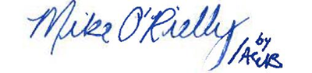
Mike O’Rielly
Commissioner

