FACT SHEET: FCC CHAIRMAN WHEELER’S PLAN TO REBOOT THE E-RATE PROGRAM
TO MEET THE NEEDS OF 21st CENTURY DIGITAL LEARNING

Federal Communications Commission (FCC) Chairman Wheeler is circulating a proposal this week to his fellow commissioners to reboot E-rate rules and funding levels so that every student in America, no matter where they live, has access to the unlimited learning opportunities enabled by high-speed broadband. The proposal is the next major step in the comprehensive modernization of E-rate – America’s largest education technology program – the first such effort since the program’s creation 18 years ago.
Step One: Top-to-Bottom Review
The proposal builds on the top-to-bottom administrative review of E-rate that was the first stage of Chairman Wheeler’s comprehensive, step-by-step approach to modernization of the 18-year-old program.
Step Two: Streamline the Program, Maximize Funds, Close the Wi-Fi Gap and Adopt 21st Century Goals
In July, the FCC took a first step forward toward modernizing E-rate by adopting a plan focused on the most urgent need—closing the Wi-Fi gap—while transitioning support away from legacy technologies to 21st century broadband connectivity, ensuring E-rate money is spent smartly, and improving program administration. The plan:

- Set critical near and long-term school and library high-capacity broadband connectivity targets based on the recommendations of school and library technology leaders.
- Took steps to enable lower prices and save program dollars by increasing transparency into E-rate supported purchases and phased out support for non-broadband services, such as paging and traditional phones, which is expected to save at least $3.5 billion over five years that can be redeployed for broadband services.
- Established a $1 billion annual target for Wi-Fi support to ensure wireless connectivity in all schools and libraries over the next five years – 20 million students over just the next two years.

Step Three: Ensure High-Speed Internet Access in Schools and Libraries within Five Years
The first two steps in E-rate modernization made the program more efficient, maximized the use of ratepayer funds, and will provide support for the majority of schools across the country that report insufficient in-classroom connectivity today. Still, 63% of public schools – over 40 million students – don’t have broadband connections to the building capable of taking advantage of modern digital learning. Since the July Order, FCC staff has continued their efforts to assess whether further program rule changes or additional funding would be needed to meet the long-term broadband connectivity targets.

- Based on a robust record and analysis by Commission staff, Chairman Wheeler is proposing a permanent increase in the E-rate cap of $1.5 billion along with a series of targeted policy changes to enhance the options available to schools and libraries to purchase affordable high-speed broadband.
- If the FCC reaches the maximum cap recommended, the estimated additional cost to an individual rate payer would be approximately 16 cents a month, about a half a penny per day or about $1.90 a year – less than a medium-sized soda at fast food restaurant or a cup of coffee.
- While the impact on consumers will be small, the impact on children, teachers, local communities and American competiveness will be significant.

BY THE NUMBERS: THE HIGH-SPEED INTERNET CONNECTIVITY GAP
Schools and libraries across the geographic and socioeconomic spectrum have significant work to do to achieve long-term high-speed Internet targets, but the gap is biggest in rural and low-income areas. If the Commission, working with state and local governments, does not act, these libraries and schools will be unable to upgrade their infrastructure, and the students and communities they serve will not have access to high-speed Internet and new educational tools and technologies.

- 68% of all districts (73% of rural districts) say that not a single school in their district can meet high-speed Internet connectivity targets today.
- Approximately 41% of rural public schools lack access to fiber networks sufficient to meet modern connectivity goals for digital learning, compared to 31% of suburban and urban public schools.
- 39% of schools in affluent areas currently meet speed targets, but only 14% of schools in low-income rural and urban areas meet those targets.
- 45% of school districts lack sufficient Wi-Fi capacity to move to one-to-one student-to-device deployments which is increasingly necessary to achieve modern digital learning objectives.
- Half of all public libraries report connections of less than 10 Mbps (70% of rural libraries) – or less than 10% of the short-term target and less than 1% of the long term target connectivity level.
- More than half (58%) of districts say the monthly recurring expense of connections is the most significant barrier to faster service.
- Nearly 40% of districts indicate that they can’t afford the high up-front capital costs of infrastructure upgrades. At the same time, 91% of these districts identify at least one infrastructure upgrade that is essential for them to implement in order to meet their connectivity goals.
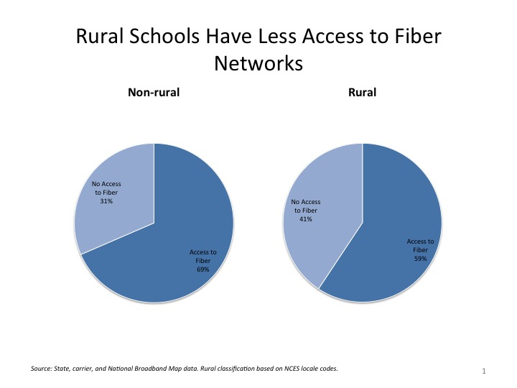
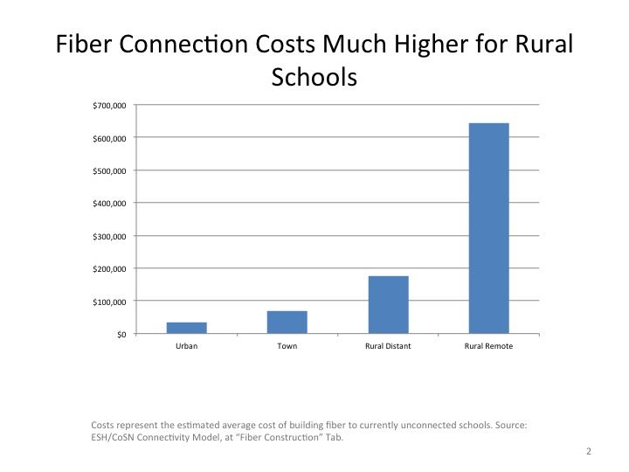

BEHIND THE NUMBERS: THE CASE FOR INCREASED E-RATE INVESTMENT
As schools and libraries upgrade their broadband infrastructure and expand Wi-Fi access, bandwidth demands will outpace savings from E-rate modernization and broadband price reductions. Even with the most efficient E-rate program that achieves all possible cost-savings, meeting the connectivity goals for all schools and libraries will require funding above the current E-rate cap.

- Even if bandwidth costs decline by 10% per year, the demand for broadband is growing at least 50% per year, which means that total bandwidth costs will continue to grow even with significant broadband price reductions.
- Chairman Wheeler’s proposed $1.5 billion cap increase is consistent with all schools and libraries achieving the long-term goals, but also requires average prices to fall by half versus current levels. These are equally aggressive goals for access AND for efficiency.
- Because Wi-Fi within every classroom and library space is an essential element of 21st century learning, the FCC has already established an annual $1 billion Wi-Fi budget target. Therefore, assessing the long-term funding needs of the program simply requires estimating the growth in spending necessary to bring high-capacity broadband to the doors of every school and library.
- The growth will be a combination of payments for costly one-time non-recurring infrastructure upgrades and increasing monthly recurring charges for Internet access. Increases in monthly Internet access charges will come from schools that already have connections capable of meeting E-rate connectivity targets and those who get access to high-speed connections as a result of rule changes Chairman Wheeler is proposing.
- Internet access demands will also grow substantially for all schools that gain access to robust Wi-Fi as a result of FCC rule changes.

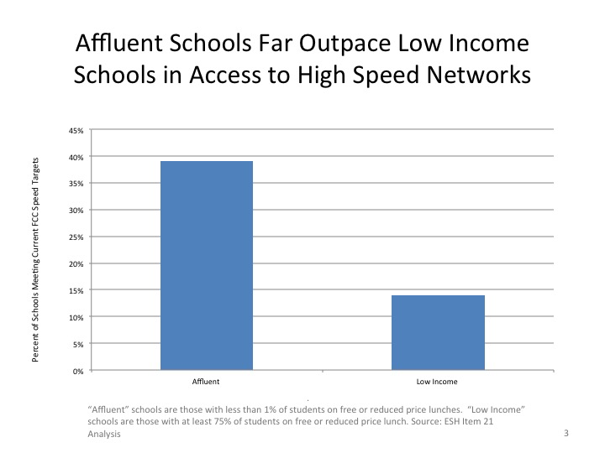
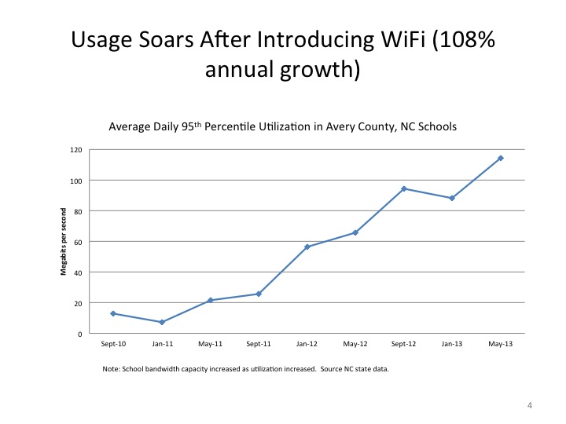

For example, schools in North Carolina, a leader in digital education that connects student tablets and laptops with Wi-Fi to deliver individualized learning, are increasing bandwidth use by more than 50% annually. Some schools and libraries are seeing bandwidth growth of 100% or more annually directly after additional Wi-Fi capacity is installed, which is exactly what the first step of Chairman Wheeler modernization strategy calls for.

Economic models submitted to the FCC show that the cost of reaching the connectivity goals for all schools and libraries would far exceed the existing program cap.
- The original E-rate program cap was set at $2.25 billion in 1997, and lacked an annual inflation adjustment until late 2010. Since that time, inflation adjustments have shifted the cap to $2.4 billion. More than 60% of the Chairman’s proposed $1.5 billion cap increase represents simply a “catch up” of the lost inflation adjustment from 1997 to 2010; the rest reflects the significant growth in the bandwidth needs of schools and libraries since 1997.
- Indeed, in 1997 a 56 Kbps (56,000 bits per second) modem was a common form of connectivity to the school. “High speed” may have meant 1 Mbps (1 million bits per second). The FCC’s new long-term targets call for 1 Gbps (1 billion bits per second). That is an increase of a thousand or many times more, or put differently, the original program was structured around bandwidth needs that are less than .1% of current targets.
- A comprehensive model by EducationSuperHighway and the Consortium for School Networking estimates the total E-rate funding needs at over $4 billion annually in some years.
- Other models project higher costs for infrastructure upgrades, suggesting a need for an even larger E-rate cap.
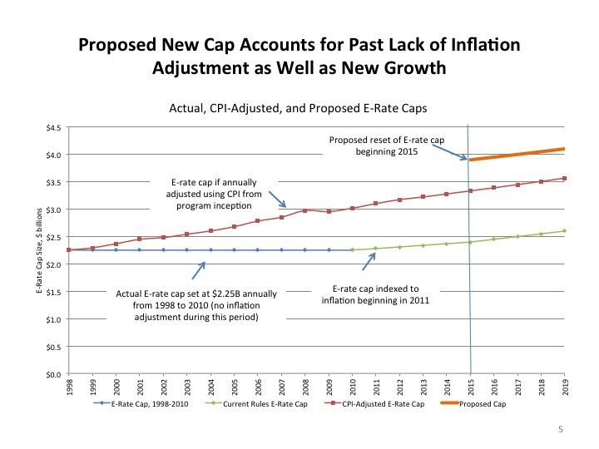

Determining the appropriate cap level involves assessing current and future needs, accounting for growth in bandwidth, and other factors.
- While spending in a given year may be less than the cap (particularly in the early years), the cap must be sufficient to anticipate future needs and technological change. Schools, libraries and state and local governments need the certainty and predictability that long-term funding will be available to justify costly infrastructure upgrades and likely increases in monthly expenses as bandwidth usage rises.
- The Chairman’s proposed increase in the program cap from $2.4 billion to $3.9 billion balances two factors: (1) establishing a clear principle that the program should support the needs of all schools and libraries – rural and urban, large and small – but (2) that the program must also demand significant efficiencies in the process to ensure that each penny collected from rate payers be necessary and appropriately invested.

The cost of E-rate is paid for through the FCC’s Universal Service Fund, which also funds three other universal service programs.
- Consumers and businesses pay for the Fund through an assessment on interstate and international phone bills, in the form of a universal service fee.
- Disbursements are driven by demand and the prices paid for connectivity – which can and does decrease due to technological advances.
- However, if the FCC reaches the maximum cap recommended, the estimated additional cost to an individual rate payer would be approximately 16 cents a month, about a half a penny per day or about $1.90 a year – less than a medium-size soda at a fast food restaurant or a cup of coffee.

