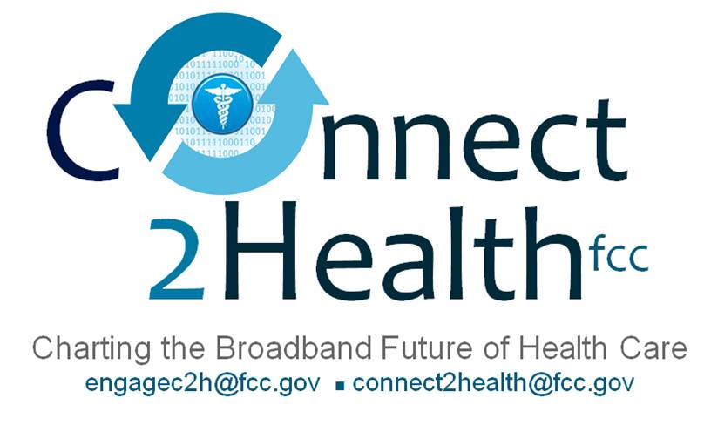
Remarks of Commissioner Mignon Clyburn
Mississippi Broadband Connect Coalition Summit
Jackson, Mississippi
December 2, 2014

(as prepared for delivery)

Meeting the Broadband Health and Care Challenge: An Opportunity
and Imperative for Mississippi

Dr. Henderson, thank you so much for that kind introduction and warm welcome. And, Governor Bryant, Mr. Ray, thank you for hosting the FCC as we get outside Washington to focus on broadband connectivity and how it can transform health and health care in rural and underserved areas.

It is an honor for the FCC to be in Central Mississippi and with you today at the Mississippi Broadband Connect Coalition Summit. This is our first visit to Jackson and with any luck it won’t be our last. Having been in town for about 24 hours, I can now easily understand why Jackson is known as the City with Soul. As the Washington Post says, if you don’t get it, you just don’t get it. Well, now I’ve got it.

* * *

Today, I want to share a simple vision with you. I want to tell you about a state that beats the national average for obesity . . . that has low mortality rates for stroke, congestive heart failure and cancer; that boasts near record levels of preventive screening for chronic diseases like diabetes; and where life expectancies are so long that they are studied nationwide.

This state also has high levels of broadband connectivity and Internet usage. And, it has somehow solved the perennial challenge of getting broadband out to its most rural areas. It is reaping the benefits of broadband not just in education, job training, and economic development, but also in health care. Health disparities based on income and education are narrowing and its students have become health-tech entrepreneurs feeding innovation nationwide.

Now, don’t spend too much time scratching your head on whether I’m talking about California, New York, or some other big state, because I’m not. I’m a fellow Southerner, and I’m envisioning Mississippi a mere generation from now.

And, you wouldn’t be here today if you didn’t share that vision. I applaud all of you for the sustained focus that it will take to get to that future. Your strategic planning work on broadband access over the last several years and your presence here today give me hope in and of themselves.

* * *

I’d like to talk for a few minutes about the vision of broadband in this country, and in Mississippi especially, and then spend the rest of our time together on how we achieve that vision.

The Broadband Vision for Mississippi

Mississippi, like every other modern community, has its economic and health problems. And, we know that broadband is not a panacea to every valley or mountain this Great State faces. Far from it. But . . . and that’s a big “but” folks . . . broadband connectivity can make a difference. I believe it and I know you believe it too.

As they say, this isn’t your first rodeo on the broadband access circuit, and I know how easy it is to get weary in well-doing. How easy it is to see the problems of the last mile, aging infrastructure, and the rural nature of your State as almost insurmountable. How easy it is to think that perhaps the dream of “everyone connected,” is too big. Or to be tempted to accept half-measures even as you fear that limited progress could constrain Mississippi’s future for generations to come.

Well, I actually want to suggest that you think bigger. That you make your broadband vision even grander.

Why? Well, it changes the stakes for all the participants in the supply and demand chain alike. Like my friend and colleague FCC Chairman Wheeler often says it’s not broadband, it’s what broadband enables. So, here’s a radical thought: stop thinking about broadband per se.

I’d challenge you to frame your discussions in “goal-terms.” The goals here are economic development, decreases in unemployment, gains in education, and improved health care. Too often, we think of these as happy by-products of broadband access. But, how you frame a problem, makes all the difference in finding a solution. And, it places the necessary investment and sacrifice into stark relief.

Take for example the case of broadband and health – which is the focus of the FCC’s multi-disciplinary Connect2Health Task Force and which brings us to Mississippi today. At Connect2HealthFCC, we have a vision -- “Everyone Connected to the people, information and services they need to get well and stay healthy.”

Yes, this is a grand vision. But, the benefit of a grand vision is that it can help people who haven’t experienced the transformative power of broadband better understand its value.

It can help Mississippians who have to choose how to spend limited discretionary income, choose to spend it on broadband.

It can transform the conversation from one about surfing the Internet (which some people may not fully value), to one about improving the health of all Mississippians – imagine the economic value that could be created if there were no lost days at work due to illness.

It can take a provider network stretched thin and give it more tools to fight obesity and diabetes before the Mississippi safety net cracks under the weight of chronic disease.

And, it will give hope to a nation filled with other communities facing these same problems.

Some may believe this “everyone connected” vision is an impossibility. We disagree. In fact, we believe it is the greatest imperative of the 21st century. And, like the icon Nelson Mandela once said, “It always seems impossible until it's done.”

Visionaries like all you aren’t daunted by what seems impossible. And, you’re in great company. I’m told that Colonel Sanders of KFC fame did the “impossible” by selling his fried chicken recipe on the 1010th try. The founder of Pandora.com approached 300 investors before he got funding. Tim Ferris’s book, the 4 Hour Work Week was rejected by publishers 25 times.

Again, it always seems impossible until it’s done.

* * *

For any remaining skeptics in the room, take asthma for example . . . a new GPS and Wi-Fi enabled inhaler logs the time and position of an asthma sufferer when he or she uses it for respiratory relief. The goal is to allow patients and their doctors to more carefully analyze inhaler use, leading to more targeted treatment. And, this connected inhaler will also allow epidemiologists to use anonymized data to analyze asthma trends among an entire population. This would potentially help scientists identify environmental and geographic contributors, with the promise of better controlling asthma as a chronic illness.

Another set of broadband enabled tools can allow patients themselves to diagnose hundreds of diseases using a simple handheld device and one drop of blood. This is not fantasy. Two such devices are already in final stages of development.

Interestingly, a recent study by Price Waterhouse Coopers indicates that 79% of physicians believe that mobile devices can help them coordinate care and almost half (49%) of physicians would be willing to consider using the results from home based “do-it-yourself” testing to prescribe medications.

Finally, consider a real bionic eye that has been recently approved by the FDA. A miniature video camera seated on a pair of glasses captures what the patient is “looking at” and sends the video to a small external computer. The computer transforms the images into signals that can be detected by the back part of the eye called the retina. These signals are then wirelessly transmitted via an antenna on the glasses to electrodes implanted on the patient’s retina. Broadband-enabled devices like these will one day help restore “sight” to our veterans and others who are now blind.

* * *

So, how do we achieve this “everyone connected” vision?

Well, we grow the demand curve and we do that by building the value proposition. By showing, not telling what broadband can do. We know that 100 million Americans are not using broadband. We need to claim that as the challenge and for the opportunity that it is. And, I believe that the value proposition is most stark for consumers in health care, where an average Mississippian can see and feel the benefits in a relatively short space of time.

In rural communities, we also need to identify new partners. This coalition is a great example of partner building. But, you should ask yourselves, are all the necessary business and community partners at the table? And, if so, how can you better incentivize them to contribute to building the broadband future you envision.

Mississippi already has generous philanthropists. How do you grow their ranks to help get to the “everyone connected” broadband future? What about Ole Miss, Mississippi State, and Jackson State alumni, what can and should they do? What new business models do you need to make broadband sustainable in rural areas? What about job training so you’re ahead of the broadband employment curve that you hope to build? There’s no silver bullet on any of this. But, I see no reason why Mississippi shouldn’t lead the way.

Some of you may be asking, “Why did the FCC choose to come to Mississippi”? Well, we’ve come because in many ways, Mississippi represents the American experience. Like many Americans across this country, too many Mississippians suffer from chronic diseases like diabetes, obesity, high blood pressure, stroke and cancer. Although healthcare providers are doing their best to meet the demand, there are simply not enough of them. To make matters worse, the healthiest food options often seem the most expensive and most difficult to find. Unfortunately, this is not just a Mississippi struggle, it is an American struggle.

The FCC would like to continue to partner with you and others to win this struggle. We want to hear from and learn from you. And, of course, my door is always open.

* * *

With that, I want to leave you with a favorite quote from famous radio personality Earl Nightingale: “don't let the fear of the time it will take to accomplish something stand in the way of your doing it. The time will pass anyway; we might just as well put that passing time to the best possible use.”

And, I say the same to you this morning. With broadband connectivity and broadband-enabled health care, there simply is no time to lose.

