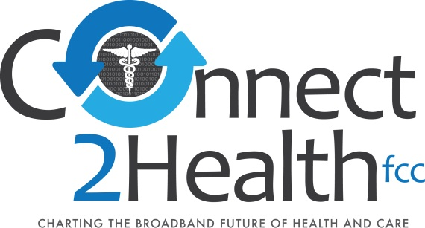

Opening Remarks of Commissioner Mignon Clyburn
Promoting Medical Technology Innovation – The Role of Wireless Test Beds
Washington, DC
March 31, 2015

(as prepared for delivery)

Throughout history, the medical field has gone through several transformations thanks to the work of innovators, researchers, and entrepreneurs. Take, for instance, the discovery and invention of the X-ray machine. Prior to x-rays, there was no way to look inside the human body for diagnosis or treatment except for cutting a patient open. With this invention, all of a sudden there was a new, noninvasive way to diagnose injury and disease. Eventually, this discovery would also lead to improved ways to treat patients by helping visualize during surgery or other interventions.
In today’s digital revolution, healthcare is in the midst of yet another remarkable transformation. Dr. Eric Topol, one of medicine’s most innovative thinkers about the digital future, has said: “Nearly anything we can do in medicine can be done remotely.” If you take a moment to really think about it, the implication behind this statement is huge. It indicates an extraordinary shift in the way healthcare is being delivered and received. At the center of this shift are wireless medical networks and devices.
In the same way x-rays used an invisible property in order to produce incredible changes to medicine, wireless networks, while invisible to the naked eye, power devices that are transforming healthcare. Today’s innovative technologies are completely changing when, how, and where medical care takes place. Virtual doctor’s visits and wireless monitoring devices allow consumers a more convenient way to get the care they need when they need it. In addition to convenience, these innovations are also making it possible to reach people that previously have been difficult to reach. Health disparities based on geography or socioeconomic status are being bridged through technologies that make healthcare more accessible and less expensive. Healthcare providers are also seeing a shift in the way they diagnose and treat illness with the help of wireless technologies. For example, patients are being sent home from the hospital sooner after a surgery or major illness with the help of in-home monitoring systems. Physicians can continue to keep track of recovering patients at home instead of keeping them in the hospital.
As this transformation of the healthcare system continues to evolve, we owe it to both consumers and clinicians to ensure medical devices are safe and reliable. We must, therefore, take into account the need for wireless coexistence. Wireless testbeds are a critical piece of ensuring safe, reliable technologies. I am grateful for all of the work the Connect2Health task force, OET and their partners at the FDA have done to make this workshop a success. I would also like to thank all the moderators and speakers who have graciously joined us today, and look forward to hearing your thoughts and perspectives.
As a final thought, I will say that just as individual musical instruments come together in an orchestra to create a symphony beautiful song, individual medical devices must work together on wireless networks to create a transformed and improved healthcare system. Working together, we can ensure that the orchestra of wireless devices coexists in harmony.

