FEDERAL COMMUNICATIONS COMMISSION
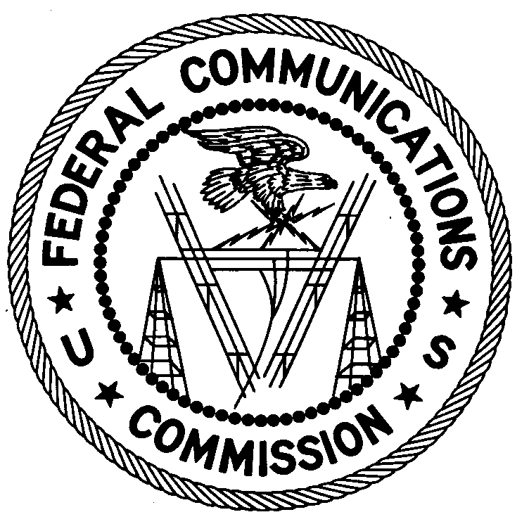
ENFORCEMENT BUREAU
SOUTH CENTRAL REGION

Miami Office
P.O. Box 520617

Miami, FL 33152

June 29, 2015

Jean R. Valsaint
Miami, Florida

NOTICE OF UNLICENSED OPERATION

Case Number: EB-FIELDSCR-15-00019330

Document Number: W201532600001

On June 8 and June 11, 2015, agents from this office confirmed by direction finding techniques that radio signals on frequency 107.1 MHz were emanating from 1251 NW 54th St., Miami, Florida 33142. On May 16, 2012, you admitted to agents from this office you were the operator of an unlicensed radio station on 98.1 MHz at the same location and voluntarily relinquished the transmitter. This location is also the registered address for several businesses operated by you. The Commission's records show that no license was issued for operation of a broadcast station on 107.1 MHz or any other frequency at this location in Miami, Florida.

Radio stations must be licensed by the FCC pursuant to 47 U.S.C. § 301. The only exception to this licensing requirement is for certain transmitters using or operating at a power level that complies with the standards established in Part 15 of the Commission’s rules, 47 C.F.R. §§ 15.1 et seq. On June 8 and June 11, 2015, the field strength of the signal on frequency 107.1 MHz exceeded the maximum permitted level of 250 microvolts per meter (µV/m) at 3 meters for non-licensed devices. Thus, this station was operating in violation of 47 U.S.C. § 301.

You are hereby warned that operation of radio transmitting equipment without a valid radio station authorization constitutes a violation of the Federal laws cited above and could subject the operator to severe penalties, including, but not limited to, substantial monetary fines, in rem arrest action against the offending radio equipment, and criminal sanctions including imprisonment. (See 47 U.S.C. §§ 401, 501, 503 and 510). Be advised that this warning does not preclude this office from pursuing additional sanctions based upon our investigation of this incident.

UNLICENSED OPERATION OF THIS RADIO STATION MUST NOT RESUME.

You have ten (10) days from the date of this notice to respond with any evidence that you have authority to operate granted by the FCC. Your response should be sent to the address in the letterhead and reference the listed case and document number. Under the Privacy Act of 1974, 5 U.S.C. § 552a(e)(3), we are informing you that the Commission’s staff will use all relevant material information before it to determine what, if any, enforcement action is required to ensure your compliance with FCC Rules. This will include any information that you disclose in your reply.

You may contact this office if you have any questions.

Stephanie Dabkowski
Resident Agent
Miami Office
South Central Region
Enforcement Bureau

Attachments:
Excerpts from the Communications Act of 1934, As Amended
Enforcement Bureau, "Inspection Fact Sheet," March 2005

