FEDERAL COMMUNICATIONS COMMISSION
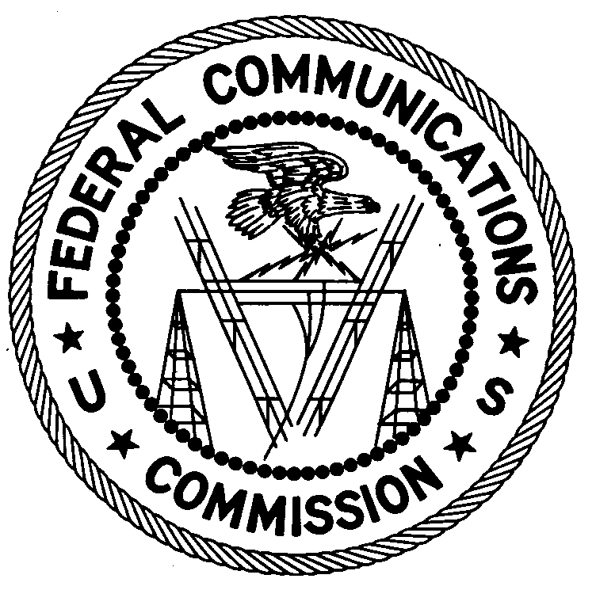
ENFORCEMENT BUREAU
WESTERN REGION

San Diego Office
4542 Ruffner Street, #370

San Diego, CA 92111
(858) 496-5111

July 23, 2015

Alfredo’s Trucking
Hobbs, NM

NOTICE OF UNLICENSED OPERATION

Case Number: EB-FIELDWR-15-00019607

Document Number: W201532940001

The San Diego Office received information that the European Space Agency (ESA) was receiving interference to their Soil Moisture and Ocean Salinity (SMOS) satellite due to radio transmissions in the 1400 -1427 MHz frequency band in Hobbs, NM. On July 15, 2015, the undersigned used direction-finding techniques to locate radio signals operating within the 1400-1427 MHz band emanating from a wireless cameras installed at Alfredo’s Trucking at 3220 W County Rd, Hobbs, NM. The Commission’s records show that no license was issued for operation of a transmitter at this location on 1400-1427 MHz in Hobbs, NM.

Radio stations must be licensed by the FCC pursuant to 47 U.S.C. § 301. You are hereby warned that operation of radio transmitting equipment without a valid radio station authorization constitutes a violation of the Federal laws cited above and could subject the operator of this illegal operation to severe penalties, including, but not limited to, substantial monetary forfeitures, in rem arrest action against the offending radio equipment, and criminal sanctions including imprisonment. (See 47 U.S.C. §§ 401, 501, 503 and 510.)

UNLICENSED OPERATION OF THIS RADIO STATION MUST BE DISCONTINUED IMMEDIATELY.

You have ten (10) days from the date of this notice to respond with any evidence that you have authority to operate granted by the FCC. Your response should be sent to the address in the letterhead and reference the listed case and document number. Under the Privacy Act of 1974, 5 U.S.C. § 552a(e)(3), we are informing you that the Commission’s staff will use all relevant material information before it to determine what, if any, enforcement action is required to ensure your compliance with FCC Rules. This will include any information that you disclose in your reply.

You may contact this office if you have any questions.

James T. Lyon
District Director
San Diego Office
Western Region
Enforcement Bureau

Attachments:
Excerpts from the Communications Act of 1934, As Amended
Enforcement Bureau, "Inspection Fact Sheet," March 2005

