FEDERAL COMMUNICATIONS COMMISSION
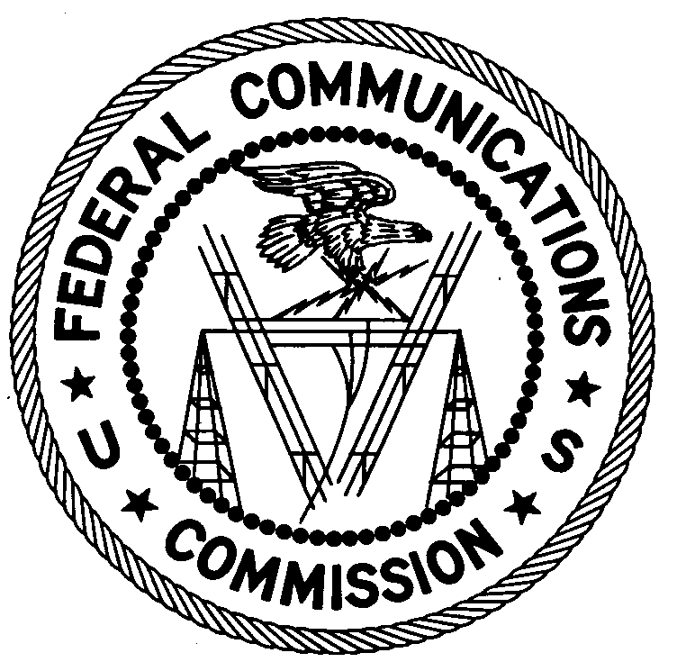
ENFORCEMENT BUREAU
NORTHEAST REGION

Columbia Office
9200 Farm House Lane

Columbia, MD 21046
301-725-1996

July 29, 2015

Manhattan Park Apartments
Baltimore, Maryland

NOTICE OF UNLICENSED OPERATION

Case Number: EB-FIELDNER-15-00019418

Document Number: W201532340001

The Columbia Office received information that an unlicensed broadcast radio station on 93.5MHz was allegedly operating in Baltimore, Maryland. On June 16, 2015 agents from this office confirmed by direction finding techniques that radio signals on frequency 93.5 MHz were emanating from your property at 5715 Park Heights Ave in Baltimore, Maryland. The Commission’s records show that no license was issued for operation of a broadcast station on 93.5 MHz at this location in Baltimore, Maryland.

Radio stations must be licensed by the FCC pursuant to 47 U.S.C. § 301. You are hereby warned that operation of radio transmitting equipment without a valid radio station authorization constitutes a violation of the Federal laws cited above and could subject the operator to severe penalties, including, but not limited to, substantial monetary fines, in rem arrest action against the offending radio equipment, and criminal sanctions including imprisonment. (see 47 U.S.C. §§ 401, 501, 503 and 510).

UNLICENSED OPERATION OF THIS RADIO STATION MUST BE DISCONTINUED IMMEDIATELY.

You have ten (10) days from the date of this notice to respond with any evidence that you have authority to operate granted by the FCC. Your response should be sent to the address in the letterhead and reference the listed case and document number. Under the Privacy Act of 1974, 5 U.S.C. § 552a(e)(3), we are informing you that the Commission’s staff will use all relevant material information before it to determine what, if any, enforcement action is required to ensure your compliance with FCC Rules. This will include any information that you disclose in your reply.

You may contact this office if you have any questions.

Salomon Satche
District Director
Columbia Office

Copy to:

Weinberg Gardens
Attn: David Jefferson
1500 Bedford Ave
Baltimore, MD 21208

Attachments:
Excerpts from the Communications Act of 1934, As Amended
Enforcement Bureau, "Inspection Fact Sheet", March 2005

