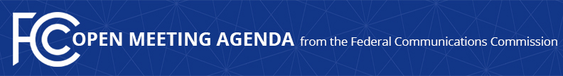

Media Contact:
Will Wiquist, 202-418-0509
will.wiquist@fcc.gov

For Immediate Release

FCC ANNOUNCES TENTATIVE AGENDA FOR SEPTEMBER OPEN MEETING
--
WASHINGTON, August 27, 2015 – Federal Communications Commission Chairman Tom Wheeler announced that the following items are tentatively on the agenda for the September Open Commission Meeting scheduled for Thursday, September 17, 2015:

Modernizing Contest Rules – The Commission will consider a Report and Order to provide broadcasters greater flexibility in their disclosure of contest terms.

Submarine Cable Reliability – The Commission will consider a Notice of Proposed Rulemaking that proposes to require submarine cable licensees to report outages.

The Open Meeting is scheduled to commence at 10:30 a.m. in Room TW-C305 of the Federal Communications Commission, 445 12th Street, S.W., Washington, D.C.

###
Office of Media Relations: 202.418.0500
TTY: 888-835-5322
Twitter: @FCC
ftp.fcc.gov
www.fcc.gov/office-media-relations

This is an unofficial announcement of Commission action. Release of the full text of a Commission order constitutes official action. See MCI v. FCC. 515 F 2d 385 (D.C. Circ 1974).

