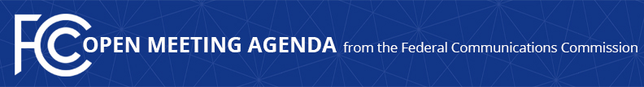

Media Contact:
Morning Washburn, 202-418-0067
Morning.Washburn@fcc.gov

For Immediate Release

FCC ANNOUNCES TENTATIVE AGENDA FOR October OPEN MEETING
--
WASHINGTON, October 1, 2015 – Federal Communications Commission Chairman Tom Wheeler announced that the following items are tentatively on the agenda for the October Open Commission Meeting scheduled for Thursday, October 22, 2015:

Rates for Inmate Calling Services (ICS): The Commission will consider a Report and Order and Third Further Notice of Proposed Rulemaking that would adopt comprehensive reform of intrastate, interstate, and international ICS calls to ensure just, reasonable and fair ICS rates, and seek comment on additional measures the Commission could take to ensure that interstate and intrastate ICS are provided consistent with the statute and public interest.
(WC Docket 12-375)

Review of Foreign Ownership Policies: The Commission will consider a Notice of Proposed Rulemaking that would streamline the foreign ownership review process for broadcast licensees and applicants, and standardize the review process for broadcast, common carrier and aeronautical licensees and applicants.
(GN Docket 15-236)

Spectrum Frontiers: The Commission will consider a Notice of Proposed Rulemaking that proposes to create new flexible use service rules in certain bands above 24 GHz to support multiple uses, including mobile wireless.
(GN Docket 14-177, RM-11664, WT Docket 10-112, IB Docket 97-95)

The Open Meeting is scheduled to commence at 10:30 a.m. in Room TW-C305 of the Federal Communications Commission, 445 12th Street, S.W., Washington, D.C.

###

Office of Media Relations: 202.418.0500
TTY: 888-835-5322
Twitter: @FCC
ftp.fcc.gov
www.fcc.gov/office-media-relations

This is an unofficial announcement of Commission action. Release of the full text of a Commission order constitutes official action. See MCI v. FCC. 515 F 2d 385 (D.C. Circ 1974).

