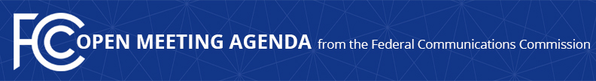

Media Contact:
Neil Grace, 202-418-0506
neil.grace@fcc.gov

For Immediate Release

FCC ANNOUNCES TENTATIVE AGENDA FOR DECEMBER OPEN MEETING
--
WASHINGTON, November 25, 2015 – Federal Communications Commission Chairman Tom Wheeler announced that the following items are tentatively on the agenda for the December Open Commission Meeting scheduled for Thursday, December 17, 2015:

US Telecom Petition for Forbearance: The Commission will consider a Memorandum Opinion and Order addressing a petition from USTelecom that seeks forbearance from various categories of statutory and Commission requirements applicable to incumbent local exchange carriers. (WC Docket No. 14-192)

Part 25 Rules for Space Stations and Earth Stations: The Commission will consider a Second Report and Order that streamlines, eliminates or updates numerous provisions of Part 25 of the Commission’s rules governing licensing and operation of space stations and earth stations for the provision of satellite communication services. (IB Docket No. 12-267)

The Open Meeting is scheduled to commence at 10:30 a.m. in Room TW-C305 of the Federal Communications Commission, 445 12th Street, S.W., Washington, D.C.

###

Office of Media Relations: 202.418.0500
TTY: 888-835-5322
Twitter: @FCC
ftp.fcc.gov
www.fcc.gov/office-media-relations

This is an unofficial announcement of Commission action. Release of the full text of a Commission order constitutes official action. See MCI v. FCC. 515 F 2d 385 (D.C. Circ 1974).

