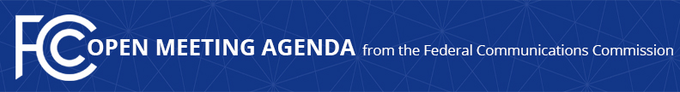

Media Contact:
Morning Washburn, 202-418-0067
Morning.Washburn@fcc.gov

For Immediate Release

FCC ANNOUNCES TENTATIVE AGENDA FOR February
OPEN MEETING
--
WASHINGTON, January 28, 2016 – Federal Communications Commission Chairman Tom Wheeler announced that the following items are tentatively on the agenda for the November Open Commission Meeting scheduled for Thursday, February 18, 2016:

Promoting Diverse and Independent Programming: The Commission will consider a Notice of Inquiry that seeks comment on the current state of programming diversity and the principal obstacles that independent programmers face in obtaining carriage on video distribution platforms.
(MB Docket No 16-XX)

Expanding Consumer Choice: The Commission will consider a Notice of Proposed Rulemaking that seeks comment on a framework for providing innovators, device manufacturers and app developers the information they need to develop new technologies to access video content.
(MB Docket No. 15-64)

The Open Meeting is scheduled to commence at 10:30 a.m. in Room TW-C305 of the Federal Communications Commission, 445 12th Street, S.W., Washington, D.C.

###

Office of Media Relations: 202.418.0500
TTY: 888-835-5322
Twitter: @FCC
ftp.fcc.gov
www.fcc.gov/office-media-relations

This is an unofficial announcement of Commission action. Release of the full text of a Commission order constitutes official action. See MCI v. FCC. 515 F 2d 385 (D.C. Circ 1974).

