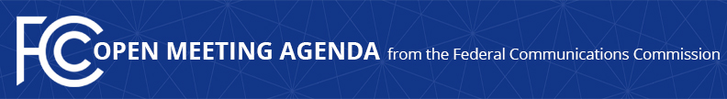

Media Contact:
Will Wiquist, 202-418-0509
will.wiquist@fcc.gov

For Immediate Release

FCC ANNOUNCES TENTATIVE AGENDA FOR APRIL OPEN MEETING
--
WASHINGTON, April 7, 2016 – Federal Communications Commission Chairman Tom Wheeler announced that the following items are tentatively on the agenda for the April Open Commission Meeting scheduled for Thursday, April 28, 2016:

Transition from TTY to Real-Time Text Technology: The Commission will consider a Notice of Proposed Rulemaking that seeks comment on proposals to support real-time text communications over Internet Protocol communications networks, to improve the accessibility of these networks for consumers who are deaf, hard of hearing, deaf-blind, and speech disabled. (GN Docket No. 15-178)

Business Data Services: The Commission will consider a Tariff Investigation Order and a Further Notice of Proposed Rulemaking proposing a new regulatory framework for the provision of business data services. (WC Docket Nos. 16-XX, 15-247, 05-25)

The Open Meeting is scheduled to commence at 10:30 a.m. in Room TW-C305 of the Federal Communications Commission, 445 12th Street, S.W., Washington, D.C.

###
Office of Media Relations: 202.418.0500
TTY: 888-835-5322
Twitter: @FCC
ftp.fcc.gov
www.fcc.gov/office-media-relations

This is an unofficial announcement of Commission action. Release of the full text of a Commission order constitutes official action. See MCI v. FCC. 515 F 2d 385 (D.C. Circ 1974).

