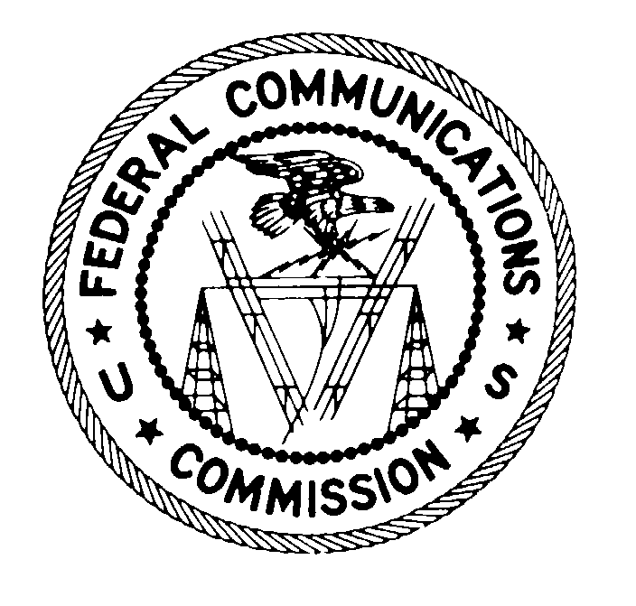
FEDERAL COMMUNICATIONS COMMISSION
Washington DC 20554

April 18, 2016

Via E-mail

Michael P. Goggin
AT&T Inc.
1120 20th Street, NW, Suite 1000
Washington, DC 20036
[michael.p.goggin@att.com]

Re: Application of New Cingular Wireless PCS, LLC, and Qualcomm Incorporated for Consent To Assign a Lower 700 MHz B Block License (WT Docket No. 16-75)

Dear Mr. Goggin:

New Cingular Wireless PCS, LLC, and Qualcomm Incorporated have filed an application pursuant to Section 310(d) of the Communications Act of 1934, as amended (the Act), seeking Commission consent to the assignment of a Lower 700 MHz B Block license. For the Commission to complete its review of the application and make the necessary public interest findings under Section 310(d) of the Act, we require additional information, documents, and clarification of certain matters discussed in the applications and other information provided to the Commission. If necessary, we will follow up with additional requests for information.
Accordingly, pursuant to Section 308(b) of the Act, we request that you provide written responses and supporting documentation for each request set forth in the attached General Information Request and, where appropriate, amend the application to reflect such responses. Each response or document should clearly indicate the specific question or request to which it responds, and each page should be marked with a corporate identification and consecutive document control numbers as specified in the attached instructions. We would appreciate receiving your response to each inquiry no later than May 2, 2016.
Your responses should be filed with Marlene H. Dortch, Secretary, Federal Communications Commission, in WT Docket No. 16-75. In addition, the Comment Public Notice and the Protective Order require the submission of multiple copies of all ex parte and other filings submitted in this proceeding. The Wireless Telecommunications Bureau also should receive, at a minimum, two copies of all paper filings. If you submit information pursuant to the Protective Order issued in this case, please call Scott Patrick of the Wireless Telecommunications Bureau at (202) 418-2853 to schedule receipt of the hand delivery of the unredacted documents, as well as follow other instructions set forth in the Protective Order. For any electronic filings made using the Commission’s Electronic Comment Filing System (ECFS), parties also should serve the documents via e-mail to Scott Patrick, scott.patrick@fcc.gov; Kate Matraves, catherine.matraves@fcc.gov; and Jim Bird, TransactionTeam@fcc.gov. For any documents and data you submit, please coordinate with Commission staff to discuss an acceptable format for their submission, as indicated in the Instructions attached to the General Information Request.
If you have any questions regarding this matter, please contact Kathy Harris, Mobility Division, Wireless Telecommunications Bureau, at (202) 418-0609, or Catherine Matraves, Spectrum and Competition Policy Division, Wireless Telecommunication Bureau, at (202) 391-6272.

Sincerely,

Jon Wilkins
Chief, Wireless Telecommunications Bureau

Attachment

cc: Joan Marsh
David C. Jatlow

47 U.S.C. § 310(d).
New Cingular Wireless PCS, LLC, and QUALCOMM Incorporated Seek FCC Consent to the Assignment of a Lower 700 MHz B Block License in New Jersey, WT Docket No. 16-75, Public Notice¸ DA 16-420 (WTB Apr. 18, 2016).
47 U.S.C. § 310(d).
47 U.S.C. § 308(b).
Application of New Cingular Wireless PCS, LLC and QUALCOMM Incorporated, for Consent To Assign License, WT Docket No. 16-75, Protective Order, DA 16-421 (WTB Apr. 18, 2016).

