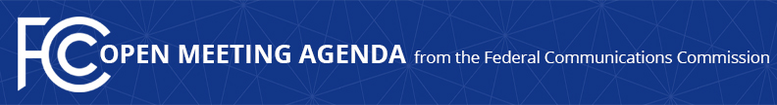

Media Contact:
Will Wiquist, 202-418-0509
will.wiquist@fcc.gov

For Immediate Release

FCC ANNOUNCES TENTATIVE AGENDA FOR MAY OPEN MEETING
--
WASHINGTON, May 4, 2016 – Federal Communications Commission Chairman Tom Wheeler announced that the following items are tentatively on the agenda for the May Open Commission Meeting scheduled for Wednesday, May 25, 2016:

Updating the Public Inspection File Requirements: The Commission will consider a Notice of Proposed Rulemaking that seeks comment on proposals to eliminate the requirement that commercial broadcast stations retain copies of letters and emails from the public in their public inspection file and the requirement that cable operators reveal the location of the cable system’s principal headend. (MB Docket No. 16-xxx)

Enhancing Public Safety and Network Reliability Through Communications Outage Reporting: The Commission will consider a Report and Order and Further Notice of Proposed Rulemaking to update its Part 4 communications network outage reporting requirements (PS Docket Nos. 15-80, 11-82; ET Docket No. 04-35)

Connect America Phase II Auction: The Commission will consider a Report & Order adopting rules to implement a competitive bidding process for high-cost universal service support from Phase II of the Connect America Fund. (WC Docket Nos. 10-90, 14-58, 14-259)

The Open Meeting is scheduled to commence at 10:30 a.m. in Room TW-C305 of the Federal Communications Commission, 445 12th Street, S.W., Washington, D.C.

###
Office of Media Relations: 202.418.0500
TTY: 888-835-5322
Twitter: @FCC
ftp.fcc.gov
www.fcc.gov/office-media-relations

This is an unofficial announcement of Commission action. Release of the full text of a Commission order constitutes official action. See MCI v. FCC. 515 F 2d 385 (D.C. Circ 1974).

