**Hispanic Television Study**

Office of Strategic Planning and

Policy Analysis

and

Industry Analysis Division,

Media Bureau

May 2016



This Study is available for download from the Federal Communications Commission at the following website: <https://www.fcc.gov/media/peer_review/peerreview>

Table of Contents

I. Executive Summary 1

II. Introduction 2

A. Determinants of Hispanic Television Viewing 2

B. Literature Review 7

III. Data 10

A. Television Schedule Data 11

B. Television Viewership Data 13

C. Ownership Data 15

D. Consolidated Database System as Crosswalk 15

E. Census data 18

F. BIA/Kelsey data 20

IV. Hispanic Viewing, Content and Population Distribution 21

V. STATION SUMMARY STATISTICS 44

A. Identifying a Station Observation 44

B. Summary of Hispanic-Owned Stations 44

C. Programming 46

1. Content by Station Subgroup 46

2. Paid Programming 48

3. Content by Deciles of Viewership 49

D. Station Summary Statistics by Sweeps Period 50

VI. EMPIRICAL FRAMEWORK AND RESULTS 52

A. Program-Level Analysis 52

1. What do Hispanic Households Watch? 52

2. Programming Decisions of Hispanic-Oriented Stations 56

3. Hispanic Household Viewing of Hispanic-Owned Stations 59

B. Station-Level Regression Analysis 63

C. Suggestion for Future Research 67

VII. Hispanic Cable Networks 68

A. Definition and Trends 68

B. Audience Coverage 69

C. Ratings 71

VIII. Conclusion 74

IX. Technical appendix 76

A. Data Overview 76

1. Television Schedule Data 76

2. Television Viewing Data 77

B. Creating the TMS-Nielsen Crosswalk 77

C. Data Aggregation and Cleaning 78

D. Additional Data Sources 79

E. Additional Characteristics of Television Markets in Study 81

# Executive Summary

1. In this document, we present the results of a rigorous, quantitative examination of the effect of Hispanic ownership on programming shown by broadcast stations and on Hispanic viewing habits. Our aim is to study the nexus between ownership, programming, and viewing to expand the discussion and understanding of these interrelationships. While we find suggestive evidence (as described in paragraph 3 below), we cannot draw strong conclusions with regard to the viewing of Hispanic-owned stations. Nonetheless, we see this study as a useful addition to the research into these issues, and the results as suggestive though insufficient for a final conclusion of the relationships we examine.
2. Using both descriptive statistics and regression techniques, we construct a unique dataset, including improved minority ownership statistics from the Federal Communication Commission’s (Commission’s) Form 323 data collection effort, and examine how Hispanic ownership is correlated with what viewers are offered and what they watch. After an introductory discussion and a review of related literature, in Section II, we describe in detail the data we use and how we assembled it in Section III (with further detail in the Technical Appendix at Section IX). Section IV includes descriptive statistics and details about the markets we study.
3. Though we cannot identify a causal effect of Hispanic ownership on outcomes of interest, we are nonetheless able to estimate conditional correlations between Hispanic-owned stations and programming and viewing choices during our period of study. Our models attempt to control for factors that may affect the relationship between a station's ownership status and its programming or viewing, such as market conditions or other station characteristics such as affiliation. The regression results, described in greater detail at Section VI, below, indicate that, among other things, Hispanic viewers: favor the major Spanish-language networks, especially Univision (which is not Hispanic-owned), watch local, Spanish-language news at higher levels than English-language news, and watch more telenovelas than other program types. With regard to programming, we find that Hispanic-owned stations are less likely to show telenovelas relative to other programming types, paid programming is strongly associated with Hispanic ownership, and Spanish-language programming and local programming are more likely to be shown on Hispanic-owned stations than other types of programming.
4. We find some indication that Hispanic ownership is associated with higher ratings among Hispanics, and in particular among Hispanics viewing Spanish-language local programming, suggesting that the programming choices of Hispanic-owned stations may lead to increased viewership among Hispanics compared to their viewing of stations that are not Hispanic-owned, although these results are limited by sample size. In addition, while Hispanic ownership of stations seems to correspond with slightly higher ratings, the results largely indicate that viewing of Hispanic-owned stations is still dwarfed by viewing of the large Spanish-language networks such as Univision and Telemundo.
5. The study’s aim is to examine the effect of Hispanic ownership on a station's programming decisions and consequently on its popularity among the Hispanic TV audience. While the data are robust, realities in the market that are reflected in the data do limit the analyses we are able to perform and the conclusions we reach. As described in more detail below, some of our findings regarding the viewing choices of Hispanic households may be particular to this demographic group because of their interest in Spanish-language programming, and not generalizable to other minority groups. Even so, this study is a step toward understanding the demand for programming content among a growing segment of the U.S. television audience. Additionally, the accuracy and precision of our models may be affected by the rather limited set of stations identified as Hispanic-owned for which we have programming and viewing data. In total, our sample has only 23 Hispanic-owned stations compared to over 500 stations identified as not Hispanic-owned. When analyzing the effect of ownership on, for example, the viewing of a particular station, we must acknowledge that this small sample of Hispanic-owned stations is likely to increase the variability of our regression models, making it difficult to identify statistically significant results. In addition, the data are essentially cross-sectional. Specifically, the Nielsen ratings data and TMS programming data are for a two week period during sweeps (four-week periods when all television markets are measured for station viewing and demographic information) in November 2011 and again in May 2012. There is no appreciable change in station characteristics or market demographics between these sweeps periods. Most importantly, during this interval there is no variation in station ownership. Consequently this study cannot establish whether viewers respond to a change in ownership by adjusting their viewing habits, or whether a change in ownership corresponds to a change in the program lineup of a station that may, in turn, affect viewing decisions.

# Introduction

## Determinants of Hispanic Television Viewing

1. The Commission has long been interested in minority ownership of broadcast stations and its possible impact on the range of programming available to American audiences. These issues have been considered in various Commission proceedings, including the agency’s reviews of its broadcast ownership rules and its initially separate proceeding on promoting diversity, now consolidated with the review of the broadcast ownership rules.[1] A few years ago, the Commission engaged in a process of revising and improving its Form 323 data collection of broadcast ownership information. As a result, a much better picture is now available of the extent of ownership of broadcast stations by members of minority groups and women.[2] These data are a key building block of any analysis of minority ownership.
2. The present study, which is the most comprehensive study to make extensive use of the Commission’s improved Form 323 data,[3] examines the extent of Hispanic ownership of television stations (full power, Class A, and low powered television (LPTV)),[4] documents the availability and viewing of Hispanic-oriented programming (specifically in the U.S. television markets in which Hispanic viewing is measured separately), and attempts to gauge the impact of Hispanic ownership on program provision. In addition to Form 323 data, the study draws on television viewing and related data from Nielsen, program scheduling data from Gracenote (formerly Tribune Media Services (TMS) and referred to as TMS in the present study), demographic data from the U.S. Census Bureau (Census), and affiliation data from BIA/Kelsey.
3. Several factors informed the choice of Hispanic television as a research topic. First, Hispanics are the largest minority group in the United States.[5] Second, Hispanic-owned television stations are more readily analyzed because there are more of them than stations owned by any other minority group.[6] And third, detailed program scheduling data are available for television, making it feasible to quantify the amount of programming from various sources and to understand some characteristics of program content. Such information is not available for radio. As noted in Section II, below, some relevant research has already been done on minority ownership and program content in radio using radio station format as an indicator of minority targeting.
4. As a threshold matter, it is necessary to adopt criteria for classifying program content as Hispanic-oriented. The data available do not allow us to make this distinction in a precise way. One obvious option in classifying program content is to ask whether the programming is in the Spanish language, and we adopt this criterion here.[7] This criterion is limited, however, because a large fraction of the U.S. Hispanic community is bilingual, so one can easily imagine English-language content aimed at this community.[8] Hence, it might be useful to look at the source (*e.g.*, the network or station) that provides the programming. As will be seen below, although most of the Hispanic-owned stations in our sample provide programming that is over 90 percent in Spanish, only four of them provide 100 percent Spanish content, two provide between 41 and 58 percent Spanish content, and one has zero Spanish content. A related methodological question is whether to differentiate between programming that is produced specifically for the U.S. Hispanic community or a subgroup thereof (because the community is not monolithic), and programming that was produced for and probably first exhibited to a foreign audience (*e.g.*, in Mexico) and then distributed in the United States. The description of our data below provides further detail on how the study identifies Hispanic-oriented programming. However, it is worth noting, that the data available do not allow us to make these distinctions in a precise way. One useful (but incomplete) approach to this question, employed below, is to study the distribution of programming by origin – network, local, etc. – and genre, *e.g.*, news. Local programming is not necessarily locally produced, but may instead be locally-selected; local news programming, however, most often is locally produced.[9]
5. We construct a dataset for the 39 geographic television markets in which Nielsen measures Hispanic viewing separately, excluding Puerto Rico. We acquired television program scheduling data for every broadcast station with measured viewing in those television markets from TMS and Nielsen. It is important to note that there are many stations for which Nielsen does not report viewing data, generally because the level of viewing is extremely low. Thus the data that we use do not reflect the full range of content available in these television markets; rather, they include all content that meets a certain viewing threshold.
6. After merging TMS programming data and Nielsen viewership data, our dataset contains entries for 544 stations of the 1472 for which TMS provides scheduling information.[10] TMS also allows us to determine whether stations are Spanish-language, and the Form 323 data allow us to determine whether a station is Hispanic-owned. The 544 stations include 133 Spanish-language stations of which 20 are Hispanic-owned. Three additional Hispanic-owned stations air programming predominantly in a language other than Spanish. Of the 133 Spanish-language stations, 127are network affiliates and 6 are independents.[11] As noted above, we identify Hispanic-owned stations from the Form 323 filings (for 2011). The Form 323 database lists 190 broadcast stations as Hispanic-owned, 97 of which are in the 39 markets that comprise our study area. The overwhelming majority of stations identified as Hispanic-owned that are not in our sample—58—are LPTV or translator stations. We excluded these 58 stations from our sample because we presume the LPTV stations have low audience shares and that translator station viewing is likely combined with that of the parent station.
7. In addition to the data on station characteristics, programming, and viewing, the study provides a description of the Hispanic audience in the United States for the 39 markets we study. The Hispanic community is made up of 13.96 million television households nationally, which account for approximately 12.2 percent of the 114.65 million television households in the United States (as of 2012).[12] The Hispanic population is not spread evenly across the country, and the present analysis uses the 39 geographic television markets in which Nielsen measures Hispanic viewing separately; these markets contain 78.8 percent of all Hispanic television households in the United States and 42.6 percent of total U.S. television households.[13] The more detailed discussion in Section III, below provides additional details about the demographics of the Hispanic population in the United States.
8. It is important to note that the Hispanic population relies more heavily on broadcast (*i.e.*, over-the-air) television than does the overall U.S. population. Nationwide, approximately 9.6 percent of U.S. television households are “broadcast-only;” thus the overwhelming majority subscribe to a pay television service.[14] The comparable figure nationwide for Hispanic households is 15.7 percent.[15] Nielsen also provides data for 30 major Hispanic television markets; broadcast-only shares in those markets range from 3.1 percent to 35.1 percent, with an average across the 30 markets of 16.4 percent.
9. Because the Commission’s regulatory authority over non-broadcast channels is limited, and because Hispanic households rely disproportionately on broadcast service, the detailed program content analysis in this paper focuses on broadcast programming. Nevertheless, it is important to note and document the substantial amount of Hispanic-oriented programming on cable and Direct Broadcast Satellite (DBS), because a significant share of Hispanic households do subscribe to pay television, both in the 39 television markets we analyze and across the country as a whole. One compilation cited Section II, below lists well over 100 networks, although of course not all are available on every distribution platform. The economic environment of producers/distributors of Hispanic-oriented programming clearly includes the non-broadcast services that many Hispanic viewers would see as substitutes for broadcast programming.
10. The descriptive analysis of Hispanic stations and programming indicates that there is a weakly positive relationship between the number of Hispanic households in a market and: the numbers of Hispanic-owned and Spanish-language stations (see Figures 6 and 7), as well as the extent of Hispanic programming available (see Figures 8 and 9). Additionally there is apparently a weak positive relationship between Hispanic television households and Hispanic viewing (see Figure 10).[16]
11. The analytical core of the paper is a series of regression analyses, some at the market level, some at the program level, and some at the station level. We chose program ratings and several measures of programming minutes as dependent variables in our market-level regressions. The coefficients on independent variables indicating the number of Spanish-language stations and the number or presence of Hispanic-owned stations in the market were not statistically significant. However, for several measures of Hispanic programming availability and viewing, the coefficient on the number of Hispanic households in the market is positive and statistically significant. The study also presents estimates of the determinants of Hispanic household viewing at the program level. After controlling for network affiliation, local news, local Spanish-language news, and telenovelas have statistically significant and positive coefficients.
12. The study also presents a series of program-level regressions that are designed to investigate the programming decisions of Hispanic-oriented stations. Using a logistic form, we estimate the probability that a program appears on an affiliated Hispanic-owned station, an independent Hispanic-owned station, or a larger, Spanish-language network as a function of the program’s characteristics and other control variables. The results suggest that local Spanish-language and local Spanish-language news programming are more likely to be associated with Hispanic ownership than other types of programming. These results are largely driven by Hispanic ownership being strongly associated with any type of Spanish-language programming, though local programming also appears to play a role. The results are similar for Hispanic-owned independent stations. With respect to stations affiliated with a Spanish language network, the association with local programming is weaker; moreover, these stations are less likely to show “paid programming,” which looms larger in the schedule of the Hispanic-owned stations. The analysis then returns to program ratings, providing estimates of the determinants of Hispanic household ratings as a function of station characteristics, including Hispanic ownership and whether the station is an independent or a network affiliate. There is some evidence that Hispanic ownership is associated with higher Hispanic viewing and the effect is more pronounced in the case of local programming, though sample size issues may impact these results.
13. Even though the total number of Hispanic-owned stations is not large, and the number of Hispanic-owned independents is smaller, we analyze viewing (ratings) at the station level. The regression equations here seek to identify the determinants of Hispanic household viewing for all programs and for local Spanish-language programming. After controlling for network affiliation and other factors, no statistically significant effect is found with respect to viewing of all programs or of Spanish-language local programs. However, many of the relevant coefficients are, in fact, positive, and some have “p-values” that approach statistical significance.[17] Thus, some of the regression results are consistent with a relationship between Hispanic ownership and Hispanic-oriented programming.
14. In the next section, we discuss two closely related studies. In Section III, we discuss the data we use in this study. Section IV presents market-level descriptive statistics for the markets we study and market-level regressions. Section V provides station-level descriptive statistics. Section VI describes our program-level and station-level regression results. Section VII gives a short summary of Hispanic cable networks, and Section VIII concludes. In Section IX, the Technical Appendix, we delve into greater detail concerning the cleaning and assembly of our dataset, and include more detailed descriptive statistics of the markets we study.

## Literature Review

1. There are primarily two pieces of relevant work on minority ownership and its possible impact on program content: (1) an article by Peter Siegelman and Joel Waldfogel,[18] and (2) an FCC-commissioned study by Joel Waldfogel for the *2010 Quadrennial Review* of broadcast ownership.[19] Siegelman and Waldfogel used the concept of “preference externalities” and used it to motivate an examination of the impact of minority ownership (African-American and Hispanic) on radio programming availability and listening.[20] Siegelman and Waldfogel define preference externalities as the benefits to an individual from being in the same market as others with similar preferences.[21] Siegelman and Waldfogel find that in the case of advertiser-supported radio programming, markets with larger populations can support more program content. In other words, the more people in the market with a particular content preference, the more of that content is likely to be provided. On the other hand, because there are certain fixed costs of producing and transmitting radio programming, some types of content may not be provided locally if there are not enough potential listeners to provide the advertising revenues necessary to cover even the fixed costs.
2. Siegelman and Waldfogel posit that if everyone had similar preferences there would be no distinct groups potentially underserved; however, if different segments of the population have different preferences, then it is possible that smaller groups will be underserved. Siegelman and Waldfogel, using data for 1993 and 1997, show that African-American and Hispanic radio listening in a market is positively related to the size of same-group population, but not to population size for other groups. Moreover, particularly with respect to the African- American audience (less so for Hispanics) this analysis finds there are substantial differences in listening patterns between white listeners and minority groups. This finding underlines the importance of provision of a diverse menu of media content. Siegelman and Waldfogel categorize radio content by station format and find African-American listening heavily concentrated in a small number of formats, with white audiences listening to those formats only a small percentage of the time.
3. Siegelman and Waldfogel next turn to the possible relationship between minority ownership of radio stations and the provision of minority-oriented programming. Based on the listening patterns mentioned above, Siegelman and Waldfogel classify certain radio station formats as African-American-oriented or Hispanic-oriented. They note that most minority-owned stations do provide minority-oriented content, but that most of the stations providing minority-oriented content are white-owned.[22] Therefore, their initial inspection of the data does not suggest a causal relationship between minority ownership and minority programming. Siegelman and Waldfogel then hypothesize that the amount of minority-oriented programming is mostly determined by demand and some of that demand is filled by white-owned stations and some by minority-owned stations. Under this hypothesis for example, an increase in African- American station ownership might not change the total amount of African-American-oriented programming but merely “crowd” some white-owned stations into another format.[23]
4. Siegelman and Waldfogel undertake cross-section regression analysis of 1993 and 1997 data, estimating the number of minority-oriented stations (separately analyzing African-American and Hispanic-oriented stations) as a function of the number of minority-owned stations in the market along with controls for the total number of stations in the market and the minority population. They find that “each additional minority-owned station begets roughly one additional net source of minority-targeted programming, suggesting that minority-owned stations do not simply replace white-owned minority-targeted stations.”
5. They acknowledge the relationship between programming and ownership may be the result of an omitted factor that is jointly and significantly determinant.[24] To address this methodological problem, Siegelman and Waldfogel regress the 1993 to 1997 change in minority-oriented programming on the change in minority ownership of stations. This regression nets out the impact of any unobserved causal factors that do not change over time, but it is still possible that changes in minority ownership are endogenous, perhaps determined in part by the demand for minority content in certain markets.[25] Siegelman and Waldfogel then exploit two regulatory changes unrelated to minority programming demand that occurred between 1993 and 1997 and had an impact on minority ownership. The Telecommunications Act of 1996 relaxed the local market limits on radio station ownership by a single entity, with looser limits for larger markets.[26] Moreover, the 1996 Act eliminated the national limit on radio station ownership.[27] Additionally, in 1995 Congress eliminated the “Tax Certificate” policy, which had provided incentives for those selling radio stations to sell them to minorities.[28]
6. Siegelman and Waldfogel argue that between 1993 and 1997 there was an exogenous shift in minority ownership, so that changes in minority-oriented programming during that period can plausibly be attributed to ownership changes.[29] Because the amount of relaxation in the ownership rule varied by market size, Siegelman and Waldfogel used market size as an instrumental variable in a two-stage least squares estimating procedure and concluded that an additional minority-owned station in a market resulted in roughly one additional minority-oriented station.[30] Given these results, Siegelman and Waldfogel were able to conclude that at least for radio in the 1990’s, with content characterized by format, increased minority ownership arguably led to increased minority-oriented content.[31] Siegelman and Waldfogel suggest further research, including extending their analysis to television viewing and seeking more detailed content classification.[32]
7. As part of its *2010 Quadrennial Review*, the Commission asked Joel Waldfogel to conduct a study similar to the Siegelman and Waldfogel study with updated data from 2005-2009.[33] No exogenous policy changes occurred during this period; therefore, Waldfogel was unable to conduct as robust an analysis as in the earlier Siegelman and Waldfogel study.Waldfogel also used radio format to categorize stations as minority-oriented, and confirmed that minority audiences – African-American and Hispanic – have listening patterns distinct from those of the majority population.[34] As in Siegelman and Waldfogel, Waldfogel found that while most minority-owned stations target the minority population, most of the minority-oriented stations are not owned by minorities.[35] Waldfogel also found that, in 2007, 34 percent of the Hispanic-oriented radio stations were Hispanic-owned.[36] Waldfogel’s statistical analysis consisted of a series of cross-section regression estimates, and results from these regressions are consistent with those from the Siegelman and Waldfogel study; specifically, that increased availability of minority-oriented stations attracts more minority listening and the presence of minority-owned stations in a market is associated with an increased amount of minority-oriented programming. As noted, however, no exogenous regulatory changes occurred that would permit an inference of causality.
8. This literature leads us to conclude that the use of radio format to characterize station content is a reasonable but imperfect indicator. One advantage of studying television rather than radio is that more detailed, program-level data on program content are available. While the analysis below includes some station and market-level regression estimates, the bulk of the work is program-level analysis of a kind that was not and could not have been done for radio.

# Data

1. To explore the relationships among Hispanic television station ownership, Hispanic-oriented programming, and Hispanic television viewing, Commission staff obtained data from several major industry data providers. The empirical analysis combines household viewership data from Nielsen, program data from TMS, and broadcast station ownership classifications from Form 323 filings. The data are further supplemented with household demographic information from Census and station affiliation data from BIA/Kelsey. By constructing a database combining these data, we are able to examine the viewing decisions of Hispanic households as a function of television station ownership structure and the quantity and characteristics of Hispanic-oriented programming.
2. We restrict our analysis to the 2011-2012 television season. The specific period of investigation was chosen to coincide with Nielsen “sweeps” months in order to facilitate the matching of viewership data with program metadata. Sweeps are four, four-week periods when all television markets are measured for station viewing and demographic information.[37] Table 1 shows all sweeps dates available for analysis in the 2011-2012 television season. For this study, we use data for the November 2011 and May 2012 sweeps periods.

**Table 1:**

**Sweeps Dates for 2011-2012 Television Season**



1. For the study period, we construct a dataset of 481,457 observations. An observation reflects a television program shown on an individual station in a television market at a particular day and timeslot. These observations span four weeks, 39 television markets, and 544 unique television stations. Of these 544 television stations, we identify 133 unique Spanish language stations and 23 unique Hispanic-owned television stations. Further, 20 of the 23 unique Hispanic-owned television stations are also Spanish-language stations. Below we describe the television schedule data from TMS, the television ratings or viewership data from Nielsen, ownership classification data from Form 323, demographic data, and affiliation data from BIA/Kelsey. Also, we provide an overview of our methodology to create this database.[38]

## Television Schedule Data

1. The Commission purchased programming content and schedule data from TMS, one of the largest sources of entertainment metadata in the United States. Staff obtained the universe of television programming for two, separate 14-day periods of television schedules for full-power broadcast television stations and major low-power television stations. Our study covers two weeks of television programming in both November 2011 and May 2012 to coincide with Nielsen sweeps periods in the 2011-2012 television season. While our corresponding Nielsen ratings data covers the entire November and May sweeps periods, yielding eight total weeks of viewing data,[39] the television schedule data comprise only two weeks in each month. The specific weeks chosen are presented in Table 2.

**Table** **2:**

**TMS Data Dates**



1. The TMS data exist in a relational database that connects five distinct files in a non-hierarchical format. Each file contains several fields of information germane to that particular record. For the study, we focus on three files corresponding to station information: (Station Record), program content (Program Record) and scheduling information (Schedule Record). We construct our television schedule dataset by joining the matrix of the three previously enumerated files for each week in our sample through the common links presented in Table 3.
2. A complete dataset appends the merged Station-Schedule-Program records for each week into one file. An example of a unique observation in the TMS database is a television program (*e.g.*, “Tengo Talento, Mucho Talento”) shown on a particular broadcast station (*e.g.*, KTNC) at a particular day and time (*e.g.*, 4 a.m., Thursday, May 3, 2012) in a particular market (*e.g.*, San Francisco).[40]

**Table** **3:**

**TMS Data Files**



1. Because the study is focused on the marginal impact of Hispanic-owned stations on Hispanic-oriented programming and viewership, we next need to identify within this database what should be considered Hispanic-oriented programming. We contacted a number of key figures in the Hispanic television programming industry and other related media advocacy groups to gain a broader view on the universe of Hispanic-oriented programming.[41] Perspectives differed substantially on how to accurately identify Hispanic-oriented programming, as well as how best to differentiate between content that is targeted to, and content that is of interest to, Hispanic audiences.
2. We recognize that Spanish language has traditionally been used to classify content of interest to, as well as content targeted to, Hispanic audiences.[42] While we appreciate that linguistic classification does not entirely capture the universe of Hispanic-oriented programming, we rely in part on this classification due to the unavailability of a more nuanced approach. We do include other classification variables including program source and genre description. Table 4 describes the variables originating from the television schedule data that are used to identify content of interest.

**Table** **4:**

**Variables Used to Identify Content of Interest in TMS Data**



## Television Viewership Data

1. The Commission purchased broadcast and cable ratings data from Nielsen for the November 2011 and May 2012 sweeps periods. While we focus on broadcast ratings data in our main econometric analysis, we provide descriptive statistics for Hispanic viewership patterns on cable networks in Section VII. Our study focuses on the broadcast ratings data available for each of the 210 contiguous geographic areas across the United States in which local television viewing is measured by Nielsen. These geographic areas are called Designated Market Areas or DMAs. According to Nielsen, a DMA is a “group of counties that form an exclusive geographic area in which the home market television stations hold a dominance of total hours viewed.”[43]
2. Nielsen tabulates viewing for all households in all 210 DMAs, and also separately for Hispanic households for select DMAs. Nielsen defines a Hispanic household as one in which the head of household self-identifies as Hispanic. Viewership data in each of these DMAs or television markets report both the total number of Hispanic television households viewing a particular program, as well as all households viewing that particular program.[44] We extrapolate the number of non-Hispanic television households viewing a particular program by taking the difference between the two. In some instances, the Hispanic viewership for a program may not be large enough to clear Nielsen’s reporting threshold. For these observations, only the total viewership for a program is given. However, although these observations have incomplete viewing measurements, we included them in the final dataset to provide a more complete picture of the universe of programming available to all households in our sample. Our study covers the 39 television markets for which Nielsen separately tabulates Hispanic household viewing.[45] Figure 1 provides a map that delineates the 39 television markets in our study and the remaining television markets that are not included. Table 11 includes a list of the television markets included in our study and selected corresponding demographics.
3. A complete dataset for Nielsen viewership averages all quarter-hour audience measurements across the entire duration of a program in the sample through a multi-step process.[46] A unique observation in the Nielsen database records the number of Hispanic and total households viewing a television program (*e.g.*, “This Old House”) shown on a particular broadcast station (*e.g.*, WCBS) at a particular day and time (*e.g.*, 5 a.m., Thursday, Nov. 3, 2011) in a particular market (*e.g.*, Philadelphia).[47]

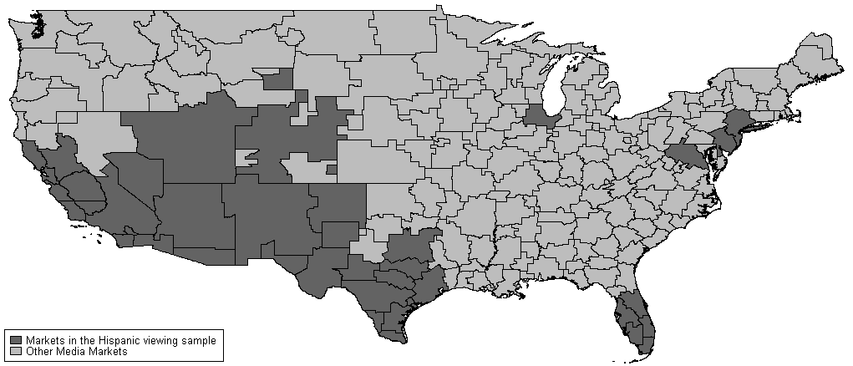

**Figure 1: Television Markets in Hispanic Study**

## Ownership Data

1. In 2009, the Commission revised the Form 323 “to obtain more complete, reliable, and accurate data on racial and ethnic minority and female broadcast ownership.”[48] Classification of minority ownership shares follows from Form 323 filings in the following manner: each individual or entity that holds a broadcast license for a commercial AM, FM, full-power, Class A, or LPTV station must file an ownership report on Form 323 every two years. If the organizational structure of the station includes forms of indirect ownership, for instance holding companies, then each attributable entity must file a separate ownership report.[49]
2. We identify commercial broadcast stations as Hispanic-owned if individuals who self-identify as Hispanic/Latino collectively or individually hold a majority of the station’s voting interests. We created a complete list of all majority Hispanic-owned television stations using data from 2011 Form 323 filings. According to the information filed, Hispanic/Latinos collectively or individually held a majority share of voting interests in 190 broadcast television stations,[50] composed of:

* 35 full-power or digital television stations;
* 34 Class A television stations;
* 93 low-power television stations;
* 4 satellites; and
* 24 translators.

1. Using the 2011 ownership classifications, we first eliminate stations not licensed in the 39 television markets in our study, leaving a possible 97 Hispanic-owned stations. Of those 97 stations, 17 are full-power, 19 are Class A, 45 are low-power, and 16 are translators. Our next step is to determine which of these 97 stations can be matched to the stations in the Nielsen and TMS databases.

## Consolidated Database System as Crosswalk

1. Nielsen viewing data for a given program on a station are classified by an internal identifier and call sign. TMS schedule data for a given program on a station are given by an internal identifier and call sign. The internal identifiers are unique to Nielsen and TMS, and thus cannot be used to match observations between the two databases. Both databases provide station call signs which could be used to combine these databases. However, Nielsen and TMS use different vintages of call signs. Nielsen uses “historic” call signs (call signs of stations at the time of the study period, *e.g.*, November 2011 and May 2012), and TMS uses “current” call signs (call signs of stations at the time the data was generated for use by the Commission, *e.g.*, late 2013). As call signs have changed over time, particularly as broadcast technology was completing the switch from analog to digital transmission during the study period, directly matching observations (for a particular program at a given timeslot in a particular geographic area) on call signs from TMS and Nielsen could potentially lead to spurious results.[51]
2. To overcome this issue, we used the Media Bureau’s Consolidated Database System (CDBS).[52] All stations operating in the United States must file an application for an initial construction permit with the Commission. Applicants are assigned an FCC Facility ID during this process, and information about each station, including changes in call sign or service designations, market of license, channel, frequency, and other characteristics are maintained in the database according to the FCC Facility ID. Because the FCC Facility ID assigned to each station does not change over time, we are able to use the appropriate historical snapshots of the CDBS, inclusive of any call sign changes, to match each Nielsen and TMS station to the time-invariant FCC Facility ID. Using the FCC Facility ID and call sign, we create a crosswalk to assign the right TMS facility ID to the Nielsen station, such that each Nielsen station will have a corresponding TMS ID and FCC Facility ID. After merging the TMS and Nielsen data, we use the FCC Facility ID in the matched dataset to identify all Hispanic-owned stations as determined by the Form 323 data.[53]
3. In the final, merged sample of Nielsen, TMS, and Form 323 data, we find 21 Hispanic-owned stations (identified by FCC Facility ID) in 17 television markets for 2011, and 23 Hispanic-owned stations in 17 television markets in 2012. Across both time periods of the study, there are 23 unique, majority Hispanic-owned television stations operating in 18 different television markets across both sample periods.[54] Of the 23 stations across our study sample, 15 are full-power, five are Class A, two are low-power, and one is a translator. Table 5 below provides information on station type overall as well as whether the data is included in the study and in the sample period. Table 8 below provides a list of the 23 Hispanic-owned television stations included in our database.

**Table** **5:**

**Summary of Hispanic-Owned Stations**



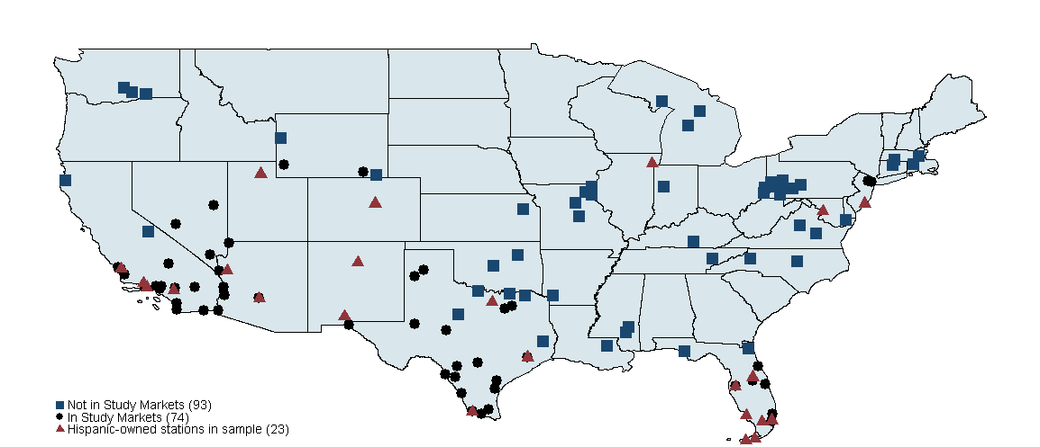

**Figure 2: Majority Hispanic-Owned Stations using 2011 Form 323 data for Continental U.S**.[55]

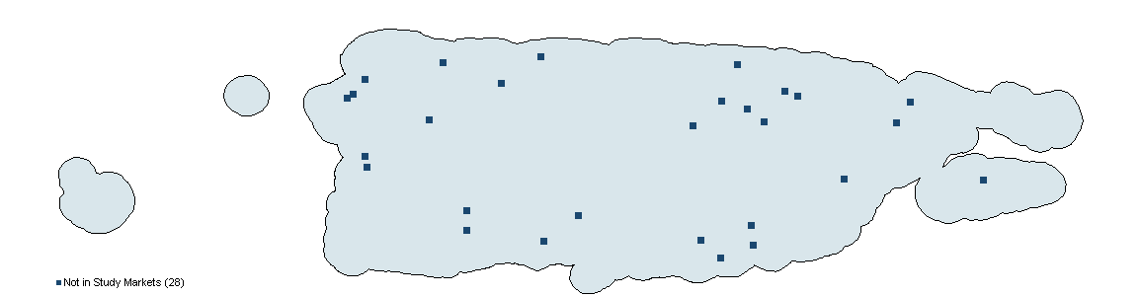

**Figure 3: Majority Hispanic-Owned Stations using 2011 Form 323 data for Puerto Rico Only[56]**

## Census data

1. Census publishes annual estimates of the population of the nation, states and counties. We collected county-level data as defined in the Office of Management and Budget’s (OMB’s) February 2013 definitions for metropolitan and non-metropolitan counties.[57] Census revises its series of annual population estimates every year starting with the decennial base year (2010) through the current year.[58] These estimates are available by age, sex, race, and Hispanic origin.[59] Table 6 below lists the Census population measures for 2011 that we used or considered for use in the study.[60]

|  |  |  |
| --- | --- | --- |
| **Table 6. Census Bureau Population Variables** | | |
| **Variable** | **Description** | **Variable Key** |
| SUMLEV | Geographic Level | 050 = County and/or statistical equivalent |
| STATE | State FIPS code | --- |
| COUNTY | County FIPS code | --- |
| YEAR | Year | 4 = population estimates for July 1, 2011 |
| AGEGRP | Age group | 0 = Total (all ages) |
| TOT_POP | Total population 2011 | --- |
| TOT_MALE | Male population 2011 | --- |
| TOT_FEMALE | Female population 2011 | --- |
| H_MALE | Hispanic males 2011 | --- |
| H_FEMALE | Hispanic females 2011 | --- |

1. Census also maintains a database containing estimates of income and poverty at the county level in order to document economic and social diversity.[61] From this database, we obtain 2011 estimates for median household income and the percent of the population in poverty.[62] The median household income is the middle income level after dividing the income distribution into two equal parts: one-half of the households falling below the median income and one-half above the median. Median household income is based on the distribution of all households including those with no income. Census calculates annual poverty rates using the sum of household income over the year divided by an income poverty threshold. In addition, our study measures include the Bureau of Labor Statistics (BLS) unemployment rate for 2011,[63] and a five-year average over 2009-2013 of education levels from the U.S. Census Bureau’s American Community Survey.[64] Table 7 below lists these variables. We match the county-level Census demographic characteristics to the television market level using proprietary Nielsen definitions and data as aggregation weights. A more complete description of this process can be found in Section IX, Technical Appendix.

|  |  |  |  |
| --- | --- | --- | --- |
| **Table 7. Typology Measures** | | | |
| **Variable** | **Source** | **Source** | **Year** |
| STATE | State FIPS code | --- | OMB |
| COUNTY | County FIPS code | --- | OMB |
| Median household income | Median household income in dollars | Census | 2011 |
| Poverty rate | Percentage rate persons in poverty | Census | 2011 |
| Unemployment rate | Percentage rate of unemployment | BLS | 2011 |
| **Education Level** | **Percentage share of adult population** | **ERS** | **2009-2013** |
| Less than high school | Have not received high school diploma or its equivalent nor attended college |  |  |
| High school diploma | Received a high school diploma or its equivalent but did not attend college |  |  |
| College attendance | Attended at least 1 one year of college but did not graduate |  |  |
| College graduate | Received a bachelor's degree or higher |  |  |

## BIA/Kelsey data

1. The study analysis leverages information on station affiliation to estimate the marginal effect of independent Hispanic ownership on viewing. We find that the TMS and Nielsen data are unsuitable to identify station affiliation. The TMS data reflect station affiliations as of 2013 when the data was generated for use by the Commission, and therefore may include entities which did not exist in 2011 and 2012. Further, the values assigned to TMS data do not account for potential changes in station affiliation over the time period of the study. Although station affiliations provided by Nielsen are historic to the study period, the data are incomplete, and do not include a comprehensive listing of independent Hispanic networks. To ameliorate this issue, we merged BIA/Kelsey affiliation data from 2011 and 2012 with the Nielsen dataset using a crosswalk. A complete description of this process can be found in Section IX, Technical Appendix.
2. After merging the BIA/Kelsey affiliation data into our dataset, we find that most of the Hispanic-owned stations in our study are affiliated with large networks such as Telemundo and very few are independently owned. In the empirical analysis in Section VI, below, we explore the extent to which small, independent Hispanic-owned stations influence Hispanic-oriented programming and viewership decisions in contrast to Spanish-language network stations. Table 8 below lists the 23 Hispanic-owned stations in our database. Table 8 also includes the television market where the station is licensed and the station’s network affiliation and service type. Of the 18 distinct television markets with a Hispanic-owned station, 15 television markets have one station. Miami, Los Angeles and Phoenix are the only television markets with multiple Hispanic-owned stations in our dataset.

**Table 8: Hispanic-Owned Stations in 23 Station Database**



# Hispanic Viewing, Content and Population Distribution

1. In this section, we provide market-level descriptive statistics for the stations and markets in our study dataset. This dataset comprises 481,457 observations and spans four weeks and 544 unique stations across 39 television markets. For this dataset, an observation is a television program shown on an individual station in a television market at a particular day and timeslot. Stations may broadcast in more than one television market, either because their signal reaches far enough to span multiple television markets or because they broadcast on translator stations. Therefore, while we accurately describe the presence of 544 unique stations across the full dataset, in total there are 646 station-by-market observations in the full dataset. We identify 133 unique Spanish-language stations in this dataset, as classified according to TMS, as well as 23 unique Hispanic-owned stations (of which 20 are also Spanish-language) as classified by the Form 323. Station language designation in this instance derives from a TMS variable classification and refers to the edited language of a station (Table 4).
2. Before turning to descriptive statistics by television market, we preview the viewing habits of Hispanic and non-Hispanic households in the complete dataset. We classify programming as Spanish-language, English-language and overall to obtain the shares of each type of programming watched by the audiences in our study. Tables 9 and 10 present information on viewing tendencies across program language designations of Hispanic versus non-Hispanic viewers in our sample. Not surprisingly, non-Hispanic viewers watch English-language programming almost exclusively, while Hispanic viewers have more mixed viewing habits. However, the vast majority of Spanish-language programming is viewed by the Hispanic audience.
3. We next aggregate the program-level characteristics of the full dataset to the market level to determine how available content and viewing behavior of Hispanic audiences varies across television markets. Tables 11 through 15 present station, viewing, program content and demographic characteristics for each television market in our study. From the full dataset of 481,457 observations, we generate descriptive statistics for selected variables of interest for each of the 39 television markets in our study. Specifically, our aggregation reduces the full dataset to 39 observations, one for each television market.
4. For programming content available in each television market by genre, such as the total number of minutes in each market devoted to local programming, we sum duration in minutes for each program classified as local within each television market across each week in the data. For viewing or audience measurements, we average the audience ratings for each program classified as local or Spanish-language on all stations within each television market across each week of the data.[65] Tabulation of overall, Spanish-language and Hispanic-owned station counts are calculated within each market. We classify a station as being “in” a market if the station has schedule data and/or viewership data in a market. Because stations may broadcast across multiple markets (viewing is recorded in a different market from which the station signal originated), summing up the number of Spanish-language or Hispanic-owned station observations in each market may overstate the total number of stations that are unique to the dataset. For instance, we find that there are 23 unique Hispanic-owned stations in our full dataset. However, because the Hispanic-owned station WJAN broadcasts in both Miami and West Palm Beach, simply summing the values in the fourth column in Table 12a would yield a total of 24. For demographic characteristics at the market level such as median household income or unemployment rates, the U.S. Census Bureau measures for all counties contained in each television market are aggregated to the television market level according to the process described in Section III.D, above.

**Table 9: Share of All Spanish and English Language Programming Viewed by Hispanics vs. Non-Hispanics**

|  |  |  |  |
| --- | --- | --- | --- |
|  | Spanish-Language | English-Language | All Programming |
| By Hispanics | 96% | 15% | 25% |
| By Non-Hispanics | 4% | 85% | 75% |

**Table 10: Share of All Hispanic and Non-Hispanic Viewing Going to Spanish and English- Language Programming**

|  |  |  |
| --- | --- | --- |
|  | Hispanic | Non-Hispanic |
| Spanish-Language | 47% | 1% |
| English-Language | 53% | 99% |

1. Below we analyze and present data categorized by television market to determine whether programming or viewing decisions are driven by the presence of Hispanic-owned stations. Tables 11 through 18 report population, demographic, programming, and viewing statistics for each of the 39 television markets in our sample. We review each of the tables in turn.

**Table 11: Demographics by Study Television Market**



1. Table 11 reports the total population, Hispanic share of total population, and Hispanic share of total television households by television market. Markets are ordered alphabetically. Generally, television markets with larger populations, particularly those with total population counts above 0.75 million, have a lower Hispanic share of the total population. Table 11 also provides a measure of the portion of Hispanic television households for which the Spanish language is dominant in the household. Nielsen provides data for five, mutually exclusive categories in the language strata: number of households speaking Spanish only; number of households speaking mostly Spanish; number of households speaking English and Spanish; number of households speaking mostly English; and number of households speaking English only. We combine the number of households that speak Spanish only and the number of households that speak mostly Spanish to report the share of Hispanic television households where Spanish is the dominant language. Missing values indicate that Nielsen did not collect the information for that particular television market. Nielsen generally reports language strata for the largest television markets, according to total population, so it is difficult to discern a pattern of language dominance among Hispanic television households with respect to Hispanic share of total population. While New York, which is the largest market, has a low Hispanic share of the total population at 0.22, the Spanish-language dominant share of Hispanic TV households is quite high, at 0.45. The Spanish-language dominant share varies between 0.16 in Albuquerque to 0.55 in Miami.

**Table 12a: Television and Station Characteristics by Study Television Market**



1. Table 12a reports for each of the 39 television markets the number of Hispanic television households, the total number of stations, the number of Hispanic-owned stations, and the total number of Spanish-language stations. Markets are ordered by total Hispanic television households, largest to smallest. Again, each station count is calculated within a television market. Because station signals sometimes span multiple television markets, summing the associated station counts across all the television markets in Table 12a will tend to overestimate the number of Hispanic-owned, Spanish-language and overall stations that are unique to the full dataset.

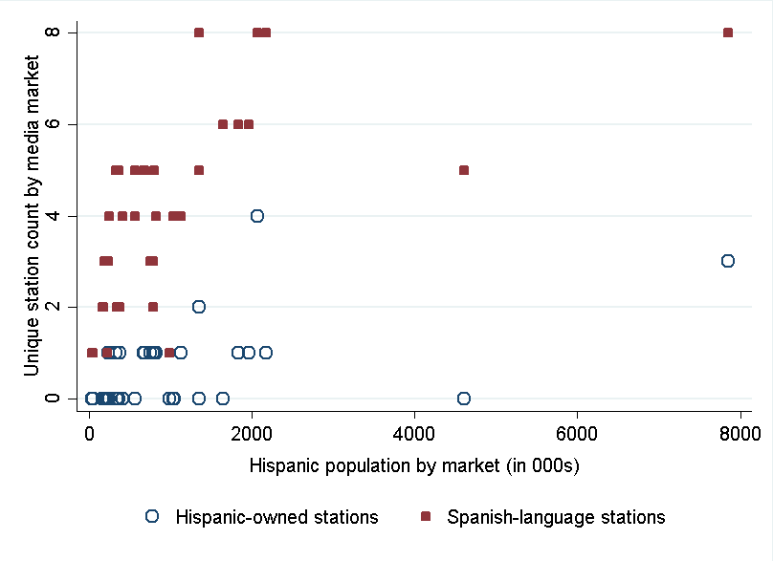

**Figure 4: Relationship between Hispanic population and station counts**

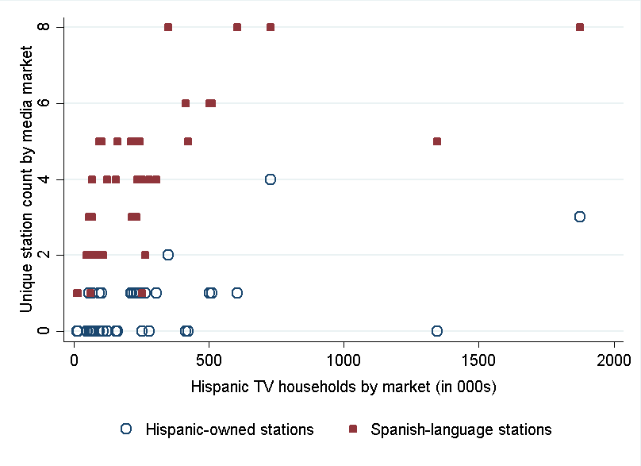

**Figure 5: Relationship between Hispanic television households and station counts**

1. Table 12b disaggregates the total number Hispanic television households by viewing technology (cable, Alternative Distribution Service (ADS)/satellite and broadcast). We find that the majority of Hispanic television households appear to be either cable or Alternative Delivery System (ADS) households. ADS designations refer to households with one or more television sets that receive programming from one of four types of systems: DBS; satellite dish (C-Band); satellite antenna television (SMATV); and multi-channel, multi-point distribution systems (MMDS). Broadcast television households, which make up a much smaller share of Hispanic television households, are defined as those households which only have the capability to receive television programming “over the air.”
2. Figures 4 and 5 present scatterplots generated using the station counts contained in Table 12a on the y-axis and the total Hispanic population by market on the x-axis. Each dot represents a television market. In Figure 4, we find a weakly positive relationship between the total number of Hispanic-owned and Spanish-language stations in a television market and total Hispanic population. In Figure 5, the positive correlation between station counts and Hispanic television household counts is slightly stronger, but not definitive. While the relationship is stronger for Spanish-language stations, it is likely that the sample size of Hispanic-owned stations is too small to be conclusive.
3. Figures 6 and 7 present scatterplots generated using the delivery technology shares contained in Table 12b on the y-axis and the Hispanic population share of total television households on the x-axis. Each dot represents a television market. The figures suggest a positive relationship between broadcast share of Hispanic television households and the share of television households in a television market that are Hispanic. By contrast, we find a slightly negative relationship between cable share of Hispanic television households and the share of television households in a television market that are Hispanic.

**Table 12b: Television and Station Characteristics by Study Television Market**



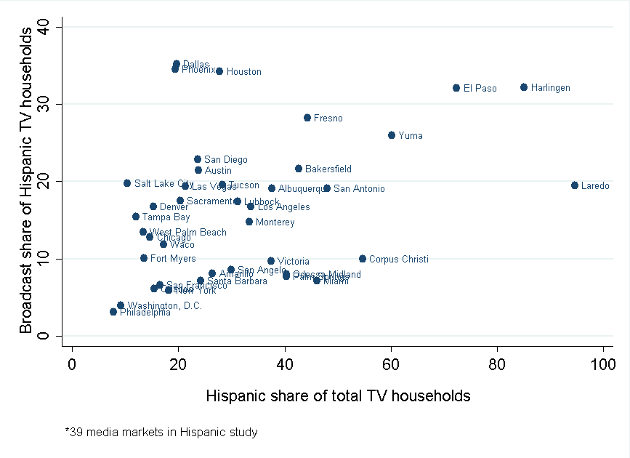

**Figure 6: Relationship between delivery technology and Hispanic television share**

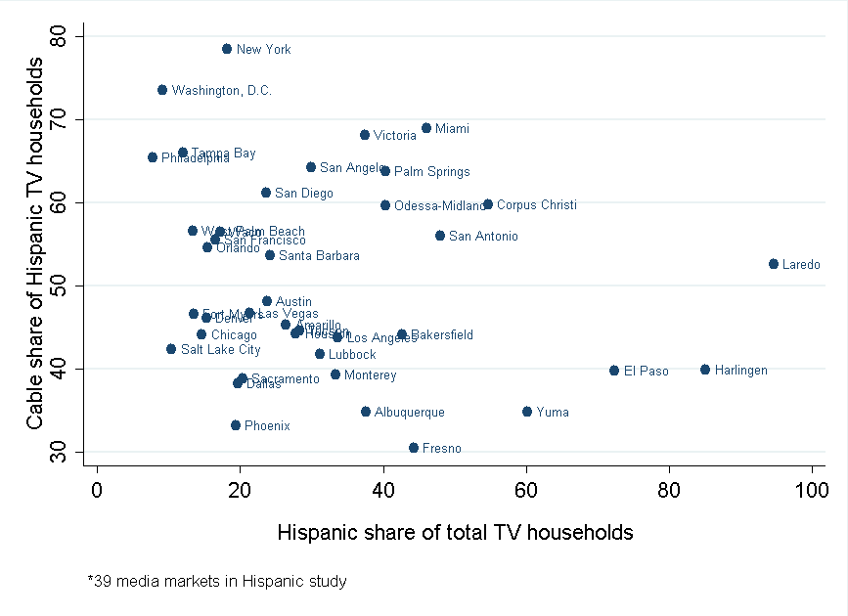

**Figure 7: Relationship between delivery technology and Hispanic television household share**

1. Table 13 reports household demographic characteristics of households within television markets. In addition to reporting demographic, the table also provides median household income, percent of population below the poverty rate and the unemployment rate, and educational attainment measures for each television market. Markets are ordered by total population, largest to smallest. The table indicates that the New York, San Francisco, and Washington, D.C., television markets have highest median household incomes in the study. Yuma, Fresno and Bakersfield have the highest unemployment rates of our study markets.

**Table 13: Demographics by Study Television Market**



1. We report programming characteristics by television market in Tables 14 and 15. Total programming minutes in each television market are calculated as the sum of the duration in minutes of each program in the November 2011 and May 2012 time periods. We report results in aggregate across both time periods and assume there are no systematic differences in how programming is either consumed or scheduled across sweeps months. Total programming minutes in each television market are further categorized by content or genre of interest, such as percentage of total programming that is from a Spanish-language network, local or syndicated source, or the percentage of total programming that is Spanish-language or news. In this manner, we identify not only Hispanic-oriented content, but also local news programming share in Spanish. From Table 14, we classify content of interest as the total amount of programming time, as well as by share of local Spanish-language programming. Markets are ordered by total population, largest to smallest. For example, the study contains 888,997 total programming minutes in the New York television market, and the fraction of total programming in Spanish in that market is approximately 19.7 percent. The percentage of Spanish-language programming that is locally sourced is 14.8 percent in New York. In comparison to New York, the largest television market by total population, the study contains 350,998 total programming minutes in Victoria, Texas, the smallest television market by total population. Of the total quantity of programming available in Victoria, 11.2 percent is in Spanish, and approximately 0.9 percent of all Spanish-language programming is locally sourced.
2. Figures 8 and 9 graphically depict the relationship between Hispanic population and Hispanic television households and selected programming characteristics for our dataset. Figure 8 illustrates a scatterplot using the quantity of Spanish-language and locally sourced Spanish-language programming minutes on the y-axis and Hispanic population on the x-axis; Figure 9 includes Hispanic television households on the x-axis. Each dot in the graph represents a television market. We find a positive relationship between total Hispanic population and the total number of Spanish-language programming minutes in a television market, as well as a weakly positive correlation between total Hispanic population and the number of Spanish-language, local minutes in a television market. There also appears to be a slight positive correlation between the total number of Hispanic television households and the number of minutes devoted to Spanish-language, local programming.

**Table 14: Programming Characteristics by Television Market**



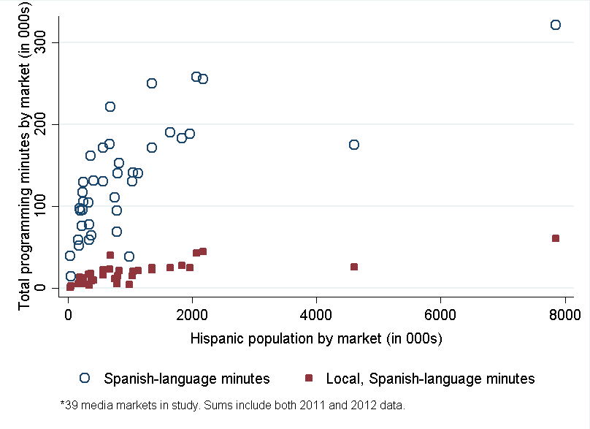

**Figure 8: Hispanic population and Spanish-language programming minutes**

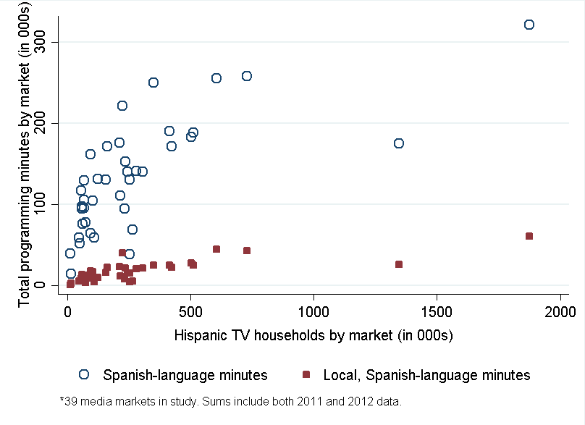

**Figure 9: Hispanic television households and Spanish-language programming minutes**

1. Table 15 highlights selected viewing and audience characteristics for our dataset. We report the average Hispanic and non-Hispanic audience ratings for programs by type and genre, including locally sourced programs, locally sourced news programs, and locally sourced news programs in Spanish. Average ratings at the television market level are determined by averaging the program-level household viewing across all days and timeslots in the dataset. We then divide by the total number of Hispanic television households in the television market, and multiply by 100 to determine the television market-level ratings for the Hispanic audience. Markets are ordered by total population, largest to smallest. In comparing viewing patterns for Hispanic and non-Hispanic households, we find that the average ratings for locally sourced and locally sourced news programs are generally comparable between Hispanic households and non-Hispanic households. In some markets, Hispanic households appear to watch more local programs than non-Hispanic households, in others the reverse is true. Similarly, in some markets Hispanic households appear to watch more locally sourced news programs than non-Hispanic households, in others, the reverse is true. We also find, as expected, that the ratings for news programs that are locally sourced and in Spanish are higher among Hispanic households than non-Hispanic households.
2. With respect to television market size and average audience ratings, the scatter plots shown in Figures 10 through 12 graphically depict the relationships between the number of Hispanic television households and select variables of interest. Figures 10 and 11 illustrate the relationship between the number of Hispanic television households and average Hispanic audience ratings for Spanish-language and local programming, respectively, in each television market. While the relationship between the total number of Hispanic television households and audience ratings for local programming appears to be mixed, average ratings for Spanish-language programming show a strong positive correlation across all television markets. This result is not surprising given that the television markets covered in our study include those with the largest number of Hispanic television households and in which Hispanic viewing is tabulated separately from overall television household viewing. Figure 12 also suggests a positive correlation between the number of Hispanic television households and the average Hispanic audience ratings for local, Spanish-language programming. We looked at similar relationships between Hispanic television households and average audience ratings for news programming, Spanish-language local news programming, and children’s programming. We find mixed results for the relationship between Hispanic television household counts and news, and a slightly positive relationship between the Hispanic television household counts and Spanish-language and local news, and children’s programming. These results are reported in more detail in the Technical Appendix, Section IX below.

**Table 15: Average Audience Ratings by Study Television Market**



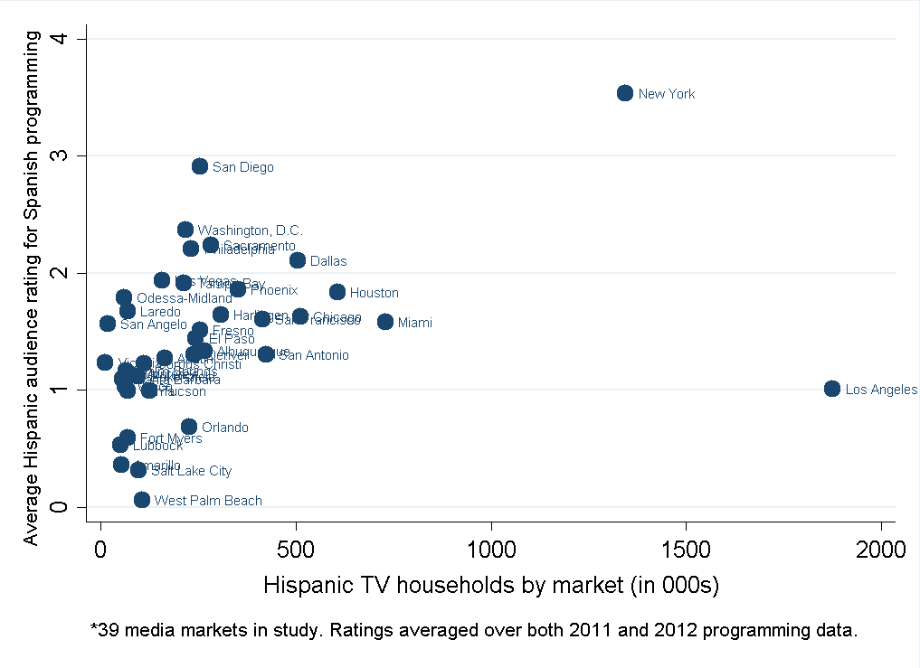

**Figure 10: Hispanic television households and ratings for Spanish programming**

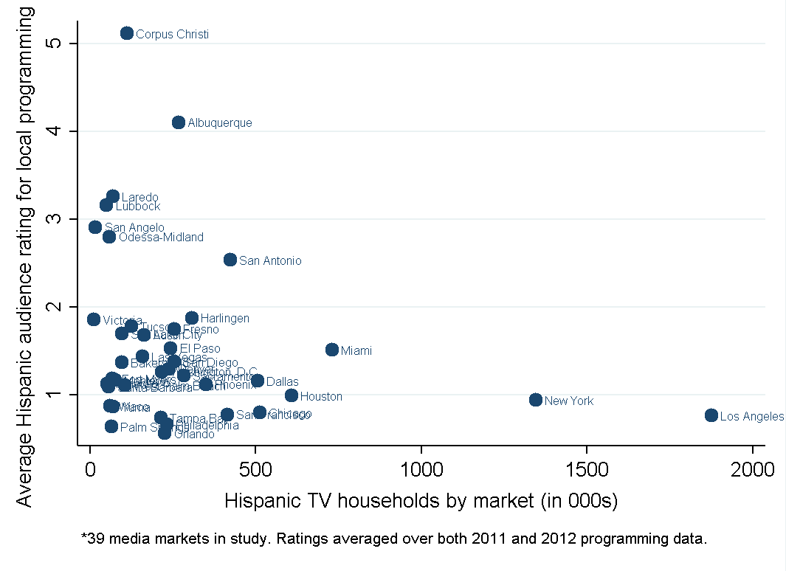

**Figure 11: Hispanic television households and ratings for local programming**

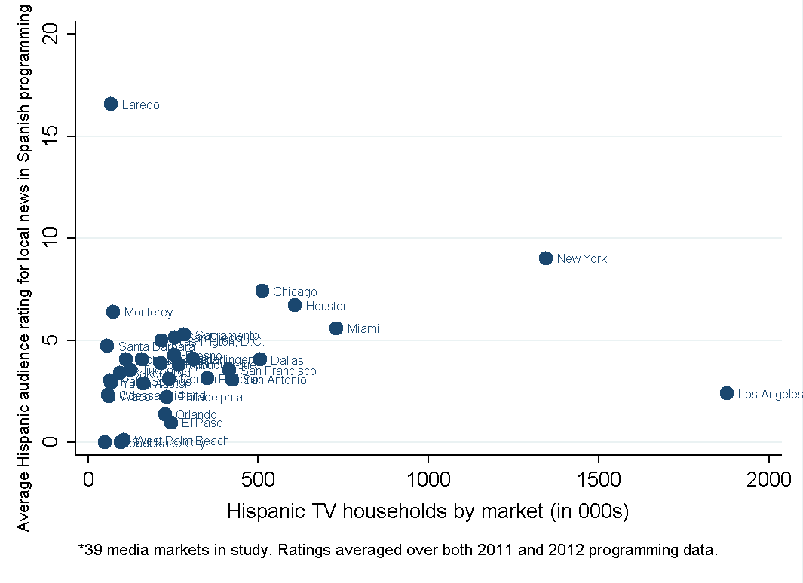

**Figure 12: Hispanic television households and ratings for local, Spanish programming**

1. We next formalize the relationship between Hispanic station ownership and availability and viewership of content of interest at the television market level. We use regression analysis to determine whether the presence of a Hispanic-owned station has a marginal effect on viewing decisions of Hispanic households or programming decisions by stations at the television market level. Specifically, we regress an outcome of interest on Hispanic station ownership and other controls using the following specification:

$Outcome_{m}=β_{0}+β_{1}Hispanic Owner_{m}+β_{2}{Stations}_{m}+β_{3} Spanish Stations_{m}+{β_{4}Hispanic TV households}_{m} +{β_{5} Income}_{m}+{β_{6} LivePlusSeven_{m}+ ε}_{m }$

where *Outcome* in television market *m* is the dependent variable of interest, such as the total number of programming minutes or the average Hispanic audience ratings for content of interest; the key explanatory variable of interest, *Hispanic Owner,* is the number of Hispanic-owned stations in market *m*. Other explanatory (control) variables include the total number of stations located in a television market (*Stations*), the total number of Spanish-language stations (*Spanish Stations*), the total number of Hispanic television households (in 10,000s) in a market (*Hispanic TV households*), the 2011 median household income (in $10,000s) (*Income*), a dummy variable = 1 if the television market reports viewership data in a live-plus-seven format for specifications that include audience ratings (*LivePlusSeven*), and an error term (.[66]

1. While we are mainly interested in the marginal impact of Hispanic ownership on viewing and programming decisions, many television markets in our sample do not contain any majority Hispanic-owned stations, such that our key explanatory variable contains a number of zero values. Standard linear regression models like the one above imply that a one-unit change in the explanatory variable leads to a corresponding change in the outcome variable equal to its predicted value. If the number of Hispanic-owned stations entered linearly in the model – that is, without any subsequent transformation – this would imply that entry (exit) into a market of one station would increase (decrease) the total number of programming minutes by a constant amount equal to the coefficient, $β_{1}$. It may be instead that the effect of a Hispanic-owned station entering into a market where none had previously existed is larger than the effect for markets that already contain one or more Hispanic-owned stations. Or it may be that the effect of a Hispanic-owned station exiting a market is greater in markets where only one station had previously existed than for a market that contained two or more stations. These examples illustrate the possibility there is not a strictly linear relationship between the outcome of interest and our key explanatory variable. There are several ways that non-linearity can be added to the standard model above. Common approaches include variable transformation, adding cubic or quadratic versions of continuous variables, and piecewise regressions.
2. We note briefly here that the outcome variables in our market-level regressions are non-negative values in all cases, suggesting instead we employ a regression model with a logarithm link and Poisson distribution. However, subsequent diagnostic analysis using this specification indicated that the Poisson model does not fit the data well. We instead employ a log-linear model in our base specification where the outcome variable is log-transformed and the other explanatory variables enter in linearly.
3. While we log-transform the dependent variable, we cannot log-transform the number of Hispanic-owned stations due to the presence of zero values.[67] Instead, we first alter the base specification by transforming the independent variable of interest into a dummy variable = 1 if the television market contains (the station reports viewing data) at least one Hispanic-owned station, and zero otherwise. However, this transformation may not completely capture the relationship between the dependent and independent variables. Therefore, we also fit a model using a piecewise regression (linear spline) that allows for a change in the effect on the dependent variable to vary based on the number of Hispanic-owned stations in a market.
4. A piecewise model is commonly used when two different relationships exist in the data. The model utilizes “knots” that represent points of separation between the relationship of the outcome variable and the key explanatory variable of interest. In our study, the knots help identify differences in the marginal effect of having one Hispanic-owned station in a market versus none, having two stations versus one station, and so forth. However, there are only three markets in our study that have more than one Hispanic-owned station, such that the sample is not rich enough to pick up the change in slope from moving through each knot in the piecewise regression. Therefore, we find that the piecewise model does not fit the data well, and the results are not functionally dissimilar to one that models the presence of a Hispanic-owned station in a market as a zero-one indicator variable.
5. The last model addresses potential non-linearity by including quadratic terms for the numbers of Hispanic-owned, total, and Spanish-language stations in a market. The introduction of quadratic terms produces the following specification:

$Outcome_{m}=β_{0}+β_{1}Hispanic Owner_{m}+β_{2}Hispanic {Owner}_{m}^{2}+ {β_{3}Stations}_{m}+{β_{4}Stations}_{m}^{2}+ β_{5}Spanish Stations_{m}+ β_{6} Spanish {Stations}_{m}^{2}+{δ_{1}Hispanic TV households}_{m} +δ_{2}{Income}_{m}+{δ_{3}LivePlusSeven_{m}+ ε}_{m }$

1. Modeling with quadratic terms fits a U-shape or curve to the data.[68] The sign of the coefficient of each squared term determines whether the curve is concave up or concave down. We interpret the difference between the non-squared and squared term in the regression in the following manner. For the number of stations in a market, if the coefficient on the non-squared term is positive and the coefficient on the squared term is negative, the non-squared term has a positive effect on the number of programming minutes until some crucial point is reached; beyond that point, the number of Hispanic-owned stations has a negative impact on the number of programming minutes.[69] A coefficient on the squared term that is statistically insignificant and sufficiently close to zero suggests misspecification of the model; the relationship between the outcome and explanatory variables may instead be linear.[70]
2. Table 16 reports the results on programming minutes by type. Each column of the table represents a different dependent variable. The first panel reports the results from entering the number of Hispanic-owned stations at the television market level into the regression untransformed. We interpret the coefficient of interest as the partial derivative of the outcome variable with respect to the number of Hispanic-owned stations, so that a one-unit change in the number of Hispanic-owned stations in a market will result in a multiplicative change equal to *exp*($β_{1}$) in the outcome variable, all other things held equal. However, we find no significance at the market level between the number of Hispanic-owned stations and programming minutes by content of interest. The coefficients in all columns, except for the last one, are indistinguishable from zero. There appears to be a marginally significant negative correlation between the number of Hispanic-owned stations and availability of children’s programming in Spanish, but as Spanish-language children’s programming represents approximately 0.6 percent of total programming and 2.6 percent of all Spanish-language programming, these results may instead stem from low statistical power.
3. The second panel reports the results from coding the variable of interest as a zero-one indicator variable. We obtain the percentage effect of the presence of a Hispanic-owned station on programming minutes by taking the exponential of both sides of the regression equation, and then evaluating the outcomes when the dummy variable representing whether a market contains a Hispanic-owned station is equal to zero and when the dummy variable is equal to one. If the indicator variable switches from zero to one, the percentage impact of entry of a Hispanic-owned station into the market on the number of programming minutes is [$100*(exp⁡(β_{2})-1)$].
4. The third panel adds a quadratic fit to the number of Hispanic-owned, total and Spanish-language stations in a market. We interpret a statistically significant coefficient on the squared terms as enumerated above. The results of the third panel suggest that in nearly all cases, the relationship between our explanatory variable of interest, the number of Hispanic-owned stations in a market, is linear. However, the coefficients on the square of the total number of Spanish-language stations in a market suggest a modest case could be made for non-linearity. We also find a marginally significant effect on the coefficient of the square of the number of Hispanic-owned stations for local programming minutes and a conventionally significant effect for children’s programming minutes. We test for joint significance of the non-squared and squared terms for both local programming minutes and children’s programming minutes. While we cannot reject the null hypothesis of no joint significance for local minutes, we are able to reject the null hypothesis of no joint significance for children’s programming minutes. This suggests that the number of Hispanic-owned stations in a market has a negative effect on the number of children’s programming minutes until $\frac{0.22}{2*0.10}=1.1$, when there is a positive effect on the number children’s programming minutes.
5. Table 17 reports the results for average Hispanic audience ratings by content of interest using the same three approaches: an untransformed explanatory variable of interest, a dummy transformation, and a quadratic fit. Again, the results across all three panels indicate no significant relationship between the number of Hispanic-owned stations in a market and the average program ratings for Hispanic households. Further, the results of the third panel appear to indicate that the quadratic model does not fit the data well, and we should instead use a linear model. All coefficients on the number of Hispanic-owned stations appear indistinguishable from zero, although we cannot rule out small sample size as the cause for this lack of significance. We find no statistically significant effect at the television market level between either the presence of a Hispanic-owned station or the number of Hispanic-owned stations and average viewership characteristics of content of interest. This lack of significance is not surprising given the low number of observations at the television market level. However, there is a positive and statistically significant relationship between the number of Hispanic households and ratings for Spanish-language programming in five out of 10 relevant regressions; and the coefficients not significant are at least positive. These results suggest the positive relationship is due to the preference externality mechanism, as outlined in the discussion of Waldfogel’s preference externality theory in the literature review at Section II.
6. While the limited number of observations in our market-level regressions restricts the maximum number of explanatory variables we can plausibly add to our model, in response to the peer review report, we investigate the possibility of misspecification in the model due to omitted variables. For example, there are a number of television markets which share a border with Mexico. Because station broadcast signals can span multiple markets and cross geographic boundaries, programming and viewing decisions may be fundamentally different in markets that border Mexico in a way that is not picked up in our model. With regard to the effect of geographic proximity to television markets to the Mexican border, Tables A.2 and A.3 in the Technical Appendix contain the models in Tables 16 and 17 inclusive of a dummy variable = 1 if the television market shares a border with Mexico, and zero otherwise. The results are not fundamentally different than the original specifications, lowering our concern about this issue, although we note that other omitted variables may exist.
7. The peer review report also raises the possibility of bias arising from simultaneity in the relationship between the explanatory and dependent variables. In the empirical economic literature, Instrumental Variables (IV) estimation is commonly used to ameliorate threats to internal validity of a model from these biases. However, we note again the limited number of observations in the market-level models. With small samples, Ordinary Least Squares (OLS) estimates have been found to be more consistent than IV estimates, and thus we feel our approach is the best given limited observations.

**Table 16: Market-Level Regression Analysis for Total Programming Minutes by Type**



**Table 17: Market-Level Regression Analysis for Average Ratings**



# STATION SUMMARY STATISTICS

## Identifying a Station Observation

1. We now describe the relevant characteristics of the stations in our sample. As previously discussed, there are 544 unique television stations for which TMS provides programming data in our merged dataset. Each station has a TMS station identifier that is associated with a unique programming schedule. Therefore, a translator station that is simulcasting an identical programming stream in another television market will have the same TMS identifier as the originating source station. Because a focus of this study is to explore the viewing preferences of Hispanic households, and such preferences frequently vary by television market, we choose to define a station observation in the following way for the statistical and regression analysis: a station observation is a station that is uniquely identified by its TMS identifier within *each* television market. That is, each station observation has a unique programming schedule within a television market.
2. There are a number of TMS stations that broadcast in more than one television market, either because their signals reach far enough to span multiple television markets or because they broadcast on translator stations. We count these stations separately for each television market in which they broadcast, as television market characteristics may well affect Hispanic viewership. In total there are 646 station observations across our two sample periods, with 595 station observations in November 2011 and 611 in May 2012. The 102 “excess” observations (646 minus 544) result from the subset of TMS stations that span multiple television markets.

## Summary of Hispanic-Owned Stations

1. Of the 646 unique station observations defined above, 22 are identified as Hispanic-owned in November 2011 and 23 are identified as Hispanic-owned in May 2012. Table 18 lists all Hispanic-owned stations that appear in either sweeps period, along with their affiliation, the percentage of their programming that is Spanish-language, their average ratings among Hispanic households, and the sweeps periods in which they appear.[71]
2. Station rating is our key indicator of performance and the primary outcome variable in our station-level regression analysis below. We determine ratings for each station in each sweeps period by averaging the program-level Hispanic household viewing across all days and timeslots. The resulting measure represents the average Hispanic viewership of a station for each sweeps period. We then divide this by the total number of Hispanic television households in the television market, and multiply by 100, to determine each station’s average rating for Hispanic viewership.
3. The average station rating across all Hispanic-owned stations is 0.82. However, ratings are strongly correlated with affiliation. The ratings of Telemundo stations are consistently above 1.00, with an average of 1.27. There is significant variation in ratings across the Hispanic-owned Estrella stations, and the average is 0.83. The average ratings of all remaining Hispanic-owned stations not affiliated with either Telemundo or Estrella are 0.37. Nielsen is missing ratings data for call sign KCHF, as indicated in Table 18.
4. Turning to affiliation, we see that only 7 of 24 station observations are identified as independent Hispanic-owned across the two sample periods; the remaining 17 are affiliated with a Spanish-language network.[72] Our primary interest in the affiliation of Hispanic-owned stations is to examine the differences in programming content and household viewing choice that may exist between independent Hispanic-owned stations that have full control of their programming and those stations affiliated with established Spanish-language networks, whose programming may be determined by the network. We include the following as Spanish-language networks: Univision, Telemundo, Telefutura, Azteca, and Estrella.[73] These were the major Spanish-language networks as of May 2012, and it is their programming and viewing that we are most interested in comparing to Hispanic-owned independent stations.
5. Lastly, examining Table 18 we can see that most Hispanic-owned stations cater exclusively to the Hispanic audience, as nearly all of their programming content is Spanish-language. However, call signs KBEH and KMOH split their programming between English-language and Spanish-language, while call sign KCHF is entirely English-language.

**Table 18: Summary of Hispanic-owned Stations**

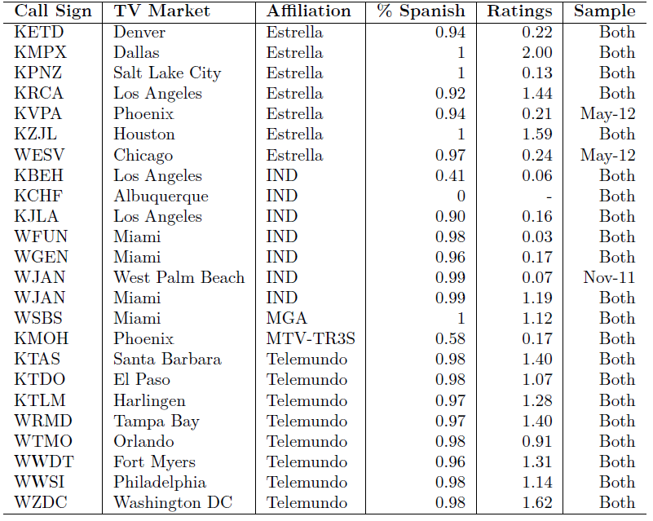

1. The variables salient to the statistical and regression analyses are presented in Table 19, below. We will utilize these indicators in much of the analysis that follows.

**Table 19: Variable Definitions**



## Programming

### Content by Station Subgroup

1. The above analysis suggests that there may be distinct “buckets” of Hispanic-owned and Hispanic-oriented stations with regard to their programming decisions and the audience that they reach. In Table 20 we present a first-order delineation of these buckets based on ownership, network affiliation, and programming language. This table presents summary statistics of the stations’ programming content broken down by these station subgroups.[74]
2. The unit of observation in Table 20 is a program timeslot for a station within a television market.[75] A few statistics stand out. First, 98 percent of programs broadcast on Spanish-language networks are, unsurprisingly, Spanish-language. This drops down to 85 percent for Hispanic-owned stations, and further to 62 percent for Hispanic-owned independents.[76] Local programming accounts for 23 percent of all programming among Hispanic independent stations, but only 14.5 percent for Spanish-language networks. Conversely, telenovelas make up 17 percent of all programming on Spanish-language networks, but only 7.4 percent among Hispanic-owned stations and only one percent for the independent stations. Lastly, paid programming makes up a substantial fraction of all programming for Hispanic-owned stations, and in particular for independent Hispanic-owned stations, with about 44 percent of all content being categorized this way.

**Table 20: Program Content by Station Type**



### Paid Programming

1. The last point regarding paid programming is of particular interest. One goal of our analysis is to determine whether Hispanic owned stations can add value to the Hispanic television market through unique programming decisions. One would not generally consider more paid programming to be a benefit to Hispanic audiences. However, if the paid programming is advertising local businesses to the Hispanic community, then the Hispanic-owned station may support local businesses by providing valuable information to consumers. Unfortunately it is not possible to answer this question because of a lack of detail in the program titles available in this category: most are described as simply “programa pagado” or “infomerciales.”
2. An additional consideration is whether the paid programming on Hispanic-owned stations is shown at different times than paid programming on other stations. For example, Hispanic-owned stations may simply have more paid programming because they fill up more late night and overnight timeslots with it. If this were the case, then the popular viewing hours would not be affected. We address this question by breaking down paid programming into timeslots. The results are presented in Table 21 below:

**Table 21: Paid Programming by Daypart**



1. We see a similar trend across all station groups, with most of the paid programming being shown late night and overnight and nearly none during early fringe and primetime hours. However, we can see that for Hispanic-owned stations, and in particular for the independent Hispanic-owned stations, paid programming makes up a substantial fraction of morning and daytime programming. This indicates that Hispanic-owned stations do not backload their paid programming to the late night hours, but do in fact air a substantial amount of it during the day.

### Content by Deciles of Viewership

1. Having identified the type of programming available on stations catering to the Hispanic television audience, Table 22 looks at what programming is popular among Hispanic viewers. We calculate a rating for each program timeslot and break ratings into deciles across sweeps periods. We then calculate the fraction of programs in each viewing decile that have certain characteristics. The table excludes all zero ratings, as about 64 percent of all timeslots in our dataset have a zero Nielsen rating.[77] The results are indicative of the viewing choices among Hispanic television households. For example, only 2.7 percent of program timeslots are categorized as telenovelas in the least-viewed decile of programming, compared to 14 percent in the most-viewed decile. We can also see that news and local programming compose a higher percentage of the most-viewed programs compared to the least-viewed. Paid programming accounts for 8.9 percent of the least-viewed decile of programming, but essentially zero percent of the most-viewed. Finally, over 45 percent of programming in the most-viewed decile is viewed on a Spanish-language network. Conversely, Hispanic-owned and Hispanic-owned independent stations are more frequently associated with the least-viewed decile of programming relative to the most-viewed.

**Table 22: Average Characteristics of Programming by Ratings Decile**



## Station Summary Statistics by Sweeps Period

1. Finally, Table 23 presents station-level summary statistics by sweeps period. Note that while there are 595 and 611 station observations for the two sample periods, ratings data are only available for 528 and 536 stations, respectively. Hispanic household viewing data are missing for 67 stations in November 2011, and for 75 stations in May 2012. The average Hispanic rating across all stations is 0.97 in 2011 and 0.88 in 2012. However, the medians are 0.55 and 0.47, respectively. This suggests a right-skewed distribution, which is confirmed by examining the histogram of ratings presented in Figure 13. There are a small number of stations with high ratings, while the mass of the distribution is much closer to zero.

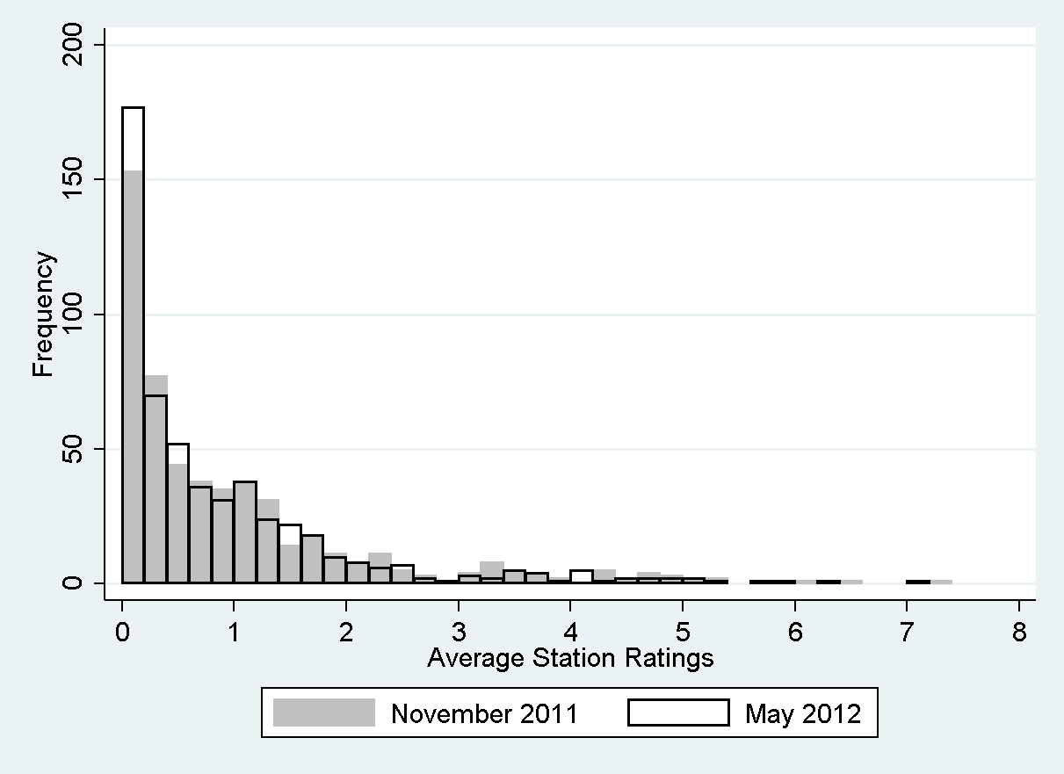

**Figure 13: Distribution of Station Ratings among Hispanic Households by Sweeps Period**

**Table 23: Station-Level Summary Statistics**



# 

# EMPIRICAL FRAMEWORK AND RESULTS

## Program-Level Analysis

### What do Hispanic Households Watch?

1. To determine whether Hispanic-owned stations are better able to provide programming desired by the Hispanic television market relative to other Hispanic-oriented stations, we first examine the observed viewing decisions of Hispanic households and the programming decisions of Hispanic-owned and Hispanic-oriented stations. As language is a major distinguishing feature of Hispanic-oriented programming, the focus of the analysis will continue to be on Hispanic-owned stations and major Spanish-language networks. We first utilize the merged TMS and Nielsen program-level data to examine the program and station characteristics that are associated with Hispanic viewership. We then ask what type of programming is most likely to be associated with Hispanic-owned stations, and how this programming differs from the programming of the large, Spanish-language networks that cater to a Hispanic audience.
2. We propose the following linear regression model to examine Hispanic viewing choices:
$$Household Viewing_{ijmt}=θStation_{jmt}+βProgram_{ijmt}+γ_{m}+ε_{ijmt}$$

3. The dependent variable is the number of Hispanic households that viewed program *i* on station *j* in television market *m* at timeslot *t*. $Station_{jmt}$ is a vector of station-level characteristics. This includes a set of dummy variables for the Big 4 networks,[78] Public Broadcasting System (PBS) networks, and the major Spanish-language networks. $Program_{ijmt}$ is a vector of program-specific characteristics. There are a number of binary indicators taking a value of 1 if the program can be categorized as any of the following, and 0 otherwise:

* the language of the program description is Spanish
* news, local news, or local Spanish-language news
* community-educational programming
* season/series premiere or finale
* telenovela
* paid programming
* has a sexual, violent, or strong language content rating[79]

1. Additional characteristics include the duration of the program in minutes and a categorical variable for the daypart during which the program is broadcast.[80] Finally, we include television market fixed effects. This set is represented by the vector $γ_{m}$ in the regression model, and includes a dummy variable for each of the 39 television markets in our sample.
2. We first estimate this model using OLS. Of note is that our dependent variable is censored, with many observations taking a value of 0 to indicate that no viewing by Hispanic households took place for a particular program. As OLS provides biased and inconsistent estimates of the regression coefficients when data censoring occurs, we additionally present two alternative models. The first is a regression where the outcome variable is the log of household viewing. As the log of zero is undefined, this log-linear model is essentially a truncated regression on the uncensored portion of our dependent variable. Lastly, we present estimates for the Tobit censored regression model as it provides consistent estimates of regression coefficients when data censoring occurs.[81] We also consider a two-part model, which first determines the likelihood that the dependent variable takes a positive value versus a value of zero, and then models its value conditional on it being positive. However, we have determined that the two-part model is not appropriate for this analysis given the structure of our data and the relationships we analyze.[82]
3. For all models, we estimate the cluster-robust standard errors clustered at the station-level to account for potential correlation between the viewing preferences of households for each station’s program lineup.
4. The results are presented in Table 24. Both the OLS and Tobit regression coefficients indicate that Univision is the most popular network among Hispanic viewers by a significant margin, followed by Telemundo, and then by several other major English-language and Spanish-language networks.
5. According to the results, local, Spanish-language news programs are popular among Hispanic viewers,[83] while community/educational programs are associated with significantly lower Hispanic viewership compared to other program types. Programs with strong language and sexual content warnings are also popular, as are premieres and finales and Spanish-language telenovelas. Finally, early-fringe and primetime programs have the most viewership while late night and overnight programs have the least.
6. These results are generally in line with expectations, and tend to reflect both viewing trends among the general public and trends specific to the Hispanic television audience. In particular, telenovelas and local Spanish-language and news programming appear to be important elements of the overall viewing preferences of Hispanic households.

**Table 24: Determinants of Hispanic Household Viewing**

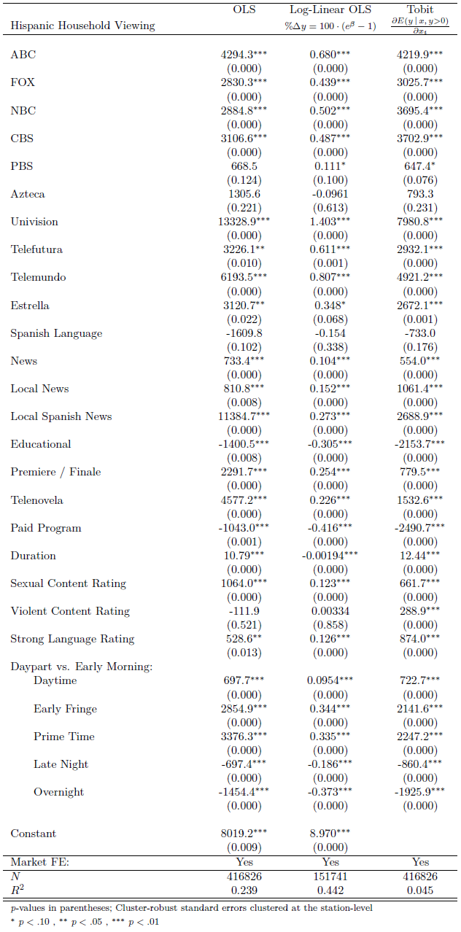

### Programming Decisions of Hispanic-Oriented Stations

1. Next we examine the programming choices of Hispanic-owned versus other Hispanic-oriented stations by determining which program characteristics are more likely to be associated with Hispanic-owned stations. We hypothesize that ownership structure may impact programming choices, and therefore the content shown on a station. The regression model to test this hypothesis would be one in which the dependent variable is a program characteristic and the explanatory variable of interest is Hispanic ownership. However, we are interested in a number of program characteristics. Estimating a separate regression for each one would be cumbersome, and presenting the results in an easily interpretable way would be challenging. We therefore reverse the model for simplicity, and estimate the likelihood that a particular type of program would be shown on a station with a particular ownership structure. Specifically, we focus on the likelihood of different types of programs to be shown on Hispanic-owned, Hispanic-owned independent, and Spanish-language network stations.
2. We present three models: the first with the outcome variable *Hispanic Owned*, which takes a value of 1 if the program is being broadcast on a Hispanic-owned station, and 0 otherwise; the second with the outcome *Spanish-Language Network*, which takes a value of 1 if the program is being broadcast on a station affiliated with or owned by a Spanish-language network, and 0 otherwise.[84] The third model focuses exclusively on the independent Hispanic-owned stations that are unaffiliated with any of the major Spanish-language networks. As previously mentioned, 17 of 24 Hispanic-owned station observations are either affiliates of Spanish-language networks or are owned by them. If their programming is determined by the network, then the more salient group of stations to analyze in comparison to network programming would be the truly independent stations owned by Hispanics. It is their programming decisions that we are most interested in.
3. We estimate logistic regression models of the following form:

$$P\left(Hispanic Owned=1 \right| X)=F(βProgram+δInteraction)$$

$$P\left(Independent Hispanic Owned=1 \right| X)=F(βProgram+δInteraction)$$

$$P\left(Spanish Language Network=1 \right| X)=F(βProgram+δInteraction)$$

Where $F\left(X\right)=\frac{\exp\left(X\right)}{1+\exp\left(X\right)}$

1. We utilize many of the same program-level explanatory variables as in the household viewing model. These variables include binary indicators for the following program characteristics: Spanish-language; multi-lingual local, news, and educational; telenovela; paid programming; and sexual, violent, or strong language content rating. The vector *Interaction* includes a set of three-way interaction terms between Spanish-language, local, and news indicators to estimate the effect of different sub-categories of programming.
2. The results of the logistic regression models are presented in Table 25. The odds of an outcome variable taking the value of 1 versus 0 for different levels of the predictor variables are presented.

**Table 25: Likelihood of Programming Associated with Hispanic-Owned and Hispanic-Oriented Stations**

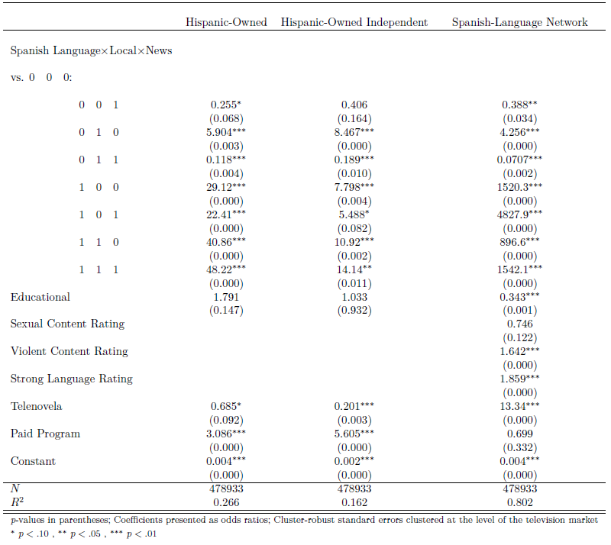

1. We exclude the sexual, violent and strong language content ratings indicators from the Hispanic-owned and Hispanic-owned independent models. This is because there are no cases of Hispanic-owned or Hispanic-owned independent stations showing such programming in either of our sample sweeps periods. The model estimates that Spanish-language telenovelas are 68.5 percent as likely to be broadcast on Hispanic-owned stations as other program types, and only 20 percent as likely for the Hispanic-owned independent stations. Conversely, paid programming is strongly associated with Hispanic ownership, as paid programs are three times more likely to be shown on Hispanic-owned stations compared to other program types, and 5.6 times more likely to be shown on Hispanic-owned independent stations. These results are in line with our earlier programming analysis in Section V, station summary statistics, above.
2. A number of results stand out for the main and interaction effects on news, Spanish-language, and local content.[85] As expected, Spanish-language programs are 29 times more likely to be associated with Hispanic ownership than English-language ones, while local programming is 5.9 times more likely than non-local programming to be broadcast on Hispanic-owned stations. The types of content most strongly associated with Hispanic ownership are local Spanish-language programs and local Spanish-language news, with odds ratios of 41 and 48, respectively. However, these results are largely driven by the strong association between Spanish-language programming and Hispanic ownership. The marginal effect of local programming being associated with Hispanic-owned stations, conditional on the program being in Spanish, is positive but weaker. Furthermore, the marginal effect of news programming on Spanish-language content is actually negative. Nonetheless, as described above, the nexus of these three program types is strongly associated with Hispanic ownership relative to programming that is non-Spanish, non-local, and non-news. The picture looks similar when turning to the independent Hispanic-owned stations, except with a slightly stronger effect of local programming and a weaker effect of Spanish-language programming. The weaker association between Hispanic-owned independent stations and Spanish-language programming is expected, as we know from the summary statistics that one Hispanic-owned independent station is English-language-only, while another provides mixed-language programming.
3. From the third column we can see that the programming content of other Hispanic-oriented stations, defined here as the major Spanish-language networks, is different from that of Hispanic-owned stations. Spanish-language networks are relatively less likely to show paid programming, as paid programming is associated with a 30 percent reduction in the odds of being a Spanish-language network. Educational programming is much less likely to be associated with major Spanish-language networks, while programs with violent and strong language content ratings are likelier to be. In contrast to Hispanic-owned stations, Spanish-language networks put a focus on telenovelas, as telenovelas are over 13 times as likely to be associated with a Spanish-language network.
4. Finally, the results suggest that Spanish-language networks actually put a lower emphasis on providing Spanish-language local content compared to Hispanic-owned and Hispanic-owned independent stations. Though not immediately evident from Table 25 above, we can see this by examining the interaction effect between Spanish-language and local programming for Spanish-language networks: while the odds ratio on Spanish language is large, the interaction effect between Spanish-language and local programming is negative, and in fact dominates the main effect of local programming.[86] This can be seen in Table 25 by calculating the marginal effect of local programming on the odds of a Spanish-language program being associated with major Spanish-language networks. For Spanish-language networks, the marginal odds ratio of local programming on Spanish-language content is 0.59 ($\frac{896.6}{1520.3}$), indicating that Spanish-language content is only half as likely to be associated with a Spanish-language network when the content is also local. For Hispanic-owned stations the marginal odds ratio is 1.4 ($\frac{40.86}{29.12}$), indicating that Spanish-language content is 1.4 times more likely to be associated with a Hispanic-owned station if it is also local. There is a similar focus on local programming for Hispanic-owned independent stations, with a marginal odds ratio of 1.4 as well.
5. The above analysis suggests that Hispanic-owned stations serve the Hispanic television market by providing content that is significantly different from that of the large Spanish-language networks. The networks and their affiliated stations focus on both Spanish-language news and entertainment. However, the programming is less likely to be local or educational. Hispanic-owned stations are less likely to broadcast entertainment such as telenovelas and appear to focus on the provision of local Spanish-language content as well as paid programming. We have learned from our analysis of household viewing that local Spanish-language content is popular among Hispanics. Next we ask whether Hispanic viewers prefer the local, Spanish-language programming of Hispanic-owned stations to other Hispanic-oriented stations. We turn to that analysis in the following section.

### Hispanic Household Viewing of Hispanic-Owned Stations

1. We have observed that the programming choices of Hispanic-owned stations, such as a focus on Spanish-language and local programming, coincide with some of the viewing preferences of the Hispanic audience. Now we will examine whether these stations are successful in attracting Hispanic viewers by extending the univariate analysis of program ratings discussed previously and presented in Table 22 above. We attempt to determine whether Hispanic ownership is associated with an increase in Hispanic household ratings in a multivariate regression setting, controlling for a number of additional program, station, and market-level factors that may affect the viewing decisions of the Hispanic television audience. We present the following regression models:
$$Program Rating_{ijmt}=β_{0}+β_{1}Hispanic Owner_{jmt}+θProgram_{ijmt}+δAffiliation_{jmt}+γ_{m}+ε_{ijmt}$$

$$Program Rating_{ijmt}=β_{0}+β_{1}Hispanic {Independent}_{jmt}+β_{2}Hispanic {Affiliate}_{jmt}+θProgram_{ijmt}+δAffiliation_{jmt}+γ_{m}+ε_{ijmt}$$

2. The dependent variable, *Program Rating*, is the Hispanic household rating of program *i* on station *j* in television market *m* at timeslot *t*. In the first model, the explanatory variable of interest is *Hispanic Owner*, which again takes the value of 1 if the station is Hispanic- owned and 0 otherwise. In the second model, we decompose *Hispanic Owner* into two components: the Hispanic-owned independent stations and the Hispanic-owned affiliates of major Spanish-language networks, and estimate their effects separately.[87] *Program* is a vector of program characteristics including all of the variables listed in Table 19; *Affiliation* is a vector of station affiliation fixed effects, while $γ$ is a vector of market fixed effects.
3. As we have seen, a majority of the Hispanic-owned stations are affiliated with one of the major Spanish-language networks. Our goal in estimating the above models separately is to determine whether any effect of Hispanic ownership on ratings is being driven by the independent Hispanic-owned stations, rather than the stations that are affiliated with a major Spanish-language network, and may therefore have their programming decisions at least partly determined by the network.
4. Given our previous analyses of viewing preferences and programming decisions, *a priori* we might suspect that any correlation between Hispanic ownership and program ratings is strongest for Spanish-language and local programming, and that the driving force of this effect may be the Hispanic-owned independent stations. Therefore we first estimate the above regression models on all program observations, but additionally perform a subset analysis by estimating the models on only the observations that are identified as local, Spanish-language programming.
5. The models are estimated using linear and log-linear OLS as well as Tobit, and we estimate cluster-robust standard errors clustered at the station-level. The results are presented in Tables 26 and 27 below. Table 26 estimates the regression models on the full sample of program observations (with the exception of the log-linear specification, where the dependent variable is the log of program ratings, and therefore only positive ratings are modeled), while Table 27 presents the results of the subset analysis for local, Spanish-language programming.

**Table 26: Hispanic Ownership and Program-Level Hispanic Household Ratings**

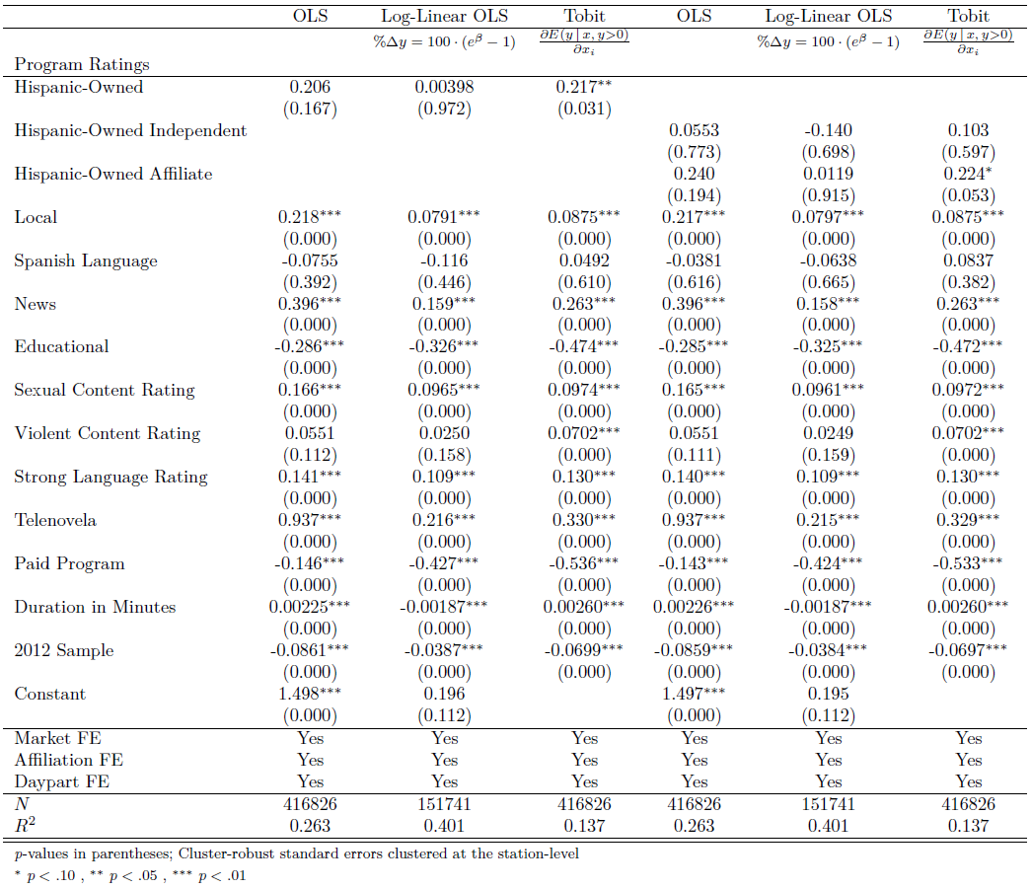

**Table 27: Hispanic Ownership and Program-Level Hispanic Household Ratings of Local, Spanish-Language Programming**

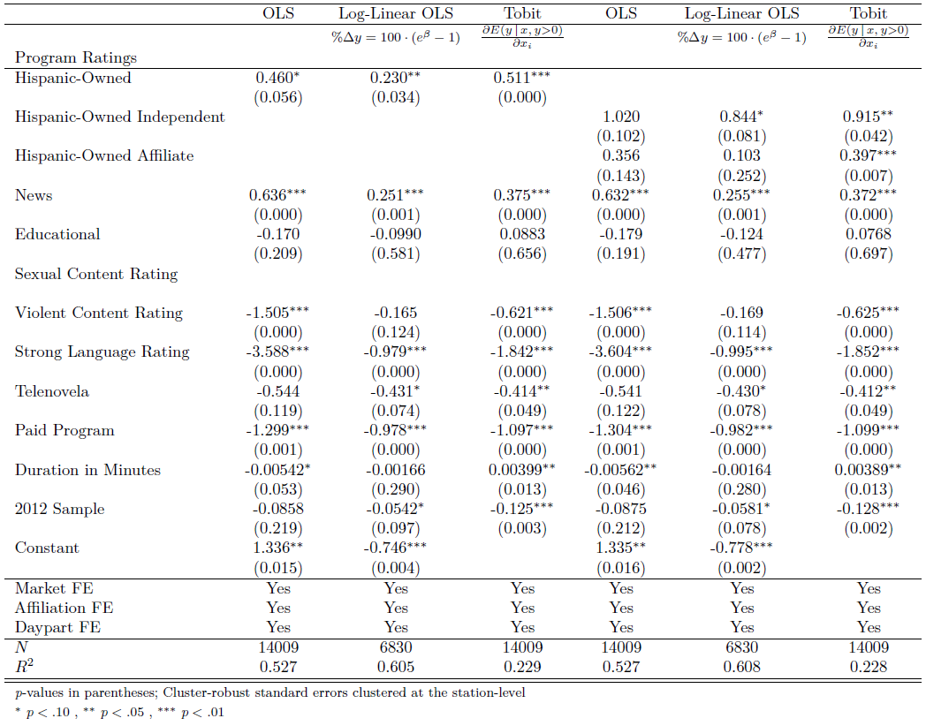

1. Examining the results in Table 26, we see that while the OLS regression models do not find a significant correlation between Hispanic ownership and Hispanic household program ratings, the Tobit model does find a positive and significant effect of Hispanic ownership on ratings.[88] The Tobit results indicate that programs viewed on Hispanic-owned stations are associated with a statistically significant increase in ratings of 0.217 points. When decomposing the effect of Hispanic ownership into affiliated versus unaffiliated stations, the Tobit results in column 6 suggest that the association between ratings and Hispanic ownership is being driven by those Hispanic-owned stations that are affiliated with a major Spanish-language network, though the coefficient on *Hispanic Affiliate* is only marginally significant.[89]
2. Turning to the subset regressions in Table 27, the Tobit results indicate that local, Spanish-language programming viewed on Hispanic-owned stations is associated with a statistically significant increase in ratings of about half a point. Comparing this effect to the magnitude of the coefficient on *Hispanic Owner* in Table 26, we can see that the effect of Hispanic ownership on program ratings is larger for the subset of programs that are identified as local, Spanish-language. In column 6, we see that both Hispanic-owned independent and Hispanic-owned affiliate stations are associated with an increase in ratings of local, Spanish-language programming. Whereas Hispanic-owned independent stations had no effect on overall program ratings (column 6 of Table 26), here they are associated with nearly a one point increase in ratings among Hispanic households. In addition, the coefficient on *Hispanic Independent* is over twice as large as that of *Hispanic Affiliate*.
3. Though television programs viewed on Hispanic-owned stations are associated with a modest increase in ratings, the magnitude of the effect increases when the programs are identified as local, Spanish-language. This increase suggests that Hispanic-owned stations are in fact rewarded for their programming decisions by capturing a larger share of the Hispanic television audience.

## Station-Level Regression Analysis

1. As we are interested in the effect of station ownership on Hispanic household viewing of not only individual programs but stations as a whole, we additionally perform the ratings regressions at the station level. We utilize the station ratings metric described at Section V, Station Summary Statistics, above, which is simply the program-level ratings averaged across all observations for a particular station observation. This measure is separately constructed for all Hispanic household viewing and Hispanic household viewing of local, Spanish-language programs. We estimate the following sets of regression models:
2. Overall Ratings:
$Rating_{jmt}=β_{0}+β_{1}Hispanic Owner_{jmt}+β_{2}Big4_{jmt}+β_{3}PBS_{jmt}+δ Spanish Language Network_{jmt}+α_{t}+γ_{m}+ε_{jmt}$

$Rating_{jmt}=β_{0}+β_{1}Hispanic {Independent}_{jmt}+β_{2}Hispanic {Affiliate}_{jmt}+β_{3}Big4_{jmt}+β_{4}PBS_{jmt}+δ Spanish Language Network_{jmt}+α_{t}+γ_{m}+ε_{jmt}$

3. Local, Spanish-Language Ratings:
$Rating Spanish Local_{jmt}=β_{0}+β_{1}Hispanic Owner_{jmt}+β_{2}Big4_{jmt}+β_{3}PBS_{jmt}+δ Spanish Language Network_{jmt}+α_{t}+γ_{m}+ε_{jmt}$

$Rating Spanish Local_{jmt}=β_{0}+β_{1}Hispanic {Independent}_{jmt}+β_{2}Hispanic {Affiliate}_{jmt}+β_{3}Big4_{jmt}+β_{4}PBS_{jmt}+δ Spanish Language Network_{jmt}+α_{t}+γ_{m}+ε_{jmt}$

4. There are two outcome variables of interest: $Rating_{jmt}$ is the average rating among Hispanic households of station *j* in television market *m* in subsample *t* across all programs; and $Rating Spanish Local_{jmt}$ is the average station rating among Hispanic households across only local, Spanish-language programming.
5. The main predictor of interest in models 1.1 and 2.1 is again *Hispanic Owner*. Due to sample size limitations when aggregating programming data to the station level, we are unable to include a full set of station affiliation dummy variables. We instead include a limited set of affiliation variables to identify major Spanish and English-language network programming. This includes controlling for whether the station is affiliated with a Big 4 network or PBS. In addition, *Spanish Language Network* is a vector of Spanish-language network indicators.[90] We again estimate the effect of each Spanish-language network separately as there appears to be significant variation in viewing preferences among them.[91] Finally, $γ_{m}$ is again the vector of television market fixed-effects, while $α_{t}$ is the indicator for the May 2012 versus November 2011 sweeps period.
6. As with the program-level ratings regressions, we estimate models 1.2 and 2.2 to determine whether any effect of Hispanic ownership on station ratings is being driven by the independent Hispanic-owned stations, rather than the stations that are affiliated with a major Spanish-language network. The data for this analysis includes only seven Hispanic-owned independent stations with available viewing data in November 2011, and six in May 2012. As such, sample size issues likely result in potentially low accuracy and precision of the estimated coefficients of interest in models 1.2 and 2.2.
7. The models are estimated using OLS and Tobit, as there are stations for which average ratings (either overall or local, Spanish-language) are 0.[92] For the local, Spanish-language ratings model, we exclude the *PBS* and *Big 4* variables as there are only one and two station observations, respectively that have those affiliations and any ratings for local, Spanish-language programming. Lastly, we estimate cluster-robust standard errors clustered at the television market level, to account for possible correlation of station viewing preferences within television markets. We present the OLS regression results in Tables 28 and 29.[93] For each regression, specification (1) examines the overall effect of Hispanic ownership on ratings, while specification (2) looks at independent versus affiliated Hispanic-owned stations.

**Table 28: Hispanic Ownership and Average Station Ratings**

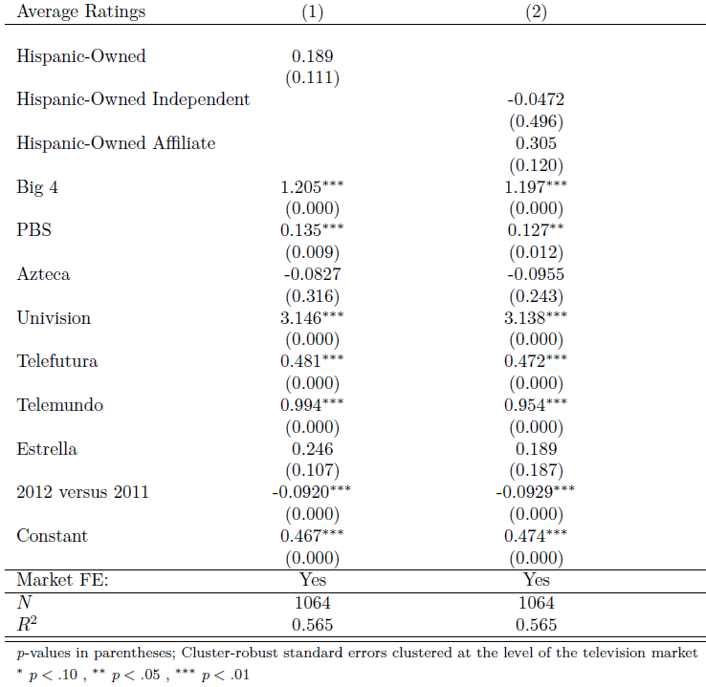

**Table 29: Hispanic Ownership and Average Station Ratings of Local, Spanish-Language Programming**

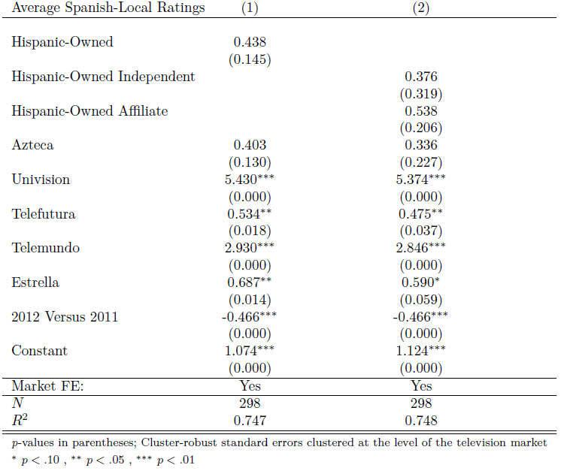

1. From the OLS results of specification (1) in Table 28, we see that Hispanic-owned stations are not associated with a statistically significant increase in ratings.[94] Conversely, the coefficient on Univision is highly significant and indicates that Univision stations are associated with about a three point ratings increase. Being a Big 4 station corresponds to a ratings increase of slightly over one point, while Telemundo and Telefutura stations both see a smaller but positive and significant increase in ratings. Though the coefficient on *Hispanic Owner* is not statistically significant, the size of the effect is similar to that found in our program-level ratings regressions. It is likely that we are unable to find significant results at the station-level due to sample size limitations, both in the overall number of stations and in the stations categorized as Hispanic-owned.[95] Regardless of statistical significance, the relative size of the coefficients suggests that Hispanic-owned stations are not able to compete with either the Spanish-language or major U.S. networks in capturing the overall Hispanic television audience. This is not surprising, however, as we have discovered that many Hispanic-owned stations focus on a particular type of programming and do not necessarily cater to the entire Hispanic audience.
2. We now turn to the local, Spanish-language program ratings model presented in Table 29. Specification (1) indicates that Hispanic-owned stations are not associated with a statistically significant increase in average station ratings of local, Spanish-language programming. However, we do see that the coefficient on *Hispanic Owner* has increased from 0.189 in the overall ratings model to 0.438 in the local, Spanish-language ratings model.[96] This increase is again similar to what we found in the program-level models. We see the ratings dominance of the large, Spanish-language networks once again, with Univision and Telemundo stations corresponding to an increase in local, Spanish-language ratings of about five and three points, respectively. Though we do not find a statistically significant association between Hispanic ownership and station ratings, the p-values in specification (1) of Tables 28 and 29 indicate that the results are not far from significance. Furthermore, comparing the magnitude of the coefficient on *Hispanic Owner* between Tables 28 and 29 does indicate that Hispanic-owned stations are capturing a larger Hispanic audience when it comes to the viewing of local, Spanish-language programs relative to overall viewing. This again tracks our program-level results.
3. We are not able to identify a statistically significant relationship between Hispanic ownership and ratings when decomposing the effect of Hispanic ownership into independents versus network affiliates. These results are presented in specification (2) of Tables 28 and 29. However, as with *Hispanic Owner*, we see that the coefficient on *Hispanic Independent* is much larger when looking at local, Spanish-language ratings as compared to overall ratings. We are not surprised by the lack of statistically significant results when decomposing Hispanic ownership as we have done in specification (2), as it is likely related to the previously-mentioned small sample of Hispanic-owned independent stations.
4. It is evident that Univision, Telemundo, and the Big 4 tend to dominate Hispanic household ratings, and that Univision and Telemundo are still far ahead of the field when looking at local, Spanish-language programming. Nevertheless, our initial analysis of programming indicates that Hispanic-owned stations have found a niche by focusing on local, Spanish-language content. The combination of the program and station-level regression models provides some evidence suggesting that Hispanic-owned stations are relatively more popular among viewers of local, Spanish-language programming. In general, we acknowledge that data limitations prevent us from drawing strong conclusions from the station-level regressions.

## Suggestion for Future Research

1. The peer review suggests implementing a discrete choice framework. Given the available data, our analysis has focused on the observed viewing choices of the Hispanic audience in a static setting, and has not examined a causal effect of ownership on programming or viewing decisions.  A logical extension to this research could be to examine how Hispanic viewers may adjust their viewing habits based on all available programming in a market, and how Hispanic-owned stations may alter their programming in response to viewer preferences.  As the peer reviewer indicates, a discrete choice framework, with actual (or perhaps simulated) viewer-level data, could be a compelling approach to modeling the underlying preferences of Hispanic viewers and the optimal programming decisions of television stations.  Discrete choice models are rich in a number of ways, including the ability to model unobserved preferences. Such an approach would require data assembly far beyond what was available in the current study.

# Hispanic Cable Networks

## Definition and Trends

1. This section examines *Hispanic cable networks,* referring to video networks designed primarily for persons of Hispanic heritage in the United States, carried by a cable television system operator, DBS, or other multichannel video programming distributor (MVPD). The vast majority of these networks are Spanish-language, with the remainder being English-language or bilingual. The table at the end of this section lists Hispanic video cable networks as of the second quarter of 2012. As of April 2012, there were 88 Hispanic cable networks available for carriage, an increase of 61 networks from the Hispanic networks available ten years earlier in 2002, representing a 12.5 percent annual change. Growth in the number of Hispanic networks corresponded with an increase in cable system operating capacity to carry additional channels and growth in the U.S. Hispanic population. Over the same period, from 2002 to 2012, the average number of video channels on cable systems grew from 194 channels to 407 channels, a 7.7 percent annual change. Also, during that same period, the Hispanic-heritage population residing in the United States grew by 3.2 percent per year to 53.1 million. These facts are summarized in Figure 14, below.[97]

**Figure 14: Growth in Hispanic Cable Networks and Influencing Trends 2002-2012**

## Audience Coverage

1. Various factors contribute to the coverage of a cable network, where coverage is the number of MVPD subscribers that have access to the network.[98] This is particularly the case for Hispanic cable networks. Coverage ultimately depends on the degree to which households subscribe to cable subscription service, whether the cable system elects to carry the network, and whether the network is part of standard (expanded basic) cable service or on a higher package of channels, or tier, requiring an extra fee, causing fewer subscribers to purchase the channel.
2. Table 30, below, summarizes cable network coverage for a group of Hispanic cable networks in reference to the percent of cable households with the network on their cable system and the cable service tier on which the system places the network.[99] The table reports the results from a 2012 survey of cable systems nationally and cable carriage of 143 non-Hispanic cable networks and 13 Hispanic cable networks. On average, cable systems carried 76 percent of the 143 non-Hispanic networks and 58 percent of the 13 Hispanic networks. Of the Hispanic networks in the survey, carriage of Discovery Communications’ Discovery en Español was highest at 76 percent. The table shows that, when carried, Hispanic networks are typically not part of the expanded basic tier. At 35 percent, Univision’s Galavisión had the most carriage on the expanded basic tier among Hispanic networks. The survey did not include Univision and Telemundo, networks that are most often carried as broadcast television affiliates on the expanded basic tier.

|  |  |  |  |  |  |
| --- | --- | --- | --- | --- | --- |
| **Table 30: Cable Carriage and Service Placement of Hispanic Cable Networks** | | | | | |
| **Cable Networks**  **in 2012 Sample** | **U.S. Launch Year** | **Cable System Carriage** | **Programming Service Placement** | | |
| **Basic Cable** | **Expanded Basic** | **Other Service** |
| **Non-Hispanic (143 networks)** | **---** | **76%** | **3.5%** | **40.8%** | **55.8%** |
| **Total Hispanic (13 networks)** | **---** | **58%** | **0.7%** | **5.4%** | **94.0%** |
| Discovery en Español | 2001 | 76% | 0% | 0% | 100% |
| CNN en Español | 1997 | 75% | 1% | 0% | 99% |
| MTV Tr3s | 1991 | 75% | 0% | 7% | 94% |
| mun2 | 2003 | 73% | 1% | 5% | 94% |
| Fox Deportes | 2004 | 70% | 1% | 11% | 89% |
| History en Español | 2007 | 70% | 0% | 0% | 100% |
| Galavisión | 1979 | 63% | 6% | 35% | 59% |
| Discovery Familia | 1996 | 48% | 0% | 0% | 100% |
| Canal Sur | 1998 | 46% | 0% | 0% | 100% |
| De Película | 2006 | 44% | 0% | 1% | 99% |
| TVE Internacional | 1999 | 40% | 1% | 1% | 99% |
| NuvoTV | 1999 | 35% | 0% | 1% | 99% |
| TV Chile | 2004 | 34% | 0% | 0% | 100% |
| Source: *Implementation of Section 3 of the Cable Television Consumer Protection and Competition Act of 1992*, *Statistical Report on Average Rates for Basic Service, Cable Programming Service, and Equipment,* 27 FCC Rcd 2427 (2012). | | | | | |

1. When compared to non-Hispanic networks, in general fewer cable households have access to Hispanic networks. This difference reflects the fact that, on average, Hispanic networks have a lower rate of cable system carriage and less frequent placement on the expanded basic tier. Figure 15 ranks cable networks in 2011, from highest to lowest number of MVPD subscribers.[100] The chart ranks 189 cable networks consisting of 166 non-Hispanic (plus symbols) and 35 Hispanic (round symbols) networks. Univision’s Galavisión, launched in the United States in 1979, is the only Hispanic cable network among the top 100 cable networks.



**Figure 15: Cable Networks Ranked by Subscribers**

## Ratings

1. The Nielsen Hispanic household survey includes household viewing covering 47 Hispanic cable networks over the 39 television markets we study during Nielsen’s October 2011 and May 2012 surveys. Table 31 includes network ratings, where the rating is the percent of Hispanic households on average viewing the network at any point in time during a day over all of the 39 television markets in which that network is viewable. The rating is a weighted average of the television markets reflecting the relative weight of Hispanic households in each television market. Table 31 is divided into two parts. The first part consists of networks that Nielsen measured in at least one of the 39 television markets in the October 2011 or May 2012 Hispanic household surveys. These ratings include cable feeds of broadcast-affiliated networks such as Univision and Telemundo. The second part of the table consists of networks for which Nielsen did not measure viewing households. Of the unmeasured networks, some may not have been carried in any of the 39 television markets, others may have lacked sufficient viewers to meet Nielsen’s sampling criteria, and some networks may not have subscribed to Nielsen’s service.

| **Table 31: Hispanic Networks in the 39 Study Markets Ranked by Hispanic Audience** | | | | | | |
| --- | --- | --- | --- | --- | --- | --- |
| **Cable Network** | **Rank** | **No. of Markets** | **TV Rating** | **Owner or Distributor** | **HQ** | **U.S. Launch** |
| Univision | 1 | 39 | 1.156 | Univision | U.S. | 1961 |
| Galavisión | 2 | 39 | 0.392 | Univision | U.S. | 1979 |
| Telemundo | 3 | 36 | 0.397 | NBCUniversal | U.S. | 1987 |
| ESPN Deportes | 4 | 30 | 0.192 | ESPN | U.S. | 2004 |
| Discovery en Español | 5 | 29 | 0.202 | Discovery | U.S. | 1998 |
| Fox Deportes | 6 | 30 | 0.186 | Fox | U.S. | 1996 |
| Cine Latino | 7 | 27 | 0.166 | Hemisphere | U.S. | 1999 |
| mun2 | 8 | 32 | 0.149 | Telemundo | U.S. | 2001 |
| History en Español | 9 | 26 | 0.109 | A+E Networks | U.S. | 2004 |
| Telefutura (UniMás) | 10 | 28 | 0.119 | Univision | U.S. | 2002 |
| Caracol TV | 11 | 6 | 0.237 | Caracol TV | CO | 2003 |
| WAPA America | 12 | 9 | 0.214 | Hemisphere | PR | 2004 |
| Azteca America | 13 | 24 | 0.092 | TV Azteca | U.S. | 2001 |
| Discovery Familia | 14 | 19 | 0.097 | Discovery | U.S. | 2007 |
| Tr3s | 15 | 21 | 0.064 | Viacom | U.S. | 2006 |
| De Pelicula | 16 | 17 | 0.081 | Univision | U.S. | 2003 |
| CNN en Español | 17 | 13 | 0.060 | Turner BCGST | U.S. | 1997 |
| TV Colombia | 18 | 7 | 0.090 | RCN Televisión | CO | 2003 |
| HITN | 19 | 15 | 0.048 | HITN | U.S. | 1987 |
| Vme Kids | 20 | 18 | 0.035 | Vme Media | U.S. | 2010 |
| Nat Geo Mundo | 21 | 18 | 0.040 | Nat Geo / Fox | U.S. | 2011 |
| Televisión Dominicana | 22 | 5 | 0.095 | ImaginalU.S. | U.S. | 2005 |
| De Pelicula Classico | 23 | 11 | 0.067 | Univision | U.S. | 2003 |
| Vme | 24 | 9 | 0.054 | Vme Media | U.S. | 2007 |
| Mega TV | 25 | 11 | 0.041 | Spanish BCGST | U.S. | 2006 |
| Utilisima | 26 | 6 | 0.047 | Fox | U.S. | 2010 |
| Bandamax | 27 | 13 | 0.049 | Univision | U.S. | 2003 |
| NuvoTV | 28 | 5 | 0.039 | Private investors | U.S. | 2004 |
| Playboy en Español | 29 | 5 | 0.050 | Playboy TV Intl. | U.S. | 2000 |
| Telefe Internacional | 30 | 2 | 0.168 | TV Federal | AR | 2001 |
| Once TV (XEIPM) | 31 | 5 | 0.037 | IPN | MX | 2004 |
| Ecuavisa Internacional | 32 | 3 | 0.054 | Corporación TV | U.S. | 2004 |
| TV Chile | 33 | 2 | 0.112 | TV Nacional | CH | 1999 |
| Canal Sur | 34 | 3 | 0.048 | SUR | U.S. | 1991 |
| Telehit | 35 | 7 | 0.036 | Univision | U.S. | 2003 |
| Mexicanal | 36 | 5 | 0.021 | Cablecom et. al. | U.S. | 2005 |
| Telefórmula | 37 | 4 | 0.066 | Telefórmula | MX | 2002 |
| Sur Peru | 38 | 2 | 0.078 | SUR | U.S. | 2005 |
| Canal 22 (XEIMT) | 39 | 4 | 0.019 | TV Metro. | MX | 2004 |
| Univision Deportes | 40 | 3 | 0.069 | Univision | U.S. | 2012 |
| Telemiami | 41 | 1 | 0.097 | Telemiami | U.S. | 1985 |
| Univision telenovelas | 42 | 3 | 0.051 | Univision | U.S. | 2012 |
| NY1 Noticias | 43 | 1 | 0.040 | Time Warner | U.S. | 2003 |
| Infinito | 44 | 2 | 0.019 | Turner BCGST | U.S. | 2001 |
| TV Venezuela | 45 | 2 | 0.036 | SUR | U.S. | 2005 |
| Latele Novela Network | 46 | 1 | 0.052 | Latele Novela | U.S. | 2005 |
| TyC Sports | 47 | 1 | 0.014 | Tele Red Imágin | AR | 2003 |
| Sorpresa | --- | --- | --- | Olympusat | U.S. | 2003 |
| AYM Sports | --- | --- | --- | Latin Am. Sports | MX | 2006 |
| Cable Noticias | --- | --- | --- | Global Media | U.S. | 2008 |
| Canal 52 MX | --- | --- | --- | MVS Televisión | MX | 1999 |
| CB Tu TV Michoacán | --- | --- | --- | Medio Ent. | MX | 2004 |
| CBeebies | --- | --- | --- | BBC Worldwide | U.S. | 2008 |
| Centroamérica TV | --- | --- | --- | ImaginalU.S. | U.S. | 2004 |
| Cine Estelar | --- | --- | --- | Carlos Vasallo | U.S. | 2008 |
| Cine Mexicano | --- | --- | --- | Olympusat | U.S. | 2004 |
| Cine Nostalgia | --- | --- | --- | Carlos Vasallo | U.S. | 2008 |
| CNC Columbia | --- | --- | --- | Cable Union | CO | 1999 |
| CubaPlay TV | --- | --- | --- | Cuba Play | U.S. | 2011 |
| El Garage TV | --- | --- | --- | El Garage TV | AR | 2005 |
| Elgourmet | --- | --- | --- | Chello L.A. | U.S. | 2003 |
| EstrellaTV | --- | --- | --- | Liberman | U.S. | 2009 |
| EWTN Español | --- | --- | --- | EWTN Global | U.S. | 1999 |
| GOL TV | --- | --- | --- | Private investors | U.S. | 2003 |
| Gran Cine | --- | --- | --- | Olympusat | U.S. | 2008 |
| HBO Latino | --- | --- | --- | HBO | U.S. | 2000 |
| HTV | --- | --- | --- | Turner BCGST | U.S. | 1995 |
| La Familia Cosmo | --- | --- | --- | Inspiration Nets. | U.S. | 2002 |
| Latin American Sports | --- | --- | --- | Latin Am. Sports | MX | 2010 |
| Latinoamérica Televisión | --- | --- | --- | Plausus UK | UR | 2006 |
| LATV | --- | --- | --- | LATV Networks | U.S. | 2007 |
| MariaVision | --- | --- | --- | Maria Vision | MX | 2003 |
| MX TV | --- | --- | --- | SUR | U.S. | 2005 |
| Momentum | --- | --- | --- | MW Networks | MX | 2008 |
| NTN24 | --- | --- | --- | RCN Televisión | CO | 2008 |
| Pasiones | --- | --- | --- | ImaginaU.S. | U.S. | 2008 |
| Peru Magico | --- | --- | --- | Media Networks | PU | 2010 |
| Puerto Rico Network | --- | --- | --- | PR Public TV | PR | 2011 |
| Regional Music TV | --- | --- | --- | Latin Am. Media | U.S. | 2009 |
| Ritmoson | --- | --- | --- | Univision | U.S. | 2003 |
| RT en Español | --- | --- | --- | Ria Novosti | UK. | 2010 |
| Semillitas | --- | --- | --- | Somos TV | U.S. | 2010 |
| TBN Enlace U.S.A | --- | --- | --- | TBN | U.S. | 2002 |
| Teleamazonas | --- | --- | --- | ImaginalU.S. | U.S. | 2008 |
| Telemicro Internacional | --- | --- | --- | Telemicro Intl. | DR | 2008 |
| Televisión Español (TVE) | --- | --- | --- | RTVE | U.S. | 1999 |
| VideoRolo | --- | --- | --- | Mega Cable | MX | 2000 |
| ViendoMovies | --- | --- | --- | Somos TV | U.S. | 2006 |

Note: Information based on Nielsen data and 2011 Census data. Ratings weighted using the number of Hispanic households in each television market.

# Conclusion

1. This study seeks a better understanding of how Hispanic ownership of broadcast television stations may affect the programming aired by those stations. By better understanding the characteristics of the programming shown by Hispanic-owned stations, in comparison with non-Hispanic-owned stations, and the television markets within which they broadcast, our aim is to document in a rigorous, quantitative fashion the nature of the nexus between Hispanic broadcast ownership and the provision of programming that is of interest to that demographic group.
2. To examine this issue, we assembled a unique dataset that combines ownership data, programming data, viewing data, and affiliation data. These data have never been combined in this way, and provide a means of understanding our research questions. The core of these data is the Commission’s Form 323 data collection, which allows us to observe the nature of the ownership of broadcast stations. We combined this ownership data with programming data to allow us to understand what the stations broadcast, and viewing data to allow us to understand the extent to which people are watching what is shown. We then used these data to create a series of descriptive tables, and to conduct multivariate regression estimations.
3. Our regressions first examine the viewing habits of Hispanic viewers. We find that Hispanic viewers: (1) favor the major U.S. Spanish-language networks, in particular Univision (which is not Hispanic-owned); (2) watch local, Spanish-language news programs at higher levels, but community and educational programs at lower levels; (3) view premieres, finales, telenovelas, and programs with content warnings at levels higher than other program types; and (4) view early-fringe and primetime programs at the highest viewing levels and late night and overnight programs at the lowest viewing levels. Many of these results are similar to all viewers, but Hispanic viewer interest in telenovelas and Spanish-language news programs are particular to this audience.
4. Our next set of regressions compare the programming shown by Hispanic-owned and Hispanic-owned independent stations with that shown by other Hispanic-oriented stations, defined as stations owned by or affiliated with large, Spanish-language networks such as Univision. In these regressions, we find: (1) Hispanic-owned stations are less likely to show telenovelas than other program types, and independent Hispanic-owned stations even less so; (2) paid programming is strongly associated with Hispanic ownership; (3) on Hispanic-owned stations, Spanish-language programming is more likely to be shown than English-language programming and local programming is more likely to be shown than non-local programming; (4) the strongest association with Hispanic-owned and independent Hispanic-owned stations is with local Spanish-language programming and local, Spanish-language news programming as compared to other programming types, though much of this effect is driven by the strong association between Hispanic-owned stations and Spanish-language programming in general; and (5) stations owned by or affiliated with Spanish-language networks place a lower emphasis on providing local content than Hispanic-owned stations. In summary, these regressions indicate that Hispanic-owned stations differ from stations owned by or affiliated with Spanish-language networks (many of which are not Hispanic-owned), and serve the Hispanic television market by placing an emphasis on local, Spanish-language content.
5. In our third set of regressions, we attempt to determine whether Hispanic ownership is associated with an increase in Hispanic household ratings in a multivariate regression setting, controlling for a number of additional program, station, and television market-level factors that may affect the viewing decisions of the Hispanic television audience. The analysis is performed at the program-timeslot level, with the outcome variable being the rating of a program among Hispanic households. The results indicate that television programs viewed on Hispanic-owned stations are associated with a modest increase in ratings of about 0.2 points. The effect is stronger when performing a subset analysis on ratings of local, Spanish-language programming. When breaking down ownership into independents versus affiliates, we find that Hispanic-owned independent and Hispanic-owned affiliate stations are both associated with an increase in ratings of local, Spanish-language programming, though the size of the coefficient is larger for the Hispanic-owned independent stations. The results suggest that Hispanic-owned stations are rewarded for their programming decisions by being able to capture a larger share of the Hispanic television audience, and support much of the previously presented univariate analysis.
6. Our final set of regressions builds on the program-level ratings models to examine whether Hispanic viewers favor the local, Spanish language programming shown on Hispanic-owned stations as compared to similar programming shown on other Hispanic-oriented stations. This analysis is performed at the station level, but is unfortunately limited by the small sample of Hispanic-owned stations, which leads to imprecise estimates for these regressions. However, we find that: (1) there is no statistically significant increase in the ratings of a television station due to Hispanic ownership, but the estimated coefficients are positive; however, we are unable to determine whether the lack of significance is due to the small sample size or a lack of correlation or both; (2) the large Hispanic-oriented networks such as Univision and Telemundo, and Big 4 affiliated networks, are extremely popular among Hispanic viewers, likely due to their propensity to show popular, entertainment-based programming; and (3) there is some indication that Hispanic-owned stations are popular among consumers of local, Spanish-language programming, thus supporting the results of the program-level models. However, these results are at near-statistical significance, not traditional levels of statistical significance. Together we take these results to indicate that Hispanic-owned stations fill a content niche with local, Spanish-language programming, and we have an imprecise suggestion that some Hispanic viewers favor this content.
7. We see this study as a step in the consideration of these issues, and the results as suggestive though insufficient for a final conclusion of the relationships we examine. The ability to do additional investigation is contingent on the realities in the market that are reflected in the data; we pushed the limits of what was possible to discover, and the imprecise results from the final set of regressions reflect this fact. Additional Form 323 ownership data and increasing Hispanic viewership due to the growing size of this population could render estimations that are more precise, while individual-level viewing data could accommodate alternative models of viewer choice.

# Technical appendix

1. Organizing the data presented a more significant challenge than anticipated. As stated in Section III, Data above, our paper combines TMS television schedule, Nielsen viewing, Form 323 station ownership, BIA/Kelsey affiliation and U.S. Census data into one master file. The individual data sources differed significantly in hierarchical structure, organizational format and identifying characteristics. In this section, we provide a comprehensive overview of the steps required to aggregate the data for this study.

## Data Overview

### Television Schedule Data

1. Programming content and schedule data for full-power and major low-power television stations were obtained from TMS. The data spanned two, separate 14-day periods to coincide with the November and May Nielsen sweeps periods in the 2011-2012 television season. The TMS data exists in a relational database comprising five distinct files: Station Record, Program Record, Schedule Record, Translation Record, and Time Zone Record. A relational database stores information in separate tables which can be combined in multiple ways according to shared variables. For our study, we concentrate on the three files that correspond to station information: (Station Record), program content (Program Record), and scheduling information (Schedule Record).[101]
2. Table 3 describes the records used from the TMS schedule data and illustrates the relationships among the records that were used to merge the three files from each time period to create the TMS database. The top panel of Table 3 indicates, for instance, that each week’s Station Record is sorted by the station ID variable. Further, the panel shows there are 1,393 broadcast stations in the first week of the sample. The middle panel of Table 3 indicates that each program (*i.e.*, a show, episode or movie) is assigned a unique Database Key for reference.
3. The merging process is as follows. For each week in our study (Table 2), we match the Station, Program and Schedule files. First, for each station, we matched the program lineup in a particular week by merging that week’s Station Record to the Schedule Record by the Station ID variable. For the same week, we next add the Program Record for each station using the Database Key variable. The final, merged TMS dataset exists at the program level. Specifically, a unique observation is a television program shown on a particular station at a particular day and time in a geographic market.

### Television Viewing Data

1. We obtain viewing data in each of the 39 DMAs where Nielsen reports Hispanic audience measurements separate from overall viewing. Again, while the Nielsen data contains viewership information for both cable and broadcast television stations across the complete sweeps periods in November and May – that is, across the entire, eight-week period in November 2011 and May 2012 – the main econometric analysis is limited by what observations we can match to schedule data from TMS.
2. An observation in the disaggregated Nielsen sample is a quarter-hour ratings measurement for a program on a given station at a particular timeslot in a television market. Because an observation in the TMS schedule database exists at the program level, in order to begin aligning viewing and schedule data, we first need to roll up the disaggregated Nielsen measurements to correspond to average viewing over the entire duration of a program. We note briefly here that station broadcasts sometimes span multiple markets, such that an audience measurement may be recorded for the same program across several geographic areas. The approach used to handle this difference in data structures is discussed in detail below.
3. We employ a multi-step aggregation process to roll up the Nielsen viewership data to the program level. First, we transform quarter-hour viewership measurements to half-hour viewership measurements by taking the average viewership over each two, quarter-hour intervals for a given program in a broadcast hour. Next, we roll up the half-hour data to the program level by taking the average viewership over the entire duration of the program. Each observation in the final viewing data set gives the average viewership for a particular program shown on a station at a particular timeslot in a television market.

## Creating the TMS-Nielsen Crosswalk

1. In order to match Nielsen viewing data with TMS schedule data, it was first necessary to create a crosswalk that assigned the appropriate TMS station identifier to the appropriate Nielsen station identifier via the FCC Facility ID. This interim step was required because Nielsen and TMS keep distinct vintages of call signs, and thus we were unable to rely on this unique station designation to directly merge the data without potentially introducing spurious matches into our final dataset.[102]
2. To overcome this discrepancy, we took advantage of the Commission’s Consolidated Database System (CDBS), which is maintained by the Media Bureau and assigns a FCC Facility ID to each broadcast station that has requested a license to operate. Because the FCC Facility ID assigned to each station does not change over time, we could use the appropriate historical snapshots of CDBS, inclusive of any call sign changes, to match each Nielsen and TMS station to the time-invariant FCC Facility ID.
3. The creation of the crosswalk proceeded iteratively. Each year of the Nielsen dataset represented a different vintage, so that we needed to match call signs in each Nielsen data year to separate vintages of CDBS station lists to obtain the correct FCC Facility ID. Of the 658 and 662 uniquely identified stations in the 2011 and 2012 Nielsen data, respectively, we obtained an FCC Facility ID for 616 and 625 stations, also respectively. For 2011, 37 of the unmatched 42 stations were Mexican stations, and as such are not included in CDBS. For 2012, 33 of the unmatched 37 stations were Mexican stations. Of the 1,472 unique stations across all weeks in the TMS data (which is considered one vintage), we obtain a corresponding FCC Facility ID for 1,380 stations. Of the 92 unmatched stations in TMS, 32 appear to be Mexican stations. We note that we were able to identify an FCC Facility ID for nearly all U.S. stations in the Nielsen data; most of the stations without a corresponding FCC Facility ID in the viewing data are located in Mexico. We further note that we initially begin with fewer stations overall on the Nielsen side of the data because stations must first meet an audience reporting threshold (not all stations qualify) to generate an audience measurement observation.
4. The crosswalk consists of the appropriate TMS station identifier for each Nielsen station as indicated by the FCC Facility ID. On both the Nielsen and TMS sides of the data, it may be the case that there are multiple FCC Facility IDs assigned to groups of stations due to the presence of multicast datastreams (digital subchannels). For instance, a station group sharing the same main call sign, KSUB, but with different suffixes representing the digital subchannels, “DT2 and “DT3, are individual station observations that are assigned the same FCC Facility ID. We first needed to identify so-called “singleton” FCC Facility IDs in each year of the Nielsen data and also in the TMS data. These are observations in Nielsen and TMS that do not share an FCC Facility ID with any other station in the same data set. Singleton FCC Facility IDs in Nielsen are matched to singleton FCC Facility IDs in TMS to obtain the appropriate TMS station ID for each Nielsen station.[103] Once these stations were matched and removed from the loop, the remaining Nielsen stations were matched to TMS using both the FCC Facility ID and call sign, manually assigning the correct match where there were two or more possible matches as indicated by the presence of multicast streams.
5. Of the 616 stations assigned an FCC Facility ID in the 2011 Nielsen station list, we were able to find the appropriate TMS station identifier for 553 Nielsen stations; in 2012, we were able to find the appropriate TMS station identifier for 562 Nielsen stations. The final crosswalk assigns a TMS station ID and FCC Facility ID to each Nielsen station in the data.

## Data Aggregation and Cleaning

1. The television schedule data are nested by program at the *station* level. For each day in our sample, the programming schedule and content elements for an individual station define the data structure. The television viewership data are nested by program and station at the television *market* level. For each day in our sample, the viewing elements for a program broadcast on a station in an individual television market define the data structure. It may be useful to think of the data sources as having separate hierarchical structures, one with higher-level (nested by station) and lower-level (nested by television market) units. The most obvious outcome of this mixed hierarchical format is that: (1) stations sometimes span multiple viewing television markets, and (2) stations often broadcast the same program lineup in multiple television markets.
2. We also encountered difficulty in matching individual programs across data sources. While the majority of the program content and schedule data is sourced from TMS, some identifying program information is included in the Nielsen data. We primarily used the overlap in identifying information as a robustness check for the matching process due to discrepancies in content reporting between Nielsen and TMS. For instance, program names are provided in both the Nielsen and TMS datasets, but program names are not standardized and vary significantly. For instance, a program with the title “NITE BSNSS RPT” in the viewing data may show up as “Nightly Business Report” in the schedule data. Moreover, while a Database Key uniquely identifies a program in the TMS data, no corresponding key exists in the Nielsen data. Finally, for a small subset of ratings data, Nielsen reports no identifying information for a program (in this case, the program name is given as “Uncollected”).
3. Variation in how program names are entered by Nielsen and TMS precluded the use of program titles for merging data sources. Instead we matched data sources by lining up the airdate and airtime for a particular program on a station in a television market after first restructuring the Nielsen data. However, an additional complication followed from matching observations on program timeslots. Television schedule data are reported in Coordinated Universal Time (UTC), whereas the viewing data are given in local time. To ensure the Nielsen and TMS data were properly lined up, we first had to convert the ratings data from local time to UCT based on time zone crosswalks. Next, the viewing data had to be adjusted to take into account DST in those television markets where it is observed.[104] Because the first week of the 2011 sample coincided with the end of DST, observations occurring before 6 a.m. local time on Nov. 6, 2011, had to be adjusted separately.
4. As mentioned previously, divergent data hierarchies resulted in station audience measurements spanning multiple viewing television markets, and stations adopting the same program lineups across television markets. In practice, this meant that once the Nielsen data had been restructured to match the TMS hierarchical format, there now existed “duplicates” when sorting observations by television market, station ID, and timeslot. To ensure a correct match, we merged both sources of data in a piecewise fashion after first converting viewership data to UTC and adjusting for DST. In the piecewise matching, we identified the “origin” television market for a station based on the physical location of the station reported by TMS. Nielsen television markets where viewing data were recorded for a station in its origin television market were split off from “duplicate” television markets, or all other Nielsen television markets where viewing data were recorded, in the matching process. Since data limitations precluded matching programs on title, we matched ratings and schedule data by television market code, station ID number, and timeslot. We then compared all program names and program lengths in the complete dataset to verify that ratings and schedule data were merged correctly. For observations where program information was reported as uncollected by Nielsen, we decided to rely solely on TMS program metadata after discussion with both Nielsen and TMS representatives.

## Additional Data Sources

1. The merged TMS-Nielsen dataset comprises 481,457 observations at the program level and spans four weeks and 544 unique stations across 39 television markets. However, in order to prepare the data for our econometric analysis, there are additional steps needed to finalize the dataset. To explore the relationships among Hispanic television station ownership, Hispanic-oriented programming, and Hispanic television viewing, we had to first identify which stations are majority Hispanic-owned in our sample.
2. Starting with the complete list of all majority Hispanic-owned television stations using data from the 2011 Form 323, we first removed all stations not located in one of the 39 television markets in our study sample. Of the 97 stations remaining, we used the corresponding FCC Facility IDs of these station to match station observations in the merged Nielsen-TMS dataset. Specifically, we matched stations from the 2011 ownership classifications by FCC Facility ID to the FCC Facility ID of an observation in the final, merged Nielsen-TMS dataset.
3. We also obtained demographic characteristics for each television market from the Census Bureau. Census data are all at the county level, while our Nielsen-TMS dataset is at the television market level which consists of one or more counties. Therefore it was necessary to match each county to a specific television market.[105] In some cases, a county overlapped more than one television market, and in these cases we allocated the county data across the set of television markets on the basis of total television households. The weight given to an individual television market equaled the number of households in that television market divided by the sum of households in the set of television markets. Then, to get population at the television market level, we summed the county level data for that television market. For variables that represent averages or percentages, we weighted the county average prior to summing the counties in a television market. The weight equaled to television households in the county divided by the sum of television households in all the counties of the television market.
4. Our main econometric analysis also leverages station affiliation data to estimate the marginal effect of independent station ownership on viewing and programming decisions. As previously enumerated, the station affiliation data in TMS post-dates the study period, as the station information corresponds to late 2013 when the data was generated for use by the Commission. While Nielsen affiliation data corresponds to our study period, it is incomplete, especially with regard to independent Hispanic networks. To alleviate these issues, we include station affiliation data by BIA/Kelsey. The BIA Media Access Pro database provides station lists from November 2011 and October 2012 along with station-level descriptive characteristics such as service type and FCC Facility ID. Further, BIA/Kelsey assigns a unique station ID (BIA Station Code), and using the BIA Station Code, we were able to create a crosswalk between the 2011 and 2012 BIA/Kelsey station lists.
5. First we generated separate BIA/Kelsey station lists for 2011 and 2012. Next, we merged these two lists together on the BIA Station Code to create a master BIA station list inclusive of affiliation changes from 2011 to 2012. The Nielsen station lists and the 2011 and 2012 merged BIA/Kelsey station data are matched using the FCC Facility ID and call sign in the same manner as the Nielsen and TMS station lists were merged.While we were able to match nearly all Nielsen stations to the BIA affiliation data, we were unable to find an appropriate match for two stations in 2011 and six stations in 2012. We do not think these omissions were significant enough to affect the main analysis, as they represented such a small number of stations relative to the total number of stations in the Nielsen data. In our analysis, we used the affiliation indicator from the BIA Media Access Pro database, except that we substitute Nielsen data where the BIA affiliation is missing.

## Additional Characteristics of Television Markets in Study

1. We present additional analysis on the select content available to Hispanic television households within the 39 television markets in our study. Table A.1 reports the news, local news and children’s programming share of both total and Spanish-language programming. Markets are ordered by total population, largest to smallest.

**Table A.1: Programming Characteristics by Study Television Market**



1. The scatter plots given in Figures A-1, A-2 and A-3 describe the relationships between the number of Hispanic television households and key variables of interest. We find mixed results for the relationship between Hispanic television household counts and news, and a slightly positive relationship between the Hispanic television household counts and Spanish-language and local news, and children’s programming.

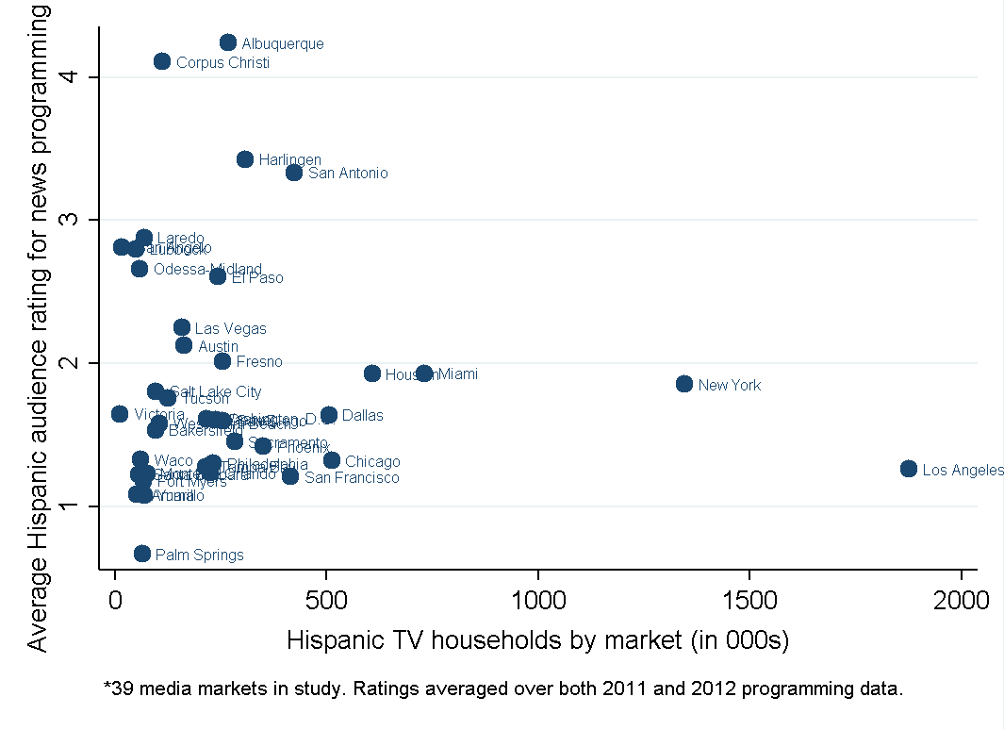

**Figure A-1: Hispanic television households and ratings for news programming**



**Figure A-2: Hispanic television households and ratings for local, Spanish-language news programming**

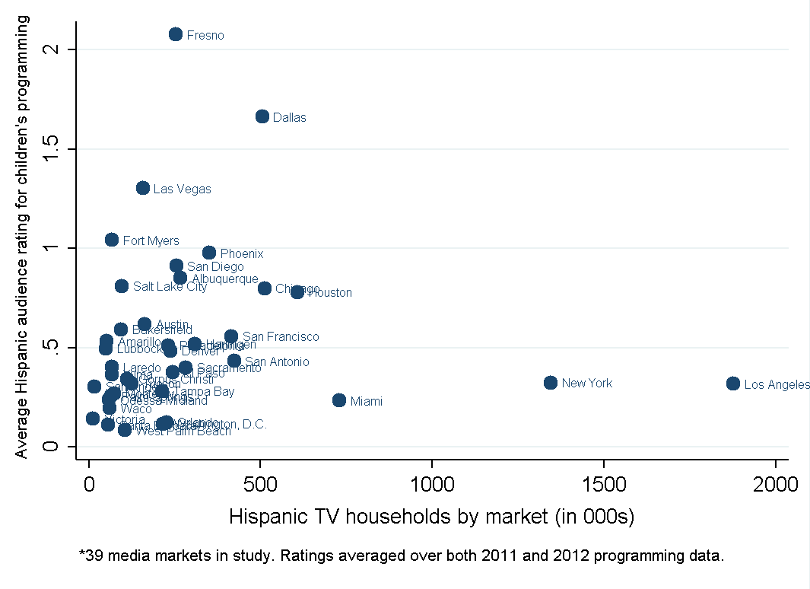

**Figure A-3: Hispanic television households and ratings for children’s programming**

**Table A.2: Market-Level Regression Analysis for Total Programming Minutes by Type**



**Table A.3: Market-Level Regression Analysis for Average Ratings**



1. *See, e.g.*, *2014 Quadrennial Regulatory Review – Review of the Commission’s Broadcast Ownership Rules and Other Rules Adopted Pursuant to Section 202 of the Telecommunications Act of 1996*, MB Docket No. 14-50, Further Notice of Proposed Rulemaking and Report and Order, 29 FCC Rcd 4371 (2014); *Promoting Diversification of Ownership in the Broadcasting Services*, MB Docket No. 07-294, Report and Order and Third Further Notice of Proposed Rulemaking, 23 FCC Rcd 5922 (2007).
2. *See* *Promoting Diversification of Ownership in the Broadcasting Services*, Report and Order and Fourth Further Notice of Proposed Rulemaking, 24 FCC Rcd 5896 (2009); *see also Promoting Diversification of Ownership in the Broadcasting Services*, Report and Order, Second Report and Order, and Order on Reconsideration, 31 FCC Rcd 398 (2016).
3. *See 2010 Quadrennial Regulatory Review – Review of the Commission’s Broadcast Ownership Rules and Other Rules Adopted Pursuant to Section 202 of the Telecommunications Act of 1996*, MB Docket No. 09-182, Report on Ownership of Commercial Broadcast Stations, 27 FCC Rcd 13814 (Med. Bur. 2012) (*2012 323 Report*). The *2012 323 Report* is based on ownership information as of November 1, 2009, and October 1, 2011, submitted by broadcasters in their biennial Form 323 filings.
4. LPTV service was created in 1982 “to provide opportunities for locally oriented television service in small communities” and “offers programming tailored to the interests of viewers in small localized areas in a less expensive and more flexible way than traditional full-service/power (television) stations.” (Consumer Guide, Low Power Television (LPTV) Service, [*https://www.fcc.gov/consumer/guides/low-power-television-lptv-service*](https://www.fcc.gov/consumer/guides/low-power-television-lptv-service)*)*. The Community Broadcasters Protection Act of 1999 established Class A television licenses for qualifying LPTV stations. *See* Pub. L. No.106-113, §5008, 133 Stat. App. I (1999). Class A stations were granted primary status as a television broadcaster. *See* *Establishment of a Class A Television Service*, MM Docket No. 00-10, Report and Order, 15 FCC Rcd 6355 (2000)). Translator or satellite stations simultaneously rebroadcast the signal of a primary station on a different frequency.
5. According to 2014 Census figures, Hispanics represented 17.4 percent of the population, whereas African Americans represented 13.2 percent of the population. The next largest minority group is Asian, which makes up 5.4 percent of the population. *See* Colby, Sandra L. and Ortman, Jennifer M., *Projections of the Size and Composition of the U.S. Population: 2014 to 2060* at 9, U.S. Census Bureau (March 2015), <https://www.census.gov/content/dam/Census/library/publications/2015/demo/p25-1143.pdf>.
6. For the data used in this study, in 2011 Hispanic owners held a majority interest in 190 (39 full power) out of 3,010 (1,348 full power) broadcast television stations, inclusive of low power and Class A television stations. In contrast, African-Americans owned 32 (10 full power) broadcast television stations, and Asians owned 42 (6 full power) broadcast television stations. *2012 323 Report*, 27 FCC Rcd at 13816-24.
7. Waldfogel’s work on Hispanic-oriented radio stations, discussed in the literature review at Section II, also utilizes this criterion.
8. Future research addressing later time periods might uncover content of this nature from more recently launched services, *e.g.*, Fusion and LATV. However these services are not necessarily distributed by broadcast stations.
9. Interviews with a handful of participants in the U.S. Hispanic television business suggest that there are currently a few U.S.-based producers of broadcast content targeted at the Hispanic audience, *e.g.*, Liberman/Estrella and LATV.
10. Due to Nielsen reporting of viewership for stations in multiple markets, the final dataset shows 646 station-market pairs.
11. We classify stations by affiliate or independent (not affiliated with a network) status using the BIA/Kelsey database. We used Nielsen data for three stations that BIA/Kelsey did not classify. We classified WFUN in Miami as independent, Spanish-language rather than MTV Tres (the BIA/Kelsey designation) based on subsequent research.  Tables 8 and 22 below provide information on Hispanic-owned stations and incorporate this affiliation information. Table 8 also includes station language information from TMS; the three Hispanic-owned stations not classified as Spanish-language, KCHF, KBEH, and KJLA, have 0, 41, and 90 percent Spanish-language content, respectively, as presented in Table 18, based on adding up available program level data. Spanish-language content for the other Hispanic-owned stations is over 90 percent in every case but one (the figure for KMOH is 58 percent).
12. According to Jan. 1, 2012, vintage Nielsen Hispanic Universe Estimates used beginning Sept. 29, 2011.
13. Generally, Nielsen measures Hispanic viewing in a market in which a client is interested in purchasing such information.
14. According to Jan. 1, 2012, vintage Nielsen National Universe Estimates used beginning Sept. 24, 2011.
15. According to Jan. 1, 2012, vintage Nielsen Hispanic Universe Estimates used beginning April 26, 2012.
16. This finding is consistent with Waldfogel’s preference externality theory, as outlined in the literature review at Section II, below.
17. The “p-value” is a statistical term that measures the reliability of an estimated regression coefficient. It tells us the likelihood that our initial hypothesis about the coefficient is correct. For example, suppose we are examining the relationship between the number of Hispanic households in a market and the quantity of Hispanic programming offered, using data on 39 markets. We might hypothesize that the relationship is positive and conduct a regression analysis to test the hypothesis. Suppose we consider the alternative to our hypothesis to be that there is no relationship at all. Our statistical test and resulting p-value will tell us, given the data we use in the test, what is the probability that there actually is no relationship as opposed to a positive one. If the analysis yields a positive relationship *and* the probability of no relationship is low, then we can be reasonably confident that our hypothesis of a positive relationship is true. For example, a p-value of 0.1 would represent a 10 percent chance of a false positive. Traditionally, p-values of 0.05 or lower (five percent or lower chance of a false positive) are referred to as “statistically significant” but results with higher p-values are still informative, as long as the increased potential for a false positive is taken into account.
18. Peter Siegelman and Joel Waldfogel, *Race and Radio: Preference Externalities, Minority Ownership, and the Provision of Programming to Minorities*, Vol. 10, Advances in Applied Microeconomics*,* (editors Michael R. Baye and Jon P. Nelson) 73-107 (2001)(Siegelman and Waldfogel Study).
19. *2010 Quadrennial Regulatory Review – Review of the Commission’s Broadcast Ownership Rules and Other Rules Adopted Pursuant to Section 202 of the Telecommunications Act of 1996* (*2010 Quadrennial Review*), MB Docket No. 09-182, Joel Waldfogel, *Radio Station Ownership Structure and the Provision of Programming to Minority Audiences: Evidence from 2005-2009*, FCC Media Study No. 7 (2011), <https://www.fcc.gov/general/2010-media-ownership-studies> (Waldfogel Study).
20. Siegelman and Waldfogel Study at 73-107. The concept of preference externalities was first introduced in Joel Waldfogel, *Preference Externalities: An Empirical Study of Who Benefits Whom in Differentiated Product Markets*, NBER Working Paper No. 7391 (1999), later published as Joel Waldfogel, *Preference Externalities: An Empirical Study of Who Benefits Whom in Differentiated Product Markets*, Vol. 34, Rand Journal of Economics, 557-568 (2003).
21. Siegelman and Waldfogel Studyat 82.
22. *Id.* at 92-93.
23. *Id.* at 94.
24. *Id.*
25. *Id.* at 96-97.
26. Telecommunications Act of 1996, Pub. L. No. 104-104, §202(b), 110 Stat. 56 (1996) (1996 Act). *See also* 47 CFR § 73.3555.
27. 1996 Act, §202(a).
28. Deduction for Health Insurance Costs of Self-Employed Individuals, Pub. L. No. 104-7, §2, 109 Stat 93, 93-94 (1995).
29. Siegelman and Waldfogel Study at 91.
30. *Id.* at 94-97.
31. *Id.*
32. *Id.* at 100.
33. *See supra* n. 18.
34. Siegelman and Waldfogel Studyat 8-9, 28-29.
35. *Id.* at 9-10.
36. *Id.* at 10. The figures cited in Section III, Data, below indicate that as of 2011, about 16 percent of Hispanic-oriented television stations were Hispanic-owned.
37. The periods are February, May, July and November.
38. Additional information on aggregating, cleaning and matching the data is available in Section IX, Technical Appendix.
39. *See supra* para. 27.
40. A complete description of how we merged together the relational files in the television schedule database is available in Section IX, Technical Appendix.
41. Individuals contacted by the study authors include: Federico Subervi, Professor, School of Journalism and Mass Communication, Kent State University; Alex Nogales, President and CEO, and Jessica Gonzalez, Executive VP and General Counsel, National Hispanic Media Coalition; Winter Horton, Chief Operating Officer, Liberman Broadcasting; Walter Ulloa, Chairman and CEO, Entravision; and Axel Caballero, Executive Director, National Association of Latino Independent Producers.
42. Siegelman and Waldfogel Study at 79, note 13.
43. A DMA is a geographic area defined by The Nielsen Company as a group of counties that make up a particular television market.  These counties comprise the major viewing audience for the television stations located in their particular metropolitan area.  For the most part, the metropolitan areas correspond to the standard metropolitan statistical areas defined by the Federal Government Office of Management and Budget.  The geographic areas do not overlap, and most counties in the United States belong to only one DMA (although in rare instances a county is divided by Nielsen and assigned to different DMAs).  DMAs are used in the evaluation of audience data as well as in the planning and buying of television advertising.
44. Total household viewership is the sum of Hispanic and non-Hispanic viewership. The use of the term “market” is for purposes of this study only and does not constitute a market for other purposes.
45. The TMS data reflects 42 DMAs or television markets. The difference in the number of markets between TMS and Nielsen data is attributable to the way each dataset is constructed. Stations in the TMS data are assigned to a television market based on where the station is licensed. Stations in the Nielsen data are assigned to a television market based on where their origin and ratings (or viewability) are measured.
46. A complete description of how we aggregated the Nielsen data in the viewership database is available in Section IX, Technical Appendix.
47. A complete description of how we merged together the relational files in the television schedule database is available in Section IX, Technical Appendix.
48. *2012 323 Report*, 27 FCC Rcd at 13815.
49. Biennial Form 323 Frequently Asked Questions, FCC, *https://www.fcc.gov/guides/form-323-frequently-asked-questions*.
50. Some of the 190 Hispanic-owned stations derived from Form 323 are located in Puerto Rico. Hispanic-owned stations located in Puerto Rico have different characteristics than stations located in the continental United States. First, the number and reach of Hispanic-owned stations in Puerto Rico is large relative to population size. Further, because most of the population in Puerto Rico speaks Spanish, it would be empirically difficult to separately identify the marginal effect of Hispanic television station ownership on both Hispanic-oriented programming and Hispanic television viewing characteristics.
51. “Although Congress established a hard deadline of June 12, 2009, for full-power TV stations to cease analog broadcasts and begin operating only in digital, the statutory deadline did not apply to low-power television stations, TV translator and Class A television stations.” Consumer Guide, Low Power Television (LPTV) Service, [*https://www.fcc.gov/consumer/guides/low-power-television-lptv-service*](https://www.fcc.gov/consumer/guides/low-power-television-lptv-service). Instead, the FCC established a separate Sept. 1, 2015, deadline for LPTV stations to terminate analog signal transmission.
52. *See* <https://licensing.fcc.gov/prod/cdbs/forms/prod/cdbs_ef.htm>.
53. Using this methodology, we are able to assign a TMS ID to 553 Nielsen stations in 2011 and 562 Nielsen stations in 2012. The total number of stations in the combined Nielsen-TMS database is limited by the ability to match an observation in Nielsen to that in TMS. We note that a number of observations are lost using this technique due to the inability to directly match Nielsen and TMS data. For instance, Nielsen and TMS provide some viewing and schedule data for Mexican stations that are not in the CDBS. More specifically, we note that there are 1,472 uniquely-identified station observations in the TMS database, 658 unique station observations in the 2011 Nielsen data, and 662 unique station observations in the 2012 Nielsen data. For TMS, we find a matching FCC Facility ID for 1,380 of the 1,472 stations. For Nielsen, we find a matching FCC Facility ID for 616 stations in 2011 and 625 stations in 2012. For a more complete description of the creation of the crosswalk see Section IX, Technical Appendix.
54. Note that while there are 21 unique Hispanic-owned television stations in 2011 and 23 unique Hispanic-owned television stations in 2012, one station broadcasts in two separate television markets in 2011.
55. Geolocation of Hispanic-owned stations is based on coordinates of the city and state and license as given on Form 323 and is approximated to avoid overlap of points in same area of license.
56. Geolocation of Hispanic-owned stations is based on coordinates of the city of license in Puerto Rico as given on Form 323 and is approximated to avoid overlap of points in the same city of license.
57. OMB Bulletin No. 13-01, *Revised Delineations of Metropolitan Statistical Areas, Metropolitan Statistical Areas, and Combined Statistical Areas, and Guidance on Uses of the Delineations of These Areas* (rel. Feb. 28, 2013), <https://www.whitehouse.gov/sites/default/files/omb/bulletins/2013/b-13-01.pdf>.
58. The Census data in our report are July 1, 2011, estimates of population from the vintage 2013 series of annual estimates.
59. Census, Population Division, Census 2010, *Vintage 2013 County Population Datasets, Annual County Resident Population Estimates by Age, Sex, Race, and Hispanic Origin: April 1, 2010 to July 1, 2013*, CC-EST2013-ALLDATA.PDF (rel. June 2014), <https://www.census.gov/2010census/data>,.
60. *Id*.
61. Census, *Census Bureau Releases 2011 Income and Poverty Estimates for All Counties and School Districts*, News Release, Dec. 12, 2013, <https://www.census.gov/newsroom/releases/archives/income_wealth/cb12-242.html>.
62. Census, Small Area Estimates Branch, *Small Area Income and Poverty Estimates, State and County Estimates for 2011,* EST11ALL.XLS (rel. Dec. 12, 2013), [https://www.census.gov/did/www/saipe/data/statecounty/ data/2011.html](https://www.census.gov/did/www/saipe/data/statecounty/%20data/2011.html).
63. U.S. Department of Labor, Bureau of Labor Statistics (BLS), Local Areas Unemployment Statistics, *Labor Force Data by County, 2011 Annual Averages,* LAUCNTY.XLS (rel. July 1, 2015), <http://www.bls.gov/lau/data.htm>.
64. Census, Data on School Enrollment, American Community Survey (2013), [http://www.census.gov/hhes/school/data /acs/index.html](http://www.census.gov/hhes/school/data%20/acs/index.html).
65. Hispanic audience ratings are defined as the number of Hispanic households watching a particular program over the total number of Hispanic television households in the television market multiplied by 100.
66. Live-plus-seven refers to a metric that encompasses all viewing within seven days of the initial broadcast of the program.
67. The linear-in-logarithms structure implies relative (multiplicative) changes between the outcome and explanatory variables, whereas a linear-scale implies absolute (additive) changes. While we believe there is sufficient reason to apply the log-transformation to our outcome variables (such as modeling the marginal effects in the explanatory variables in terms of percentage changes in the outcome variable, as well as addressing potential non-normality in the distribution of the error terms), there is no corresponding theoretical prediction with regard to the explanatory variables. However, to the extent that the relationship between the number of within-market Hispanic-owned stations and our outcome variables is non-linear, we retain flexibility in the characterization of the regression relationship.
68. We also employed a model that included a cubic polynomial, but the results indicated that the data did not fit this specification well (there was no statistical significance on the coefficients corresponding to the higher-order polynomials).
69. In this example, that critical value according to our quadratic specification would be represented by .
70. An insignificant coefficient on the squared term might also result from a small sample size.
71. The statistics presented in Table 18 are averaged across sweeps periods if the station appears in both.
72. All seven of the Hispanic-owned independent station observations are present in the November 2011 sample, while only six remain in May 2012. Note also that WJAN broadcasts in both the Miami and West Palm Beach television markets. These broadcasts are treated as two separate observations with distinct household viewing estimates.
73. This classification is as of May 2012. The landscape has changed since then as, for example, Telefutura relaunched as UniMas in 2013, and MundoFox (now MundoMax) launched in August 2012. In addition, LATV is a significantly larger player than it was just a few years ago.
74. These and all other variables relevant to the analysis are defined in Table 19, above.
75. Timeslot refers to both time of day and date of program within the two sample sweeps periods. For example, one observation might be Futurama on call sign KTLA in Los Angeles, on May 19, 2012, at 9 pm local time.
76. This is somewhat misleading, however, due to the small sample of Hispanic-owned independents. Five of the seven station observations are almost entirely Spanish-language. Call sign KBEH is a mix of Spanish-language and English-language, while call sign KCHF is entirely English-language.
77. A zero rating does not necessarily indicate that the program was not viewed by any Hispanic households. However, it does indicate that the Nielsen in-tab sample (the number of households in Nielsen’s research sample supplying useable information) of Hispanic household viewing was in fact zero. Nielsen does not extrapolate zero in-tab viewing to a population metric, and therefore we still observe zeroes in our dataset. However, a zero rating indicates that the actual viewership was likely very low.
78. As described in Table 23 above, the Big 4 networks include ABC, NBC, Fox, and CBS.
79. This is an indicator variable provided by TMS. It is not specified whether this variable is constructed based on MPAA or TV Parental Guidelines ratings, or some alternative definition.
80. A “daypart” is a division of the 24-day into different viewing periods for the purposes of categorizing viewing patterns. Prime time is a frequently mentioned daypart.
81. This is not true data censoring, where values of a dependent variable above or below a threshold are limited to that threshold. Here we observe zeroes that represent an actual choice, when viewers choose not to watch a particular program (at least according to the in-tab sample). However, this still presents an econometric challenge with regard to estimating the model using OLS. Specifically, if we want to estimate $y^{*}=x’β+ε$ but only observe $y=\max\left(y^{*}, 0\right)$, then the marginal effect of $x$ on the expectation of $y$ becomes: $E[y|y>0, x]=xβ+σλ(xβ/σ)$, where $λ$ is the inverse mills ratio and $σ$ is the standard error of $ε$ in the latent variable model. This is non-linear in $β$, leading to bias when estimating with OLS either on the entire sample or on the non-censored portion.
82. A two-part model is most applicable in situations where the participation decision can be separated from the subsequent decision of how much to consume. For example, the decision of whether to smoke and then how much to spend on cigarettes, or how many cigarettes to smoke a day. Because each observation in our dataset is a program timeslot with a corresponding viewing total, we do not observe individual decisions by economic actors. Instead, we observe the collective decisions of all Hispanic viewers with regard to their total viewership of each program. While viewing cannot be negative and so zero is a lower bound, it is nonetheless a representation of the total viewership of a given program. Therefore, there is no differentiation between participation and consumption when the outcome variable is total viewership or ratings.
83. Of note is that the Spanish Language program indicator has a negative and statistically insignificant coefficient in both the OLS and Tobit models. This result may appear counterintuitive, but is plausible given that we have controlled for the major Spanish-language networks. In fact, when running this regression model without the Spanish-language network dummies, Spanish Language becomes positive and highly significant.
84. This includes Univision, Telemundo, Telefutura, Estrella, and Azteca.
85. We present the interaction effects as a full set of indicators for each combination of *Spanish Language*, *Local*, and *News*, rather than the standard approach of presenting main effects for each variable along with their interactions. This is for clarity and ease of exposition, as all coefficients for each combination of the explanatory variables are presented in Table 25, above. The results are unaffected, but the interpretation of the coefficients is different. For example, the baseline comparison group, {0, 0, 0}, indicates non-Spanish language, non-local, non-news programming. Therefore, the coefficient on {0, 1, 0} is the effect of local, non-Spanish language, non-news programming. Because we present odds ratios, marginal effects can be determined by *dividing* coefficients. For example, the marginal effect of news on Spanish-language programming would be the coefficient on {1, 0, 1} divided by the coefficient on {1, 0, 0}.
86. While the coefficient is negative when presented as a change in the log-odds of the outcome for a one unit change in a predictor, in terms of odds ratios this is equivalent to a coefficient that is less than 1. This is not directly evident in Table 25 because we present the full set of factor combinations rather than pure interaction effects. However, as we detail above, this effect is still estimable from the coefficients in our table by calculating the marginal odds ratio.
87. A similar decomposition could be achieved by simply interacting *Hispanic Owner* with an indicator for whether a station is affiliated with a Spanish-language network. The interaction term would indicate an affiliated Hispanic-owned station, while the new interpretation of the coefficient on *Hispanic Owner* would be the effect of the non-network stations. However, this is not the preferred approach because of the Hispanic-owned stations that are affiliated with Mega-TV and MTV Tres. We do not consider these to be affiliated with a large, Spanish-language network, but neither are these stations truly independent. We therefore exclude them in the decomposition for models 1 and 2 and focus on the two explicitly defined categories of Hispanic-owned stations (independents versus affiliates). As such, we end up with 7 Hispanic-owned independent stations and 15 Hispanic-owned stations affiliated with a large, Spanish-language network.
88. The Tobit coefficients presented above are marginal effects, interpreted as the effect of the explanatory variables on the conditional mean of the non-censored ratings (those above zero).
89. A marginally significant result is generally one in which the p-value of the coefficient is between 5 and 10 percent. That is, the higher p-value suggests that we are more likely to mistakenly reject the null hypothesis when the null hypothesis should not be rejected.
90. Again, the Spanish-language networks include Univision, Telemundo, Telefutura, Estrella, and Azteca.
91. This is evidenced by the coefficients on the various Spanish-language network indicators in the program-level household viewing regression model.
92. An average rating of zero indicates that no Hispanic households viewed any of the station’s programs over the entire sample period. This is different from missing ratings data, where Hispanic viewership was simply not recorded by Nielsen. As station ratings are averaged over all programs, there are fewer cases of zero viewership than in the program-level data. However, some still exist: in 2011 and 2012, there were six and two stations with a rating of zero, respectively; for local, Spanish-language ratings there were 13 and 11 cases of zero ratings, respectively.
93. Though we do not present them here, the results of the Tobit model are consistent with and qualitatively similar to the OLS estimates. This suggests that the limited data censoring at the station-level does not bias the OLS results.
94. We have also estimated these models for each sweeps period separately, as there is little variation in station characteristics or television market demographics between the two subsamples. We do not find a significant effect of Hispanic ownership on overall station ratings in either sample period. Though we essentially have a two period panel of stations, there is no change in ownership for the subset of Hispanic-owned stations between November 2011 and May 2012. As such, we are unable to exploit changes in ownership between sample periods to help identify the causal effect of Hispanic ownership on ratings.
95. It is likely that the program-level models afforded us the opportunity to identify a statistically significant correlation between Hispanic ownership and ratings largely due to the additional variation at the program level, though these station-level results suggest that the relationship may not be as strong as, for example, the relationship between ratings and large, Spanish-language networks.
96. We again perform these regressions separately for each sweeps period, and similarly find no statistically significant effect of Hispanic ownership in either subsample. Likewise, the Tobit model results are in line with the OLS estimates.
97. Sources: (1) Hispanic cable networks: The Nielsen Company, *Local Monthlies File Format for Quarter-Hours, Program Names & Program Updates,* October 2011 and May 2012 surveys (accessed in Nov. 2014); SNL Kagan, *TV Networks, Network Summary,* [https://www.snl.com/](https://www.snl.com/‌) (May 2014); and Broadcasting and Cable, *Guide to U.S. Hispanic Channels,* Oct. 2, 2013, [www.broadcast‌ingcable.com/file/‌‌‌‌10489‌-Hispanic_TV_Special.pdf](http://www.broadcastingcable.com/file/‌‌‌‌10489‌-Hispanic_TV_Special.pdf); (2) Channel data: *Implementation of Section 3 of the Cable Television Consumer Protection and Competition Act of 1992*, *Statistical Report on Average Rates for Basic Service, Cable Programming Service, and Equipment,* MM Docket No. 92-266, 2002-2012 reports, <https://fcc.gov/general/media-bureau-reports-industry>; (3) Population: Census, *National Intercensal Population Estimates (2000-2010),* [https://census‌.gov/popest/data/intercensal/index.html](https://census.gov/popest/data/intercensal/index.html) (Dec. 2015); Census, *Annual Estimates of the Resident Population by Sex, Race, and Hispanic Origin for the United States, States, and Counties: April 1, 2010 to July 1, 2014,* 2014, estimates, <http://factfinder.census.gov/faces/nav/jsf/pages/index.xhtml>.
98. For a discussion of these factors, *see, e.g.,* Lin, Haizhen, Waterman, David and Ji, Sung Wook, *Basic Cable Network Segmentation Toward Minorities and Other Niche Audiences in a Digital World: An Empirical Study of Cable Advertising*, (rev. May 2014), papers.ssrn.com/sol3/papers.cfm?abstract_id=2032250.
99. *Implementation of Section 3 of the Cable Television Consumer Protection and Competition Act of 1992*, *Statistical Report on Average Rates for Basic Service, Cable Programming Service, and Equipment,* 27 FCC Rcd 2427 (2012). Because the survey does not collect data on carriage of every cable network, not all Hispanic cable networks are represented in Table 30.
100. SNL Kagan, *TV Networks, Network Summary,* <https://www.snl.com/> (May 2014).
101. The Translation Record contains language translations for data fields in the other files, such as the language of the copy (description) of a program in the Program Record; the Time Zone Record contains an offset in hours for converting Coordinated Universal Time (UCT) to local standard time. In our study, the program data provided by TMS were given in UCT, while Nielsen viewing data were given in local time. To ensure that dates and times lined up across both sources, we converted the Nielsen viewing data from local time to UCT based on time zone crosswalks. We chose to convert data on the Nielsen side (rather than the TMS side) because Daylight Savings Time (DST) overlapped partially with the study period and not all television markets in the Nielsen data observe DST. According to Nielsen, television stations located in the Phoenix, Tucson and Yuma television markets do not participate in DST.
102. Nielsen uses call signs from time period of the data, in this case those that are current as to November 2011 and May 2012. TMS, conversely, uses call signs that are current to the time period the data was generated for use by Commission staff, here late 2013. As call signs change over time, particularly due to the digital transition, directly matching observations may in some cases result in an incorrect match.
103. Matching was done separately for each data year. We first matched the 2011 Nielsen station list to the full TMS station list, then the 2012 Nielsen station list to the full TMS station list.
104. According to Nielsen, TV stations located in the Phoenix, Tucson and Yuma television markets do not participate in Daylight Savings Time.
105. DMAs assigned to stations by TMS and Nielsen differ in their methodology. *See* *supra* n. 53 for a detailed description of our methodology to overcome these differences.