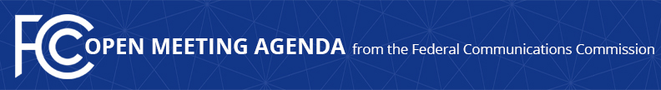

Media Contact:
Will Wiquist, 202-418-0509
will.wiquist@fcc.gov

For Immediate Release

FCC ANNOUNCES TENTATIVE AGENDA FOR JUNE OPEN MEETING
--
WASHINGTON, June 3, 2016 – Federal Communications Commission Chairman Tom Wheeler announced that the following items are tentatively on the agenda for the June Open Commission Meeting scheduled for Friday, June 24, 2016:

Reforming Executive Branch Review Process of Certain FCC Applications and Petitions Involving Foreign Ownership: The Commission will consider a Notice of Proposed Rulemaking that seeks comments on changes to streamline and increase the transparency of the Executive Branch review of applications and petitions for national security, law enforcement, foreign policy and trade policy concerns. (IB Docket No. 16-155)

Adding Hurricane-Related Event Codes to the Emergency Alert System: The Commission will consider a Report and Order that would revise the Emergency Alert System rules by adding new event codes covering extreme high winds and storm surges caused by Category 3 (and greater) hurricanes. (PS Docket No. 15-94)

Improving Outage Reporting for Submarine Cables: The Commission will consider a Report and Order to require submarine cable licensees to report communications network outages to the FCC. (GN Docket No. 15-206)

The Open Meeting is scheduled to commence at 10:30 a.m. in Room TW-C305 of the Federal Communications Commission, 445 12th Street, S.W., Washington, D.C.

###
Office of Media Relations: 202.418.0500
TTY: 888-835-5322
Twitter: @FCC
ftp.fcc.gov
www.fcc.gov/office-media-relations

This is an unofficial announcement of Commission action. Release of the full text of a Commission order constitutes official action. See MCI v. FCC. 515 F 2d 385 (D.C. Circ 1974).

