FEDERAL COMMUNICATIONS COMMISSION
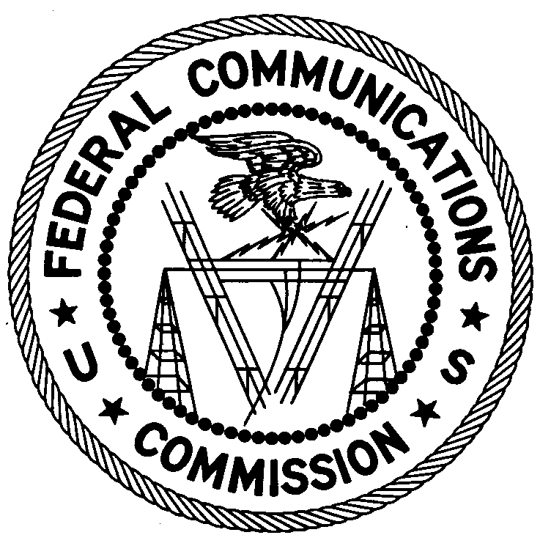
ENFORCEMENT BUREAU
Region 2

Miami Office
P.O. Box 266468

Weston, FL 33326

June 13, 2016

Aptech Networks Corp.
Doral, Florida

NOTICE OF UNLICENSED OPERATION AND
NOTIFICATION OF HARMFUL INTERFERENCE

Case Number: EB-FIELDSCR-16-00021849

Document Number: W201632600014

The Miami Office, in response to information received from the Federal Aviation Administration (FAA) that the Terminal Doppler Weather Radar (TDWR) serving the Miami International Airport was receiving interference on or adjacent to 5.605 GHz, conducted an investigation in the area. On June 3, 2016, agents from this office confirmed by direction finding techniques and through an inspection that radio emissions on frequency 5.605 GHz were emanating from the tower at 8180 NW 36th St. Doral, Florida. Your system was using a Ubiquiti Networks NanoBeam NBE-M5-400 Unlicensed National Information Infrastructure (“U-NII”) device. One of these devices was programmed to operate on 5.605 GHz. You changed the operating frequency of the system and the interference to the FAA radar ceased.

Radio stations operating on many frequencies must be authorized by the FCC pursuant to 47 U.S.C. § 301. The only exception to this licensing requirement is for certain transmitters using or operating at a power level or mode of operation that complies with the standards established in Part 15 of the Commission’s rules. Non-licensed operation pursuant to Part 15 of the Commission’s rules, however, is conditioned upon compliance with all applicable regulations in the subpart, 47 C.F.R. § 15.1(b). All intentional radiators operating pursuant to Part 15 of the FCC’s rules must be certified for use as a Part 15 device, 47 C.F.R. § 15.201(b) and failure to operate such device consistent with its authorization violates Part 15 of the Commission’s rules.

You operated Ubiquiti NanoBeam NBE-M5-400 devices on the frequency 5.605 GHz. The Ubiquiti NBE-M5-400 with FCC ID SWX-NBEM5 is not authorized for use in the 5.45 GHz through 5.725 GHz frequency band. The FCC has no record of a license being issued to you to operate a transmitter on 5605 MHz from 8180 NW 36th St. Doral, Florida. Thus, your operation was in violation of 47 U.S.C. § 301.

Non-licensed operation of a U-NII device is also subject to the condition that it must not cause harmful interference and, if harmful interference occurs, operation of the device must cease. See 47 C.F.R. §§ 15.5(c), 15.405. Harmful interference is defined as “[a]ny emission, radiation or induction that endangers the functioning of a radio navigation service or of other safety services or seriously degrades, obstructs or repeatedly interrupts a radio communications service.” 47 C.F.R. § 15.3(m).

You are notified that your Ubiquiti device operating on 5.605 GHz was causing harmful interference to the TDWR at the Miami International Airport and that your operation of this device must not resume until the interference can be resolved. You are also warned that operation of radio transmitting equipment without a valid radio station authorization, including non-certified equipment or modified equipment which voids the certification, and/or operation of otherwise authorized equipment that continues to cause harmful interference after your receipt of this warning, constitutes a violation of the Federal laws cited above and could subject the operator to severe penalties, including, but not limited to, substantial monetary fines, in rem arrest action against the offending radio equipment, and criminal sanctions including imprisonment. (See 47 U.S.C. §§ 401, 501, 503 and 510.)

UNLICENSED OPERATION ON FREQUENCY 5.605 GHZ MUST NOT RESUME. NONLICENSED OPERATION OF A U-NII DEVICE MAY NOT RESUME UNLESS YOU ARE IN FULL COMPLIANCE WITH PART 15 OF THE FCC’S RULES AND UNTIL YOU RESOLVE THE HARMFUL INTERFERENCE.

You have ten (10) days from the date of this notice to respond with any evidence that your transmitter is not the source of the interference to the TDWR. Your response should describe the steps you are planning to take to eliminate future interference to the TDWR of the Miami International Airport. Your response should be sent to the address in the letterhead and reference the listed case number and document number. Under the Privacy Act of 1974, 5 U.S.C. § 552a(e)(3), we are informing you that the Commission’s staff will use all relevant material information before it to determine what, if any, enforcement action is required to ensure your compliance with FCC Rules. This will include any information that you disclose in your reply.

You may contact this office if you have any questions.

Ronald Ramage
Regional Director

Attachments:
Excerpts from the Communications Act of 1934, As Amended
Enforcement Bureau, "Inspection Fact Sheet", March 2005
Joint OET and EB Memo dated July 27, 2010 regarding interference to Terminal Doppler Weather Radars

