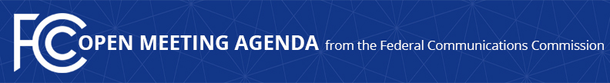

Media Contact:
Will Wiquist, 202-418-0509
will.wiquist@fcc.gov

For Immediate Release

FCC ANNOUNCES TENTATIVE AGENDA FOR JULY OPEN MEETING
--
WASHINGTON, June 23, 2016 – Federal Communications Commission Chairman Tom Wheeler announced that the following items are tentatively on the agenda for the July Open Commission Meeting scheduled for Thursday, July 14, 2016:

Spectrum Frontiers – The Commission will consider a Report and Order and Further Notice of Proposed Rulemaking that would make spectrum in bands above 24 GHz available for flexible use wireless services, including for next-generation, or 5G, networks and technologies. (GN Docket No. 14-177; IB Docket No. 15-256; RM-11664; WT Docket No. 10-112; IB Docket No. 97-95).

Advancing Technology Transitions – The Commission will consider a Declaratory Ruling, Report and Order, and Order on Reconsideration that adopts a framework to guide transitions to next-generation communications technologies while protecting the interests of consumers and competition. (WC Docket No. 13-5; WC Docket No. 13-3; RM-11358).

The Open Meeting is scheduled to commence at 10:30 a.m. in Room TW-C305 of the Federal Communications Commission, 445 12th Street, S.W., Washington, D.C.

###
Office of Media Relations: 202.418.0500
TTY: 888-835-5322
Twitter: @FCC
ftp.fcc.gov
www.fcc.gov/office-media-relations

This is an unofficial announcement of Commission action. Release of the full text of a Commission order constitutes official action. See MCI v. FCC. 515 F 2d 385 (D.C. Circ 1974).

