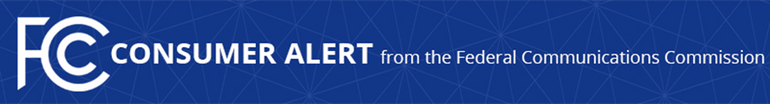

Consumer Complaints:
Online: https://consumercomplaints.fcc.gov
Phone: (888) 225-5322
TTY: (888) 835-5322
Videophone: 1-844-432-2275

Media Contact:
Will Wiquist, (202) 418-0509
will.wiquist@fcc.gov

For Immediate Release

CONSUMER ALERT: GIFT CARD CALL SCAM
Phone Fraudsters Posing as Government Officials Demand Payment with Gift Cards

*FCC to Host Twitter Town Hall on Friday about Robocalls*

WASHINGTON, November 3, 2016 – The Federal Communications Commission is alerting consumers to be on the lookout for callers pretending to be government or law enforcement officials demanding immediate payment, often by buying gift cards and providing the card numbers to the scammers. These “officials” typically say that payment will protect the consumer – or the consumer’s family or friends – from arrest or some other legal action. According to complaints the FCC has received and public news reports, the Commission believes that the fraudulent callers pretend to be officials from organizations such as the IRS, the FBI, and local sheriffs’ offices, among others.

The FCC also announced today that it will host a Twitter town hall tomorrow from 1:30 pm to 2:30 pm EDT to answer consumers’ questions about and provide information on robocalls. The public is encouraged to participate in this online conversation by following #RobocallChat and submitting questions using the hashtag. This conversation will revolve around robocall rules and FCC actions to protect consumers from unwanted calls, including scams like those highlighted in this alert. Senior commission staff will address questions through the account of Gigi B. Sohn, Counselor to the Chairman, at the Twitter handle: @GigiBSohnFCC

As part of the gift card call scam, the callers typically give consumers, many of whom are older adults, seemingly legitimate reasons for the call. They are told, for example, that a loved one has been caught texting while driving or that the consumer owes back taxes. The caller then advises the consumer that he or she can resolve the problem immediately by paying with store gift cards, often Apple iTunes gift cards. The consumer is instructed to provide the card’s access code, which allows the scammer to use or sell the gift card to third parties.

Government agencies and legitimate companies never call consumers to seek payment via gift cards. Anyone who believes they have been targeted by this scam should immediately report the incident to the company linked to the gift card (such as Apple Support at 800-275-2273), to local police, and to the FCC’s Consumer Help Center.

Consumers should always be on alert for this scam and others. The following tips can help ward off unwanted calls and scams:

- Don’t answer calls from unknown numbers. Let them go to voicemail.
- If you are unclear if a caller is legitimate, hang up, independently look up the organization’s publicly listed phone number or legitimate website, and contact them through an official number, web form or email address to see if they called you.
- If you answer and the caller (often a recording) asks you to hit a button to stop getting the calls, just hang up. Scammers often use these tricks to identify – and then target – live respondents.
- If you receive a scam call, write down the number and file a complaint with the FCC so we can help identify and take appropriate action to help consumers targeted by illegal callers.
- Ask your phone service provider if it offers a robocall blocking service. If not, encourage the provider to start offering it. You can also visit the FCC’s website for information and resources on available robocall blocking tools to help reduce unwanted calls.

As the agency that implements and enforces the Telephone Consumer Protection Act, the FCC reviews all consumer complaints and will continue, when appropriate, to issue consumer alerts based on those complaints and other public information related to possible scams and frauds. This is part of a new, standing series of consumer alerts from the FCC in hopes of informing and empowering consumers.

###

Office of Media Relations: (202) 418-0500
TTY: (888) 835-5322
Twitter: @FCC
www.fcc.gov/office-media-relations

