FEDERAL COMMUNICATIONS COMMISSION
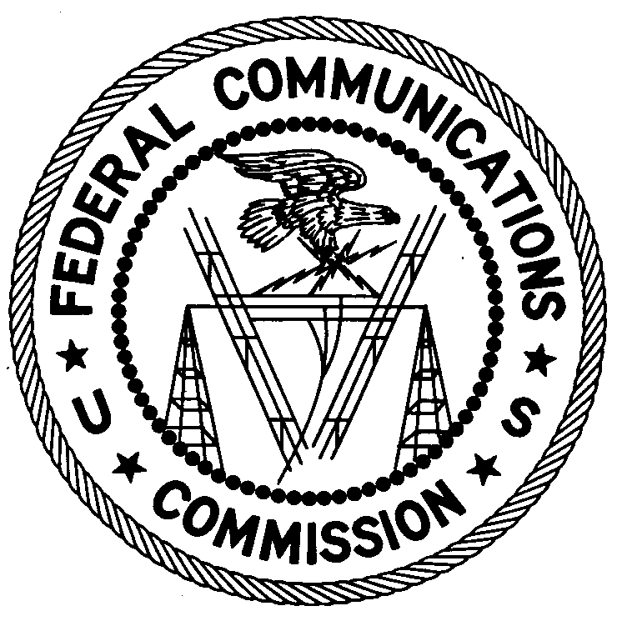
ENFORCEMENT BUREAU
Region 2

Houston Office
9597 Jones Road, #362
Houston, Texas 77065
713-983-6103

June 20, 2016

Robert Heiney
The Woodlands, Texas

NOTICE OF UNLICENSED OPERATION

Case Number: EB-FIELDSCR-16-00021953 Document Number: W201632540001

The Houston Office received information that an unlicensed broadcast radio station on 94.9 MHz was allegedly operating in The Woodlands, Texas. On June 5, 2016, agents from this office confirmed by direction finding techniques that radio signals on frequency 94.9 MHz were emanating from your residence in The Woodlands, Texas. The Commission’s records show that no license was issued for operation of a broadcast station on 94.9 MHz at this location in The Woodlands, Texas.

Radio stations operating on many frequencies, including 94.9 MHz, must be licensed by the FCC pursuant to 47 U.S.C. § 301. The only exception to this licensing requirement is for certain transmitters using or operating at a power level or mode of operation that complies with the standards established in Part 15 of the Commission’s rules, 47 C.F.R. §§ 15.1 et seq. On June 15, 2016, the field strength of the signal on frequency 94.9 MHz exceeded the maximum permitted level of 250 microvolts per meter (µV/m) at 3 meters for non-licensed devices. Thus, this station is operating in violation of 47 U.S.C. §301.

You are hereby warned that operation of radio transmitting equipment without a valid radio station authorization constitutes a violation of the Federal laws cited above and could subject the operator to severe penalties, including, but not limited to, substantial monetary fines, in rem arrest action against the offending radio equipment, and criminal sanctions including imprisonment. (See 47 U.S.C. §§ 401, 501, 503 and 510.) Be advised that this warning does not preclude this office from pursuing additional sanctions based upon our investigation of this incident.

UNLICENSED OPERATION OF THIS RADIO STATION MUST NOT RESUME.

You have ten (10) days from the date of this notice to respond with any evidence that you have authority to operate granted by the FCC. Your response should be sent to the address in the letterhead and reference the listed case and document number. Under the Privacy Act of 1974, 5 U.S.C. § 552a(e)(3), we are informing you that the Commission’s staff will use all relevant material information before it to determine what, if any, enforcement action is required to ensure your compliance with FCC Rules. This will include any information that you disclose in your reply.

You may contact this office if you have any questions.

Ronald Ramage
Regional Director

