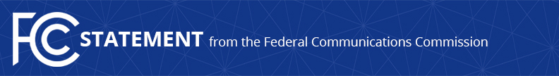

Media Contact:
Mark Wigfield, (202) 418-0253
mark.wigfield@fcc.gov
For Immediate Release

STATEMENT OF FCC CHAIRMAN AJIT PAI
ON THE INTRODUCTION OF THE GIGABIT OPPORTUNITY ACT
An Important Step Toward Closing the Digital Divide
WASHINGTON, May 3, 2017— Federal Communications Commission Chairman Ajit Pai issued the following statement today on the introduction of the Gigabit Opportunity Act:

“Introduced today by Senator Shelley Moore Capito, the Gigabit Opportunity (GO) Act is an important step toward closing the digital divide, and one that has my full support. Next-generation networks are increasingly critical to economic opportunity, job creation, and civic engagement. But too many parts of rural and urban America can’t attract the investment needed to deploy those networks. With targeted tax incentives and regulatory streamlining, the GO Act aims to remove the major barriers holding back Internet access in economically challenged areas.

“I commend Senator Capito for her vision of extending digital opportunity to all Americans. The FCC shares that vision and stands ready to provide any necessary assistance to Congress as it considers this critical legislation.”

###
Office of Chairman Ajit Pai: (202) 418-2000
Twitter: @AjitPaiFCC
www.fcc.gov/leadership/ajit-pai

This is an unofficial announcement of Commission action. Release of the full text of a Commission order constitutes official action. See MCI v. FCC, 515 F.2d 385 (D.C. Cir. 1974).

