Study Area Boundary Map Navigation

If you would like to highlight and zoom to your boundary you may use the search box located in the upper left of the map. Searches may be made by SAC or company name.

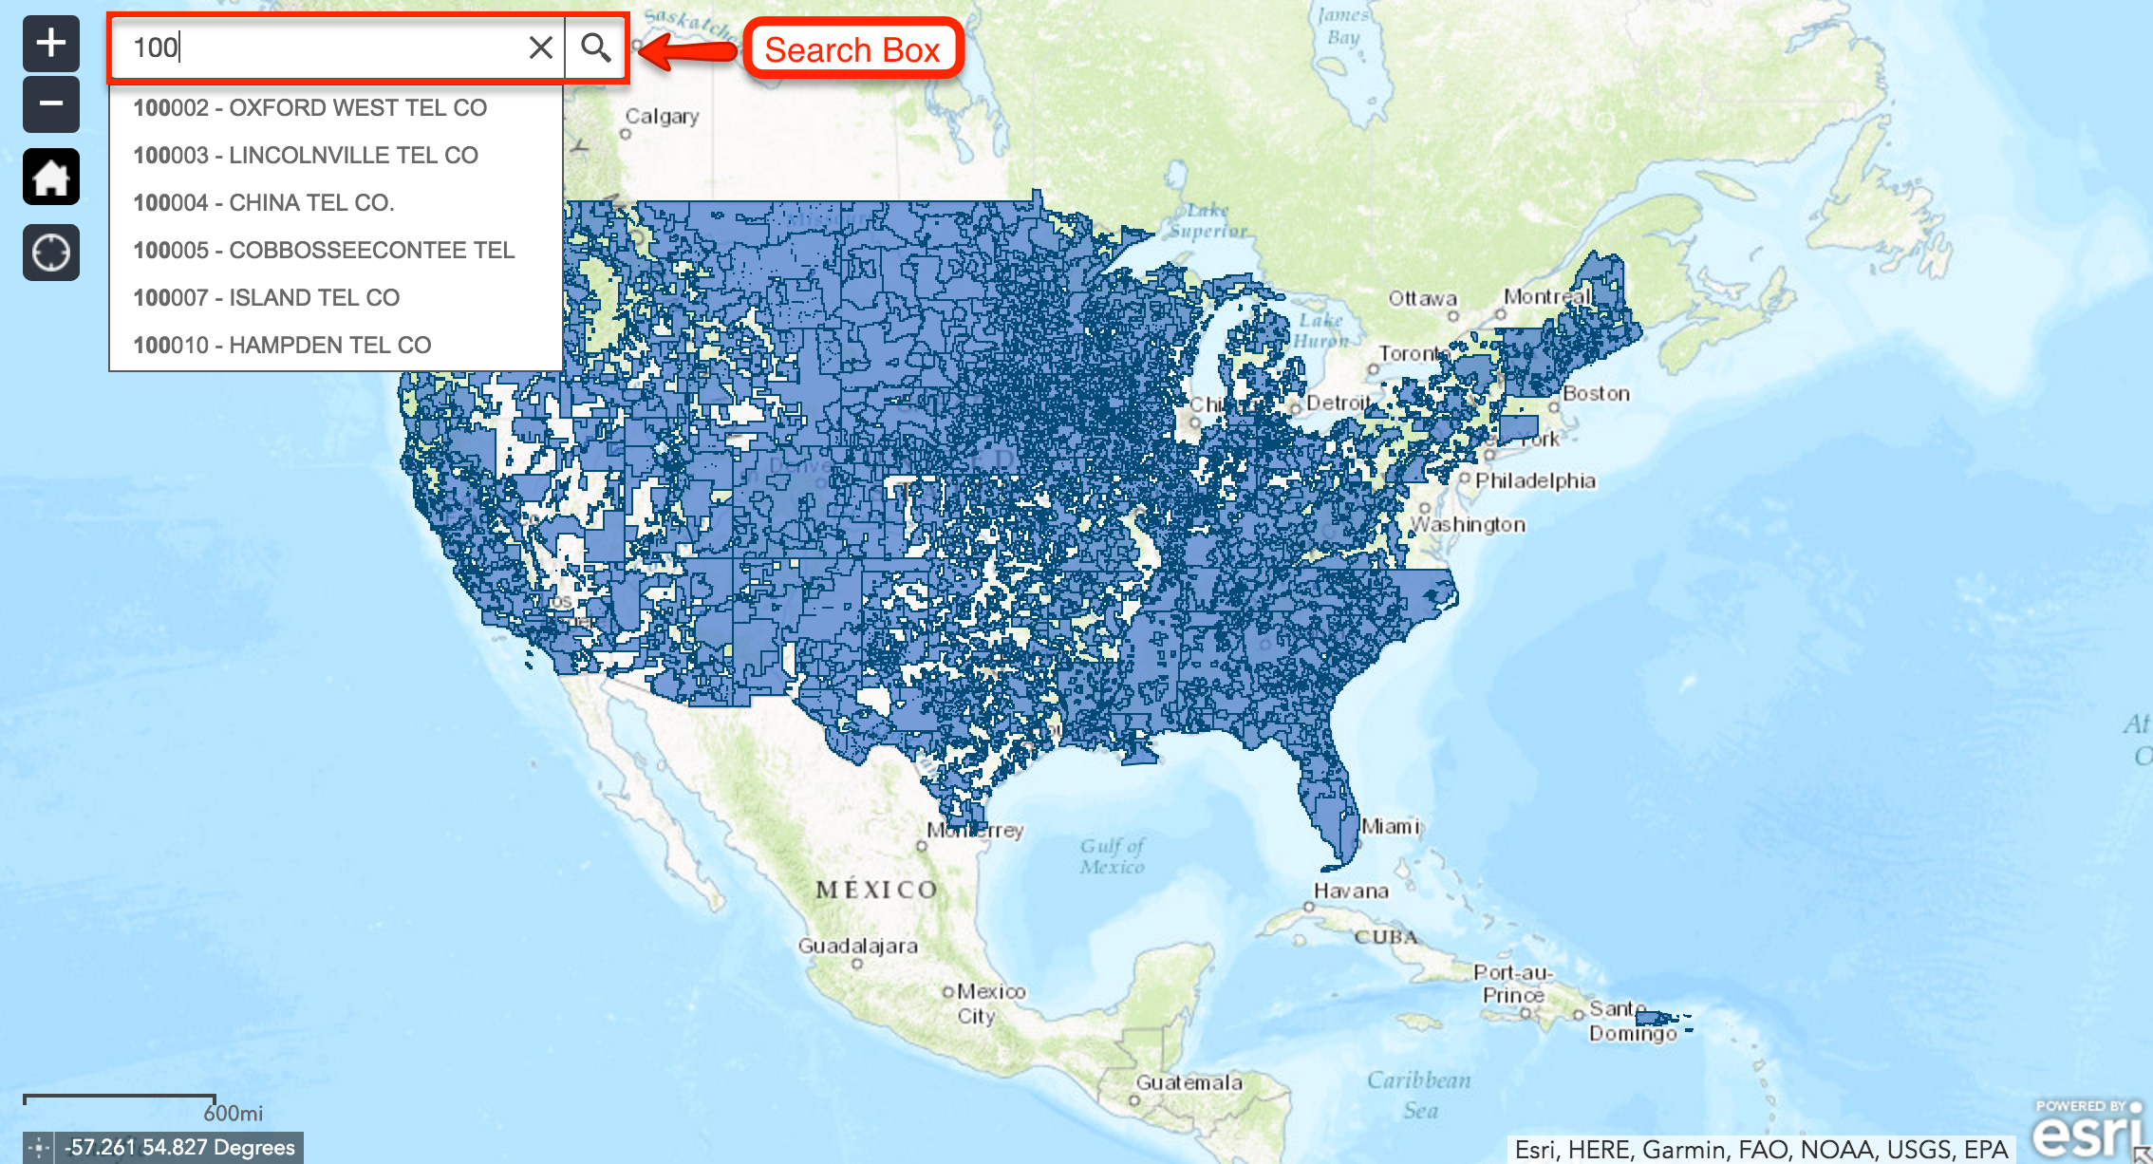

Once you have selected a SAC or company name in the search box the map will highlight the boundary, zoom in to the general area and display a pop-up with ancillary information. If you would like to zoom to the full extent of the selected boundary, click the “Zoom to” link at the bottom left of the pop-up window. Also any overlaps with adjacent boundaries will appear as a darker blue area as noted in the image below.

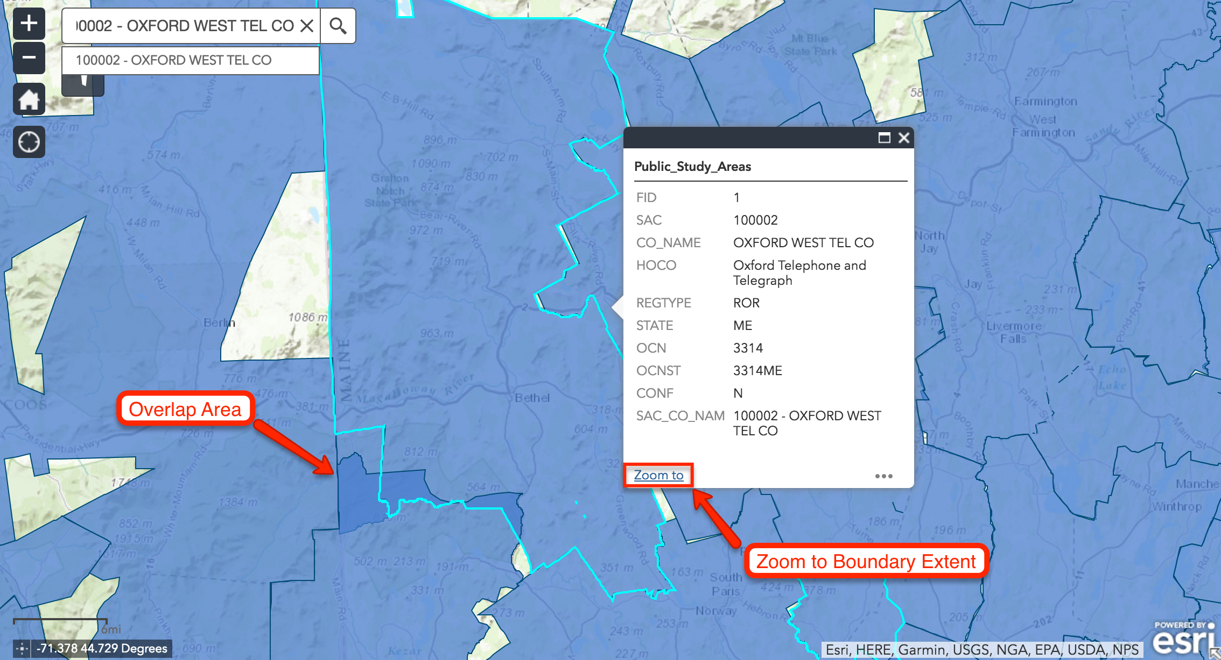
To display the polygon or polygons for only one study area code on the map click the filter button shown below, enter a 6 digit SAC in the filter field and click “Apply”. To clear the filter and display all the boundary polygons again, click the checkmark in the upper right of the filter box.

