**Federal Communications Commission**



**Fiscal Year 2018**

**Budget Estimates to Congress**

**May 2017**

**Table of Contents**

INTRODUCTION AND SUMMARY OF REQUEST 1

Organizational Chart – May 2017 7

Fiscal Year 2018 Proposed Appropriation Language 8

Legislative Proposals 9

Summary of FYs 2016 - 2018 FTEs and Funding by Bureaus and Offices 10

Fiscal Year 2018 FTEs Distribution by Strategic Goals 11

Fiscal Years 2016 - 2017 FTEs Distribution by Strategic Goals 12

FTEs by Resource Category 13

Number of Contractors 13

FTEs - Historical and Estimated 14

Summary of Changes - Regulatory Fees (Offsetting Collections) 15

Narrative Explanation of Changes - Salaries and Expenses - Regulatory Fees 16

Overall Status of Audit Recommendations 20

Status of FCC Headquarters Move/Restack 21

Crosswalk - Summary of Changes for Regulatory Fees 22

SPECTRUM AUCTIONS 23

Spectrum Auctions Program - Explanation of Requested Change 25

Spectrum Auctions Program 26

Spectrum Auctions Activities 31

Summary of Distribution of Resources - Spectrum Auctions Program 32

Spectrum Auctions Expenditures Report 33

Spectrum Auctions and Collections 36

Spectrum Auctions Program – Collections vs. Expenditures 36

Crosswalk - Summary of Changes for Spectrum Auctions Program 37

ECONOMY ACT REIMBURSABLE AGREEMENTS 39

FEE COLLECTIONS 41

Regulatory Fees 43

Availability of Regulatory Fees 43

Historical Distribution of Appropriated Budget Authority – Regulatory Fees 44

Historical Appropriated Budget Authority – Spectrum Auctions Program 45

Application Processing Fees 46

PERFORMANCE PLAN 47

FISCAL YEAR 2018 REQUIREMENTS BY BUREAUS AND OFFICES 59

Offices of the Chairman and Commissioners 61

Consumer and Governmental Affairs Bureau 62

Enforcement Bureau 64

International Bureau 66

Media Bureau 68

Public Safety and Homeland Security Bureau 69

Wireless Telecommunications Bureau 71

Wireline Competition Bureau 73

Office of Administrative Law Judges 75

Office of Communications Business Opportunities 77

Office of Engineering and Technology 79

Office of General Counsel 81

Office of Legislative Affairs 83

Office of the Managing Director 85

Office of Media Relations 87

Office of Strategic Planning and Policy Analysis 88

Office of Workplace Diversity 90

Office of Inspector General 92

APPENDICES 95

Summary - Requested Resources 97

Summary - Distribution of Resources 100

Summary - Distribution of Resources by Strategic Goals 110

Allocation of Obligations by Object Class Code 111

EXHIBITS AND REPORTS 113

Universal Service Fund Exhibit 115

Spectrum Auctions Program Account Exhibit 116

Spectrum Auctions Direct Loan Financing Account Exhibit 118

Responses to Congressional Inquiries Concerning GAO Recommendations 119

# INTRODUCTION AND SUMMARY OF REQUEST

This page is intentionally left blank

**INTRODUCTION AND SUMMARY OF REQUEST**

The Federal Communications Commission (FCC or Commission) is pleased to present its fiscal year (FY) 2018 budget request. The funding request will be used to:

* Carry out the authorized mission of the Commission in section 1 of the Communications Act, as amended, which states that the Commission’s purpose is “to make available, so far as possible, to all the people of the United States, without discrimination on the basis of race, color, religion, national origin, or sex, a rapid, efficient, Nation-wide, and world-wide wire and radio communication service with adequate facilities at reasonable charges.” [1] In addition, section 1 provides that the Commission was created “for the purpose of the national defense” and “for the purpose of promoting safety of life and property through the use of wire and radio communication.”[2]
* Close the “digital divide” that currently exists across the United States. In FY 2017, the Commission unanimously adopted two Universal Service Fund (USF) orders to address the “digital divide” in America. These unanimous orders will provide over $6.5 billion over a 10-year period to the successful reverse auction winners to expand mobile and fixed networks in high cost areas, including Tribal Lands, through the USF High Cost programs – Mobility Fund Phase II and Connect America Fund Phase II. In order to provide this much needed support on an equitable basis, the Commission must develop appropriate reverse auction mechanisms so that the American people receive the biggest benefit for the finite resources of the USF. The planning, implementation and completion of these two reverse auctions will be achieved in significantly less time and less cost than previous reverse auctions due to the Commission already having highly skilled and talented staff with reverse auction experience.
* Reduce the regulatory burden for the industries that the Commission oversees and eliminate unnecessary rules that do not protect the public interest or promote competition.
* Develop and implement the FCC Agency Reform Plan to deliver on the needs of today and the future in a more proactive and efficient manner.
* Continue investments in critical information technology (IT) systems. By prioritizing critical IT work, the Commission will continue the replacement of its legacy systems with a service based infrastructure to further reduce operations and maintenance costs in FY 2018. In moving towards the goal of 100 percent cloud based services, the FCC will continue to modernize its IT systems and applications to ensure the availability, integrity, and confidentiality of the Commission’s systems and support our nation’s communication infrastructure.
* Make more spectrum available for commercial use through: repacking and reimbursing broadcasters and multichannel video programming distributors (MVPDs) for relocation costs in order to clear contiguous spectrum in the ultra-high frequency band that will be repurposed as the 600 MHz Band; upgrading and improving auctions’ infrastructure in preparing for future auctions; and continue implementing the Spectrum Pipeline Act of 2015, which includes promoting the use of 3.5 GHz band through auctions; and conducting additional spectrum auctions.

For FY 2018, the Commission is requesting the budget and personnel amounts that are summarized in the bullets and table below:

* The Commission requests $322,035,000 in budget authority from regulatory fee offsetting collections. This request represents a decrease of $17,809,000 or 5.2 percent from the FY 2017 level of $339,844,000 that excludes the one-time request amount $16,866,992 for the headquarters move/restack.
* The Commission requests $111,150,000 in budget authority for the spectrum auctions program. This request represents a decrease of $5,850,000 or 5 percent from the FY 2017 level of $117,000,000. To date, the spectrum auctions program has generated over $114.6 billion for government use, including funding for the FirstNet (First Responders Network), and for deficit reduction. In raising over $114.6 billion, the total cost of the auction program has been less than $1.8 billion.
* In creating a lean, accountable, more efficient Commission that works for the American people, the Commission requests 1,448 Full Time Equivalents (FTE’s) for regulatory fee offsetting collections and the spectrum auctions program. This request represents a decrease of 102 FTEs or 6.6 percent from the FY 2017 enacted level of 1,550. This will allow an alignment of the Commission workforce to meet the needs of today and the future rather than the requirements of the past.



In furtherance of these objectives and the FCC’s mission, the FY 2018 budget request will be used to support the following updated Strategic Goals for FY 2018:

**Strategic Goal 1: Closing the Digital Divide**

Develop a regulatory environment to encourage the private sector to build, maintain, and upgrade next-generation networks so that the benefits of advanced communications services are available to all Americans. Where the business case for infrastructure investment doesn’t exist, employ effective and efficient means to facilitate deployment and access to affordable broadband in all areas of the country.

**Strategic Goal 2: Promoting Innovation**

Foster a competitive, dynamic, and innovative market for communications services through policies that promote the introduction of new technologies and services. Ensure that the FCC’s actions and regulations reflect the realities of the current marketplace, promote entrepreneurship, expand economic opportunity, and remove barriers to entry and investment.

**Strategic Goal 3: Protecting Consumers and Public Safety**

Develop policies that promote the public interest by providing consumers with freedom from unwanted and intrusive telephone calls, improving the quality of communications services available to those with disabilities, and protecting public safety.

**Strategic Goal 4: Reforming the FCC’s Processes**

Modernize and streamline the FCC’s operations and programs to increase transparency, improve decision-making, build consensus, reduce regulatory burdens, and simplify the public’s interactions with the agency.

Below is some additional useful information for readers to know to better understand the information presented in the Commission’s budget request:

* FY 2016 numbers presented are actual numbers.
* FY 2017 numbers presented are the numbers enacted.
* FY 2018 FTEs were calculated assuming a hiring freeze in place from January 23, 2017 through September 30, 2018.
* FTE numbers listed for each Bureau and Office for FY 2018 were calculated by prorating the total decline in FTE’s across the Bureaus and Offices by using the FTE number enacted in FY 2017 with the exception of the Office of the Chairman and Commissioners.
* The Commission’s Lease for Portals II (headquarters building) expires in October 2017, and the Commission does not know the amount of rent it will pay for this facility in FY 2018. As such, the Commission has included an estimate for rent for FY 2018 that shows no increase in the amount for rent from FY 2017.

## Organizational Chart – May 2017

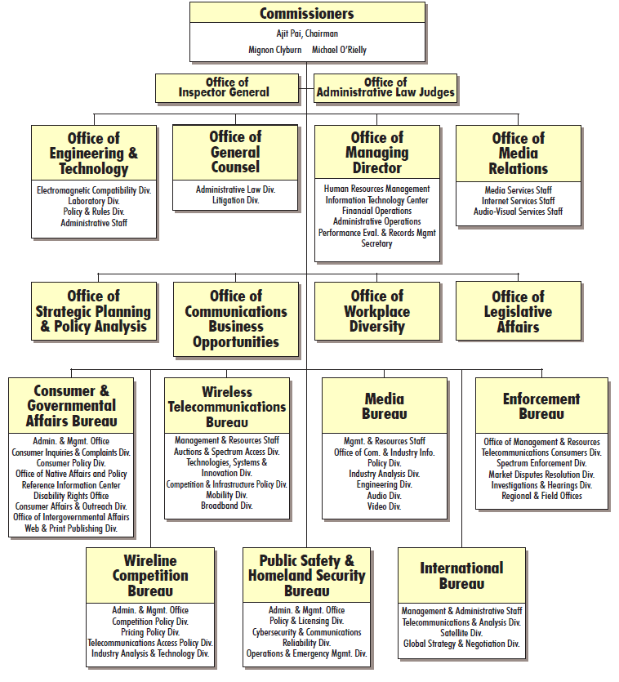

## Fiscal Year 2018 Proposed Appropriation Language

For necessary expenses of the Federal Communications Commission, as authorized by law, including uniforms and allowances therefor, as authorized by 5 U.S.C. 5901–5902; not to exceed $4,000 for official reception and representation expenses; purchase and hire of motor vehicles; special counsel fees; and services as authorized by 5 U.S.C. 3109, $322,035,000, to remain available until expended: *Provided*, That $322,035,000 of offsetting collections shall be assessed and collected pursuant to section 9 of title I of the Communications Act of 1934, shall be retained and used for necessary expenses and shall remain available until expended: *Provided further*, That the sum herein appropriated shall be reduced as such offsetting collections are received during fiscal year 2018 so as to result in a final fiscal year 2018 appropriation estimated at $0: *Provided further*, That any offsetting collections received in excess of $322,035,000 in fiscal year 2018 shall not be available for obligation: *Provided further*, That remaining offsetting collections from prior years collected in excess of the amount specified for collection in each such year and otherwise becoming available on October 1, 2017, shall not be available for obligation: *Provided further*, That, notwithstanding 47 U.S.C. 309(j)(8)(B), proceeds from the use of a competitive bidding system that may be retained and made available for obligation shall not exceed $111,150,000 for fiscal year 2018: *Provided further*, That, of the amount appropriated under this heading, not less than $11,020,000 shall be for the salaries and expenses of the Office of Inspector General.

## Legislative Proposals

The Administration is proposing legislative changes in the President’s FY 2018 Budget that pertain to the FCC. These proposals are designed to improve spectrum management and represent sound economic policy.

**Spectrum License Fee Authority**

To promote efficient use of the electromagnetic spectrum, the Administration proposes to provide the FCC with new authority to use other economic mechanisms, such as fees, as a spectrum management tool. The FCC would be authorized to set charges for unauctioned spectrum licenses based on spectrum-management principles. Fees would be phased in over time as part of an ongoing rulemaking process to determine the appropriate application and level for fees.

**Spectrum Auctions**

The Spectrum Pipeline Act of 2015 requires 30 MHz of spectrum to be reallocated from Federal use to non-Federal use or shared Federal and non-Federal use, or a combination thereof; requires the FCC to auction this spectrum by 2024; and extends the FCC’s auction authority only to allow auction of this spectrum. To facilitate this, the Act also authorizes the use of funds from the Spectrum Relocation Fund for research and development and planning activities by Federal entities that are expected to increase the probability of relocation from or sharing of Federal spectrum and that meet other requirements. The Budget proposes to require the auction of additional spectrum by 2027 and further extend the FCC’s auction authority solely to allow this auction to proceed. Auction proceeds are expected to reach $6.0 billion in 2027.

**Auction or Assign via Fee 1675-1680 Megahertz**

The Budget proposes that the FCC either auction or use fee authority to assign spectrum frequencies between 1675-1680 megahertz for flexible use by 2020, subject to sharing arrangements with Federal weather satellites. Currently, the spectrum is being used for radiosondes (weather balloons), weather satellite downlinks, and data broadcasts, and the band will also support future weather satellite operations. NOAA began transitioning radiosondes operations out of the band in 2016 as part of the Advanced Wireless Services 3 (AWS-3) relocation process. If this proposal is enacted, NOAA would establish limited protection zones for the remaining weather satellite downlinks and develop alternative data broadcast systems for users of its data products. Without this proposal, these frequencies are unlikely to be auctioned and repurposed to commercial use. The proposal is expected to raise $600 million in receipts over 10 years.

Summary of FYs 2016 - 2018 FTEs and Funding by Bureaus and Offices



The Commission is responsible for the overall management, oversight, and administration of the Universal Service Fund (USF), including all USF policy decisions. All USF related activities are currently funded by regulatory fees. The Universal Service Fund Activities and Costs section on pages 18 through 20 provides more details related to Commission’s USF activities and related costs.

## Fiscal Year 2018 FTEs Distribution by Strategic Goals



## Fiscal Years 2016 - 2017 FTEs Distribution by Strategic Goals



FTEs by Resource Category

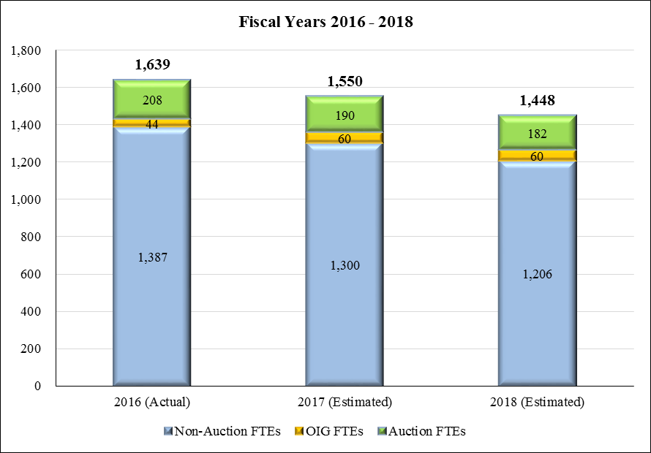

## Number of Contractors

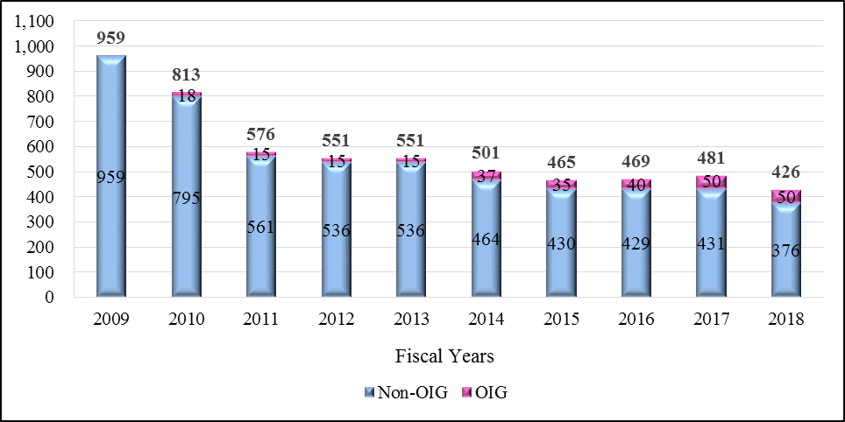

## FTEs - Historical and Estimated

Fiscal Years 1983 – 2018

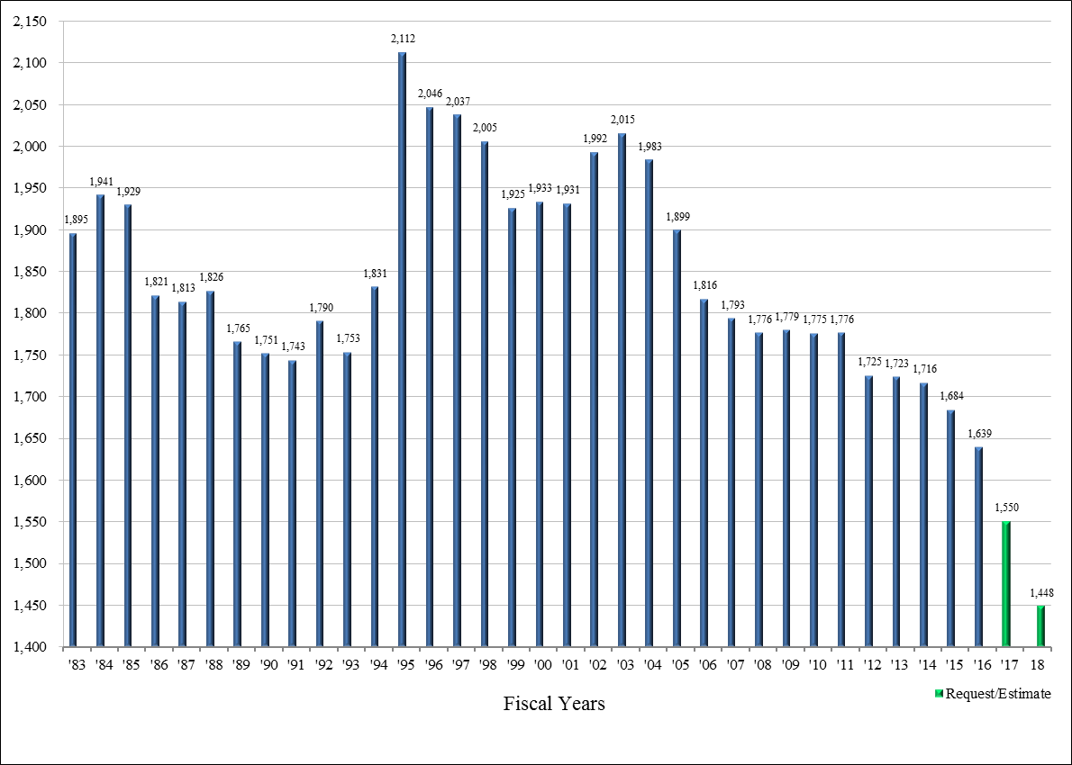

Summary of Changes - Regulatory Fees (Offsetting Collections)



## Narrative Explanation of Changes - Salaries and Expenses - Regulatory Fees

1. **Personnel Compensation and Benefits** – The request includes a decrease of over $13.8 million, which is a reduction of 94 non-auction FTEs from the FY 2017 estimated level of 1,300 to 1,206 FTEs for FY 2018.[3] This reduction in non-auction FTEs is a 7.2 percent reduction and is due to the assumption that the hiring freeze would be in effect through FY 2018.
2. **Other Reductions –** The request includes a decrease of $4 million in travel, rent, contract services, supplies and materials, and equipment.

**FCC Agency Reform Plan**

Develop and implement the FCC Agency Reform Plan to deliver on the needs of today and the future in a more proactive and efficient manner.

* Develop and implement reforms that focus the Commission on effectively and efficiently delivering programs that are the highest need to citizens and where there is a unique Federal role rather than assuming current programs are optimally designed or even needed.
* Maximize employee performance and strengthen the Commission by enabling and empowering front-line employees to deliver results, hold them accountable, and reward innovation and success.
* Collaborate with other agencies and use their lessons learned; leverage shared services opportunities.
* Leverage business management tools that provide real time access to relevant and reliable information for better decision making and overall improved performance.
* Use an enterprise systems management approach to increase economies of scale and reduce administrative costs.

**FCC IT Modernization Strategy**

The Federal Communications Commission is engaged in an effort to modernize the Commission’s Information Technology (IT) systems. The goal of this effort is to transform the services and tools offered by IT from costly legacy solutions to innovative, cloud-based solutions that lower costs and improve security and performance. FCC prioritizes IT spend according to impact, value, and efficiency gains by investing in modernization instead of maintaining the status quo.

The FCC has reduced its legacy spend by 35% via achieving technology wins, leveraging agile processes, and ultimately, reducing contract personnel. Since 2013, IT has accomplished two major milestones which translate in reducing steady state (operations & maintenance) spending from 85% to less than 50% of the IT budget. First, FCC has targeted and begun migrating legacy systems to Software-as-a-Service (SaaS) and Platform-as-a-Service (PaaS) cloud solutions. Second, IT physically moved government-owned legacy systems to a commercial cloud provider. Additionally, as part of this transformation, the security posture of the FCC has been dramatically improved, and reduced audit findings demonstrate the benefit of the investment in next-generation cloud-based security tools.

FY 2018 finds the FCC approaching the half-way point in its modernization journey. Efforts are focused on moving licensing systems to the cloud, supporting Mobility Fund II and Connect America Phase II efforts, modernizing the Equipment Authorization System, and completing the Broadcast Incentive Auction.

Recently completed modernization efforts include:

1. **Operation Server Lift**

FCC IT completed “Operation Server Lift” in September 2015. The move to the cloud and a commercial service provider reduced rack count from 90 to 72, lowering both physical footprint and operating costs. As a result, the Commission was able to avoid $9 million in hosting costs by performing the Server Lift in 2015 instead of waiting for the Commission headquarters move/restack effort in 2019-2020. The effort also provided the FCC a more accurate inventory of all the applications, unique configurations, and software in its environment, which has allowed for a more targeted technology modernization.

1. **FCC Consumer Helpdesk**

FCC IT delivered a cloud-based consumer helpdesk solution – instead of spending $3.2 million to internally build a new system over two years as originally quoted, the FCC spent $450,000 for a system that was ready to go in six months. Additionally, the new solution has annual operations costs of $100,000 in the cloud instead of an estimated annual cost of $640,000 to maintain the system on premises with FCC contract staff and government-owned equipment and software.

1. **Office365 and Virtual Desktop Infrastructure**

The FCC IT team completed a 100% migration of the Commission staff to the Microsoft Office 365 SaaS cloud environment as of August 2015. To improve accessibility and remote capabilities, the Commission implemented a Virtual Desktop Infrastructure (VDI) solution that supports nearly the entire FCC staff. The robust platforms have improved the ability for information sharing and collaboration and eliminated nearly a dozen legacy servers.

**Progress and Funding Challenges**

To date, the FCC has made good progress in the drive to modernize and migrate systems to the cloud. Challenges to the Commission’s progress include obtaining continued funding necessary to appropriately staff modernization teams and perform migration of legacy systems to cloud platforms. The FCC continues to pursue its goals towards 100% cloud services within the decade to best serve the American public and the FCC mission of ubiquitous communication for public safety, defense, education, health, commerce, and international competition.

**Office of Inspector General Narrative**

The Office of the Inspector General’s (OIG) workload continues to increase in the areas of audit and investigation and administration.  Currently OIG only takes on top-level investigation cases and high priority financial, information technology and program audits, inspections, and assessments.  The Office keeps focus on increasing mission responsibility and ensuring appropriate staff levels to keep pace with the workload.  The OIG Full Time Equivalent (FTE) staff has been increasing over the past few budget years and this influx has provided OIG more capability to maintain the mission of the OIG and assist with taking on more investigations and performing more audits.

The OIG FY 2018 budget request of $11,020,000 includes a reduction of $731,000 from the FY 2017 enacted level of $11,751,000.

OIG audits help FCC management identify internal control weaknesses and program risks, including fraud, waste and abuse, and recommend corrective actions to safeguard public funds and improve program outcomes. In addition to audits and assessments mandated by laws and regulations, Office of Audit (OA) plans include over 50 projects over the next five years. Those projects include audits, inspections, and assessments both FCC and Universal Service Fund Programs.  This equates to more than 10 audits per year not including any Congressional requests, special projects, and non-recurring mandates.

The OIG Office of Investigation (OI) has 85 open cases as of September 30, 2016.  OIG continues working with the Department of Justice (DOJ) and has recovered millions of dollars of government funds resulting from criminal and civil fraud cases referred to the DOJ.

In compliance with the IG Reform Act of 2008 this FCC OIG FY 2018 budget request includes:

* A fair share ratio in the amount of $26,000 for contribution to the Council of the Inspectors General on Integrity and Efficiency (CIGIE),
* Funds to support IGNet Management Services, and,
* Training funds in the amount of $82,000.

**Universal Service Fund Activities and Costs**

The Commission is responsible for the overall management, oversight, and administration of the Universal Service Fund (USF), including all USF policy decisions. During FY 2017, the FCC has asked the Universal Service Administrative Company (USAC), as administrator of the USF, to review its administrative expenses to find savings and also to review the effectiveness of its internal controls around USAC’s spending, procurement, information technology, and personnel processes. The FCC’s Chairman has publicly communicated to USAC his concerns about cost overruns and schedule delays surrounding the implementation of information technology supporting the E-rate program. Furthermore, the FCC is evaluating improvements to USAC’s collection and disbursement processes in an effort to improve the efficiency and effectiveness of the management of the USF funds. For additional information about how the FCC coordinates with USAC, below are descriptions of the USF oversight duties and responsibilities of the various Commission Bureaus and Offices that work closely together as an oversight team.

Office of Managing Director. The Office of Managing Director (OMD) is responsible for all USF management and administrative activities, including finance, accounting, procurement, information technology, and audits of beneficiaries and contributors. OMD provides instruction and oversight to the USAC on these issues.

Wireline Competition Bureau. The Wireline Competition Bureau (WCB) oversees USF policy and provides guidance on the applicability of the Commission’s USF rules, orders, and directives to USAC and to stakeholders. WCB also is primarily responsible for USF rulemaking proceedings, appeals of USAC decisions, requests for waivers of the Commission’s USF rules, petitions for USF declaratory rulings, interactions with the Federal-State Joint Board on Universal Service, and preparation and publication of USF information in the Universal Service Monitoring Report.

Wireless Telecommunications Bureau. The Wireless Telecommunications Bureau (WTB) oversees USF policy concerning the Mobility Fund, a universal service support mechanism dedicated exclusively to mobile services. WTB also oversees reverse auctions activity for the Mobility Fund and the Connect America Fund. The FCC has formed a Rural Broadband Auctions Task Force to implement upcoming USF-related auctions

Office of General Counsel. The Office of General Counsel (OGC) oversees issues relating to litigation and settlements of civil, criminal, or bankruptcy matters. OGC is also the lead contact on issues relating to the treatment and potential disclosure of confidential information and of other nonpublic information as defined in the Commission’s rules.

Enforcement Bureau. If USAC identifies a possible violation of the Communications Act or a Commission rule, order, or directive, it will refer the issue to the Enforcement Bureau (EB) for possible investigation and administrative enforcement action. EB also pursues potential investigations of USF related matters from other sources of information as well.

Office of Inspector General. The Office of Inspector General (OIG) conducts audits, evaluations, and inspections of USF program service providers and beneficiaries designed to prevent and detect fraud, waste, and abuse. Those oversight activities and related initiatives help promote economy, effectiveness, and efficiency of the USF.

**USF Activities**

On February 23, 2017, the Commission adopted rules for allocating nearly $2 billion, through a reverse auction, from the Connect America Fund, which aims to advance fixed broadband service to unserved and underserved areas across the country. Through the auction mechanism, the Commission will seek the best deal for the American people with the limited available funds.

Under Mobility Fund Phase II, the Commission’s goal is to ensure that all Americans have access to advanced wireless services. In order to solve this problem, the FCC adopted, on a bipartisan basis, a plan to bring 4G LTE service to millions of rural Americans who currently do not have it. Over ten years, the USF will spend over $4.5 billion to bring mobile broadband to unserved areas. This support will be distributed through a reverse auction, which ensures fiscal responsibility.

In the Lifeline program, the Commission’s goals are to: (1) continue implementation of the modernization of the Lifeline program to support affordable, high-speed Internet access for our nation’s poorest families; and (2) ensure fiscal responsibility and combat waste, fraud, and abuse so Lifeline USF dollars spent reach the consumers Lifeline was created to help. Actions to accomplish these goals include closing loopholes that let unscrupulous carriers exploit the Lifeline program.

In the E-rate program, the Commission is committed to solving recent problems with USAC’s application system that have negatively impacted the ability of schools and libraries to apply for and receive funding. The Commission will ensure that USAC remediates these problems and administers this program in a manner which is transparent and accountable.

Finally, under the Rural Healthcare program, the Commission remains committed to ensuring all Americans have access to advanced medicine and health care services no matter where they live.

The chart below shows the costs the Commission has incurred and paid by regulatory fees in overseeing the USF Fund activities, which includes costs incurred by the OIG.



## Overall Status of Audit Recommendations

The chart below shows the number of audit recommendations outstanding from various audits conducted by FCC’s Office of Inspector General (OIG) and the Government Accountability Office (GAO). The Commission reduced its total number of outstanding recommendations by 61 percent from September 30, 2015 to September 30, 2016.

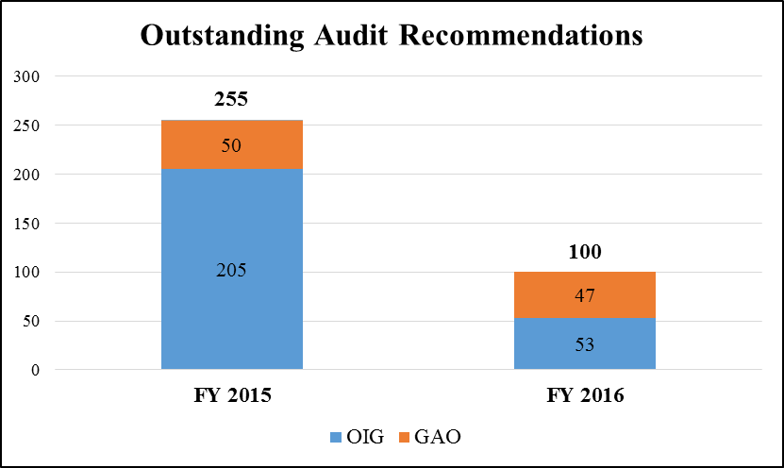

## Status of FCC Headquarters Move/Restack

The Commission’s current headquarters (HQ) lease for Portals II building at 445 12th Street SW, Washington, DC will expire in October 2017. In 2015 Congress approved a prospectus for a replacement lease for a 15-year term that would reduce our headquarters square footage by approximately 30 percent and lower the overall rental expense. It is estimated that the move will provide up to $119 million in total savings over the 15 years of the new lease.

Subsequently, the General Services Administration (GSA) conducted a competitive lease procurement and the current lessor filed pre-award protests with GSA, Government Accountability Office (GAO), and the Court of Federal Claims, all of which denied the lessor’s protests. In December 2016, GSA awarded a lease, which will require the Commission to move to a newly built facility in fiscal year 2019. Post award, the current lessor filed a protest with the United States Court of Appeals for the Federal Circuit, and the case remains pending a decision. Since the Commission cannot move to a new facility before the termination of the lease, GSA informed the Commission that the current lessor may want a 20% premium over the current rental rate, translating to an increase of approximately $9 million per year in lease costs. GSA is working on negotiating with the current lessor for a lease extension.

In FY 2016, Congress provided the funding for the first part of the headquarters move/restack. In FY 2017, Congress provided only S&E portion of the Commission’s remaining request of the funding necessary to complete the headquarters move/restack. Total funds provided for the headquarters move/restack is as follows:

|  |  |  |  |
| --- | --- | --- | --- |
|  | **Total** | **S&E (Reg. Fees)** | **Auctions** |
| Amount Provided in FY 2016 | **$51,358,497** | $44,168,497 | $7,190,000 |
| Amount Provided in FY 2017 | **$16,866,992** | $16,866,992 | $0 |
| **TOTAL** | **$68,225,489** | **$61,035,489** | **$7,190,000** |

In order for GSA to complete the final execution of the lease, we must send the majority of the FY 2016 funds to GSA to cover real property costs, such as design and drawings, construction, lessor’s management and inspection fees, GSA management fees, contingency and escalation.  The funds provided in FY 2017 will be used to fund our personal property costs, such as information technology (IT) and telecommunications, security, project management, furniture and the physical move. The first six months after the lease award is critical as the Commission will be required to meet design and construction timetables established by the GSA and the new lessor. The FCC is also required to provide the details related to specialized areas and requirements related to electrical, heating, air conditioning, floor loading, specialized construction and the equipment to support them.  The procurements necessary for the FCC to be able to provide the necessary information to GSA and the new lease holder are project management and acquisition support; change management; engineering and design services for IT, audio visual, communications, and special construction; space reduction strategies for records; long lead procurements for the IT infrastructure, communications and security; furniture; equipment; and move services.

## Crosswalk - Summary of Changes for Regulatory Fees



# SPECTRUM AUCTIONS

This page is intentionally left blank

## Spectrum Auctions Program - Explanation of Requested Change

The Federal Communications Commission is requesting $111,150,000 for the Spectrum Auctions Program for FY 2018, as shown below, in furtherance of making more spectrum available for commercial use; repacking and reimbursing broadcasters and multichannel video programming distributors (MVPDs) in order to clear contiguous spectrum in the ultra-high frequency band that will be repurposed as the 600 MHz Band; upgrading and improving auctions infrastructure in preparing for future auctions; continue implementing the Spectrum Pipeline Act of 2015, which includes promoting the use of 3.5 GHz band through auctions; and conducting additional spectrum auctions.



## Spectrum Auctions Program

The Omnibus Budget Reconciliation Act of 1993, P.L. 103-66, required the Commission to auction portions of the spectrum for certain services, replacing the former lottery process. The Commission is required to ensure that small businesses, women, minorities, and rural telephone companies have an opportunity to participate in the competitive bidding process. The Commission initiated regulations implementing the spectrum auction authority granted by the legislation and conducted its first round of auctions in July 1994. At the official date of the completion of the incentive auction on April 13, 2017, the Commission has completed 88 spectrum auctions and the total amount collected for broader government use and deficit reduction exceeds $114 billion. The original spectrum auction authority was scheduled to expire in FY 1998; however, it was extended through FY 2007 in the Balanced Budget Act of 1997, P.L. 105-33; extended through FY 2011 by the Deficit Reduction Act of 2005, P.L. 109-171; extended through FY 2012 by the DTV Delay Act (2012), P.L. 111-4; and extended through FY 2022, by the Middle Class Tax Relief and Job Creation Act of 2012, P.L. 112-96. Furthermore, the Commission’s authority to conduct auctions with respect to electromagnetic spectrum identified under section 1004(a) of the Spectrum Pipeline Act of 2015, which was included as Title X in the Bipartisan Budget Act of 2015, P.L. 114-74, does not expire until September 30, 2025.

The Commission is authorized to retain funds from auction revenues to develop, implement, and maintain the auctions program. These funds cover the personnel and administrative costs required to plan and execute spectrum auctions; operational costs to manage installment payments and collections activities; development, implementation, and maintenance of all information technology systems necessary for auctions operations, including development of a combinatorial bidding system; and a proportional share of the general administrative costs of the Commission. This budget submission assumes the auctions program will continue to recover the costs of conducting all auctions activities from spectrum license auction receipts as the Commission continues to use auctions as a licensing mechanism for spectrum-based communications services.

The FY 2017 Appropriations language capped the auctions program obligations at $117.0 million. The FCC request of $111.15 million for FY 2018 is a decrease of $5.85 million or 5 percent. While this amount reflects reductions related to the end of bidding in the incentive auction, funding at this level will enable the Commission to continue substantial post incentive auctions work related to repacking and reimbursing broadcasters and multichannel video programming distributors (MVPDs) for relocation costs; to upgrade and improve auctions infrastructure in preparation for future actions; and to continue implementing the Spectrum Pipeline Act of 2015 by, for example, taking the steps necessary to promote use of the 3.5 GHz band through auctions of certain licenses, and conducting additional spectrum auctions.

*Post Incentive Auctions Work*

Because of the complex, two-sided nature of the broadcast incentive auction, the Commission will need to engage in an unprecedented amount of post-auctions activity to fully and successfully complete follow-up auction implementation tasks. The results of the incentive auctions showed that 957 full-power and Class A broadcasters nationwide will be required to be relocated in order to create contiguous spectrum in the 600 MHz band that has been repurposed and auctioned for flexible wireless uses. Some secondary broadcast stations, low power, and TV translator stations will also be displaced and will have the opportunity to apply for alternative channels. The bidding concluded in the forward auction’s assignment phase on March 30, 2017, and the Media and Wireless Telecommunications Bureaus released the Auction Closing and Channel Reassignment Public Notice on April 13, 2017, which announced the completion of the incentive auction and publicly provided the results of the reverse auction, the forward auction and assignment phase, and the channel reassignments of television stations that will be required to change their channels during the 39-month relocation process that commenced as of the release of that Public Notice. The release of that Public Notice also started the licensing process for the winning bidders for the new flexible use wireless spectrum licenses.

The auction proceeds from the winning bidders of new spectrum licenses will be used to pay the winning broadcast bidders in the reverse auction and to reimburse full power and Class A broadcast stations and MVPDs for their eligible expenses incurred as a result of being involuntarily relocated to new channels as authorized by Congress in the Middle Class Tax Relief and Job Creation Act of 2012, P.L. 112-96. The following highlights many of the activities that will be taking place during the 39-month transition period. All of these activities will have started in FY 2017 and will continue at a high tempo through FY 2020, and the Commission estimates that the total resources needed for these activities will exceed the amount of resources used to design the auction and complete bidding.

* Wireless Licensing – Winning bidders must submit license applications and deposit the winning bid amounts with the Commission within four weeks after the close of the auction. The Commission will review the applications and make them available for public comment. After public comments are reviewed and any issues raised are resolved, the Commission will grant the wireless spectrum licenses. The Commission may grant these licenses on a rolling basis. Historically, some licenses have been granted in as little as two months while others may take one to two years as issues are resolved.
* Payments to Reverse Auction Winning Bidders – Broadcasters will be paid as funds become available after grants of wireless licenses. Broadcasters that are relinquishing their licenses will have 90 days to discontinue operations on their pre-auction channels while broadcasters that will be channel-sharing will have 180 days to discontinue operations on their pre-auction channels. Waivers may be requested to extend these deadlines. The Commission will issue a series of ‘ready to pay’ public notices to announce when specific broadcasters will be paid as the funds from the winning wireless spectrum bidders become available.
* Submission of Banking Information by Broadcasters and MVPDs – The Commission requires broadcasters that will be receiving payments for relinquishing their spectrum or for reimbursement of repacking expenses and MVPDs that will be receiving payments for reimbursement of expenses related to continued carriage of repacked stations to provide detailed banking information that is notarized on paper form and in a secure electronic system. The information will be reviewed by the Commission prior to making any payments. This process will start after the Closing and Channel Reassignment Public Notice is released.
* Licensing for Broadcasters Being Relocated – Broadcast licensing is performed in two steps: (1) application review and grant of a construction permit (CP) and (2) application review and grant of a license to cover. Broadcasters being relocated are required to file a construction permit application with the Commission that includes detailed technical parameters of their broadcast configuration. There will be three sequential windows in which broadcasters may submit their CPs to the Commission, depending on the broadcaster’s specific circumstances and needs. In addition, broadcasters may ask for waivers of some of the deadlines based on certain criteria. The Commission has adopted a phased transition process in which each station that is being repacked is assigned one of ten transition phases, each with a specific sequential testing period, at the end of which they must discontinue operations on their pre-auction channels. Consideration of all CPs and requests for waivers and applications to alter deadlines must be analyzed by staff for compliance with applicable rules and to determine the impact that granting such requests would have on the phased transition schedule. If applications filed during the window are mutually exclusive, certain priorities apply and applicants will be provided an opportunity to resolve remaining issues through settlement or technical solution. If they are unable to do so they will be resolved pursuant to the Commission’s competitive bidding rules. Including the consideration of processing waivers, the CP process is anticipated to take nine to twelve months. Additional waiver applications and requests for transition relief may be received outside of the three windows and after the anticipated processing period. Pursuant to Commission rules, all broadcasters must cease operation on their pre-auction channels no later than 39 months after the issuance of the Closing and Channel Reassignment Public Notice. After a broadcaster completes the construction of its new facilities, it will file an application with the Commission for its license.
* Reimbursements to MVPDs and Repacked Broadcasters – Congress established a TV Broadcaster Relocation Fund, not to exceed $1.75 billion, to reimburse broadcasters and MVPDs for their relocation expenses. The reimbursement process has two major components: (1) cost estimates and fund allocation and (2) invoice reimbursement processing. Broadcasters and MVPDs will have 90 days from the Closing and Channel Reassignment Public Notice to file their relocation cost estimates with the Commission. The Commission will review the cost estimates and issue a reimbursement allocation public notice announcing the initial amount of money that the eligible broadcasters and MVPDs will have available for reimbursement of their repacking expenses. After the allocations are announced, the Commission will review and pay approved invoices submitted by broadcasters and MVPDs. Entities are required to update their cost estimates if their plans for purchasing reimbursable equipment or services change. The Commission will announce one or more additional allocations during the transition period and subsequent allocations may be based on revised cost estimates. Prior to the end of the three-year reimbursement period, entities will provide information regarding their actual and remaining estimated costs and will be issued a final allocation, if appropriate, to cover the remainder of their eligible costs. The Commission has engaged an independent consulting firm, Ernst & Young, to assist in administering the TV Broadcaster Relocation Fund.
* Displaced LPTV (Low Powered Television) and TV Translators – After licensing for full power and Class A broadcasters being relocated in the three filing periods described above is substantially complete, the Commission will open a special filing window for operating LPTV and TV translator stations that are displaced by the reallocation of the television bands and the repacking. The displacement window is anticipated to open approximately seven to nine months after release of the Closing and Channel Reassignment Public Notice. Processing of applications is anticipated to take nine to twelve months. If applications filed during the window are mutually exclusive, certain priorities apply and applicants will be provided an opportunity to resolve remaining issues through settlement or technical solution. If they are unable to do so, they will be resolved pursuant to the Commission’s competitive bidding rules.
* Stakeholder Outreach – To minimize disruptions and ensure an orderly transition, the Commission will conduct necessary stakeholder and consumer communications, education, and outreach. These efforts include developing training materials for broadcast stations, MVPDs, wireless microphone operators, and unlicensed users affected by the transition, as well as consumer outreach efforts geared toward reaching affected Americans where they live and work. The Commission will also maintain a comprehensive website to serve as a single point of reference for all transition-related information.

*Spectrum Pipeline Act of 2015 and other Auction Program Improvements*

The Spectrum Pipeline Act of 2015 (Act) requires the Commission to auction 30 megahertz of spectrum identified by the Secretary of Commerce for reallocation from Federal use to non-Federal use, shared use, or a combination thereof. The Act also appropriates funds from the Spectrum Relocation Fund to support activities by Federal entities to improve the efficiency and effectiveness of Federal use of spectrum in order to make Federal spectrum available for non-Federal use, shared use, or a combination thereof, and requires the FCC, as part of its role on the Technical Panel, to review Federal entities’ proposals for funds for these purposes. Additionally, the Act also requires the Commission to submit four separate reports to Congress. By November 2018, the Commission must submit a report with an analysis of its new rules for the innovative Citizens Broadband Radio Service in the 3550-3650 MHz band, and a report analyzing proposals to promote and identify additional bands that can be shared and identify at least 1 gigahertz of spectrum between 6 GHz and 57 GHz for such use. By January 1, 2022, the Commission must submit a report, in coordination with the Assistant Secretary of Commerce for Communications and Information, which identifies at least 50 megahertz of spectrum below 6 GHz for potential auction. Finally, by January 2, 2024, the Commission must submit a report, in coordination with the Assistant Secretary of Commerce for Communications and Information, which identifies at least an additional 50 megahertz of additional spectrum below 6 gigahertz for potential auction. Both of these latter two reports must contain an assessment of the Federal operations in such spectrum, an estimated timeline for the competitive bidding process, and a proposed plan for balance between unlicensed and licensed use.

To fulfill these statutory requirements and enhance the Commission’s ability to execute upcoming auctions, auctions funding will be used for the following:

* Auctions Systems Replacement – The replacement of 10-year-old old backend database and software components that support the auction application set-up and management. Modernization of this system is critical to conform to current best practices, allow for modular builds, communicate with auction bidding systems and other Commission databases, and enable greater flexibility for future auction development. This modernization will support all future auctions.
* 3.5 GHz Auction Development and Implementation – These auctions will have a unique set of requirements, which includes auctioning more than 500,000 licenses every three years, at a minimum.
* Other Auction Development and Implementation – The Commission needs to make additional changes to the auction bidding system for other planned auctions that include an AWS-3 re-auction, millimeter wave auction(s), FM Auction 83, and FM Translators.
* Auction Security Enhancements – As recent news headlines have emphasized, the threat of cyber-attacks and security vulnerabilities are very real, and the Commission takes these threats and vulnerabilities very seriously. The FCC will proactively engage security engineers and architects to ensure the modernization of systems in the cloud are secure and adhere to Federal mandates and regulations to include two factor authentication. Making FCC auction systems resilient to cyber-attacks and mitigating security vulnerabilities will be a critical part of these efforts.

* SAS/ESC Testing for 3.5 GHz and Beyond – The Spectrum Access System (SAS)/Environmental Sensing Capability (ESC) are necessary components to share additional spectrum, and are necessary to protect incumbent Federal operations. These systems will first be launched for the 3.5 GHz band, and may have additional applications in the future. Because the systems will work as a dynamic frequency coordinator for millions of devices, we need to ensure they operate properly and consistently with our rules prior to approval.
* Optimization for New Spectrum Opportunities – The optimization team will help us analyze and study options for making new spectrum available, including through sharing scenarios, to ensure we are maximizing the amount of useful commercial spectrum. They will develop optimal band plans accommodating incumbent uses and demonstrate the value of additional clearing or sharing as necessary.
* Spectrum Visualization Tools – Public Facing and Internal – The public has a significant interest in understanding who has the rights to different spectrum bands at different locations, and desires the ability to manipulate and analyze this data. Federal agencies would also benefit from this information as they consider sharing/relocation options. Additionally, it is critical for internal teams to have robust data, including mapping, to understand coverage and operations across the country.
* Integrated Spectrum Auctions System (ISAS) Enhancement/Modifications – It is necessary to modify the application forms for participation in each auction in response to the auction’s unique requirements. This work will provide additional modernization of the primary auctions application via the ability to customize the form to support each auction.
* Auction Warehouse – The Commission will create a persistent data warehouse where it will host the vast amounts of data generated from each auction. Keeping the data over time will help as both a reference and a tool to continue to improve the auctions and bidding systems.

The Balanced Budget Act of 1997, P.L. 105-33, required that the Commission provide to authorizing committees a detailed report of obligations in support of the auctions program for each fiscal year of operation, as a prerequisite to the continued use of auctions receipts for the costs of all auctions activities. As required by the law, each year the FCC provides the spectrum auctions expenditures report for the preceding fiscal year to Congress by the statutory deadline of September 30 of the following fiscal year. The following table shows available auction cash for the respective fiscal years.

## Spectrum Auctions Activities



## Summary of Distribution of Resources - Spectrum Auctions Program

**SPECTRUM AUCTIONS COST RECOVERY REIMBURSABLE AUTHORITY**

**INCLUDING OFFICE OF INSPECTOR GENERAL**



## Spectrum Auctions Expenditures Report

Section 309(j) of the Communications Act permits the Commission to utilize funds raised from auctions to fund auction purchases, including contracts for services, and personnel performing work in support of Commission auctions authorized under that section. The FCC’s Office of General Counsel (OGC) and Office of Managing Director (OMD) provide direction to FCC employees attributing hours for this purpose. The House of Representatives and Senate Appropriations Committees review and set a yearly cap for the spectrum auctions program. The requested cap level for FY 2018 is $111,150,000 in furtherance of making more spectrum available for commercial use; to continue the post incentive auctions work; to upgrade and improve auctions infrastructure in preparation for future actions; and to continue implementation of the Spectrum Pipeline Act of 2015. The FY 2018 request is a decrease of $5,850,000 or 5 percent, from the FY 2017 enacted cap level of $117,000,000.

The Commission’s spectrum auctions program expenditures support efficient licensing while also contributing significant funds to the U.S. Treasury for deficit reduction and providing direct support to other broader government programs. In particular, in the Middle Class Tax Relief and Job Creation Act of 2012, Congress directed that proceeds from certain spectrum auctions, including auctions of licenses covering spectrum offered in the H-Block, AWS-3, and the broadcast incentive auction, fund certain public safety related programs and contribute to deficit reduction. Specifically, Congress directed that the net proceeds from these auctions be distributed as follows: $135 million for a state and local First Responder Network Authority (FirstNet) implementation fund; $7 billion for FirstNet build out; $115 million for 911, E911, and NG911 implementation; $300 million for public safety research; and $20.4 billion plus any additional proceeds for deficit reduction.

As of September 30, 2016, the FCC has transferred $39.8 billion from the H-Block and AWS-3 auctions to satisfy all the distribution requirements as directed by Congress in the Middle Class Tax Relief and Job Creation Act of 2012. Of this total, in FY 2016, the Commission transferred $8.4 billion to the Public Safety Trust Fund. This amount includes $328.9 million for deficit reduction above and beyond the initial $20.4 billion initially mandated by Congress in the Middle Class Tax Relief and Job Creation Act of 2012.

At the conclusion of the incentive auctions on April 13, 2017, the Commission had raised over $114 billion in auctions revenues since initiating the auctions program in 1994. During this period, the auctions program expenses have been less than two percent of the Commission’s total auctions revenues. The Commission operated the auctions program for nine years at $85 million without any increase in funding, including increases for inflation, only receiving increases in FYs 2013 through 2017 to fund the implementation costs for the incentive auctions and Spectrum Pipeline Act of 2015, and to fund the necessary expenses associated with headquarters move to a new facility or reconfiguring the existing space in FY 2016.

Spectrum auctions activities are performed agency-wide and are very information technology (IT) intensive, as reflected in our Spectrum Auctions Expenditures Reports, which are provided to Congress on an annual basis. For example, the Incentive Auctions team is composed of staff from across the Commission, including the Wireless Telecommunications Bureau, Media Bureau, International Bureau, Office of Engineering and Technology, Office of the Managing Director, and Office of General Counsel. Auctions funds also cover the program’s share of Commission operating expenses. The Commission uses these funds to enable successful auctions and expends them in a manner consistent with that objective.

Every auction is different and unique with very specific requirements, which require careful attention to detail and planning. Since auctions activities are performed agency-wide and are unique, allocating appropriate amount of cost and overhead related to the auctions program is a challenge. In addition, the complexity of spectrum auctions has increased steadily as the Commission works through more difficult technical and policy issues, and spectrum auctions generally require long lead times to design, develop, and implement secure, reliable, and effective auction application, bidding, and post-auction licensing systems.

In the practice of cost accounting, costs are identified as one of the following: (1) direct cost, (2) indirect cost, or (3) generally allocated cost. The methodology for deriving the proportional share of generally allocated administrative costs to be charged to the auctions program is based on the Commission’s time reporting system and Generally Accepted Accounting Principles.  The allocation is based on the percentage of actual hours that employees worked to support the auction program plus the same proportional share of the employee’s indirect hours (leave hours). This full time equivalent (FTE) rate is applied to costs that benefit the Commission as a whole.  These items that are allocated by the FTE rate include Commission-wide information technology systems, guard service, administrative facility services, supplies, furniture, equipment, and human resources training activities.  The FCC has maintained an average of 14 percent for this purpose, with minor deviations.

After years of planning with all the rules in place, and at the direction of Congress, the Commission concluded the final bidding phase of the historic broadcast incentive auction. The incentive auction makes available 84 megahertz of low-band spectrum for commercial and unlicensed wireless use by repurposing a portion of the broadcast TV bands for wireless use.  The auction that began on March 29, 2016, ended on March 30, 2017. The total net winning bids of $19.3 billion from this first-ever incentive auction put it in second place among all Commission auctions in terms of the amount of total winning bids. Approximately $6.5 billion will be transferred to the General Fund of the U.S. Treasury for deficit reduction.

The Commission’s primary auctions focus in FY 2018 is to carry on its responsibilities related to the post incentive auction activities. This includes disbursing $1.75 billion to broadcasters and MVPDs and relocating 957 broadcasters and planning to provide with minimum disruption to the viewing public. The Commission must also carry out its responsibilities to consider the relocation of potentially hundreds of LPTV and TV translator stations that are displaced by the reallocation of the television bands and repacking. The “repacking” process” began on April 13, 2017, with the release of the Closing and Channel Reassignment Public Notice, and will continue for 39 months. Repacking involves reorganizing and assigning channels to the remaining broadcast television stations in order to create contiguous blocks of cleared spectrum suitable for flexible wireless use. The scope of the repacking component of this auction makes it uniquely, computationally complex challenge that will require substantial resources and engagement from the Commission over the next four years. The task mandates that the Commission manage and organize every station’s transition in a manner that respects the constraints imposed by linked-station sets - that is, a set of two or more stations with interference relationships and dependencies - as well as accounting for limited resources available to accomplish transition-related work. Active oversight of the multi-year process will require substantial Commission staff resources to coordinate with broadcasters, vendors involved in transition tasks, and other government and regulatory agencies, including at the federal, state, and local level and with international regulatory partners in the U.S. - Canada and U.S. - Mexico border zone regions. It will require Commission staff to monitor broadcaster progress, identify and resolve transition-related problems and challenges that could endanger the transition schedule, process applications, and review and verify information. Accomplishing the transition will require additional software, cloud computing resources, and assistance from skilled computer scientists, software engineers, and technology security experts. It also requires an administrator, overseen by Commission staff, to manage the reimbursement of $1.75 billion to the qualified relocating broadcasters to minimize fraud.

In planning for the post-auction transition, the Commission is focused on communications, education, and outreach efforts to all stakeholders. The Media Bureau and Incentive Auction Task Force are developing training materials for broadcast stations, MVPDs, wireless microphone operators, and unlicensed users affected by the transition. Additionally, the Consumer and Governmental Affairs Bureau is preparing an extensive consumer outreach effort geared toward reaching affected Americans where they live and work, including public service announcement-style videos, scripts, and troubleshooting guides for our consumer call center staff; an updated Consumer Q&A; and updated Consumer Guides. Wherever possible we want to make these materials available in multiple languages. The Commission is also developing, and will maintain and update throughout the transition, a comprehensive “Post-Auction Transition” website that will serve as a single point of reference for all transition information for stakeholders and consumers.

In addition, the Commission continues to plan for future auctions, including the re-auction of certain AWS-3 licenses; the auction of a number of FM translator allocations that will be paired with full-power AM stations, and possibly full-power FM stations; a potential auction of unsold 600 MHz licenses from the broadcast incentive auction; and the creation of a new auction for Citizens Broadband Radio Service (CBRS) licenses.  The CBRS auctions will involve over 500,000 licenses and will take place every three years, at a minimum.  The Commission is also working to update and modernize its overall auctions system to be prepared to quickly hold new auctions when additional spectrum that could be made available is identified.

The actual and estimated FTE levels for the spectrum auctions program for FYs 2016 through 2018 are shown on page 13. At the end of the Spectrum Auctions section is a crosswalk showing how spectrum auctions program funds will be utilized in FY 2018.

The following two schedules provides some details of the spectrum auctions held since its inception in 1994. These schedules also provide some perspective into how much money was collected for the U.S. Treasury or for broader government use and the total cost in running the Commission’s spectrum auctions program.

## Spectrum Auctions and Collections

Fiscal Years 1994 through Aprill 24, 2017

As of April 24, 2017



## Spectrum Auctions Program – Collections vs. Expenditures

Fiscal Years 1994 through April 24, 2017

(Dollars in Millions)



## Crosswalk - Summary of Changes for Spectrum Auctions Program



This page is intentionally left blank

# ECONOMY ACT REIMBURSABLE AGREEMENTS

The Economy Act provides authority for Federal agencies to order goods and services from other Federal agencies and be reimbursed for costs of those goods and services. An interagency agreement is an arrangement in which one agency (Servicing Agency) provides goods or services to another agency (Requesting Agency) and receives reimbursement of costs incurred. Agencies can use interagency agreements to conduct a wide variety of operations. Interagency agreements can be routine in nature, involving the acquisition of goods or services necessary to maintain agency operations or support a specific program.

As the servicing agency, the Commission earned approximately $0.6 million in Economy Act Reimbursable Agreements with other Federal agencies in FY 2016.  The Commission estimates that in FYs 2017 and 2018, interagency reimbursable agreement revenues will total approximately $4 million for each fiscal year.

This page is intentionally left blank

# FEE COLLECTIONS

This page is intentionally left blank

## Regulatory Fees

The Omnibus Budget Reconciliation Act of 1993, P.L. 103-66, requires that the Commission annually collect fees and retain them for Commission use in order to offset certain costs incurred by the Commission.

The fees collected are intended to recover the costs attributable to the Commission’s enforcement, policy and rulemaking, user information services, and international regulatory activities.

The fees, often referred to as Section 9 fees, apply to the current holder of the license as of a specific date and to other entities (e.g., cable television systems) which benefit from Commission regulatory activities not directly associated with its licensing or application processing functions.

The regulatory fees do not apply to governmental entities, amateur radio operator licensees, nonprofit entities holding tax exempt status under section 501(c) of the Internal Revenue code, 26 U.S.C. § 501, and certain other non-commercial entities.

The provisions of this law, codified at 47 U.S.C. § 159, give the Commission authority to review the regulatory fees and to adjust the fees to reflect changes in its appropriation from year to year. It may also add, delete or reclassify services under certain circumstances. Additionally, the legislation requires the Commission to charge a 25% late payment penalty and to dismiss applications or revoke licenses for non-payment of the fees, although it may waive, reduce, or defer payment of a fee for good cause.

The Commission implemented the Regulatory Fee Collection Program by rulemaking on July 18, 1994.  The most recent fee schedule became effective on September 1, 2016, pursuant to an order adopted and released by the Commission on September 1, 2016.

## Availability of Regulatory Fees

Appropriations language for FY 2017 prohibits the Commission from using any excess offsetting collections received in FY 2017 or any prior years. The Commission proposed the same treatment of excess collections in its FY 2018 budget request. As of September 2016, the Commission has collected just over $102.6 million in excess regulatory fees in total, including prior years.

The Commission receives an annual Salaries and Expenses appropriation. On March 1, 2013, the Office of Management and Budget (OMB) issued a report to Congress on sequestration for FY 2013. For the FCC, this translated into a $17 million reduction in new budgetary authority. The sequestered amount is currently maintained in offsetting collections and the availability of this fund is subject to appropriation authority.

The FY 2018 request reduced regulatory fees to the $322 million level, which is a decrease of $34.7 or -9.7 percent million from FY 2017 enacted level of $356.7 million. The FY 2017 enacted level includes $16.9 million for the necessary expenses associated with moving the FCC headquarters to a new facility or reconfiguring the existing space to significantly reduce space consumption. These regulatory fee levels will support Commission-wide goals that will allow the Commission to serve the American public in an efficient, effective, and responsive manner.  The distribution of budget authority between direct and offsetting collections from regulatory fees is illustrated in the following graph.

## Historical Distribution of Appropriated Budget Authority – Regulatory Fees

The following graph depicts the historical distribution of appropriated budget authority since Fiscal Year 2000.



## Historical Appropriated Budget Authority – Spectrum Auctions Program

The following graph depicts the historical appropriated budget authority for the spectrum auctions program since fiscal year 2000.



Application Processing Fees

Since FY 1987, the Commission has collected and deposited application processing fees, often referred to as Section 8 fees, into the General Fund of the U.S. Treasury. These fees are intended to recover a substantial portion of the costs of the Commission’s application processing functions. The program encompasses over 300 different fees, with the vast majority collected at the time an original license application, renewal, or request for modification is filed with the Commission. Most fees are assessed as a one-time charge on a per-application basis, although there are certain exceptions.

Government, nonprofit, non-commercial broadcast, and amateur license applicants are exempt from the fees. A commercial bank is used to collect the fees, with all fees deposited into the General Fund of the U.S. Treasury. Once deposited, these fees are generally not refundable regardless of the outcome of the application process. The Commission must review and revise the fees every two years based upon changes to the Consumer Price Index (CPI).  The most recent Order increasing application fees to reflect changes in the CPI index was adopted by the Commission on July 6, 2016, and released on July 7, 2016. This adjustment complies with the statutory formula set forth in Section 8(b). Application Processing Fee Collections (Section 8) and Regulatory Fee collections are summarized in the following graph.



# PERFORMANCE PLAN

This page is intentionally left blank

**PERFORMANCE PLAN**

**Mission**

As specified in section 1 of the Communications Act of 1934, as amended, the Federal Communications Commission’s (FCC or Commission) mission is to “make available, so far as possible, to all the people of the United States, without discrimination on the basis of race, color, religion, national origin, or sex, rapid, efficient, Nation-wide, and world-wide wire and radio communication service with adequate facilities at reasonable charges.” [4] In addition, section 1 provides that the Commission was created “for the purpose of the national defense” and “for the purpose of promoting safety of life and property through the use of wire and radio communications.”[5]

**Vision Statement**

The FCC’s vision is to develop a regulatory environment to encourage the private sector to build, maintain, and upgrade next-generation networks so that the benefits of advanced communications services are available to all Americans.   The FCC will work to foster a competitive, dynamic and innovative market for communications services through policies that promote the introduction of new technologies and services and ensure that Commission actions promote entrepreneurship and remove barriers to entry and investment.  The Commission will also strive to develop policiesthat promote the public interest, improve the quality of communications services available to those with disabilities, and protect public safety.

**About the Federal Communications Commission**

The FCC is an independent regulatory agency of the United States Government. The FCC is charged with regulating interstate and international communications by radio, television, wire, satellite, and cable. The Commission also regulates telecommunications and advanced communication services and video programming for people with disabilities, as set forth in various sections of the Communications Act.

The FCC is directed by five Commissioners appointed by the President and confirmed by the Senate for five-year terms, except when filling the unexpired term of a previous Commissioner. Only three Commissioners can be from the same political party at any given time. The President designates one of the Commissioners to serve as Chairman.

The FCC is organized by function. There are seven Bureaus and ten Offices. The Bureaus and the Office of Engineering and Technology process applications for licenses to operate facilities and provide communications services; analyze complaints from consumers and other licensees; conduct investigations; develop and implement regulatory programs; and organize and participate in hearings and workshops. Generally, the Offices provide specialized support services. The Bureaus and Offices are:

* **The Consumer & Governmental Affairs Bureau** develops and implements consumer policies, including disability access and policies affecting Tribal nations. The Bureau serves as the public face of the Commission through outreach and education, as well as responding to consumer inquiries and complaints. The Bureau also maintains collaborative partnerships with state, local, and tribal governments in such critical areas as emergency preparedness and implementation of new technologies.
* **The Enforcement Bureau** enforces the Communications Act and the FCC’s rules. It protects consumers, ensures efficient use of spectrum, furthers public safety, promotes competition, and protects the integrity of FCC programs and activities from fraud, waste, and abuse.
* **The International Bureau** administers the FCC’s international telecommunications and satellite programs and policies, including licensing and regulatory functions. The Bureau promotes pro-competitive policies abroad, coordinating the FCC’s global spectrum activities and advocating U.S. interests in international communications and competition. The Bureau works to promote a high-quality, reliable, globally interconnected, and interoperable communications infrastructure.
* **The Media Bureau** recommends, develops, and administers the policy and licensing programs relating to electronic media, including broadcast, cable, and satellite television in the United States and its territories.
* **The Public Safety & Homeland Security Bureau** develops andimplements policies and programs to strengthen public safety communications capabilities that assist the public, first responders, the communications industry, and all levels of government in preparing for and responding to emergencies and major disasters.
* **The Wireless Telecommunications Bureau** is responsible for wireless telecommunications programs and policies in the United States and its territories, including licensing and regulatory functions. Wireless communications services include cellular, paging, personal communications, and other radio services used by businesses and private citizens. The Bureau also conducts auctions of spectrum licenses.
* **The Wireline Competition Bureau** develops and recommends policies and licensing programs for wireline telecommunications, including telephone landlines, and fixed (as opposed to mobile) broadband, striving to promote the widespread development and availability of these services as well as more options for consumers. The Bureau has particular responsibility for the Universal Service Fund, a public-private partnership that helps connect all Americans to communications networks.

* **The Office of Administrative Law Judges** is composed of one judge (and associated staff) who presides over hearings and issues decisions on matters referred by the FCC.
* **The Office of Communications Business Opportunities** promotes competition and innovation in the provision and ownership of telecommunications services by supporting opportunities for small businesses as well as women and minority-owned communications businesses.
* **The Office of Engineering and Technology** advises the FCC on technical and engineering matters. This Office develops and administers FCC decisions regarding spectrum allocations and grants equipment authorizations and experimental licenses.
* **The Office of the General Counsel** serves as the FCC’s chief legal advisor.
* **The Office of the Inspector General** conducts and supervises audits and investigations relating to FCC programs and operations.
* T**he Office of Legislative Affairs** serves as the liaison between the FCC and Congress, as well as other Federal agencies.
* **The Office of the Managing Director** administers and manages the FCC.
* **The Office of Media Relations** informs the media of FCC decisions and serves as the FCC’s main point of contact with the media.
* **The Office of Strategic Planning and Policy Analysis** works with the Chairman, Commissioners, Bureaus, and Offices in strategic planning and policy development for the agency. It also provides research, advice, and analysis of complex, novel, and non-traditional economic and technological communications issues.
* **The Office of Workplace Diversity** ensures that the FCC provides employment opportunities for all persons regardless of race, color, sex, national origin, religion, age, disability, or sexual preference.

**Strategic Goals**

The FCC is responsible to Congress and the American people for ensuring a vibrant competitive marketplace driven by principles and policies that create an environment for innovation, investment, better products and services for consumers, lower prices, more job creation, and faster economic growth. The FCC must also provide leadership to assure that the communications needs of public safety officials are met; promote the universal availability and deployment of broadband and telecommunications services; make communications services accessible to all people; and protect and empower consumers in the communications marketplace. For FY 2018, the Commission revised its strategic goals to reflect the focus of effort and resources on the broadband network revolution that is affecting our commerce and culture. The Commission’s revised strategic goals are:

1. Closing the Digital Divide
2. Promoting Innovation
3. Protecting Consumers & Public Safety
4. Reforming the FCC’s Processes

**What the FCC Commits to Accomplish in FY 2018**

In implementing its strategic goals, the FCC identified four (4) strategic objectives. Each objective has associated performance goals and targets.

***Closing the Digital Divide***

***Strategic Objective 1.1:*** Create an environment that encourages the private sector to deploy broadband in all parts of the country, including hard-to-serve areas, and reduce the digital divide across America.

***Performance Goals and Targets:***

1.1.1 Adopt rules that promote facilities-based competition among wireless, satellite, and wireline voice, mobile and fixed data service providers, for domestic and international services.

1.1.2 Ensure that the broadband networks are built and available to all American consumers, regardless of race, gender, religion, sexual orientation, geography or other factors.

***Strategic Objective 1.2:*** Develop a flexible approach that will modernize, reform, and simplify the Universal Service Fund programs to facilitate affordable broadband deployment, reduce and remove regulatory burdens and barriers to infrastructure investment and provide opportunities for innovation in broadband services and technologies.

***Performance Goals and Targets:***

1.2.1 Implement USF reverse auctions that use market-based funding mechanisms that are grounded in sound economics, so as to efficiently support broadband deployment where it is most needed.

1.2.2 Remove regulatory barriers to broadband deployment so as to decrease the cost and expedite the construction of next-generation networks.

***Strategic Objective 1.3:*** Ensure that effective policies utilizing basic principles of economics are in place to promote entrepreneurship and expand economic opportunity to reduce the digital divide and bring the benefits of the digital age to all Americans.

***Performance Goals and Targets:***

1.3.1 Coordinate with industry, state and local regulators, consumers and community organizations to develop recommendations and model codes for accelerating broadband deployment.

1.3.2 Foster an environment that will encourage participation in broadband markets by new and non-traditional participants.

***Strategic Objective 1.4:*** Develop and implement flexible, market-oriented policies related to the assignment and use of spectrum, to reduce the digital divide, create incentives for providers to connect consumers in hard-to-serve areas, meet consumer demand for mobile connectivity, and bring the benefits of communications services to all Americans.

***Performance Goals and Targets:***

1.4.1 Pursue spectrum allocation and license assignment policies to achieve the effective and efficient use of spectrum by encouraging facilities-based competition, embracing a flexible use policy for spectrum and freeing up spectrum for mobile broadband.

1.4.2 Continue post-incentive auction repacking and reimbursement efforts for broadcasters.

1.4.3 Conduct effective and timely spectrum licensing and equipment authorization activities.

1.4.4 Employ effective and efficient means, such as reverse auctions, to facilitate broadband deployment and access.

***Strategic Objective 1.5:*** Develop a light-touch regulatory approach backed by long-standing principles of competition law to maximize the availability of broadband to all - including those in rural areas and Tribal lands, and individuals with disabilities.

***Performance Goals and Targets:***

1.5.1 Create a flexible and accessible environment that will facilitate the investment in and development, deployment, and adoption of 5G networks and the services they will support.

1.5.2 Create incentives for deployment of broadband and ensure that these benefits are made available and accessible to Americans with disabilities.

***Promoting Innovation***

***Strategic Objective 2.1:*** Remove barriers to innovation and investment, ensure flexibility in the decision making process, and advance the networks of the future and innovative new products and services that take advantage of those networks.

***Performance Goals and Targets:***

2.1.1 Implement actions to allow television broadcasters to innovate, leverage the power of the Internet, and fully enter the digital era.

2.1.2 Ensure a competitive and vibrant unlicensed ecosystem that fosters innovation and promotes the efficient use of spectrum.

2.1.3 Expedite processes to allow new services and devices to come to market.

***Strategic Objective 2.2:*** Take targeted action to address real problems in the marketplace instead of imposing broad, preemptive regulations to address hypothetical harms.

***Performance Goals and Targets:***

2.2.1 Consider actions that promote a flexible approach to oversight and foster investment in 5G networks. Decisions will be fact-based, relying on economic analysis, ongoing fact-gathering initiatives and data analysis.

2.2.2 Eliminate unnecessary administrative burdens to promote investment in infrastructure and 5G networks.

2.2.3 Work to promote a high-quality, globally interconnected communications infrastructure through international telecommunications and satellite programs and policies.

2.2.4 Continue AM radio revitalization efforts as vital part of the nation’s communications infrastructure.

***Protecting Consumers and Public Safety***

***Strategic Objective 3.1:*** Develop and implement an aggressive consumer agenda and improve communications services for all Americans, including those with disabilities who are deaf and hard of hearing.

***Performance Goals and Targets:***

3.1.1 Implement proposals to target and eliminate unlawful robocalling.

3.1.2 Improve the quality of Video Relay Services to make them more functionally equivalent to voice services available to hearing individuals.

***Strategic Objective 3.2:*** Develop and implement policies and procedures that will support the ability of first responders, including law enforcement, to strengthen public safety.

***Performance Goals and Targets:***

3.2.1 Develop reforms to combat the use of contraband cellphones in correctional facilities.

3.2.2 Take short-term public safety action, such as emergency waivers, to aid law enforcement efforts to identify perpetrators of violent threats to the public.

***Strategic Objective 3.3:*** Develop and implement policies that will improve public safety across the country and advance access to public safety communications using a broad range of technology.

***Performance Goals and Targets:***

3.3.1 Improve consumer access to reliable and available 911 services everywhere.

3.3.2 Implement and enforce policies to promote the nationwide availability of reliable and effective 911, Enhanced 911 (E911), and Next Generation 911 (NG911) service.

3.3.3 During a crisis, work closely with state and federal partners to provide situational awareness data.

3.3.4 Strengthen access to emergency services and support improved preparedness, reliability of communications networks, and disaster management practices.

***Reforming the FCC’s Processes***

***Strategic Objective 4.1:*** Improve the efficiency, effectiveness, and transparency of the FCC’s operations in serving the American public.

***Performance Goals and Targets:***

4.1.1 Develop and post information online to provide the public information about the status of matters pending before the FCC.

4.1.2 Implement and enforce a regulatory reform agenda guided by the principles of Executive Order 13771 of January 30, 2017 (Reducing Regulation and Controlling Regulatory Costs).

***Strategic Objective 4.2:*** Effectively manage and modernize the FCC’s information technology, financial, record keeping, facilities and human capital resources to best achieve the FCC’s mission.

***Performance Goals and Targets:***

4.2.1 Improve Commission systems to make information readily available to agency management for decision making.

4.2.2 Upgrade and enhance technology and tools used by Commission staff to carry out the agency’s mission.

4.2.3 Provide FCC staff with a secure digital infrastructure and maintain a high level of cybersecurity readiness and presence.

4.2.4 Conduct a program of continuous review and evaluation to assure that all financial operations are helping control or contain costs, providing high quality customer service, and improving the effectiveness and efficiency of Commission operations.

4.2.5 Develop workforce recruitment initiatives to expand the role of economics and engineering at the FCC.

***Strategic Objective 4.3:*** Continuously review the FCC’s regulatory and operational processes and significant regulations to achieve statutory objectives, while reducing burdens on industry and promoting innovation and job growth.

***Performance Goals and Targets:***

4.3.1 Using effective cost-benefit analysis, review existing regulations within the FCC’s program areas and eliminate those regulations that do not produce a net benefit. Similarly, use cost-benefit analysis to ensure that new regulations are necessary, and that they produce a net benefit.

4.3.2 Using effective cost-benefit analysis, review the Commission’s information collection processes and eliminate unnecessary and duplicative reports and related filing requirements.

4.3.3 For each program objective, provide timely and accurate legal advice and representation regarding proposed and existing policies and rules within the FCC’s purview, and ensure that the Commission adheres to all legal requirements in its operations.

***Strategic Objective 4.4:*** Ensure that universal service fund programs are well managed, efficient and fiscally responsible and reduce waste, fraud and abuse.

***Performance Goals and Targets:***

4.4.1 Reduce the potential for waste, fraud and abuse in the USF programs.

4.4.2 Review the administration costs of the USF programs to ensure that the programs are administered efficiently and effectively.

This page is intentionally left blank

# FISCAL YEAR 2018 REQUIREMENTS BY BUREAUS AND OFFICES

This page is intentionally left blank

## Offices of the Chairman and Commissioners



The FCC is directed by five Commissioners who are appointed by the President and confirmed by the Senate for five-year terms, except when filling an unexpired term. The President designates one of the Commissioners to serve as the Chairman. Only three Commissioners may be members of the same political party. None of them can have a financial interest in any Commission-related business.

The Chairman serves as the Chief Executive Officer of the Commission, supervising all FCC activities, delegating responsibilities to Offices and Bureaus, and formally representing the Commission before the Congress and the Administration.

## Consumer and Governmental Affairs Bureau



The Consumer and Governmental Affairs Bureau (Bureau) develops and administers the Commission’s consumer and inter-governmental affairs policies and initiatives to enhance the public’s understanding of the Commission’s work and to facilitate the Agency’s relationships with other governmental agencies and organizations. The Bureau advises and recommends to the Commission, or acts for the Commission under delegated authority, regarding consumer and disability policy and governmental affairs. The Bureau serves as the public face of the Commission and maintains collaborative partnerships with state, local, and Tribal governments. The Bureau performs the following duties and responsibilities:

* Initiating and directing the policy development and coordination of matters pertaining to consumers and governmental affairs, consistent with the priorities of the Commission.
* Advising the Chairman and Commissioners on matters of general consumer and disability policy.
* Communicating with the general public regarding Commission policies, programs, and activities in order to facilitate public education and participation in the Commission’s decision-making processes.
* Providing responses to informal consumer inquiries and complaints consistent with Commission regulations, including facilitation, mediation, and resolution of certain classes of informal complaints.
* Collaborating with, advising, and assisting state, local and Tribal governments, and other governmental agencies and industry groups, on consumer matters including disability access, emergency preparedness, and implementation of new technologies.
* Developing, recommending, and administering policies, rules, procedures and programs regarding consumer and disability policy and any other related issues affecting consumer policy.
* Representing the Commission on consumer and inter-governmental-related committees, working groups, task forces, and conferences within and outside the Agency.
* Providing expert advice and assistance within the Commission and to consumers and industry regarding compliance with applicable disability and accessibility requirements, rules, and regulations.
* Serving as the focal point within the Commission for planning, development, collaboration, and coordination of consumer outreach and education materials, events, and programs.
* Researching, developing, and distributing material to inform consumers about the Commission’s rules, procedures, policies, and programs.
* Coordinating all sign language interpreting requests for the Agency and ensuring that alternative formats of Commission materials are available to Commission employees and members of the public.
* Coordinating with the Office of Managing Director to ensure compliance with section 508 of the Rehabilitation Act, requiring the Commission to procure and maintain accessible information and communication technologies for people with disabilities inside and outside the Agency.
* Coordinating with the Chairman, Commissioners, Bureaus and Offices, and other federal agencies to provide Tribal perspectives on regulatory policies impacting the provision and deployment of telecommunications services on Tribal lands and to Tribal and Native homeland communities.
* Engaging with Tribal governments and organizations representing those constituencies through meetings, trainings, and formal consultations to facilitate a dialogue on telecommunications issues in Indian Country and how the FCC’s rules, policies and programs impact the provision of telecommunications services on Tribal lands and in Native homeland communities.

## Enforcement Bureau



The Enforcement Bureau serves as the primary Commission entity responsible for enforcement of the Communications Act and other communications statutes, the Commission’s rules, orders, and authorizations, other than matters that are addressed in the context of a pending application for a license or other authorization or in the context of administration, including post-grant administration, of a licensing or other authorization or registration program. The Enforcement Bureau’s responsibilities include, among other things:

* Investigating and resolving complaints regarding, for example:
  + Compliance with statutory and regulatory provisions, including complaints filed under section 208 of the Communications Act;
  + Acts or omissions of non-common carriers subject to the Commission’s jurisdiction under Title II of the Communications Act and related provisions;
  + Accessibility to communications services and equipment for persons with disabilities;
  + Radiofrequency interference and radiofrequency equipment and devices;
  + Compliance with the Commission’s Emergency Alert System rules;
  + The lighting and marking of radio transmitting towers;
  + Indecent communications subject to the Commission’s jurisdiction;
  + The broadcast and cable television children’s television programming commercial limits contained in section 102 of the Children’s Television Act;
  + Unauthorized construction and operation of communications facilities;
  + False distress signals;
  + Title III licensees and permittees;
  + Pole attachments filed under section 224 of the Communications Act;
  + Multichannel video and cable television service under part 76 of the Commission’s rules; and
  + Other matters assigned to it by the Commission.
* Policing Integrity:
  + Investigating violations of the Communications Act, the Commission’s rules, and other laws bearing on Universal Service Fund (USF) programs and contributions. Such investigations may involve coordination with the FCC’s Inspector General, the U.S. Department of Justice, and other law enforcement agencies.
  + Overseeing proceedings suspending or debarring parties from Universal Service Fund programs.
* Protecting Consumers:
  + Investigating unlawful marketing and billing practices, including cramming, phone and text harassment, including spoofing; and unlawful disclosure of customer proprietary network information.
* Safeguarding Competition:
  + Enforcing merger conditions and unfair or anti-competitive practices that violate the law.
* Securing Networks:
  + Investigating interference or misuse of critical infrastructure.
* Mediating and settling disputes between service providers, upon request.
* Serving as trial staff in formal hearings conducted pursuant to 5 U.S.C. § 556 regarding applications, revocation, forfeitures, and other matters designated for hearing.
* Providing field support for, and field representation of, the Bureau, other Bureaus and Offices, and the Commission.
* Handling congressional and other correspondence relating to or requesting specific enforcement actions, specific complaints, or other specific matters within the responsibility of the Bureau.

## International Bureau



The International Bureau develops, recommends, and administers policies, standards, procedures, and programs for the regulation of international telecommunications facilities and services, and the licensing of satellite and submarine cable facilities under its jurisdiction. The Bureau advises and recommends to the Commission, or acts for the Commission under delegated authority, in the development of and administration of international telecommunications policies and programs. The International Bureau assumes the principal representational role for Commission activities in international organizations.  The International Bureau has the following duties and responsibilities:

* Initiating and directing the development and articulation of international telecommunications policies, consistent with the priorities of the Commission.
* Advising the Chairman and Commissioners on matters of international telecommunications policy, and on the status of the Commission's actions to promote the vital interests of the American public in international commerce, national defense, and foreign policy areas.
* Developing, recommending, and administering policies, rules, and procedures for the authorization, licensing, and regulation of international telecommunications services and facilities (including submarine cables), and domestic and international satellite systems.
* Coordinating with executive branch agencies certain applications and petitions involving foreign ownership.
* Representing the Commission on international telecommunications matters at both domestic and international conferences and meetings, and directing and coordinating the Commission’s preparation for such conferences and meetings.
* Serving as the single focal point within the Commission for cooperation and consultation on international telecommunications matters with other federal agencies, international or foreign organizations, and appropriate regulatory bodies and officials of foreign government.
* Directing and coordinating, in consultation with appropriate Bureaus and Offices, negotiation of international agreements to provide for arrangements and procedures for bilateral coordination of radio frequency assignments to prevent or resolve international radio interference involving U.S. licensees.
* Developing, coordinating with other federal agencies, and administering regulatory assistance and training programs for foreign administrations to promote telecommunications development.
* Providing advice and technical assistance to U.S. trade officials in the negotiation and implementation of telecommunications trade agreements.
* Conducting economic, legal, technical, statistical, and other appropriate studies, surveys, and analyses in support of development of international telecommunications policies and programs.
* Collecting and disseminating within the Commission information and data on international telecommunications, and regulatory and market developments in other countries and international organizations.
* Promoting the international coordination of spectrum allocation, and frequency and orbital assignments, so as to minimize cases of international radio interference involving U.S. licensees.
* Ensuring fulfillment of the Commission’s responsibilities under international agreements and treaty obligations, and, consistent with Commission policy, ensuring that the Commission’s regulations, procedures, and frequency allocations comply with mandatory requirements of all applicable international and bilateral agreements.
* Overseeing and, as appropriate, administering activities pertaining to the international consultation, coordination, and notification of U.S. frequency and orbital assignments, including activities required by bilateral agreements, the International Radio Regulations, and other international agreements.
* Monitoring compliance with the terms and conditions of authorizations and licenses granted by the Bureau, and pursuing enforcement actions in conjunction with appropriate Bureaus and Offices.

## Media Bureau



The Media Bureau develops, recommends, and administers the policy and licensing programs for the regulation of media, including cable television, broadcast television and radio, and satellite services in the United States and its territories. The Bureau advises and recommends to the Commission, or acts for the Commission under delegated authority, in matters pertaining to multichannel video programming distribution, broadcast radio and television, direct broadcast satellite service policy, and associated matters. The Bureau will, among other things:

* Process applications for authorization, assignment, transfer, and renewal of licensed media services, including AM, FM, TV, the cable TV relay service, and related matters.
* Conduct rulemaking proceedings concerning the legal, engineering, and economic aspects of electronic media services.
* Conduct comprehensive studies and analyses concerning the legal, engineering, and economic aspects of electronic media services.
* Resolve waiver petitions, declaratory rulings, and adjudications related to electronic media services.

## Public Safety and Homeland Security Bureau



The Public Safety and Homeland Security Bureau (PSHSB) advises and makes recommendations to the Commission, acts for the Commission under delegated authority, and coordinates within the Commission on all matters pertaining to public safety, homeland security, national security, emergency management and preparedness, disaster management, and related matters. The Bureau also performs the following functions:

* Develops, recommends, and administers policy goals, objectives, regulations, programs, and plans for the Commission in the areas of 911, enhanced 911, and Next Generation 911; licensing of public safety radio services; priority emergency communications; alert and warning systems; Continuity of Government (COG) and Continuity of Operations (COOP); National Security and Emergency Preparedness, to include implementation of Homeland Security Presidential Directives and Orders; disaster management coordination and outreach; communications infrastructure protection; reliability, operability and interoperability of networks and communications systems; the *Communications Assistance for Law Enforcement Act* (CALEA); and network security.
* Recommends and develops emergency plans, policies, and preparedness programs covering: (1) reporting and situational awareness of communications status during emergency; (2) Commission functions during emergency conditions, and (3) the provision of service by communications service providers during emergency conditions.
* Under the general direction of the Defense Commissioner, coordinates the Commission’s role in national security and emergency preparedness and defense mobilization, COG planning, and other functions as may be delegated during a national emergency; conducts deliberate planning and maintaining readiness to lead response actions for major communications disruptions as directed by the President.
* Administers Commission recordkeeping and information collection requirements pertaining to public safety issues.
* Serves as the point of contact for the U.S. Government in matters of international spectrum monitoring and interference resolution; oversees coordination of non-routine communications and materials between the Commission and international or regional public organizations or foreign administrations.
* Maintains and operates the Commission’s 24-hour Operations Center and central spectrum monitoring and analysis center.
* Acts on emergency requests for Special Temporary Authority (STA) during non-business hours when the other Offices and Bureaus of the Commission are closed.
* Is authorized to declare that a temporary state of communications emergency exists pursuant to § 97.401(b) of this chapter and to act on behalf of the Commission with respect to the operation of amateur stations during such temporary state of communications emergency.
* When the FCC is invited, represents the Chairman in deputies’ meetings and, in his absence, principals’ committee meetings of the National Security Council.
* Performs such other functions and duties as may be assigned or referred to it by the Commission or the Defense Commissioner.

## Wireless Telecommunications Bureau



The Wireless Telecommunications Bureau (WTB) advises and makes recommendations to the Commission, or acts for the Commission under delegated authority, in matters pertaining to the regulation and licensing of wireless communications services, devices, facilities, and electromagnetic spectrum resources.  The Bureau develops and recommends policy goals, objectives, programs, and plans for the Commission on matters concerning wireless communications and electromagnetic spectrum resources, drawing upon relevant economic, technological, legislative, regulatory, and judicial information and developments. The Bureau serves as the Commission’s principal policy and staff resource with regard to spectrum auctions and provides policy and technical assistance to other Bureaus and Offices on auction issues. Such matters include:

* Addressing the present and future wireless communications and spectrum needs of U.S. consumers, businesses, state, local, and tribal governments, and other entities.
* Promoting access, efficiency, and innovation in the allocation, licensing and use of the electromagnetic spectrum.
* Promoting investment in wireless communications infrastructure, including wireless and broadband.
* Developing policies and implementing the Commission’s authority regarding the conduct of auctions of Commission spectrum licenses.
* Ensuring choice, opportunity, and fairness in the development of wireless communication services and markets.
* Facilitating competition in the provision of mobile wireless services to the benefit of consumers by avoiding excessive concentration of licenses and ensuring that applications to assign or transfer licenses will serve the public interest.
* In conjunction with the Wireline Competition Bureau, serves as the Commission’s principal policy and implementation resource with respect to use of market-based mechanisms, including auctions, to distribute universal service support.
* Promoting the integration and interconnection of wireless communications networks with other communications networks and facilities.

In addition to the above, the Bureau’s activities also include:

* Developing and coordinating policy.
* Conducting rulemaking and licensing work.
* Conducting auctions for other services and programs as needed.
* Acting on applications for wireless licenses and facility authorizations.
* Determining the resource impact of existing, planned, or recommended Commission activities concerning wireless communications.
* Reviewing and coordinating orders, programs, and actions initiated by other Bureaus and Offices in matters affecting wireless communications to ensure consistency of overall Commission policy.

## Wireline Competition Bureau



The Wireline Competition Bureau advises and makes recommendations to the Commission, or acts for the Commission under delegated authority, on matters concerning wireline communications and ancillary operations, drawing on relevant economic, technological, legislative, regulatory, and judicial information and developments. The Bureau has the following duties and responsibilities:

* Ensuring that all Americans are included in 21st century communications by reaching all of America with affordable broadband and voice services.
* Ensuring access to affordable broadband connectivity for schools, school districts, libraries, and health-care institutions.
* Ensuring a sustainable framework for competitive providers.
* Protecting and preserving the open Internet, and ensuring that the public has access to accurate and comprehensive data about communications services, including data about broadband.
* Developing and coordinating wireline telecommunications policy.
* Handling adjudicatory and rulemaking proceedings affecting wireline telecommunications service providers and broadband providers.
* Preparing for Commission consideration of orders responding to petitions, filed pursuant to the Communications Act, seeking Commission forbearance from applying certain of its regulations or provisions of the Communications Act.
* Administering the provisions of the Communications Act relating to charges, practices, and classifications for wireline telecommunications service providers to ensure that they are just and reasonable.
* Taking action on requests for interpretation or waiver of rules affecting wireline telecommunications.
* Ensuring wireline carrier networks and personnel are protected from harms caused by the attachment of terminal equipment.
* Making determinations regarding lawfulness of carrier tariffs.
* Administering U.S. numbering policy (including local number portability).
* Taking action on applications filed pursuant to section 214 of the Communications Act for authorization to transfer service and facility authorizations or to discontinue services or the operation of facilities.
* Reviewing wireline carrier performance.
* Administering accounting requirements for incumbent local exchange carriers.
* Administering FCC reporting requirements affecting wireline telecommunications and broadband providers.
* Collecting data, and preparing statistical reports and other informational resources for publication, pertaining to the telecommunications and broadband industries.
* Performing economic research and analysis.
* Interacting with the public; local, state, tribal, and other government agencies; industry groups; and other stakeholders on wireline communications regulation and related matters.
* Reviewing and coordinating orders, programs, and actions initiated by other Bureaus and Offices in matters affecting wireline communications to ensure consistency with overall Commission policy.

## Office of Administrative Law Judges



The Office of Administrative Law Judges (OALJ) hears and conducts all adjudicatory cases designated for formal evidentiary hearing, other than those designated to be heard by the Commission *en banc* or by one or more members of the Commission. The Office may also conduct other hearings which the Commission may assign in accordance with the Administrative Procedure Act (APA).

OALJ functions substantially as U.S. District Court Judges in non-jury cases, with the exception that Initial Decisions rendered are subject to review by the Commission if requested by a party, or on the Commission’s own motion.

OALJ has the following responsibilities:

**Adjudicative**

* Prepares and maintains hearing calendars, showing time, and place of hearings.
* Presides over and conducts formal proceedings and adjudications.
* Acts on motions, petitions and other pleadings filed in proceedings.
* Conducts on-the-record prehearing conferences.
* Issues subpoenas, administers the oath, examines witnesses, makes findings of fact, and rules upon evidentiary questions.
* Prepares and issues Initial Decisions.

**Administrative**

* Prepares reports, statistical data and other information requested or received by the Office of Personnel Management, and other offices or agencies of the U.S. Government concerned with proper operation of the Office of Administrative Law Judges.
* Upon request of the Chairman, serves as liaison for the Commission in securing advice or information from representatives of agencies, bar associations, and interested persons in connection with Office practices and hearing procedures.
* Exercises such further authority as may be assigned by the Commission pursuant to section 5(c) of the Communications Act of l934, as amended.

## Office of Communications Business Opportunities



The Office of Communications Business Opportunities (OCBO), as a staff office to the Commission, develops, coordinates, evaluates, and recommends to the Commission policies, programs, and practices that promote participation by small entities, women, and minorities in the communications industry. A principal function of OCBO is to lead, advise, and assist the Commission, including all of its component Bureau/Office managers, supervisors, and staff, at all levels, on ways to ensure that the competitive concerns of small entities, women, and minorities are fully considered by the agency in notice and comment rulemakings.  In accordance with this function, the Office:

* Conducts independent analyses of the Commission’s policies and practices to ensure that those policies and practices fully consider the interests of small entities, women, and minorities.
* Advises the Commission, Bureaus, and Offices of their responsibilities under the Congressional Review Act provisions regarding small businesses; the Report to Congress regarding Market Entry Barriers for Small Telecommunications Businesses (47 U.S.C. § 257); and the Telecommunications Development Fund (47 U.S.C. § 614).

The Office has the following duties and responsibilities:

* Serving, through its director, as the principal small business policy advisor to the Commission.
* Developing, implementing, and evaluating programs and policies that promote participation by small entities, women, and minorities in the communications industry.
* Managing the Regulatory Flexibility Analysis process pursuant to the Regulatory Flexibility Act and the Small Business Regulatory Enforcement Fairness Act to ensure that small business interests are fully considered in agency actions.
* Developing and recommending Commission-wide goals and objectives for addressing the concerns of small entities, women, and minorities and reports of achievement.
* Acting as the principal channel for disseminating information regarding the Commission’s activities and programs affecting small entities, women, and minorities.
* Developing, recommending, coordinating, and administering objectives, plans and programs to encourage participation by small entities, women, and minorities in the decision-making process.
* Promoting increased awareness within the Commission of the impact of policies on small entities, women, and minorities.
* Acting as the Commission’s liaison to other federal agencies on matters relating to small business.

## Office of Engineering and Technology



The Office of Engineering and Technology allocates spectrum for commercial, private and non-Federal governmental use and provides expert advice on technical and engineering issues before the Commission, including recommendations on technical standards for spectrum users. The Office also performs the following duties and responsibilities:

* Developing overall policies, objectives, and priorities for the Office of Engineering and Technology programs and activities; performing management functions; and supervising the execution of these policies.
* Advising and representing the Commission on frequency allocation and spectrum usage matters, including those covered by international agreements.
* Planning and directing broad programs for development of information relative to communication techniques and equipment, radio wave propagation, and new uses for communications, and advising the Commission and staff offices in such matters.
* Representing the Commission at various national and international conferences and meetings devoted to the progress of communications and the development of information and standards.
* Conducting engineering and technical studies in advanced phases of terrestrial and space communications, and special projects to obtain theoretical and experimental data on new or improved techniques, including cooperative studies with other staff units and consultant and contract efforts as appropriate.
* Advising the Commission and other Bureaus/Offices concerning spectrum management, emerging technologies, technical standards, international considerations, and national security matters involved in making or implementing policy or in resolving specific situations involving these matters.
* Developing and implementing procedures to acquire, store and retrieve scientific and technical information required in the engineering work of the Commission.
* Providing advice to the Commission, participating in and coordinating staff work with respect to general frequency allocation proceedings and other proceedings not within the jurisdiction of any single Bureau, and providing assistance and advice with respect to rulemaking matters and proceedings affecting more than one Bureau.
* Administering Parts 2 (Frequency allocations and radio treaty matters), 5 (Experimental radio service), 15 (Unlicensed Radio frequency devices), and 18 (Industrial, scientific and medical equipment) of the Commission’s Rules and Regulations.
* Maintaining a test facility with appropriate and latest equipment to perform technical analyses to facilitate introduction of new services and technology and compliance testing of devices subject to the Commission rules.
* Performing technical, engineering and management functions of the Commission with respect to formulating rules and regulations, technical standards, and general policies for Parts 2, 5, 15 and 18, and for equipment authorization of radio equipment for compliance with appropriate rules.
* Maintaining liaison with other agencies of government, technical experts representing foreign governments and members of the public and industry concerned with communications and frequency allocation and usage.
* Coordinating frequency assignments for Commission licensees with Federal Government agencies, and representing the Commission on issues regarding use of spectrum when jurisdiction is shared with the Federal Government. Serves as the Agency liaison to National Telecommunications and Information Administration (NTIA) within the Department of Commerce for coordinating policy decisions and frequency assignments between Federal agency and non-Federal spectrum users.
* Preparing recommendations for legislation and reviewing recommendations for rule changes and rulemaking proposals initiated by other offices affecting Bureau programs and operations.

## Office of General Counsel



As chief legal advisor to the Commission and its various components, the Office of General Counsel performs the following duties and responsibilities:

* Reviews all proposed Commission orders and rules for consistency with the Constitution, laws of the United States, and other rules and precedents.
* Represents the Commission in litigation and other dispute-resolution matters.
* Ensures consistent and timely public-interest analysis of transactions considered by the Commission, and provides technical expertise on various corporate, bankruptcy, fraud, and other transactional issues.
* Assists and makes recommendations to the Commission with respect to matters handled via adjudication (including the Commission’s review of initial decisions by Administrative Law Judges), as well as with respect to such other matters that, by Commission policy, are handled in a similar manner and that have been designated for hearing.
* Advises and makes recommendations to the Commission with respect to proposed legislation.
* Interprets statutes, regulations, and international agreements affecting the Commission.
* Prepares for the Commission procedural rules of general applicability, and makes recommendations concerning the interpretation and implementation of such rules.
* Provides advice to the Commission and its components on general law issues (e.g., leases, contracts, debt collection, tort claims, fiscal law, and labor law) common to most federal agencies.
* Serves as principal advisor to the Commission in the administration of laws and regulations regarding government ethics, the Freedom of Information, Privacy, Government in the Sunshine, and Alternative Dispute Resolution Acts.
* Exercises such authority as may be assigned or referred to it by the Commission pursuant to section 5(c) of the Communications Act of 1934, as amended, as well as the Commission’s rules.

## Office of Legislative Affairs



The Office of Legislative Affairs informs the Congress of the Commission’s decisions, facilitates responses to Congressional letters and inquiries, and provides technical assistance to Congressional staff regarding proposed legislation.  Specifically, the Office has the following functions:

* Advising and making recommendations to the Commission with respect to legislation proposed by Members of Congress or other government agencies, and coordinating the preparation of Commission views for submission to Congress or other government agencies.
* Tracking, monitoring, and analyzing legislation impacting the Commission, and providing technical assistance to Congressional staff, as necessary.
* Coordinating Commission and Bureau responses to formal inquiries by Congressional committees and individual Members of Congress, including tracking inquiries and setting response times.
* Prepare the Chairman and all Commission-designated witnesses for appearances before the United States Congress.
* Coordinating briefings for Congressional Members and staff on issues before the Commission.
* Communicating and consulting with Congressional Members and staff on the Commission’s policy agenda.
* Assisting the staffs of Members of Congress in responding to constituent concerns.
* Assisting the Office of Managing Director in the preparation of annual reporting requirements to Congress, including the annual submission of the Commission’s budget.

## Office of the Managing Director



The Managing Director is appointed by the Chairman with approval of the Commissioners. Under the supervision and direction of the Chairman, the Managing Director serves as the Commission’s Chief Operating Officer with the following duties and responsibilities:

* Providing managerial leadership to, and exercising supervision and direction over, the Commission’s Bureaus and Offices with respect to organization and operations, information technology systems and cybersecurity, and personnel and contract management.
* Providing input to Commission policy development and rulemakings on operational requirements, implementation risks and feasibility, software and systems requirements, fraud prevention and audit considerations, and financial or budgetary impacts.
* Managing all budget and financial operations within the Commission, including collection of approved regulatory fees for agency operations; overseeing funding allocations and performance management for the operations of the Commission’s Bureaus and Offices; managing of auction proceeds; accounting for other monies received by the commission including licensing fees, forfeitures, and other actions; and providing financial oversight of the Universal Service Fund (USF), Telecommunications Relay Service (TRS) Fund, and the North American Numbering Plan (NANP) Fund.
* Formulating and implementing all management and operational policies, programs, and directives for the Commission consistent with authority delegated by the Commission and the Chairman, and recommending to the Chairman and the Commission major changes in such policies and programs.
* Advising the Chairman and the Commission on management, organizational, and operational matters; reviewing and evaluating the programs and procedures of the Commission; and initiating action or making recommendations as may be necessary to administer the Communications Act most effectively in the public interest.
* Assist the Chairman in carrying out the administrative and executive responsibilities delegated to the Chairman as the administrative head of the agency.

## Office of Media Relations



The Office of Media Relations provides the public with information about Commission policies, plans, and actions through news media, social media and FCC channels. The Office’s duties and responsibilities include:

* Serving as the agency’s primary liaison to the news media.
* Producing press releases, fact sheets, speeches and other public relations materials.
* Managing and creating content for the FCC's social media sites, including Twitter, Facebook, YouTube, Flickr, and others.
* Working with other Bureaus and Offices to manage content on the FCC’s web site and overseeing the agency’s web standards and guidelines.
* Providing audio/visual support services for the Commission.
* Releasing final Commission and Bureau documents to the public.
* Producing the Daily Digest of Commission releases.

## Office of Strategic Planning and Policy Analysis



The Office of Strategic Planning and Policy Analysis (OSP) works with Bureaus and other Offices, including those of the Chairman and other Commissioners, to develop and implement communications policies in all areas of the Commission’s authority and responsibility. The Office and its staff:

* Work collaboratively with other Bureaus and Offices on major rulemaking proceedings and transaction reviews; serve as a “common pool resource” of highly skilled economists, attorneys, and other professional staff.
* Provide expert advice to the Chairman, Commissioners, or Bureau-Office Chiefs.
* Include and support the Commission’s Chief Economist and Chief Technologist.
* Conduct medium-range policy research on issues of future priority to the Commission.
* Coordinate the publication of the Commission’s White Paper series, a forum for staff to publish research aside from formal Commission actions.
* Host visiting scholars from academia and elsewhere who join the FCC on a temporary basis to contribute to the Commission’s mission.
* Conduct outreach efforts to relevant stakeholders, e.g., within academia, think tanks, the business community, and the capital markets.

## Office of Workplace Diversity



* The Office of Workplace Diversity develops, coordinates, evaluates, and recommends to the Commission policies, programs, and practices that foster a diverse workforce, and promotes and ensures equal employment opportunity (EEO) for all employees and applicants. A principal function of the Office is to lead, advise, and assist the Commission, including all of its component Bureau/Office managers, supervisors, and staff at all levels, on ways to promote inclusion and full participation of all employees in pursuit of the Commission’s mission. In accordance with this principal function, the Office shall: (1) conduct independent analyses of the Commission’s policies and practices to ensure that those policies and practices foster diversity in the workforce and ensure equal opportunity for employees and applicants; and (2) advise the Commission, Bureaus, and Offices of their responsibilities under: Title VII of the Civil Rights Act of 1964 as Amended; the Rehabilitation Act of 1973 as amended; Age Discrimination in Employment Act of 1967, as amended; Executive Order 11478; the Genetic Information Nondiscrimination Act and all other statutes, Executive Orders, and regulatory provisions relating to workforce diversity, equal employment opportunity, nondiscrimination, and civil rights. The Office has the following duties and responsibilities:
* Serving through its Director, as the principal advisor to the Chairman and Commission officials on all aspects of workforce diversity, organization, equal employment opportunity, nondiscrimination, and civil rights.
* Providing leadership and guidance to create a work environment that values and encourages diversity in the workforce.
* Developing, implementing, and evaluating programs and policies to foster a workforce whose diversity reflects the diverse makeup of the Nation, enhances the mission of the Commission, and demonstrates the value and effectiveness of a diverse workforce.
* Developing, implementing, and evaluating programs and policies that promote understanding among members of the Commission's workforce of their differences and the value of those differences, and provides a channel for communication among diverse members of the workforce at all levels.
* Developing, implementing, and evaluating programs and policies to ensure that all members of the Commission’s workforce and candidates for employment have equal access to opportunities for employment, career growth, training, and development, and are protected from discrimination and harassment.
* Developing and recommending Commission-wide workforce diversity goals and reporting on achievements.
* Developing, implementing, and evaluating programs and policies to enable all Bureaus and Offices to manage a diverse workforce effectively and in compliance with all equal employment opportunity and civil rights requirements.
* Working closely with the Associate Managing Director - Human Resources Management to ensure compliance with Federal and Commission recruitment and staffing requirements.
* Managing the Commission’s EEO compliance program. Responsibilities in this area include processing complaints alleging discrimination, issuing final agency decisions on EEO complaints within the Commission, and providing consulting services to employees and applicants for employment on EEO matters.
* Developing and administering the Commission’s program of reasonable accommodation for employees with disabilities in accordance with applicable laws and regulations.
* Developing and administering the Commission’s program of Alternative Dispute Resolution (ADR) to provide mediation services and to promote the use of dispute prevention and alternative dispute techniques.
* Representing the Commission at meetings with other public and private groups and organizations on matters concerning workforce diversity and equal employment opportunity.
* Maintaining liaison with and soliciting views of organizations within and outside the Commission on matters relating to equal opportunity and workforce diversity.

## Office of Inspector General



The Federal Communications Commission (FCC) Office of Inspector General (OIG) was established in compliance with the Inspector General Act of 1978 (Public Law 94-454), as amended.  OIG conducts and supervises audits, inspections and investigations relating to FCC programs and operations.  OIG provides management feedback, leadership, and recommends policies for activities designed to promote economy, efficiency, and increase the effectiveness of the administration.  Further, the OIG works to both prevent and detect fraud, waste, and abuse in such programs and operations.  OIG communicates with the Commission and Congress to keep them informed about issues and deficiencies relating to the administration of such programs and operations and the necessity for and progress of corrective action.  The Inspector General reports directly to the Commission.  The primary duties and responsibilities of OIG include:

* Conducting, supervising, and coordinating audits and investigations relating to the programs and operations of the FCC.
* Reviewing existing and proposed legislation and regulations relating to programs and operations of the FCC and making recommendations in semiannual reports required by section 5(a) of the Inspector General Act concerning the impact of such legislation or regulations on the economy and efficiency in the administration of programs and operations administered or financed by the FCC and the prevention and detection of fraud, waste, and abuse in such programs and operations.
* Recommending policies for, and conducting or coordinating other activities carried out by or financed by the FCC for the purpose of promoting economy and efficiency in the administration of, or preventing and detecting fraud and abuse in its programs and operations.
* Recommending policies for matters relating to the promotion of economy and efficiency in the administration of, or the prevention and detection of fraud and abuse in, programs and operations administered or financed by the FCC.
* Reporting expeditiously to the Attorney General whenever the Inspector General has reasonable grounds to believe there has been a violation of Federal criminal law.

This page is intentionally left blank

# APPENDICES

This page is intentionally left blank

**Fiscal Year 2018 Budget Estimates to Congress**

## Summary - Requested Resources

**DISTRIBUTION OF BUDGET AUTHORITY**



**Fiscal Year 2018 Budget Estimates to Congress**

**Summary - Requested Resources**

**OUTLAYS**



**Fiscal Year 2018 Budget Estimates to Congress**

**Summary - Requested Resources**

**FULL-TIME EQUIVALENTs (FTEs)**



**Fiscal Year 2018 Budget Estimates to Congress**

## Summary - Distribution of Resources

**REGULATORY FEES – OFFSETTING COLLECTIONS**

**(INCLUDING OIG)**



**Fiscal Year 2018 Budget Estimates to Congress**

**Summary - Distribution of Resources**

**SPECTRUM AUCTIONS COST RECOVERY REIMBURSABLE AUTHORITY**

**(INCLUDING OIG)**



**Fiscal Year 2018 Budget Estimates to Congress**

**Summary – Distribution of Resources**

**GOVERNMENT/OTHER REIMBURSABLE AUTHORITY**



**Fiscal Year 2018 Budget Estimates to Congress**

**Summary – Distribution of Resources**

**CREDIT PROGRAM ACCOUNT**



**Fiscal Year 2018 Budget Estimates to Congress**

**Summary – Distribution of Resources  
  
TV BROADCASTER RELOCATION FUND**



**Fiscal Year 2018 Budget Estimates to Congress**

**Summary – Distribution of Resources**

**OFFICE OF INSPECTOR GENERAL – UNIVERSAL SERVICE FUND**



**Fiscal Year 2018 Budget Estimates to Congress**

**Summary – Distribution of Resources**

**REGULATORY FEES – OFFSETTING COLLECTIONS**

**(EXCLUDING OIG)**



**Fiscal Year 2018 Budget Estimates to Congress**

**Summary – Distribution of Resources**

**SPECTRUM AUCTIONS COST RECOVERY REIMBURSAMENT AUTHORITY (EXCLUDING OIG)**



**Fiscal Year 2018 Budget Estimates to Congress**

**Summary – Distribution of Resources**

**REGULATORY FEES – OFFSETTING COLLECTIONS**

**(OFFICE OF INSPECTOR GENERAL)**



**Fiscal Year 2018 Budget Estimates to Congress**

**Summary – Distribution of Resources**

**SPECTRUM AUCTIONS COST RECOVERY REIMBURSABLE AUTHORITY**

**(OFFICE OF INSPECTOR GENERAL)**



**Fiscal Year 2018 Budget Estimates to Congress**

## Summary - Distribution of Resources by Strategic Goals



**Fiscal Year 2018 Budget Estimates to Congress**

## Allocation of Obligations by Object Class Code



This page is intentionally left blank

# EXHIBITS AND REPORTS

This page is intentionally left blank

## Universal Service Fund Exhibit



## Spectrum Auctions Program Account Exhibit





## Spectrum Auctions Direct Loan Financing Account Exhibit



## Responses to Congressional Inquiries Concerning GAO Recommendations

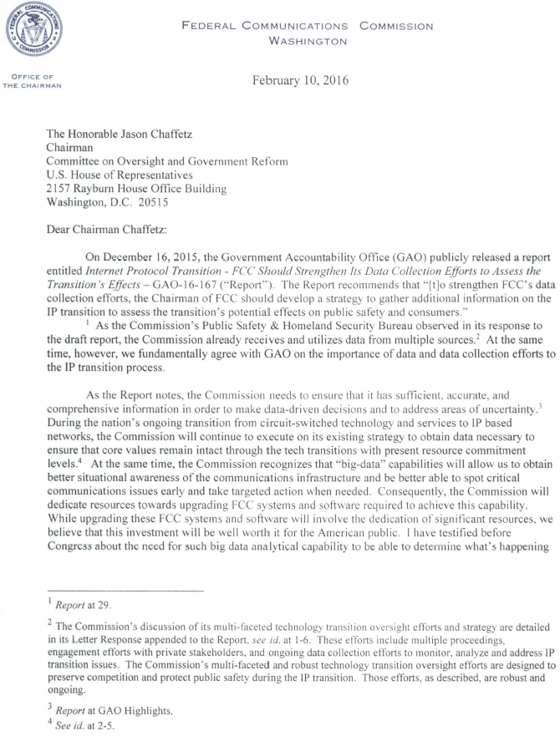

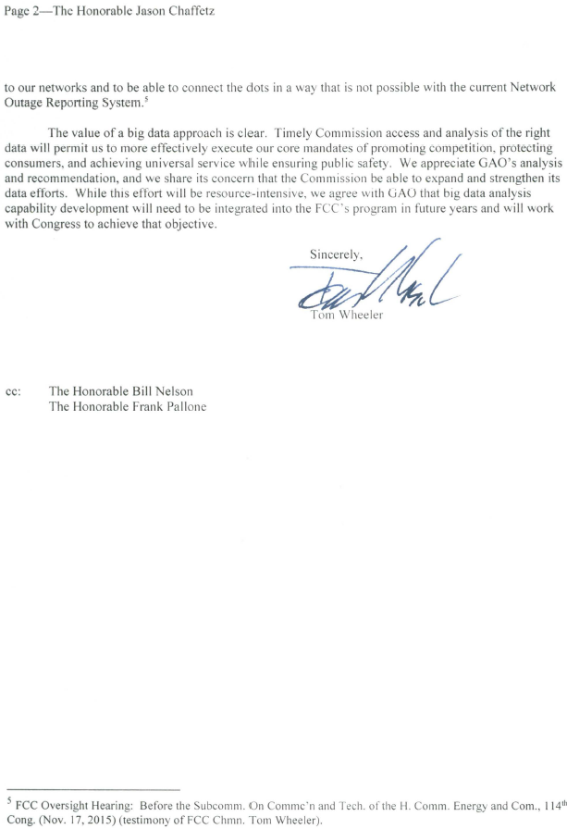

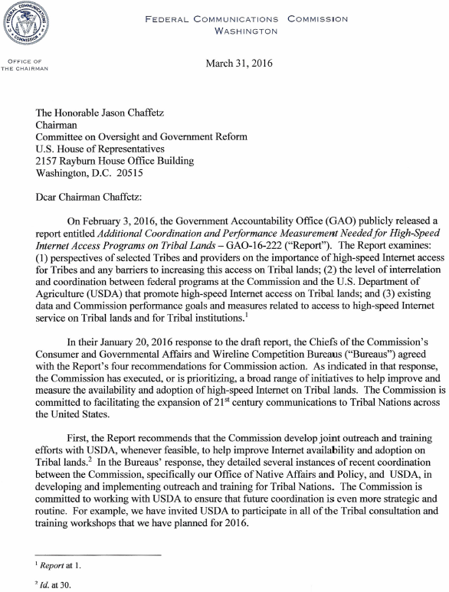

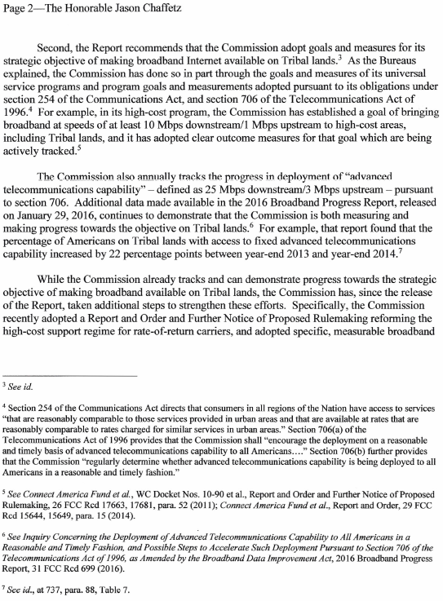

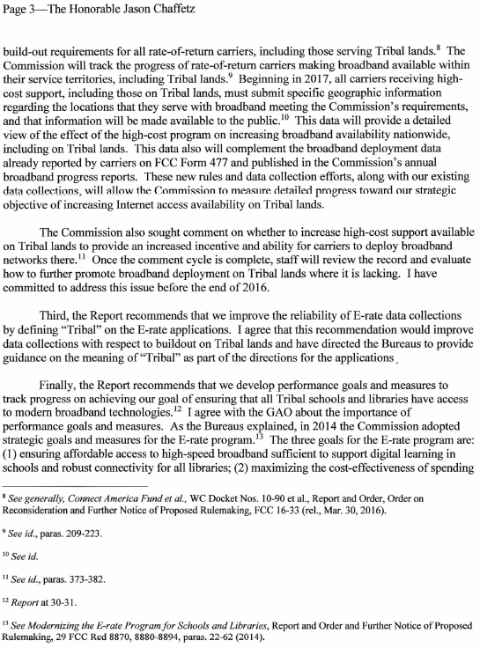

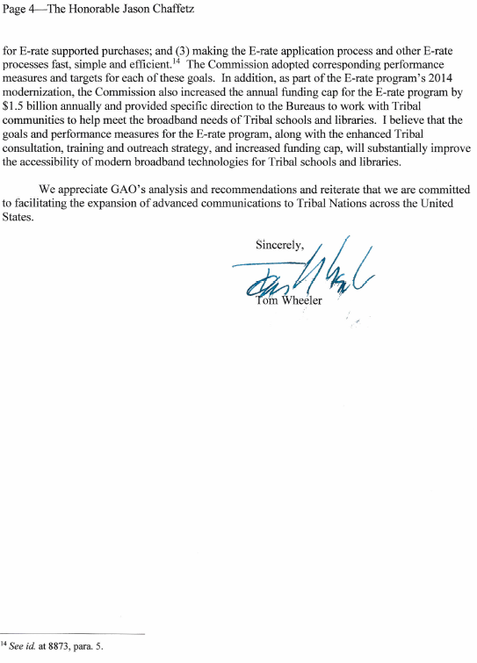

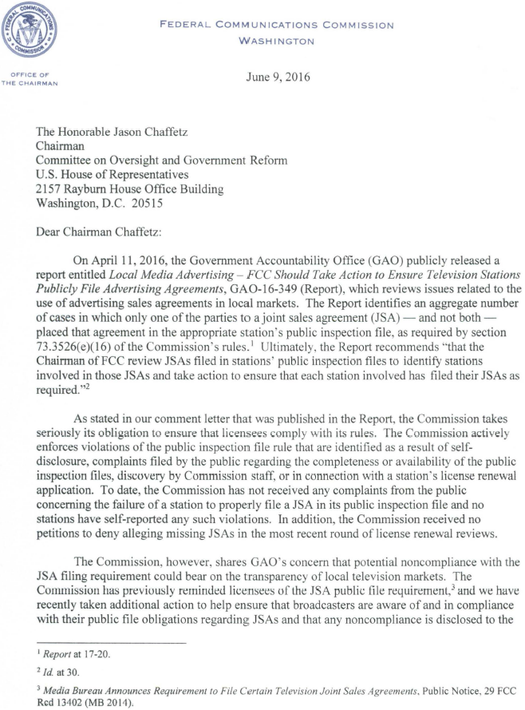

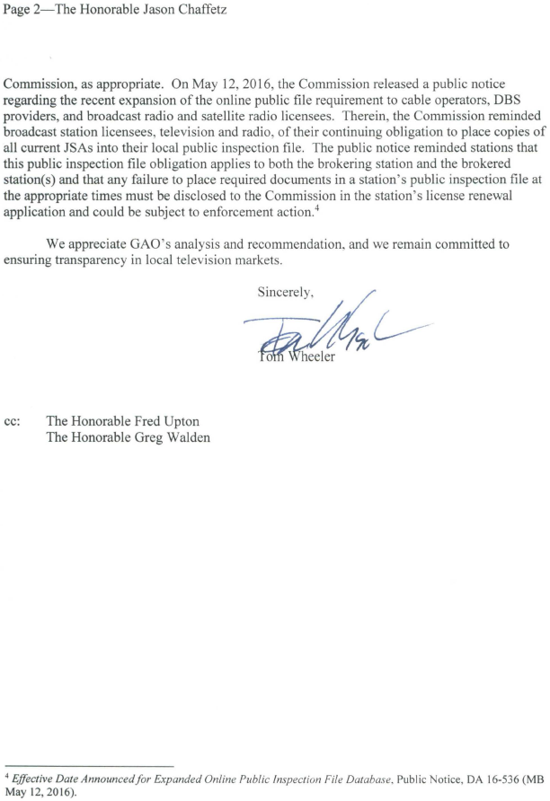

1. 47 U.S.C. § 151.
2. *Id.*
3. Refer to a chart on page 13 for a breakdown of FTEs between non-auctions (Regulatory Fees) and auctions.
4. 47 U.S.C. § 151.
5. *Id.*