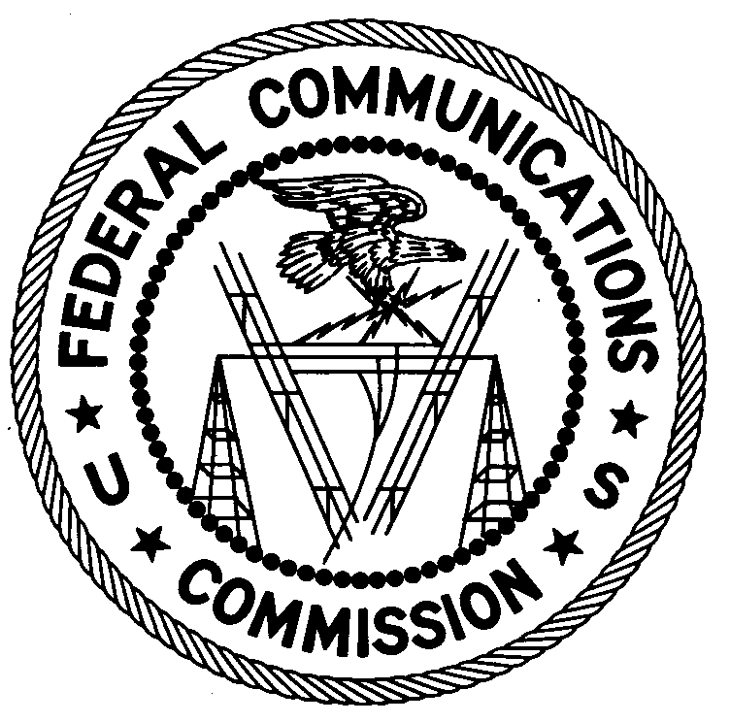
FEDERAL COMMUNICATIONS COMMISSION
ENFORCEMENT BUREAU
REGION ONE

Columbia Regional Office
9200 Farm House Lane

Columbia, Maryland 21046

(301) 725-1996

June 1, 2017

Maria Santiago
New York, New York

NOTICE OF UNLICENSED OPERATION

Case Number: EB-FIELDNER-16-00022165

On May 5, 2017, Agents from the New York Office of the Federal Communications Commission’s (Commission’s) Enforcement Bureau responded to a complaint of an unlicensed FM station operating on the frequency 95.3 MHz in New York, New York. The Agents confirmed by direction finding techniques that radio signals on frequency 95.3 MHz were emanating from your apartment on Saint Nicholas Avenue, New York, New York. The Commission’s records show no license issued for operation of a radio station on 95.3 MHz at this location in New York, New York.

Radio stations operating on many frequencies, including 95.3 MHz, must be licensed by the Commission pursuant to Section 301 of the Communications Act of 1934, as amended (Act). The only exception to this licensing requirement is for certain transmitters using or operating at a power level or mode of operation that complies with the standards established in Part 15 of the Commission’s rules. The field strength of the signal on frequency 95.3 MHz was measured at 823,656 microvolts per meter (µV/m) at 1,088 meters, which exceeded the maximum permitted level of 250 µV/m at 3 meters for non-licensed devices. Thus, this station is operating in violation of Section 301 of the Act.

In addition, the Commission has adopted rules limiting human exposure to radiofrequency (RF) radiation emitted by radio transmitters to acceptable levels. Agents from the New York Office have determined that the RF radiation caused by the radio signals emanating from your apartment exceed those limits by a significant margin.

You are hereby warned that operation of radio transmitting equipment without a valid radio station authorization, or in violation of the Commission’s RF radiation limits, constitutes a violation of the Federal laws cited above and could subject the operator to severe penalties, including, but not limited to, substantial monetary fines, in rem arrest action against the offending radio equipment, and criminal sanctions, including imprisonment.

UNLICENSED OPERATION OF THIS RADIO STATION MUST BE DISCONTINUED IMMEDIATELY.

You have ten (10) days from the date of this notice to respond with any evidence that you have authority to operate granted by the Commission. Your response should be sent to the address in the letterhead and reference the listed case number. Under the Privacy Act of 1974, we are informing you that the Commission’s staff will use all relevant material information before it to determine what, if any, enforcement action is required to ensure your compliance with the Commission rules. This will include any information that you disclose in your reply.

You may contact this office if you have any questions.

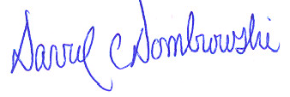
David C. Dombrowski
Regional Director
Region One
Enforcement Bureau
Federal Communications Commission

Attachments:
Excerpts from the Communications Act of 1934, As Amended
Enforcement Bureau, "Inspection Fact Sheet", March 2005

47 U.S.C. § 301.
47 CFR §§ 15.1 et seq.
47 U.S.C. § 301.
See 47 CFR 1.1310. See also Reassessment of Federal Communications Commission Radiofrequency Exposure Limits and Policies, First Report and Order, 28 FCC Rcd 3498, 3503, para. 10 (2013).
See 47 U.S.C. §§ 401, 501, 503, and 510.
5 U.S.C. § 552a(e)(3).

