Study Area Boundary TIP SHEET
Accessing the Study Area Boundary Application
- To log into the application with an existing Username/Password

- To create a new account for the application
Create and Submit a New Recertification
- Once inside the application, click the Study Area Codes (SAC) icon (see below).
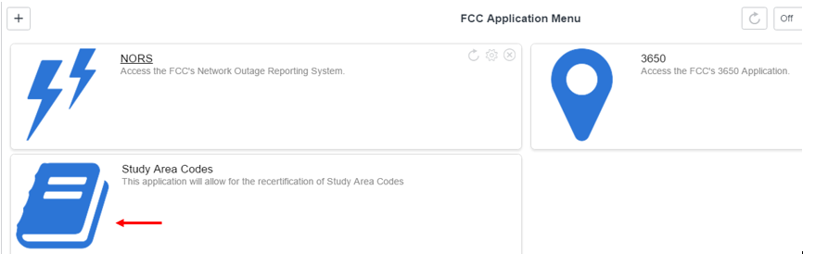

- You can also create a new recertification by clicking the Study Area Boundary menu item on the navigation panel located on left side of the screen:

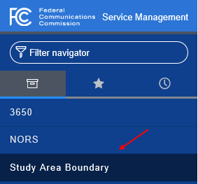

- Click the New button at the top of the page:

- Fill in all the required fields in the form. Note: The User field will auto populate; click the magnifying glass to choose the correct FRN.

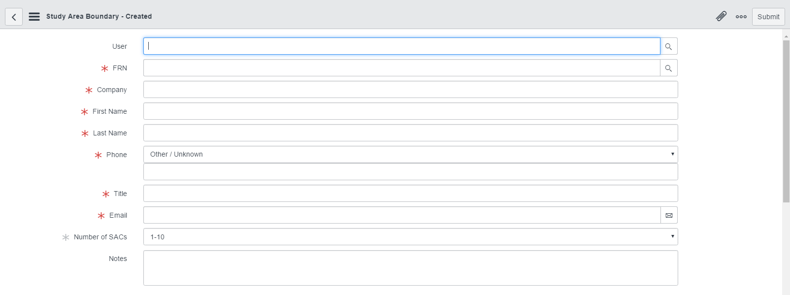

- Fill in the Study Area Codes, SACs to be Recertified fields as needed:

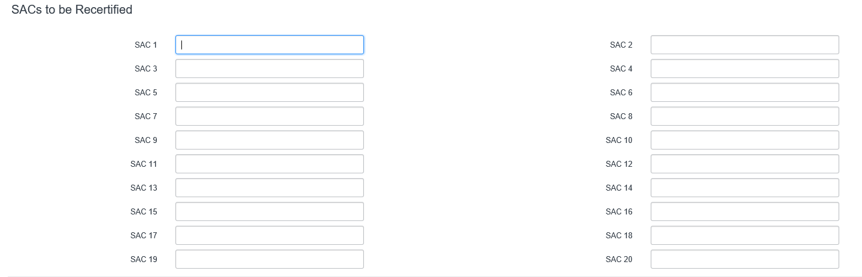

- Filers recertifying more than 20 SACs for this FRN are asked to upload a CSV file listing the SACs. Attach the file by clicking on the Paperclip located on the top right of the screen.
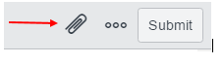
- When you have completed all information check the Attest box and click Submit to file your recertification.
