FEDERAL COMMUNICATIONS COMMISSION
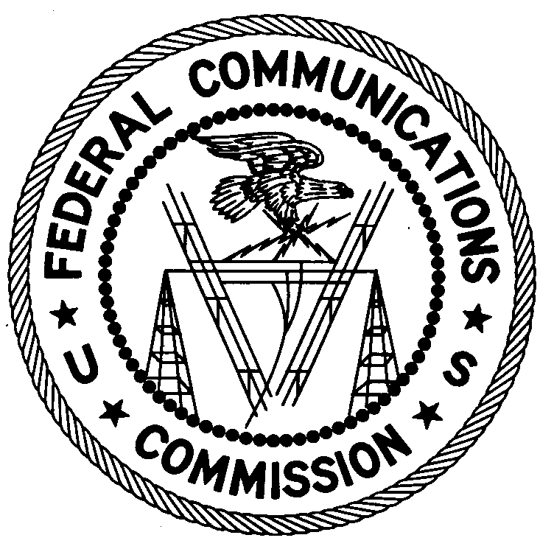
ENFORCEMENT BUREAU
Office of Director – Region Two
3600 Hiram Lithia Spring Rd. SW
Powder Springs, GA 30127

June 15, 2017

Greenpoint Aerospace
5035 Warbird Drive
Denton, TX 76207

NOTICE OF UNLICENSED OPERATION

Case Number: EB-FIELDSCR-17-00024339

On May 18, 2017, an Agent from the Dallas Office of the Federal Communications Commission’s (FCC’s) Enforcement Bureau responded to a complaint from the Federal Aviation Administration (FAA) concerning interference to their Traffic Collision Avoidance System (TCAS) on 1030 MHz and 1090 MHz. Based on the compliant, the Agent spoke to Greenpoint Aerospace (GA) regarding the interference. A representative for GA stated to the Agent that it has been periodically testing TCAS for the commercial airline industry using GA’s own transmitting equipment, but that they had no authorization for their operation on 1030 MHz and/or 1090 MHz.

You are hereby warned that operation of radio transmitting equipment without a valid radio station authorization constitutes a violation of the Federal laws cited above and could subject the operator to severe penalties, including, but not limited to, substantial monetary fines, in rem arrest action against the offending radio equipment, and criminal sanctions, including imprisonment.

YOUR UNLICENSED OPERATION MUST NOT BE RESUMED.

You have ten (10) days from the date of this notice to respond with any evidence that you have authority to operate granted by the FCC. Your response should be sent to the address in the letterhead and reference the listed case number. Under the Privacy Act of 1974, we are informing you that the Commission’s staff will use all relevant material information before it to

determine what, if any, enforcement action is required to ensure your compliance with FCC rules. This will include any information that you disclose in your reply.

You may contact this office if you have any questions.

Ronald D. Ramage
Regional Director
Region Two
Enforcement Bureau
Federal Communications Commission

Attachments:
Excerpts from the Communications Act of 1934, As Amended
Enforcement Bureau, "Inspection Fact Sheet", March 2005

See 47 U.S.C. §§ 401, 501, 503 and 510.
5 U.S.C. § 552a(e)(3).

