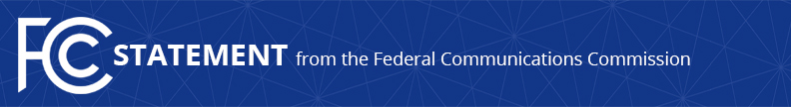

Media Contact:
Will Wiquist, (202) 418-0509
will.wiquist@fcc.gov

For Immediate Release

CHAIRMAN PAI STATEMENT ON BIPARTISAN SUPPORT FOR
THE GIGABIT OPPORTUNITY ACT
--
WASHINGTON, June 21, 2017 – Federal Communications Commission Chairman Ajit Pai today issued the following statement on news that U.S. Senator Christopher Coons of Delaware has cosponsored the Gigabit Opportunity (GO) Act introduced by Senator Shelley Moore Capito of West Virginia. The bill has also been introduced in the U.S. House of Representatives by Congressman Doug Collins of Georgia, and was originally cosponsored by Congressman Jason Smith of Missouri.

“Closing the digital divide is a top national priority. Gigabit Opportunity Zones would go a long way toward meeting that priority. By streamlining regulations to encourage broadband deployment and establishing targeted tax incentives for entrepreneurs to build those networks, we can empower millions of Americans, rural and urban alike. This is a common sense idea, and I’m excited to see it gaining bipartisan support.

“I am grateful to Senator Coons for supporting this effort. Along with Senator Capito and Representatives Collins and Smith, he is providing the leadership we need to help deliver digital opportunity. Disadvantaged communities will benefit from high-speed broadband in so many ways, like more jobs, better health care, stronger education, and more productive agriculture. And they’ll have a greater sense of hope about the future.”

###
Office of Chairman Ajit Pai: (202) 418-2000
Twitter: @AjitPaiFCC
www.fcc.gov/leadership/ajit-pai

This is an unofficial announcement of Commission action. Release of the full text of a Commission order constitutes official action. See MCI v. FCC, 515 F.2d 385 (D.C. Cir. 1974).

