FEDERAL COMMUNICATIONS COMMISSION
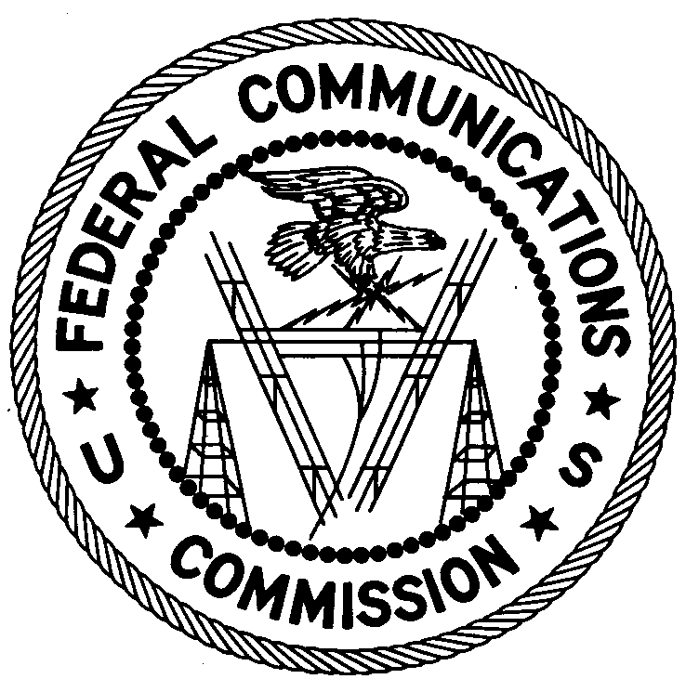
ENFORCEMENT BUREAU
REGION ONE

Columbia Regional Office
9200 Farm House Lane

Columbia, Maryland 21046

(301) 725-1996

June 27, 2017

Wisland Georges
New England Evangelical Church of Mount Olives
Medford, Massachusetts

NOTICE OF UNLICENSED OPERATION

Case Number: EB-FIELDNER-17-00024120

On May 25, 2017 and June 2, 2017, an Agent from the Boston Office of the Federal Communications Commission’s (FCC’s or Commission’s) Enforcement Bureau (Bureau) responded to a complaint of an unlicensed FM station operating on the frequency 98.7 MHz north of Boston, Massachusetts. The Agent confirmed by direction finding techniques that radio signals on frequency 98.7 MHz were emanating from the New England Evangelical Church of Mount Olives on Rear Mystic Ave. in Medford, Massachusetts. The Commission’s records show that no license was issued for operation of a radio station on 98.7 MHz at this location in Medford, Massachusetts. You identified yourself to the Agent as the pastor of the New England Evangelical Church of Mount Olives. You admitted that you were the operator of the radio station and you acknowledged that you had no authorization to operate the radio station.

Radio stations operating on a range of frequencies, including 98.7 MHz must be licensed by the FCC pursuant to Section 301 of the Communication Act of 1934, as amended (Act). The only exception to this licensing requirement is for certain transmitters using or operating at a power level or mode of operation that complies with the standards established in Part 15 of the Commission’s rules. The field strength of the signal on frequency 98.7 MHz was measured at 67,775 microvolts per meter (µV/m) at 121 meters, and 2,322 µV/m at 448 meters, which exceeded the maximum permitted level of 250 µV/m at 3 meters for non-licensed devices. Thus, this station is operating in violation of Section 301 of the Act.

You are hereby warned that operation of radio transmitting equipment without a valid radio station authorization constitutes a violation of the Federal laws cited above and could subject the operator to severe penalties, including, but not limited to, substantial monetary fines, in rem arrest action against the offending radio equipment, and criminal sanctions, including imprisonment.

UNLICENSED OPERATION OF THIS RADIO STATION MUST BE DISCONTINUED IMMEDIATELY.

You have ten (10) days from the date of this notice to respond with any evidence that you have authority to operate granted by the FCC. Your response should be sent to the address in the letterhead and reference the listed case number. Under the Privacy Act of 1974, we are informing you that the Commission’s staff will use all relevant material information before it to determine what, if any, enforcement action is required to ensure your compliance with FCC Rules. This will include any information that you disclose in your reply.

You may contact this office if you have any questions.

David C. Dombrowski
Regional Director
Region One
Enforcement Bureau
Federal Communications Commission

Attachments:
Excerpts from the Communications Act of 1934, As Amended
Enforcement Bureau, "Inspection Fact Sheet", March 2005

47 CFR § 73.201.
47 U.S.C. § 301.
47 CFR §§ 15.1 et seq.
47 U.S.C. § 301.
See 47 U.S.C. §§ 401, 501, 503 and 510.
5 U.S.C. § 552a(e)(3).

