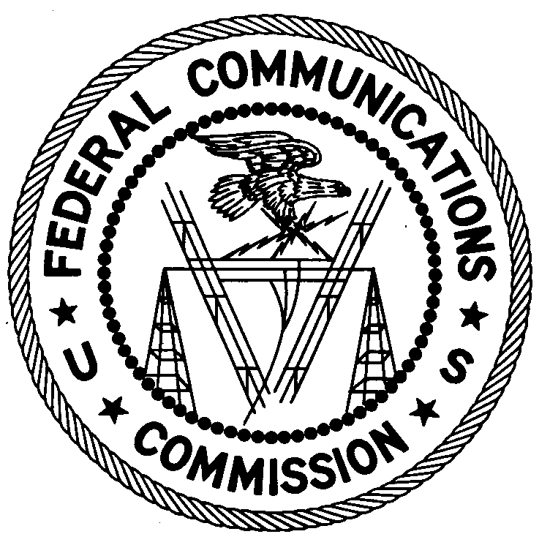
FEDERAL COMMUNICATIONS COMMISSION
ENFORCEMENT BUREAU
REGION ONE

Columbia Regional Office
9200 Farm House Lane

Columbia, Maryland 21046

(301) 725-1996

June 30, 2017

Winston Tulloch
Paterson, New Jersey

NOTICE OF UNLICENSED OPERATION

Case Number: EB-FIELDNER-15-00019211

On June 12, 2017, Agents from the Federal Communications Commission’s (FCC or Commission’s) Enforcement Bureau (Bureau) conducted a follow up investigation of an unlicensed FM station operating on the frequency 90.9 MHz in Paterson, New Jersey. The Agents confirmed by direction finding techniques that radio signals on frequency 90.9 MHz were emanating from a residence on E. 30th Street, Paterson, New Jersey. They identified you as the owner of the station. The Commission’s records show no license issued for operation of a radio station on 90.9 MHz at this location in Paterson, New Jersey.

Radio stations operating on a range of frequencies, including 101.5 MHz must be licensed by the FCC pursuant to Section 301 of the Communication Act of 1934, as amended (Act). The only exception to this licensing requirement is for certain transmitters using or operating at a power level or mode of operation that complies with the standards established in Part 15 of the Commission’s rules. The field strength of your signal on frequency 90.9 MHz was measured at 5,705 microvolts per meter (µV/m) at 185 meters, which exceeded the maximum permitted level of 250 µV/m at 3 meters for non-licensed devices. Thus, this station is operating in violation of Section 301 of the Act.

You are hereby warned that operation of radio transmitting equipment without a valid radio station authorization constitutes a violation of the Federal laws cited above and could subject the operator to severe penalties, including, but not limited to, substantial monetary fines, in rem arrest action against the offending radio equipment, and criminal sanctions, including imprisonment.

UNLICENSED OPERATION OF THIS RADIO STATION MUST BE DISCONTINUED IMMEDIATELY.

You have ten (10) days from the date of this notice to respond with any evidence that you have authority to operate granted by the FCC. Your response should be sent to the address in the letterhead and reference the listed case number. Under the Privacy Act of 1974, we are informing you that the Commission’s staff will use all relevant material information before it to determine what, if any, enforcement action is required to ensure your compliance with FCC Rules. This will include any information that you disclose in your reply.

You may contact this office if you have any questions.

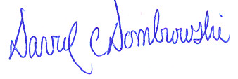
David C. Dombrowski
Regional Director
Region One
Enforcement Bureau
Federal Communications Commission

Attachments:
Excerpts from the Communications Act of 1934, As Amended
Enforcement Bureau, "Inspection Fact Sheet", March 2005

47 CFR § 73.201.
47 U.S.C. § 301.
47 CFR §§ 15.1 et seq.
47 U.S.C. § 301.
See 47 U.S.C. §§ 401, 501, 503 and 510.
5 U.S.C. § 552a(e)(3).

